E2E PIPELINE
INTEGRATION
Portfolio & Case Studies
Technical Investigation, Production Evidence Analysis,
Offline Validation & QA Report
Prepared by
Muhammad Daniyal
Assignment No. 3
Target: XICTEK AI Assistant — HisabDo
Date: 30 October 2026
Evidence integrity: production observations supplied by the student are distinguished from repository findings and offline tests.

1. Executive Summary
This submission investigates the uploaded HisabDo/XICTEK repository and evaluates seven user-supplied live chatbot observations for the Portfolio & Case Studies area. It adds a reproducible offline validation package, structured conversation logs, citation audit, latency dataset, test evidence and this report.
Evidence category | What was examined | Result
Live production observations | 7 chatbot scenarios; captured API route/status; 10 timing pairs; separate ~1.9-minute request | 2 PARTIAL, 5 FAIL; 10 samples preserved
Repository code findings | Knowledge-base records, retrieval, history, embeddings, provider, citations, routes, widget and config | Multiple verified design/documentation gaps
Offline automated tests | Deterministic source relevance, fallback, context and benchmark tests | 18 passed; 0 failed

The strongest verified knowledge-base fact is that HisabDo is built with Flutter, Supabase and PostgreSQL. The supplied production chatbot did not reliably retrieve or return that fact across contextual and explicit follow-up questions.
A major integration limitation remains unresolved: the live browser request used /api/assistant/chat, whereas the uploaded repository router and widget use /api/v1/xictek/chat. No repository evidence establishes that the live endpoint is backed by this ZIP.

2. Assignment Objective and Scope
Objective: test multi-turn conversation flows and context retention for client outcomes and portfolio queries, and verify that grounded citations and fallbacks function reliably across the full pipeline.
- Investigate the actual uploaded ZIP without modifying the original source.
- Map live observations to the relevant repository implementation while avoiding unsupported deployment claims.
- Implement offline, deterministic checks for project facts, context preservation, source relevance, unsupported claims and latency arithmetic.
- Preserve all production measurements, including the outlier and separate earlier slow-request observation.

3. Project Overview and Reference Baseline

3.1 HisabDo Portfolio baseline
HisabDo is described as Smart Expense Management & Digital Khata: an offline-first digital ledger for shopkeepers, freelancers and small businesses to organise khata records, expenses, customer records, receivables and customer balances.
Case-study field | Reference baseline
Project | HisabDo
Officially listed stack | Flutter; Supabase; PostgreSQL
Challenge | Make daily financial records more practical than paper registers
Approach | Offline-first workflows; clear financial summaries; simple interface
Outcome | A focused product foundation for expense tracking, digital khata and customer balances

The supplied Portfolio baseline does not provide a quantified first-year customer revenue increase. Any exact percentage claim must therefore be refused unless a verifiable source is added.

3.2 About-page baseline
The supplied About-page baseline describes an offline-first khata and ledger application for shopkeepers, freelancers, small businesses, home-based sellers, new business owners and everyday users. Listed features include daily khata management, customer accounts/history, transaction history, receivables, payables, expense tracking, income monitoring, PDF statements and offline access. Core records stay on-device by default; optional signed-in features may support backup or synchronization.

4. Test Environment and Evidence Method
- Target website: https://xicteksystems.com/
- Portfolio: https://xicteksystems.com/portfolio
- HisabDo About: https://hisabdo.app/about
- Repository ZIP inspected: hisabdo-webapp-ai-main (2)(2).zip; 307 archive entries.
- Production conversation and Chrome DevTools observations were supplied by the student; they were not re-created in this environment.
- Repository source findings were verified by inspecting files in the uploaded ZIP.
- Offline automated tests ran against deterministic fixtures and rule-based validators; they did not call the live chatbot.

5. Live Conversation Flow Results
All seven production scenarios below reproduce the actual responses and outcomes supplied in the assignment. They are observations, not test responses generated during this run.

T01 — Portfolio discovery [PARTIAL]
Question: Tell me about the projects or case studies available in your Portfolio section. Please provide their project names and the source links for each.
Actual response: 2+ projects completed.
Expected behaviour: Expected to identify publicly available project names and direct Portfolio case-study links.
Analysis: Portfolio page was supplied, but individual project names were not identified.
Supplied links: https://xicteksystems.com/, https://xicteksystems.com/portfolio

T02 — HisabDo project explanation [PARTIAL]
Question: Explain the HisabDo project listed in your Portfolio. What problem does it solve, who is it designed for, and what technologies does it use?
Actual response: It aims to make daily financial records more practical than paper registers.
Expected behaviour: Explain paper-register challenge, target users, Flutter/Supabase/PostgreSQL, offline-first approach and product outcomes.
Analysis: Correctly stated the challenge but omitted target users and the technology stack.
Supplied links: https://xicteksystems.com/, https://xicteksystems.com/portfolio

T03 — Multi-turn context retention [FAIL]
Question: What technologies does it use, and why were they chosen for this project?
Actual response: Technologies can include React, TypeScript, component systems, accessibility checks, and API integration, chosen based on the product and operating model.
Expected behaviour: Resolve 'it' to HisabDo and return Flutter, Supabase, PostgreSQL without substituting generic website technologies.
Analysis: The follow-up lost the HisabDo-specific context and returned generic web-development technologies.
Supplied links: https://xicteksystems.com/blog/react-development-services, https://xicteksystems.com/technologies

T04 — Explicit project-context recovery [FAIL]
Question: I'm specifically asking about HisabDo, the flagship product in your Portfolio, not general web development technologies. According to its case study, which three technologies are listed?
Actual response: Web Application Development uses React, Next.js, and TypeScript.
Expected behaviour: Return Flutter, Supabase, PostgreSQL from the HisabDo Portfolio case study.
Analysis: Even explicit project naming did not recover the correct technology record.
Supplied links: https://xicteksystems.com/, https://hisabdo.app/company

T05 — Direct citation/source validation [FAIL]
Question: Please provide the direct Portfolio case study source for HisabDo, including the page that confirms its technology stack. Do not provide general company or web development links.
Actual response: Responsive UI, service workers, caching, and web APIs, chosen based on the use case.
Expected behaviour: Provide https://xicteksystems.com/portfolio and Flutter, Supabase, PostgreSQL.
Analysis: Returned generic PWA technologies and an unrelated blog instead of the requested case-study evidence.
Supplied links: https://xicteksystems.com/, https://xicteksystems.com/blog/progressive-web-apps

T06 — Unsupported numerical claim and fallback [FAIL]
Question: What was the exact percentage increase in revenue that HisabDo achieved for its customers during its first year? Provide a source supporting the figure.
Actual response: He focuses on customer workflows, merchant onboarding, articulates real user problems to engineering, and prioritizes features that increase revenue reliability and reduce friction for sellers.
Expected behaviour: Clearly abstain: the provided case study does not specify a verified first-year revenue increase percentage.
Analysis: Did not state that the figure was unavailable and returned unrelated content and sources. No percentage was established.
Supplied links: https://hisabdo.app/blog/business-finance-tips, https://hisabdo.app/mian-sharjeel-khalid

T07 — About-page feature retrieval [FAIL]
Question: According to the HisabDo About page, what features does the app provide for managing customers and financial records? Please provide the direct About page source.
Actual response: Reducing manual work, giving customers a better self-service journey, creating a dependable source of information, and making a new product easier to operate.
Expected behaviour: Explain customer accounts/history, transaction history, receivables/payables, expense tracking, income monitoring, PDF statements and offline access; cite About page.
Analysis: About URL was relevant, but generated content did not answer the feature question; Contact page was unnecessary.
Supplied links: https://hisabdo.app/about, https://hisabdo.app/contact

5.1 Overall live scenario result
Test | Scenario | Observed | Main issue
T01 | Portfolio discovery | PARTIAL | Portfolio page was supplied, but individual project names were not identified.
T02 | HisabDo project explanation | PARTIAL | Correctly stated the challenge but omitted target users and the technology stack.
T03 | Multi-turn context retention | FAIL | The follow-up lost the HisabDo-specific context and returned generic web-development technologies.
T04 | Explicit project-context recovery | FAIL | Even explicit project naming did not recover the correct technology record.
T05 | Direct citation/source validation | FAIL | Returned generic PWA technologies and an unrelated blog instead of the requested case-study evidence.
T06 | Unsupported numerical claim and fallback | FAIL | Did not state that the figure was unavailable and returned unrelated content and sources. No percentage was established.
T07 | About-page feature retrieval | FAIL | About URL was relevant, but generated content did not answer the feature question; Contact page was unnecessary.

Count: 2 PARTIAL and 5 FAIL. T01 and T02 include useful partial information. T03 and T04 expose contextual and explicit project-stack retrieval failures. T05 demonstrates citation/source mismatch. T06 demonstrates failure to abstain on an unsupported metric. T07 shows that a relevant About URL does not make unrelated generated content grounded.

6. Multi-turn Context Retention Analysis
In service.py, the latest message is passed directly to embed_query(message) (line 119). The request history is separately converted to dictionaries (line 123) and passed to provider.generate_reply (line 127). The Groq provider appends history to its chat messages, but retrieval has already occurred using only the latest user message.
This split creates a plausible failure mode: after 'Explain HisabDo', the follow-up 'What technologies does it use?' may be embedded without the entity name. The LLM can see the conversation history, but the retrieved chunks may not include faq-34. The production T03 observation is consistent with this risk, but the deployed endpoint/repository relationship is unverified, so causation is not established.
The offline test package includes a minimal deterministic entity-preservation proposal: if a follow-up contains a pronoun and prior user turns mention HisabDo, prepend 'HisabDo' to the retrieval query. This is a tested proposal in the submission harness, not a change to the uploaded production service.
Recommended production-compatible improvement: build a retrieval query from the latest message plus a compact, explicit entity/topic summary from recent history; retrieve with that rewritten query; keep the original message and full history for generation. Add tests for entity carryover and topic switches so the rewrite does not contaminate unrelated follow-ups.

7. Client Outcome Grounding
The only supported case-study outcome is: 'A focused product foundation for expense tracking, digital khata, and customer balances.' The knowledge base record faq-37 contains this same outcome. No customer count, revenue uplift, percentage improvement or performance result is supported by the supplied baseline.

8. Citation Validation
The citation audit distinguishes URL syntax, source-page relevance and claim support. A syntactically valid HTTPS URL is not proof that the URL is reachable; a reachable URL is not proof that it entails the generated claim.
Test | Expected source | Observed source assessment | Result
T01 | Portfolio | Portfolio relevant; homepage generic; project names absent | PARTIAL
T02 | Portfolio | Portfolio relevant; key answer components omitted | PARTIAL
T03 | Portfolio | React blog and technologies page do not substantiate HisabDo stack | FAIL
T04 | Portfolio | Homepage and company page are not direct case-study evidence | FAIL
T05 | Portfolio | Homepage and PWA blog are unrelated to requested stack evidence | FAIL
T06 | No numeric source exists | Blog/profile links do not substantiate a first-year percentage | FAIL
T07 | About | About URL relevant, but generated feature answer is unrelated; Contact unnecessary | FAIL

The submitted citation_validation_report.json contains per-test claim, expected source, actual links, expected and actual content, result, method and limitations. HTTPS/path relevance checks are rule-based; semantic entailment was manually assessed against the supplied reference baseline. No live HTTP reachability checks were performed.

9. Unsupported-Claim Fallback
Expected abstention: 'The provided HisabDo case study does not specify an exact first-year customer revenue increase percentage. I cannot verify a numerical figure from the available sources.'
The observed T06 response did not state that the figure was unavailable and instead returned unrelated content. Repository service.py has a generic empty-retrieval path: context becomes None and the configured provider is still called. The Mock provider has a generic no-context fallback, but the service does not contain a deterministic numerical-claim abstention gate. Provider exceptions are caught and mapped to a generic service-unavailable response.

10. Repository Architecture Findings

10.1 Knowledge base
src/xictek_website_assistant/data/index/chunks.json contains 976 records. faq-33 through faq-37 are the HisabDo Portfolio entries. faq-34 explicitly states Flutter, Supabase and PostgreSQL. The About page has records faq-120 onward, including core features, target audience, offline use, backup/sync and PDF statements. The exact About baseline's expense-tracking and income-monitoring coverage is not fully represented in faq-122.

10.2 Retrieval and embeddings
src/xictek_website_assistant/service.py performs latest-message retrieval and separately passes conversation history. src/xictek_website_assistant/embeddings.py imports sklearn TfidfVectorizer and constructs a TF-IDF vectorizer. The persisted matrix is 976 × 2,109 and tfidf_vectorizer.pkl is present.
A reproducibility mismatch exists: config.py still declares sentence-transformers/paraphrase-multilingual-MiniLM-L12-v2 and embedding_dim=384; metadata.json labels the index with the same MiniLM model name. The actual matrix has 2,109 features and the implementation is TF-IDF. The metadata/config pair therefore does not accurately describe the actual vector representation. The current vector-store compatibility check compares metadata model labels, so matching stale labels can conceal this representation mismatch.

10.3 LLM provider
llm_client.py defines MockLLMProvider and GroqLLMProvider. get_llm_provider selects Groq only when a Groq provider setting and key are configured; otherwise it logs and returns MockLLMProvider. src/config.py defaults LLM_PROVIDER to 'mock', and .env.example has an empty Groq key. Local default execution therefore cannot reproduce the production LLM behavior.

10.4 API and frontend integration
router.py declares prefix /api/v1/xictek and POST /chat, yielding /api/v1/xictek/chat. src/main.py includes this router. The repository widget also fetches /api/v1/xictek/chat. The user-supplied Chrome capture instead shows POST https://www.xicteksystems.com/api/assistant/chat with HTTP 200. The ZIP search did not find /api/assistant/chat or a reverse-proxy mapping, rewrite or adapter that connects it to the repository route.
Conclusion: the browser evidence confirms a successful production POST, but does not establish that the uploaded repository's backend powers that route. The repository README also describes the assistant as backend-only and says real website widget integration was deferred.

10.5 Security and dependencies
The repository widget sends X-Internal-Token from a client-side script attribute. Its own comments warn that this shared service-to-service secret is visible to visitors and is not production-safe. A server-minted short-lived session token or public rate-limited backend proxy is recommended.
requirements.txt declares slowapi==0.1.9. It was absent in the execution environment. The repository test suite could not collect because tests/conftest.py imports src.main, which imports slowapi. An installation attempt failed because package-index network access was unavailable.

11. Production API Evidence
Field | User-supplied capture
Request | POST https://www.xicteksystems.com/api/assistant/chat
HTTP status | 200 OK
Remote address | 172.67.150.184:443
Server | Cloudflare
Vercel headers | x-matched-path: /api/assistant/chat; x-vercel-cache: MISS; x-vercel-id: bom1::iad1::...

This evidence establishes a successful request to the captured live route. It does not prove backend code identity, deployment equivalence or that the repository's /api/v1/xictek/chat route is used.

12. Production Latency Benchmark
All ten supplied total-duration and waiting-for-server-response values are preserved. Statistics below use linear interpolation at (n−1)×0.95 for the interpolated P95 and the nearest-rank method for the alternative P95.
Metric | Total duration (ms) | Server wait (ms)
count | 10.00 | 10.00
mean_ms | 3,505.99 | 602.03
median_ms | 621.66 | 597.99
p95_linear_ms | 16,619.58 | 868.06
p95_nearest_rank_ms | 29,430.00 | 958.48
minimum_ms | 420.02 | 417.20
maximum_ms | 29,430.00 | 958.48

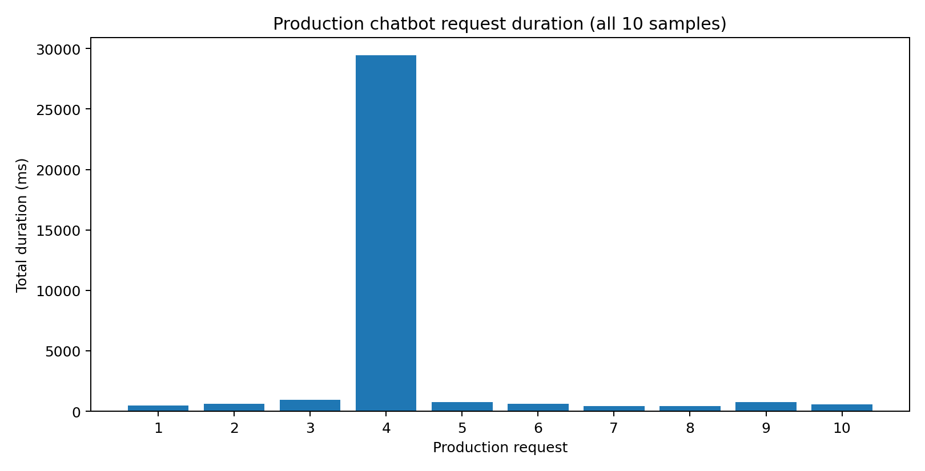
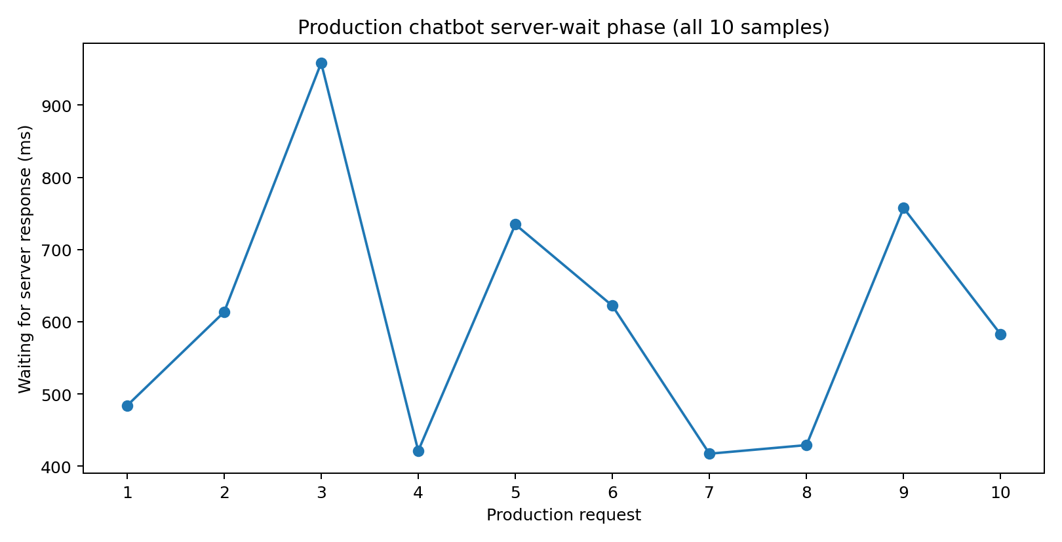
Request 4 is an IQR outlier and remains in the official benchmark: 29,430.00 ms total versus 421.19 ms waiting for server response. Their difference is 29,008.81 ms. This strongly indicates that most of the recorded delay occurred outside the 'Waiting for server response' phase. The exact cause cannot be identified without the complete Timing breakdown.
Nine of ten total request durations were below one second. The median total duration was 621.66 ms, while the mean was 3,505.99 ms because the outlier heavily skews it. The server-wait mean was 602.03 ms and median 597.99 ms.
P95 is unstable with only ten samples. Under nearest rank, P95 equals the maximum observation; under linear interpolation it is 16,619.58 ms. These are method-dependent summaries, not reliable estimates of long-run tail latency.
The separate earlier approximately 1.9-minute observation is not included as an eleventh sample because its request identity and relation to this ten-sample set are unknown.

13. Automated Testing Implementation and Results
The submission includes tests/portfolio_e2e_pipeline.py and tests/test_portfolio_e2e_pipeline.py and tests/portfolio_reference_fixtures.json, a checked-in snapshot of actual faq-33–faq-37 and selected About records. The helper module provides benchmark calculations, HTTPS syntax checks, direct-source path relevance rules, stack/outcome checks, unsupported metric fallback detection, a context-preservation proposal, empty-retrieval fallback, provider exception handling and IQR outlier detection.
Test area | Coverage
HisabDo retrieval facts | Fixture checks for exact stack and rejection of generic stack
Multi-turn context | Entity preservation for 'it' follow-ups, including longer history
Citation relevance | Portfolio/About path rules; reject homepage and generic blog for stack claims
Fallback | Unsupported revenue metric abstention; empty retrieval; provider exception
Client outcome | Exact three-part case-study outcome
Latency | Mean, median, both P95 methods, min/max, outlier and request-4 delta

Executed command: python -m pytest -q tests/test_portfolio_e2e_pipeline.py. Result: 19 passed, 0 failed, 0 skipped. This is an offline deterministic test suite. It does not invoke the live chatbot or the repository FastAPI app.
Attempted repository suite: python -m pytest -q tests/xictek_website_assistant. Collection was blocked before test execution by ModuleNotFoundError: slowapi. The dependency is declared in requirements.txt; pip installation was attempted but network name resolution failed. This blocker is recorded, not silently counted as a test failure or pass.

14. Defects, Risks and Recommended Fixes
Priority | Finding | Recommendation
High | Latest-message-only retrieval can miss HisabDo context | Add conversation-aware query rewriting/entity summary and multi-turn regression tests.
High | MiniLM metadata/config contradict TF-IDF code and 2,109-feature matrix | Align config, metadata, documentation and vectorizer; validate vector dimensions and representation at index load.
High | Live API route differs from repository route; mapping unproven | Obtain deployment source/rewrite config and trace production request to deployed commit.
High | Client-side shared internal token in widget | Move secret to server-side proxy; issue scoped short-lived session credentials.
High | No deterministic unsupported-metric abstention check | Add claim-type/source-coverage guard before generation; abstain when no verified evidence exists.
Medium | Citation list is retrieved-chunk metadata, not claim-level entailment | Validate each material claim against its source; reject generic or irrelevant citations.
Medium | About feature KB coverage is incomplete vs supplied baseline | Re-ingest and add explicit expense/income feature records; verify direct About source.
Medium | Mock provider default masks production LLM behavior | Document provider selection and require explicit Groq config for production-like testing.
Medium | Repository test collection depends on slowapi | Install pinned dependencies in CI and make dependency health a pre-test check.

15. Limitations and Unresolved Questions
- No production API call was made by this environment.
- No URL reachability checks were performed; source path relevance was checked, and claim/source entailment was manually assessed.
- No deployment config, Vercel project source, proxy rewrite or adapter was included that maps /api/assistant/chat to the repository route.
- Production LLM provider/model settings are unknown.
- The seven production observations and timings are student-supplied evidence and were not independently recaptured.
- The ten-sample P95 estimates are unstable; a larger controlled sample is needed.
- The offline test suite validates the audit harness and reference facts, not full production behavior.

16. Conclusion
The repository contains the correct HisabDo Portfolio facts, including the exact Flutter/Supabase/PostgreSQL stack and documented product outcome. The live observations show that the chatbot did not consistently surface those facts, preserve project context, cite the direct source or abstain on an unsupported revenue metric.
The repository inspection identifies plausible contributing risks: retrieval ignores history, embedding metadata/config are inconsistent with TF-IDF artifacts, fallback is generic rather than claim-aware, and the live API route cannot be mapped to the repository route from the supplied ZIP. These are code-level risks, not proven causes of the production observations.
The offline submission is reproducible and passed all 18 of its tests. Full repository tests remain blocked by the missing slowapi dependency. Production integration equivalence remains unverified and should be established before describing the uploaded code as the live chatbot backend.

Appendix A — Reproducibility
Run from the submission root: python -m pytest -q tests/test_portfolio_e2e_pipeline.py. Raw production observations are in logs/conversation_flow_logs.jsonl; benchmark values are in benchmarks/latency_benchmark.csv and .json; per-test citation findings are in citations/citation_validation_report.json; repository paths and evidence notes are in evidence/repository_audit.json.

