AI Feasibility Research
Local AI Assistant for HisabDo — AI/ML Team
Covers: technical feasibility, model research, Ollama, RAG, FastAPI, offline-first design, cost, hardware, and security
Documented by: Laiba Yousuf

1. Overview & Objective
HisabDo is a digital ledger app for small Pakistani shopkeepers, recording sales, expenses, and customer credit (udhaar). This research evaluates whether an AI assistant layer — chatbot Q&A, natural-language business insights, and smart suggestions — can realistically be added on top of that ledger data. The core question is where the AI should run: entirely on the shopkeeper's phone, on a small local server/PC at the shop, or in the cloud. Because target users often have budget Android phones and inconsistent internet in smaller towns, this report leans toward an offline-first, locally-hosted approach and evaluates it against Ollama, RAG, and FastAPI as the specific building blocks.

2. Technical Feasibility Analysis
Three deployment models were compared against HisabDo's constraints:
Model | Where it runs | Fit for HisabDo
On-device (phone) | Quantized 1B–3B model inside the app | Works fully offline, but answer quality is limited and it drains battery/storage on budget phones.
Local server (recommended) | Small PC/POS box at the shop, or a lightweight VPS | Best balance: strong-enough models, still works with poor internet, keeps ledger data close to the shop.
Cloud API | Hosted LLM provider (OpenAI, Anthropic, etc.) | Best quality, but depends on stable internet and recurring per-token cost — a poor fit for low-connectivity areas.

Feasibility verdict
Overall: Feasible — as a hybrid, offline-first system using a small local model for core features and optional cloud sync for heavier tasks
The recommended architecture keeps the AI assistant local to each shop (via a lightweight backend process) so it works without internet, and only reaches out to the cloud for optional, non-critical syncing. This matches how HisabDo already treats the ledger as the source of truth on-device.
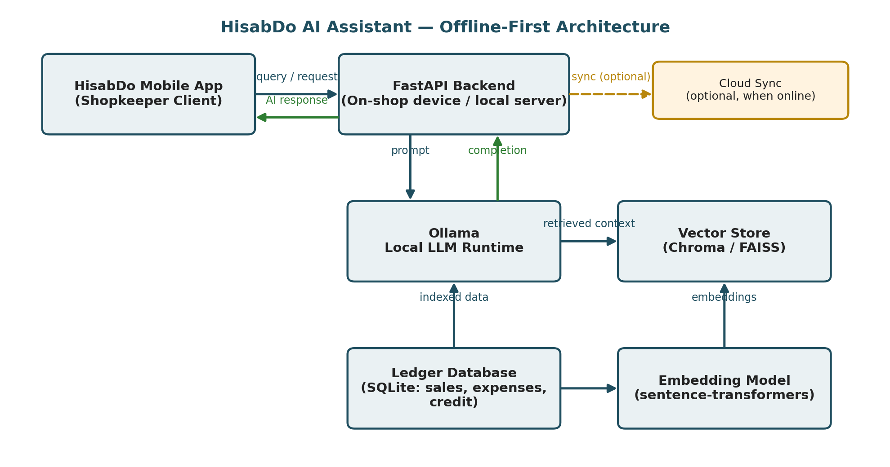
Figure 1: Recommended offline-first system architecture for HisabDo's AI assistant.

3. AI Model Research
For a shop-ledger assistant, the workload is mostly short Q&A and summarization over structured data — this does not require a very large model. Small, open-weight models in the 1B–8B range are the realistic candidates for local deployment:
Model family | Typical size | Notes for HisabDo
Llama 3.2 | 1B / 3B | Very light, good for on-device or CPU-only fallback; weaker reasoning.
Qwen 3 | 0.6B / 4B / 8B | Strong quality-to-size ratio; 4B–8B is a good sweet spot for a shop-level server.
Gemma 3n | small, mobile-oriented | Google's on-device-focused line; worth testing directly on Android.
Mistral 7B / small MoE variants | 7B+ | Good general quality but heavier; best reserved for a stronger local server, not a phone.

A practical starting point is an 8B-class model (e.g. Qwen 3 8B or Llama 3.1 8B) at Q4 quantization on the backend server, with a 1B–3B model as an optional pure-offline fallback directly on the phone for very basic queries when the shop server itself is unreachable.

4. Ollama Feasibility
Ollama is a practical fit as the local inference engine. It wraps llama.cpp behind a simple REST API, which is exactly the interface a FastAPI backend needs to call. Its own baseline requirements are modest — around 8 GB RAM and 10 GB of disk with no GPU required just to start — with 16 GB RAM plus a mid-range GPU recommended for comfortable day-to-day use of 7B–8B models.
Ollama on a shop PC / small server: Feasible — a low-cost mini-PC or existing shop computer with 16 GB RAM can comfortably serve an 8B Q4 model to a handful of concurrent users
Ollama directly on a shopkeeper's phone: Not recommended yet — Ollama itself targets desktop/server OSes; on-device inference on typical Android hardware is better handled by a dedicated mobile runtime and a much smaller model
Minimal FastAPI-to-Ollama call
import requests

def ask_ollama(prompt: str, model: str = 'qwen3:8b') -> str:
response = requests.post(
'http://localhost:11434/api/generate',
json={'model': model, 'prompt': prompt, 'stream': False},
timeout=60,
)
response.raise_for_status()
return response.json()['response']

# Example usage
answer = ask_ollama('Summarize today\'s sales for this shop.')
print(answer)

5. RAG Implementation Feasibility
Retrieval-Augmented Generation (RAG) lets the assistant answer questions grounded in a specific shop's actual ledger, instead of the LLM guessing from general knowledge. Ledger rows (sales, expenses, credit entries) are converted into short text chunks, embedded into vectors, and stored in a lightweight local vector store. At query time, the shopkeeper's question is embedded and matched against the closest chunks, which are inserted into the prompt sent to Ollama.
RAG on ledger data: Feasible — ledger data is small, structured, and per-shop, so a lightweight local vector database (Chroma or FAISS) is more than sufficient — no large-scale vector infrastructure is needed
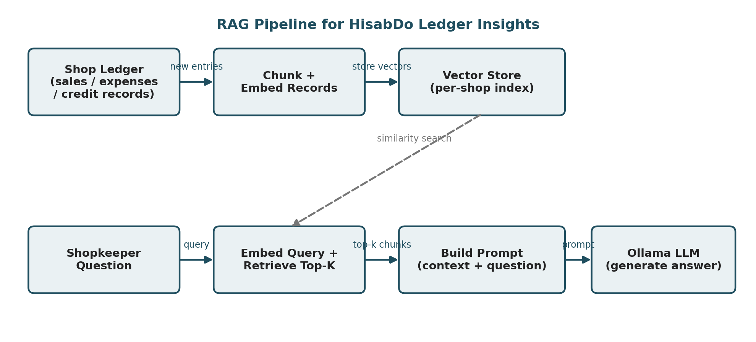
Figure 2: RAG pipeline turning ledger rows into grounded, per-shop AI answers.
RAG retrieval sketch
from sentence_transformers import SentenceTransformer
import chromadb

embedder = SentenceTransformer('all-MiniLM-L6-v2')
client = chromadb.PersistentClient(path='./shop_index')
collection = client.get_or_create_collection('ledger')

# --- Indexing (run whenever new ledger entries are added) ---
def index_entry(entry_id, text):
vector = embedder.encode(text).tolist()
collection.add(ids=[entry_id], embeddings=[vector], documents=[text])

# --- Retrieval (run for each shopkeeper question) ---
def retrieve_context(question, top_k=5):
query_vector = embedder.encode(question).tolist()
results = collection.query(query_embeddings=[query_vector], n_results=top_k)
return '\n'.join(results['documents'][0])

context = retrieve_context('How much credit does Ahmed still owe?')
prompt = f"Ledger context:\n{context}\n\nQuestion: How much credit does Ahmed still owe?"

6. FastAPI Integration Research
FastAPI is a natural fit as the glue layer between the HisabDo mobile app, the RAG retrieval step, and Ollama. It is async-native (important since LLM calls are I/O-bound and can be slow), has automatic request validation via Pydantic, and is lightweight enough to run on the same modest hardware as Ollama itself.
FastAPI as the backend layer: Feasible — a single FastAPI service can expose one endpoint (e.g. /ask) that internally handles retrieval and calls Ollama, keeping the mobile app simple
Minimal FastAPI endpoint
from fastapi import FastAPI
from pydantic import BaseModel

app = FastAPI()

class Question(BaseModel):
shop_id: str
text: str

@app.post('/ask')
async def ask(question: Question):
context = retrieve_context(question.text) # from the RAG module
prompt = f"Ledger context:\n{context}\n\nQuestion: {question.text}"
answer = ask_ollama(prompt) # from the Ollama module
return {'answer': answer}

7. Offline-First AI Possibilities
Given inconsistent connectivity in many of HisabDo's target markets, three tiers of offline support were considered:
- Tier 1 — Fully offline core: the shop-level FastAPI + Ollama + RAG stack runs entirely on local hardware with no internet dependency at all for day-to-day Q&A and insights.
- Tier 2 — Optional cloud sync: when internet is available, non-urgent data (aggregated, anonymized usage patterns, backups) can sync to the cloud for cross-device access or analytics, without blocking core features.
- Tier 3 — Pure on-device fallback: a very small on-device model (1B class) answers basic questions directly in the app if even the local shop server is temporarily unreachable (e.g. the shop PC is off).
This tiered design means the AI assistant degrades gracefully rather than failing outright when connectivity drops — a good match for HisabDo's existing offline-first philosophy for the ledger itself.

8. Cost Analysis
Because the proposed stack (Ollama, open-weight models, Chroma/FAISS, FastAPI) is entirely open-source and self-hosted, there is no per-token API fee. Costs instead come from hardware and hosting:
Cost item | One-time / recurring | Notes
Local mini-PC or reused shop computer | One-time | 16 GB RAM machine is enough for an 8B Q4 model; can often reuse an existing shop PC.
Cloud VPS (optional, for pilot/testing) | Recurring, monthly | Only needed if testing before hardware is deployed to shops; can be dropped once local hardware is in place.
Developer time (integration, testing) | One-time | Main cost driver — building and testing the FastAPI + RAG + Ollama pipeline.
Cloud LLM API (comparison baseline) | Recurring, per-token | Avoided in the recommended design, but would otherwise scale with usage and become expensive at higher shop volumes.

Cost outlook: Favorable — the self-hosted approach trades a one-time hardware/engineering cost for near-zero ongoing inference cost, which scales well as more shops adopt the feature

9. Performance and Hardware Requirements
Based on current guidance for running local models with Ollama, minimum and comfortable hardware tiers for HisabDo's use case are:
Tier | Hardware | Expected experience
Minimum (CPU-only) | 8 GB RAM, modern CPU, no GPU | Runs small 1B–3B models; usable but slow (roughly 5–10 tokens/sec).
Recommended (shop server) | 16 GB RAM + 8–12 GB VRAM GPU (e.g. RTX 3060/4060) or 16 GB Apple Silicon | Comfortably runs 7B–8B Q4 models at real-time speed (30+ tokens/sec).
Higher-end (multi-shop / franchise) | 24 GB+ VRAM | Supports larger 13B–32B models for noticeably better answer quality if needed later.

For a single shop with light, intermittent AI usage, the minimum tier is workable; the recommended tier is a better target if the assistant is meant to feel responsive during business hours.

10. Security and Privacy Considerations
Ledger data is financially sensitive — sales figures, customer names, and credit balances. Keeping inference local is itself a privacy advantage, since raw ledger data never has to leave the shop's device to reach a third-party AI provider. Additional considerations:
- Data locality: with the recommended architecture, ledger data and its vector index stay on local hardware; only optional, non-sensitive sync data would ever leave the shop.
- Access control: the FastAPI service should require authentication (e.g. a per-shop API key or the same login session as the app) so only the shop's own app instance can query its data.
- Encryption at rest: the SQLite ledger and vector store should be encrypted on disk, especially on shared or resellable hardware.
- Model behavior: local open-weight models avoid sending prompts to an external API, reducing exposure, but should still be tested so they don't leak one customer's data into another shop's session if a server is ever shared across shops.
- Update integrity: since models and the Ollama runtime are pulled from the internet, verify checksums and pin versions before deploying to shop hardware.
Security posture: Favorable — the local-first design meaningfully reduces data exposure compared to a cloud-API design, provided standard access control and encryption practices are followed

11. Summary and Recommendation
All eight researched areas point toward the same architecture: a shop-level FastAPI backend running Ollama with a small (7B–8B, Q4 quantized) open-weight model, backed by a lightweight RAG pipeline (Chroma/FAISS) indexed from the existing SQLite ledger. This keeps the assistant fully functional offline, avoids recurring API costs, runs on modest and affordable hardware, and keeps sensitive financial data local to the shop by default.
Research area | Feasibility
Technical feasibility | Feasible (hybrid offline-first)
AI model research | Feasible — 7B–8B open models fit the use case
Ollama feasibility | Feasible on shop server; not yet on-phone
RAG implementation | Feasible — small per-shop vector index
FastAPI integration | Feasible — single lightweight service
Offline-first design | Feasible — tiered graceful degradation
Cost analysis | Favorable — low recurring cost
Performance / hardware | Feasible on 16 GB RAM class hardware
Security & privacy | Favorable — local-first reduces exposure

12. Sources Consulted
General technical background on Ollama hardware requirements and local LLM deployment was reviewed from current public guides, including:
- sitepoint.com — Ollama Setup 2026 / Local LLMs Are Getting Easier guides
- overchat.ai — Local LLM Hardware Requirements in 2026
- convly.ai — Ollama System Requirements in 2026
- localllm.in — Ollama VRAM Requirements 2026 Guide
- localaimaster.com — Ollama System Requirements 2026

