HisabDo AI User Engagement Module
POC / Demo Proof Report
Prepared by: Laiba Yousuf
Department/ Track: 3-AI/ML
Module tested: "Refactor and Finalize AI POC"

1. Objective
This report demonstrates a working proof-of-concept (POC) of the AI User Engagement / AI Help & Support module built for HisabDo. It shows the complete AI workflow end-to-end, sample user queries with real captured responses, FAQ/knowledge-base handling, the existing AI engagement capabilities already implemented in the repository, successful and fallback response scenarios, and the observed limitations of the current build.
All results in this report were captured by running the actual Flask application from the "Refactor and Finalize AI POC" folder and sending live requests to it — nothing here is simulated or hand-written.

2. Working AI POC Demonstration
The POC is a Flask REST API with a lightweight web UI. It was started locally and verified healthy before running any queries.

2.1 Startup and Health Check
$ python app.py
Running on http://127.0.0.1:5000
GET /health -> {"data": {"service": "HisabDo AI Help & Support", "status": "healthy"}, "message": "API health check successful.", "status": "success"}

2.2 Web UI
The prototype exposes a simple chat-style UI at /ui where a user can type a question and receive the AI-generated answer along with a confidence level and related questions.
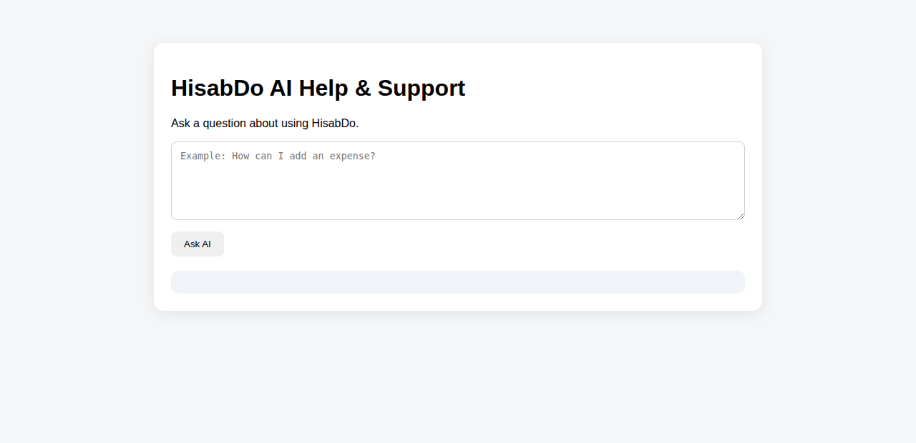
Figure 1 — HisabDo AI Help & Support UI, initial state.

3. Complete AI Workflow
Every query submitted to the /ai/help/faq endpoint passes through the following pipeline:
- 1. Input validation — rejects empty queries and queries over 500 characters.
- 2. Language detection — classifies the query as English, Urdu, or Roman Urdu.
- 3. Intent detection — classifies intent as product_info, feature, how_to, faq, support, greeting, or unknown, with an intent confidence score.
- 4. Verified FAQ retrieval — searches the local, verified knowledge base for a matching entry.
- 5. Response quality validation — checks the candidate answer for verification status, relevance, clarity, and confidence.
- 6. Decision — if the answer passes all checks it is returned as-is; otherwise a safe fallback is returned (low-confidence, ambiguous, or unknown) instead of an invented answer.
This pipeline is the project's main anti-hallucination safeguard: unverified or low-confidence content is never sent to the user as a factual answer.

4. Sample User Queries
The following queries were sent live to POST /ai/help/faq and the exact responses were captured.
Query | Intent | AI Response | Outcome
What is HisabDo? | product_info | Low-confidence fallback — no verified entry found for the general product question. | Fallback
What features does HisabDo have? | feature | Low-confidence fallback — no verified entry found. | Fallback
How can I add an expense? | how_to | "Open the Expenses section, select Add Expense, enter the expense details, review them, and save the transaction." (confidence: medium) | Success
My backup is not working. | faq (low conf.) | Clarification prompt in Roman Urdu asking the user to specify customer / expense / transaction / account. | Ambiguous
What is the weather today? | unknown | "I couldn't find a verified HisabDo answer for that question." (confidence: low) | Fallback
How do I do it? (no context) | how_to (matched Expenses by keyword overlap) | Returned the Add-Expense steps, but with lower relevance score — shows a limitation of context-free follow-ups. | Success (weak)
Expense kaise add karain? (Roman Urdu) | how_to | Same verified Add-Expense answer, correctly returned in English with language detected as roman_urdu. | Success
میں خرچہ کیسے شامل کروں؟ (Urdu script) | unknown | "مجھے اس سوال کا تصدیق شدہ HisabDo جواب نہیں ملا۔" — safe fallback, in Urdu. | Fallback
How do I track my monthly profit? | how_to (mismatched) | Candidate answer failed the relevance check (relevance_score 0.12) and was replaced with a safe fallback instead of being shown. | Fallback (caught by QA)
Hi | greeting | "Hello! I'm the HisabDo assistant. Ask me about expenses, customers, transactions, accounts, or any other HisabDo feature." | Success

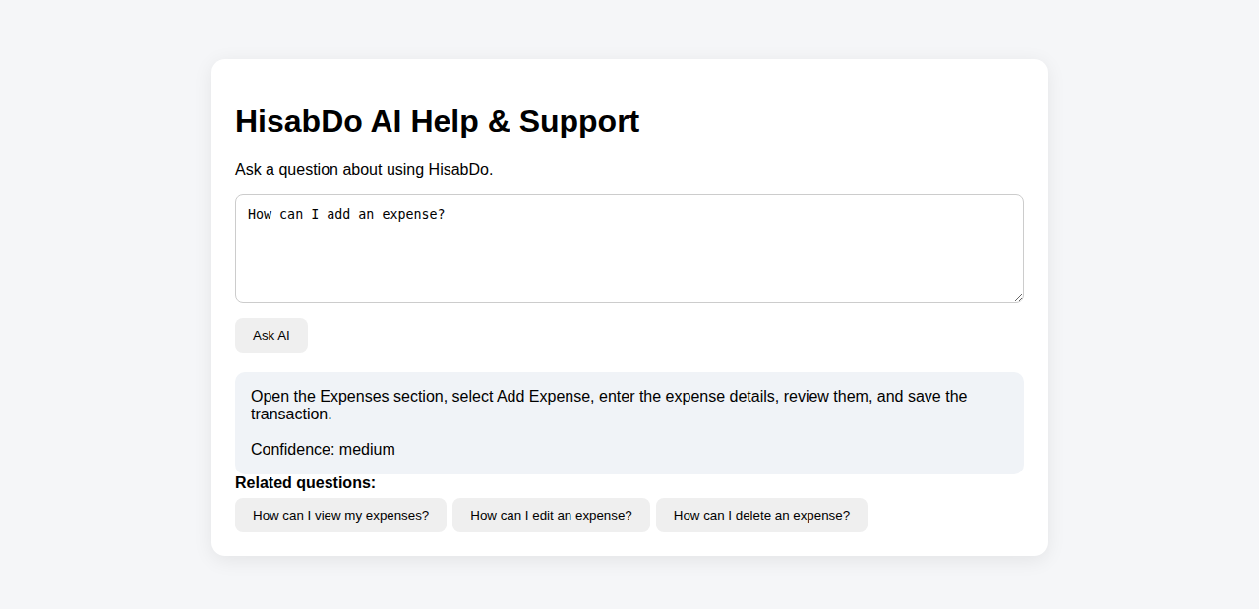
Figure 2 — Successful FAQ response: "How can I add an expense?"
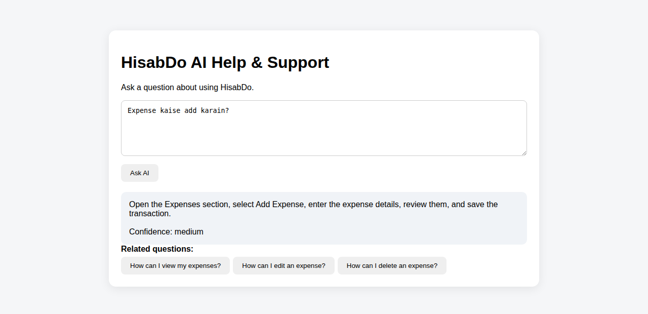
Figure 3 — Roman Urdu query correctly detected and answered.

5. FAQ / Knowledge Base Response Demonstration
Answers only come from a local, verified JSON knowledge base (faq.json). Each entry carries a verified flag and a source; only verified entries are eligible to be returned directly. Related questions are suggested from the same category to keep the user in a supported conversation path (see Figure 2, where the Add-Expense answer also surfaces View / Edit / Delete Expense as related questions).

6. Existing AI Engagement Capabilities
Beyond the FAQ endpoint, the POC already implements seven additional AI-assisted engagement endpoints. Each was exercised live:
Capability / Endpoint | Method | Sample Output
Context-Aware Help POST /ai/help/context | context_page + user_action | "You are currently on Expenses. For 'adding a new expense', follow the instructions shown in the app or ask a more specific question for step-by-step help."
Feature Guidance POST /ai/help/feature | feature name | "Open Invoices, choose Create Invoice, add customer and items, then save."
Step-by-Step Help POST /ai/help/steps | task name | 5-step ordered checklist for "add expense" (Open Expenses → Select Add Expense → Enter details → Review → Save).
Error Assistance POST /ai/help/error | error_message + feature | "Check the required fields, verify your connection, try again, and contact support if the issue continues."
Help Article Suggestions POST /ai/help/articles | free-text query | Returned 3 matching articles (Adding an Expense, Managing Expenses, Viewing Reports) for a query about expense reports.
Support Automation POST /ai/help/automate | free-text query | "Support request classified and prepared for assistance." (automated: true)
Human Escalation POST /ai/help/escalate | issue_type | Generated a unique ticket (e.g. HD-8D4B3AA9), priority HIGH, and a confirmation message.

7. Successful and Fallback Scenarios

7.1 Successful Scenario
A verified, relevant, high-confidence match returns the answer directly with a confidence level and related questions (Figure 2).

7.2 Unknown-Query Fallback
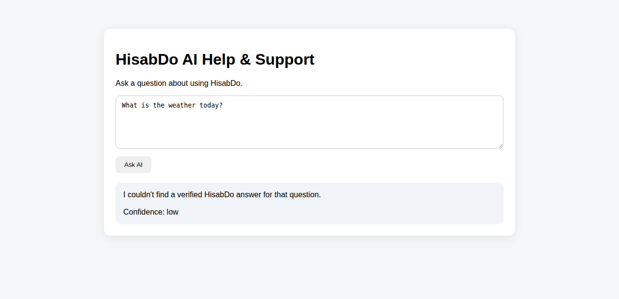
Figure 4 — Out-of-scope query correctly rejected with a safe fallback instead of a guess.

7.3 Ambiguous-Query Fallback (Clarification)
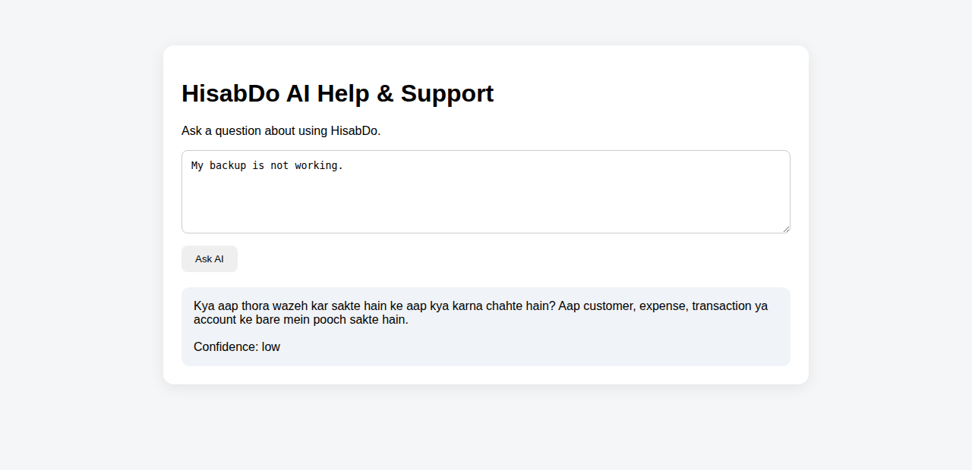
Figure 5 — Ambiguous query triggers a clarification question rather than a guessed answer.

7.4 Relevance-Check Fallback
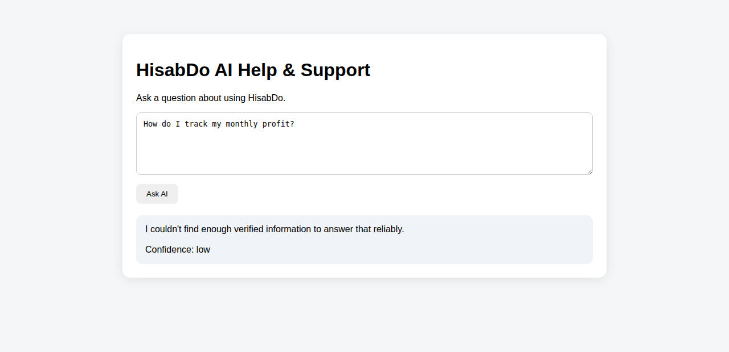
Figure 6 — A candidate answer that failed the relevance check (score 0.12) was withheld and replaced with a fallback, showing the quality-validation layer working as intended.

7.5 Nonsense-Input Fallback
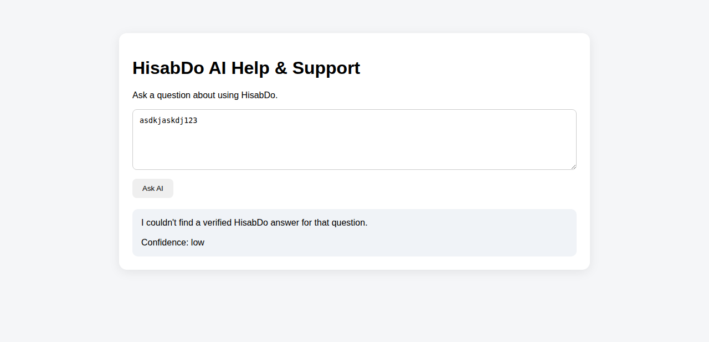
Figure 7 — Meaningless input safely handled with the unknown-intent fallback.

7.6 System-Level Fallbacks (HTTP layer)
POST /ai/help/faq (no body) -> 400 {"data": null, "message": "Request data is required.", "status": "error"}
GET /this/route/does/not/exist -> 404 {"data": null, "message": "API endpoint not found.", "status": "error"}

8. Limitations and Observations
- Intent detection and retrieval are rule/keyword-based, not semantic — paraphrased or loosely-worded questions (e.g. general "What is HisabDo?") often miss verified entries and fall back, even though the product clearly has an answer worth adding to the knowledge base.
- The knowledge base is small; several plausible categories (profit tracking, backups) currently have no verified entry, so relevant-sounding questions correctly fall back rather than being answered.
- Context/follow-up handling is session-basic — a vague follow-up like "How do I do it?" without prior context can still match an unrelated FAQ entry by keyword overlap, at reduced relevance score.
- Urdu-script coverage is weaker than English/Roman Urdu — the Urdu-script query in this demo fell back to "unknown" even though a corresponding English answer exists.
- No real-time or user-account-specific financial data is used; the system will never report specific numbers, which is intentional (anti-hallucination) but means it cannot yet answer account-specific questions.
- This is a local, single-process development server (Flask debug/dev server) — not yet a production deployment (no auth, no persistent storage for tickets, in-memory rate limiting only).
Overall, the response-quality validation layer (Section 3, step 5) is working as designed: in this demo it correctly intercepted a low-relevance answer (Figure 6) before it could reach the user, which is the core hallucination-prevention behaviour the module was built to guarantee.

9. Demo Material
All screenshots referenced in this report, plus the raw JSON evidence captured from the live API (query_results.json and engagement_results.json), are included alongside this report in the Screenshots and Evidence folders.

