Semester Project
Analyzing Binary Search vs Linear Search Using Calculus and Python

Course Code: MT-1003
Group Members Name: Usman Khan, Rameen Azhar, Fatima Tehreem
Groups members ID’s: 25I-0592, 25I-0586, 25I-0565
Date: 30-11-2025

Project Task:
1: Introduction and Objectives
a)
Introduction:
Searching is a fundamental operation in computer science used to locate an element in a data structure. Different search algorithms have different performance behaviors depending on how they access data.
Objectives:
- Compare the efficiency of Linear Search and Binary Search
- Derive mathematical expressions for their expected number of comparisons.
- Implement these expressions using Python.
Solution Methodology:
- Derive formulas analytically.
- Interpret each term in the expressions.
- Represent the procedure with a flowchart.
- Implement the expressions symbolically in Python.
b) Flowcharts
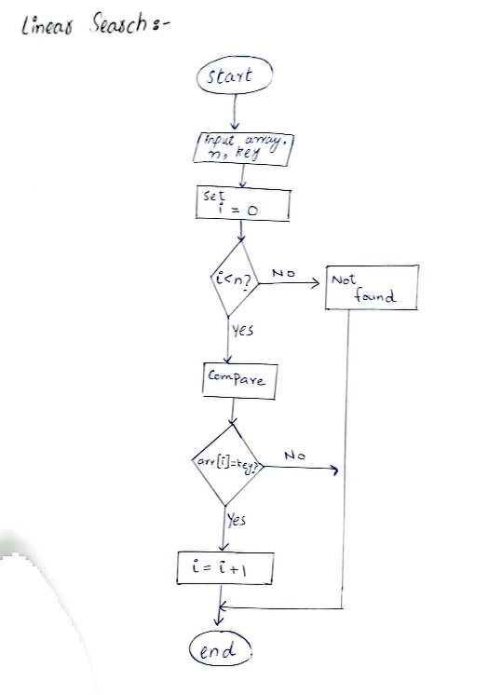
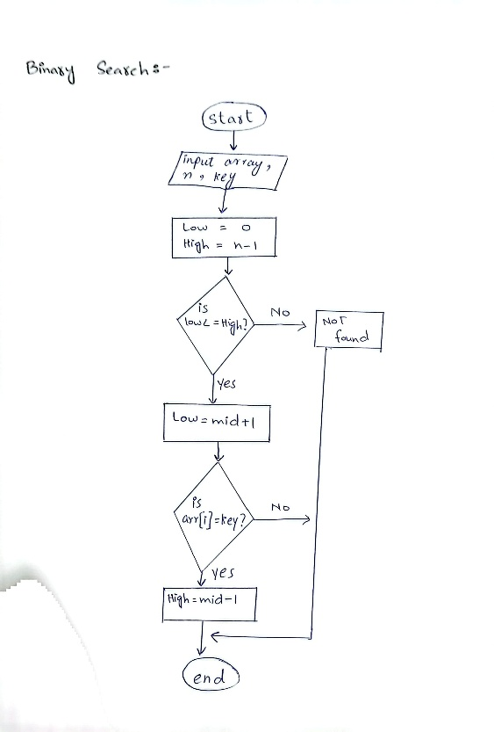

2: Mathematical modeling of search Performance
a) Expected Comparisons:
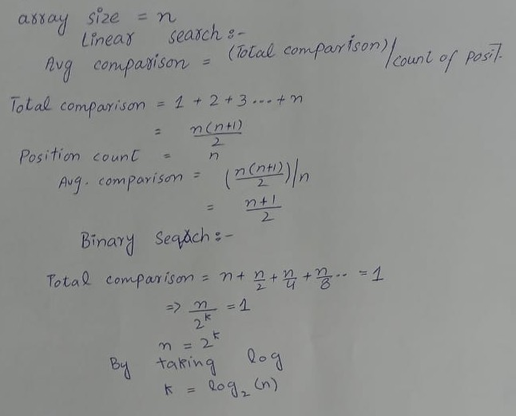

b) Significance of each term:
L(n)=(n+1)/2
n is total number of elements and (n+1) is the range of all positions. Linear search checks elements one by one.
B(n)= log2​(n)
log2 is the number of times array can be divided, and n is the total elements in array. Binary search checks halve the elements.
c) Python implementation:
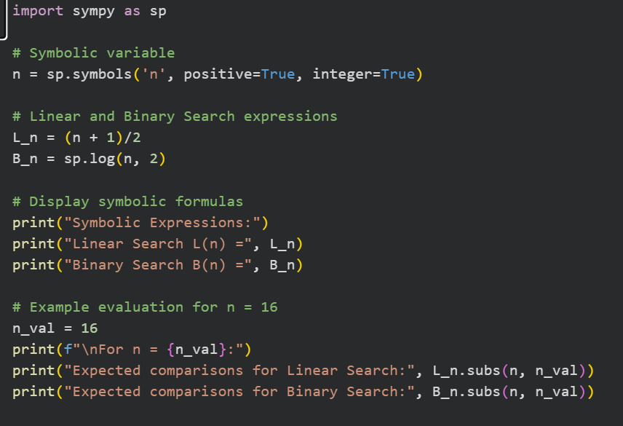
Output:
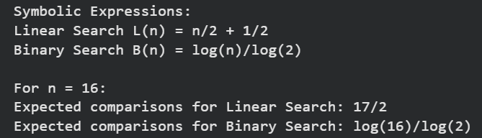

3.Understanding Growth Rates and Complexity
a) Growth Rates:
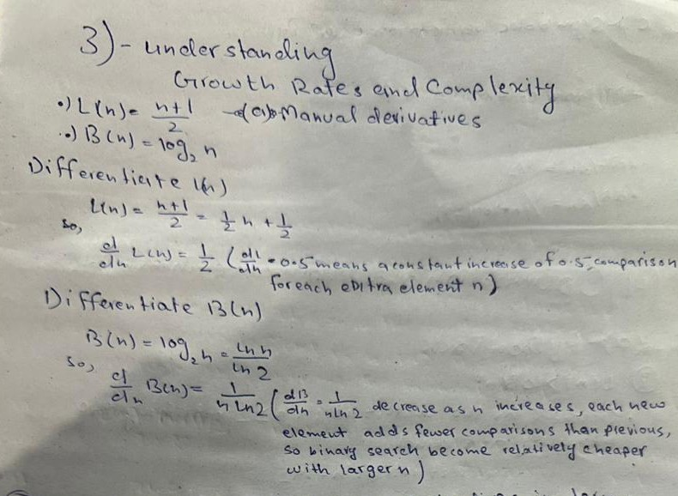
b)
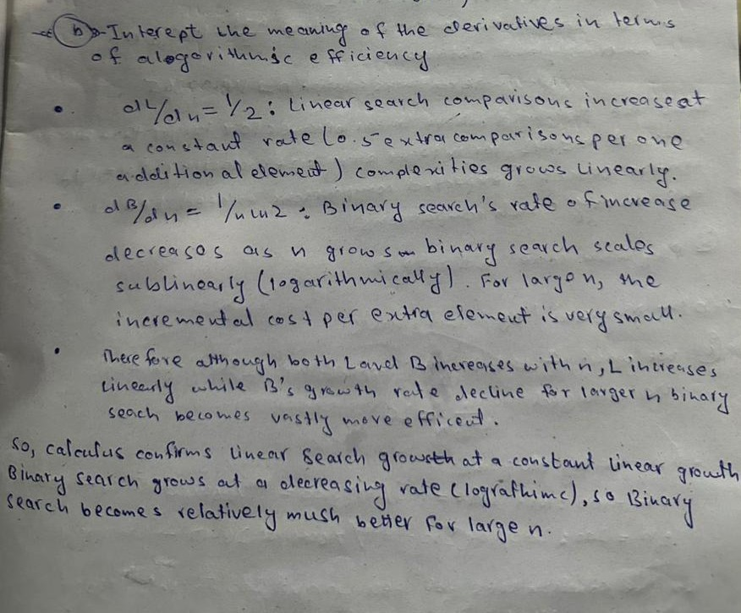
c) Python Task:
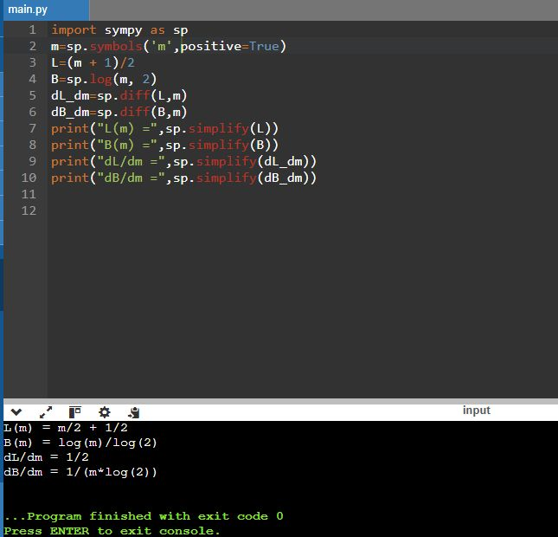
4.Optimization and Performance Thresholds
i- Value of n:
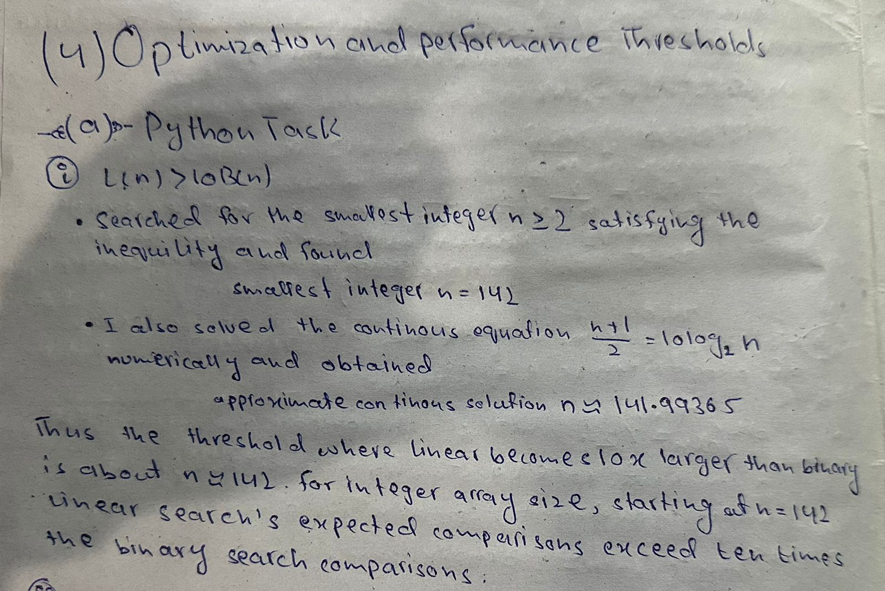
ii- Python Task:
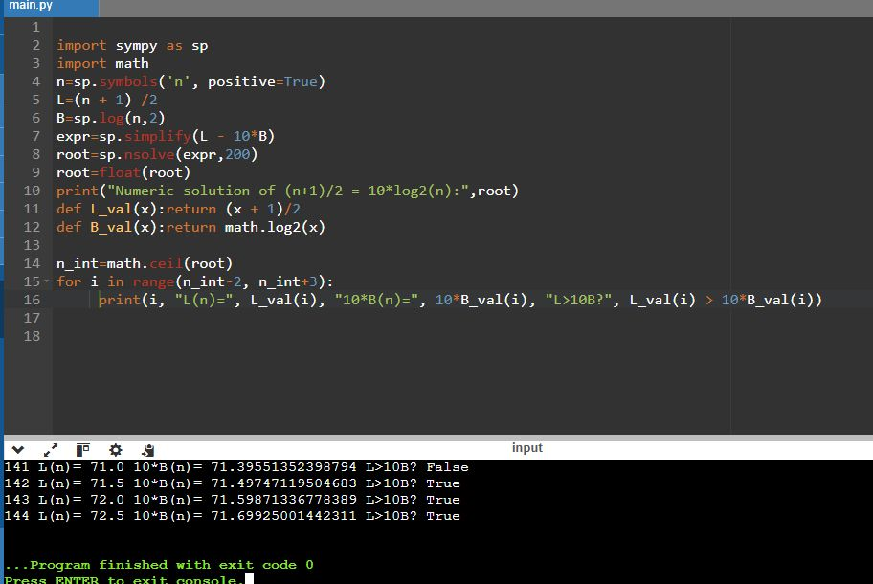
b) Manual Task:
i- Solving the inequality:
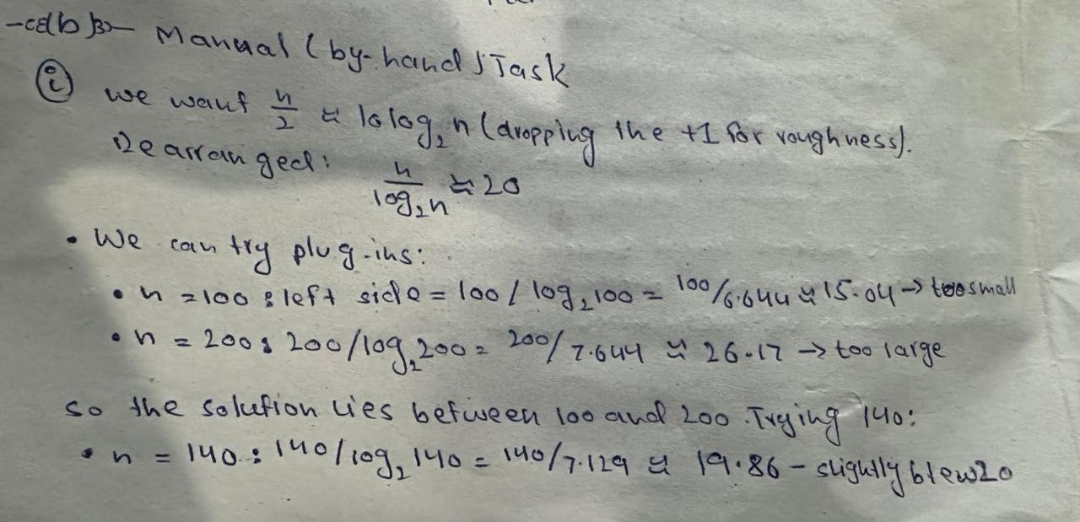

ii- Comparison
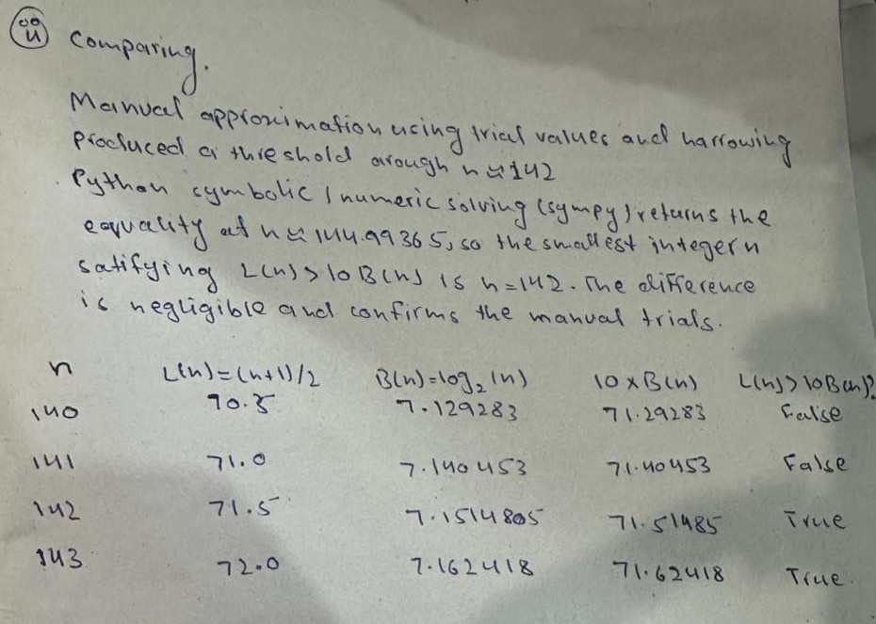
5. Visualization and Analysis
a) Python task
i- Comparison of L(n) and B(n):
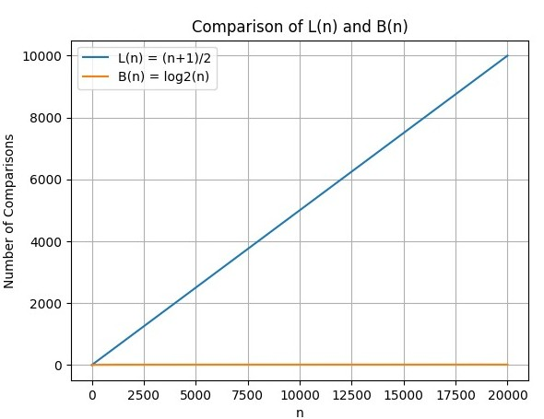
ii- Derivatives of L(n) and B(n):
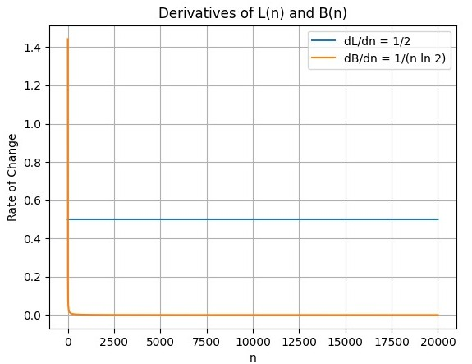

iii-Analysis:
b) Manual Task
i- Sketch:
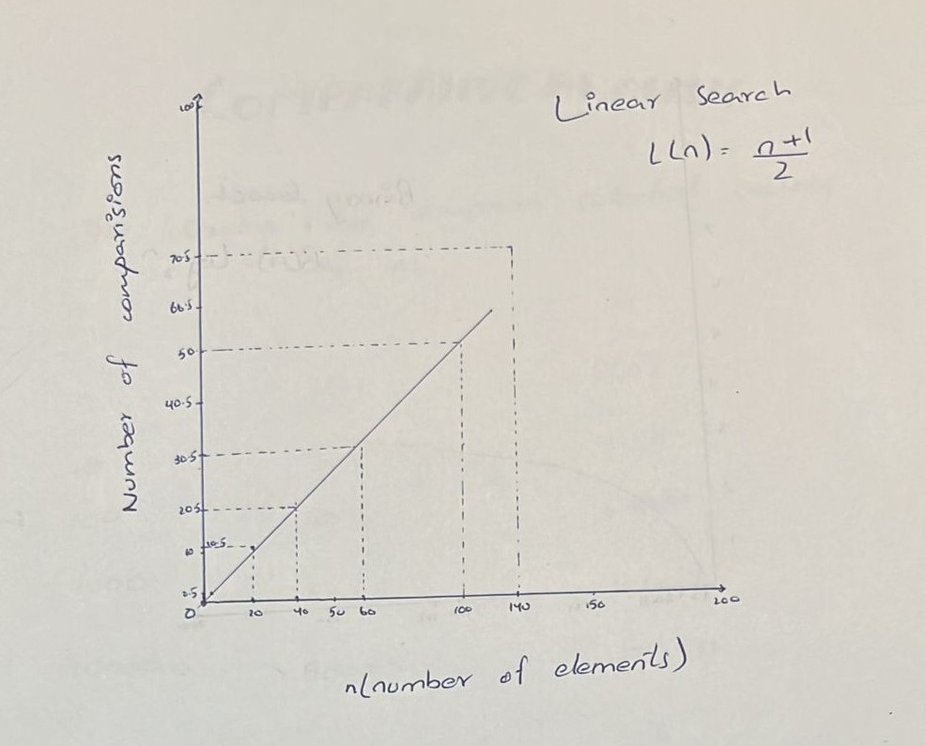
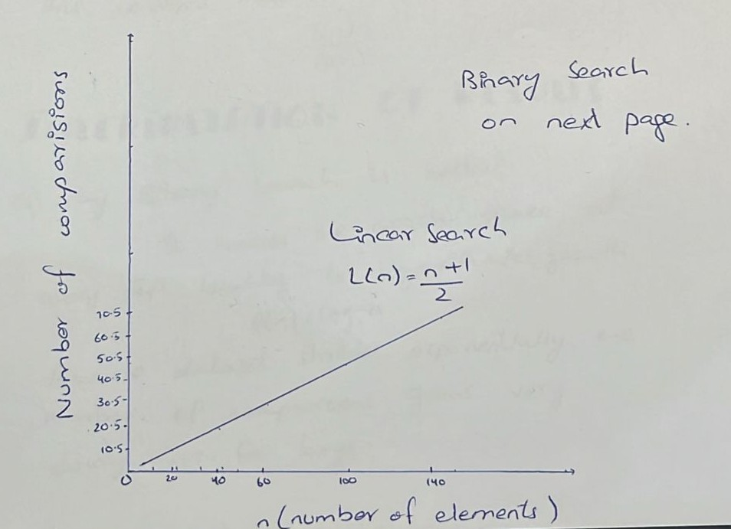

ii- Point mark:
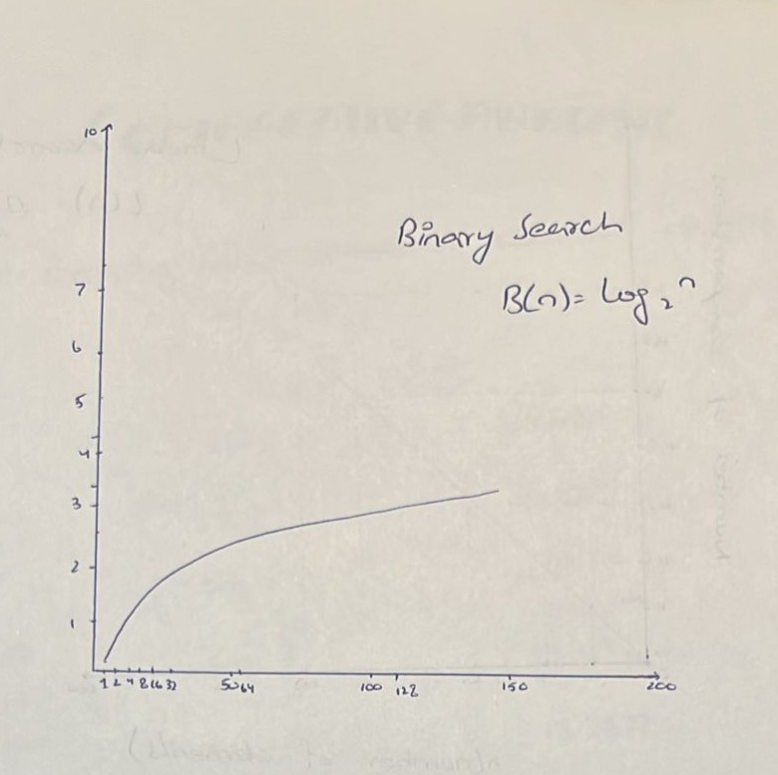

6. Comparative Analysis
a) Python Task:
Table:
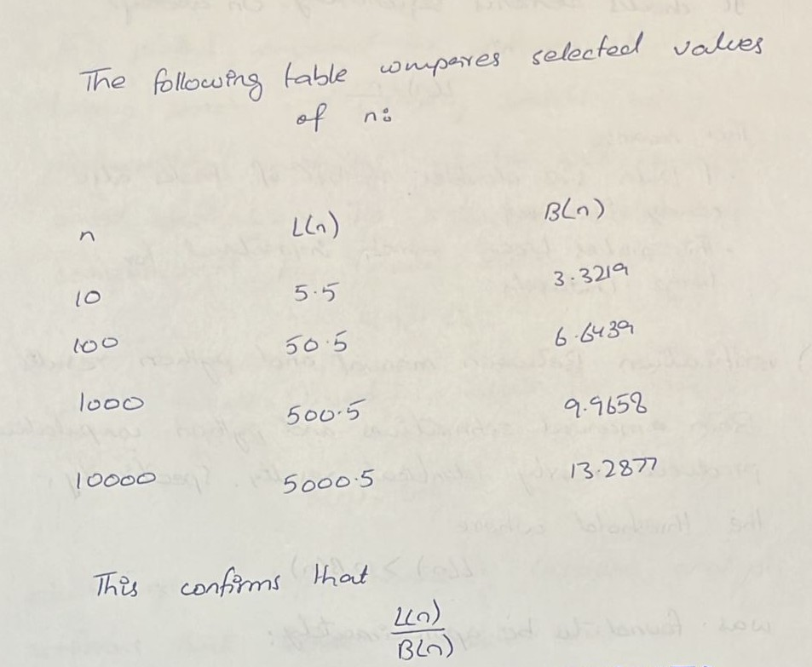
b) Manual Task:
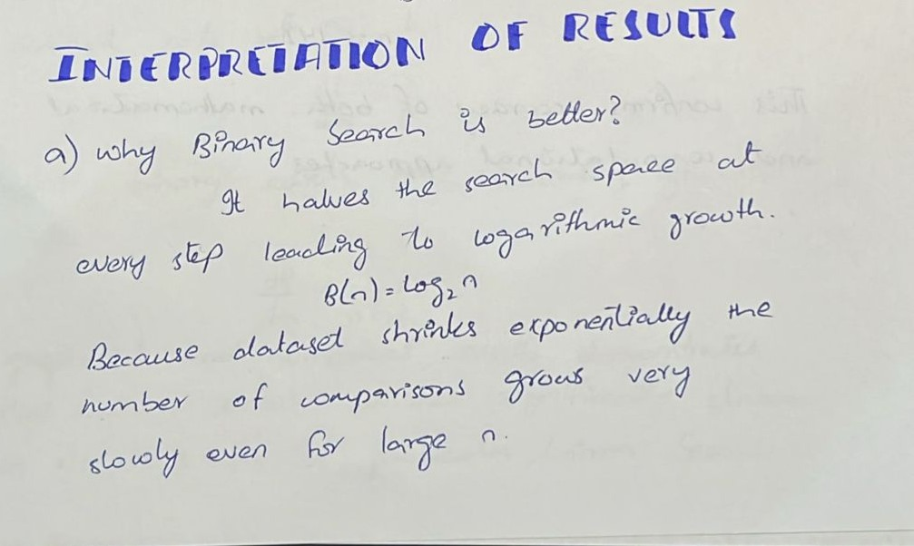
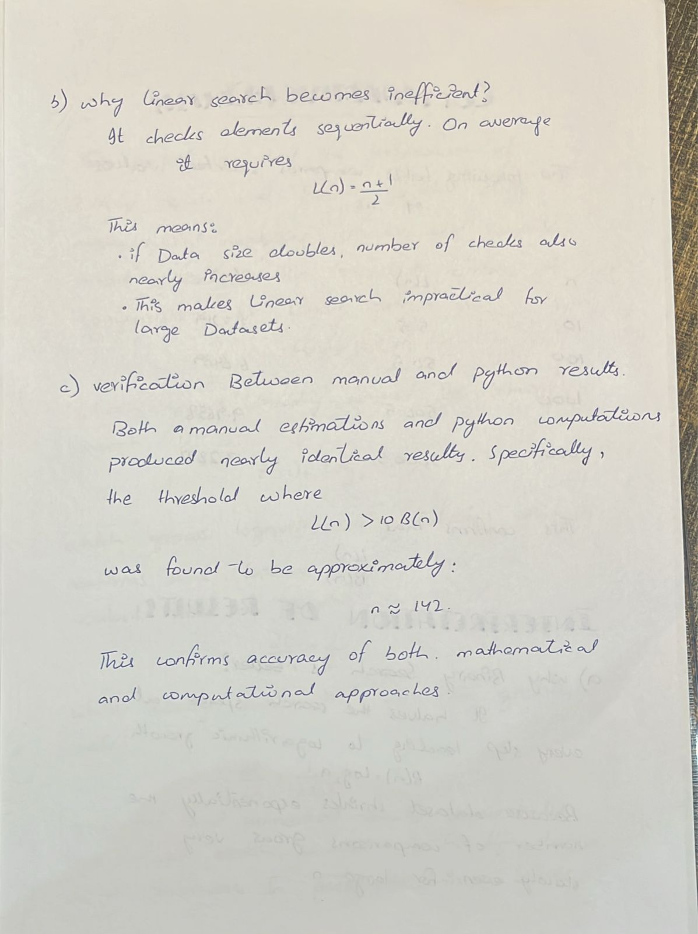

c) Conclusion:
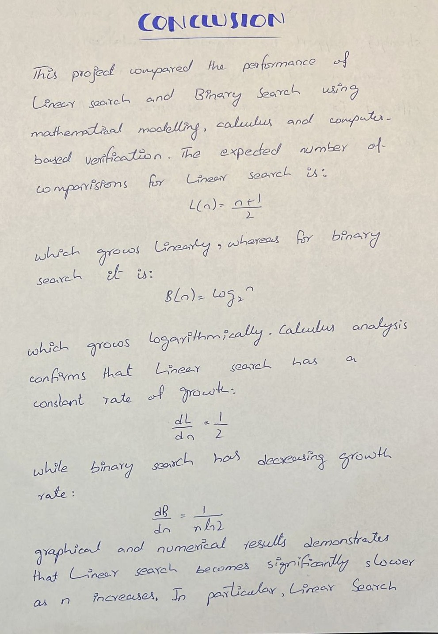
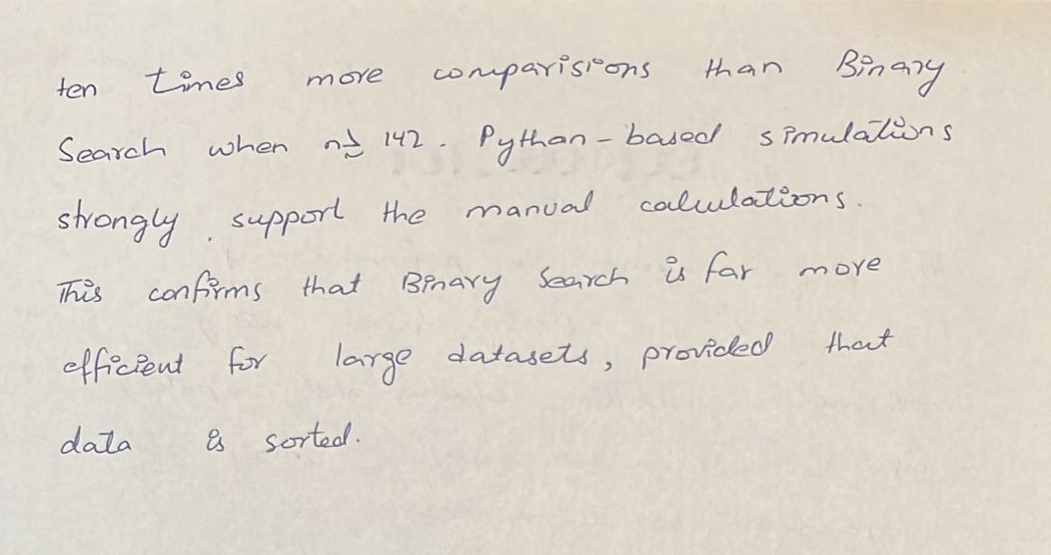

d) Contribution:
