**DB21**

**Admin**

**Login**

* It uses the admin table
* Admin will login for the website secretly from the visitor or user. 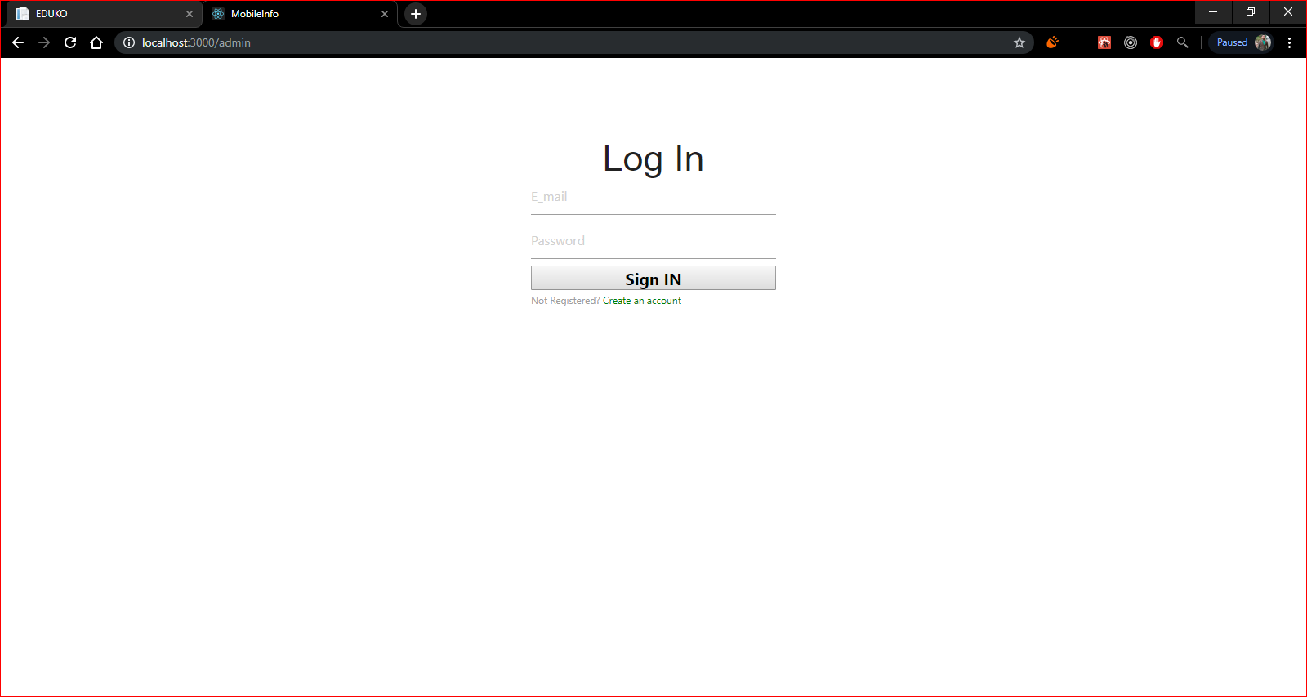

completed by 2016-cs-114(Admin Dashboard)

completed by 2016-cs-311(Admin SignUp)

**Password Recovery**

* It uses this admin database table

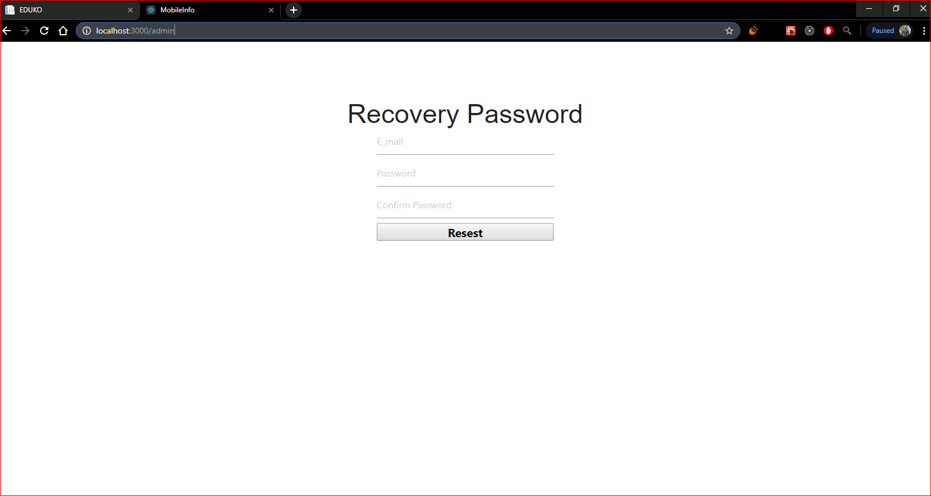

completed by 2016-cs-114(Admin and Dashboard

**Administration Management**

* It can manage Category, Model or mobile, News, can give responses After login

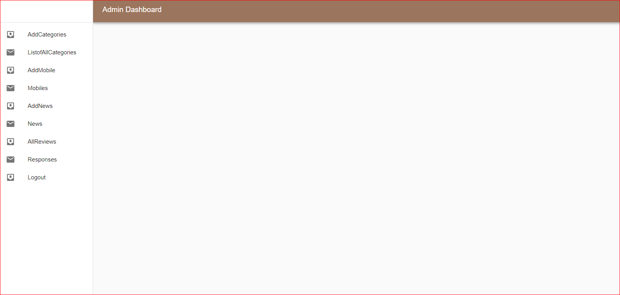

completed by 2016-cs-311(Point of sale)

**Cateogory Add and Show**

Admin Can add category and also show the added one.

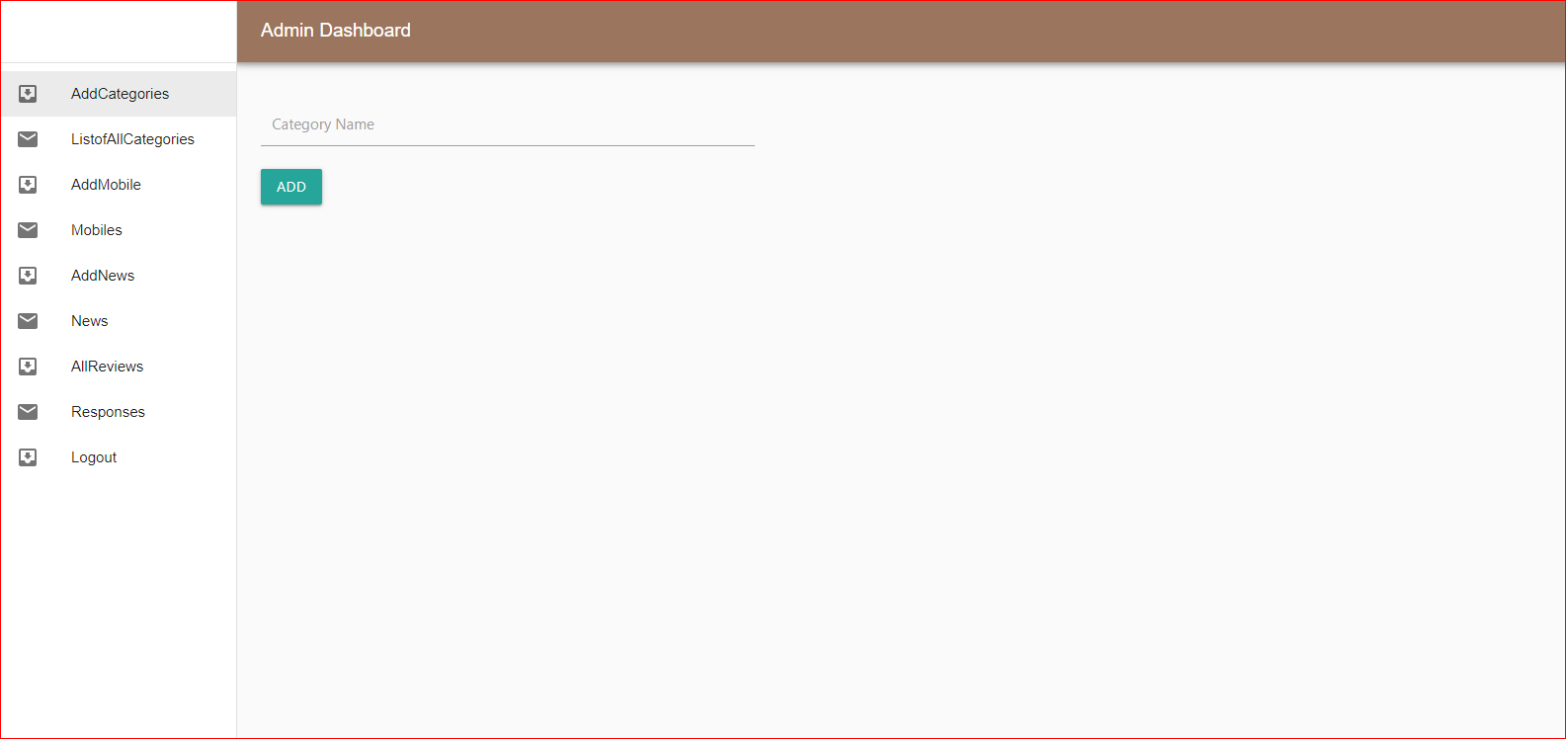

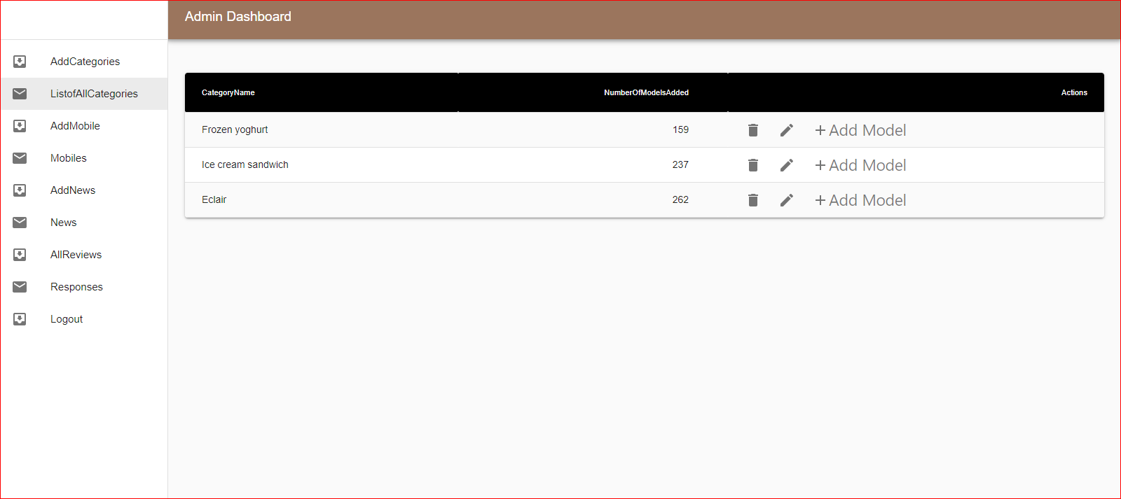

completed by 2016-cs-114(Admin Dashboard)

**Model or Mobile**

It can add or show the model added.

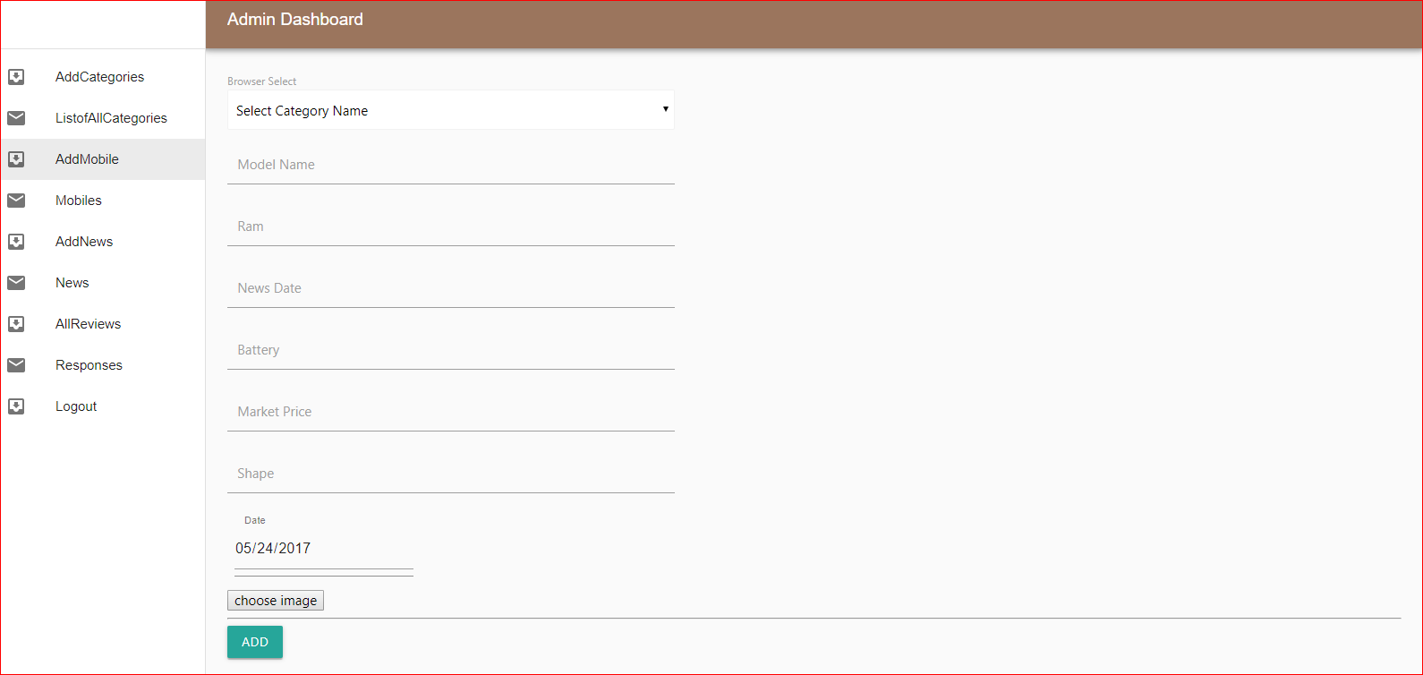

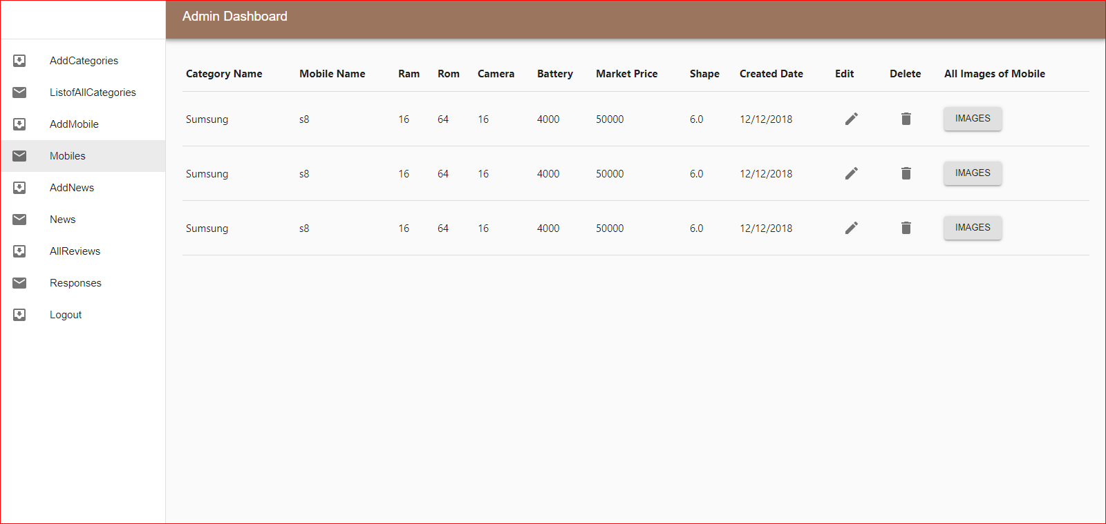

completed by 2016-cs-114(Model)

**News add or show**

* Admin can past e news and show to the visitor also.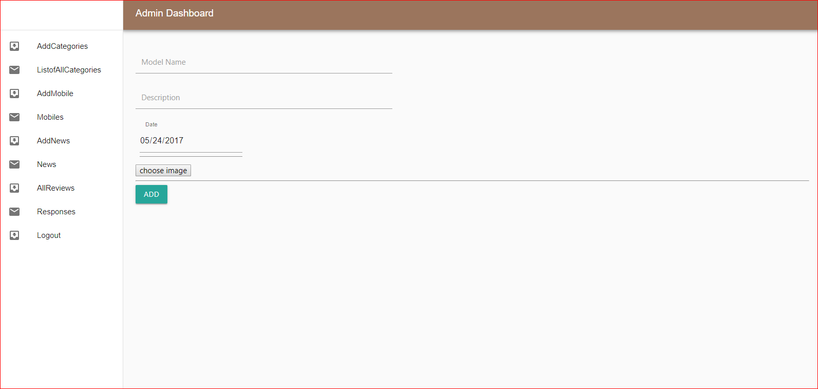

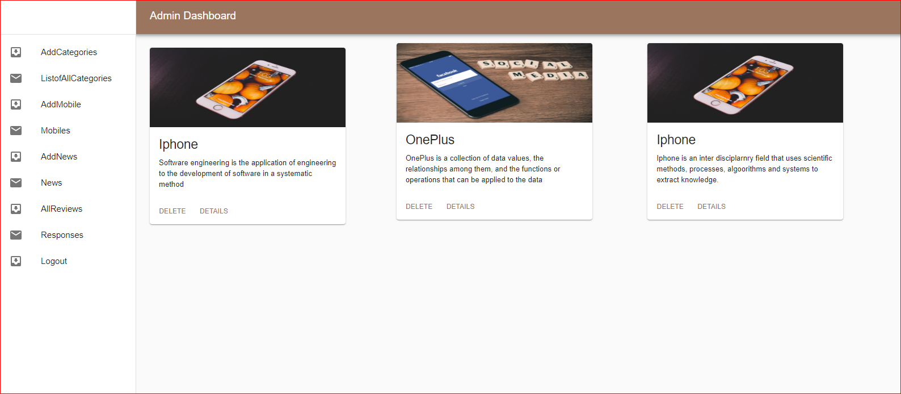

completed by 2016-cs-114(News)

completed by 2016-cs-365(Add Salary)

**Visitor or User**

**Visitor View to the Website**

When visitor(unregister user) will visit the website will see this.

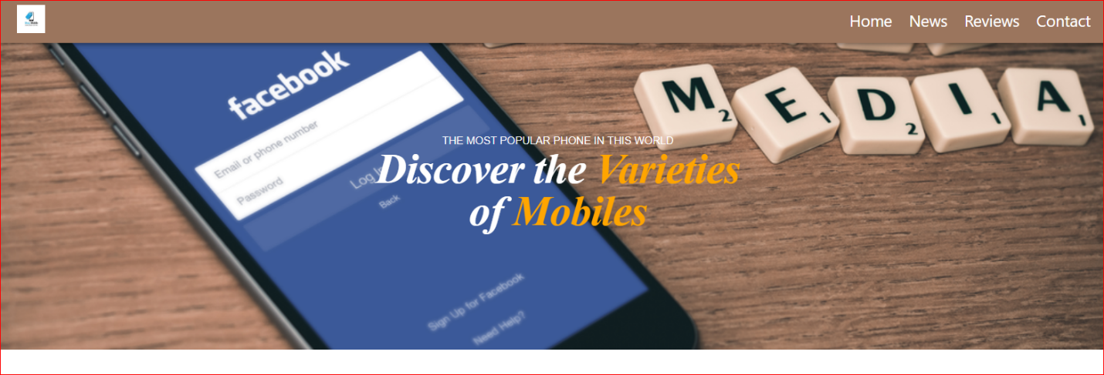

Figure completed by 2016-cs-102

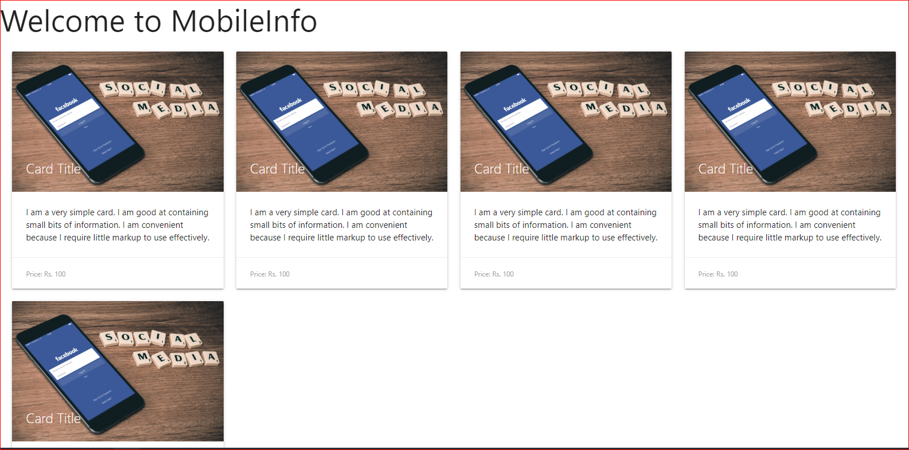

**News for User:**

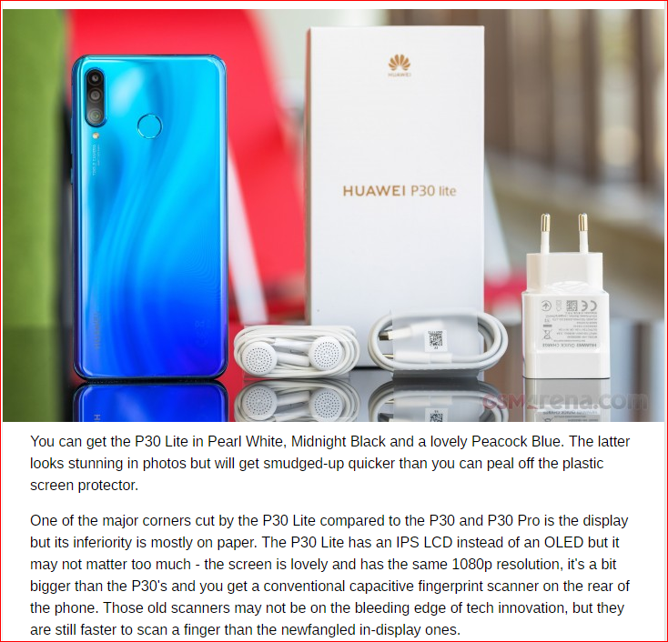

Figure 1completed by 2016-cs-102

**Contact Us for User:**

User can contact to the administration.

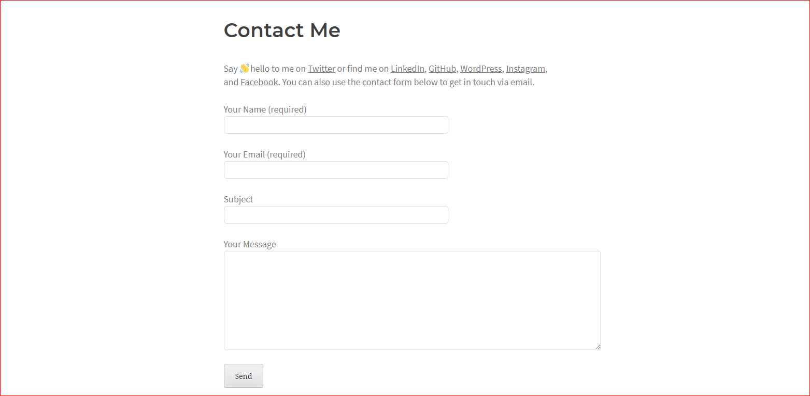

Figure 1completed by 2016-cs-102

**Contribution:**

Figure 1completed by 2016-cs-102

|  |  |
| --- | --- |
| Group Members | Tasks |
| 2016-cs-114 | * Admin Login. * Admin Dashboard Completely |
| 2016-cs-102 | * User View completely. * News page, index page contact page and reviews for visitor. |