Software Requirements Specification (SRS)
Appendix A: Glossary
Appendix B: Analysis Models
Appendix C: To Be Determined List
1.1 Purpose
1.2.1 Headings are numbered for clarity
1.2.2 Functional requirements are labeled as REQ-x
1.2.3 Priority levels: High, Medium, Low
1.3 Intended Audience and Reading Suggestions
1.3.1 Developers → for implementation
1.3.2 Testers → for validation
1.3.3 Project supervisors → for evaluation
1.4 Product Scope
1.5 References
1.5.1 IEEE SRS Template
1.5.2 Project SDS Document
2.1 Product Perspective
2.2 Product Functions
2.2.1 User registration and login
2.2.2 Flight booking
2.2.3 Flight scheduling
2.2.4 Baggage handling
2.2.6 Admin management
2.3 User Classes and Characteristics
2.3.1 High-level access
2.3.3 Basic user
2.3.4 Books flights and makes payments
2.3.5 Operational role
2.3.6 Handles baggage and logistics
2.4.2 Database server
2.4.3 Internet required
2.5.1 Must integrate with payment gateway
2.5.3 Dependent on internet connectivity
2.6.2 Online help guide
2.7.1 Users understand basic web usage
2.7.2 External APIs remain available
3.1.1 Web dashboards for Admin and Users
3.1.2 Forms for booking and registration
3.2.1 Standard computing devices (PC, laptop)
3.3.2 Database system
3.4.1 Internet (HTTP/HTTPS protocols)
4.1 User Registration
4.1.1 Description and Priority
4.1.2 Stimulus/Response
4.1.3.1 REQ-1: System shall allow users to register
4.2 User Login
4.3 Flight Booking
4.4 Baggage Management
4.5 Flight Management (Admin)
4.6 Payment Processing
5.1.1 System should handle multiple concurrent users
5.2.1 Prevent data loss
5.3.2 Data encryption
5.4.3 Usability
5.5.2 Only registered users can book flights
Appendix A: Glossary
Appendix B: Analysis Models(USE –CASE DIAGRAM)
Appendix C: To Be Determined List

Table of Contents

Airport Management System (AMS)
Version: 1.0
Prepared by: Aleem Abbas

Revision History
Name | Date | Reason | Version
Aleem Abbas | 5/3/2026 | Initial Draft | 1.0

1. Introduction

1.1 Purpose
This document specifies the requirements for the Airport Management System (AMS). It defines the expected behavior of the system and serves as a guideline for developers, testers, and stakeholders.
  - Document Conventions
1.2.1 Headings are numbered for clarity
1.2.2 Functional requirements are labeled as REQ-x
1.2.3 Priority levels: High, Medium, Low

1.3 Intended Audience and Reading Suggestions
This document is intended for:
1.3.1 Developers → for implementation
1.3.2 Testers → for validation
1.3.3 Project supervisors → for evaluation
Readers should begin with Section 1 and proceed sequentially.

1.4 Product Scope
The Airport Management System (AMS) is a web-based system designed to automate airport operations such as passenger management, flight booking, baggage handling, and payment processing. The system aims to improve efficiency, accuracy, and user experience.

1.5 References
1.5.1 IEEE SRS Template
1.5.2 Project SDS Document

2. Overall Description

2.1 Product Perspective
AMS is a standalone web-based application that interacts with external services such as payment gateways and regulatory databases.

2.2 Product Functions
Major system functions include:
2.2.1 User registration and login
2.2.2 Flight booking
2.2.3 Flight scheduling
2.2.4 Baggage handling
    - Payment processing
2.2.6 Admin management

2.3 User Classes and Characteristics

Administrator
2.3.1 High-level access
    - Manages flights, airlines, and system data

Passenger
2.3.3 Basic user
2.3.4 Books flights and makes payments

Airport Staff
2.3.5 Operational role
2.3.6 Handles baggage and logistics
  - Operating Environment
    - Web browsers (Chrome, Edge)
2.4.2 Database server
2.4.3 Internet required
  - Design and Implementation Constraints
2.5.1 Must integrate with payment gateway
    - Requires secure data handling
2.5.3 Dependent on internet connectivity
  - User Documentation
    - User manual
2.6.2 Online help guide
  - Assumptions and Dependencies
2.7.1 Users understand basic web usage
2.7.2 External APIs remain available

3. External Interface Requirements
  - User Interfaces
3.1.1 Web dashboards for Admin and Users
3.1.2 Forms for booking and registration
  - Hardware Interfaces
3.2.1 Standard computing devices (PC, laptop)
  - Software Interfaces
    - Payment Gateway
3.3.2 Database system
  - Communications Interfaces
3.4.1 Internet (HTTP/HTTPS protocols)

4. System Features

4.1 User Registration

4.1.1 Description and Priority
Allows users to create accounts (High Priority)

4.1.2 Stimulus/Response
User enters details → System validates → Account created
    - Functional Requirements
4.1.3.1 REQ-1: System shall allow users to register
      - REQ-2: System shall validate input data
      - REQ-3: System shall store user data securely

4.2 User Login

Description and Priority
Allows users to access system (High)

Functional Requirements
    - REQ-4: System shall authenticate users
    - REQ-5: System shall deny invalid login attempts

4.3 Flight Booking

Description and Priority
Users can book flights (High)

Stimulus/Response
User selects flight → System checks availability → Booking confirmed

Functional Requirements
    - REQ-6: System shall display available flights
    - REQ-7: System shall allow booking
    - REQ-8: System shall generate ticket

4.4 Baggage Management

Functional Requirements
    - REQ-9: Staff shall log baggage weight
    - REQ-10: System shall flag overweight baggage

4.5 Flight Management (Admin)

Functional Requirements
    - REQ-11: Admin shall add flights
    - REQ-12: Admin shall update flight schedules

4.6 Payment Processing

Functional Requirements
    - REQ-13: System shall process payments
    - REQ-14: System shall support multiple payment methods
    - REQ-15: System shall validate transactions

5. Other Nonfunctional Requirements
  - Performance Requirements
5.1.1 System should handle multiple concurrent users
  - Safety Requirements
5.2.1 Prevent data loss
  - Security Requirements
    - Secure login authentication
5.3.2 Data encryption

  - Software Quality Attributes
    - Reliability
    - Scalability
5.4.3 Usability
  - Business Rules
    - Only Admin can manage flights
5.5.2 Only registered users can book flights

6. Other Requirements
  - Database consistency must be maintained

Appendix A: Glossary
AMS: Airport Management System
Admin: System controller

Appendix B: Analysis Models(USE –CASE DIAGRAM)

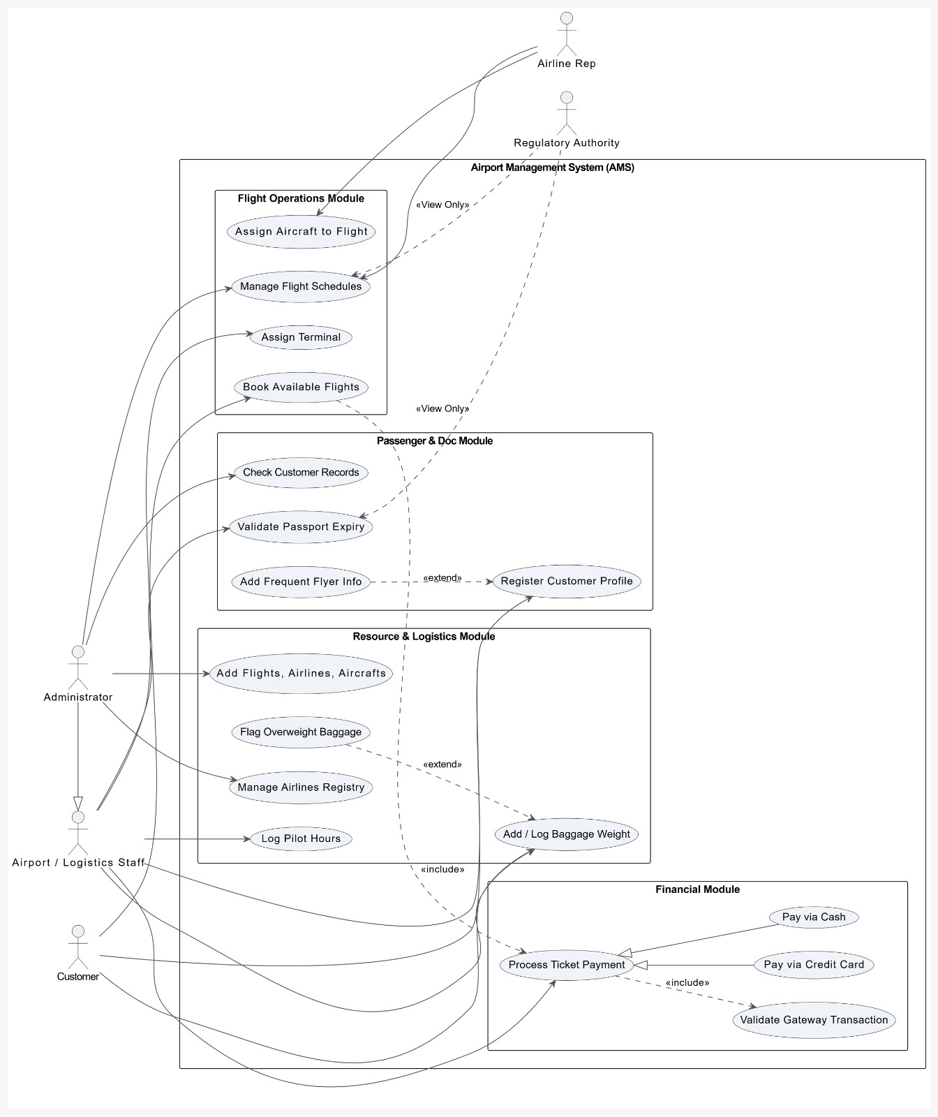

Appendix C: Interaction Matrix
- Analysis for independent, conflicting and overlapping requirements
