

**Bachelor of Computer Science**

**FA21-BCS-3B**

**Quiz 4**

M Usman Malik

Fa21-bcs-072

Routes

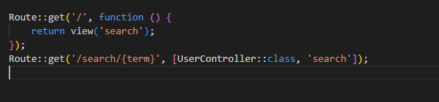

Javascript

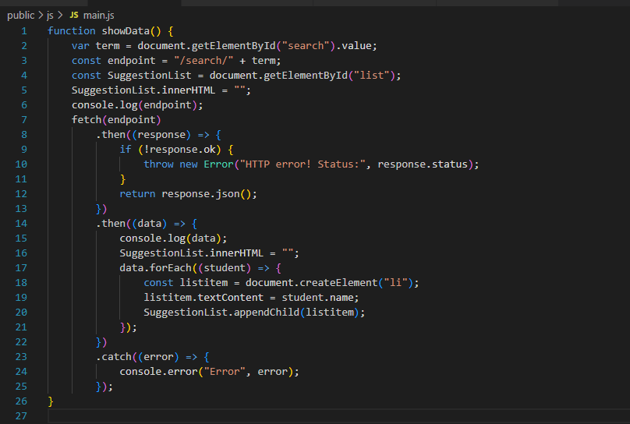

Controller

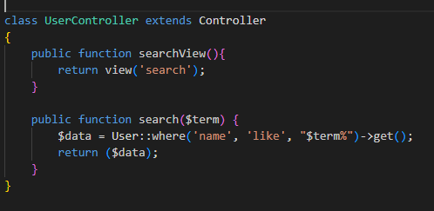

Frontend

