**ACKNOWLEDGEMENTS**

In completing this graduate project I have been fortunate to have help, support and

Encouragement from many people. I would like to acknowledge them for their cooperation.

First and foremost deeply thankful to Professor Dr. Soon-Ok Park, for her wonderful guidance

during this project work in field of Computer Science, at Governors State University. I am also

Thankful for her continuous feedback and encouragement throughout this project work. Her

broad knowledge and hardworking attitude has left me with very deep impressions and they will

greatly benefit me throughout my life.

I would like to thank my project Readers Dr. Kong-Cheng Wong and Dr. Steve Hyzny for their

support throughout this project work.

**ABSTRACT**

In today’s fast-changing business environment, it’s extremely important to be able to respond

to client needs in the most effective and timely manner. If your customers wish to see your

business online and have instant access to your products or services.

Online Shopping is a lifestyle e-commerce web application, which retails various fashion and

lifestyle products (Currently Men’s Wear). This project allows viewing various products

available enables registered users to purchase desired products instantly using PayPal payment

processor (Instant Pay) and also can place order by using Cash on Delivery (Pay Later) option.

This project provides an easy access to Administrators and Managers to view orders placed

using Pay Later and Instant Pay options.

In order to develop an e-commerce website, a number of Technologies must be studied and

understood. These include multi-tiered architecture, server and client side scripting techniques,

implementation technologies such as ASP.NET, programming language (such as C#) and

relational databases. This is a project with the objective to develop a basic website where a

consumer is provided with a shopping cart application and also to know about the technologies

used to develop such an application.

This document will discuss each of the underlying technologies to create and implement an ecommerce website.

**INTRODUCTION:**

E-commerce is fast gaining ground as an accepted and used business paradigm. More and more business houses are implementing web sites providing functionality for performing commercial transactions over the web. It is reasonable to say that the process of shopping on the web is becoming commonplace.

The e-commerce concept relates to business or financial transactions that facilitate electronic payments of items purchased from online stores and service vendors. E-commerce covers a broad range of business activities, from digital content used for online consumption to conventional orders of online merchandise. Online banking is another form of e-commerce. E-commerce transactions are conducted between businesses, businesses and consumers, businesses and government, businesses and employees and consumers and businesses.

Online shopping is an e-commerce format, in which real-time sales transactions occur as a consumer purchases an item or service from an online store. This may be explained as an interactive collaboration between a consumer and merchant. In online shopping, there is no intermediary - just the interaction between the online buyer and store/service provider. Here, electronic financial transactions are conducted securely. E-commerce also describes the exchange of data between the financing, billing and payment aspects of electronic business transactions.

* 1. **Scope**

Electronic commerce (e-commerce) is the marketing, buying and selling of merchandise or services over the Internet. It encompasses the entire scope of online product and service sales from start to finish. E-commerce tools include computer platforms, applications, solutions, servers and various software formats manufactured by e-commerce service providers and purchased by merchants to increase online sales.

E-commerce facilitates the growth of online business. It is categorized as follows:

Online marketing

`Online advertising

Online sales

Product delivery

Product service

Online billing

Online payments

* 1. **Objective**

The objective of this project is to develop a general purpose e-commerce store where product can be bought from the comfort of home through the Internet. However, for implementation purposes, this paper will deal with an online shopping for clothes , electronics , footwear and many more.

An online store is a virtual store on the Internet where customers can browse the catalog and select products of interest. The selected items may be collected in a shopping cart. At checkout time, the items in the shopping cart will be presented as an order. At that time, more information will be needed to complete the transaction. Usually, the customer will be asked to fill or select a billing address, a shipping address, a shipping option, and payment information such as credit card number. An e-mail notification is sent to the customer as soon as the order is placed.

* 1. **Goals**

This year, here are a few good goals to consider setting for your website in 2019.

**Increase relevant traffic**

Increasing traffic is probably a familiar goal for you. For pretty much every website, accomplishing whatever it’s meant to do requires people visiting the site. But not all traffic is created equal. If your marketing is bringing in traffic, but it’s mostly made up of people who will never have a need for your products or services, then it’s not doing you much good. For instance, a B2B software company probably wouldn’t benefit from a huge amount of traffic if most of it was coming from teenagers

In addition to continuing your marketing efforts for raising traffic, this year take some time to analyze if the traffic you’re getting seems to match up with the target audience you’re trying to reach. In the Audience section of Google Analytics, you can find a lot of information about the kinds of people visiting your website, including:

Demographic information like age and gender

Interests they have, based on their other browsing information

Geographic information

Tech information like the device and browser they use goggle analytics traffic visitor interests

That can go a long way to helping you figure out if you’re reaching the people you’re trying to. If you find that you’re not, then it’s time to rethink and refine your marketing efforts to make sure they’re more targeted moving forward.

Once you increase your site traffic, it’s time to upgrade your hosting to meet demand. Learn more about your web hosting options to choose the best fit for your website needs.

**Grow your email list**

Getting people to your website is a big part of being successful, but getting them to come back so you can form an ongoing relationship is even more important. One of the best tools you have to do that is your email list. When someone opts into your email list, they’re opening the door to ongoing communication with your brand – which is a big deal! It’s no surprise that email marketing has one of the highest conversion rates of the main online marketing activities.

Email marketing ROI

That means that one of the best ways to improve your website’s success in the coming year is to put more of an emphasis on growing your email list. You can do that by offering deals to your customers for signing up, promoting it on social media, and including CTAs throughout your website urging people to subscribe.

And make sure you keep the emails you send relevant and useful so you keep those subscribers once you get them. They’re too valuable to lose lightly.

If you haven’t set up email marketing for your website yet, get started today with Constant Contact.

**Provide visitors a personalized experience**

Each of your visitors is a unique person who interacts with your website in their own way. Technology now makes it possible for you to track how people interact with your website and customize their experience on the site as they go. You can suggest items that are similar or complementary to what they’re looking at, or deliver up content on topics that are related to the piece they clicked on.

One study found that providing a personalized web experience for visitors can cause an 18% uptick in sales. When you make it easier for people to see the parts of your website that are most relevant to them, it increases their chances of having a good experience and continuing their relationship with your brand.

**Make your website responsive**

By this point, the reasons to make your website mobile friendly are well known and if you’re reading this, you’ve probably already taken that step (you have, right?). In the coming year, Google’s planning to roll out mobile-first indexing, meaning that their algorithm will give greater priority to your mobile website in determining rankings.

That means you want your mobile website to have the same content and information on it as your desktop website, just visually optimized for a mobile screen. Making your website responsive is one of the best and easiest ways to do that. And in general, make it a goal to make an effort to pay attention to your mobile experience and make sure your website is easy and intuitive for people on mobile to use. Mobile’s not going away and is likely to continue to become more important with every passing year, so you have to treat it like the priority it is.

**Increase sales**

For e-commerce businesses, this goal will remain consistent in all years. For your website and business to thrive, you have to be making sales. Everything else on this list is designed to help make that happen, but you should also look to your own analytics from past years. Figure out what tactics have worked the best for getting you sales – not just traffic or email signups (which matter too), but marketing activities specifically led to sales.

While there are general trends each year that should guide what you try, the most important thing you should look to is what’s working best for your particular business. At the end of the day, your business is unique. Only you can work out what makes the most sense for you and your audience. Analyze your metrics and design your marketing plan to optimize doing more of whatever is getting you sales now.

**Chapter No 2**

**System Requirement Analysis**

**Relational Diagram**

Invoice

Delivery

Address

Credit Card

Payment

User Session

Shopping Cart

Order

Order Item

Cart detail

Sale number

Qty Number

Inventory Item

User Accounts

Profiles

**Use Case Diagram**

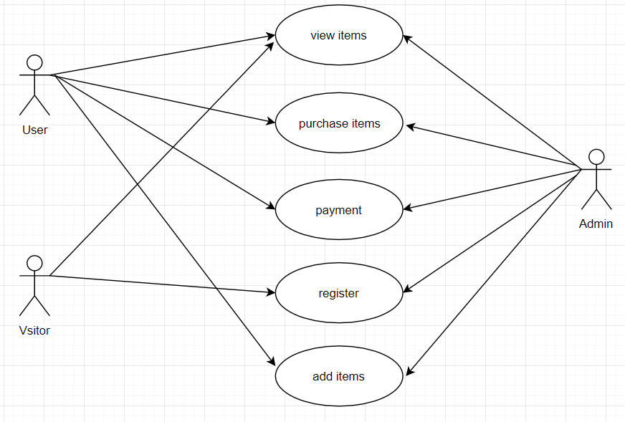

**Schema:-**

Product

Shopping Cart

Customer Feedback

Order

Customer specific items

Inventory

Delivery and payment Invoice

Ads and Promotion

User Accounts

Customer Acc:

Business Acc:

User session

**Database Design:-**

