Huawei ICT Competition · Innovation Competition
NotebookOS
AI-powered business memory with traceable evidence for traders who keep handwritten records
Design Scheme
Item | Details
Team name | [Team name]
Institution (Huawei ICT Academy) | [University / college]
Team members | [Student 1], [Student 2], [Student 3]
Instructor | [Instructor name]
Topic | [Competition topic, e.g. General AI topic]
Source code | https://github.com/usmanmasud/NOTEBOOK-OS (open source, MIT licence)
Live demo | https://notebook-os-xi.vercel.app (fictional demo data)
Date | [Submission date]

Contents
1. Problem description 3
2. Solution design 3
2.1 User flow 3
2.2 Design principles 4
3. Technology selection 4
3.1 Huawei technologies 4
3.2 Other technologies 5
4. Function implementation 6
4.1 Review: AI reads, the trader checks 6
4.2 Dashboard from confirmed records only 7
4.3 Evidence: “this number did not come from nowhere” 7
4.4 Business report and sharing 8
4.5 Reliability and safety features 8
5. Effect and value 9
5.1 Social value 9
5.2 Commercial potential 9
5.3 Current results 9
6. Limitations and next steps 9

1. Problem description
In many markets, small traders keep their entire business in a paper notebook: cash sales, goods given to customers on credit (in Hausa, bashi), repayments, expenses and restocks. Entries are short, written in a mix of languages and abbreviations, and often smudged. For example:
“Musa shinkafa 2? 20k bashi”: Musa took rice on credit worth ₦20,000. The quantity is hard to read.
The notebook is trusted and works, but its contents are not computable. The trader cannot easily total the week's sales, see who still owes money, or show a reliable summary to a lender or supplier. Asking traders to abandon the notebook for an accounting app ignores how they actually work.
Existing OCR tools can turn a photo into text, but text is not business information. And an AI that silently “fills in” unclear values creates numbers nobody can trust. The problem we address is:
How can a handwritten business notebook become structured, trustworthy business data, without changing the trader's habit and without letting AI invent figures?

2. Solution design
NotebookOS turns a notebook photo, a voice note or typed text into structured transaction records. Its core idea is AI-powered business memory with traceable evidence: AI does the reading, application code does the checking and the arithmetic, and the trader makes the final decision. Every important number can be traced back to the exact line on the original page.

2.1 User flow
- Capture. The trader photographs a notebook page (or records a voice note, or types).
- Read. OCR or speech-to-text produces text lines with a confidence score and a position on the page.
- Understand. An AI interpreter converts mixed Hausa/English entries into strict structured records (date, type, item, quantity, amount, person). Each record must cite the line it came from. Unclear values become null rather than guesses.
- Validate. Deterministic rules check every record. They also verify that each amount and name the AI proposes actually appears in the source text, and they compare the totals written on the page with the extracted sales.
- Human confirmation. Uncertain fields are highlighted. The trader corrects and confirms. Only CONFIRMED records become official business data.
- Summarize. The dashboard (sales, expenses, outstanding debt, debt collected, stock movement) is calculated by application code from confirmed records only.
- Evidence and report. Clicking any number shows the contributing records, the original text and the highlighted line on the notebook photo. A one-page business report can be shared through a revocable, read-only link.
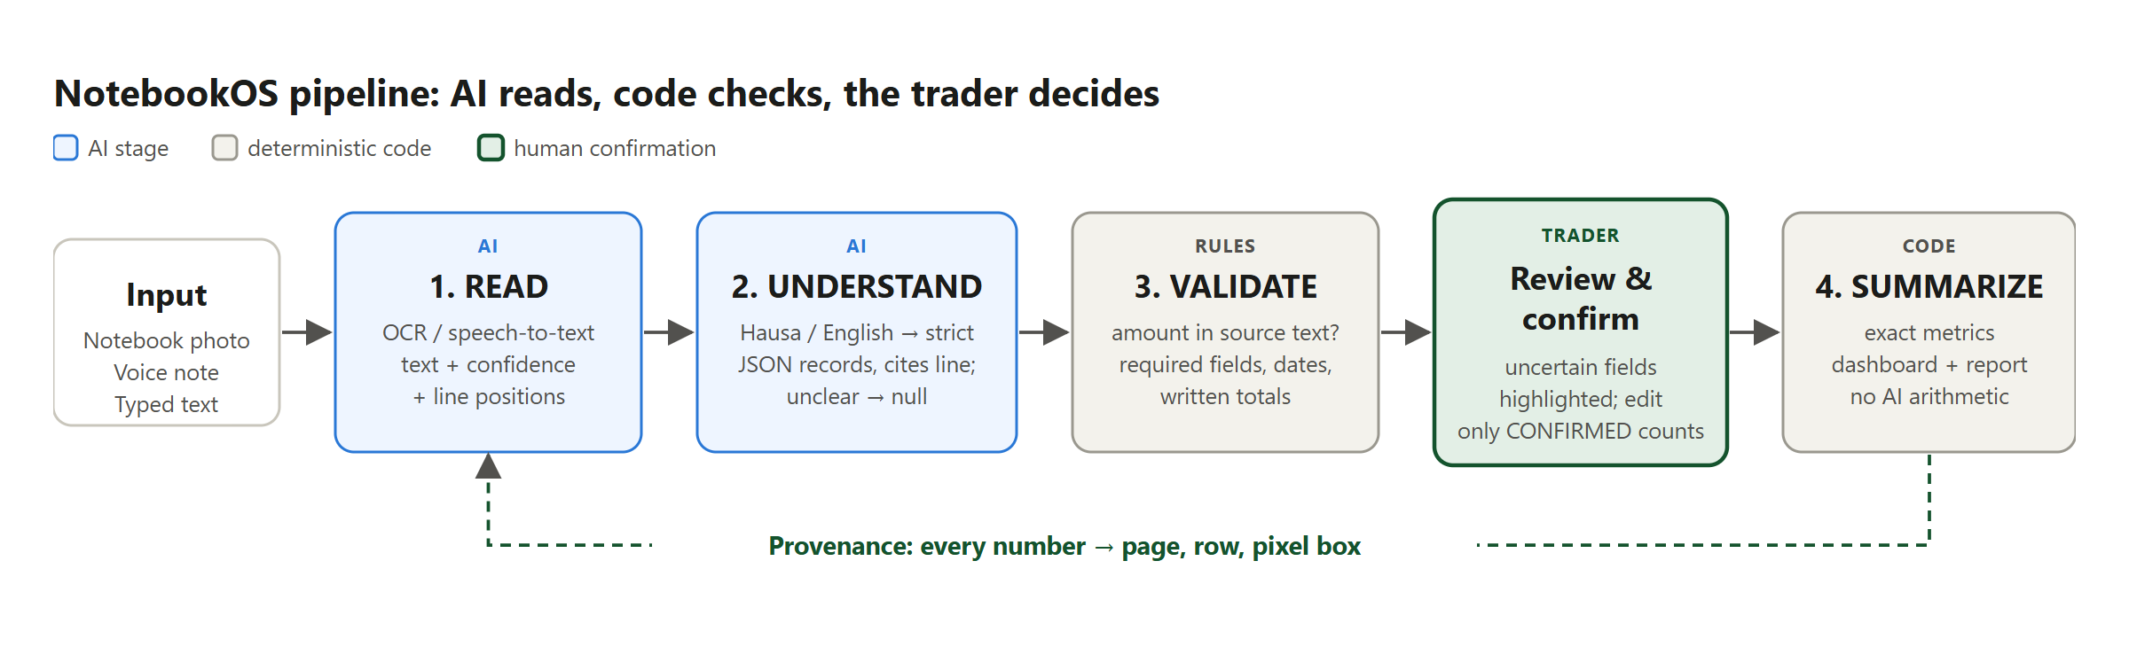
Figure 1. The NotebookOS pipeline: AI reads, code checks, the trader decides.

2.2 Design principles
- Human confirmation is a feature, not a fallback. AI output never becomes official data on its own.
- AI never does the arithmetic. All metrics use exact decimal arithmetic in application code. An optional AI-written report summary is rejected if it contains any number that is not already in the calculated figures.
- No invention. Unclear values are null with low confidence. Records that cannot be linked to a source line are discarded.
- Provenance for every number. Each record stores its upload, page, row, original text, bounding box, AI confidence, the AI's original proposal and the trader's corrections.
- Works when AI is unavailable. AI providers sit behind interfaces with fallbacks, so the trader can always enter or correct records manually.
- Not tied to one market. Currency, language vocabulary, date format and confidence thresholds are configuration.

3. Technology selection

3.1 Huawei technologies
The table below shows each Huawei technology's role and its status at the time of writing. [Update the Status column as integration is completed before submission.]
Huawei technology | Role in NotebookOS | Status
ModelArts | Hosts the language model for the UNDERSTAND stage, which turns notebook lines into structured records. Called through ModelArts' OpenAI-compatible model service. | Integration in progress. The interface is implemented; ModelArts is not yet configured.
Huawei Cloud OCR (handwriting) | READ stage for notebook photos: text, confidence and bounding box for each line. | Provider implemented and unit-tested with recorded responses; not yet run against the live service.
SIS (speech interaction) | READ stage for voice notes (speech-to-text). | Provider implemented; not yet run against the live service.
ECS | Hosts the web application (nginx + React) and the API (FastAPI) in Docker. | Deployment scripts and runbook ready; not yet deployed.
RDS for MySQL | System of record: users, uploads, records, provenance, reports. | Schema and migrations verified on MySQL 8.4; RDS deployment pending.
DCS (Redis) / OBS | Sessions and rate limits / private storage of notebook photos. | Supported by configuration; optional.

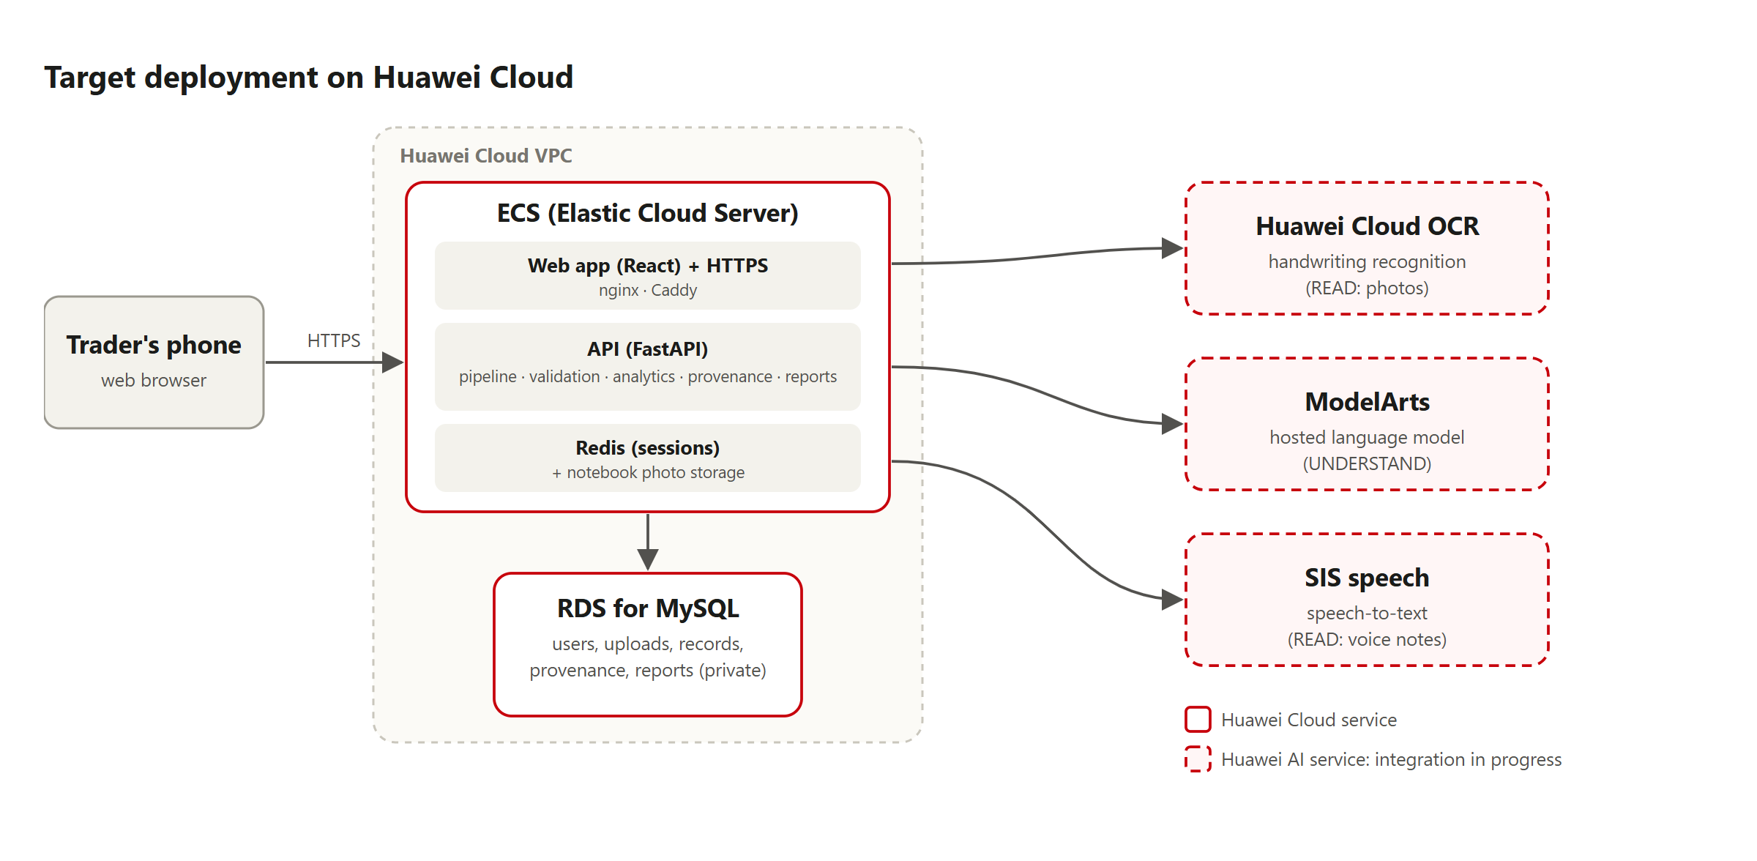
Figure 2. Target deployment on Huawei Cloud. Dashed boxes are AI services being integrated.

3.2 Other technologies
Layer | Technology
Frontend | React 19, TypeScript, Vite; mobile-first; English with partial Hausa
Backend | Python, FastAPI, SQLAlchemy, Alembic; background processing pipeline
AI interfaces | OCRProvider, SpeechProvider and LLMProvider interfaces with provider chains and fallbacks; a deterministic rule-based interpreter using English and Hausa vocabulary packs
Testing | pytest (86 backend tests, including an end-to-end test); vitest; browser automation of the full demo flow
Interim hosting | The live demo currently runs on Vercel (web) and Render (API) while the Huawei deployment is completed

4. Function implementation

4.1 Review: AI reads, the trader checks
The original page is shown with a box around every line the AI read. Each extracted record shows the text it came from, its confidence and any validation issues. In the example below, the smudged line about Musa is flagged at 61% and the unreadable quantity is marked unclear rather than guessed.
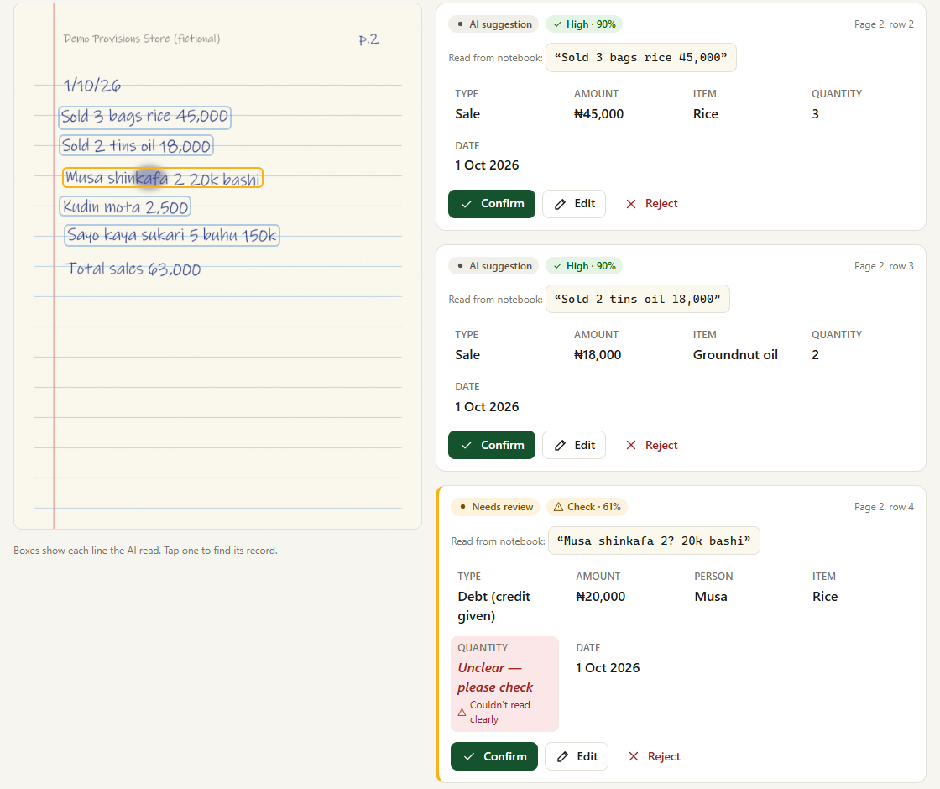
Figure 3. Review screen: original evidence with line boxes (left), extracted records with confidence (right).

4.2 Dashboard from confirmed records only
After confirmation, the dashboard shows total sales, outstanding debt, expenses, stock purchases, debt collected, credit given, net cash flow and the transaction count. It also shows a sales trend, who owes money, stock movement and recent transactions. Records that are still waiting for review are counted separately and are not included.
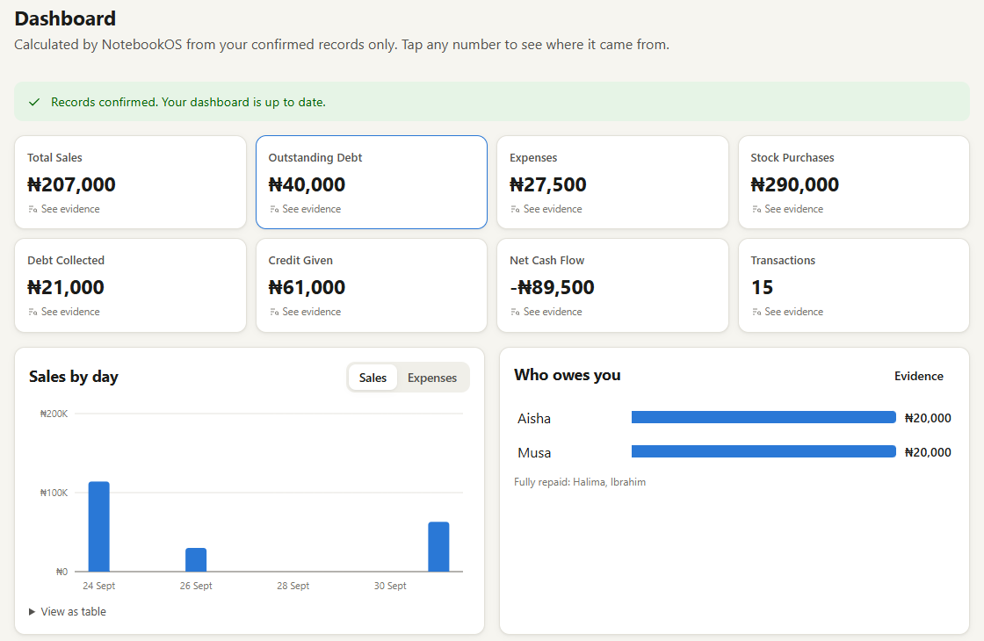
Figure 4. Dashboard. Every tile opens its evidence.

4.3 Evidence: “this number did not come from nowhere”
Clicking Outstanding Debt (₦40,000) lists the contributing confirmed records. For Musa, it shows: the source (notebook page 2, row 4), the original text, the AI confidence (61%), the trader's correction (quantity; the AI read it as unclear) and the confirmation time. The exact line is highlighted on the original photo.
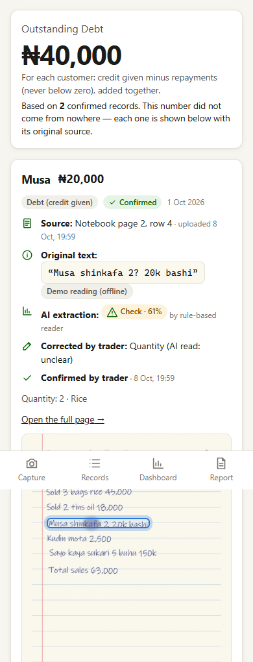
Figure 5. Evidence view on a phone (live deployment).

4.4 Business report and sharing
The trader can generate a one-page summary after giving explicit consent. It shares a frozen snapshot through a random, revocable, read-only link. Customer names, internal IDs and notebook photos are not exposed. The report states that it summarises confirmed, user-provided records and is not a credit score.

4.5 Reliability and safety features
- Validation errors (such as a missing amount, or a debt with no person) block confirmation until they are fixed. Warnings highlight uncertain values.
- A written-total check compares the page's own total with the extracted sales and flags a possible missed or misread line.
- If OCR, speech or the language model is unavailable, the upload is marked with a clear message and the trader can retry or enter records manually. The rule-based interpreter takes over if the language model fails or returns invalid output.
- Security: one-time-code sign-in architecture, hashed session tokens, file-type checks by content, size limits, rate limits, per-user authorisation and no stack traces shown to users.

5. Effect and value

5.1 Social value
- Traders keep the notebook they already trust. The tool adapts to them, including mixed Hausa/English writing and informal abbreviations.
- A trader can see at a glance who owes money and how much, which supports collecting debts and managing credit.
- Confirmed, traceable records give the trader something concrete to show a lender or supplier, while staying honest that the records are self-reported.

5.2 Commercial potential
- A clear path to services for traders and the organisations that serve them, such as microfinance institutions and cooperatives, built on reports that are confirmed by the trader and traceable to source.
- Scales across markets through configuration: currency, language vocabulary packs (a new language is a data file), date format and thresholds.

5.3 Current results
- A complete end-to-end flow works on the live demo: capture, AI extraction, review and correction, confirmation, dashboard, evidence and a shared report. It was verified in a browser against the deployed site.
- 86 automated backend tests pass. They include a deterministic financial test (sale ₦100,000, expense ₦20,000 and debt ₦40,000 are calculated by code) and a full upload-to-report test.
We have not yet measured accuracy on real traders' notebooks, and NotebookOS has no users or pilots yet. All demo data is fictional.

6. Limitations and next steps
- Complete the ModelArts and Huawei Cloud OCR integration and evaluate them on a set of real (consented, anonymised) notebook pages.
- Deploy on Huawei Cloud ECS with RDS for MySQL. The interim demo hosting does not keep data permanently.
- Connect an SMS gateway for one-time-code sign-in (the architecture is in place).
- Have a native speaker review the Hausa interface text, and extend the vocabulary packs.

