Mohamed Usman Mohamed Milas
Freelance Web Designer & Developer
+94 77 919 4083 | mohamadusman200@gmail.com | Veyangoda, Gampaha, Sri Lanka https://portfolio-usman-milas.vercel.app/

Personal Information
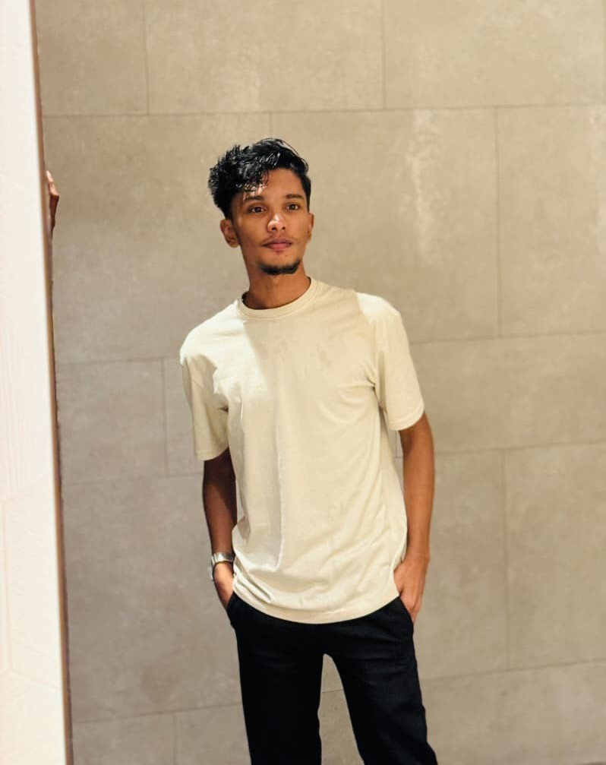
Full Name
Mohamed Usman Mohamed Milas
Preferred Name
Usman
Date of Birth
10
th September
2004
Gender
Male
Nationality
Sri Lankan
Address
45
, Kahatowita, Veyangoda, Gampaha, Sri Lanka

Summary

Motivated and adaptable individual with a strong foundation in computing, creative design, and problem-solving. Skilled in programming, digital media production, and collaboration, with a passion for creating effective and user-friendly digital solutions. Dedicated to continuous learning and applying innovative ideas in both technical and creative fields. I believe continuous learning is essential in the technology industry, so I actively stay updated with modern tools, AI driven workflows, and emerging development trends to continuously improve my skills and adapt to industry changes.

Languages

- Sinhala - Native
- Tamil - Native
- English - Intermediate

Core Skills

- Team Collaboration
- Communication
- Leadership
- Coordination
- Media & Digital Design Creativity
- Adaptability
- Flexibility
- Time Management
- Critical Thinking
- Problem Solving

Technical Skills

Programming | HTML, Python, PHP, JavaScript (Visual Studio, VS Code)
Database | MySQL, XAMPP
Software | Microsoft Word, Excel, PowerPoint
Creative Tools | Photo Editing, Media Production, Digital Design
Web Platforms | WordPress, Webflow

Professional Experience

Assistant Web Designer & Developer
2022 - 2024 | Remote Collaboration with Senior Web Designer & Developer
- Worked alongside a senior professional web designer and developer with a strong international freelance client base for 3 years.
- Earned $2,000 - $3,000 per month through consistent delivery of high-quality web design and development services to international clients.
- Assisted in designing and developing modern, responsive websites using HTML, PHP, JavaScript, WordPress, and Webflow.
- Collaborated on real client projects, improving UI/UX design, website structure, and performance optimization.
- Gained hands-on experience in professional web development workflows, client communication, and project coordination.

Freelance Web Designer
2022 - 2024 | Self-Employed
- Designed and developed responsive websites tailored to client requirements.
- Applied creative digital design techniques to enhance user experience.
- Managed full-cycle projects including planning, coding, testing, and delivery.

Webflow Projects

- https://webworks-amazing-site.webflow.io/
- https://web-works-portfolio.webflow.io/
- https://giros-dandy-site-209cb8.webflow.io/

Education

Al Badriya Maha Vidyalaya, Kahatowita
2010 - 2023
- Successfully completed Advanced Level education.
- Focused on Information Technology, Art, and Sinhala.

Professional Qualifications

British Way English Academy
2022
• Successfully completed English language training.

ESOFT University, Colombo 04
2025
• Reading: Pearson Assured (UK) RQF Level 4 - Higher National Certificate (HNC) in Computing.

Declaration

I hereby declare that the information provided above is true and accurate to the best of my knowledge. I understand that any misrepresentation may lead to disqualification from consideration.

