Personal Information

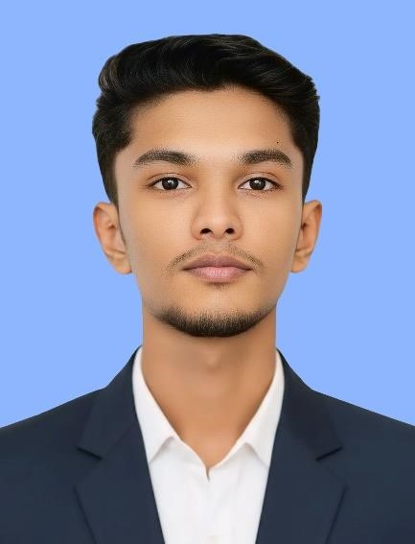
- Full Name: Mohamed Usman Mohamed Milas
- Preferred Name: Usman
- Date of Birth: 10th September 2004
- Gender: Male
- Nationality: Sri Lankan
- Address: 45, Kahatowita, Veyangoda, Gampaha, Sri Lanka
- Contact Number: +94 77 919 4083
- Email: mohamadusman200@gmail.com
- Website: https://web-works-portfolio.webflow.io/

Summary

Motivated and adaptable individual with a strong foundation in computing, creative design, and problem-solving. Skilled in programming, digital media production, and collaboration, with a passion for creating effective and user-friendly digital solutions. Dedicated to continuous learning and applying innovative ideas in both technical and creative fields. I believe continuous learning is essential in the technology industry, so I actively stay updated with modern tools, AI driven workflows, and emerging development trends to continuously improve my skills and adapt to industry changes.

Languages

- Sinhala – Native
- Tamil – Native
- English – Intermediate

Core Skills

- Team Collaboration
- Communication
- Leadership
- Coordination
- Media & Digital Design Creativity
- Adaptability
- Flexibility
- Time Management
- Critical Thinking
- Problem Solving

Technical Skills

- Programming: HTML, Python, PHP, JavaScript (Visual Studio, VS Code)
- Database Management: MySQL, XAMPP
- Software Tools: Microsoft Word, Excel, PowerPoint
- Creative Tools: Photo Editing, Media Production, Digital Design
- Web Development Platforms: WordPress, Webflow

Professional Experience - 1

2022 – 2024 | Assistant Web Designer & Developer (Remote Collaboration)
- Worked alongside an experienced professional web designer with a strong international freelance client base.
- Assisted in designing and developing modern, responsive websites using HTML, PHP, JavaScript, WordPress, and Webflow.
- Collaborated on real client projects, improving UI/UX design, website structure, and performance optimization.
- Gained hands on experience in professional web development workflows, client communication, and project coordination.

Professional Experience - 2

2022 – 2024 | Freelance Web Designer (Self-Employed)
- Designed and developed responsive websites tailored to client requirements.
- Applied creative digital design techniques to enhance user experience.
- Managed full-cycle projects including planning, coding, testing, and delivery.

Education

2010 – 2023 | Al Badriya Maha Vidyalaya, Kahatowita
- Successfully completed Advanced Level education.
- Focused on Information Technology, Art, and Sinhala.

Professional Qualifications

2022 | British Way English Academy
• Successfully completed English language training.

2025 | ESOFT University, Colombo 04
• Reading: Pearson Assured (UK) RQF Level 4 – Higher National Certificate (HNC) in Computing.

Declaration
I hereby declare that the information provided above is true and accurate to the best of my knowledge. I understand that any misrepresentation may lead to disqualification from consideration.

