AI-Powered Chat-Based Academic Advisor for CS Department

Department of Computer Science
Final Year Project (Updated Implementation Documentation)
Submitted by: Usman Mustafa
Registration No.: 04072213047
Supervisor: Dr. Mudassar Azam Sindhu
Session (2022-26)

Acknowledgment
To begin with, I want to thank Almighty Allah whose blessings, wisdom, and guidance I have always used to be my source of strength in the process of completing this project. This would not have been able to be achieved without His grace. I would also like to thank my respected supervisor Dr. Mudassar Azam Sindhu who has provided invaluable supervision, constant motivation, and brilliant suggestions during the progression of this project. His experience, patience and work ethics have inspired and motivated me a lot so as to complete this work successfully.
I would also like to acknowledge an owed debt to the Department of Computer Science, Quaid-i-Azam University, Islamabad, to make this project possible and offer me the academic resources, the technical facilities, and a favorable learning environment. I am also thankful to teachers and people who guided me throughout my studies as they assisted me in acquiring the necessary skills and knowledge to pursue this project.
Last but not least, I would like to thank my family and friends, who have been my constant encouragement, moral support and prayers all along the way. They understood and were patient enough to make me believe that I was capable of conquering all the challenges that I was going through.

Abstract
The AI-Powered Chat-Based Academic Advisor for the Department of Computer Sciences at Quaid-i-Azam University (QAU) is a web-based academic support platform that provides students with timely guidance from departmental and university information. It reduces the effort required to search scattered websites, notices, schemes of study, fee records, policies, and schedules while clearly stating that final academic decisions remain with the department.
The implemented system combines structured academic APIs with retrieval-augmented generation (RAG). It detects English, Urdu, and Roman Urdu queries, retrieves relevant passages using multilingual embeddings and lexical search, reranks evidence, and produces a grounded answer through configurable local or remote language-model providers. Answers expose their supporting sources, and the assistant abstains or reports uncertainty when reliable evidence is unavailable.
The implemented platform supports the following major academic and administrative tasks:
- Course catalogues, study plans, credit hours, prerequisites, and progression guidance.
- Admissions, registration, fees, policies, deadlines, and departmental notices.
- Class timetables, instructors, rooms, examination information, and schedule search.
- Final-year project, thesis, faculty, research, and programme information.
- Source-backed conversational answers in English, Urdu, and Roman Urdu.
- Private history, feedback, analytics, content governance, and administrator oversight.
The knowledge pipeline ingests official QAU CS webpages and documents, supports OCR for scanned PDFs, records source versions and checksums, and publishes reviewed retrieval snapshots with rollback support. A protected administration panel manages academic content, timetable corrections, AI-provider settings, notices, query analytics, feedback, and knowledge refresh operations. Guest conversations can remain ephemeral, while authenticated history is private and owner-scoped.

Table of Contents
Acknowledgment 2
Abstract 3
List of Figures 7
List of Tables 8
• Table 3.2: Component Description ................................... 55 8
CHAPTER - 01 9
SOFTWARE PROJECT MANAGEMENT PLAN 9
1.1-Introduction 9
1.2-Problem Definition 9
1.3 Proposed System 9
1.4 Scope 11
1.5 Objectives 11
User Objectives 11
Technical Objectives 12
Learning Objectives 12
1.6 Motivation 12
1.7 Risk & Contingencies 12
Project Schedule 13
1.8 Application 14
1.9 Comparative Analysis of Existing Local Systems 14
1.10 Project Organization 14
Process Model 14
Tools & Technologies 15
CHAPTER – 02 16
SOFTWARE REQUIREMENTS SPECIFICATION 16
2.1 Introduction 16
2.2 Product Overview 16
2.3 Specific Requirements 17
Functional and Technical Requirements: 17
2.4 Software Product Features 17
2.5 Software System Attributes 17
2.6 List of Use Cases 18
2.7 Use Case Diagram 18
2.7.1 Use Case Descriptions 21
2.7.2 System Sequence Diagram 26
2.7.3 Sequence Diagram 36
CHAPTER – 03 46
SOFTWARE DESIGN DESCRIPTION 46
3.1 Introduction 46
The main purpose of the software design chapter is to show that how the component of our system are working together so that maintaining the system will become easier and in future our system is easy to upgrade or extend. 46
Design Overview 46
How Components Interact 46
Requirements Traceability Matrix 47
Requirements Traceability Matrix (RTM) for AI-Powered Chat-Based Academic Advisor 47
3.2 System Architecture Design 48
3.2.1 Chosen System Architecture 48
1. Presentation Layer 48
2. Application Layer 49
3. NLP Processing Layer 49
4. Data Layer 50
3.3 Architectural Diagram 50
Figure 3.1: Architecture Diagram of Academic Advisor 50
3.4 Class Diagram 51
3.5 Component Description 53
3.6 Activity Diagrams 54
3.7 Interface/Screen Design 55
3.7.1 Login Screen 55
3.7.2 Ask Academic Query 55
3.7.3 View Query History 56
3.7.4 Admin Login and Dashboard 56
3.7.5 Admin Manage Data 57
3.7.6 Admin Monitor Activity 58
3.8 Summary 58
CHAPTER: 04 59
SOFTWARE TEST DOCUMENTATION 59
4.1 Introduction 59
4.1.1 System Overview 59
4.1.2 Test Approach 59
4.1.3 Features to be Tested 60
4.1.4 Features Not to be Tested 60
4.2 Testing Tools and Environment 60
Environment 60
Tools 60
4.3 Test Cases 61
4.3.1 Test Case: Student Registration (UC1) 61
S4.3.2 Test Case: Student Login (UC2) 61
4.3.3 Test Case: Ask Academic Query (UC3) 61
4.3.4 Test Case: View Chatbot Response (UC4) 62
4.3.5 Test Case: View Query History (UC5) 62
4.3.6 Test Case: Admin Login (UC6) 62
4.3.7 Test Case: Admin Update Academic Data (UC7) 63
4.3.8 Test Case: Search Course by Name (UC8) 63
4.3.9 Test Case: Ask Policy / Fee / Timetable Information (UC9) 63
4.3.10 Test Case: Bilingual Query Input (UC10) 64
4.3.11 Test Case: Manage Course Information (UC11) 64
4.3.12 Test Case: Manage Fee Structure (UC12) 64
4.3.13 Test Case: Manage Timetables (UC13) 64
4.3.14 Test Case: Manage Policies & Guidelines (UC14) 65
4.3.15 Test Case: View Student Query Logs (UC15) 65
4.3.16 Test Case: Manage User Accounts (UC16) 65
4.3.17 Test Case: Generate Reports (UC17) 65
4.3.18 Test Case: Admin Logout (UC18) 66
4.4 Summary 66
CHAPTER: 05 67
CONCLUSION 67
5.1 Conclusion 67
References 68

List of Figures
- Figure 1.1: System Flow ............................................. 11
- Figure 1.2: Project Schedule (Gantt Chart) .......................... 13
- Figure 2.1: Use Case Diagram ........................................ 20
- Figure 2.2: System Sequence Diagram – Student Registration .......... 28
- Figure 2.3: System Sequence Diagram – Student Login ................. 28
- Figure 2.4: System Sequence Diagram – Ask Academic Query ............ 29
- Figure 2.5: System Sequence Diagram – View Chatbot Response........ 29
- Figure 2.6: System Sequence Diagram – View Query History ............ 30
- Figure 2.7: System Sequence Diagram – Admin Login ................... 30
- Figure 2.8: System Sequence Diagram – Admin Update Academic Data .... 31
- Figure 2.9: System Sequence Diagram – Search Course by Name ....... 31
- Figure 2.10: System Sequence Diagram – Ask Policy / Fee / Timetable Information... 32
- Figure 2.11: System Sequence Diagram – Bilingual Query Input ........ 32
- Figure 2.12: System Sequence Diagram – Manage Course Information. 33
- Figure 2.13: System Sequence Diagram – Manage Fee Structure ......... 33
- Figure 2.14: System Sequence Diagram – Manage Timetables ............ 34
- Figure 2.15: System Sequence Diagram – Manage Policies & Guidelines 34
- Figure 2.16: System Sequence Diagram – View Student Query Logs .... 35
- Figure 2.17: System Sequence Diagram – Manage User Accounts ....... 35
- Figure 2.18: System Sequence Diagram – Generate Reports ............. 36
- Figure 2.19: System Sequence Diagram – Admin Logout ................ 36
- Figure 2.20: Sequence Diagram – Student Registration .......... 37
- Figure 2.21: Sequence Diagram – Student Login ................. 37
- Figure 2.22: Sequence Diagram – Ask Academic Query ............ 38
- Figure 2.23: Sequence Diagram – View Chatbot Response........ 38
- Figure 2.24: Sequence Diagram – View Query History ............ 39
- Figure 2.25: Sequence Diagram – Admin Login ................... 39
- Figure 2.26: Sequence Diagram – Admin Update Academic Data .... 40
- Figure 2.27: Sequence Diagram – Search Course by Name ....... 40
- Figure 2.28: Sequence Diagram – Ask Policy / Fee / Timetable Information... 41
- Figure 2.29: Sequence Diagram – Bilingual Query Input ........ 41
- Figure 2.30: Sequence Diagram – Manage Course Information. 42
- Figure 2.31: Sequence Diagram – Manage Fee Structure ......... 42
- Figure 2.32: Sequence Diagram – Manage Timetables ............ 43
- Figure 2.33: Sequence Diagram – Manage Policies & Guidelines 43
- Figure 2.34: Sequence Diagram – View Student Query Logs .... 44
- Figure 2.35: Sequence Diagram – Manage User Accounts ....... 44
- Figure 2.36: Sequence Diagram – Generate Reports ............. 45
- Figure 2.37: Sequence Diagram – Admin Logout ................ 45
- Figure 3.1: Architecture Diagram of AI-Powered Chat-Based Academic Advisor ....... 51
- Figure 3.2: Class Diagram of AI-Powered Chat-Based Academic Advisor 52
- Figure 3.3: Combined Activity Diagram ……………………….54

List of Tables
- Table 1.1: Risk & Contingencies ..................................... 12
- Table 1.2: Comparative Analysis of Existing Local Systems ........... 14
- Table 2.1: UC1 – Student Registration ............................... 21
- Table 2.2: UC2 – Student Login ...................................... 21
- Table 2.3: UC3 – Ask Academic Query ................................. 21
- Table 2.4: UC4 – View Chatbot Response .............................. 22
- Table 2.5: UC5 – View Query History ................................ 22
- Table 2.6: UC6 – Admin Login ........................................ 22
- Table 2.7: UC7 – Admin Update Academic Data ........................ 23
- Table 2.8: UC8 – Search Course by Name .............................. 23
- Table 2.9: UC9 – Academic Policy Query .............................. 23
- Table 2.10: UC10 – Bilingual Query Input ............................ 23
- Table 2.11: UC11 – Manage Course Information ....................... 24
- Table 2.12: UC12 – Manage Fee Structure ............................. 24
- Table 2.13: UC13 – Manage Timetables ............................... 24
- Table 2.14: UC14 – Manage Policies ................................. 25
- Table 2.15: UC15 – View Query Logs .................................25
- Table 2.16: UC16 – Manage User Accounts ............................ 25
- Table 2.17: UC17 – Generate Reports ................................ 26
- Table 2.18: UC18 – Admin Logout .................................... 26
- Table 3.1: Requirements Traceability Matrix (RTM) .................. 47
- Table 3.2: Component Description ................................... 53

CHAPTER - 01

SOFTWARE PROJECT MANAGEMENT PLAN

1.1-Introduction
The rising need to access academic support in a timely manner has put forth the necessity of having an effective communication in university. Traditional academic advising is constrained by office hours, the number of personnel available and the increase in students in need of help. Students will usually have difficulties in getting reliable answers to the academic questions fast.
This is a process that may take up much time since they have to go through different resources such as course catalogs, academic regulations and departmental guidelines. In that regard, the given project will attempt to develop a web-based application within the Computer Science Department in Quaid-i-Azam University (QAU).
With this system, the students will have direct access to academic information, by querying a structured body of knowledge, consisting of course outlines, academic policies, and outlining fee policies. This is aimed at cutting down on administrative burden, enhancing student experience and offering academic guidance to students in a fast and precise way.

1.2-Problem Definition
Students in the Computer Science Department at Quaid-i-Azam University (QAU) have a lot of trouble getting academic information, especially about acidic matters, this information is so scattered across different places like department offices, official university websites, and academic advisors, which makes it hard for students to find what they need. Offices are only open for hours, so students can’t always get help when they need it. Advisors are also very busy, so students don’t always get answers quickly. Many students end up asking the same questions over and over, which makes the staff’s work even harder. On top of all this, academic documents like course catalogs and rules are very long and formal, which makes it difficult for students to find the specific information they are looking for.
.

1.3 Proposed System
The implemented project acts as an academic information assistant for QAU Computer Science students. Students can use the portal or guest chat to ask natural-language questions and receive streamed answers supported by official sources. The system combines structured records for precise programme, course, fee, policy, and timetable views with document retrieval for broader departmental guidance.
1. Dataset
The knowledge base contains programme and course information, schemes of study, prerequisite relationships, fee records, timetables, examination information, policies, deadlines, faculty and research information, and FYP or thesis guidance. Each retrievable document carries provenance, source type, programme scope, effective-date metadata, version information, and verification status where available.
2. Preprocessing
The implemented preparation and indexing pipeline performs:
- Document acquisition from allow-listed official websites and administrator uploads.
- HTML cleaning, PDF extraction, OCR for scanned pages, and bounded text normalization.
- Structure-aware chunking that preserves tables, course codes, fee columns, and prerequisite conditions.
- Multilingual embedding generation, lexical indexing, metadata filtering, and source versioning.
These stages make evidence searchable while preserving the wording, context, date, and provenance of the original source.
3. Multilingual Retrieval and Language Models
The portal includes multilingual language and intent processing, while the advisor retrieval engine uses the multilingual-e5-small embedding model and a cross-encoder reranker. Retrieved evidence is converted into a conversational answer through configurable Ollama/Qwen or Gemini providers. The language model is not treated as the source of academic truth; factual claims must be supported by the retrieved evidence and displayed citations.
4. Intent, Retrieval, Verification, and Response Generation
The request pipeline performs the following operations:
- Detects language, academic intent, programme scope, course codes, semesters, dates, and follow-up context.
- Routes exact structured requests to academic APIs and open-ended questions to the retrieval pipeline.
- Retrieves and reranks records from official webpages, documents, and structured academic data.
- Generates a readable answer, validates citations and numerical claims, and safely abstains when evidence is insufficient.
5. Deployment
The system is packaged as a responsive web platform. Docker Compose orchestrates the React frontend, Nginx gateway, FastAPI services, PostgreSQL/pgvector, the advisor engine, and an optional local Ollama service. Students can use the system on desktop or mobile browsers.
- Ask academic questions in English, Urdu, or Roman Urdu.
- Receive streamed, source-backed answers and inspect the cited evidence.
- Browse study plans, courses, fees, timetables, and policies through dedicated views.
Authorized administrators can manage content, correct timetables, review activity and feedback, configure AI providers, refresh official knowledge, and roll back a published knowledge build.
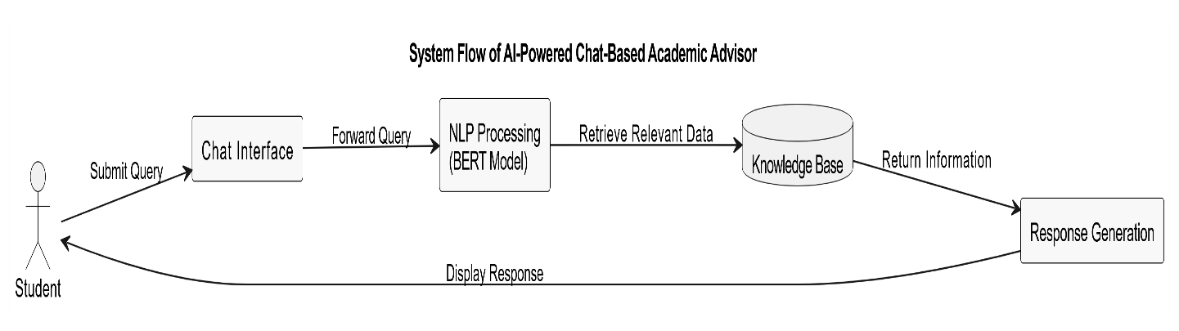

Figure 1.1 System Flow

1.4 Scope
The implemented system provides information and tools related to:
- Registration of courses offered in department/
- Course prerequisites and eligibility requirements.
- Credit hour distribution across semesters.
- Fee structure and payment guidelines.
- Class schedules and examination timetables.
- Final year project and thesis guidelines
- Departmental academic policies and regulations
The system is accessible from desktop and mobile browsers through the QAU CS academic portal. It supports English, Urdu script, and Roman Urdu. Users may continue as guests with an ephemeral conversation or sign in through the portal to enable private history and feedback.
The assistant does not replace an academic advisor and cannot make binding eligibility, registration, financial, or policy decisions. Important decisions must be confirmed with the department office, particularly when a source is undated, archived, incomplete, conflicting, or marked as demonstration data.

1.5 Objectives
User Objectives The platform provides immediate, understandable, and traceable answers about programmes, courses, prerequisites, study plans, fees, policies, timetables, examinations, admissions, and research requirements. It supports English, Urdu, and Roman Urdu, exposes citations, and provides dedicated academic-data views.
Technical Objectives The system combines FastAPI services, React interfaces, PostgreSQL/pgvector, an advisor runtime store, multilingual retrieval, evidence reranking, configurable language-model providers, and versioned official-source ingestion. The design prioritizes grounded answers, maintainable content, privacy, security, and operational observability.
Learning Objectives The project demonstrates multilingual NLP, hybrid information retrieval, retrieval-augmented generation, academic rule processing, source governance, secure web development, API integration, containerized deployment, automated testing, and responsible AI behavior.

1.6 Motivation
- Students may frequently be interested in courses, prerequisites and academic policies.
- Sometimes the advisors in the departments and academic university may not be present and accessible.
- Sometimes there is wasting of time by students in searching the notices, regulations and course outlines.
- Because of this, a number of students pose same academic questions to the academic again and again; this overburdens the administrative members of staff.
- Chatbot can be an AI-based service representing a fast and trustworthy response to frequent academic questions.
- Intelligent assistants are being exploited in the educational systems, and these types of solutions are becoming helpful and pertinent.

1.7 Risk & Contingencies
Risk | Impact | Mitigation
Incomplete academic data | Medium | Organize official data into a structured knowledge base
Incorrect query interpretation | High | Fine-tune BERT model on academic queries and test regularly
Expired polices or expired schedules | High | Add admin panel for updating information
Limited performance | Medium | Use training data in English and Urdu
System integration issues | Medium | Perform regular testing and development
Low student adoption | Medium | Design a simple and user-friendly interface
Table 1.1: Risk & Contingencies

Project Schedule
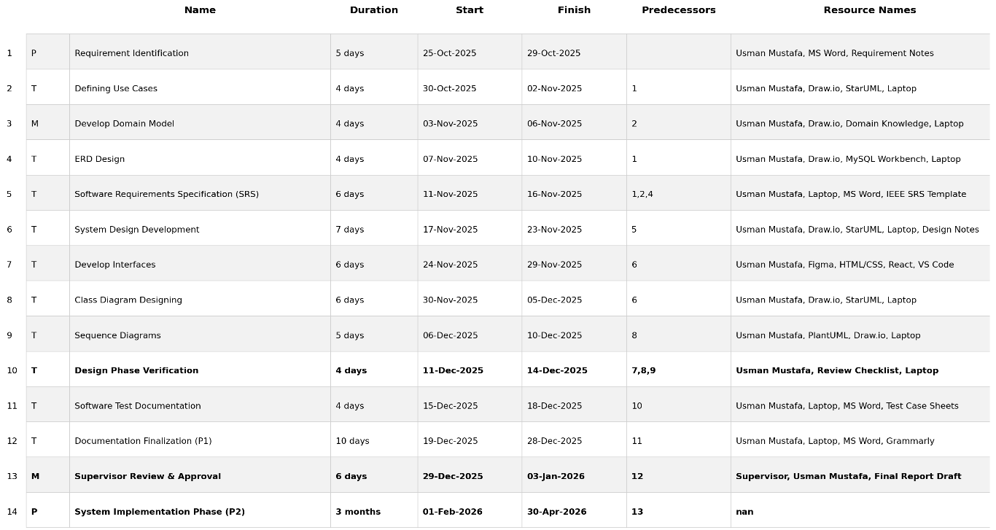
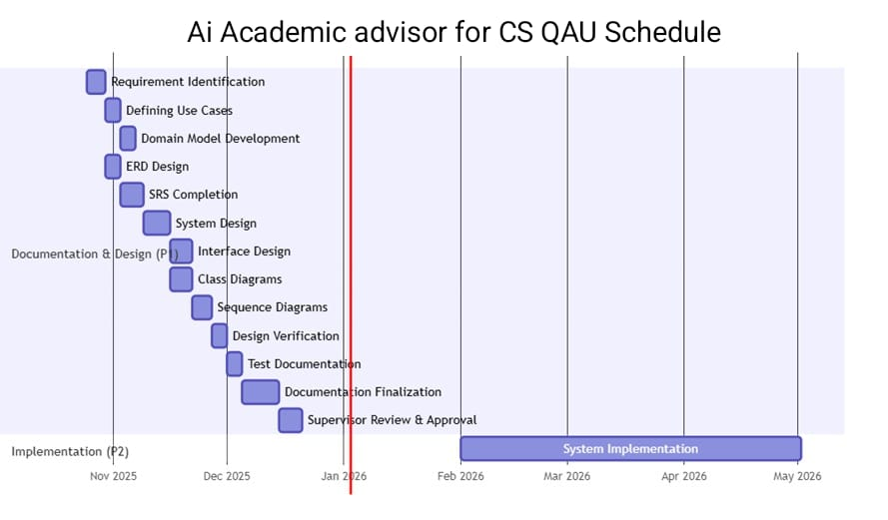
1.2: Project Schedule

1.8 Application
• Academic query processing on Computer Science students.
• Course prerequisite and credit-hour information.
• Semester planning support
• Fee structure and timetable information.
• Thesis and research guideline.
• Reducing the repetitive workload of student advisor.
• 24/7 academic information access to students.

1.9 Comparative Analysis of Existing Local Systems
• Previous systems are static and not interactive.
• Academic advisors are available only during limited hours.
• These systems don’t support intelligent bilingual question answering.
• Some international universities also have chatbots but they don’t support multilingual they are only limited to English and are based on their local rules
Platform | Chat-Based | English/Urdu Support | Department-Specific | AI-Based
Department Website | No | Partial | Yes | No
Printed Handbook | No | No | Yes | No
Academic Advisor (Manual) | Yes | Yes | Yes | No
Generic University Portal | No | Partial | Partial | No
Proposed System | Yes | Yes | Yes | Yes
Table 1.2: Comparative Analysis of Existing Local Systems

1.10 Project Organization

Process Model

The project was developed iteratively using an Agile approach. Work was divided across official-data collection, database and API design, multilingual retrieval, grounded response generation, portal and administration interfaces, timetable intelligence, security, testing, and deployment. Each increment was checked against traceable requirements and the available official evidence.
• Python and FastAPI • React 19 and Vite • PostgreSQL with pgvector • SQLite runtime storage • multilingual-e5-small embeddings • cross-encoder reranking • Ollama/Qwen and configurable Gemini • Docker Compose and Nginx • Pytest, Vitest, and Playwright
.

1.11 Implemented Contributions and Design Rationale
• Source-grounded advising: answers are based on retrieved departmental or university evidence rather than unsupported model memory.
• Hybrid academic access: dedicated structured pages handle study plans, courses, fees, policies, and timetables, while the conversational interface supports broader questions.
• Multilingual interaction: the interface and request pipeline support English, Urdu script, and common Roman Urdu queries.
• Knowledge governance: official sources are versioned, reviewed, published as snapshots, and recoverable through rollback.
• Responsible behavior: the system exposes citations, distinguishes verified and demonstration data, and declines to invent unsupported academic requirements.
• Operational administration: authorized staff can manage content, schedules, models, notices, analytics, query outcomes, and feedback.

CHAPTER – 02

SOFTWARE REQUIREMENTS SPECIFICATION

2.1 Introduction
The software requirements for our project are covered in this chapter.Questions regarding prerequisites, credit hours, fee structures, class schedules, exam schedules, and thesis guidelines, Our system offers students immediate academic support.
Our system can comprehend and answer questions in both Urdu and English thanks to artificial intelligence (AI) and natural language processing (NLP),because of which it became possible for making our system and reducing the load of academic advisor.

2.2 Product Overview
The AI-Powered Chat-Based Academic Advisor is designed to serve the stakeholders such as:
Students:
Who need guidance in courses, prerequisites, fee structure, timetables, thesis requirements, and departmental policies.
Newly Admitted Students:
Students who are unfamiliar with departmental procedures or want to take admission in Qau can have access to academic information.
Academic Advisors:
cannot replace academic advisor but will be very helpful in reducing the workload on academic advisor or staff members.
Departmental Administration:
staff can use the system to streamline academic communication and keep information organized.

2.3 Specific Requirements

Functional and Technical Requirements:
- Text Query Input: Students can submit natural-language questions and receive an incremental streamed response.
- Structured Academic Views: Students can browse study plans, courses, prerequisites, fees, policies, timetables, and related source status.
- Grounded Policy and Document Lookup: Open-ended questions retrieve relevant passages from official departmental and university sources.
- Multilingual Support: The system accepts English, Urdu script, and Roman Urdu and preserves right-to-left presentation where applicable.
- Context and Intent Processing: The system detects academic entities, programme scope, dates, course codes, and follow-up context.
- Evidence Retrieval and Reranking: Hybrid search retrieves, filters, and reranks source passages before answer generation.
- Grounded Response Generation: Answers include citations and use safe fallback or abstention when evidence is incomplete.
- Administration and Governance: Authorized staff manage content, documents, timetables, AI providers, notices, and knowledge publication.
- Conversation Privacy: Guest chats can be ephemeral; authenticated students receive owner-scoped history and deletion controls.
- Responsive Web Access: The React interface supports desktop and mobile use, keyboard interaction, sanitised output, retry, stop, and copy controls.
.

2.4 Software Product Features
- Academic Query Input: Students ask questions through a responsive streaming chat interface.
- Academic Data Views: Study plans, courses, prerequisites, fees, policies, and timetables are available through dedicated pages.
- Multilingual Support: English, Urdu script, and Roman Urdu queries are supported.
- Grounded Retrieval: Answers are assembled from official, versioned sources and display citations.
- Conversation Controls: The interface supports follow-up context, stop, retry, copy, feedback, and graceful degraded answers.
- Private History: Signed-in users can revisit and delete owner-scoped conversations; guest chats can remain ephemeral.
- Administration: Staff can manage academic data, CMS entries, documents, knowledge builds, AI providers, timetables, analytics, notices, feedback, and account security.

2.5 Software System Attributes
The system must satisfy the following quality attributes:
• Usability and Accessibility: The responsive interface provides keyboard-friendly controls, readable output, Urdu direction support, and clear system status.
• Performance: Streaming begins before the complete answer is available; retrieval, provider latency, and outcomes are recorded for operational review.
• Reliability and Grounding: Answers are checked against retrieved evidence, citations are preserved, and unsupported requests fail safely.
• Scalability: Containerized services, bounded retrieval, caching, concurrency controls, and configurable providers support future expansion.
• Security and Privacy: Admin authentication, login lockout, expiring sessions, rate limiting, owner checks, security headers, sanitization, and retention cleanup protect the system.
• Maintainability and Governance: Versioned sources, runtime settings, audit information, cache invalidation, knowledge snapshots, and rollback simplify controlled updates.

2.6 List of Use Cases
• UC1: Student Registration • UC2: Student Login or Guest Access • UC3: Ask Academic Query • UC4: View Grounded Response and Sources • UC5: Manage Private History • UC6: Admin Login • UC7: Update Academic Data • UC8: Search Courses and Study Plans • UC9: Ask Policy, Fee, Exam, or Timetable Information • UC10: Multilingual Query • UC11: Manage Courses and Prerequisites • UC12: Manage Fees and Policies • UC13: Manage Timetable • UC14: Manage Knowledge and Documents • UC15: Review Query Logs and Feedback • UC16: Manage Users and Privacy Requests • UC17: View Analytics and Reports • UC18: Admin Logout

2.7 Use Case Diagram
There are two primary actors admin and students and the interaction is shown by the use case diagram below:
The Use case diagram is divided into two logical parts
• Student Interaction (UC1–UC10) supports registration or guest access, academic chat, source inspection, structured searches, multilingual queries, feedback, and private history. • Admin Oversight (UC6–UC18) supports protected academic-data management, knowledge ingestion, timetable correction, AI-provider configuration, query and feedback review, reporting, privacy operations, and logout.
Figure 2.1: Use Case Diagram
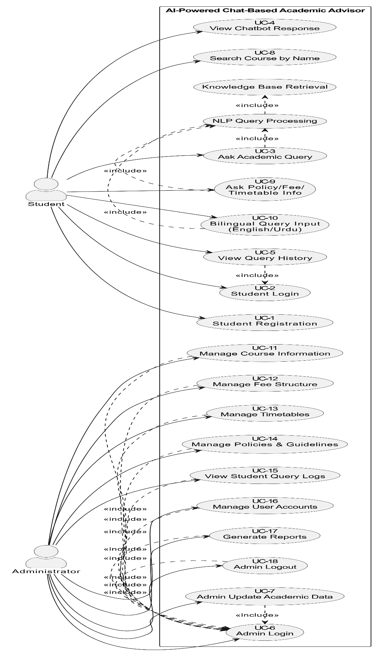

2.7.1 Use Case Descriptions

Use Case 1: Student Registration
Use Case | UC1: Student Registration
Primary Actor | Student
Pre-Conditions | Student is not registered in the system
Post-Conditions | Student account is created and stored in the database
Main Scenario | 1. Student opens the system and selects “Register”.  2. System displays registration form.  3. Student enters required details.  4. System validates the data.  5. System creates account and confirms registration.
Alternative Scenario | 5a. If email already exists, system shows an error.  5b. If required fields are missing, system asks student to complete the form.
Table 2.1: UC1 – Student Registration

Use Case 2: Student Login
Use Case | UC2: Student Login
Primary Actor | Student
Pre-Conditions | Student is registered
Post-Conditions | Student is authenticated and redirected to home/chat screen
Main Scenario | 1. Student selects “Login”.  2. System displays login form.  3. Student enters credentials.  4. System validates credentials.  5. On success, system grants access.
Alternative Scenario | 4a. Invalid email/password results in an error message.  5a. Network/system issue results in login failure notice.
Table 2.2: UC2 – Student Login

Use Case 3: Ask Academic Query
Use Case | UC3: Ask Academic Query
Primary Actor | Student
Pre-Conditions | Student is logged in
Post-Conditions | Query is processed and relevant answer is generated
Main Scenario | 1. Student opens chat interface.  2. Student types academic query.  3. System preprocesses query.  4. NLP model detects intent.  5. Knowledge base is searched.  6. System generates response.
Alternative Scenario | 3a. If query is unclear, system asks the student to rephrase.  5a. If no result is found, system informs the student accordingly.
Table 2.3: UC3 – Ask Academic Query
Use Case 4: View Chatbot Response
Use Case | UC4: View Chatbot Response
Primary Actor | Student
Pre-Conditions | Query has been processed
Post-Conditions | Student reads academic guidance returned by the chatbot
Main Scenario | 1. System displays the answer.  2. Student reviews the response.  3. Student may ask follow-up queries.
Alternative Scenario | 1a. If response confidence is low, system suggests rephrasing the question or contacting the department.
Table 2.4: UC4 – View Chatbot Response
Use Case 5: View Query History
Use Case | UC5: View Query History
Primary Actor | Student
Pre-Conditions | Student is logged in
Post-Conditions | Student views previous queries and responses
Main Scenario | 1. Student opens “History”.  2. System retrieves stored queries.  3. System displays past queries and answers.
Alternative Scenario | 1a. If no records exist, system shows “No history available”.
Table 2.5: UC5 – View Query History
Use Case 6: Admin Login
Use Case | UC6: Admin Login
Primary Actor | Administrator
Pre-Conditions | Admin account exists
Post-Conditions | Admin is authenticated and accesses dashboard
Main Scenario | 1. Admin opens login page.  2. Admin enters credentials.  3. System validates credentials.  4. Dashboard access is granted.
Alternative Scenario | 3a. Invalid credentials result in access denial message.
Table 2.6: UC6 – Admin Login
Use Case 7: Admin Update Academic Data
Use Case | UC7: Admin Update Academic Data
Primary Actor | Administrator
Pre-Conditions | Admin is logged in
Post-Conditions | Academic records are updated
Main Scenario | 1. Admin opens dashboard.  2. Admin selects module (courses, fees, schedules).  3. Admin updates data.  4. System saves changes.
Alternative Scenario | 3a. Invalid data results in validation error.
Table 2.7: UC7 – Admin Update Academic Data
Use Case 8: Search Course by Name
Use Case | UC8: Search Course by Name
Primary Actor | Student
Pre-Conditions | Student is logged in
Post-Conditions | Course information is displayed
Main Scenario | 1. Student selects course search option.  2. Student enters course name.  3. System retrieves matching course.  4. Course details are displayed.
Alternative Scenario | 3a If course is not found, system suggests alternative keywords.
Table 2.8: UC8 – Search Course by Name

Use Case 9: Ask Policy / Fee / Timetable Information
Use Case | UC9: Ask Policy / Fee / Timetable Information
Primary Actor | Student
Pre-Conditions | Student is logged in
Post-Conditions | Relevant academic information is displayed
Main Scenario | 1. Student enters query about fees, policies, or timetable.  2. System detects query intent.  3. Knowledge base retrieves data.  4. System displays answer.
Alternative Scenario | 3a .If no record exists, system informs student accordingly.
Table 2.9: UC9 – Academic Policy Query

Use Case 10: Bilingual Query Input
Use Case | UC10: Bilingual Query Input
Primary Actor | Student
Pre-Conditions | Student is logged in
Post-Conditions | System processes query in English or Urdu
Main Scenario | 1. Student enters query in English or Urdu.  2. System preprocesses text.  3. BERT model interprets intent.  4. Knowledge base is queried.  5. System displays response.
Alternative Scenario | 3a. If language is unclear, system asks student to rephrase query.
Table 2.10: UC10 – Bilingual Query Input

Use Case 11: Manage Course Information
Use Case | UC11: Manage Course Information
Primary Actor | Administrator
Pre-Conditions | Admin logged in
Post-Conditions | Course information updated
Main Scenario | 1. Admin opens course management module.  2. Admin edits or adds course information.  3. System validates data.  4. System saves changes.
Alternative Scenario | 3a. Invalid course data triggers validation error.
Table 2.11: UC11 – Manage Course Information
Use Case 12: Manage Fee Structure
Use Case | UC12: Manage Fee Structure
Primary Actor | Administrator
Pre-Conditions | Admin logged in
Post-Conditions | Fee records updated
Main Scenario | 1. Admin opens fee module.  2. Admin edits or updates fee structure.  3. System saves changes.
Alternative Scenario | 2a Invalid values trigger error message.
Table 2.12: UC12 – Manage Fee Structure
Use Case 13: Manage Timetables
Use Case | UC13: Manage Timetables
Primary Actor | Administrator
Pre-Conditions | Admin logged in
Post-Conditions | Updated timetable stored
Main Scenario | 1. Admin opens timetable module.  2. Admin updates class schedule.  3. System validates and saves timetable.
Alternative Scenario | 2a Incorrect schedule format results in validation error.
Table 2.13: UC13 – Manage Timetables

Use Case 14: Manage Policies & Guidelines
Use Case | UC14: Manage Policies
Primary Actor | Administrator
Pre-Conditions | Admin logged in
Post-Conditions | Policies updated
Main Scenario | 1. Admin selects policy module.  2. Admin edits policy details.  3. System stores updated policy.
Alternative Scenario | 2a, Missing information triggers validation message.
Table 2.14: UC14 – Manage Policies

Use Case 15: View Student Query Logs
Use Case | UC15: View Student Query Logs
Primary Actor | Administrator
Pre-Conditions | Admin logged in
Post-Conditions | Admin views student queries
Main Scenario | 1. Admin opens query log module.  2. System retrieves logs.  3. Admin views query activity.
Alternative Scenario | 2a If logs unavailable, system shows message.
Table 2.15: UC15 – View Query Logs

Use Case 16: Manage User Accounts
Use Case | UC16: Manage User Accounts
Primary Actor | Administrator
Pre-Conditions | Admin logged in
Post-Conditions | User accounts managed
Main Scenario | 1. Admin views list of users.  2. Admin updates or disables account.  3. System saves changes.
Alternative Scenario | 1a Unauthorized action triggers error.
Table 2.16: UC16 – Manage User Accounts

Use Case 17: Generate Reports
Use Case | UC17: Generate Reports
Primary Actor | Administrator
Pre-Conditions | Admin logged in
Post-Conditions | System generates usage reports
Main Scenario | 1. Admin selects report module.  2. System processes data.  3. System displays report statistics.
Alternative Scenario | 2a If insufficient data exists, system displays warning.
Table 2.17: UC17 – Generate Reports

Use Case 18: Admin Logout
Use Case | UC18: Admin Logout
Primary Actor | Administrator
Pre-Conditions | Admin logged in
Post-Conditions | Admin session terminated
Main Scenario | 1. Admin selects logout option.  2. System ends session.  3. Admin redirected to login page.
Alternative Scenario | 3a Session timeout logs admin out automatically.
Table 2.18: UC18 – Admin Logout

2.7.2 Additional Implemented Use Cases
• UC19 – Inspect Sources: The student expands source cards to inspect titles, snippets, source type, and links used by an answer.
• UC20 – Submit Answer Feedback: An authenticated student records or removes a helpful/not-helpful vote for an owned assistant message.
• UC21 – Refresh Official Knowledge: An administrator starts a bounded crawl and document build, reviews its status, and publishes the resulting snapshot.
• UC22 – Roll Back Knowledge: An administrator restores a previously published retrieval build when a new source set is incomplete or incorrect.
• UC23 – Configure AI Providers: An administrator selects provider order, model names, timeouts, and generation controls and verifies connectivity.
• UC24 – Import and Correct Timetable: An administrator previews a CSV import, applies corrections, exports data, undoes changes, or returns to the PDF baseline.
• UC25 – Protect User Data: The system isolates owner-scoped conversations and feedback, supports deletion, and removes records beyond the configured retention period.
• UC26 – Degraded Safe Answer: If the generation service is unavailable, the system returns relevant evidence or a clear limitation rather than fabricating an academic rule.

2.7.3 System Sequence Diagrams

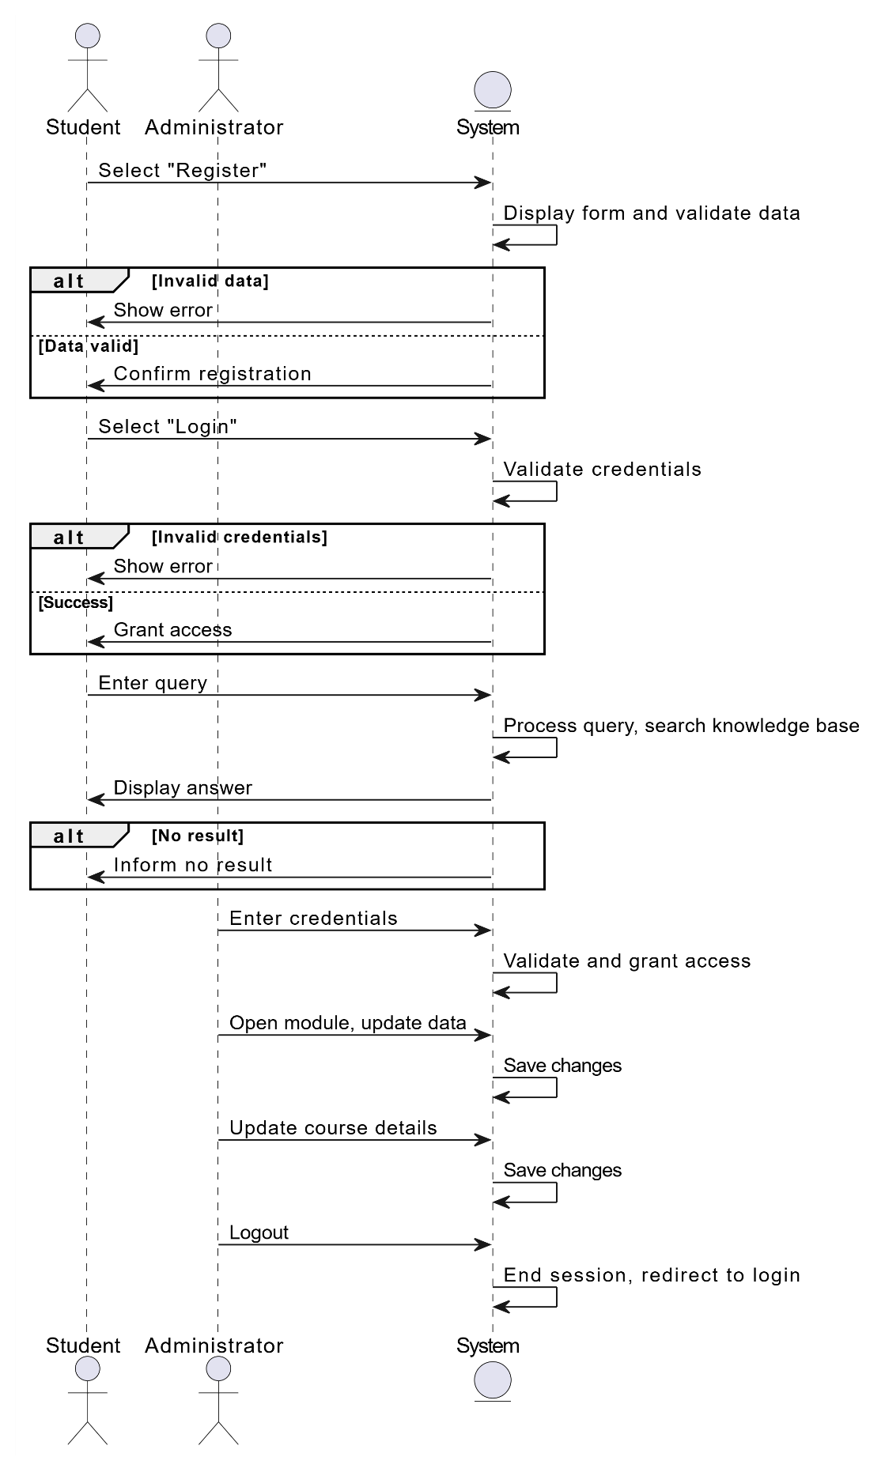

Figure 2.2: System Sequence Diagram – Student Registration
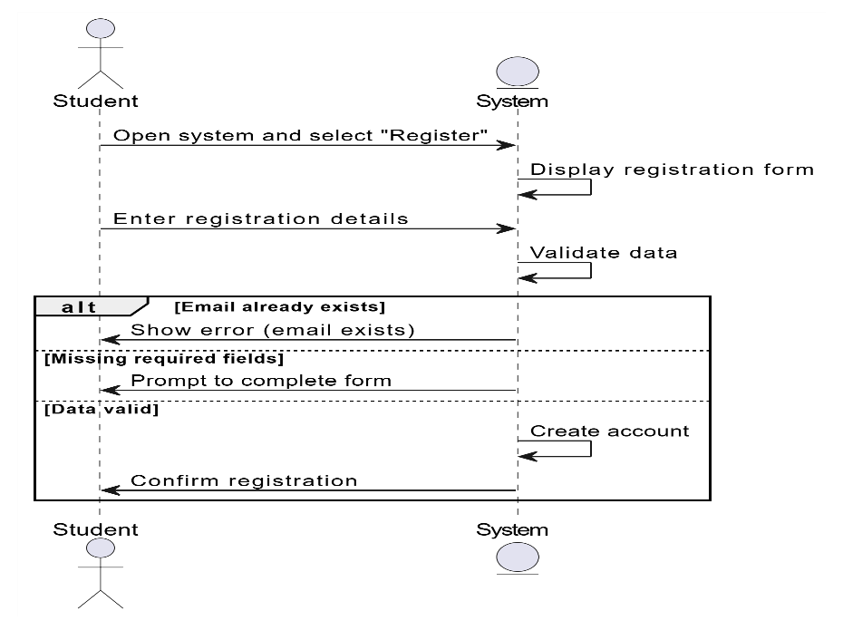

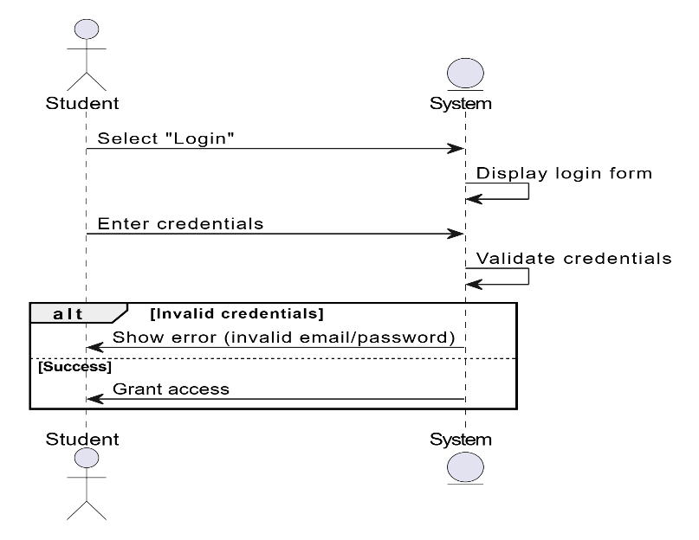
Figure 2.3: System Sequence Diagram – Student Login

Figure 2.4: System Sequence Diagram – Ask Academic Query
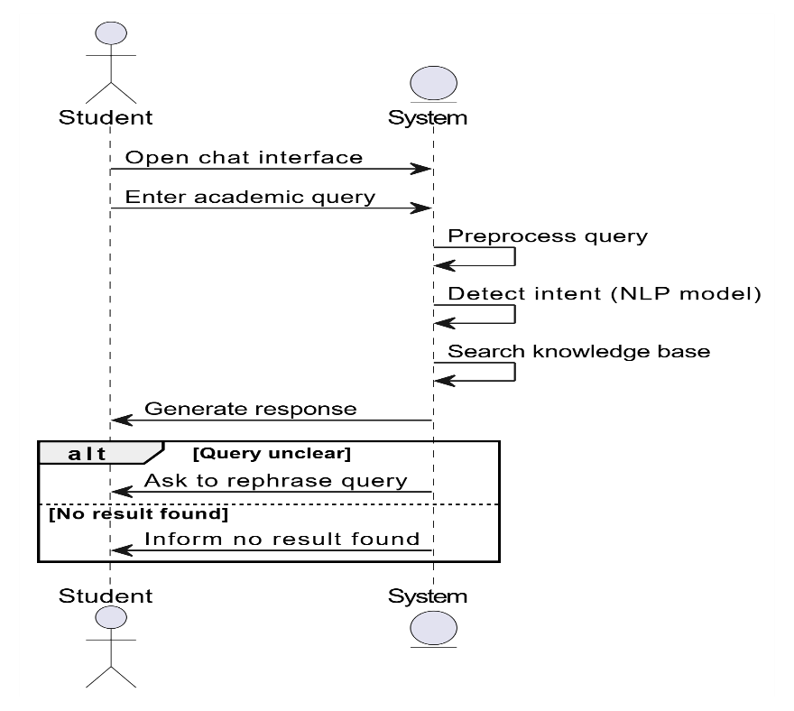

Figure 2.5: System Sequence Diagram – View Chatbot Response
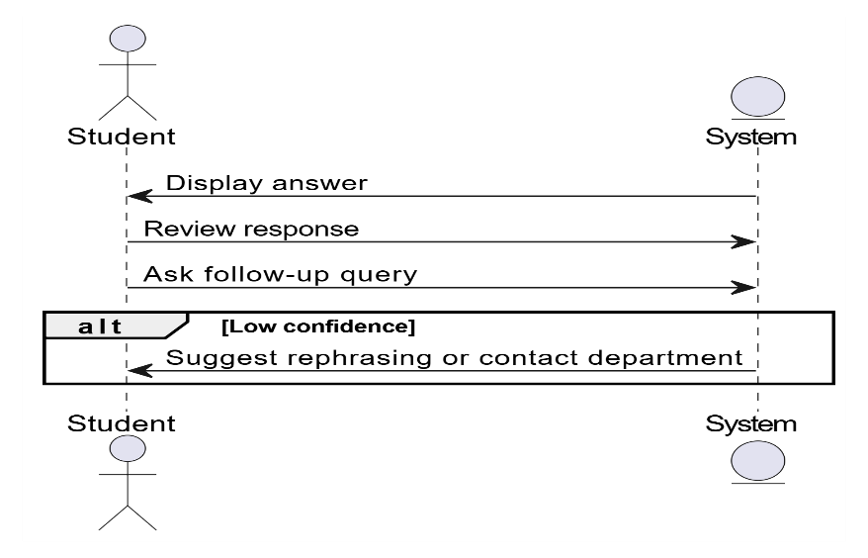

Figure 2.6: System Sequence Diagram – View Query History
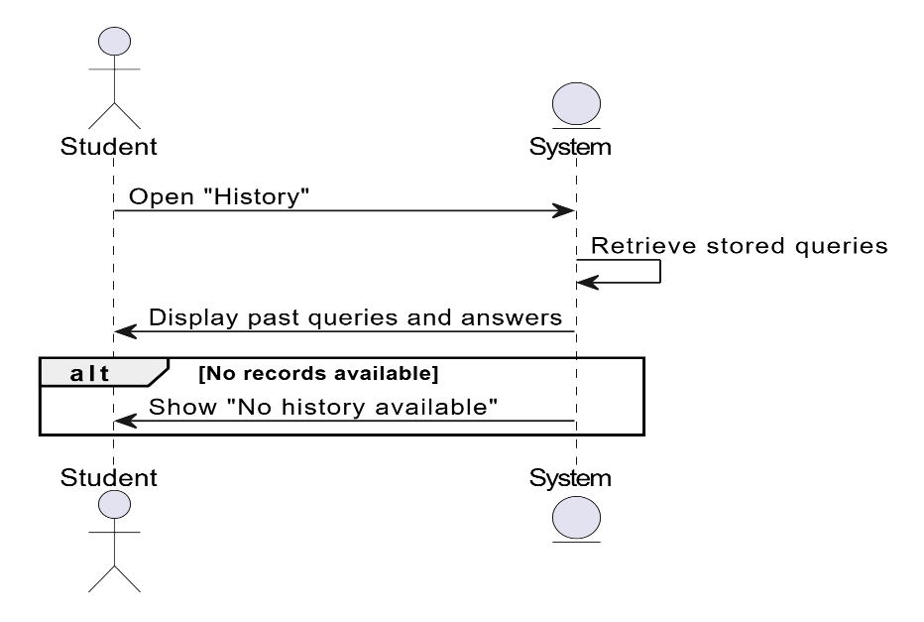

Figure 2.7: System Sequence Diagram – Admin Login
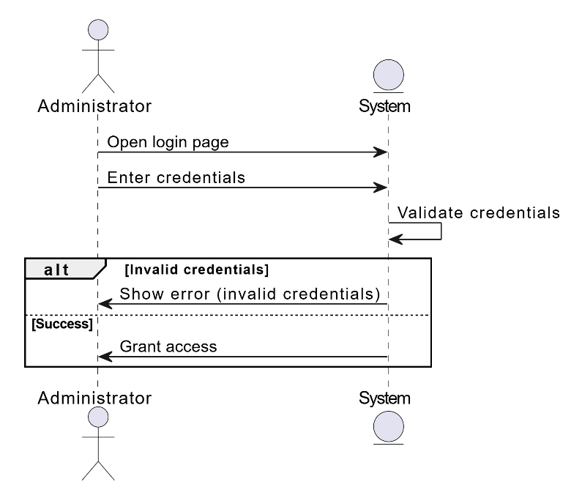

Figure 2.8: System Sequence Diagram – Admin Update Academic Data
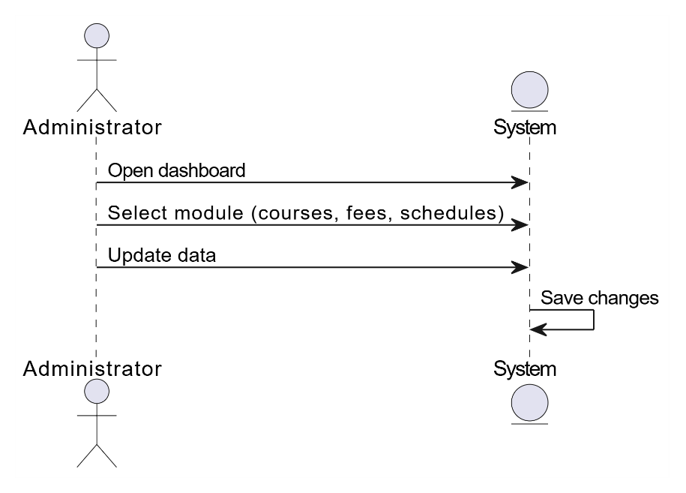

Figure 2.9: System Sequence Diagram – Search Course by Name
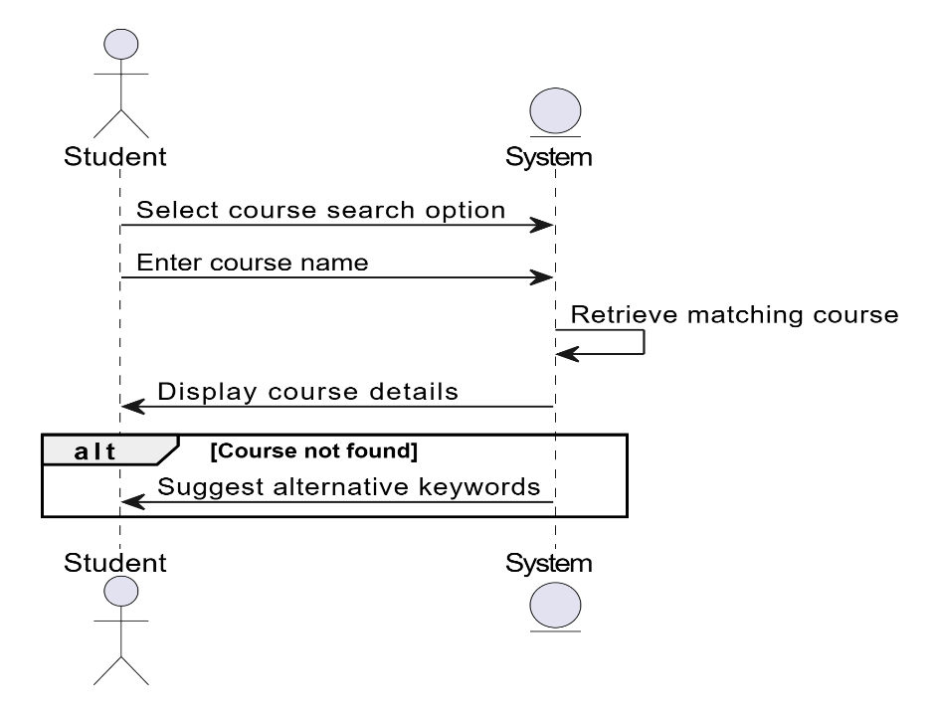

Figure 2.10: System Sequence Diagram – Ask Policy / Fee / Timetable Information
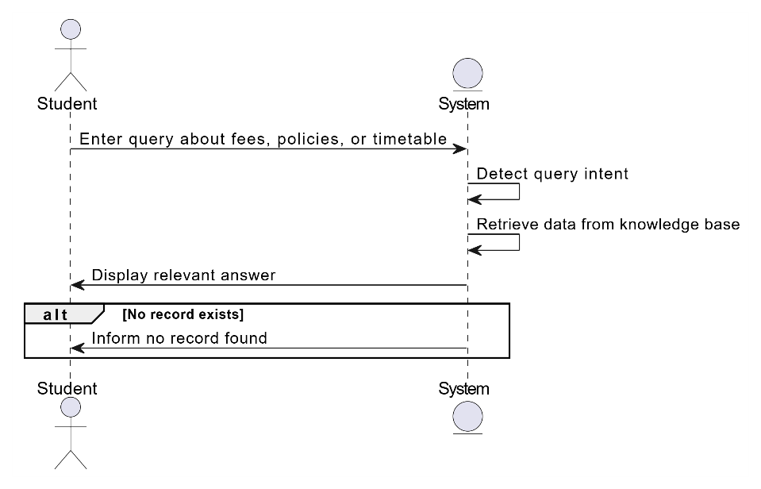

Figure 2.11: System Sequence Diagram – Bilingual Query Input
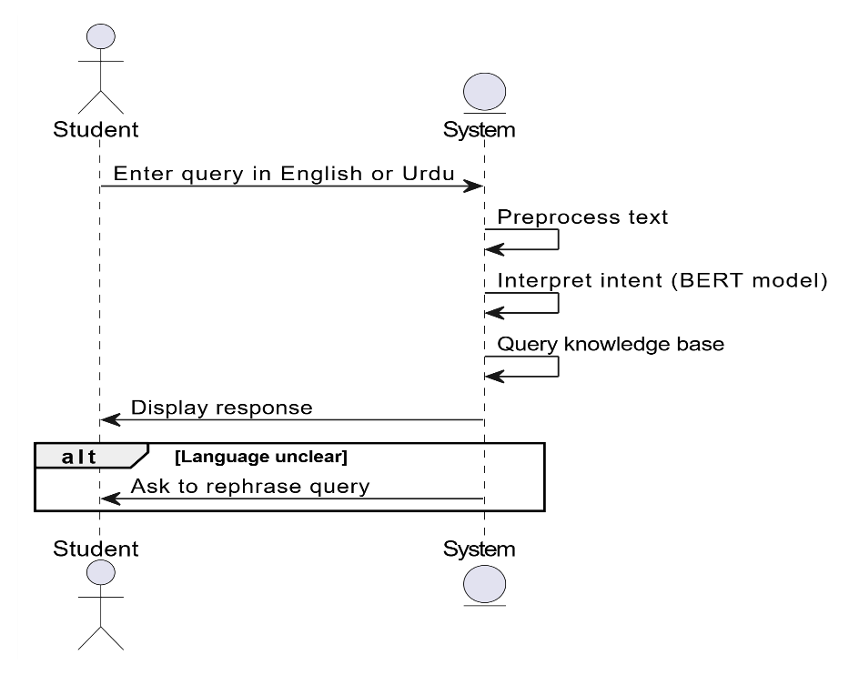

Figure 2.12: System Sequence Diagram – Manage Course Information
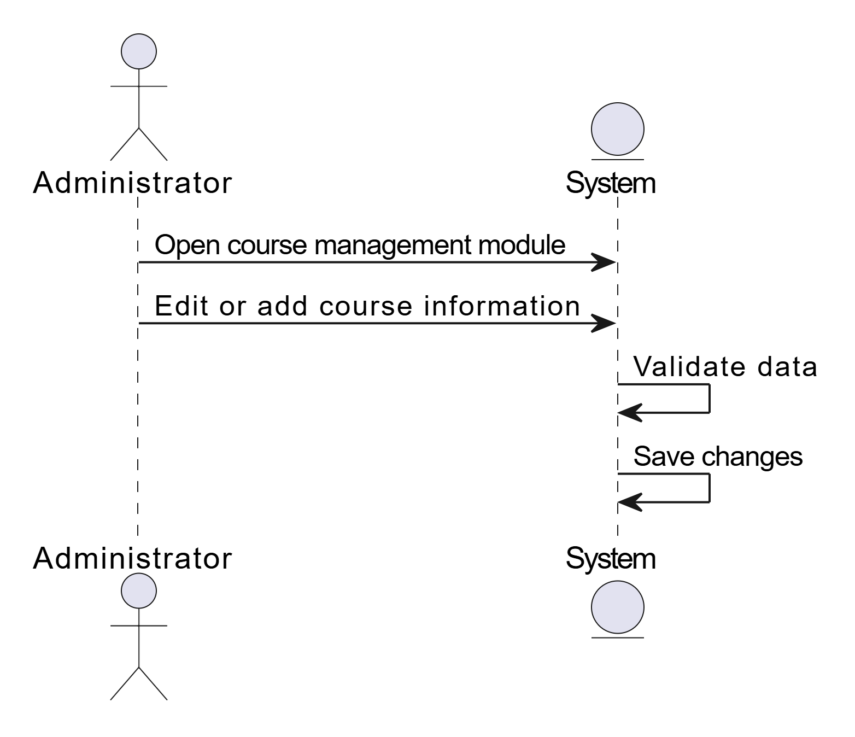
Figure 2.13: System Sequence Diagram – Manage Fee Structure
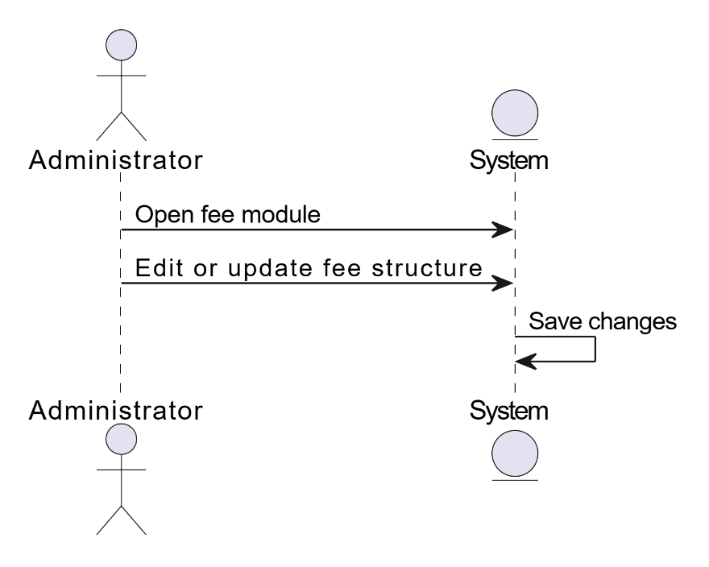

Figure 2.14: System Sequence Diagram – Manage Timetables
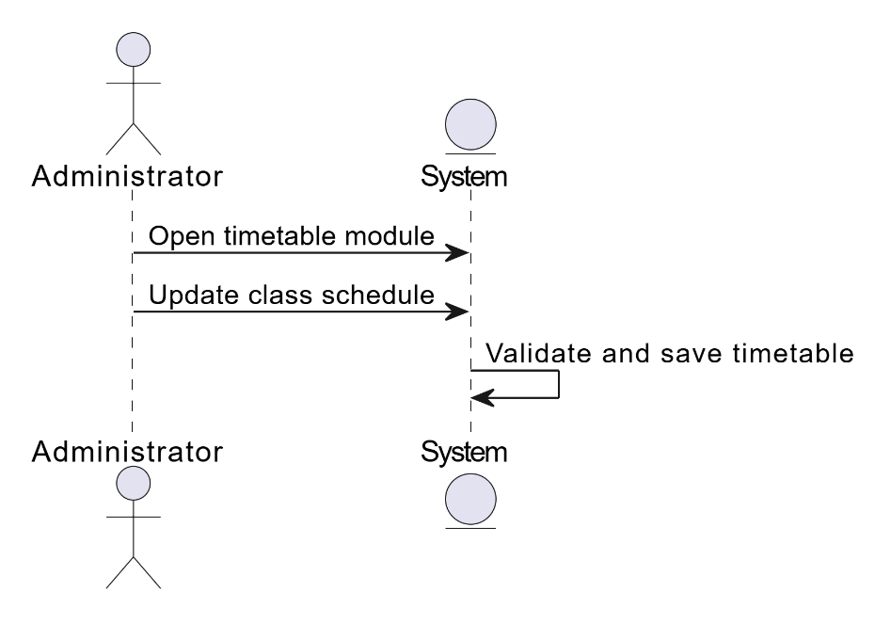

Figure 2.15: System Sequence Diagram – Manage Policies & Guidelines
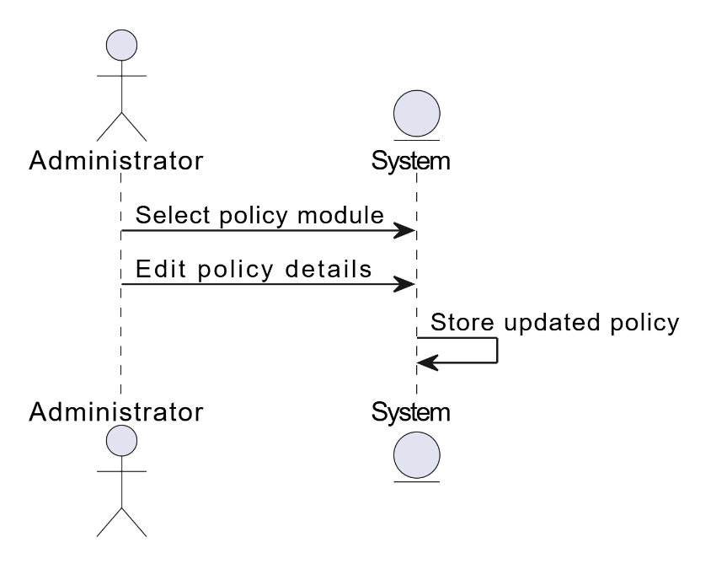

Figure 2.16: System Sequence Diagram – View Student Query Logs
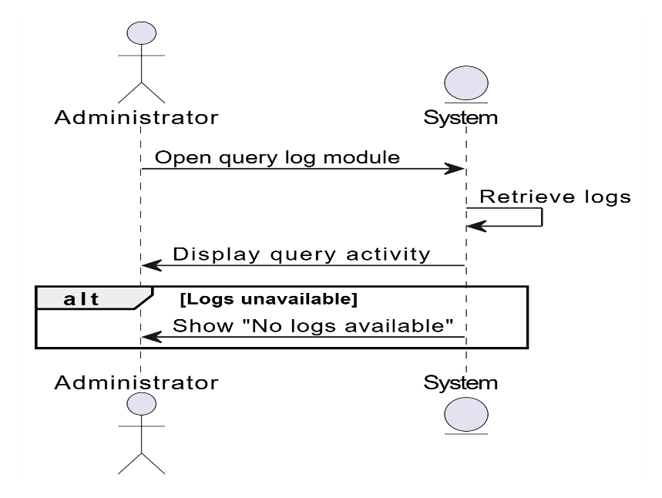

Figure 2.17: System Sequence Diagram – Manage User Accounts
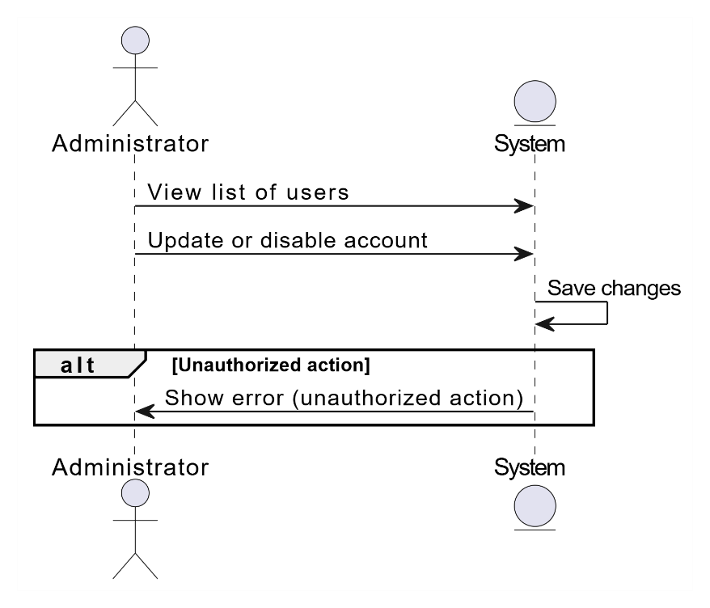

Figure 2.18: System Sequence Diagram – Generate Reports
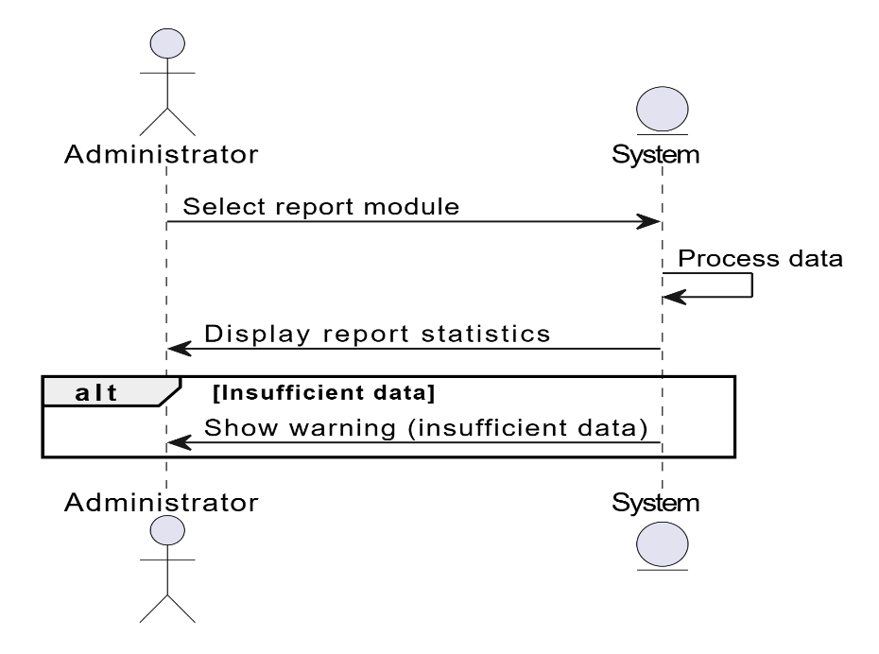

Figure 2.19: System Sequence Diagram – Admin Logout
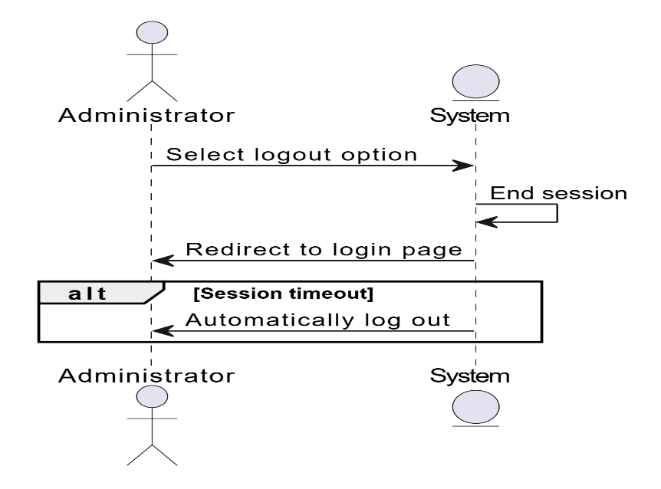

2.7.4 Detailed Sequence Diagrams

Figure 2.20: Sequence Diagram – Student Registration
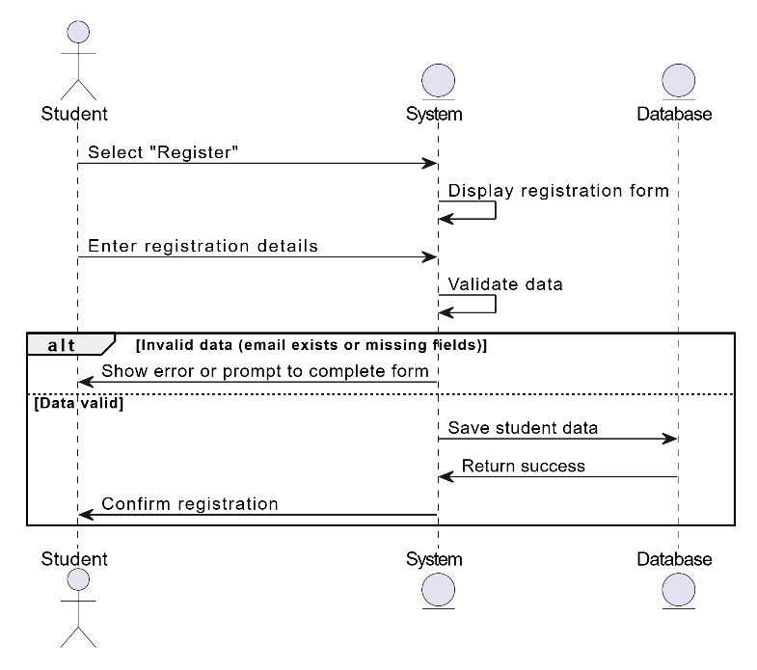
Figure 2.21: Sequence Diagram – Student Login
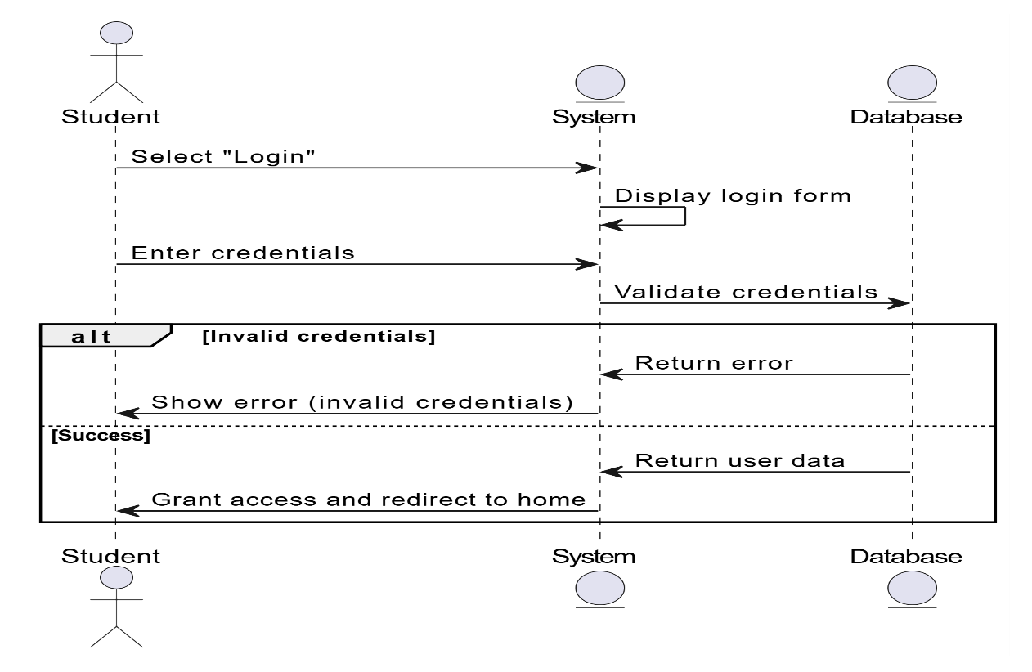

Figure 2.22: Sequence Diagram – Ask Academic Query

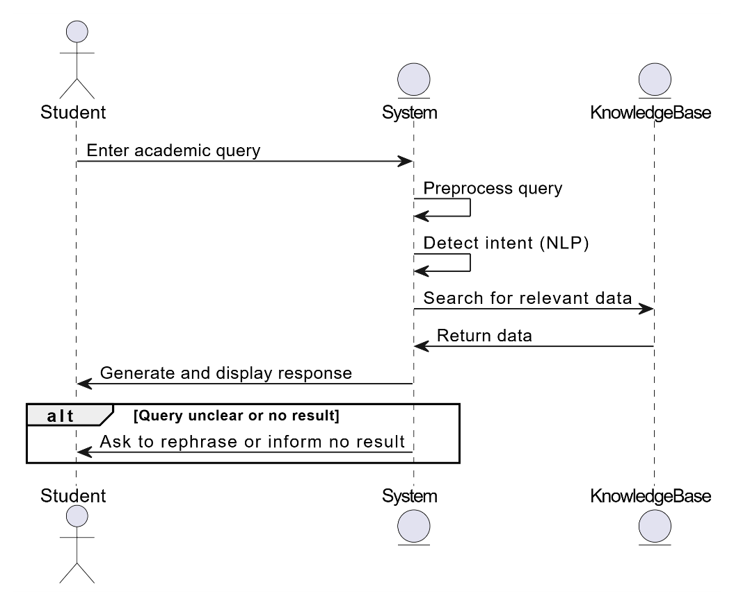

Figure 2.23: Sequence Diagram – View Chatbot Response
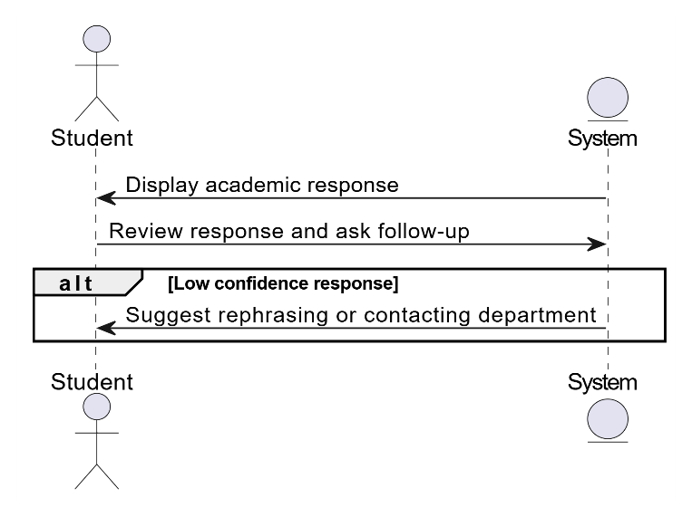
Figure 2.24: Sequence Diagram – View Query History
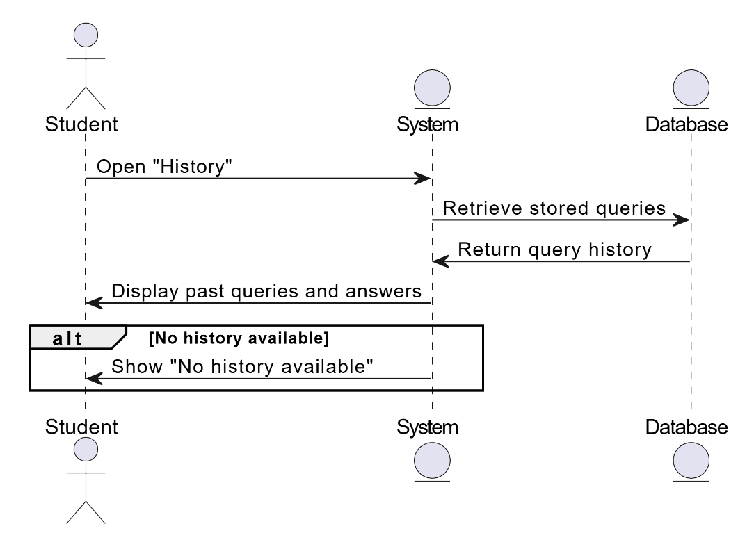
Figure 2.25: Sequence Diagram – Admin Login
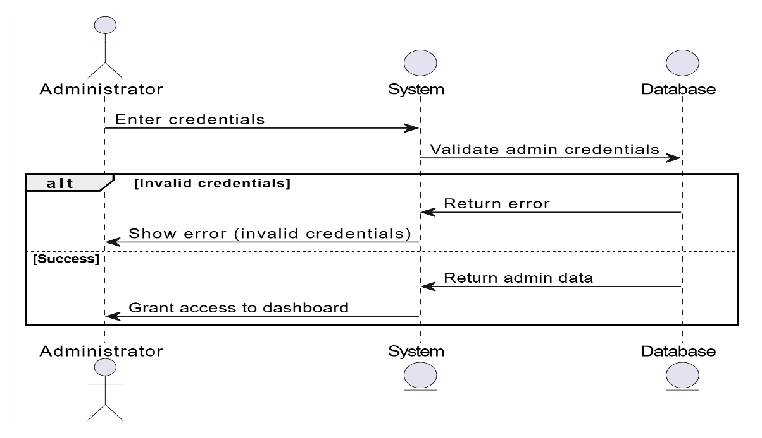

Figure 2.26: Sequence Diagram – Admin Update Academic Data

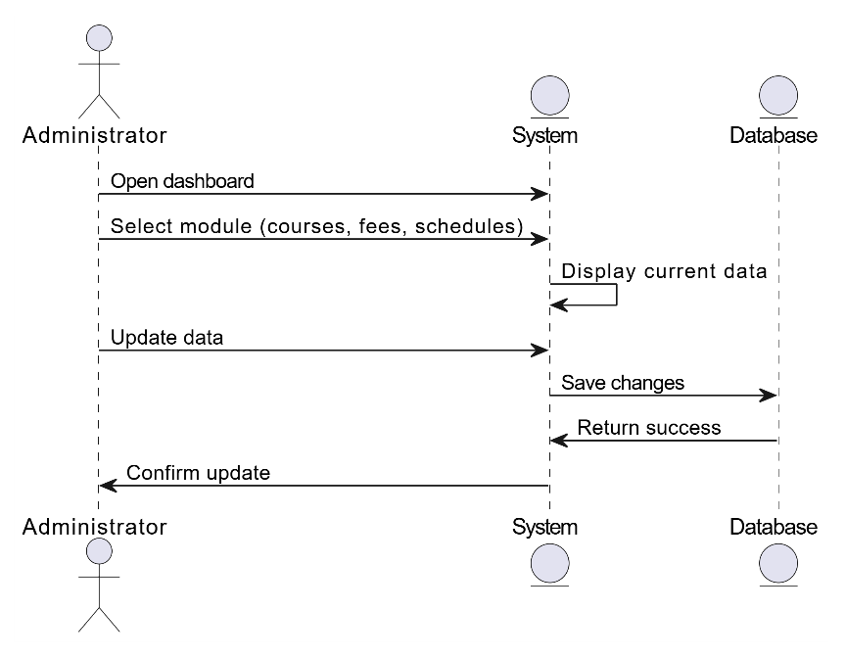
Figure 2.27: Sequence Diagram – Search Course by Name
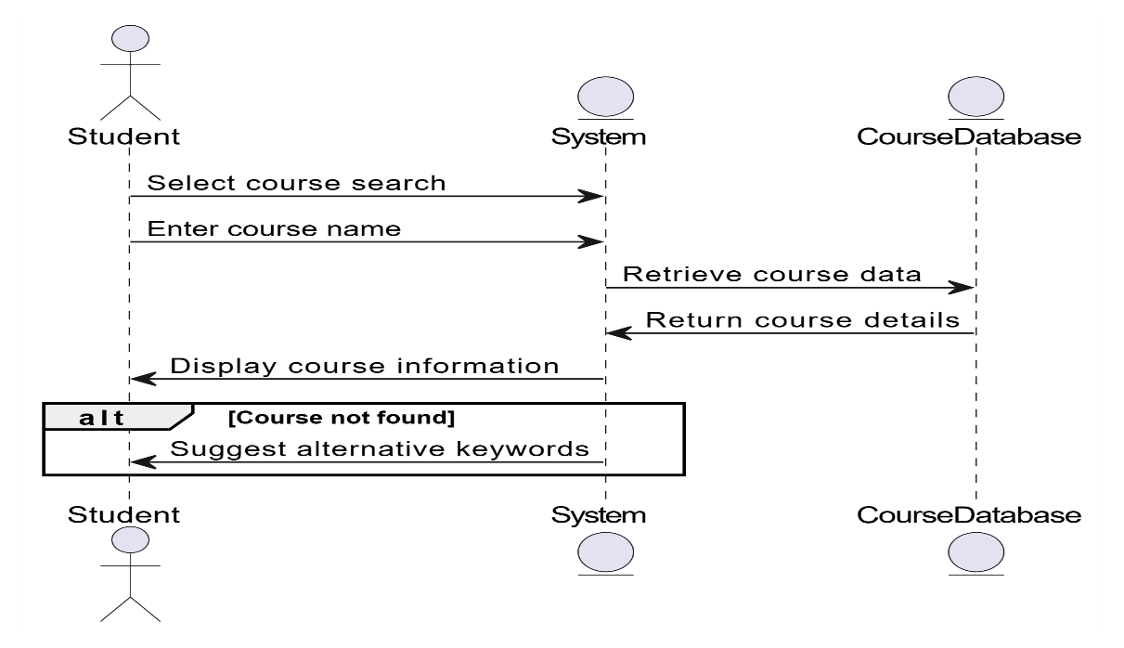

Figure 2.28: Sequence Diagram – Ask Policy / Fee / Timetable Information
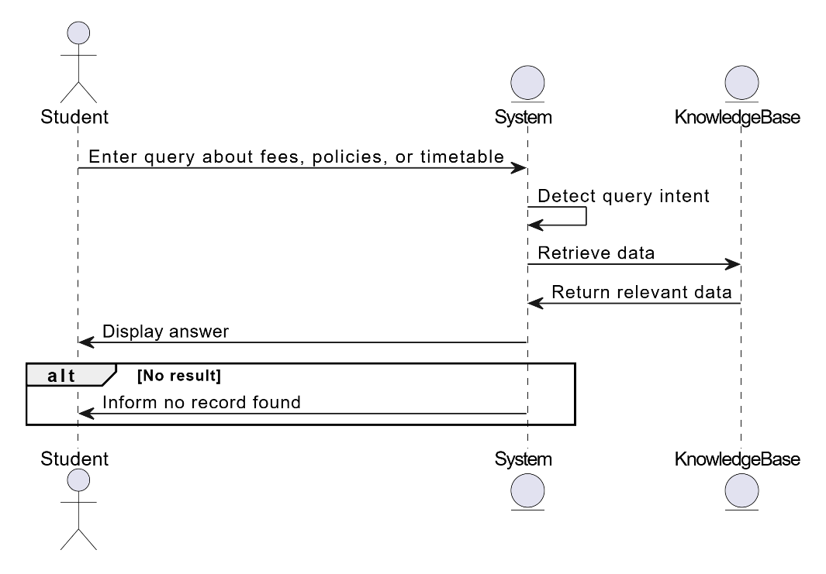

Figure 2.29: Sequence Diagram – Bilingual Query Input
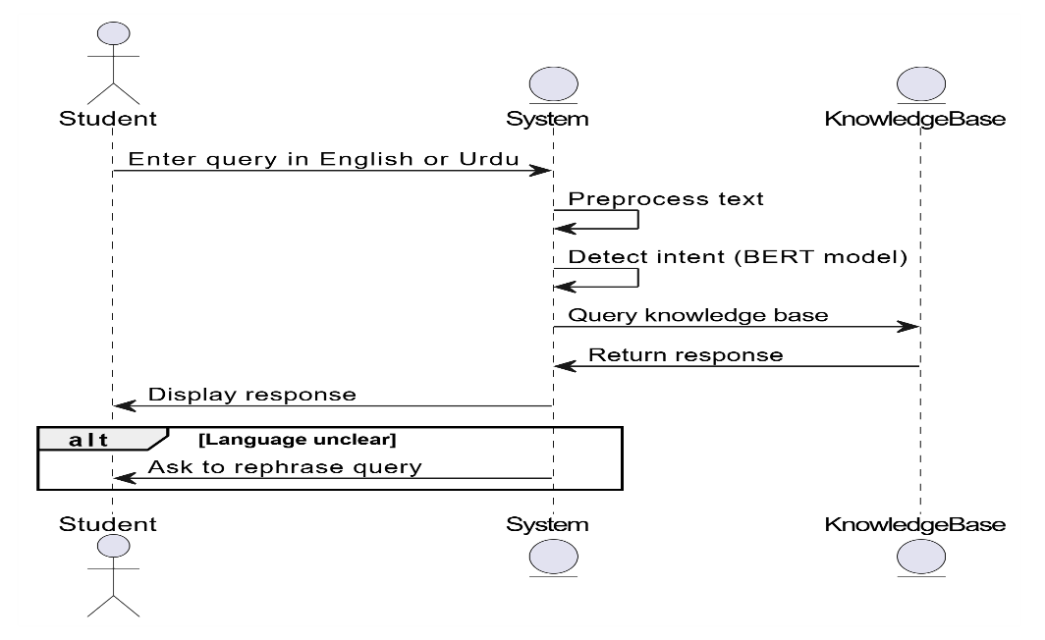

Figure 2.30: Sequence Diagram – Manage Course Information
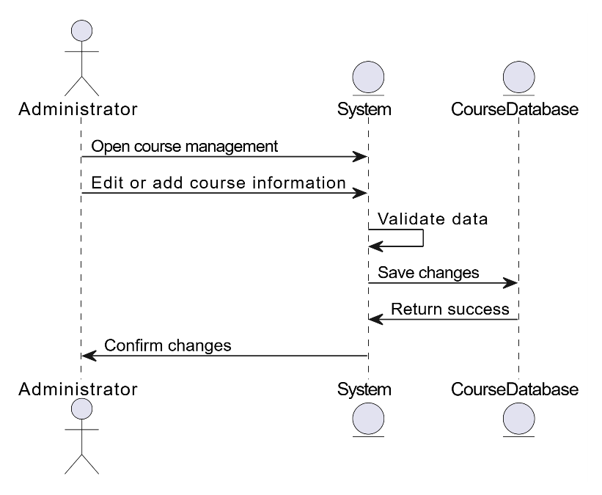
Figure 2.31: Sequence Diagram – Manage Fee Structure
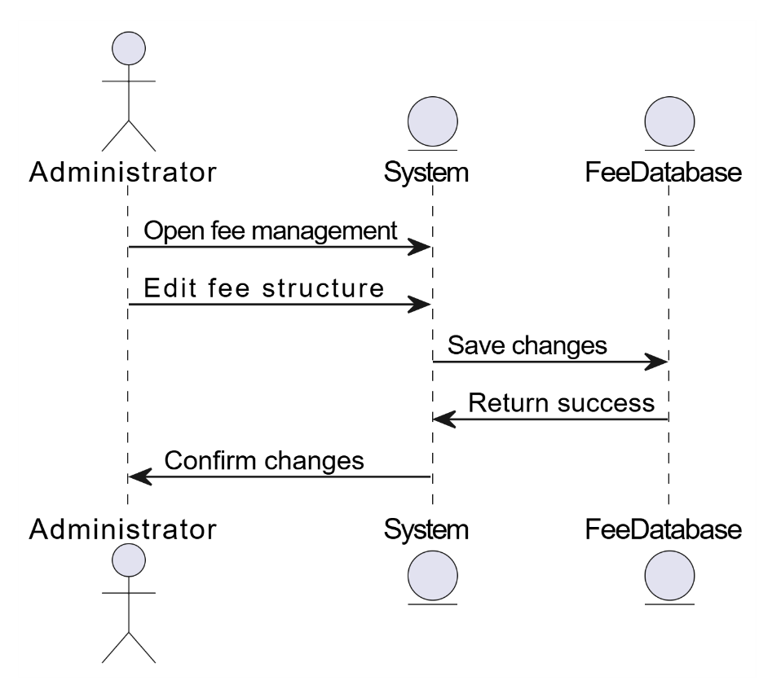

Figure 2.32: Sequence Diagram – Manage Timetables
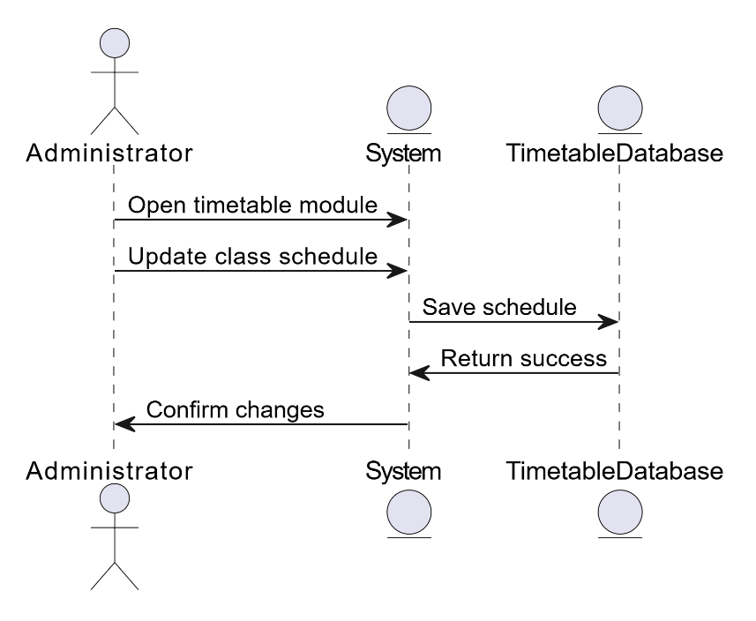
Figure 2.33: Sequence Diagram – Manage Policies & Guidelines
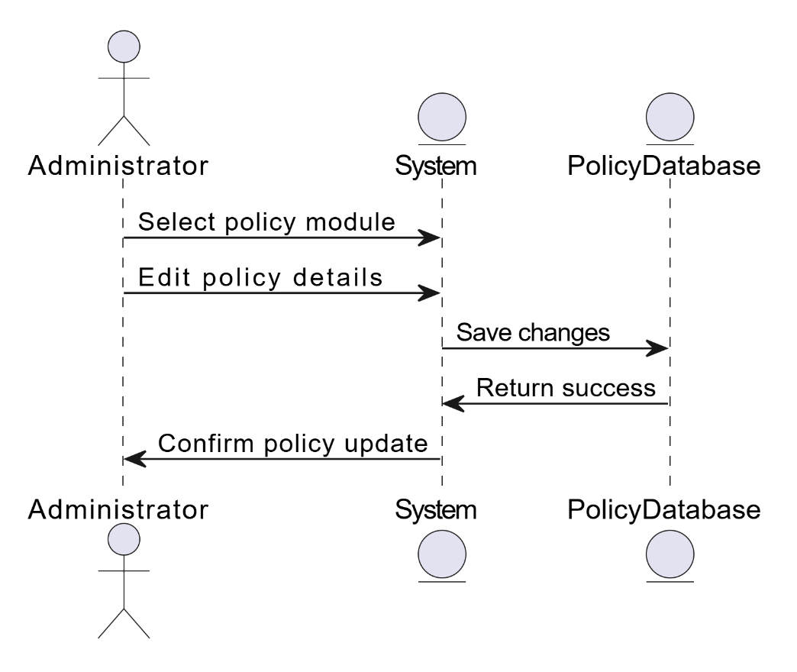

Figure 2.34: Sequence Diagram – View Student Query Logs
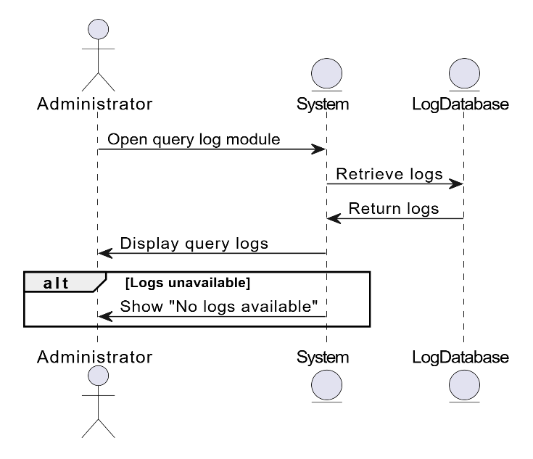

Figure 2.35: Sequence Diagram – Manage User Accounts
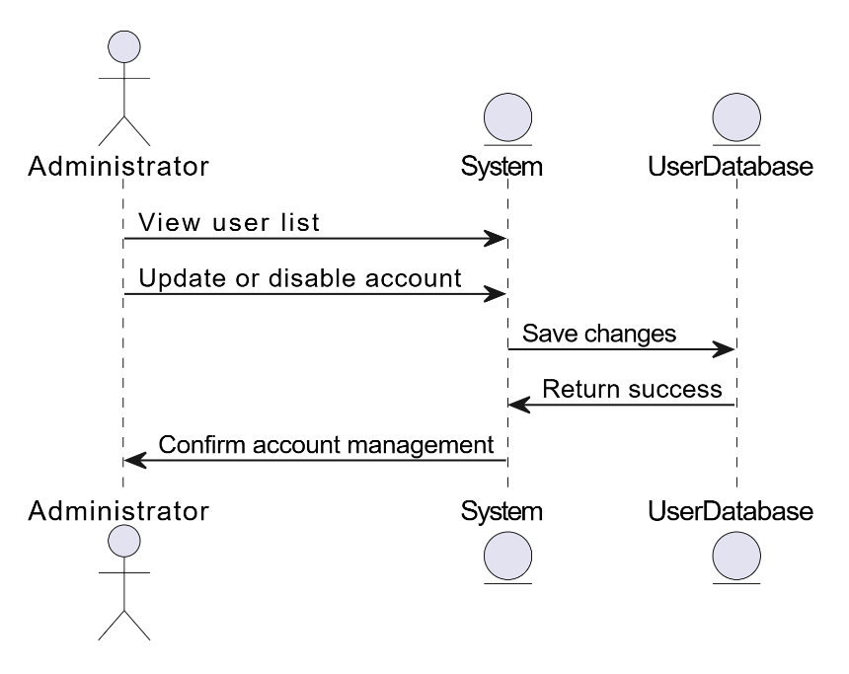

Figure 2.36: Sequence Diagram – Generate Reports
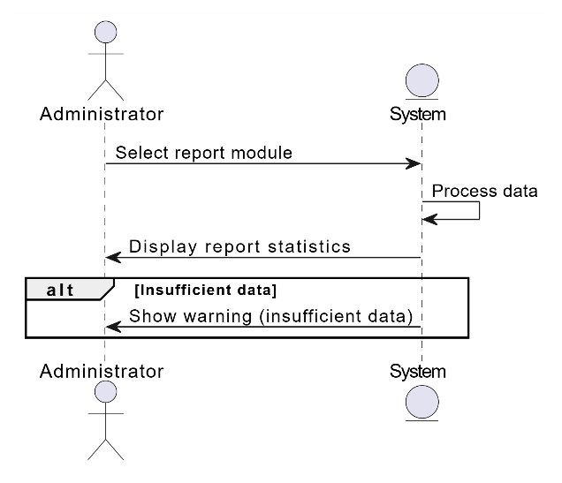
Figure 2.37 : Sequence Diagram – Admin Logout

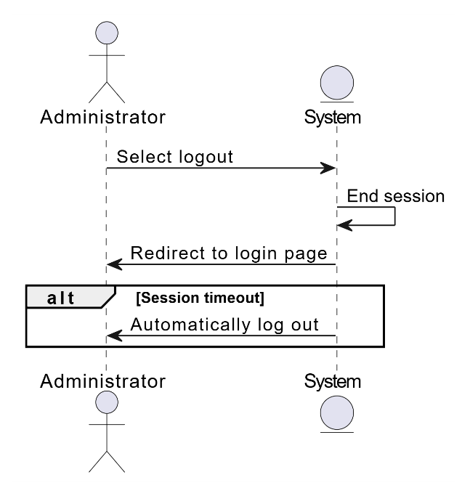

CHAPTER – 03

SOFTWARE DESIGN DESCRIPTION

3.1 Introduction
This chapter documents the implemented architecture and explains how the student portal, advisor engine, structured academic APIs, retrieval pipeline, language-model providers, administrative controls, and storage services cooperate to satisfy the requirements.

The architecture separates presentation, academic business rules, evidence retrieval, answer generation, and data governance. This separation allows official information to be updated without rebuilding the user interface and allows AI providers to change without changing the authoritative academic data.

Design Overview
- Academic Query Input: Streamed multilingual chat with follow-up context, stop, retry, copy, and feedback controls.
- Structured Academic Views: Study plans, courses, prerequisites, fees, policies, and timetable interfaces.
- Grounded Retrieval: Hybrid multilingual retrieval, metadata filters, reranking, citations, and safe abstention.
- Knowledge Governance: Official crawling, PDF/OCR ingestion, versions, review, checksums, publishing, and rollback.
- Private Conversation Handling: Ephemeral guest chat and owner-scoped authenticated history.
- Administration: Academic CRUD, CMS, timetable tools, provider controls, analytics, logs, notices, and feedback.
- Deployment and Security: Docker, Nginx, health checks, rate limits, session security, sanitization, and retention cleanup.

How Components Interact
A browser request first reaches the React portal through Nginx. Structured views call the portal FastAPI service and PostgreSQL/pgvector database. Conversational requests are streamed to the advisor FastAPI service, which resolves identity, checks rate limits, detects context and language, retrieves and reranks official evidence, and asks the configured provider to generate a constrained answer. The response is validated, streamed with citations, and recorded according to the user's privacy mode. Administrators use protected APIs to manage academic data, documents, knowledge snapshots, timetables, provider settings, notices, analytics, and feedback.

Requirements Traceability Matrix

Requirements Traceability Matrix (RTM) for AI-Powered Chat-Based Academic Advisor
Requirement ID | Requirement Name | Interface | Test Case | Use Case
FR-01 | Student Registration, Login, and Guest Access | Portal / Sign-in | Validate auth and ephemeral guest flow | UC-01/02
FR-02 | Multilingual Input | Chat | English, Urdu, and Roman Urdu | UC-10
FR-03 | Streaming Academic Query | Chat | SSE status, delta, stop, and retry | UC-03
FR-04 | Grounded Answer and Citations | Chat / Sources | Answer uses only retrieved evidence | UC-04/19
FR-05 | Private Conversation History | History | Owner isolation, retrieval, and deletion | UC-05/25
FR-06 | Study Plan and Programme Data | Study Plan | Programme, semester, and credit totals | UC-08
FR-07 | Course and Prerequisite Guidance | Courses / Chat | Exact code, chain, and safe eligibility | UC-08
FR-08 | Fees, Policies, and Deadlines | Academic Views | Date/source status and safe fallback | UC-09
FR-09 | Timetable and Examination Search | Timetable / Chat | Course, teacher, room, day, and term | UC-09
FR-10 | Answer Feedback | Chat | Owned vote create/update/delete | UC-20
FR-11 | Administrator Authentication | Admin Sign-in | Lockout, token expiry, logout | UC-06/18
FR-12 | Analytics and Query Review | Admin Dashboard | Counts, outcomes, latency, languages | UC-15/17
FR-13 | Academic Data Management | Admin Modules | Course, prerequisite, fee, policy CRUD | UC-07/11/12
FR-14 | Knowledge CMS | Admin CMS | Entry validation, activation, and cache clear | UC-14
FR-15 | Document Ingestion | Admin Knowledge | Upload, remove, crawl, OCR, provenance | UC-21
FR-16 | Knowledge Version and Rollback | Admin Knowledge | Build, publish, list, and restore | UC-21/22
FR-17 | AI Provider Configuration | Admin AI | Ollama/Gemini settings and verification | UC-23
FR-18 | Timetable Administration | Admin Timetable | CRUD, import/export, undo, reset | UC-13/24
FR-19 | Security and Privacy Controls | All interfaces | Rate limits, sanitization, retention | UC-25
FR-20 | Deployment and Health | Operations | Docker services and health/readiness | UC-26
Table 3.1: Requirements Traceability Matrix (RTM)

3.2 System Architecture Design
The implemented system uses a service-oriented layered architecture. The React portal and advisor interface form the presentation layer. Nginx routes frontend, portal API, and advisor streaming traffic. FastAPI services implement authentication, academic business logic, retrieval, chat, and administration. PostgreSQL/pgvector stores structured portal data and vector-ready records, while the advisor engine maintains its runtime database, source snapshots, and retrieval indexes.

3.2.1 Chosen System Architecture
The implemented system is organized into the following coordinated layers:
- Presentation Layer
- Application Layer
- NLP Processing Layer
- Data Layer

1. Presentation Layer

Overview
The presentation layer consists of React and Vite interfaces for sign-in, guest or authenticated chat, history, study plans, courses, fees, policies, timetables, and administration.

Functionality
• Students may register/sign in through the portal or continue as guests. • Students can ask English, Urdu, and Roman Urdu questions. • Signed-in students receive private history and feedback controls. • Administrators receive role-protected operational interfaces.

Technologies Used
• React 19 • Vite • HTML5 and CSS • DOMPurify and Markdown rendering

2. Application Layer

Overview
The application layer is implemented with FastAPI services. It handles identity, academic APIs, deterministic rules, conversation ownership, streaming, feedback, analytics, administration, and communication with retrieval and storage services.

Functionality
• Processes registration, authentication, guest access, and admin sessions.
• Serves structured programme, course, prerequisite, fee, policy, and timetable requests.
• Streams chat requests to the advisor service and preserves permitted follow-up context.
• Retrieves structured records and official documentary evidence.
• Produces source-backed answers, citations, safe fallback responses, and feedback targets.
• Maintains owner-scoped history, query outcomes, latency statistics, and privacy-aware logs.

Technologies Used
• Python 3.12 • FastAPI • REST/JSON • Server-Sent Events • Pydantic validation

3. NLP Processing Layer

Overview
This layer detects language and request scope, expands academic aliases, retrieves lexical and semantic candidates, applies programme/cohort/date filters, reranks evidence, and prepares bounded context for grounded generation.

Functionality
• English, Urdu, and Roman Urdu handling • follow-up context • entity and intent analysis • hybrid retrieval • metadata filtering • cross-encoder reranking • evidence validation

Technologies Used
• multilingual-e5-small embeddings • cross-encoder/mmarco-mMiniLMv2-L12-H384-v1 reranker • deterministic academic rules • configurable Ollama/Qwen and Gemini generation

4. Data Layer

Overview
The data and governance layer stores structured academic records, identity data, conversations, feedback, query analytics, knowledge documents, source versions, published retrieval snapshots, runtime settings, timetable corrections, and audit information.

Functionality
• PostgreSQL stores portal accounts and structured academic records. • pgvector supports vector-ready retrieval data. • The advisor runtime database stores settings, sessions, conversations, feedback, and analytics. • Filesystem snapshots store source archives and versioned retrieval indexes.

Technologies Used
• PostgreSQL 16 with pgvector • SQLite advisor runtime database • versioned source archive and retrieval bundles • encrypted secrets and checksummed snapshots

3.3 Architectural Diagram
Figure 3.1 presents the implemented flow from React interfaces through Nginx and FastAPI services to structured data, official-source retrieval, grounded generation, citations, and governance controls.

Figure 3.1: Architecture Diagram of Academic Advisor
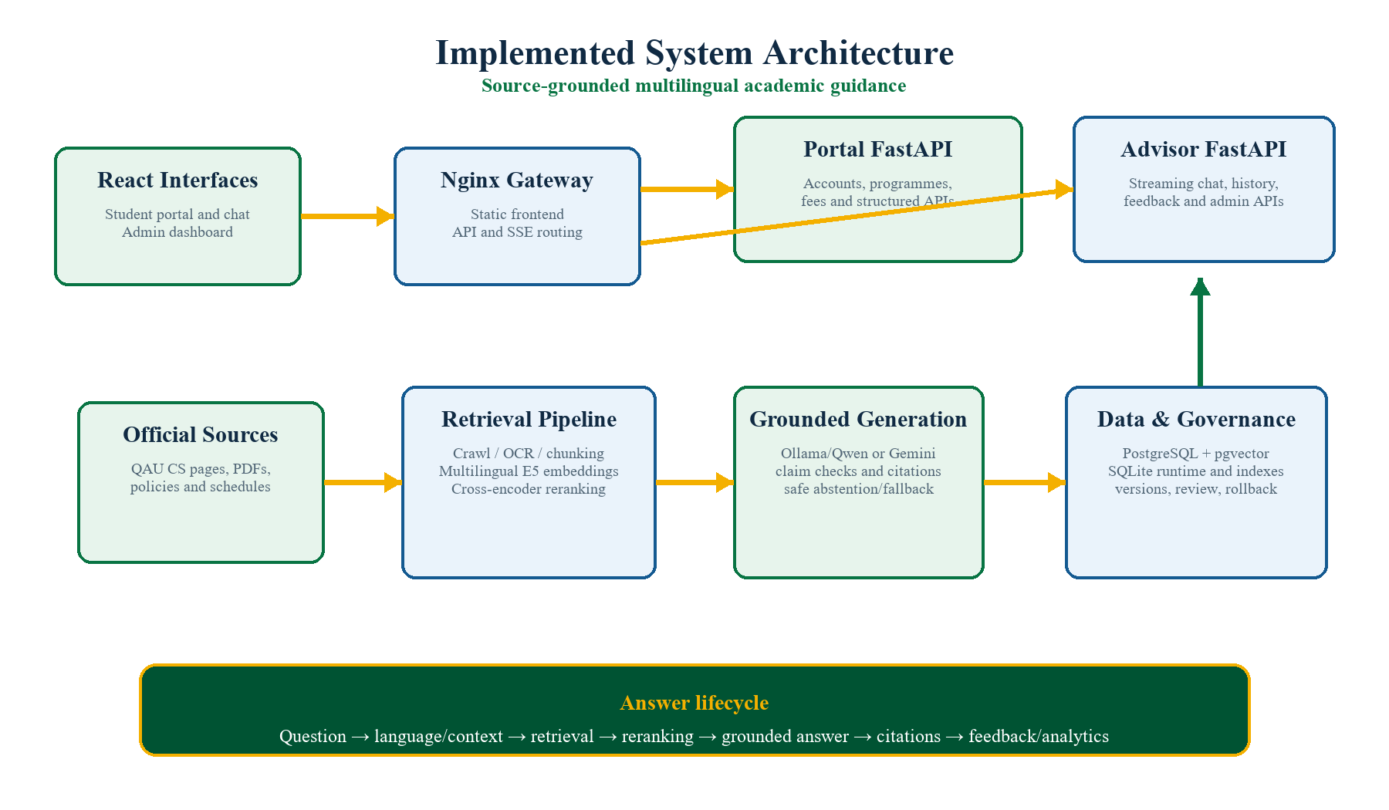
Figure 3.1: Architecture Diagram of AI-Powered Chat-Based Academic Advisor

3.4 Class Diagram
The implemented logical model includes identity and admin sessions; conversations, messages, feedback, and query logs; programmes, courses, prerequisites, fees, policies, and timetables; knowledge documents, source versions, chunks, citations, build snapshots, and runtime configuration.

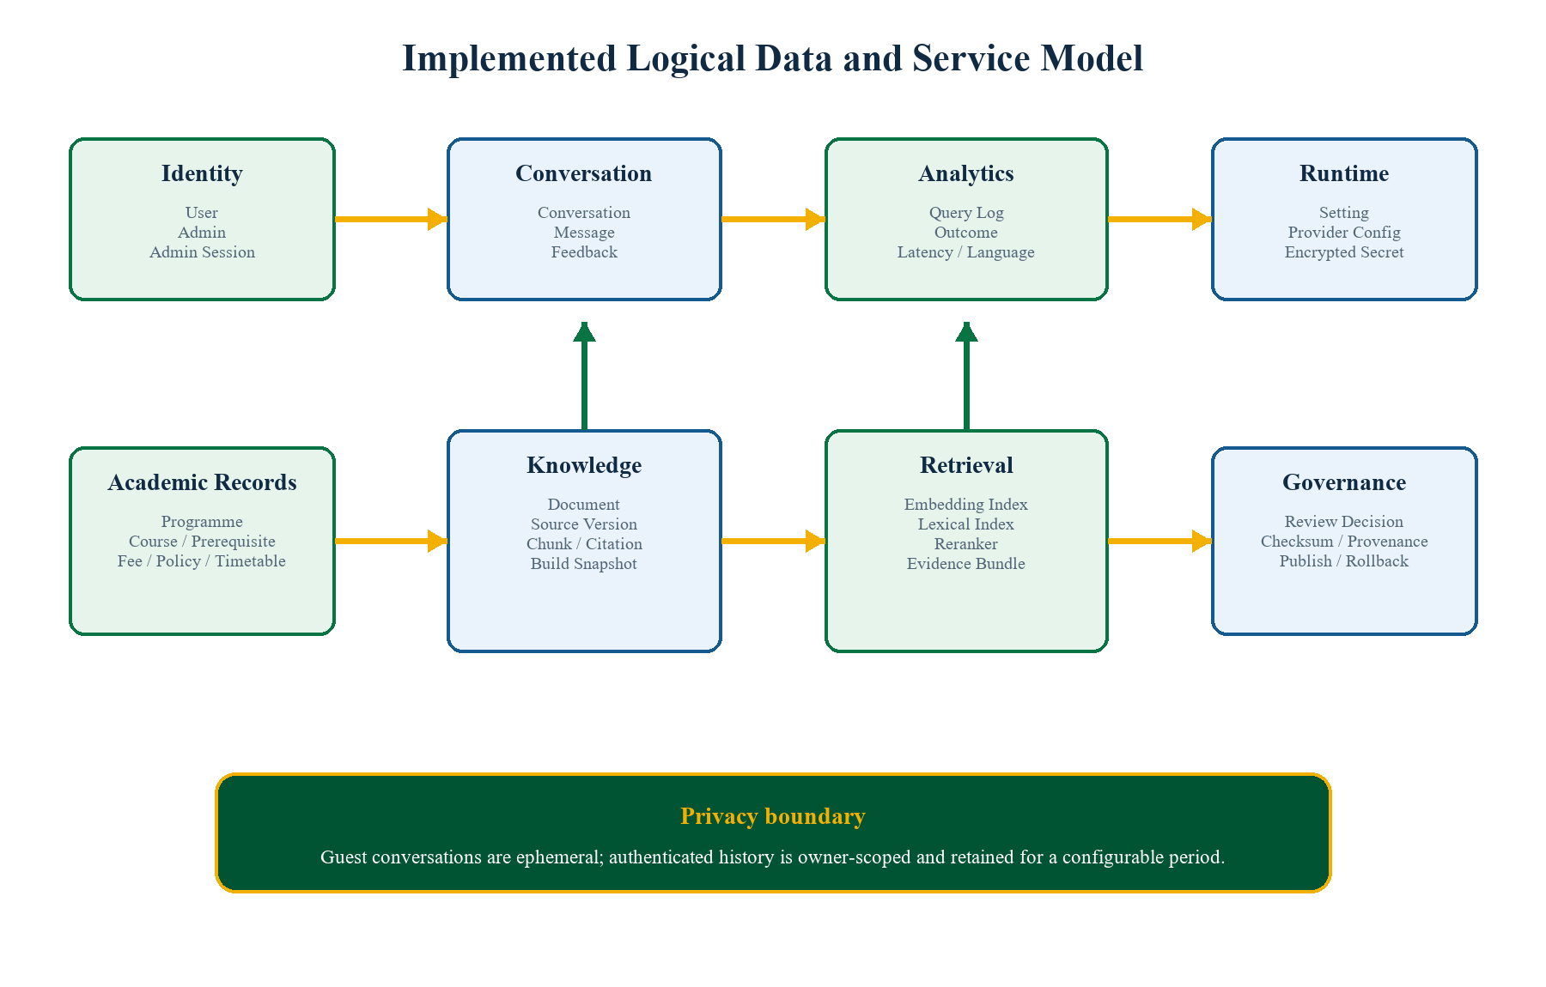
Figure 3.2: Class Diagram of AI-Powered Chat-Based Academic Advisor

3.5 Component Description
Component | Description | Technologies
Student Portal and Chat | Responsive academic views, guest/authenticated chat, private history, citations, and feedback | React 19, Vite, CSS, DOMPurify
Gateway | Serves the portal and routes API and unbuffered streaming traffic | Nginx
Portal API | Accounts, structured academic records, rules, CMS, and portal administration | Python, FastAPI, PostgreSQL
Advisor API | Streaming chat, identity bridge, conversations, feedback, analytics, and advisor administration | Python, FastAPI, SSE
Language and Context | English/Urdu/Roman Urdu detection, intent, entities, aliases, and follow-up scope | Python NLP and deterministic routing
Retrieval Pipeline | Hybrid search, metadata filters, multilingual embeddings, reranking, and evidence packaging | multilingual-e5-small, cross-encoder
Grounded Generator | Constrained answer generation, citations, numerical checks, abstention, and fallback | Ollama/Qwen or Gemini
Structured Academic Store | Programmes, courses, prerequisites, fees, policies, timetables, and user data | PostgreSQL 16 and pgvector
Advisor Runtime Store | Sessions, settings, conversations, feedback, logs, timetable edits, and indexes | SQLite and versioned files
Ingestion and Review | Official crawl, PDF extraction, OCR, versions, checksums, review, publish, and rollback | HTTPX, BeautifulSoup, PDF tools, Tesseract
Administration | Academic CRUD, CMS, timetable tools, providers, notices, analytics, feedback, and account security | React and protected FastAPI endpoints
Table 3.2: Component Description

s

3.6 Activity Diagrams
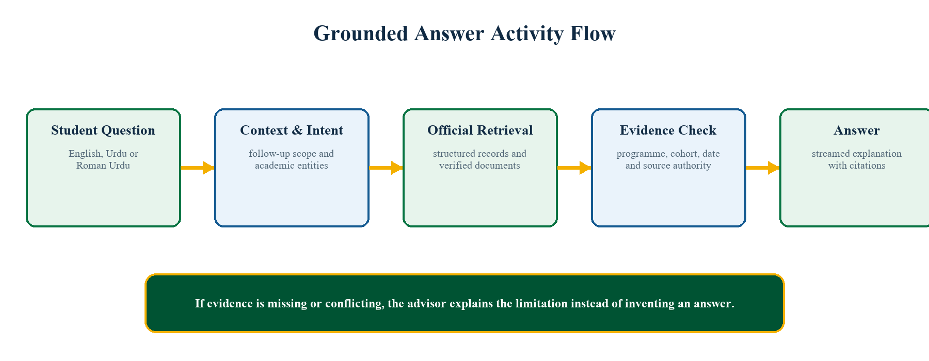
Figure 3.3: Combined Activity Diagram of AI-Powered Chat-Based Academic Advisor

3.7 Interface/Screen Design

3.7.1 Secure Login and Guest Access
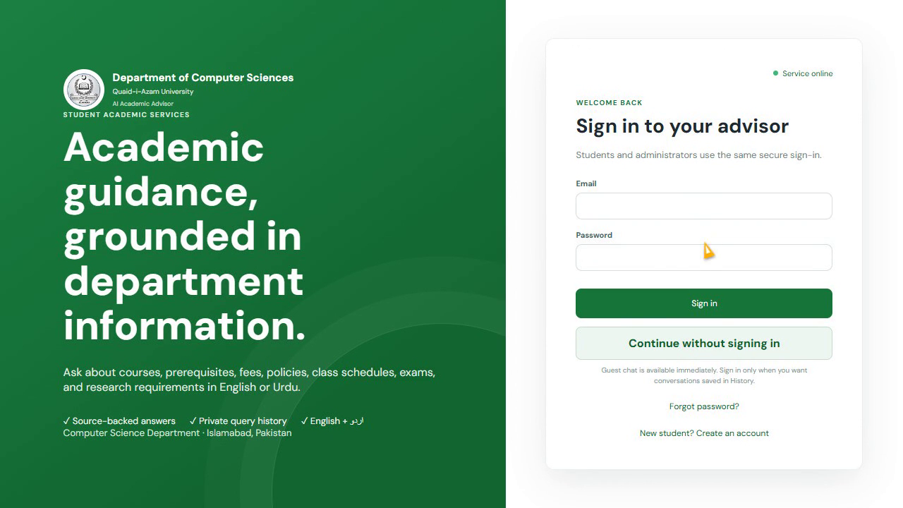

3.7.2 Grounded Chat with Source Citations
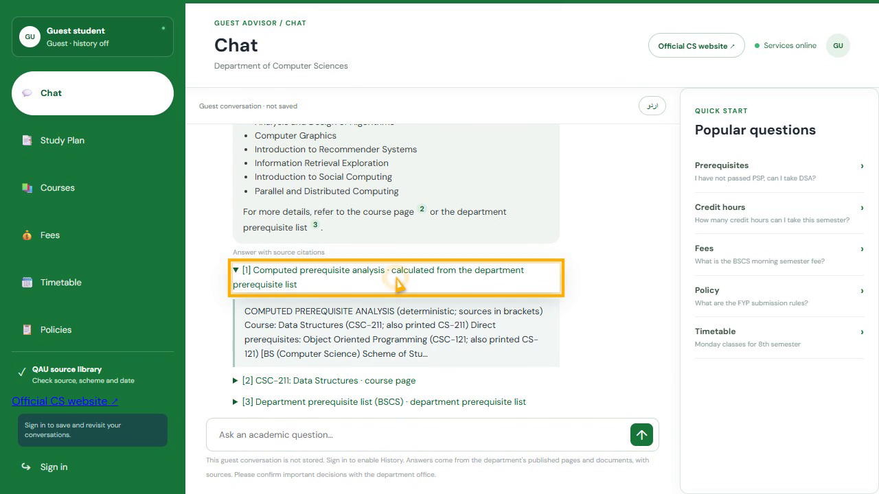

3.7.3 Verified Study Plan
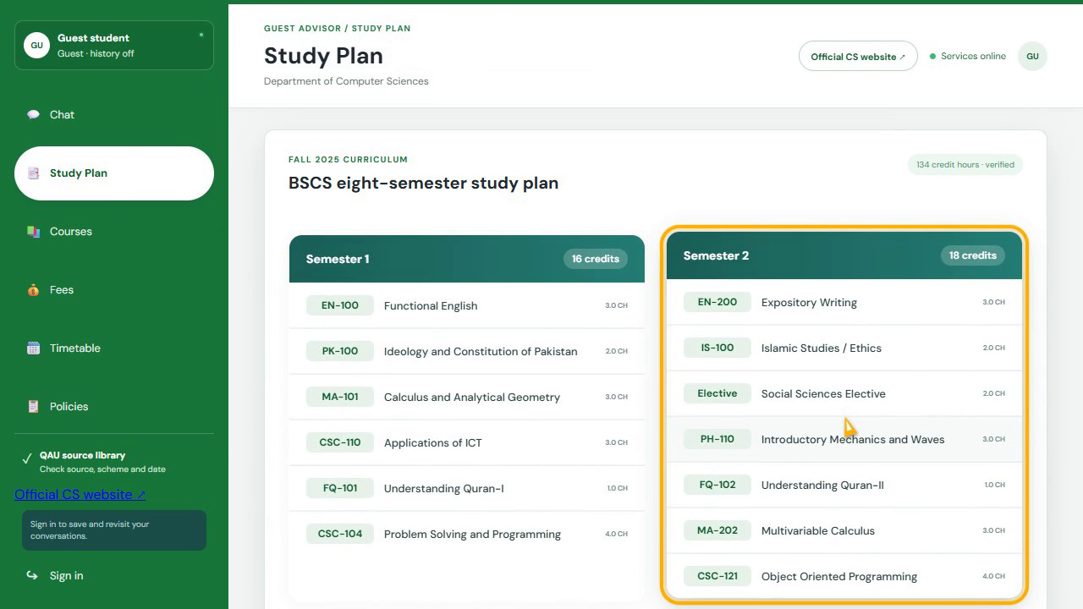

3.7.4 Admin Dashboard and Academic Operations

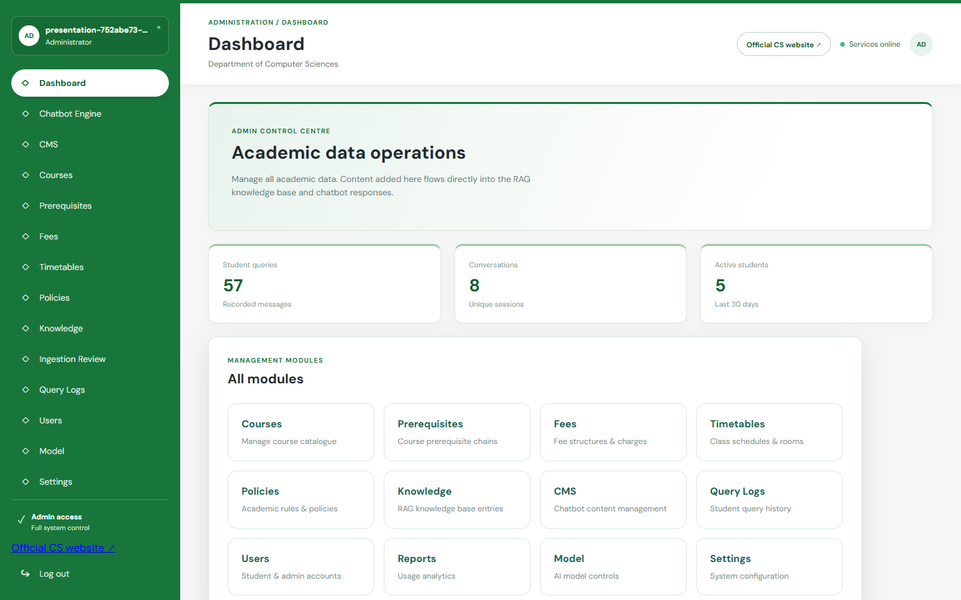

3.7.5 Admin CMS and Knowledge Management
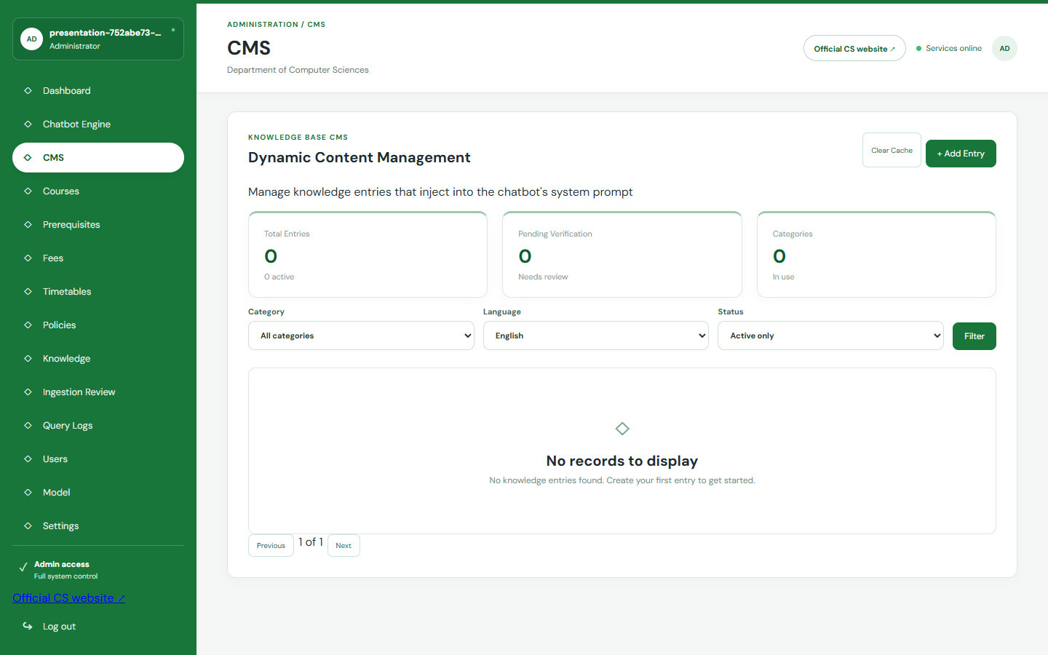

3.7.6 Admin Analytics and Model Controls
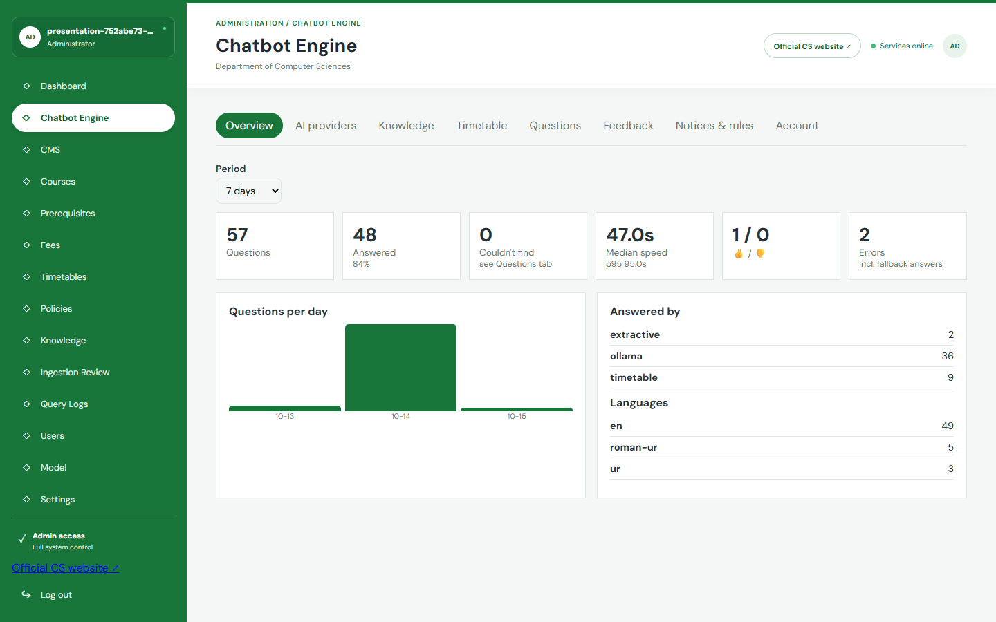

3.8 Security, Privacy, and Knowledge Governance
• Administrator passwords are stored as secure hashes; failed sign-ins trigger temporary lockout, and administrator sessions expire and can be revoked.
• API rate limits, bounded input lengths, strict validation, CORS controls, security headers, and sanitized Markdown reduce abuse and unsafe rendering.
• Guest chats may be processed ephemerally. Authenticated conversations and feedback are checked against the owner identity, and retention cleanup removes old records.
• Only allow-listed official hosts are crawled. Redirects, robots rules, document limits, checksums, source versions, and review state are preserved for auditability.
• Knowledge builds are published as snapshots. Administrators can inspect source coverage, refresh the index, invalidate caches, and roll back to a previous build.

3.9 Summary
This chapter documented the implemented service architecture, logical data model, grounded-answer activity flow, concrete technologies, component responsibilities, and current student and administrator interfaces.

CHAPTER: 04

SOFTWARE TEST DOCUMENTATION

4.1 Introduction
In this chapter, one can learn about the testing plan of the AI-Powered Chat-Based Academic Advisor of the Computer Science Department at Quaid-i-Azam University (QAU). Testing is intended to ensure that the system is functioning as per the needs that were identified in the previous chapters and has the ability to offer quality academic assistance to the students. Because the project is founded on a chatbot, which will answer academic questions, it is not only essential to test the basic functions of a software (e.g., the ability to log in and register), but also to test the query processing, information search, bilingual input processing, and administration functions.
The process of testing is supposed to verify that the system gives appropriate answers, the invalid inputs are handled and the system is able to continue to be used by students, as well as, administrators.

4.1.1 System Overview
The AI-Powered Chat-Based Academic Advisor is an academic support web-based platform created in the Computer Science Department of Quaid-i-Azam University. The students can communicate with a chatbot and see the information concerning the courses, prerequisites, fee structure, class schedules, academic regulations, and thesis structures.
The implemented system uses structured academic APIs and a multilingual retrieval-augmented generation pipeline. It combines lexical and semantic retrieval, evidence reranking, deterministic academic rules, configurable Ollama/Qwen or Gemini generation, citations, and safe fallback behavior. The student portal and protected administration panel are integrated through FastAPI services.

4.1.2 Test Approach
Testing basically focuses on verifying functional behavior of all the major use cases of the system. Both functional testing and selected non-functional testing are considered. The main goal is to ensure that our sytem responds correctly, handles invalid input safely, and performs reliably under normal usage conditions.
Testing combines automated Python unit and integration tests, React component tests, browser end-to-end tests, API checks, multilingual evaluation data, database verification scripts, and focused manual validation of the user and administrator journeys.

4.1.3 Features to be Tested
- Student Registration (UC1)
- Student Login (UC2)
- Ask Academic Query (UC3)
- View Chatbot Response (UC4)
- View Query History (UC5)
- Admin Login (UC6)
- Admin Update Academic Data (UC7)
- Search Course by Name (UC8)
- Ask Policy / Fee / Timetable Information (UC9)
- Bilingual Query Input (UC10)
- Manage Course Information (UC11)
- Manage Fee Structure (UC12)
- Manage Timetables (UC13)
- Manage Policies & Guidelines (UC14)
- View Student Query Logs (UC15)
- Manage User Accounts (UC16)
- Generate Reports (UC17)
- Admin Logout (UC18)

4.1.4 Features Not to be Tested
- Heavy Load and Stress Testing
- Advanced Security Penetration Testing
- Cross-Browser Legacy Support
- Long-Term Monitoring

4.2 Testing Tools and Environment

Environment
• Windows/Linux development environment • React/Vite web clients • FastAPI services • PostgreSQL/pgvector and advisor runtime storage • Ollama or configured remote provider • Docker Compose and Nginx

Tools
• Pytest • Vitest and Testing Library • Playwright • Postman/API inspection • SQL verification scripts • browser responsive checks • multilingual evaluation datasets

4.3 Test Cases

4.3.1 Test Case: Student Registration (UC1)
TEST ID | T-01
USE CASE | UC1 – Student Registration
PURPOSE | Verify that a new student can create an account successfully
PRE-CONDITIONS | Student is not already registered. Registration page is accessible.
POST-CONDITIONS | Student account is created and stored in the system.

TEST SCENARIO | TEST DATA | EXPECTED OUTPUT
Valid: Register with correct details | Name: “Ali Khan”, Email: “ali@example.com”, Password: “Password123” | Account created successfully and redirect to login
Invalid: Existing email | Email already stored in database | Error message: “Email already registered”
Invalid: Password too short | Password: “123” | Error message: “Password must be at least 6 characters”
Invalid: Password mismatch | Password and confirm password do not match | Error message shown
Invalid: Empty fields | All fields empty | Error message: “All fields are required”

4.3.2 Test Case: Student Login (UC2)
TEST ID | T-02
USE CASE | UC2 – Student Login
PURPOSE | Verify that registered students can log in successfully
PRE-CONDITIONS | Student account exists
POST-CONDITIONS | Student is authenticated and redirected to dashboard

TEST SCENARIO | TEST DATA | EXPECTED OUTPUT
Valid: Correct login | Registered email and password | Login successful
Invalid: Wrong password | Correct email, wrong password | Error message: “Invalid email or password”
Invalid: Unregistered email | Unknown email | Error message: “Account does not exist”
Invalid: Empty fields | Empty input | Error message asking to enter credentials

4.3.3 Test Case: Ask Academic Query (UC3)
TEST ID | T-03
USE CASE | UC3 – Ask Academic Query
PURPOSE | Verify that student queries are processed correctly
PRE-CONDITIONS | Student is logged in
POST-CONDITIONS | System retrieves and displays academic answer

TEST SCENARIO | TEST DATA | EXPECTED OUTPUT
Valid: Course prerequisite query | What are the prerequisites for data structure? | Correct information displayed
Valid: Credit hour query | How many credit hours a student can take in a semester | Relevant data to be displayed
Invalid: Unclear query | Tell me that thing | System asks students to rephrase
Invalid: Unknown topic | Query unrelated to available data | Output of system No relevant information found

4.3.4 Test Case: View Chatbot Response (UC4)
TEST ID | T-04
USE CASE | UC4 – View Chatbot Response
PURPOSE | To check our system responses are shown correctly
PRE-CONDITIONS | Query has processed
POST-CONDITIONS | Academic data or answer to be displayed

TEST SCENARIO | TEST DATA | EXPECTED OUTPUT
Valid: Successful answer display | Returned chatbot text | Response to be seen on system chat window
Valid: Multi-line response | Long explanation | Maintain proper formatting
Invalid: Empty response | missing backend response | Error message shown

4.3.5 Test Case: View Query History (UC5)
TEST ID | T-05
USE CASE | UC5 – View Query History
PURPOSE | Verify that students can view previous queries
PRE-CONDITIONS | Student is logged in and history exists
POST-CONDITIONS | Query history is displayed

TEST SCENARIO | TEST DATA | EXPECTED OUTPUT
Valid: Existing history | Student with saved records | Previous queries and responses displayed
Invalid: No history | New user | Message: “No history found”
Invalid: Database error | History retrieval fails | Error message shown

4.3.6 Test Case: Admin Login (UC6)
TEST ID | T-06
USE CASE | UC6 – Admin Login
PURPOSE | Verify that administrator can log in securely
PRE-CONDITIONS | Admin account exists
POST-CONDITIONS | Admin enters dashboard

TEST SCENARIO | TEST DATA | EXPECTED OUTPUT
Valid: Correct admin credentials | Valid admin email and password | Dashboard access granted
Invalid: Wrong credentials | Incorrect password | Access denied
Invalid: Empty fields | No credentials entered | Validation error message

4.3.7 Test Case: Admin Update Academic Data (UC7)
TEST ID | T-07
USE CASE | UC7 – Admin Update Academic Data
PURPOSE | Check admin can update academic records
PRE-CONDITIONS | Admin logged in
POST-CONDITIONS | Academic data updated successfully

TEST SCENARIO | TEST DATA | EXPECTED OUTPUT
Valid: Update course info | New course title added | Course title successfully
Valid: Update fee info | fee structure updated | Fee structure updated
Invalid: Missing required field | Incomplete academic data entry | error shown

4.3.8 Test Case: Search Course by Name (UC8)
TEST ID | T-08
USE CASE | UC8 – Search Course by Name
PURPOSE | Verify that course search works correctly
PRE-CONDITIONS | Student is logged in
POST-CONDITIONS | Course details displayed

TEST SCENARIO | TEST DATA | EXPECTED OUTPUT
Valid: Search by full course name | “Data Structures” | Correct course displayed
Valid: Search by course code | “CS-201” | Matching course data shown
Invalid: Unknown course | “ABC Course” | Message: “Course not found”
Invalid: Empty search | No input | Prompt to enter course name

4.3.9 Test Case: Ask Policy / Fee / Timetable Information (UC9)
TEST ID | T-09
USE CASE | UC9 – Ask Policy / Fee / Timetable Information
PURPOSE | Verify policy and schedule related question handling
PRE-CONDITIONS | Student is logged in
POST-CONDITIONS | Requested information displayed

TEST SCENARIO | TEST DATA | EXPECTED OUTPUT
Valid: Fee query | “What is the semester fee?” | Correct fee information shown
Valid: Timetable query | “Show class timetable for 6th semester” | Matching timetable displayed
Valid: Policy query | “What is the attendance policy?” | Relevant policy returned
Invalid: Unknown query | Policy not stored in system | “No record found” message

4.3.10 Test Case: Bilingual Query Input (UC10)
TEST ID | T-10
USE CASE | UC10 – Bilingual Query Input
PURPOSE | Check that system can process English and Urdu queries
PRE-CONDITIONS | Student is logged in
POST-CONDITIONS | Queries translated or response shown

TEST SCENARIO | TEST DATA | EXPECTED OUTPUT
Valid: English query | What are the prerequisites for AI? | answer shown correctly
Valid: Urdu query | AI ke prerequisites kya Hain? | answer shown correctly
Invalid: Mixed unclear input | Unclear multilingual sentence | System asks to rephrase

4.3.11 Test Case: Manage Course Information (UC11)

TEST ID | T-11
USE CASE | UC11 – Manage Course Information
PURPOSE | Verify admin can add, edit, and delete course data
PRE-CONDITIONS | Admin logged in
POST-CONDITIONS | Course records updated

TEST SCENARIO | TEST DATA | EXPECTED OUTPUT
Valid: Add course | New course entry | Course saved
Valid: Edit course | Updated prerequisite | Changes saved
Invalid: Missing fields | No course code/title | Validation error

4.3.12 Test Case: Manage Fee Structure (UC12)
TEST ID | T-12
USE CASE | UC12 – Manage Fee Structure
PURPOSE | Check whether admin can update fee information
PRE-CONDITIONS | Admin logged in
POST-CONDITIONS | Fee records updated

TEST SCENARIO | TEST DATA | EXPECTED OUTPUT
Valid: Edit fee structure | Updated semester fee | Saved successfully
Invalid: Incorrect amount format | Text instead of numeric value | Validation error

4.3.13 Test Case: Manage Timetables (UC13)
TEST ID | T-13
USE CASE | UC13 – Manage Timetables
PURPOSE | Verify admin can maintain timetable records
PRE-CONDITIONS | Admin logged in
POST-CONDITIONS | Timetable updated

TEST SCENARIO | TEST DATA | EXPECTED OUTPUT
Valid: Add timetable entry | Semester + course + timing | Timetable saved
Invalid: Invalid schedule format | Missing day/time info | Validation error

4.3.14 Test Case: Manage Policies & Guidelines (UC14)
TEST ID | T-14
USE CASE | UC14 – Manage Policies & Guidelines
PURPOSE | Verify admin can update policy data
PRE-CONDITIONS | Admin logged in
POST-CONDITIONS | Policy information updated

TEST SCENARIO | TEST DATA | EXPECTED OUTPUT
Valid: Add new policy | Attendance policy text | Policy saved
Invalid: Empty content | Blank policy field | Validation message

4.3.15 Test Case: View Student Query Logs (UC15)
TEST ID | T-15
USE CASE | UC15 – View Student Query Logs
PURPOSE | Verify admin can inspect query logs
PRE-CONDITIONS | Admin logged in
POST-CONDITIONS | Query logs displayed

TEST SCENARIO | TEST DATA | EXPECTED OUTPUT
Valid: View logs | Existing stored logs | Log table displayed
Invalid: No logs | Empty log table | Message indicating no records

4.3.16 Test Case: Manage User Accounts (UC16)
TEST ID | T-16
USE CASE | UC16 – Manage User Accounts
PURPOSE | Check whether admin can manage student accounts
PRE-CONDITIONS | Admin logged in
POST-CONDITIONS | account changes updated

TEST SCENARIO | TEST DATA | EXPECTED OUTPUT
Valid: Disable account | Select a account | updated
Valid: Edit account info | Update student record | Updated and saved
Invalid: Unauthorized action | Invalid admin access | Access denied

4.3.17 Test Case: Generate Reports (UC17)
TEST ID | T-17
USE CASE | UC17 – Generate Reports
PURPOSE | Verify admin can generate system reports
PRE-CONDITIONS | Admin logged in
POST-CONDITIONS | Report generated and shown

TEST SCENARIO | TEST DATA | EXPECTED OUTPUT
Valid: Generate usage report | Date range selected | Report displayed
Invalid: No data in range | Empty result set | Informative warning shown

4.3.18 Test Case: Admin Logout (UC18)
TEST ID | T-18
USE CASE | UC18 – Admin Logout
PURPOSE | Check logout functionality
PRE-CONDITIONS | Admin logged in
POST-CONDITIONS | Session terminated

TEST SCENARIO | TEST DATA | EXPECTED OUTPUT
Valid: Click logout | Active admin session | Redirect to login page
Valid: Session timeout | Inactive session | Automatic logout

4.4 Automated Verification and Evidence
• The repository contains 208 Python test functions covering health, authentication, multilingual intent handling, deterministic academic rules, RAG retrieval, evidence validation, citation integrity, ingestion, source versions, privacy, feedback, security boundaries, and production regression cases.
• The standalone advisor web client contains unit tests for streaming-event parsing, Unicode handling, citation rendering, table rendering, safe external links, HTML sanitization, and Urdu direction detection.
• Playwright browser tests cover the real streaming conversation, follow-up context, topic switching, mobile viewport behavior, timetable workflows, and portal integration.
• A final submission should attach the clean test execution output and environment versions. Static test inventory alone is not reported as a passing result; pass/fail claims must come from an executed clean run.

4.5 Limitations of Verification
• Heavy sustained-load testing, independent penetration testing, long-term production monitoring, and legacy-browser certification remain outside the present validation scope.
• Academic correctness depends on the authority, completeness, date, and programme scope of the available source documents; therefore, high-impact decisions must still be confirmed with the department.

4.6 Summary
This chapter described the manual and automated verification approach for the student portal, advisor engine, structured academic services, administration functions, multilingual processing, evidence pipeline, security boundaries, and responsive user interface.
The tests are designed to verify correct behavior, safe handling of invalid or unsupported requests, source and citation integrity, privacy isolation, administrative authorization, and reliable fallback when a dependency or evidence source is unavailable.
.

CHAPTER: 05

CONCLUSION

5.1 Conclusion
This project implemented an accessible, source-grounded academic advisor for the Department of Computer Sciences at Quaid-i-Azam University. It provides structured academic views and a multilingual conversational interface while reducing the effort required to locate information across departmental records, webpages, schedules, and policy documents.

The final system combines React interfaces, FastAPI services, PostgreSQL/pgvector, a versioned advisor retrieval engine, multilingual embeddings, cross-encoder reranking, deterministic academic rules, and configurable Ollama/Qwen or Gemini generation. Answers expose citations and verification context, while the administration panel supports academic data operations, document ingestion, knowledge refresh and rollback, timetable correction, provider settings, notices, analytics, feedback, and security controls.

The implementation includes automated and manual verification for multilingual queries, structured academic endpoints, prerequisite logic, retrieval relevance, citation integrity, data ingestion, privacy, feedback, security boundaries, responsive interfaces, and administrator workflows. The system remains an advisory aid: it deliberately avoids making binding academic decisions and directs students to confirm important matters with the department.

5.2 Current Limitations
• Accuracy is constrained by the completeness and currency of official source material. Some timetable, deadline, prerequisite, or operational records may require department-authorized updates.
• Language coverage is strongest for English and common Urdu or Roman Urdu academic phrasing; broader evaluation with real students is still required.
• Generated explanations are constrained by evidence but remain advisory. Binding eligibility, registration, fee, and policy decisions must be confirmed by authorized staff.
• Independent penetration testing, large-scale load testing, production monitoring, and a larger reviewed answer-quality benchmark remain future validation work.

5.3 Future Work
• Establish approved operational feeds for current timetables, examinations, deadlines, and prerequisite matrices.
• Expand the reviewed multilingual evaluation set and conduct usability studies with students and departmental staff.
• Add scheduled source-health monitoring, administrator notifications, and deployment observability dashboards.
• Evaluate additional local models and retrieval configurations for lower latency while preserving citation fidelity.
• Extend the governed architecture to other QAU departments after programme-specific data and approval processes are defined.

References
[1] J. Devlin, M.-W. Chang, K. Lee, and K. Toutanova, “BERT: Pre-training of Deep Bidirectional Transformers for Language Understanding,” in Proceedings of NAACL-HLT, 2019, pp. 4171–4186.
[2] T. Wolf et al., “Transformers: State-of-the-Art Natural Language Processing,” in Proceedings of the 2020 Conference on Empirical Methods in Natural Language Processing: System Demonstrations, 2020, pp. 38–45.
[3] J. Brownlee, Natural Language Processing with Python: Quick Start Guide for Beginners. Machine Learning Mastery, 2017.
[4] I. Sommerville, Software Engineering, 10th ed. Boston, MA, USA: Pearson, 2016.
[5] R. S. Pressman and B. R. Maxim, Software Engineering: A Practitioner’s Approach, 8th ed. New York, NY, USA: McGraw-Hill, 2015.
[6] D. Jurafsky and J. H. Martin, Speech and Language Processing. Draft online edition, Stanford University, 2023.

[7] P. Lewis et al., “Retrieval-Augmented Generation for Knowledge-Intensive NLP Tasks,” Advances in Neural Information Processing Systems, vol. 33, 2020.
[8] N. Reimers and I. Gurevych, “Sentence-BERT: Sentence Embeddings using Siamese BERT-Networks,” Proceedings of EMNLP-IJCNLP, 2019.
[9] L. Wang et al., “Multilingual E5 Text Embeddings: A Technical Report,” arXiv preprint arXiv:2402.05672, 2024.
[10] FastAPI Project, “FastAPI Documentation,” https://fastapi.tiangolo.com/.
[11] React Team, “React Documentation,” https://react.dev/.
[12] PostgreSQL Global Development Group, “PostgreSQL Documentation,” https://www.postgresql.org/docs/.
[13] pgvector Contributors, “pgvector: Open-source vector similarity search for PostgreSQL,” https://github.com/pgvector/pgvector.
[14] OWASP Foundation, “Application Security Verification Standard,” https://owasp.org/www-project-application-security-verification-standard/.

