**Search Engine**



**Description:**

* **Data Structures**
* **C++**

We want to design a small search engine that can help its users to retrieve documents related to the search query from a collection of documents. A search query is a collection of one or more words. A document is said to be related to the search query if it contains one or more query words. The idea is to examine all documents of the collection and output only those that contain the words from the search query. For example, if the search query has the word “velocity”, then we have to find all those documents that contain the word “velocity”.

The job of a search engine is to efficiently retrieve the set of desired documents and then rank them according to their relevance. To make things faster, an index of important terms/words is maintained. For each word in the index, a list is maintained that keeps the record of documents in which that term appears along with some other important information like term frequency, and list of positions where that word occurs.

**TF: Term Frequency,** which measures how frequently a term occurs in a document. TF(t,d)

= Number of times term t appear in document d

## EXAMPLE

Consider a small example below where we have following documents

**Doc 1** breakthrough drug schizophrenia drug released july

**Doc 2** new schizophrenia drug breakthrough drug

**Doc 3** new approach treatment schizophrenia

**Doc 4** new hopes schizophrenia patients schizophrenia cure

Unique terms are breakthrough, drug, schizophrenia, released, july, new, approach, treatment, hopes, patients, cure.

The index will be as follows: Terms will be stored in an AVL tree and for each term there is a list that contains document ID, and term frequency. See the following figure 1 for the structure of the index.

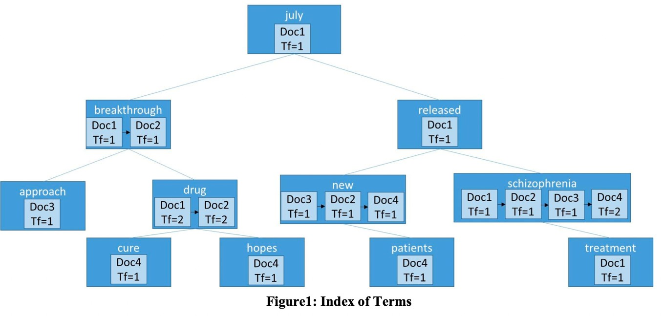

## IMPLEMENTATION

Task is to design a small search engine that can perform following functionality: **Create_Index:** Given the collection of documents, tokenize words in each document, compute their term frequencies and create the index. **Search_Documents:** Given the query word(s), output a ranked list of related documents using the following algorithm.

1. Input search query
2. Tokenize the text in the query
3. Remove stop words (of, for, the etc).
4. For each query term, search it in the index, collect the list of documents. If there is more than one word in the query, take the union of all the lists.
5. Rank the retrieved documents.

The ranking function works according to the following rules.

**Rule1:** Documents containing more query terms must be ranked higher than the documents containing lesser query terms. **Rule2:** If two documents have the same number of query terms then rank the document higher that has higher collective term frequency. **Rule3:** If two documents have the same number of query terms and the same collective term frequency then rank the document alphabetically by Doc ID

Suppose you are given this Query= “drug schizophrenia”

Word *drug* occurs in Doc1 and Doc2. *Schizophrenia* occurs in Doc1, Doc2, Doc3, and Doc4. Doc1 and Doc 2 will be ranked higher than Doc3 and Doc4 because of *Rule1*. Doc 4 will be ranked higher than Doc3 because of *Rule2* as Doc4 has high term frequency. (Term “schizophrenia” occurs 2 times in Doc4 and occurs one time in Doc3)

Doc1 will be ranked higher than Doc2 because the number of query terms in both documents is the same i.e. 2. Also the collective term frequency is 3 in both documents so using *Rule3* Doc1 will be ranked higher.

The final ranked document will be Doc1

Doc2

Doc4 Doc3

**Add_Doc_to_Index:** Given a new document (DOC ID and the text), tokenize its words, compute their term frequencies. If a word is already present in the index, add the Doc ID and computed term frequency at the end of the corresponding list. Otherwise add the new word in the AVL tree. For example if we have to add a new document:

“Doc5 miracle drug” to the index shown in Figure1, then updated index will be as follows:

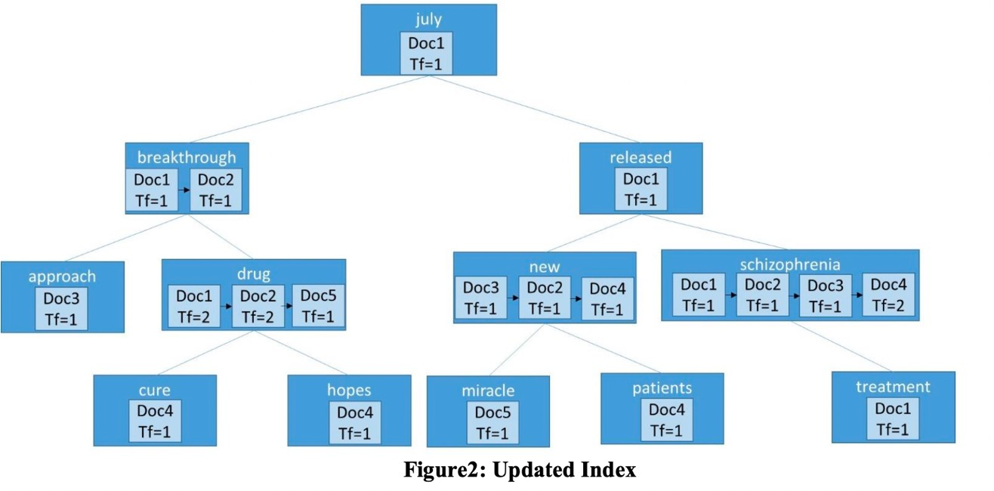

**Important Note:** For simplicity, you can assume that all the documents and query do not contain any stop word and all words are separated by white space.

## IMPORTANT CLASSES

You have to implement the following classes

## Class List

Create List class that must have the following data members: head, tail, and size. Head and tail will store the first and last node address respectively, and size counts the total number of data items in the list.

## Class AVLTree

Implement AVLTree class and node class. The node class must have following data members: data, left, right and height. The AVLTree class will have one data member root. Implement all the required operations including constructor, destructor, copy constructor.

## Class Doc_Info

This class must contain two data members DocID and term frequency of a particular term.

## Class Term_Info

This must contain a key term and a list of Doc_Info as its data members.

## Class Search_Engine

This must contain an AVLTree **Index** of type Term_Info, Following is the list of required functions:

**Create_Index:** This function takes an array ***Docs*** of type strings/char* that contains the file names and an integer ***n***. Here n is the size of array ***Docs***. For each file in ***Docs***: call **Add_Doc_to_Index**

**Search_Documents:** Given the query word(s), output a ranked list of related documents.

**Add_Doc_to_Index:** Given a file name: open it, read it and tokenize words on white space. Also, compute the term frequency of each unique word in the file. For each unique word, if the word is already present in the index, add the Doc ID and computed term frequency at the end of the corresponding Doc_Info list. Otherwise add the new word in the Index.

Adding any function that you find important to implement above mentioned functions. For simplicity you can declare Doc_info and Term_info as friends of Search_Engine.