TASK 1:
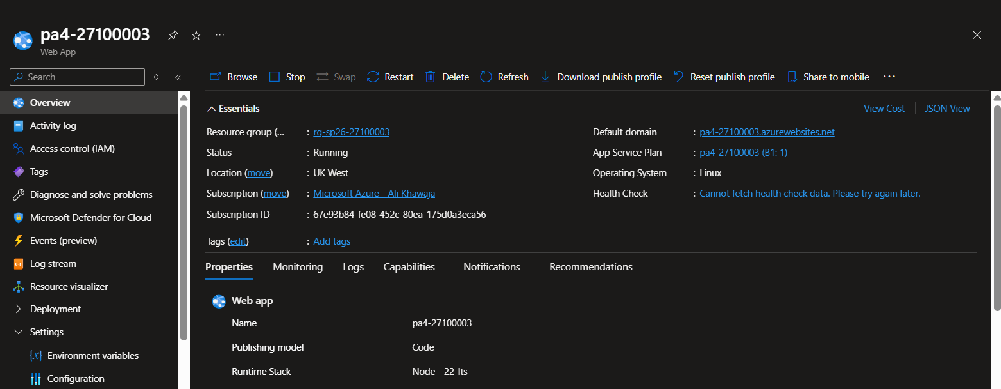
app service running

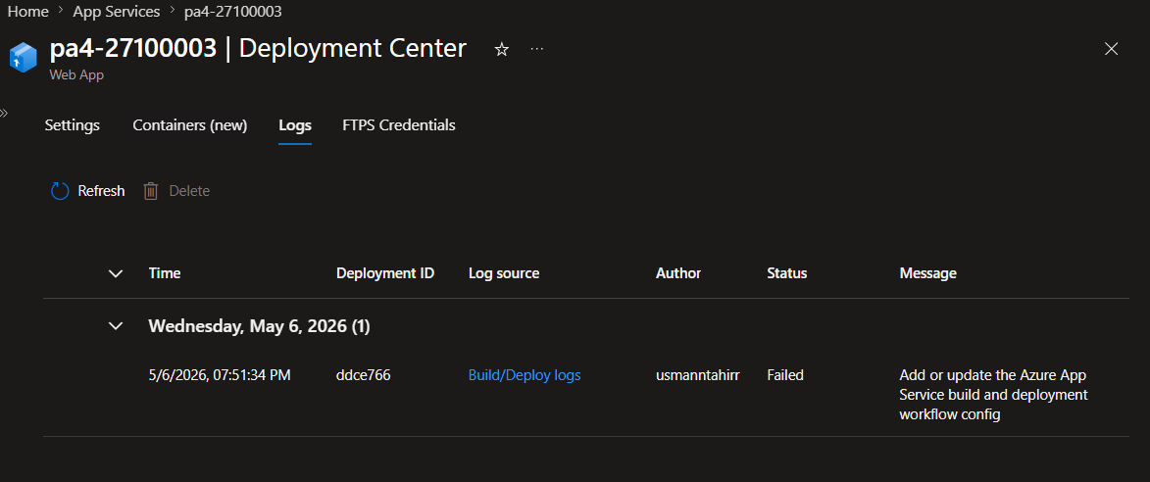
deployment center connected with my github

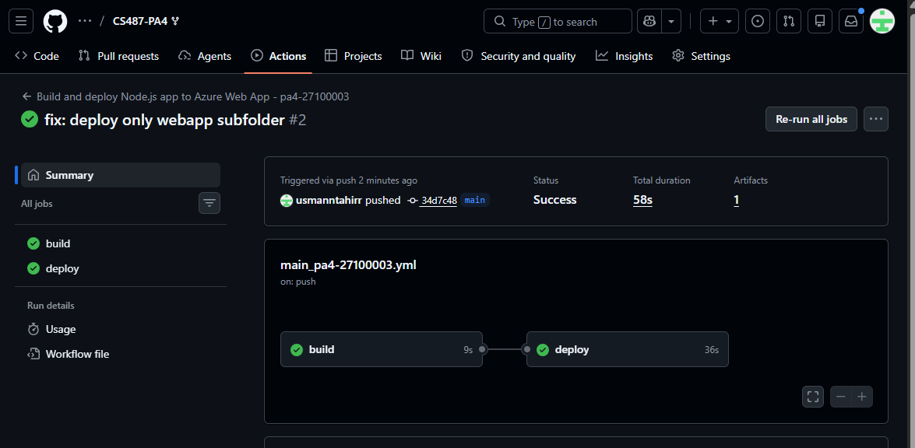
fixed the error of build: now its deployed, workflow is green

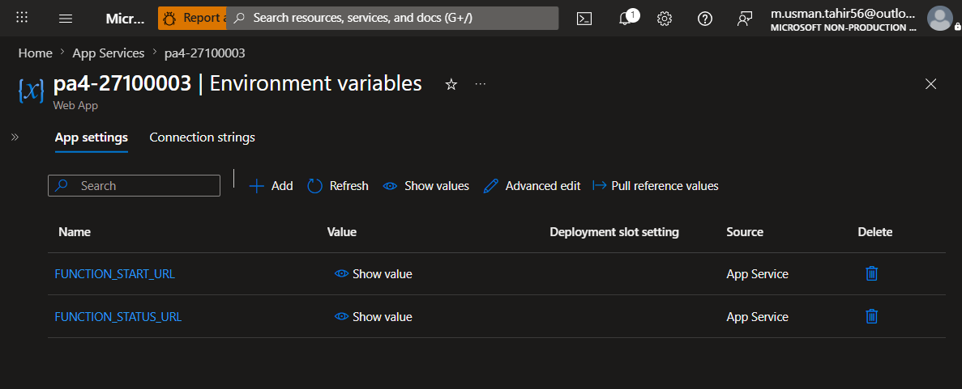
both FUNCTION_START_URL and FUNCTION_STATUS_URL listed
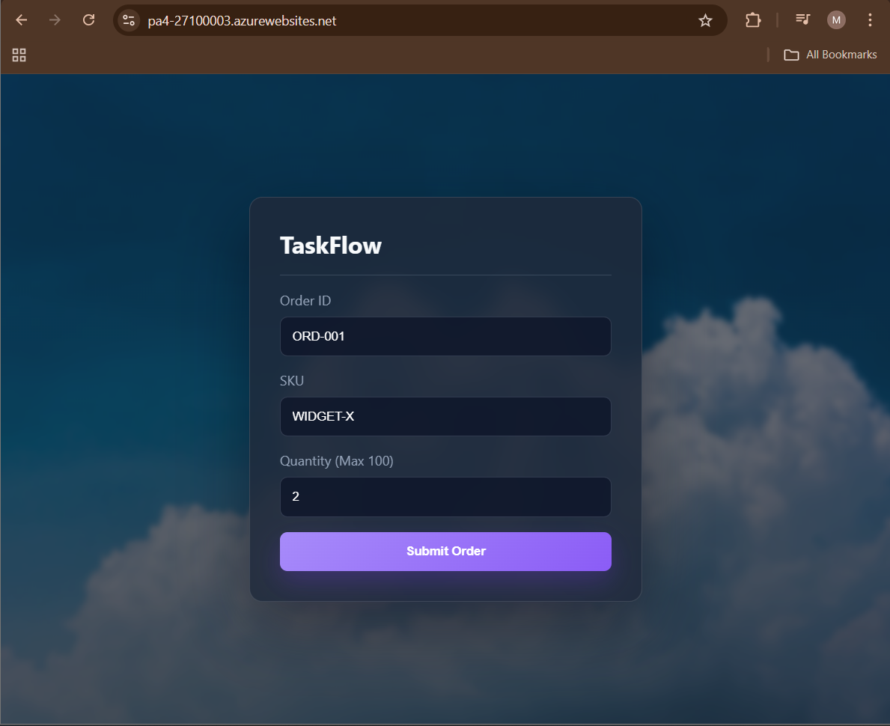
successful load of the dashboard

TASK 2:
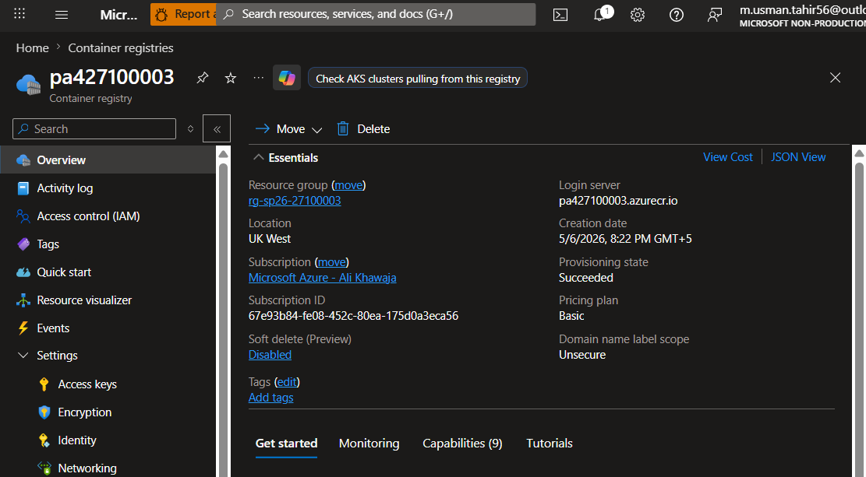
overview of the pa427100003 in container registries

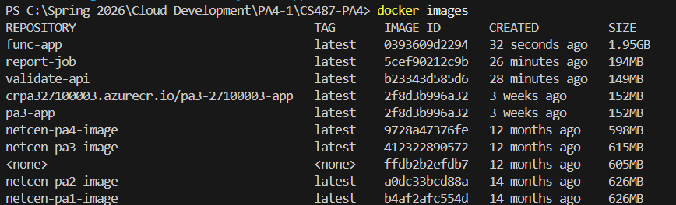
all 3 images created (top 3)

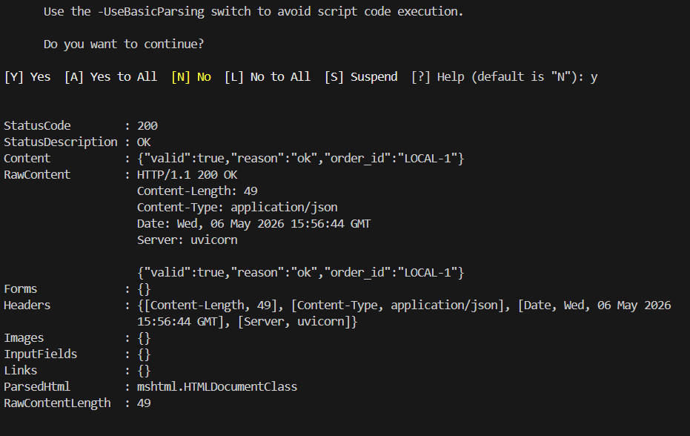
terminal output showing StatusCode: 200 and the JSON response.
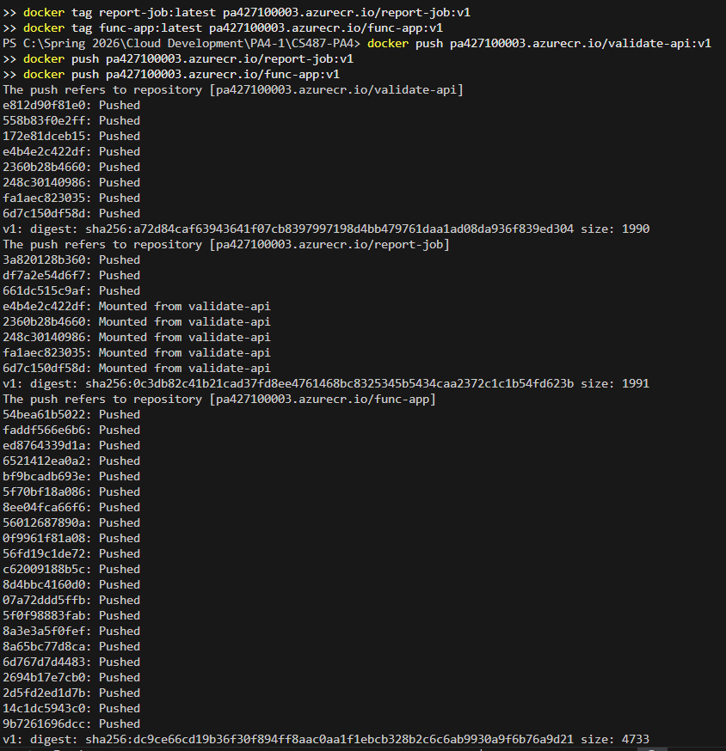
all 3 images pushed successfully

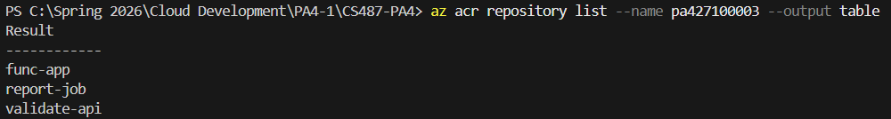
output of az acr repo list

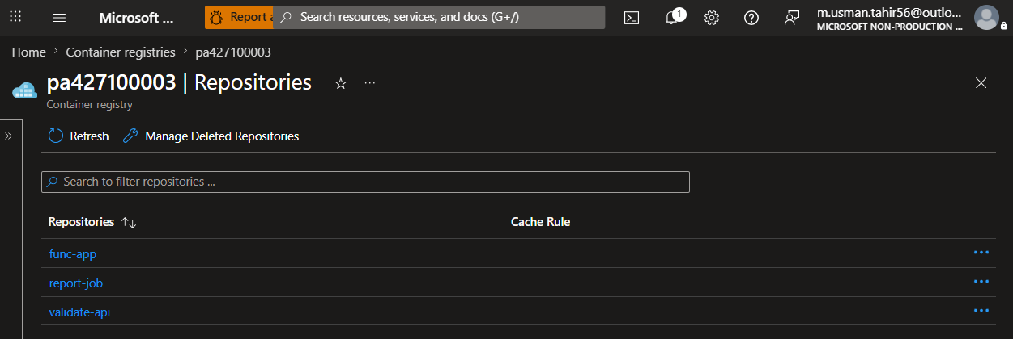
all 3 repos showing in the portal

TASK 3:
check function_app in repo
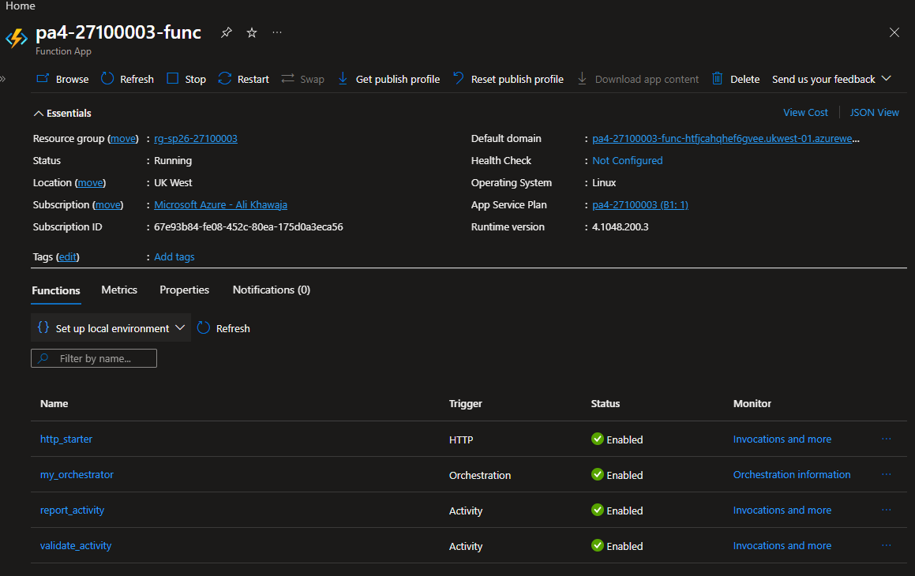
func start was not working at all; after a million attempts i just took a ss of function app lisitng the same 4 functions (same purpose)

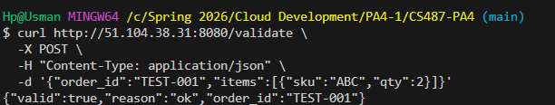
Local smoke test of validate_activity against AKS

TASK 4:
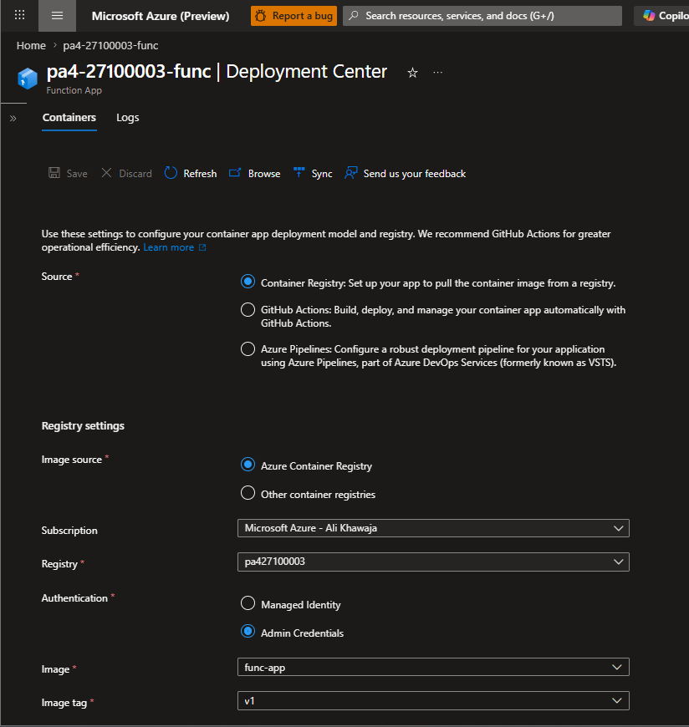
Function App Overview showing container image configuration

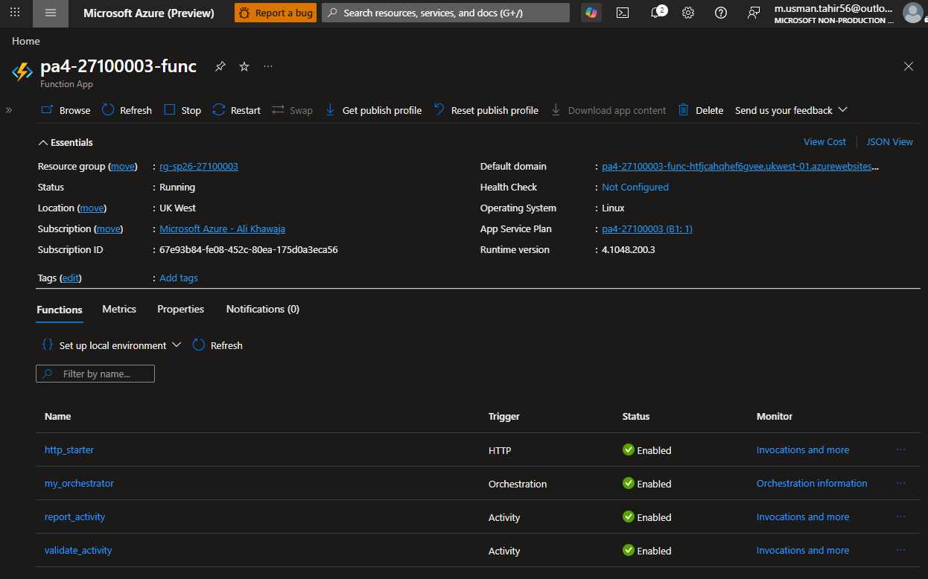
all 4 functions showing in a list
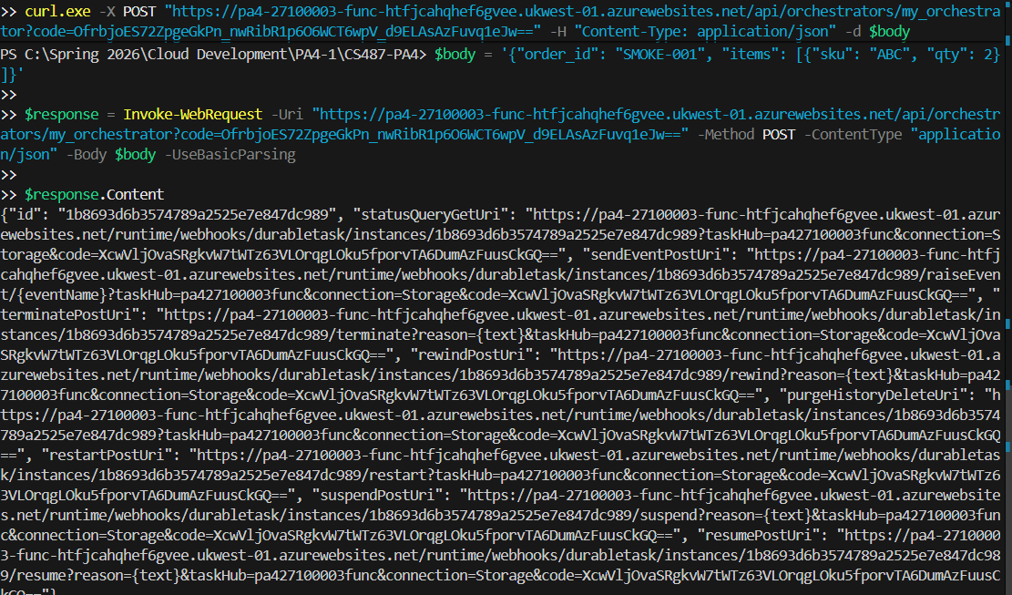
curl/JSON output showing orchestration started (instance id + statusQueryGetUri)

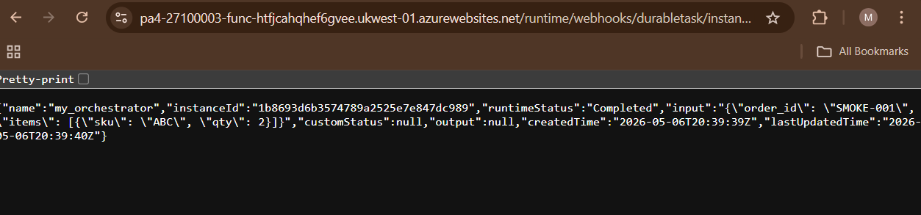
Screenshot of the status query URL JSON showing Completed not failed because i did task 5 and 6 first

TASK 5:
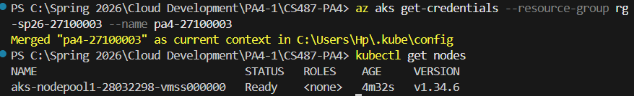
node is ready

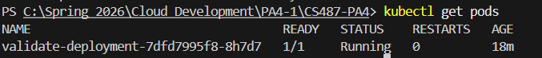
ss of get pods running successfully

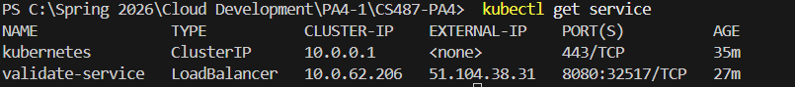
assigned external ip

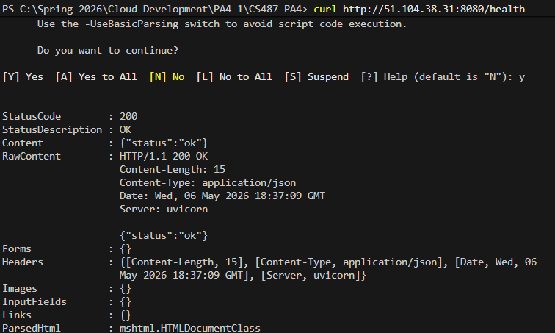
curl health check

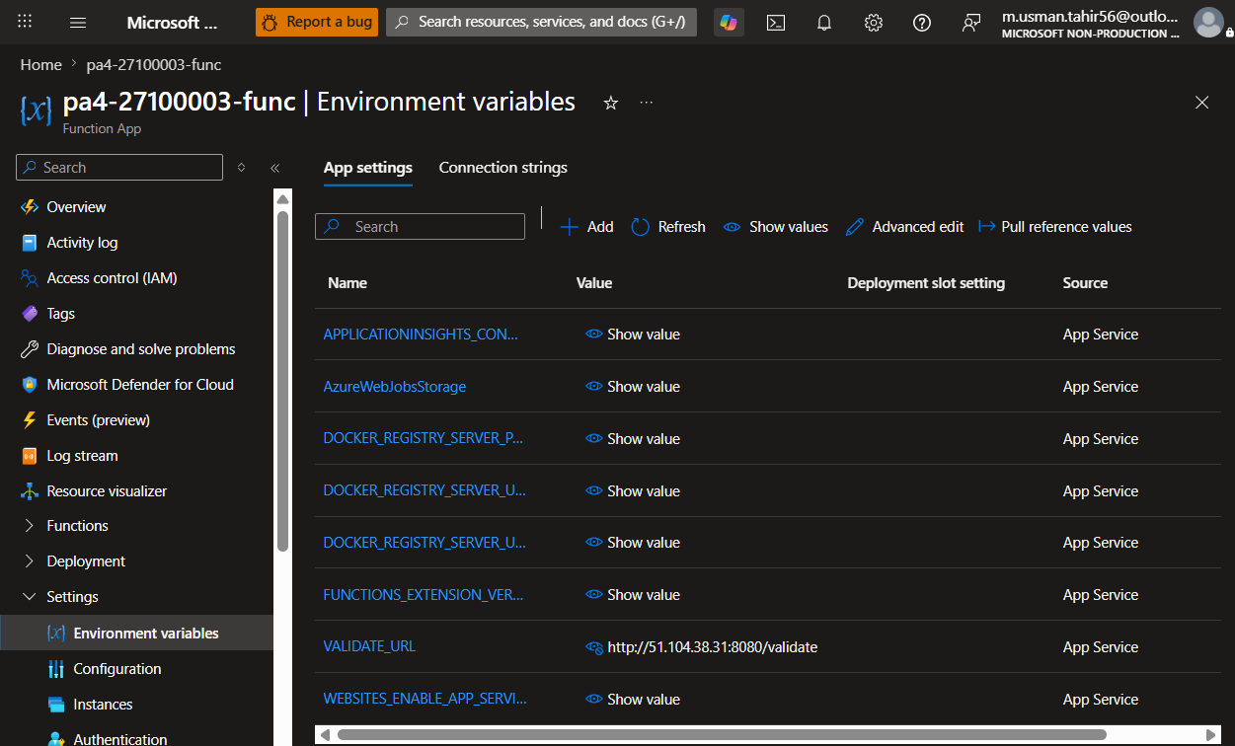
showing value of VALIDATE_URL

TASK 6:
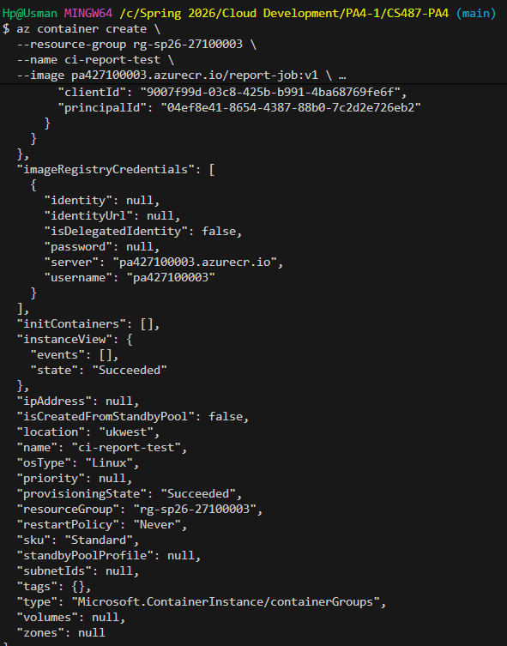
state: Succeeded
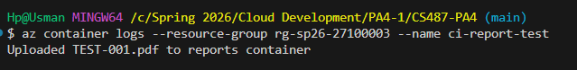
uploaded pdf successfully

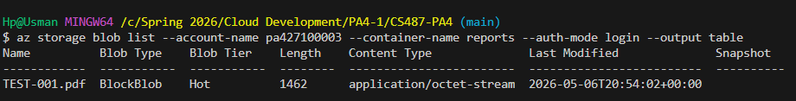
verified: pdf is in blob storage

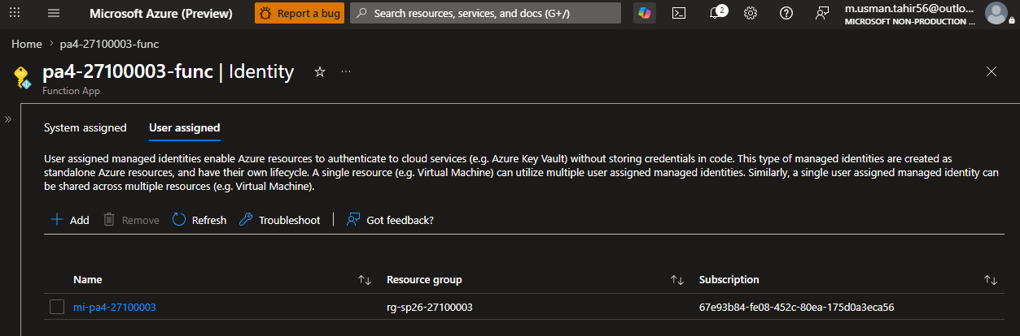
User assigned showing mi-pa4-27100003 attached

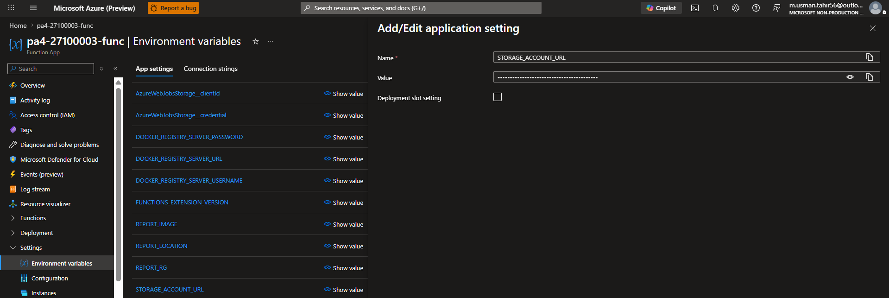
STORAGE_ACCOUNT_URL

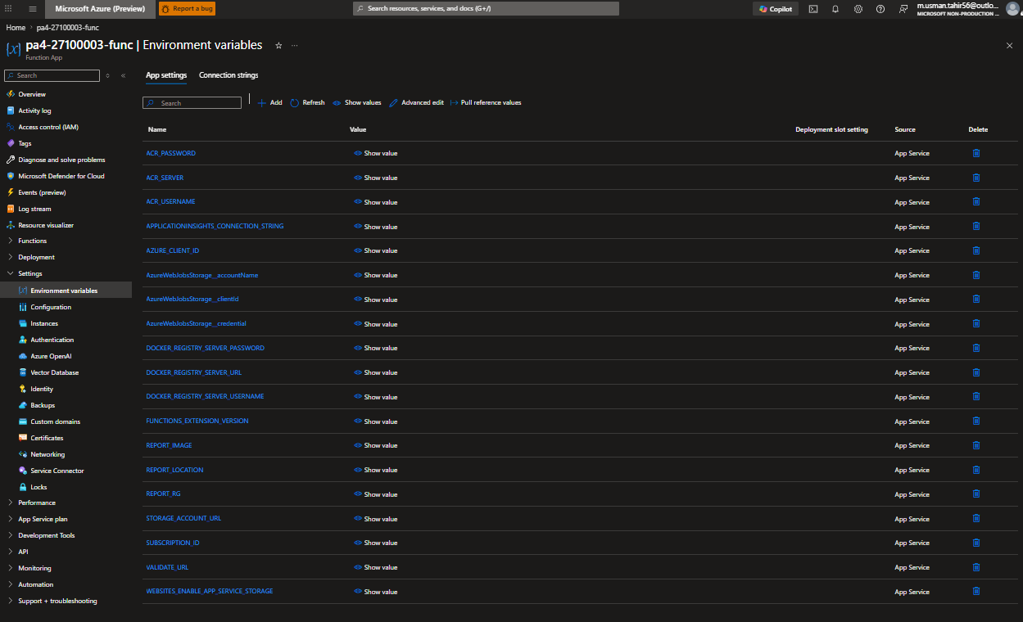
Environment variables showing REPORT_*, ACR_*, STORAGE_ACCOUNT_URL values
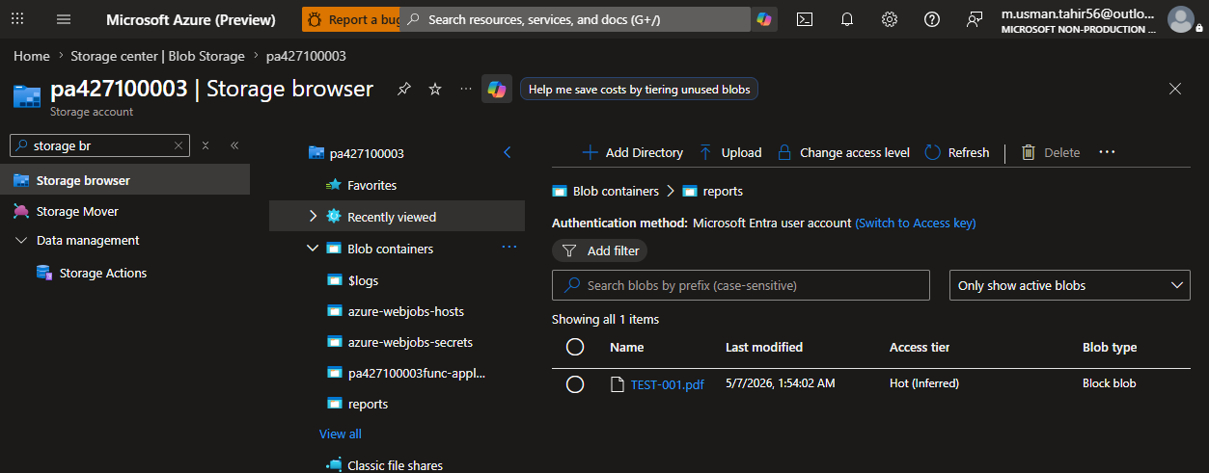
pdf listed

TASK 7:
TASK 8:
CHECK SUBMISSION.MD

