Freight Rate Prediction - Model Report
Training data 2025-01-01 to 2025-10-31 (48,000 loads). Predictions for 12,000 loads across 2025-11-01 to 2025-12-31.

Summary
The shipped model is a blend of five learners predicting log(rate per mile). Averaged over three rolling-origin folds, each hiding a two-month future block, it reaches $147.05 mean absolute error (6.23% MAPE, R² 0.824), against $209.79 for the strongest naive rate-per-mile baseline - a 30% reduction in error.

1. What the data says
- Distance dominates the raw rate (correlation 0.91), so the model predicts log(rate per mile) with distance as an offset rather than predicting dollars directly.
- quote_signal is a decoy. Its correlation with realised rate per mile is 0.05; its mean sits next to the rate-per-mile mean, so it looks like a price quote but carries no signal. It is dropped everywhere.
- market_index only works in aggregate: 0.08 correlation row by row, 0.58 once averaged to a day. It is a daily market reading seen through per-row noise, so the model uses a daily calendar built from it.
- Rate per mile falls with length of haul and separates cleanly by equipment (Dry Van 2.05, Flatbed 2.22, Reefer 2.31 $/mile median).
- 8 cities appear in the prediction set that never appear in training (Allentown, Charlotte, Chicago, Jackson, Knoxville, Laredo, Norfolk, San Diego). No raw city identifier is used as a feature; geography enters through coordinates, great-circle distance and bearing, and every lane encoding carries a fallback flag.
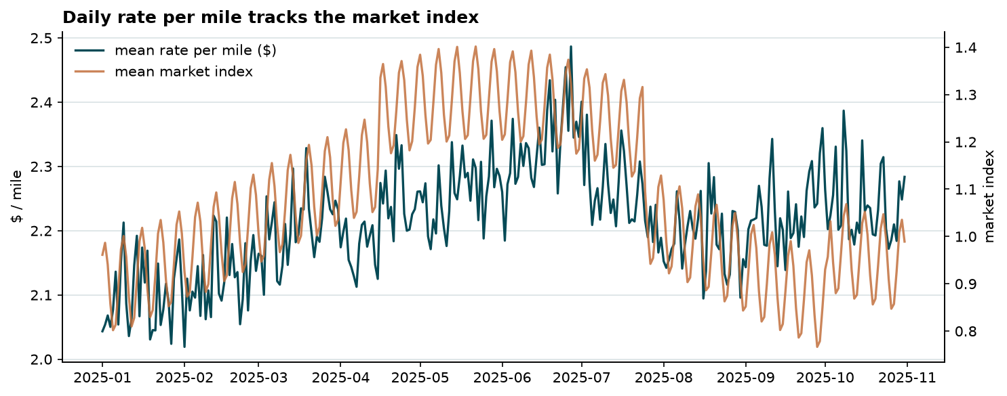
Daily mean rate per mile against the daily mean market index.
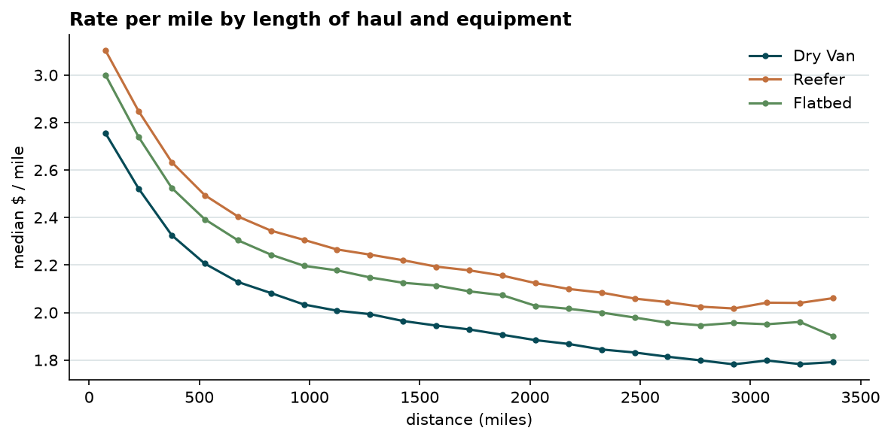
Rate per mile by length of haul and equipment type.

2. Data quality and how it was handled
Issue | Rows | Handling
Negative weight (correct magnitude, flipped sign) | 292 | Absolute value
Missing weight | 300 | Left missing and flagged; the boosters split on missing natively
Missing market_index | 374 | Filled from that day's market calendar and flagged
Injected multiplicative rate shocks | ~1% | Not deleted. The primary learner optimises absolute error, which estimates the conditional median and is not dragged by them
distance long against great-circle distance | 214 | Not repaired. The ratio is constant within a lane (std 0.02), so it is distortion in the synthetic coordinates, not per-row corruption
The shock diagnosis is what drives the choice of loss. Measured against each lane's own median, the log rate-per-mile residual tails are near-perfectly mirrored (-1.07 at the 0.5th percentile against +1.06 at the 99.5th). A fat-tailed price distribution would not be symmetric in log space; an injected multiplicative shock is. Deleting those rows would also delete genuine hot-market pricing, so they are kept and absorbed by a robust objective instead.
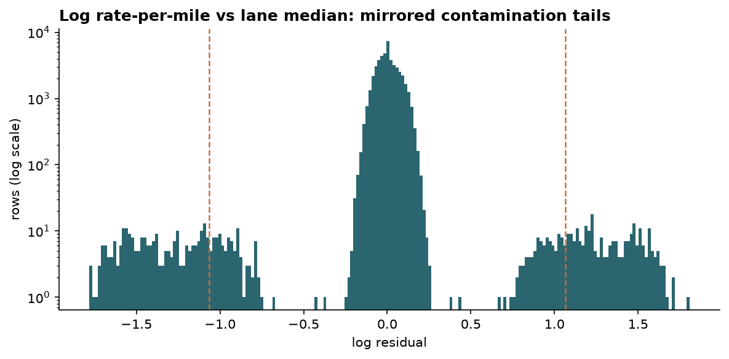
Log rate-per-mile against the lane median. Dashed lines mark the 0.5th and 99.5th percentiles.

3. Train/test split and validation approach
Training data ends 2025-10-31 and every graded prediction falls in November and December. That makes this a forward-extrapolation problem, not a random-holdout problem, and the validation scheme is built to match it: three rolling-origin folds, each hiding a two-month future block at exactly the horizon the real submission faces.
Fold | Fitted on | Blend/calibration window | Evaluated on | Rows scored
1 | 9,255 rows | 9,855 rows (2 months) | 2025-05-01 to 2025-06-30 | 9,696
2 | 19,110 rows | 9,696 rows (2 months) | 2025-07-01 to 2025-08-31 | 9,671
3 | 28,806 rows | 9,671 rows (2 months) | 2025-09-01 to 2025-10-31 | 9,523
- Nothing inside an evaluated block ever reaches the model: base learners, lane encodings, blend weights and the dollar calibration factor are all fitted strictly on earlier dates.
- Blend weights and the calibration factor are fitted on the most recent two months available inside each fold, never on the block being scored, which mirrors how the shipped model is built.
- Lane encodings are computed out of fold, so a lane's own labels never reach its own features.
- No raw time index is used as a feature. A tree cannot split past the last date it saw, and the target window is two months beyond the end of training. Seasonality enters only through cyclical calendar terms, holiday proximity and the market calendar, all defined for future dates.
For contrast, the same model scored on a random 80/20 split of the same rows reports $84.77 MAE against $147.05 on the time-based folds - 42% optimistic. Random splitting lets the model see the same weeks it is scored on; the time-based number is the one to trust.

4. Model
Five learners are fitted over one shared design matrix so they can be compared honestly, but the shipped model is a fixed, equal-weight average of the two absolute-error boosters. Nothing about that weighting is fitted, and that is the result of measurement rather than taste.

Why the ensemble weights are not fitted
Three weighting schemes were tried and rejected under the same rolling-origin validation:
- Non-negative least squares in log space produced a blend that scored worse than its own best member - $188 against $166 - because least squares in log space is not the metric being graded.
- Greedy ensemble selection against dollar MAE fixed that, then overfitted the blend window: on the earliest fold it handed 74% of the weight to the ridge model, which went on to score $498 MAE on the very block it was meant to predict.
- Bagging that selection moved the weights by under a percentage point, which is what ruled out sampling noise as the explanation.
The cause is a mismatch no weighting scheme can repair. Weights are learned from base models fitted on the pre-blend window, then applied to models refitted on that window plus the blend window. On the earliest fold that refit doubles the training data: the boosters improve sharply, ridge barely moves, and the learned weights are stale before they are ever used. Across all three folds fitted blending never beat the best single member - it either tied or lost badly - so the fitting was removed. Averaging two near-equivalent robust boosters is a free variance reduction with nothing fitted, and it avoids choosing between two learners separated by ten cents of cross-validated MAE.
Predictions are converted back to dollars with a single multiplicative calibration factor (1.0300) fitted on held-out data, because a log-space fit is biased in dollar space and the textbook smearing correction targets the mean rather than the metric here. That scalar is the only quantity the held-out block still determines.
Learner | Role | Weight
hgb_mae | Gradient boosting, absolute-error loss | 0.50
hgb_deep | Gradient boosting, deeper, absolute-error loss | 0.50
Features: log distance and great-circle distance, detour ratio, bearing, endpoint and midpoint coordinates, weight and weight per mile with a missing flag, equipment indicators, distance band, day of week, cyclical day-of-year and month terms, distance to the nearest holiday, the market calendar (daily mean, 7- and 28-day rolling means and the gap between them), and shrunk out-of-fold median log rate-per-mile encodings for lane, origin, destination, corridor, origin-by-equipment and equipment-by-distance-band, each with a count and a seen flag.

5. Results
Mean across the three rolling-origin folds, best first.
Model | MAE | RMSE | MAPE | Median APE | R²
Shipped model (equal-weight robust boosters) | $147.05 | $637.68 | 6.23% | 3.66% | 0.824
Gradient boosting, deeper, absolute-error loss | $147.18 | $637.83 | 6.23% | 3.67% | 0.824
Gradient boosting, absolute-error loss | $147.21 | $637.67 | 6.24% | 3.66% | 0.824
Random forest | $165.28 | $645.60 | 7.14% | 4.38% | 0.820
Gradient boosting, squared-error loss | $189.56 | $656.94 | 8.06% | 5.05% | 0.813
Baseline: lane median rate per mile x distance | $209.79 | $671.89 | 8.73% | 5.67% | 0.805
Baseline: global median rate per mile x distance | $249.25 | $676.94 | 11.56% | 8.04% | 0.802
Ridge regression | $412.60 | $786.12 | 17.36% | 15.31% | 0.730
The squared-error twin of the primary learner is kept in the table deliberately: it shares every feature and hyperparameter with the absolute-error version and differs only in objective, so the gap between them is the measured cost of letting the injected shocks pull the fit.

Error by segment (most recent fold)
Equipment | MAE | MAPE
Dry Van | $144.71 | 6.03%
Flatbed | $157.44 | 7.09%
Reefer | $173.19 | 7.04%
Distance band (mi) | MAE | MAPE
0-300 | $31.80 | 6.65%
300-600 | $75.29 | 6.58%
600-1000 | $106.51 | 6.54%
1000-1500 | $169.84 | 6.21%
1500-2500 | $267.58 | 6.71%
2500+ | $315.62 | 5.58%

6. Fixed December prediction chart
Produced by the provided score.py from december_chart_inputs.csv: Lexington to Fort Wayne, 360 miles, Dry Van, 32,000 lb, with only the date changing across the 31 days.
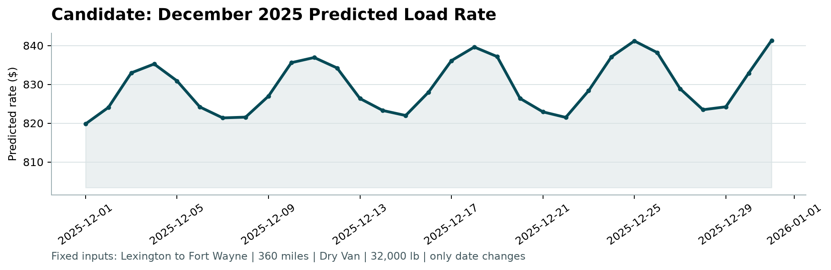
candidate_december.png, generated by score.py.
These rows arrive with six columns and no coordinates, market index or quote signal, yet they are scored by exactly the same model as the validation set: coordinates come from the city table and the market state from the daily calendar, both built from feature columns of the supplied files and never from labels. That is what makes the curve move day to day rather than sitting flat - the only inputs that change are the calendar terms, the holiday proximity and the market calendar.

7. Reproducing this
python -m pip install -r requirements.txt
python src/eda.py
python src/validate.py
python src/train.py
python src/predict.py
python score.py --predictions validation_predictions.csv \
--december-predictions december_chart_inputs.csv

