# 1. SAMPLE PROFILLING REPORT FOR PERFORMANCE CHEACKING

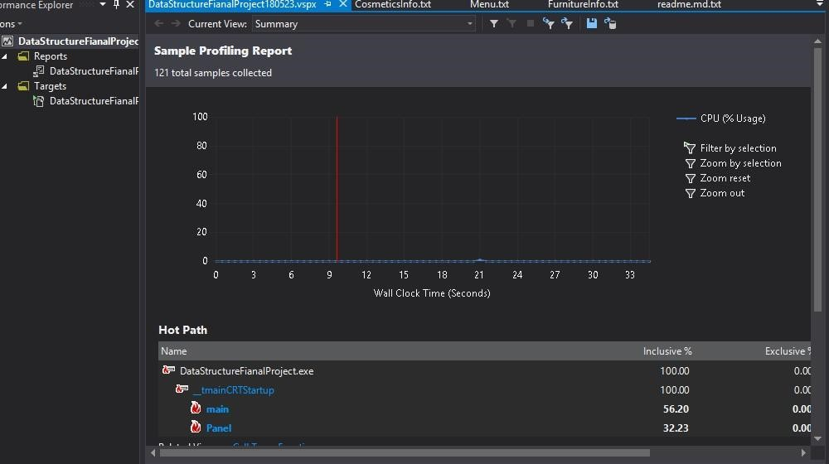

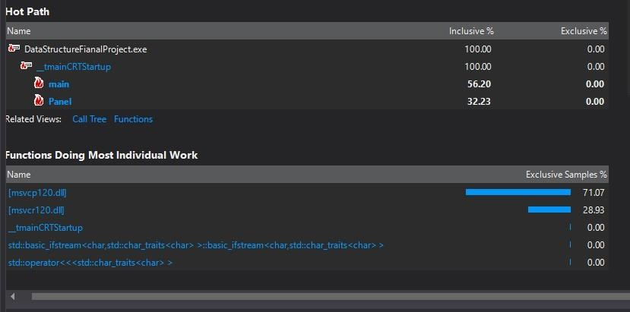

2. TRIMMED CALL TREE

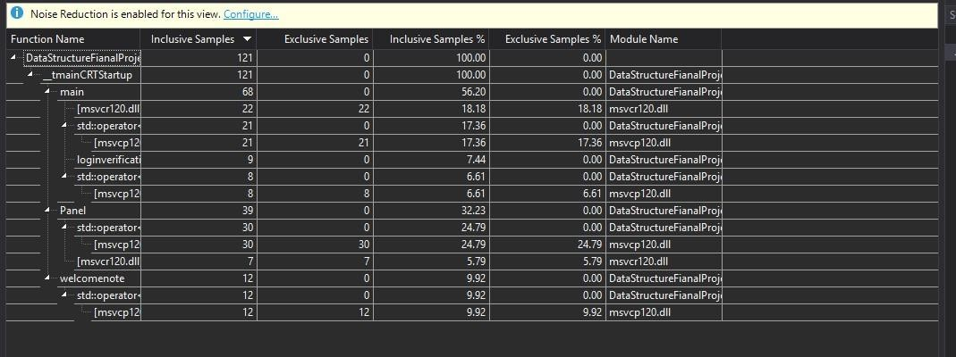

# 3. INSTRUMENTAL PROFILING REPORT

