**TimeKeeper Project First Phase Requirements**

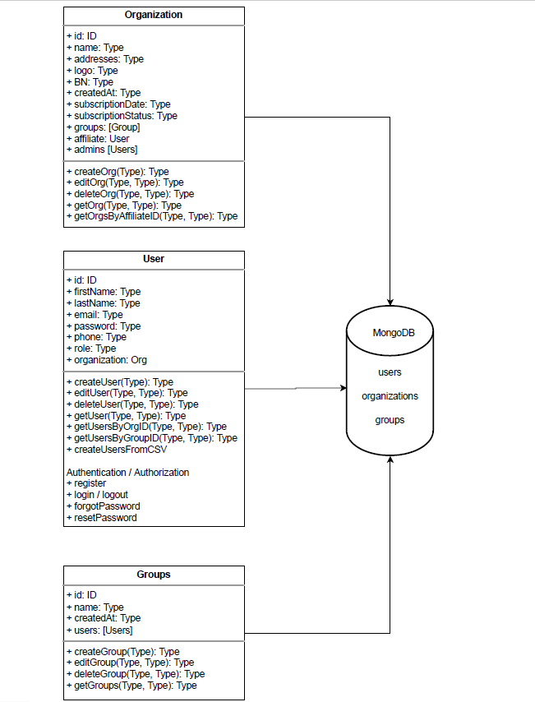

**Backend [NestJs, MongoDb], [GraphQL, Mongoose]:**

1. Registration of an employee

2. Auth/ Login (JWT as a cookie on the server, Passport)

3. Logout

4. Forgot password using e-mail 5. Roles

5.1. MASTER USER - for me - can create affiliates

5.2. AFFILIATE - can create admins (companies)

5.3. Admin - can create group managers and users

5.4. Group manager - can create users

5.5. User - employee

6- Process to create a user with a role according to above permissions.

**User Roles:**

1. MASTER USER - for me - can create affiliates

2. AFFILIATE - can create admins (companies)

3. Admin - can create group managers and users

4. Group manager - can create users

5. User – employee

**Questions**

1. Which user role can create an organization?

Ans: **Two roles - affiliate and the first admin**.

When affiliate create org he have to create the first organization's admin.

The affiliate form will have:

* organization name

* business number

* email (the first admin user), organization can have several admins.

Also the registration form on the app, will have the same fields.

On the DB organization thet will be created by affiliate will have affiliate_id and organization thet will be created directlly on the register form will have affiliate_id = 'super_admin_id'

1. **How a Group is assigned a manager or how an employee is added in the group?**

Ans: The admin can create all the users in the org with a default role of - 'employee'.

Then the admin can create groups.

And he also can create or change an existing user to a admin / group_manager.

In the group settings he can assign for each group several or one group_manager.

Then, the group manager can pick users from the organization and assign then to his group.

Also the organization admin can do all the work... and assign each user to a group by group name or by group_manager.

This is not complicated.

Imagine you have a table of all the users.

And after you create groups and group_managers you can go every user one by one and from the column 'group' you can pick from a drop down to which group to relate the user.

The all group thing by the admin view its only one table..