**Firebase Email Notifications:**

**Create Collections:**

1: create collection for send emails, for example **mail_notifications.** This is used for store emails on firebase.

2: create one more collection for set **email template,** for example

**mail_templates.** This is used for set html email template.

In second collection which name is **mail_templates** save your html code of email template.

Like:

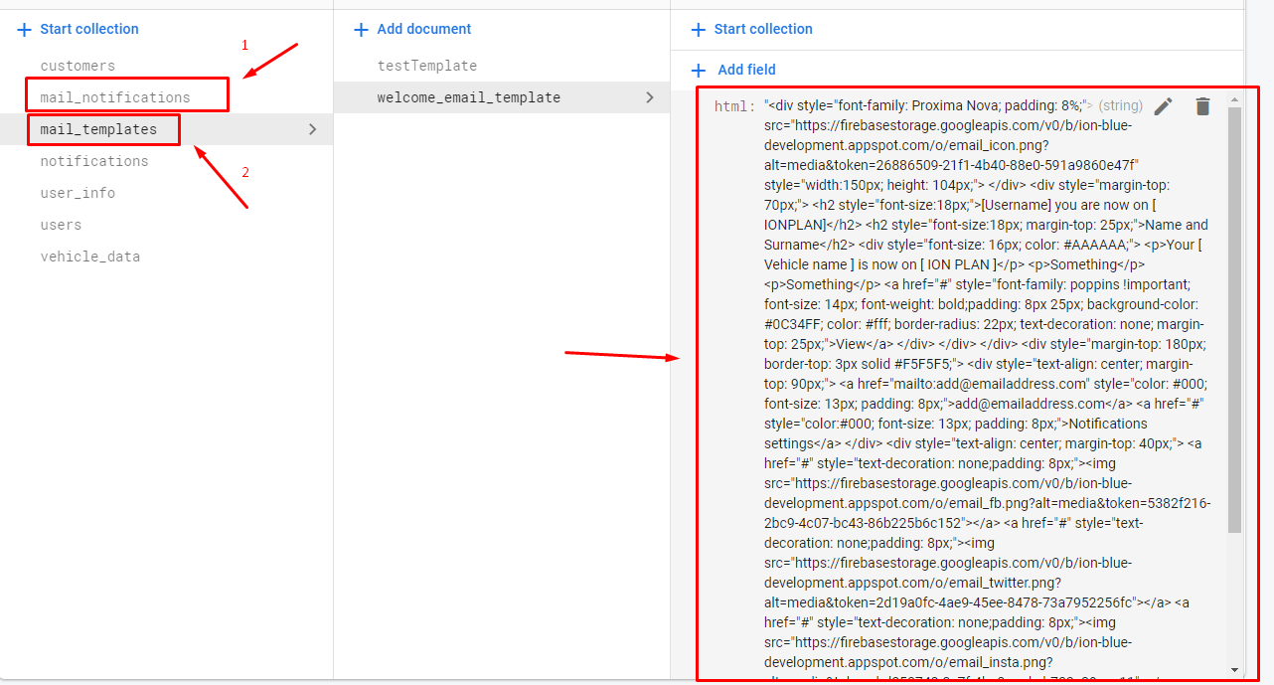

**Install extensions for emails in firebase:**

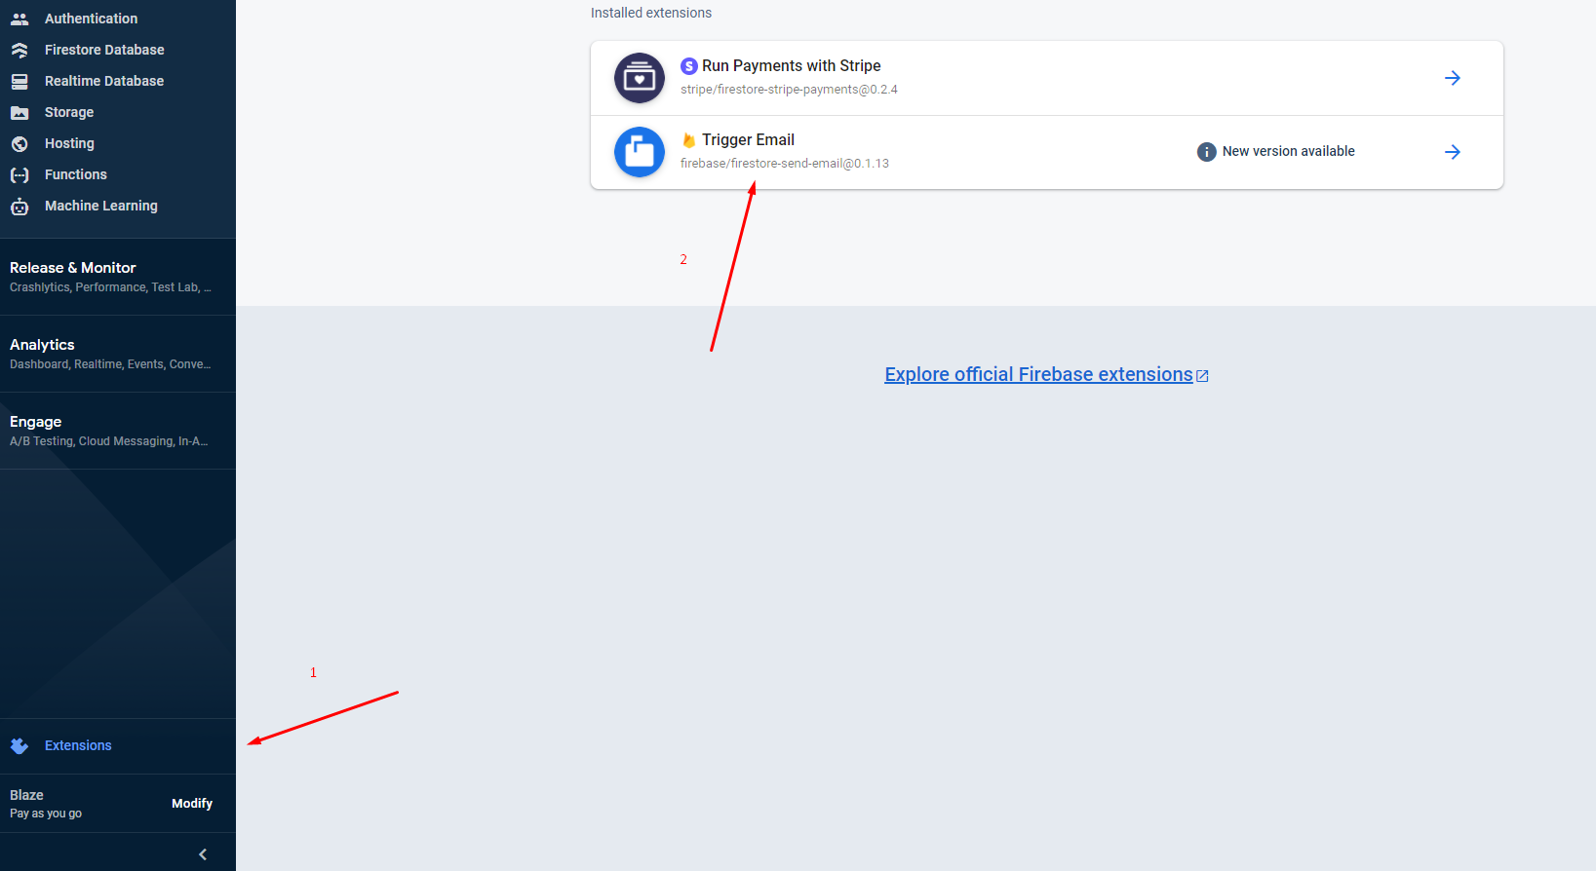

**Now add SMPT credentials in firebase.**

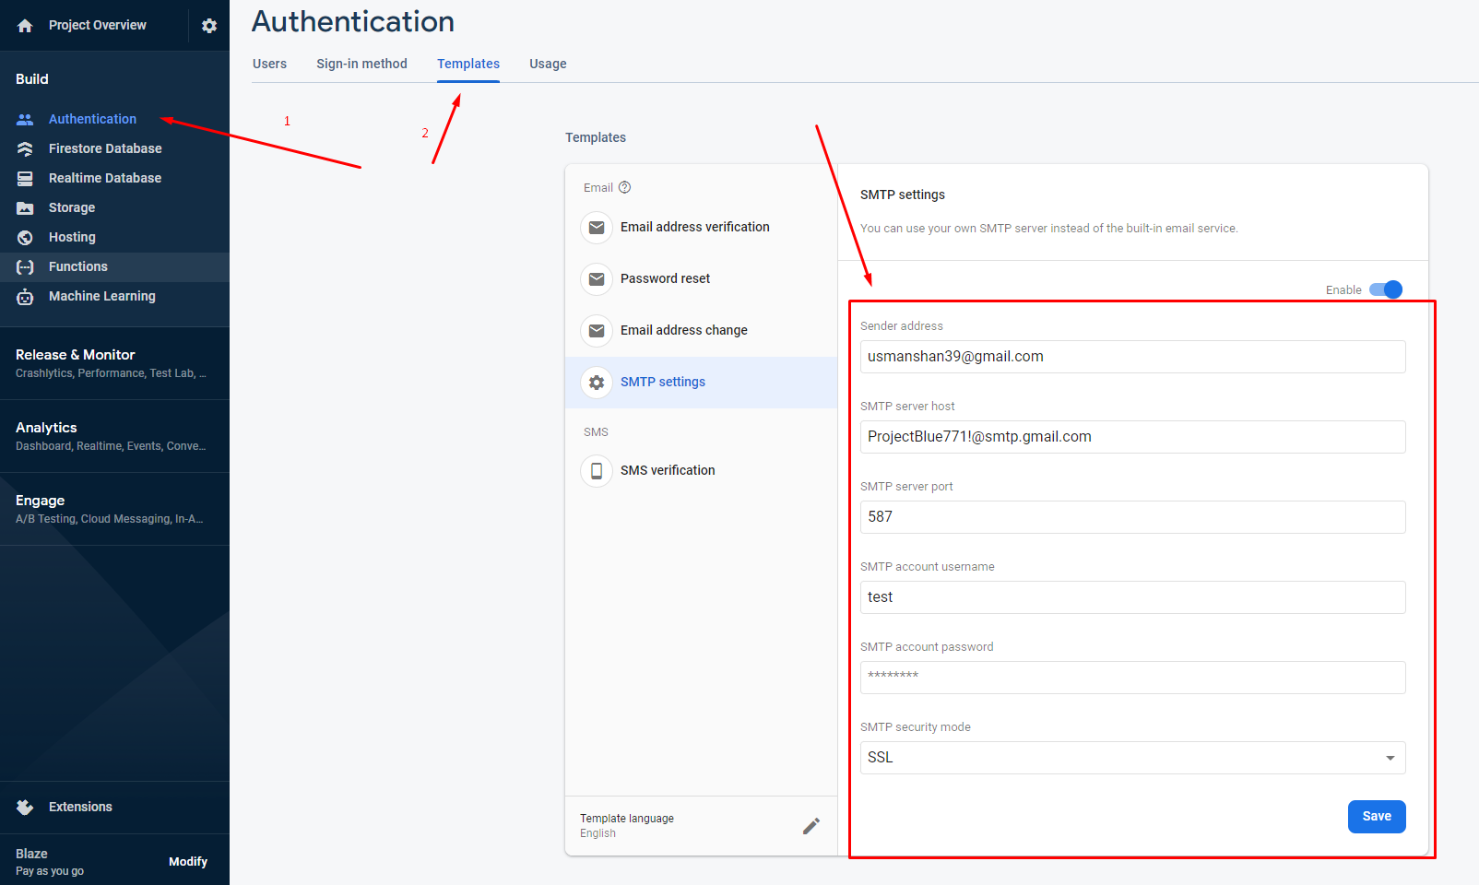

**Angular Coding:**

**Create Functions in service file.**

sendEmailNotification(emailTemplate:any): Promise<any> {

        let data = Object.assign({}, emailTemplate);

        delete data.id;

        return this.db.collection('mail_notifications').add(data);

    }

Here db variable used in constructor.

constructor(public db: AngularFirestore, public globalService: GlobalService,

        public afAuth: AngularFireAuth,) { }

**Create Email Object for send data in email collection:**

Notification name is **mail_notifications.**

const emailTemplate = {

            to: "usmanshan339@gmail.com",

            template: {

                name: 'welcome_email_template',

                data: {

                    mail_subject: "ION BLUE",

                    title: fname + " you are now on " + plan,

                    name: fname + " " + lname,

                    viewURL: "http://localhost:4200/home/carsplan",

                }

            }

            //this.notService.sendEmailNotification

        }

Now call the function in service file.

this.notService.sendEmailNotification(emailTemplate).then((res: any) => {

            console.log("email sending response", res);

        })

**Complete code of send email function in .ts file is.**

sendEmailsNotifications(fname:any, lname:any, plan:any) {

        const emailTemplate = {

            to: "usmanshan339@gmail.com",

            template: {

                name: 'welcome_email_template',

                data: {

                    mail_subject: "ION BLUE",

                    title: fname + " you are now on " + plan,

                    name: fname + " " + lname,

                    viewURL: "http://localhost:4200/home/carsplan",

                }

            }

            //this.notService.sendEmailNotification

        }

        this.notService.sendEmailNotification(emailTemplate).then((res: any) => {

            console.log("email sending response", res);

        })

    }

Here **welcome_email_template** is document in collection for used as a html template.

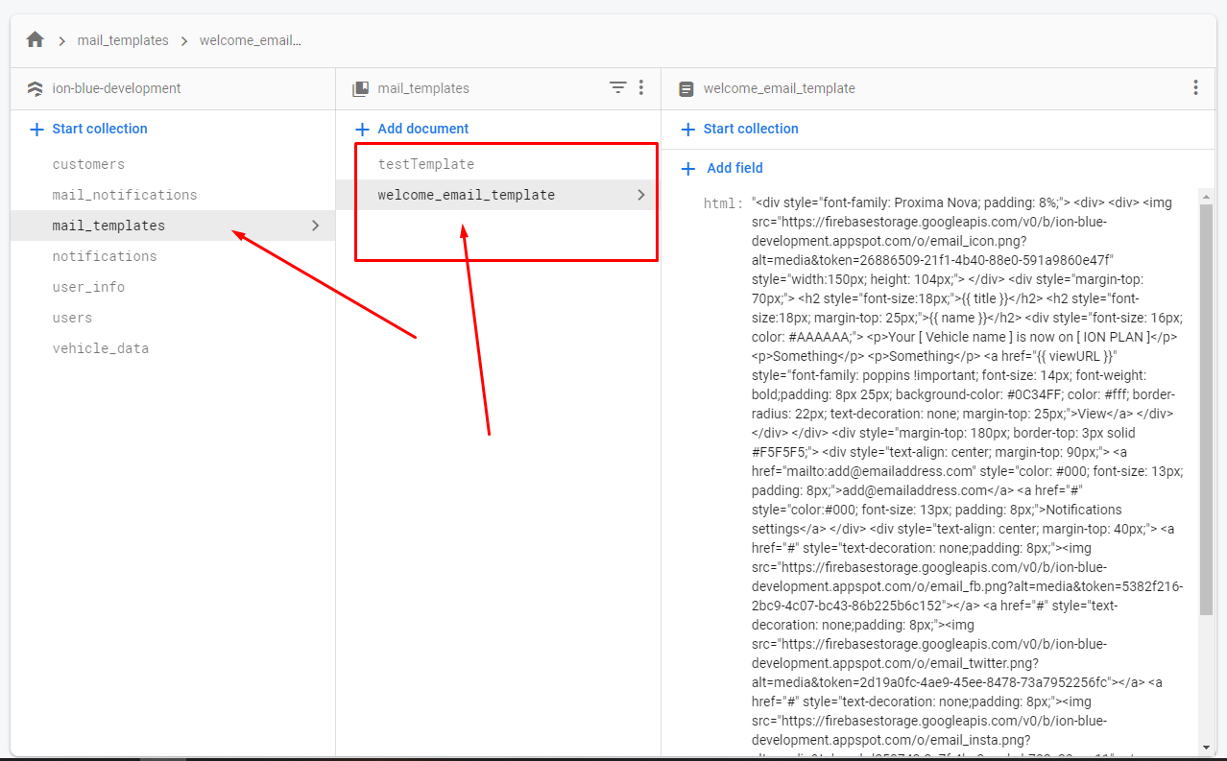

**How to send Dynamic data in emails:**

Email object that we create above is used for send dynamic emails