**GraphQl:**

https://docs.nestjs.com/graphql/quick-start

npm i @nestjs/graphql @nestjs/apollo graphql apollo-server-express

**Schema:**

First thing that we need in graphQl is schema it’s mean we first need to define the structure of the data like table structure that we define in SQL:

**Simple structure is:**

type structure_name{

id : Int!

firstName : string

lastName : string

pots : [Post]

}

As we can see I use **!** mark with id it’s mean **required.** And **[Post]** mean array of post that is also called relationship so for this we also need to define **Post schema**.

Type Post {

id: int!

title : string

details:string

}

**Implementations with NestJS:**

<https://docs.nestjs.com/graphql/quick-start>

NestJs provide us two types of approach for implement graphql.

**1: Schema first approach:**

**2: Code first approach:**

**install required Dependencies:**

npm i @nestjs/graphql @nestjs/apollo graphql apollo-server-express

**Import graphql in our app.module.ts file.**

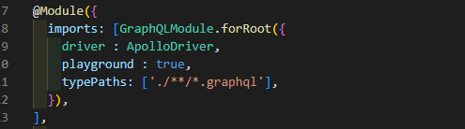

Playground should be true in locals in productions it should be false.

**1: Schema First Approach:**

* Create new file with extension .**graphql** and create a schema in it.

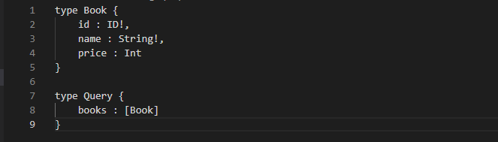

* Create resolver for the **Query** we need to create new resolver for every Query.

**Create Resolver:**

Create new file in our module folder with name book.resolver.ts.

1: Import resolver from graphql:

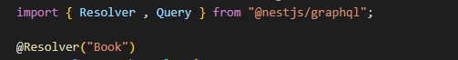

2: Inject **@Resolver** with name of **schema**  here is **Book** is our scheme.



3: Create class with resolver name:



4: Inject **@Query** with parameter **query name** here books is our query name that we define in our schema file.



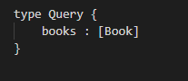

5: create function that will execute against the query.

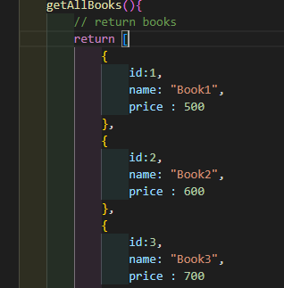

Complete Resolver code is :

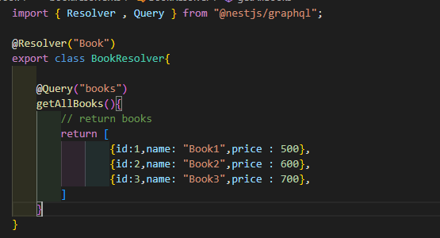

6: import **Resolver** in books.module.ts **providers.**



7: Import our **Book Module** in our main module.

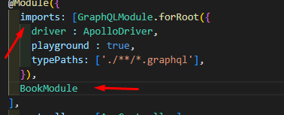

**2: Code First Approach:**

1: after install graphql in nest import it in app.module.ts file.

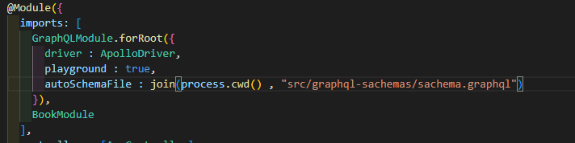

2: Create schema file.

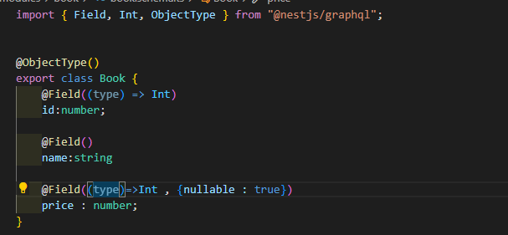

3: Create resolver.

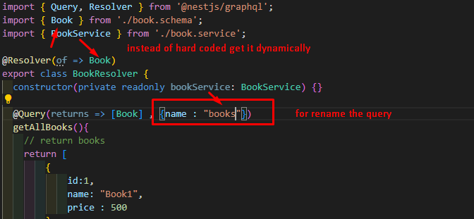

**Graph QL Crud:**