**Services**

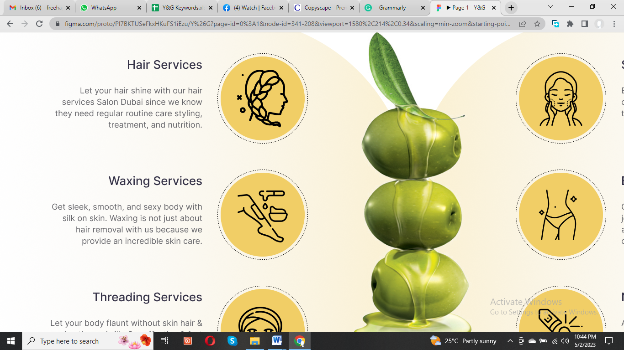

**Hair Services**

At Y&G **Salon in Dubai**, we understand that your hair deserves the best care possible. That's why our skilled hair experts offer a range of **hair salon services**, from routine haircuts to nourishing treatments and personalized styling. Let your hair shine with our exceptional **hair salon home services**, customized to match your personality and style. Visit us today to experience the best hair care in town.

**Waxing Service**

Enjoy our exceptional **waxing services** that go beyond hair removal. Our waxing treatments are designed to provide an incredible skincare experience that leaves your skin feeling silky smooth, and sexy. Our skilled technicians use high-quality **waxing service at home** and techniques to ensure a comfortable and effective hair removal. Visit us today to experience our exceptional **waxing in Dubai** and enjoy the benefits of silky smooth skin.

**Threading Service**

We believe perfectly groomed eyebrows can enhance your facial features and transform your look. That's why we offer high-quality **threading services** from skilled and experienced technicians. Our **threading in Dubai** is gentle, precise, and efficient, ensuring flawless and long-lasting results. Visit us today to experience the best threading in town.

**Skincare Service**

Our team is aware that your skin deserves the best care possible. Skilled estheticians at Y&G Salon offer personalized **skincare services** tailored to meet your unique needs. From luxurious facials to effective acne treatments, we use only the finest products and techniques to give you healthy, glowing skin. Schedule your appointment today and experience the best **skincare services in Dubai**.

**Body Care**

Experience the ultimate relaxation with our **body care services** at Y&G Salon Dubai. Our highly skilled professionals provide a range of **body care** treatments, including body scrubs, massages, and more, to leave you feeling refreshed and rejuvenated. We use only the finest quality products to nourish and pamper your skin. Visit us today for the ultimate body care experience.

**Nail Care**

At Y&G **Salon in Dubai**, we believe beautifully manicured nails are essential to any polished look. Our expert technicians offer a range of **nail care** services, from classic manicures to gel extensions, using high-quality products and tools. Experience our salon's ultimate nail care treatment and leave with perfectly polished and healthy nails.