**Services**

**Experience Our Magical Service to accentuate your natural beauty!**

**Every visit leaves you feeling refreshed, rejuvenated, and ready to conquer the world!**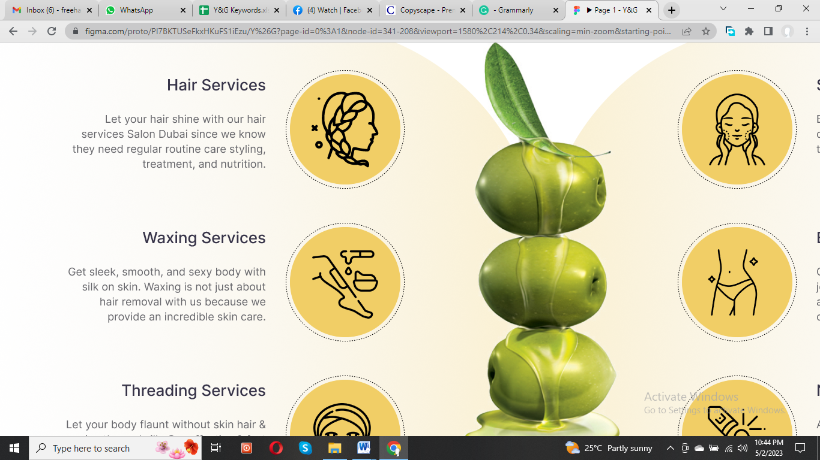

**Hair Services**

Revitalize your hair with our professional treatments, tailored to nourish, repair, and strengthen your locks for a healthy, radiant look at Y&G **Salon in Dubai.**

**Waxing Service**

Experience the silky smooth skin with our expert **waxing services** designed for a comfortable, efficient, and long-lasting hair removal solution.

**Threading Service**

We believe perfectly groomed eyebrows can enhance your facial features and transform your look. Enjoy painless and gentle **threading services** with long-lasting results.

**Skincare Service**

Skilled estheticians at Y&G Salon offer **skincare services** from facials to acne treatments. We use only the finest products to give you healthy, glowing skin with **skincare services in Dubai**.

**Body Care**

Experience the ultimate relaxation with our **body care services**. Avail a range of **body care** treatments, like body scrubs, massages, and more, to leave you feeling refreshed and rejuvenated.

**Nail Care**

At Y&G **Salon in Dubai**, we believe beautifully manicured nails are essential. We **nail care** services, from classic manicures to gel extensions, using high-quality products and tools.