Game Design Document

Fill up the following document

1. **Write the title of your project.**

Zombiemania part1

1. **What is the goal of the game?** 
   1. Eliminate the zombies
   2. Make high score
   3. Survive the zombie attack for a long time
2. Write a brief story of your game.

A zombie apocalypse has began. All humans have turned into zombies,except Usman.He is the last human surviver. Help him to defeat all the zombies.

1. **Which are the playing characters of this game?**

* **Playing characters are the ones who respond to the user based on the input from the user.**
* **Cars, monkeys, dinos, wizards, etc., are the playing characters in the game.**

|  |  |  |
| --- | --- | --- |
| Number | Character Name | What can this character do? |
| 1 | Usman | Strength:Guns  Weakness:Zombie |
| 2 | Zombie | Strength:Speed  Weakness:Guns |
| 3 |  |  |
| 4 |  |  |
| 5 |  |  |
| 6 |  |  |
| 7 |  |  |
| 8 |  |  |

**Draw your imagination of this game. What does this game look like?**

* **Draw the game either on your computer or on paper.**
* **Add images of the game scenes to show each of the playing and non-playing characters at least once.**

Images that I’ll use are:

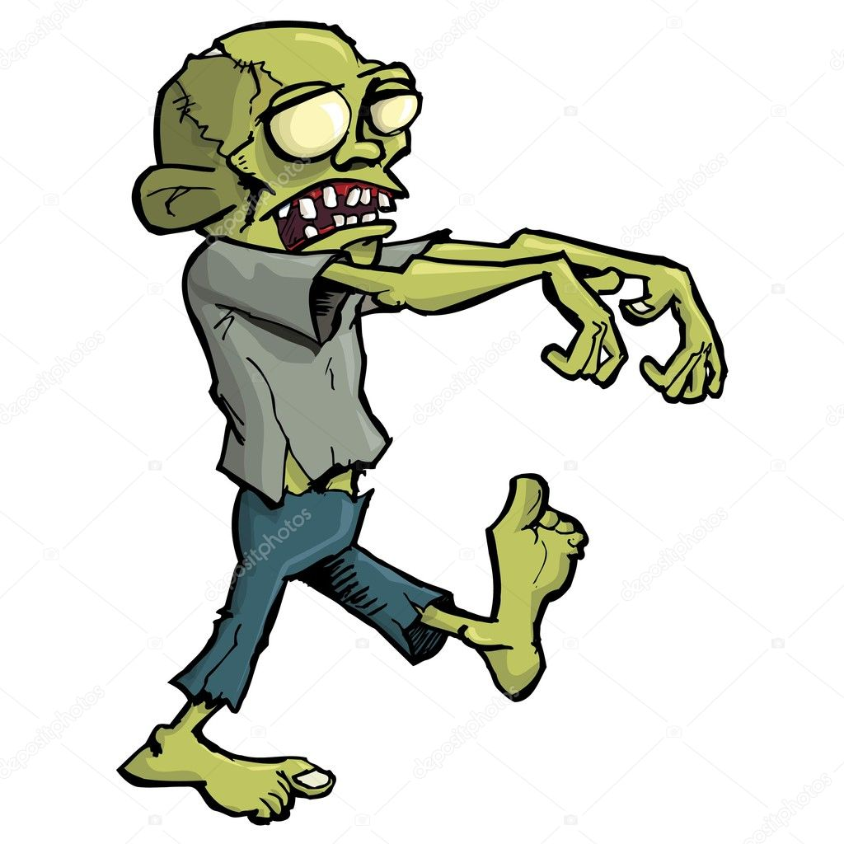



**How do you plan to make your game engaging?**

Answer- 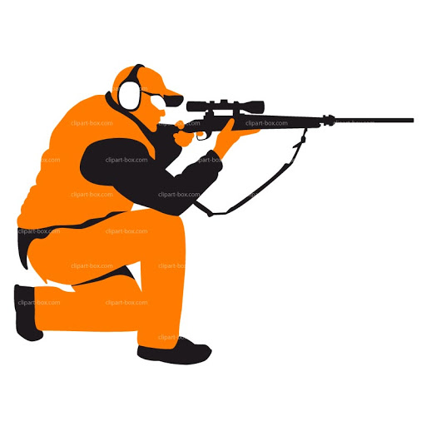

Limited amount of bullets

Game ends when bullets are over

**Conditions for ending game:**

* + - 1. **WHEN THE SHOOTER LOSES ALL THE LIVES**
      2. **WHEN THE SHOOTER RUNS OUT OF BULLETS**