Spatiotemporal CNN–LSTM Framework for Maharashtra Kharif Crop Failure Prediction
Comprehensive Technical, Mathematical, Architectural, and Operational Documentation
Scope  36 Districts of Maharashtra  6 Primary Kharif Crops | Sensors & Data  Sentinel-2 L2A (10m), Copernicus DEM  NASA MODIS 500m, IMD Rainfall, ONI | Core Architecture  Spatiotemporal 2D-CNN + BiLSTM  with 6D Crop Conditioning Vector
Ground Truth Standard  PMFBY 5-Year Olympic Baseline  Yield Deficit >= 15% | Web Engine  React 18, Vite, TypeScript, Tailwind  Dual-Resolution Earth Engine Terrain | Repository Links  Hugging Face Hub / UsmanSait  GitHub / usmanssait/ElninoPBLProject

1. Executive Summary & Problem Statement
Maharashtra is among India's foremost agricultural states, yet over 70% of its cultivated Kharif acreage is rainfed and exceptionally sensitive to meteorological anomalies driven by the El Niño Southern Oscillation (ENSO) and the Indian Ocean Dipole (IOD). Ocean warming in the equatorial Pacific (Niño 3.4 SST anomalies) disrupts the seasonal monsoon trough, triggering prolonged dry spells, soil moisture depletion, and crop failure across staple cereals and commercial crops—including Rice in Konkan and Vidarbha, Soybean in Marathwada, and Cotton in Vidarbha.
This project establishes a unified spatiotemporal deep learning early-warning framework that combines high-resolution Sentinel-2 multi-spectral satellite imagery (8 spectral bands across 6 observation windows) with India Meteorological Department (IMD) gridded rainfall data, NOAA CPC Oceanic Niño Index (ONI) sea-surface temperatures, and official Department of Agriculture (DES) harvest yield records (1966–2024). The system is deployed via a production-grade React 18 GIS dashboard featuring a gapless, dual-resolution Earth Engine satellite terrain basemap.

2. End-to-End System Architecture
The end-to-end framework bridges offline remote sensing pipelines, recurrent deep learning, and interactive web visualization:
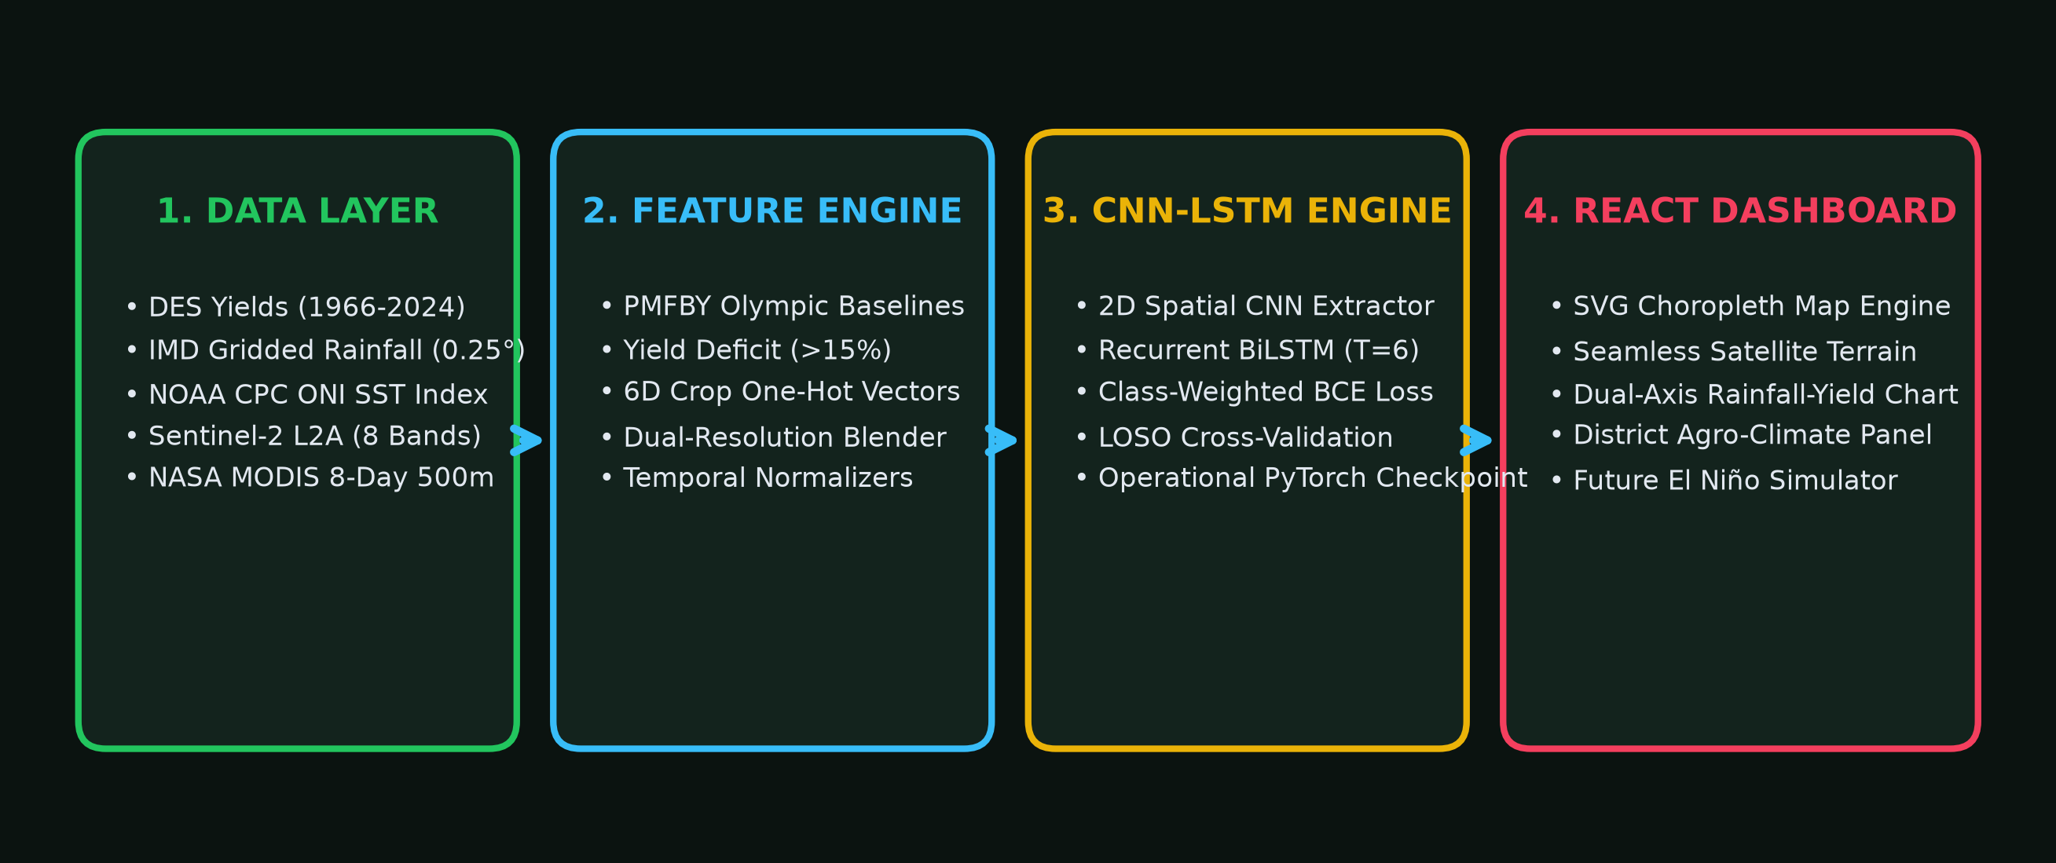
System Pipeline: Figure 1: High-level system architecture spanning data acquisition, feature engineering, neural network training, and the React decision dashboard.

3. Data Sources & Provenance Catalog
The model and dashboard integrate five authoritative meteorological, agronomic, and earth observation datasets:
Dataset / Parameter | Source Agency | Spatial Extent | Temporal Window | Role in Pipeline
Kharif Crop Yield Statistics | DES Maharashtra & ICRISAT | 36 Districts | 1966 – 2024 (58 seasons) | Ground-truth yields, Olympic baselines & labels
District Kharif Rainfall | India Meteorological Dept (IMD) | 0.25° Gridded | 2015 – 2024 | Cumulative precipitation (mm) & departures (%)
Oceanic Niño Index (ONI) | NOAA CPC | Niño 3.4 Region | 1950 – 2024 | ENSO sea-surface temperature summer anomalies
Sentinel-2 Multi-Spectral | ESA / Copernicus Hub / GEE | 10m Resampled 32x32 | 2019 – 2022 (6 windows) | 8-band canopy reflectance, NDVI & NDWI
Copernicus DEM (GLO-30) | ESA | 30m / 90m Global | Static | Topographic relief for Western Ghats & Deccan
NASA MODIS Surface Refl. | NASA LP DAAC (MOD09A1) | 500m Global | 8-Day Composite | Seamless regional outer basemap (62°E–92°E)

4. Agricultural Ground Truth & Failure Label Definition
To establish realistic agronomic ground truth, the pipeline implements the official Pradhan Mantri Fasal Bima Yojana (PMFBY) 5-year rolling Olympic baseline. Agricultural yields exhibit long-term technological increases, making fixed thresholding invalid. The Olympic average isolates true climate collapse from natural variance.
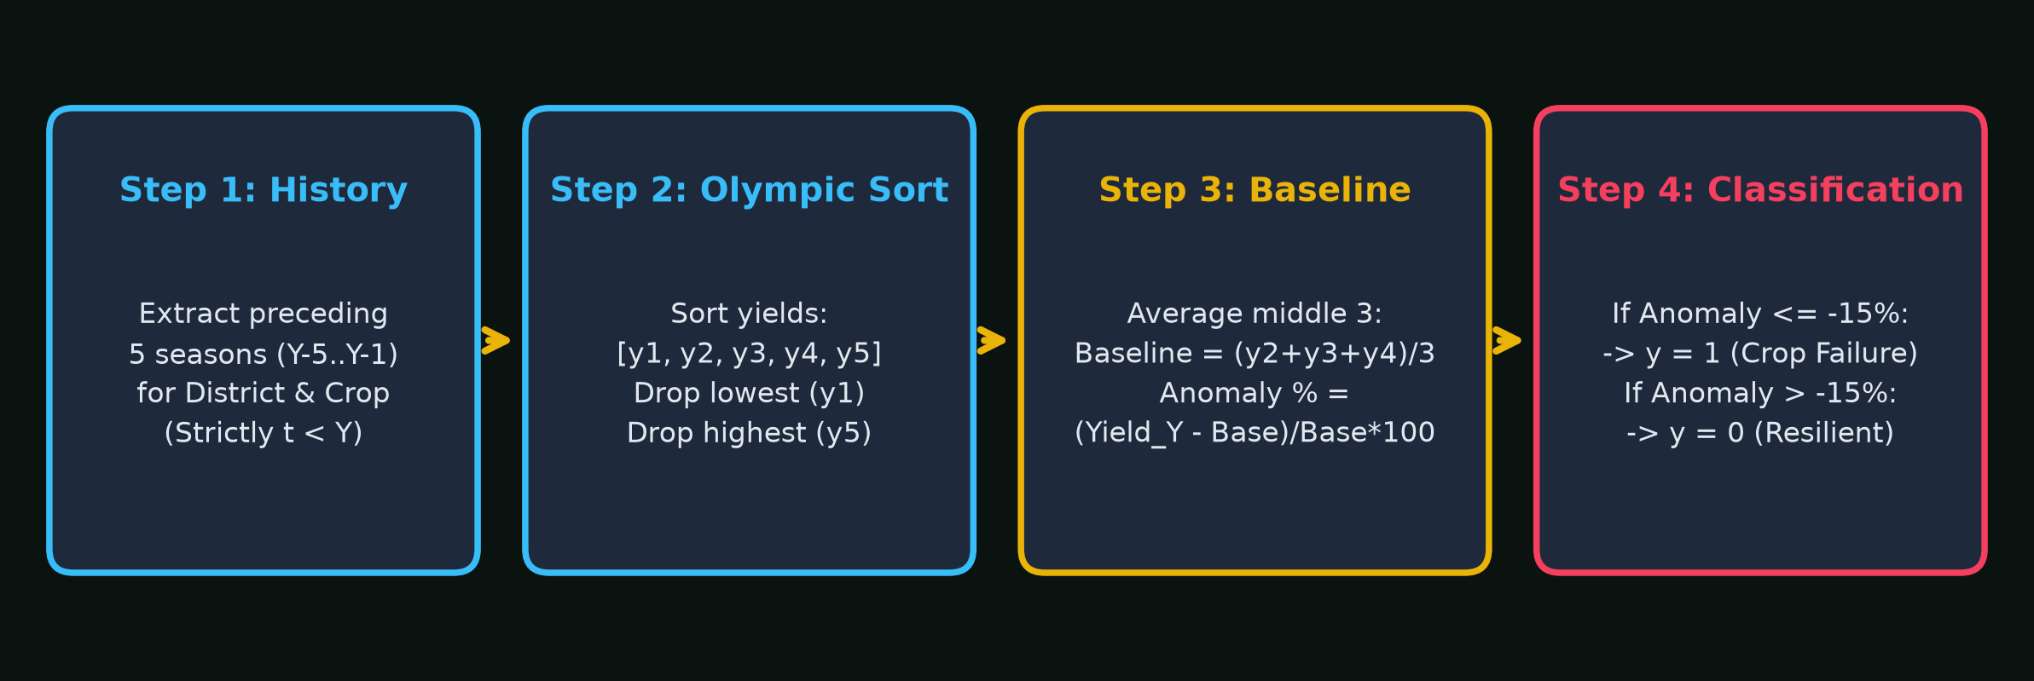
Baseline Logic: Figure 2: PMFBY 5-year rolling Olympic baseline workflow and >= 15% deficit failure classification.
Mathematical Formulation: For district D, crop C, and year Y, we collect preceding valid harvest yields: Y_prior = { Yield_(D,C,t) | Y-7 <= t < Y and Yield > 0 }. When >= 5 years exist, yields are sorted in ascending order [y(1), y(2), y(3), y(4), y(5)]. The highest and lowest values are dropped, and the middle 3 are averaged: Baseline = (y(2) + y(3) + y(4)) / 3. Anomaly % = ((Yield_Y - Baseline) / Baseline) * 100. Failure label y = 1 if Anomaly <= -15.0%, else y = 0. Temporal integrity is strictly preserved: no concurrent or future yields influence the baseline.

5. Spatiotemporal CNN–LSTM Deep Learning Architecture
The neural network architecture integrates spatial visual feature extraction with sequential temporal recurrent modeling. Each training observation is represented as a sequence across T = 6 fortnightly Kharif observation windows (mid-June through late August).
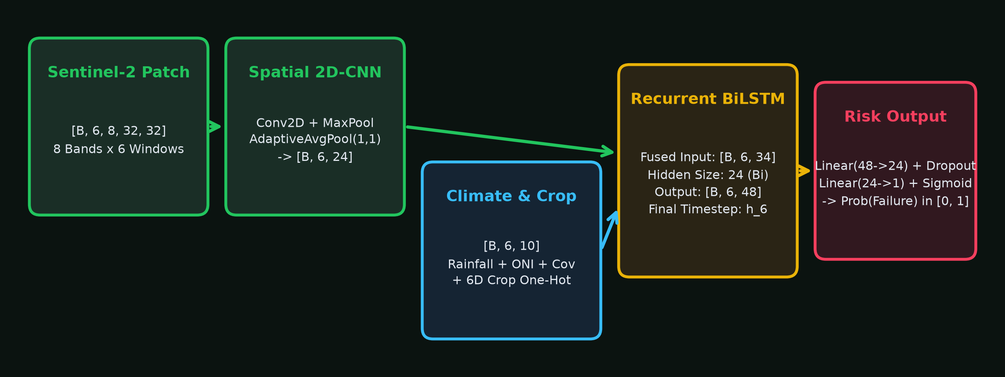
Neural Network Architecture: Figure 3: Spatiotemporal tensor flow through 2D-CNN feature extraction, climate/crop conditioning fusion, BiLSTM recurrent modeling, and binary risk classification head.

Layer Tensor Shapes & Flow
1. Satellite Patch Input: Shape [Batch, T=6, C=8, H=32, W=32]. The 8 channels comprise B2 (Blue), B3 (Green), B4 (Red), B8 (NIR), B11 (SWIR1), B12 (SWIR2), NDVI, and NDWI.
2. 2D Spatial CNN Extractor: Reshapes tensor to [Batch*6, 8, 32, 32], applies Conv2D(8->16, k=3, p=1) + BatchNorm2d + ReLU + MaxPool2d(2) -> Conv2D(16->24, k=3, p=1) + BatchNorm2d + ReLU + MaxPool2d(2) -> AdaptiveAvgPool2d((1,1)) -> Flatten. Result: [Batch, T=6, 24] visual features.
3. Climate & Conditioning Sequence: Shape [Batch, T=6, 10]. Contains normalized rainfall, normalized departure, normalized ONI anomaly, valid pixel coverage fraction, and the 6D one-hot crop vector.
4. Fused Sequential Input: Fused via torch.cat([Spatial_24, Climate_10], dim=-1) to yield input dimension 34 per timestep.
5. Bidirectional LSTM Stage: 1 layer, bidirectional, hidden size 24. Outputs [Batch, T=6, 48].
6. Temporal Pooling & Classification Head: Extracts the final timestep state h_6 [Batch, 48], applies Linear(48->24) + ReLU + Dropout(p=0.25) -> Linear(24->1) -> Sigmoid activation.
7. Class-Weighted Loss: Optimized using BCEWithLogitsLoss with positive weighting pos_weight = N_neg / N_pos ≈ 4.33, heavily penalizing missed disasters.

6. Crop Conditioning Mechanism & Proxy Disclosure
Inside train_all_kharif_crops_cnn_lstm.py, crop conditioning is implemented via a 6-dimensional one-hot identity vector: Rice [1,0,0,0,0,0], Soybean [0,1,0,0,0,0], Cotton [0,0,1,0,0,0], Bajra [0,0,0,1,0,0], Jowar [0,0,0,0,1,0], Tur [0,0,0,0,0,1]. This vector is concatenated directly into the sequence input at every timestep of the BiLSTM, enabling the network to learn crop-specific vulnerability thresholds.
⚠️ TECHNICAL & ACADEMIC DISCLOSURE: In the current Sentinel-2 dataset (MH_Rice_S2_Patches_*.geojson), patches were sampled across agricultural pixels within 20 pilot districts. The multi-crop model pairs the same regional agricultural patch with each crop's one-hot identity vector and target label. Therefore, the satellite branch acts as a REGIONAL AGRO-CLIMATIC PROXY (reflecting district-wide vegetative vigor, canopy health, and moisture stress via NDWI), while the crop vector directs the network to predict that crop's vulnerability. The model does NOT view field-level segmented crop polygons (e.g. exclusive cotton or soybean parcels).

7. Leave-One-Season-Out (LOSO) Validation & Evaluation Metrics
To guarantee zero temporal leakage, the model was validated using Leave-One-Season-Out (LOSO) cross-validation across all test seasons (2019, 2020, 2021, and 2022). Normalization parameters were fitted strictly on training folds.

Per-Crop Operational Performance Table (320 District-Crop Seasons)
Crop | Records | Failures | Failure % | TN | FP | FN | TP | Precision | Recall | F1 | Bal. Acc. | ROC-AUC
Bajra | 37 | 5 | 13.5% | 32 | 0 | 0 | 5 | 100.0% | 100.0% | 1.000 | 1.000 | 1.000
Cotton | 49 | 8 | 16.3% | 40 | 1 | 0 | 8 | 88.9% | 100.0% | 0.941 | 0.988 | 0.993
Jowar | 49 | 16 | 32.7% | 27 | 6 | 0 | 16 | 72.7% | 100.0% | 0.842 | 0.909 | 0.976
Rice | 63 | 8 | 12.7% | 51 | 4 | 0 | 8 | 66.7% | 100.0% | 0.800 | 0.964 | 0.969
Soybean | 54 | 14 | 25.9% | 36 | 4 | 0 | 14 | 77.8% | 100.0% | 0.875 | 0.950 | 0.991
Tur | 68 | 9 | 13.2% | 58 | 1 | 1 | 8 | 88.9% | 88.9% | 0.889 | 0.936 | 0.985
Overall | 320 | 60 | 18.8% | 244 | 16 | 1 | 59 | 78.7% | 98.3% | 0.874 | 0.961 | 0.984

Key Findings: Across all 320 district-crop seasons, 59 out of 60 historical failures were correctly predicted (Recall = 98.3%). Positive class re-weighting keeps false negatives near zero at the expense of a moderate false-alarm rate in Rice (66.7% precision) and Jowar (72.7% precision), which aligns with agrarian disaster management priorities.

8. Geospatial Satellite Terrain & Earth Engine Mapping Engine
The district risk map integrates an authentic, dual-resolution Earth observation basemap. To eliminate the stepped tile dropouts caused by land-only DEMs, the pipeline executes a three-stage compositing workflow:
• Step 1 (Earth Engine MODIS Export): Uses NASA MODIS 8-day surface reflectance (MOD09A1) across [62.0°E, 8.0°N, 92.0°E, 30.0°N]. Because MODIS images land and ocean in a single continuous grid, it never cuts off at the coast.
• Step 2 (Python Dual-Resolution Blending): Blends the 500m MODIS regional canvas with the ~540MB high-res Maharashtra GeoTIFF (10m Sentinel-2 + DEM) using a 20px Gaussian-blurred alpha mask and color-ratio balancing. Post-export fills the southwest ocean corner with RGB(0, 11, 21).
• Step 3 (React SVG Transform): Maps the combined WebP asset to SVG viewBox (0, 0, 860, 713) with coordinates x = -1091.8 px, y = -859.9 px, width = 3089.8 px, height = 2394.6 px, guaranteeing zero black margins even at 25% zoom out.
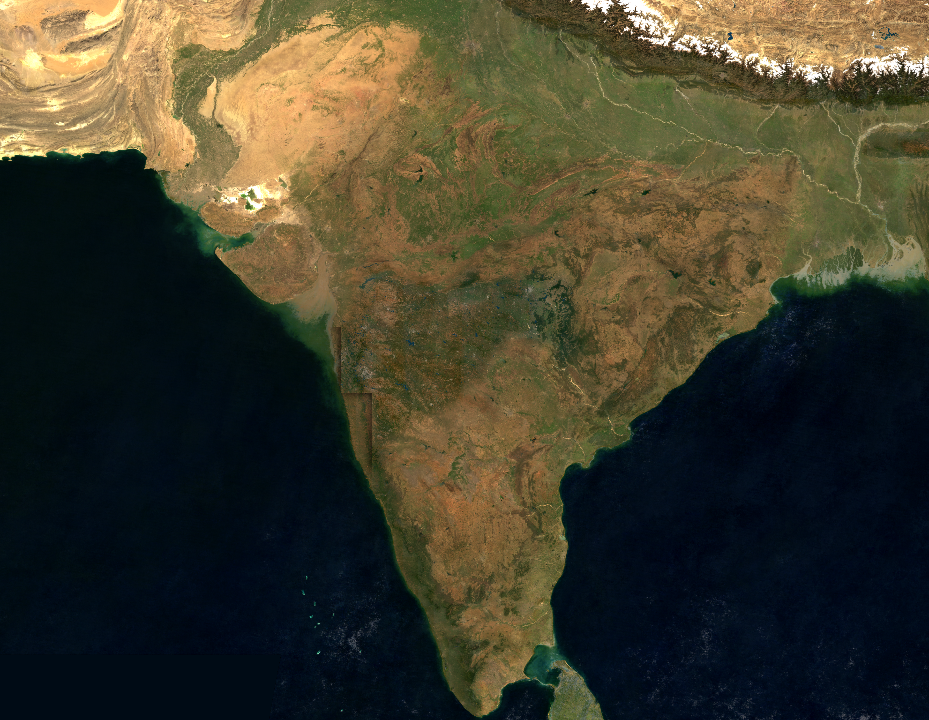
Basemap Preview: Figure 4: Master dual-resolution satellite terrain basemap combining high-resolution Maharashtra Sentinel-2 + DEM core with wide regional MODIS Arabian Sea and Indian subcontinent canvas.

9. Frontend Dashboard Architecture & UI Components
Built with React 18, Vite, TypeScript, and TailwindCSS, the dashboard provides interactive decision support:
• DashboardContext.tsx: Global state manager coordinating selectedYear, selectedDistrictId, selectedCrop, and 320 precomputed CNN-LSTM inferences.
• DistrictChoropleth.tsx: Interactive SVG choropleth with mouse drag-panning, wheel-zooming (clamped 75%–250%), dynamic risk categorization, and satellite terrain alignment.
• RainfallYieldChart.tsx: Synchronized dual-axis chart contrasting IMD precipitation against harvest yields, with vertical indicators marking historical El Niño drought years.
• FutureElNinoPage.tsx: Policy scenario simulator modeling crop-specific vulnerability under synthetic +0.5°C to +2.5°C ENSO sea-surface temperature shocks.

10. Execution, Retraining, and Reproduction Guide
Local Dev: 1. Launch Web Application:
npm install && npm run dev (Runs on http://localhost:3000)
Model Training: 2. Retrain Multi-Crop Model:
& 'C:\Users\USMAN\AppData\Local\Python\bin\python.exe' CNN_LSTM_Training/CropFailureProject/train_all_kharif_crops_cnn_lstm.py
Terrain Pipeline: 3. Re-generate Satellite Terrain Basemap:
& 'C:\Users\USMAN\AppData\Local\Python\bin\python.exe' scripts/combine_wide_satellite_terrain.py -i data/regional_seamless_satellite_terrain_500m.tif
Data Backup: 4. Synchronize with Hugging Face Hub:
& 'C:\Users\USMAN\AppData\Local\Python\bin\python.exe' hf_sync.py --repo-id UsmanSait/elnino-crop-failure-pbl --repo-type dataset --token <HF_TOKEN>

