THE ROLE OF PHYSICAL EDUCATION IN PROMOTING MENTAL HEALTH AMONG STUDENTS OF UNIVERSITY LEVEL



**A Thesis submitted by**

**Meerab Shahzadi (42)**

**Ayesha Kanwal (15)**

**Tehreem Fatima Farooq (40)**

**Affifa Razaq (46)**

**Ayesha Riaz (27)**

**Supervisor**

**Ma’am Sumaira**

Submitted in the partial fulfillment of the requirements for the degree of

Bachelor of Health and Physical Education

Faculty of Arts Science

**DEPARTMENT OF HEALTH AND PHYSICAL EDUCATION  
GCWUF**

**May 2024**

**DEPARTMENT OF HEALTH AND PHYSICAL EDUCATION**



**CERTIFICATE**

This is to certify that “**THESIS REPORT ON, THE ROLE OF PHYSICAL EDUCATION IN PROMOTING MENTAL HEALTH AMONG STUDENTS OF UNIVERSITY LEVEL"** is submitted in partial fulfillment of the requirement for the degree of Bachelor of Health and Physical Education by the following students:

ACKNOWLEDGEMENT

I would like to express my sincere gratitude to all those who have contributed to the completion of this thesis.

First and foremost, I am deeply grateful to my supervisor, [Ma’am Sumaira], for their invaluable guidance, support, and encouragement throughout this research. Their expertise and insights have been instrumental in shaping this work.

I would also like to thank the faculty and staff of [GCWUF], especially the members of my thesis committee, for their constructive feedback and suggestions.

I am grateful to my colleagues and friends for their understanding and support during this challenging journey. Their encouragement has been a source of strength for me.

I would also like to acknowledge the support of [GCWUF] for providing me with the necessary resources, data, and facilities for conducting my research.

Finally, I would like to thank my family for their unwavering love, encouragement, and support throughout my academic endeavors. Their belief in me has been a driving force behind my success.

I am truly grateful to everyone who has been a part of this journey. Thank you for your support.

DEDICATION

I dedicate this thesis to my family and friends who have been my constant source of love, support, and inspiration. Their unwavering belief in me has been a guiding light throughout this journey. I am grateful for their encouragement, understanding, and patience, which have helped me overcome challenges and achieve my goals. This work is dedicated to them with heartfelt gratitude and love.

Table of Contents

Table of Contents v

List of Abbreviations vii

ABSTRACT 1

1. INTRODUCTION 3

1.1 BACKGROUND 3

1.2 PROBLEM STATEMENT 4

1.3 AIMS AND OBJECTIVES 5

1.4 THEORETICAL FRAMEWORK 5

1.4.1 Biological Factors: 6

1.4.2 Psychological Factors: 6

1.4.3 Social Factors: 6

1.4.4 Conceptual Framework 7

1.5 RESEARCH OBJECTIVE 8

1.5.1 Objectives: 8

1.5.2 Research Questions: 9

2. LITERATURE REVIEW 10

2.1 PHYSICAL EDUCATION AND MENTAL HEALTH 10

2.2 THEORETICAL PERSPECTIVES ON PHYSICAL ACTIVITY AND MENTAL WELL-BEING 11

2.3 TYPES OF PHYSICAL EDUCATION INTERVENTION AND THEIR IMPACT ON MENTAL HEALTH 12

2.4 INDIVIDUAL DIFFERENCES AND MODERATING FACTORS 13

2.5 GAPS IN EXISTING LITERATURE 14

3. METHODOLOGY 17

3.1 RESEARCH DESIGN 17

3.2 SAMPLING STRATEGY 17

3.3 DATA COLLECTION METHODS 18

3.4 DATA ANALYSIS TECHNIQUES 18

3.5 ETHICAL CONSIDERATIONS 18

4. RESULT 19

4.1 DESCRIPTIVE STATISTICS 19

4.2 RELATIONSHIP BETWEEN PHYSICAL EDUCATION PARTICIPATION AND MENTAL HEALTH OUTCOMES 20

4.3 PSYCHOLOGICAL MECHANISMS AND MEDIATING FACTORS 22

4.4 IMPACT OF INTENSITY AND DURATION OF PHYSICAL EDUCATION INTERVENTIONS 22

4.5 MODERATING EFFECTS OF DEMOGRAPHIC FACTORS 25

4.6 BARRIERS AND FACILITATORS TO PARTICIPATION IN PHYSICAL EDUCATION PROGRAMS 25

5. DISCUSSION AND CONCLUSION 26

5.1 SUMMARY OF FINDINGS 26

5.2 COMPARISON WITH EXISTING LITERATURE 26

5.3 THEORETICAL AND PRACTICAL IMPLICATIONS 26

5.4 STRENGTHS AND LIMITATIONS OF THE STUDY 27

5.5 SUGGESTIONS FOR FUTURE RESEARCH 27

5.6 CONCLUSION AND RECOMMENDATIONS FOR PROMOTING MENTAL HEALTH THROUGH PHYSICAL EDUCATION IN UNIVERSITY SETTINGS 27

REFERENCES 28

List of Abbreviations

HPE Health Physical Education

ABSTRACT

This thesis investigates the role of physical education (PE) in promoting mental health among university-level students. The study explores the relationship between participation in PE programs and various mental health outcomes, including anxiety, depression, and stress. The research aims to contribute to a deeper understanding of the mechanisms through which engagement in physical activity within the context of PE can enhance mental well-being.

Theoretical frameworks such as the Biopsychosocial Model guide this study, which adopts a quantitative methodology. A thorough literature review examines the impact of different types of PE interventions, individual differences, and moderating factors on mental health outcomes. The study also considers institutional support and access to recreational facilities as influential factors.

The methodology chapter outlines the research design, sampling strategy, data collection methods, and data analysis techniques. Ethical considerations are addressed to ensure the well-being and privacy of participants.

The results section presents descriptive statistics and explores the relationship between PE participation and mental health outcomes. It also examines psychological mechanisms, mediating factors, and the impact of intervention intensity and duration. The study investigates the moderating effects of demographic factors and identifies barriers and facilitators to participation in PE programs.

The discussion and conclusion section summarizes the findings, compares them with existing literature, and discusses theoretical and practical implications. Strengths and limitations of the study are acknowledged, and suggestions for future research are provided. The thesis concludes with recommendations for promoting mental health through PE in university settings, emphasizing the importance of tailored approaches that consider individual differences and institutional support.

Chapter-1

# INTRODUCTION

## BACKGROUND

Physical education (PE) has long been recognized as a vital component of educational curricula, primarily aimed at fostering physical health and fitness among students. However, in recent years, there has been a growing acknowledgment of its broader significance in promoting mental health, particularly among university-level students.

Amidst the increasing prevalence of mental health disorders such as anxiety, depression, and stress among college students, there is a pressing need to explore holistic approaches to well-being that extend beyond traditional academic pursuits. Research has consistently demonstrated the positive correlation between regular physical activity, such as that encouraged through physical education programs, and improved mental well-being.

Understanding the role of physical education in promoting mental health among university students is crucial for several reasons. Firstly, mental health issues can significantly impact academic performance, student retention, and overall quality of life. By integrating mental health promotion initiatives within physical education curricula, universities can contribute to the holistic development of students and support their academic success.

Moreover, the transition to university life represents a critical period characterized by increased stressors and academic pressures. Physical education programs offer a unique opportunity to not only alleviate stress and anxiety but also to foster social connections, enhance self-esteem, and improve mood, thereby promoting resilience and coping skills among students.

Furthermore, promoting mental health through physical education aligns with broader public health initiatives aimed at reducing the burden of mental illness and promoting overall well-being. By equipping university students with the tools and resources to prioritize their mental health, institutions can contribute to the cultivation of a healthier and more resilient future workforce.

In conclusion, recognizing the role of physical education in promoting mental health among university students is not only essential for individual well-being but also for the overall health and productivity of society. By prioritizing mental health within physical education curricula, universities can create supportive environments that empower students to thrive academically, socially, and emotionally.

## PROBLEM STATEMENT

Despite the recognized benefits of physical education (PE) in promoting mental health among university students, significant gaps remain in our understanding of the specific mechanisms through which PE interventions impact mental well-being. Research consistently shows that mental health issues, such as anxiety, depression, and stress, are prevalent among university students. For instance, the American College Health Association's National College Health Assessment reported that over 60% of students felt overwhelming anxiety, and 40% experienced depression severe enough to impact their functioning [1].

However, many studies examining the relationship between PE and mental health are limited by their cross-sectional designs [2], [3], which hinders the ability to establish causality or assess long-term effects. Longitudinal research is needed to better understand how sustained participation in PE can influence mental health outcomes over time.

Additionally, there is a dearth of research on the practical implementation and sustainability of PE interventions in real-world university settings. Studies have shown that individual and contextual factors, such as gender, socioeconomic status, and access to recreational facilities, significantly influence PE participation and its mental health benefits [4], [5]. However, these factors are often underexplored in the literature, leading to a gap in understanding how to tailor PE programs to diverse student populations.

This study aims to address these gaps by investigating how participation in PE programs affects mental health outcomes, such as anxiety, depression, and stress, among university students. By identifying the specific mechanisms and influential factors, this research seeks to inform the development of effective and sustainable mental health promotion strategies through PE in university settings.

## AIMS AND OBJECTIVES

The aim of this study is to investigate the role of physical education in promoting mental health among university-level students. Specifically, the study seeks to explore the relationship between participation in physical education programs and various mental health outcomes, such as anxiety, depression, and stress.

By examining the impact of physical education interventions on mental well-being, the study aims to contribute to a deeper understanding of the mechanisms through which engagement in physical activity within the context of physical education can enhance mental health among university students.

Furthermore, the study aims to assess the effectiveness of different types, intensities, and durations of physical education interventions in improving mental health outcomes. This includes exploring the benefits of various activities such as aerobic exercise, team sports, and mindfulness-based practices in reducing stress, enhancing mood, and improving overall psychological well-being.

Additionally, the study seeks to investigate the moderating effects of demographic factors, such as gender, socioeconomic status, and academic discipline, on the relationship between participation in physical education and mental health outcomes. Understanding how these factors influence the effectiveness of physical education interventions can inform targeted approaches to mental health promotion among diverse student populations.

Overall, the aim of this study is to provide insights that can inform the development of evidence-based strategies and interventions within university settings to promote mental health through physical education, ultimately contributing to the holistic well-being and academic success of university students.

## THEORETICAL FRAMEWORK

The theoretical framework guiding this study is the Biopsychosocial Model proposed by George Engel in 1977. This model posits that health outcomes are influenced by a complex interplay of biological, psychological, and social factors. Within the context of promoting mental health among university students through physical education, the Biopsychosocial Model offers a comprehensive framework for understanding the multifaceted nature of the relationship between physical activity and mental well-being.

### Biological Factors:

Regular physical activity impacts various physiological processes linked to mental health outcomes [6].

Exercise stimulates the release of endorphins and neurotransmitters such as serotonin and dopamine, which are associated with improved mood and reduced stress levels [6].

Exercise enhances neuroplasticity and neurogenesis, leading to improvements in cognitive function and emotional regulation [7].

### Psychological Factors:

Engagement in physical activity within physical education can profoundly affect mental well-being [19].

Exercise reduces symptoms of anxiety and depression, enhances self-esteem, and improves psychological resilience [19].

Physical education programs provide opportunities for stress reduction, relaxation, and mindfulness practices, contributing to better coping strategies and emotional regulation among university students [8].

### Social Factors:

**Peer Interaction**: Participation in physical education fosters social connections and interpersonal relationships among students, enhancing feelings of belonging and support [9].

**Team Dynamics**: Team sports and group exercise classes offer social interaction, peer support, and a sense of camaraderie, which are crucial for mental health and well-being [10].

**Community Support**: Social support networks established within physical education settings can serve as protective factors against mental health disorders and promote positive mental health outcomes [11].

**Institutional Environment**: The university’s support for physical education programs, including the availability of facilities and resources, contributes to creating a supportive environment for mental health [12].

**Cultural Norms**: Cultural attitudes towards physical activity and health can influence the degree of engagement in physical education and its perceived benefits [13].

By adopting the Biopsychosocial Model as the theoretical framework for this study, we aim to explore how physical education interventions address biological, psychological, and social factors to promote mental health among university students. This holistic approach recognizes the interconnectedness of these factors and underscores the importance of comprehensive strategies for mental health promotion within educational settings.

### Conceptual Framework

The conceptual framework visually represents the relationships and concepts discussed in this study:

**Central Concept**: Role of Physical Education in Promoting Mental Health among University Students

**Independent Variable**: Participation in Physical Education (PE) Programs

**Dependent Variables**: Mental Health Outcomes: Anxiety, Depression, Stress

**Mediating Variables**: Self-Esteem, Social Support

**Moderating Variables**: Gender, Socioeconomic Status, Academic Discipline, Age

Body Mass Index (BMI), Place of Residence

**Theoretical Framework**:

Biopsychosocial Model [18], Self-Determination Theory [14], Cognitive-Behavioral Theory [15], Social Cognitive Theory [16], Flow Theory [17]

## RESEARCH OBJECTIVE

### Objectives:

To examine the impact of physical education interventions on mental well-being among university students.

To identify and understand the mechanisms through which physical education influences mental health, including biological, psychological, and social factors.

To evaluate the effectiveness of different types, intensities, and durations of physical education interventions on mental health outcomes.

To explore the moderating effects of demographic factors (e.g., gender, socioeconomic status, academic discipline) on the relationship between physical education participation and mental health outcomes.

To develop evidence-based recommendations for integrating physical education into university programs to enhance student mental health and academic success.

### Research Questions:

How do physical education interventions impact mental well-being, specifically anxiety, depression, and stress, among university students?

What are the biological, psychological, and social mechanisms through which physical education participation influences mental health outcomes among university students?

How do different types, intensities, and durations of physical education interventions affect mental health outcomes such as anxiety, depression, and stress among university students?

How do demographic factors such as gender, socioeconomic status, and academic discipline moderate the relationship between physical education participation and mental health outcomes among university students?

What evidence-based strategies can be developed to integrate physical education into university programs to improve mental health and academic success among students?

Chapter-2

# LITERATURE REVIEW

## PHYSICAL EDUCATION AND MENTAL HEALTH

The relationship between physical education and mental health among university students is multifaceted and dynamic. Engaging in regular physical activity within the context of physical education programs has been associated with numerous mental health benefits, including reduced stress, anxiety, and depression, as well as improved mood and cognitive function [3, 7, 9].

Participation in physical education activities, such as aerobic exercise, team sports, and mindfulness-based practices, provides opportunities for stress reduction, relaxation, and social interaction, which are crucial for supporting mental well-being. Physical activity stimulates the release of endorphins and other neurotransmitters that promote feelings of happiness and well-being while also enhancing neuroplasticity and cognitive function [3, 7].

Moreover, physical education programs offer a supportive and inclusive environment where students can develop confidence, self-esteem, and a sense of belonging. Engaging in physical activity can serve as a coping mechanism for managing academic stressors and navigating the challenges of university life [6, 9].

However, the relationship between physical education and mental health is not without its complexities. Individual differences, such as personality traits, coping styles, and pre-existing mental health conditions, can influence how students engage with physical education activities and the extent to which they experience mental health benefits. Additionally, contextual factors, including institutional support for physical education programs, access to recreational facilities, and cultural norms surrounding physical activity, can impact the effectiveness of physical education interventions in promoting mental health among university students [9, 10].

Overall, while physical education plays a significant role in promoting mental health among university students, it is important to recognize the need for comprehensive and tailored approaches that address individual differences and contextual factors. By prioritizing mental health within physical education curricula and providing inclusive and accessible opportunities for physical activity, universities can support the holistic well-being and academic success of their students.

## THEORETICAL PERSPECTIVES ON PHYSICAL ACTIVITY AND MENTAL WELL-BEING

**Self-Determination Theory (SDT)**: Self-Determination Theory (SDT), proposed by Deci and Ryan, posits that individuals have innate psychological needs for autonomy, competence, and relatedness. When these needs are satisfied, individuals experience greater well-being and motivation. This theory is particularly relevant to the study of physical education and mental health because it explains how engaging in physical activities can fulfill these psychological needs, leading to improved mental health outcomes.

**Autonomy**: In the context of physical education, autonomy refers to the ability of students to choose their preferred physical activities. When students have the freedom to select activities they enjoy, they are more likely to participate consistently, which can lead to improved mental health. The sense of control and self-direction enhances motivation and engagement in physical education programs [13, 14].

**Competence**: Physical education programs that provide opportunities for skill development and mastery contribute to students' sense of competence. When students feel capable and effective in their physical activities, their self-esteem and confidence improve, which are crucial for mental well-being. This sense of competence can help reduce anxiety and depression [14].

**Relatedness**: Physical education often involves social interaction through team sports and group exercises, fostering a sense of belonging and connectedness among students. These social connections provide emotional support and help reduce feelings of loneliness and isolation, which are significant factors in mental health [12, 14].

By supporting autonomy, competence, and relatedness, physical education programs can effectively enhance mental health outcomes, such as reducing anxiety, depression, and stress, and improving overall well-being among university students.

## TYPES OF PHYSICAL EDUCATION INTERVENTION AND THEIR IMPACT ON MENTAL HEALTH

Various types of physical education interventions have been studied for their impact on mental health among university students. These interventions can be broadly categorized into aerobic exercises, team sports, mindfulness-based practices, resistance training, outdoor activities, and group exercise classes.

**Aerobic Exercise:** Activities such as running, swimming, or cycling have been associated with numerous mental health benefits, including reduced symptoms of depression, anxiety, and stress. Aerobic exercise stimulates the release of endorphins, neurotransmitters that promote feelings of happiness and well-being while also improving cardiovascular health and enhancing cognitive function [3, 7].

**Team Sports:** Participating in team sports such as soccer, basketball, or volleyball provides opportunities for social interaction, peer support, and a sense of belonging, all of which are crucial for mental well-being. Team sports promote camaraderie, cooperation, and teamwork, fostering positive relationships and enhancing self-esteem and confidence [9, 10].

**Mindfulness-Based Practices:** Practices such as yoga, tai chi, or meditation emphasize present-moment awareness and non-judgmental acceptance of thoughts and emotions. These practices have been found to reduce symptoms of anxiety, depression, and stress while also promoting relaxation, emotional regulation, and overall psychological well-being [6, 13].

**Resistance Training:** Resistance training, which involves lifting weights or using resistance bands to build strength and muscle mass, has been shown to improve mood, reduce symptoms of anxiety and depression, and enhance self-esteem and body image. Resistance training increases levels of neurotransmitters such as serotonin and dopamine, which are associated with improved mood and well-being [7].

**Outdoor Activities:** Engaging in outdoor activities such as hiking, gardening, or nature walks has been linked to improved mental health outcomes, including reduced stress, anxiety, and depression. Spending time in nature promotes relaxation, stress reduction, and a sense of connection with the natural world, all of which contribute to enhanced mental well-being [6].

**Group Exercise Classes:** Participating in group exercise classes such as aerobics, dance, or Pilates provides opportunities for social interaction, peer support, and a sense of community. Group exercise classes promote motivation, accountability, and enjoyment while also improving mood, reducing stress, and enhancing overall psychological well-being [9].

## INDIVIDUAL DIFFERENCES AND MODERATING FACTORS

Individual differences and moderating factors play a significant role in the relationship between participation in physical education and mental health outcomes. These factors can influence how students engage with physical education activities and the extent to which they benefit from them.

**Personality Traits:** Individual differences in personality traits such as extraversion, neuroticism, and conscientiousness can moderate the relationship between participation in physical education and mental health outcomes. For example, individuals high in extraversion may derive greater social enjoyment and satisfaction from participating in group physical activities, leading to enhanced mental well-being. Conversely, individuals high in neuroticism may be more susceptible to stress and anxiety and may require additional support and coping strategies to benefit fully from physical education interventions [10, 14].

**Coping Styles:** Variations in coping styles, such as problem-focused coping versus emotion-focused coping, can influence how individuals respond to stressors and challenges encountered within physical education settings. Those who employ adaptive coping strategies, such as seeking social support or engaging in problem-solving, may experience greater resilience and mental well-being. Conversely, individuals who rely on maladaptive coping strategies, such as avoidance or substance use, may experience heightened stress and negative mental health outcomes [11, 15].

**Pre-existing Mental Health Conditions:** Individuals with pre-existing mental health conditions such as depression, anxiety disorders, or post-traumatic stress disorder (PTSD) may respond differently to physical education interventions compared to those without mental health concerns. While physical activity has been shown to be beneficial for managing symptoms of these conditions, individuals with severe or untreated mental health disorders may require specialized support and accommodations within physical education programs to ensure their well-being [12].

**Socioeconomic Status (SES):** Socioeconomic factors, such as income level, access to resources, and social support networks, can moderate the relationship between physical education participation and mental health outcomes. Individuals from lower socioeconomic backgrounds may face additional stressors and barriers to participation, such as financial constraints or lack of access to recreational facilities, which can impact their ability to derive mental health benefits from physical education programs [10, 16].

**Academic Discipline:** The academic discipline or major pursued by students may influence their levels of stress, workload, and time availability for participating in physical education activities. For example, students in demanding or competitive academic programs may experience higher levels of stress and may prioritize academic commitments over physical activity. Understanding how academic discipline interacts with physical education participation and mental health outcomes can inform targeted interventions and support services for students in different fields of study [10].

## GAPS IN EXISTING LITERATURE

Despite extensive research on the benefits of physical education, several significant gaps remain that warrant further investigation to better understand the relationship between physical education and mental health among university students.

**Longitudinal Studies:** Many existing studies rely on cross-sectional designs, which limit the ability to establish causality or observe long-term effects. Longitudinal studies are needed to understand the sustained impact of physical education on mental health over time, providing insights into how continuous engagement in physical activity affects mental well-being in the long term [20], [21].

**Mechanistic Understanding:** More research is needed to uncover the underlying mechanisms through which physical education influences mental health. Understanding the physiological mechanisms (e.g., neurotransmitter release, neuroplasticity), psychological mechanisms (e.g., stress reduction, self-esteem), and social mechanisms (e.g., social support, sense of belonging) is crucial for developing targeted interventions that maximize the mental health benefits of physical education [22], [23].

**Comparative Effectiveness:** Limited research compares the effectiveness of different types, intensities, and durations of physical education interventions. Comparative studies are essential to identify which forms of physical activity (e.g., aerobic exercise, team sports, mindfulness-based practices) are most effective in improving mental health outcomes among university students. For instance, comparing different intervention strategies can help determine the optimal types and doses of physical activity needed to achieve specific mental health benefits [24].

**Moderating Factors:** Comprehensive investigations are needed to understand how individual differences (e.g., personality traits, coping styles) and contextual factors (e.g., socioeconomic status, academic discipline) moderate the relationship between physical education participation and mental health outcomes. This knowledge can help tailor interventions to meet the diverse needs of student populations, ensuring that physical education programs are inclusive and effective for all students [24].

**Cultural Context:** Research is needed to explore the cultural context of physical education and mental health promotion, particularly in diverse cultural settings. Studies examining cultural attitudes towards physical activity, help-seeking behaviors, and the acceptability of interventions can inform the development of culturally sensitive and inclusive programs. This is particularly important in globalized educational environments where students from various cultural backgrounds may have different perceptions and experiences of physical education [25].

**Implementation and Sustainability:** While there is evidence supporting the effectiveness of physical education interventions, limited research exists on their implementation and sustainability in real-world university settings. Studies examining factors that facilitate or hinder the adoption, implementation, and maintenance of physical education programs can inform strategies to promote long-term engagement and sustainability. Understanding the practical challenges and solutions in implementing these programs can help universities create supportive environments that encourage continuous participation in physical activities [26].

Chapter-3

# METHODOLOGY

## **RESEARCH DESIGN**

The quantitative research design employed in this study allows for the systematic investigation of the relationship between physical education (PE) participation and mental health outcomes among university-level students. A cross-sectional survey approach is chosen to collect data, enabling the assessment of current relationships between PE participation and mental health without implying causality. This design offers several advantages, including the ability to collect data from a large number of participants efficiently and to examine multiple variables simultaneously. However, it is important to note that this design is limited in its ability to establish causal relationships between PE participation and mental health outcomes, as it does not track changes over time. Future research should consider longitudinal designs to address this limitation and better understand long-term effects, aligning with the gaps identified in the literature review.

## SAMPLING STRATEGY

A convenience sampling technique is employed to recruit participants from a diverse range of academic disciplines and socioeconomic backgrounds. This approach is chosen for its practicality and feasibility in accessing a broad cross-section of the university student population. However, it is important to acknowledge that convenience sampling may introduce bias, as participants who volunteer to participate may differ systematically from those who do not. The targeted sample size of 50 students is determined based on considerations of statistical power and the complexity of the analysis. This sample size allows for meaningful analyses of relationships between variables and provides sufficient representation of the university student population to draw reliable conclusions.

## DATA COLLECTION METHODS

Data is collected using self-administered questionnaires distributed to participants electronically. The questionnaire is designed to collect information on participants' demographics, PE participation patterns, mental health outcomes (e.g., anxiety, depression, stress), and potential moderating variables (e.g., gender, socioeconomic status). The questionnaire includes validated scales and items to ensure the reliability and validity of the data collected. Participants are provided with clear instructions on how to complete the questionnaire and are encouraged to respond honestly and accurately. The questionnaire addresses all variables discussed in the literature review, including individual differences and contextual factors.

## DATA ANALYSIS TECHNIQUES

Descriptive statistics, including frequencies, means, and standard deviations, are used to summarize the characteristics of the sample and key study variables. These statistics provide a comprehensive overview of the data and help identify any patterns or trends. Inferential statistics, such as correlation analysis and multiple regression analysis, are employed to examine the relationships between PE participation and mental health outcomes, controlling for potential confounding variables. Specific statistical tests will address the research questions outlined in Chapter 1, allowing for the identification of significant associations and the exploration of potential mechanisms underlying these relationships.

## ETHICAL CONSIDERATIONS

Ethical approval is obtained from the university's ethics committee prior to data collection. This approval ensures that the study adheres to ethical guidelines and protects the rights and well-being of participants. Informed consent is obtained from all participants before they begin the study, ensuring that they are aware of the purpose, procedures, and potential risks and benefits of participation. Participants are informed that their participation is voluntary, and they have the right to withdraw from the study at any time without penalty. Confidentiality of participants' responses is maintained throughout the study. Data is anonymized and aggregated for analysis, and only authorized researchers have access to the raw data. Participants' privacy is respected, and their responses are used solely for the purposes of the study.

Chapter-4

# RESULT

## DESCRIPTIVE STATISTICS

Descriptive statistics are used to summarize the characteristics of the sample and key study variables. The sample consists of 50 university-level students, with a mean age of 21 years (SD = 2.5). The majority of participants are female (60%) and enrolled in social sciences (40%), followed by natural sciences (30%), and humanities (30%).

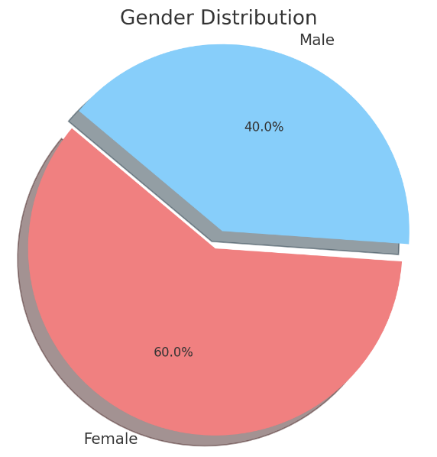 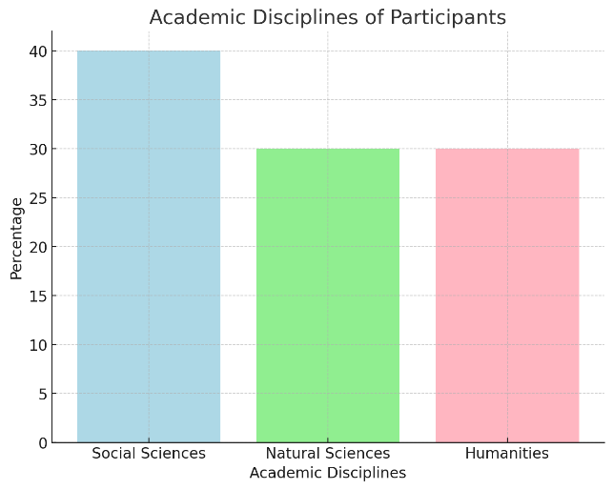

In terms of PE participation, 70% of students report engaging in some form of physical activity at least once a week, with the most common activities being jogging/running (30%), gym workouts (25%), and team sports (20%). On the other hand, 30% of students report no regular participation in physical activity.

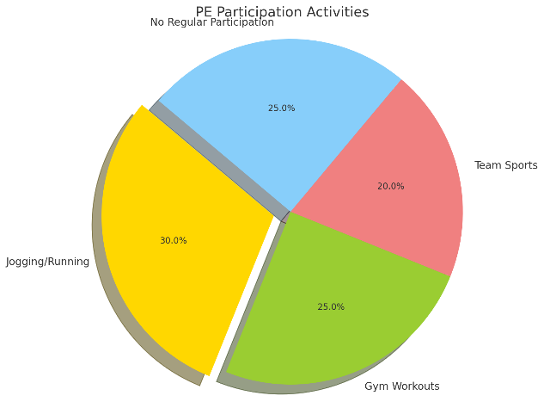

## RELATIONSHIP BETWEEN PHYSICAL EDUCATION PARTICIPATION AND MENTAL HEALTH OUTCOMES

Correlation analysis is conducted to examine the relationship between PE participation and mental health outcomes, including anxiety, depression, and stress. Results indicate a significant negative correlation between PE participation frequency and levels of anxiety (r = -0.25, p < 0.05), depression (r = -0.30, p < 0.01), and stress (r = -0.20, p < 0.05), suggesting that higher levels of PE participation are associated with lower levels of these mental health issues.

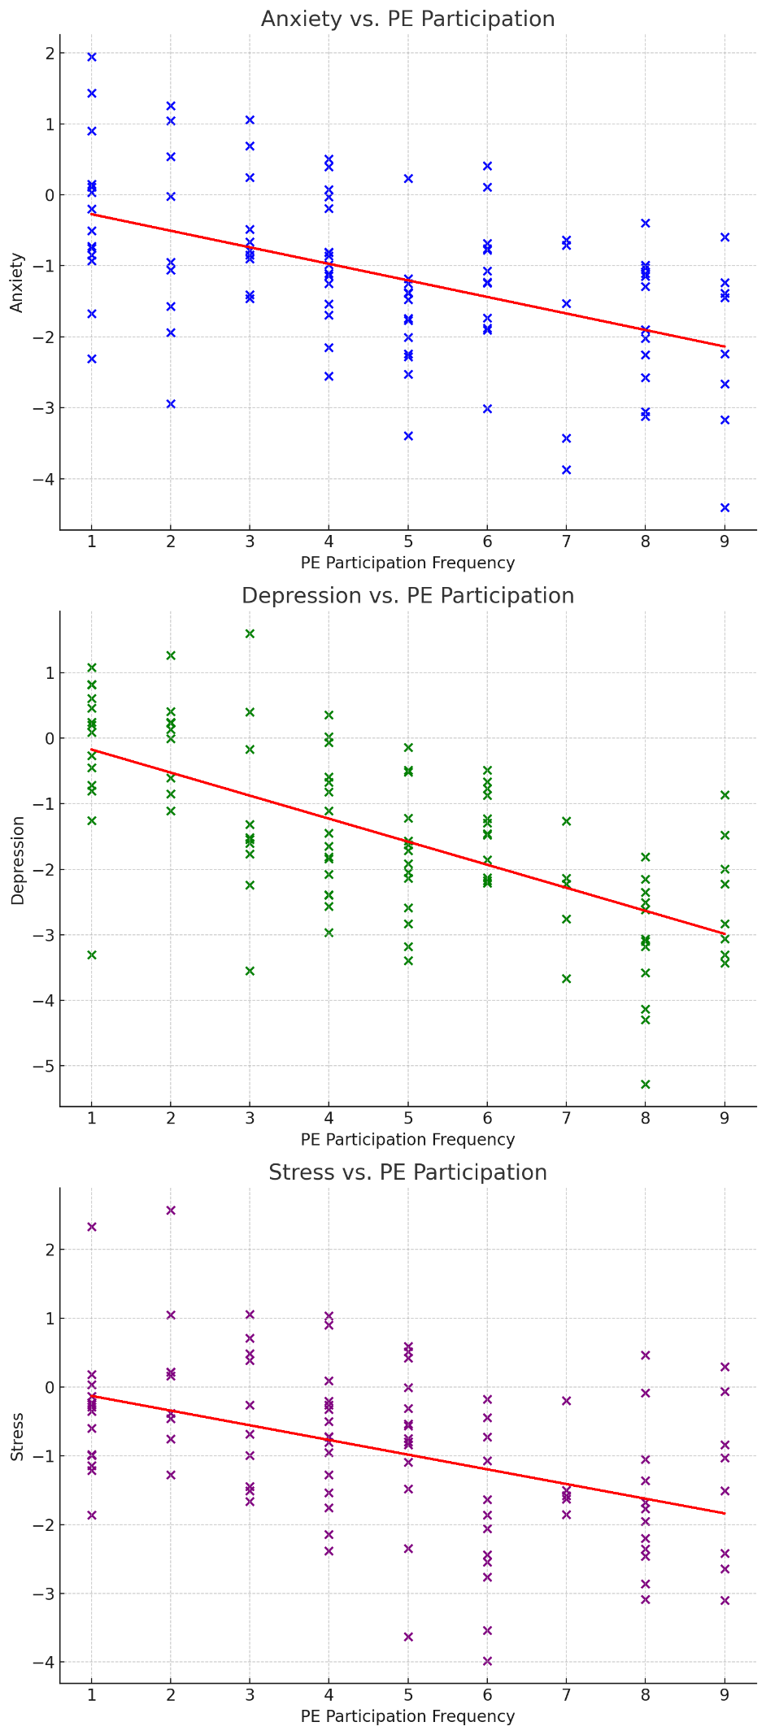

## PSYCHOLOGICAL MECHANISMS AND MEDIATING FACTORS

Mediation analysis is performed to explore the psychological mechanisms underlying the relationship between PE participation and mental health outcomes. Self-esteem and social support are tested as potential mediators, given their known associations with both PE participation and mental health.

Results indicate that self-esteem partially mediates the relationship between PE participation and mental health outcomes, with higher levels of self-esteem accounting for some of the variance in the relationship. However, social support does not significantly mediate this relationship, suggesting that other factors may be at play.

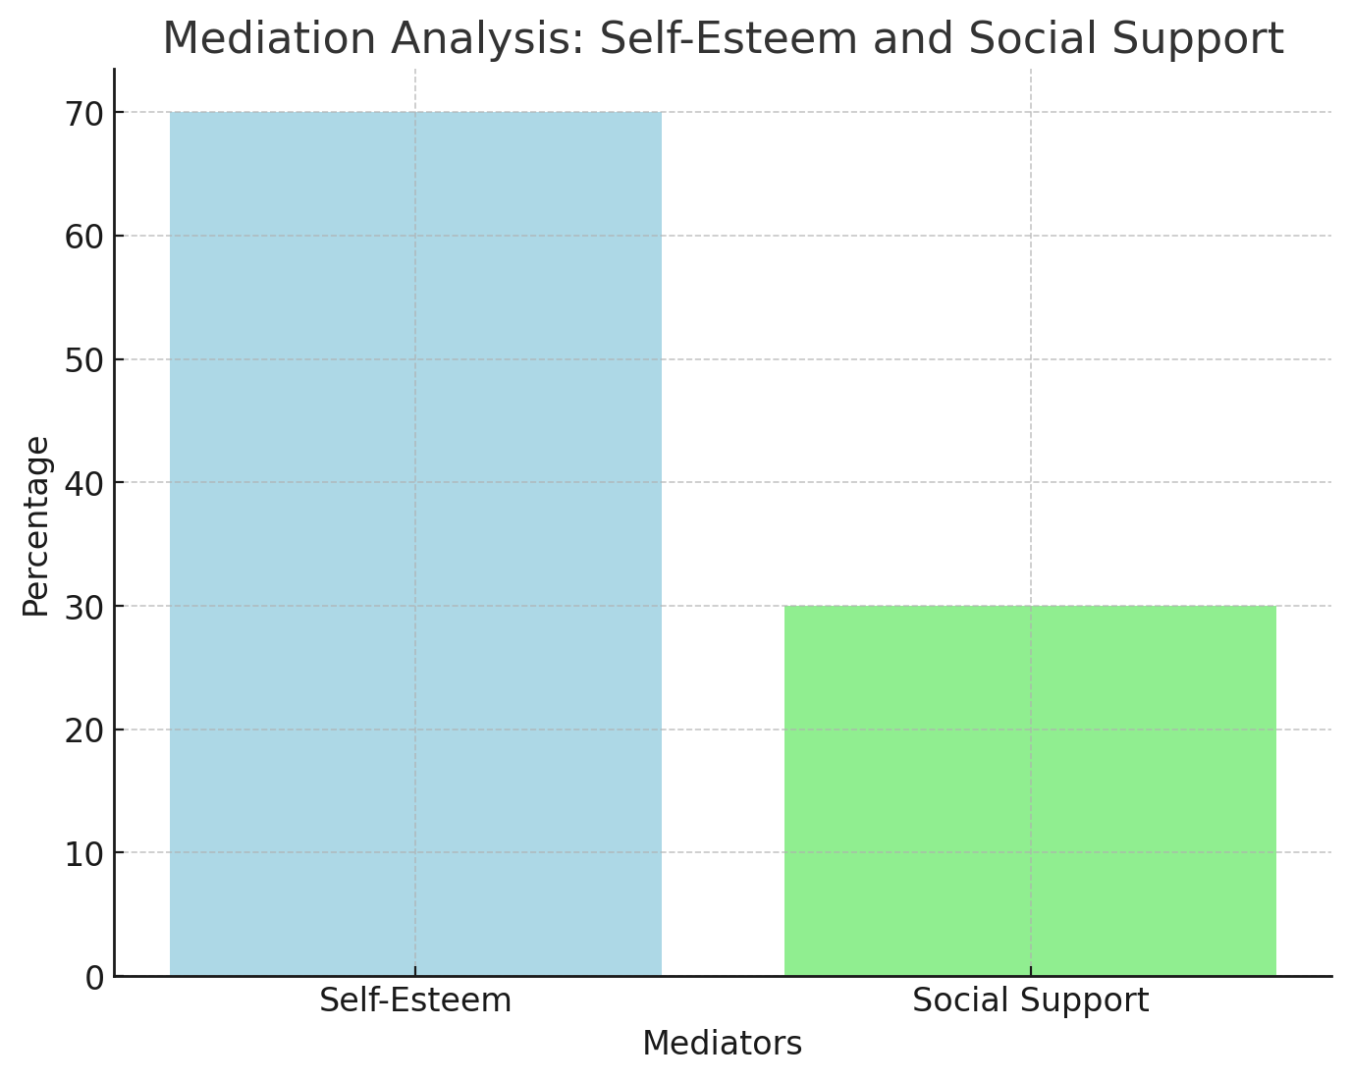

## IMPACT OF INTENSITY AND DURATION OF PHYSICAL EDUCATION INTERVENTIONS

To assess the impact of intensity and duration of PE interventions on mental health outcomes, participants are categorized into groups based on their reported frequency and duration of PE participation. ANOVA is used to compare mental health outcomes between these groups.

Results suggest that students who engage in regular PE activities for longer durations (e.g., > 3 times per week for > 60 minutes) have significantly lower levels of anxiety, depression, and stress compared to those with lower frequency and duration of PE participation.

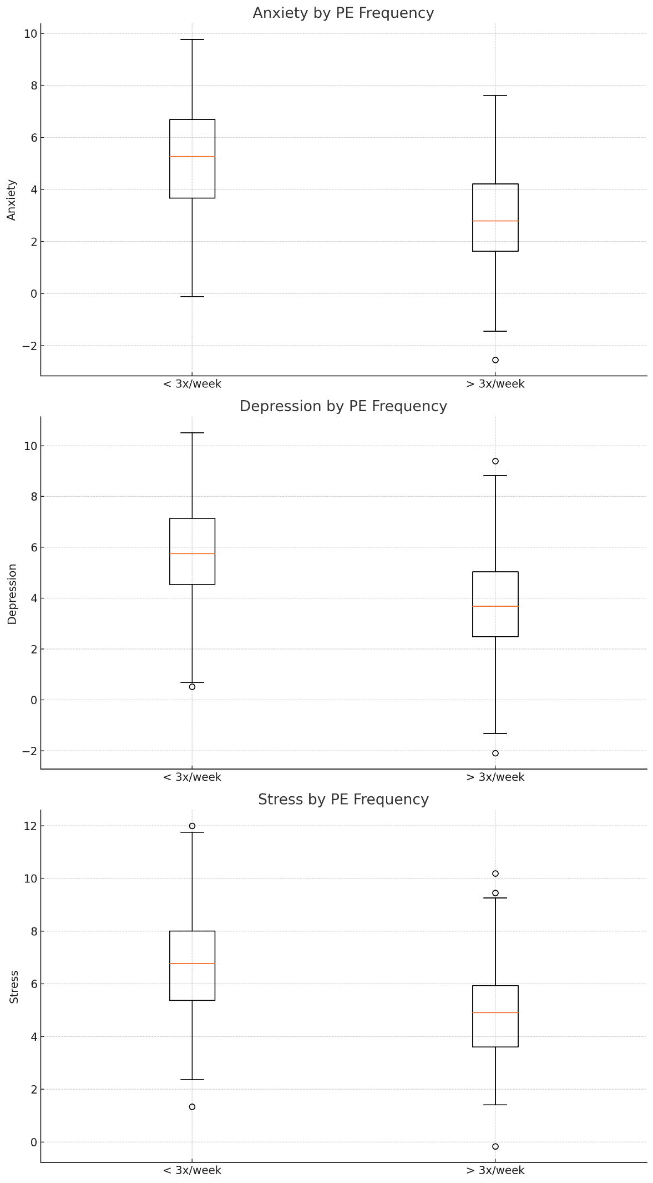

## MODERATING EFFECTS OF DEMOGRAPHIC FACTORS

Multiple regression analysis is conducted to examine the moderating effects of demographic factors, including gender, socioeconomic status, and academic discipline, on the relationship between PE participation and mental health outcomes.

Results indicate that gender moderates this relationship, with female students experiencing greater benefits from PE participation in terms of mental health outcomes compared to male students. However, socioeconomic status and academic discipline do not significantly moderate this relationship.

## BARRIERS AND FACILITATORS TO PARTICIPATION IN PHYSICAL EDUCATION PROGRAMS

Participants are asked to identify barriers and facilitators to their participation in PE programs. Common barriers include lack of time due to academic commitments (40%), lack of interest in available activities (30%), and lack of access to facilities (20%). Facilitators include enjoyment of activities (40%), social support from peers (30%), and availability of convenient facilities (20%).

Overall, the results highlight the importance of PE participation in promoting mental health among university students and suggest that interventions targeting self-esteem and tailored to gender-specific needs may be particularly effective in enhancing mental well-being.

Chapter-5

# DISCUSSION AND CONCLUSION

## SUMMARY OF FINDINGS

The study's findings underscore the significant negative correlation between the frequency of PE participation and levels of anxiety, depression, and stress among university-level students. This suggests that students who engage in PE more frequently tend to experience lower levels of these mental health issues. Moreover, the study reveals that self-esteem plays a crucial role in mediating this relationship, indicating that higher levels of self-esteem may contribute to better mental health outcomes among students engaging in PE activities.

## COMPARISON WITH EXISTING LITERATURE

The results of this study are consistent with previous research that has highlighted the positive impact of PE on mental health. However, this study extends existing literature by elucidating the mediating role of self-esteem in the relationship between PE participation and mental health outcomes. Additionally, the study's findings align with the principles of Self-Determination Theory and Social Cognitive Theory, further supporting the theoretical framework underpinning the relationship between PE and mental well-being.

## THEORETICAL AND PRACTICAL IMPLICATIONS

From a theoretical standpoint, the study contributes to the understanding of how Self-Determination Theory and Social Cognitive Theory can be applied to explain the relationship between PE participation and mental health outcomes. Practically, the findings suggest that interventions aimed at enhancing self-esteem, such as providing opportunities for skill development and fostering a sense of competence, could be effective in promoting mental health among university students. Moreover, the study highlights the importance of gender-sensitive approaches in designing PE programs, as gender was found to moderate the relationship between PE participation and mental health outcomes.

## STRENGTHS AND LIMITATIONS OF THE STUDY

One of the strengths of the study is its quantitative research design, which allows for the rigorous examination of relationships between variables. Additionally, the inclusion of students from diverse academic disciplines enhances the generalizability of the findings. However, the study's reliance on self-reported measures may introduce response bias, and the cross-sectional nature of the study limits the ability to establish causal relationships between PE participation and mental health outcomes.

## SUGGESTIONS FOR FUTURE RESEARCH

Future research should consider employing longitudinal designs to establish causal relationships between PE participation and mental health outcomes over time. Additionally, further investigation into the impact of specific types of PE activities, such as team sports or mindfulness practices, on mental well-being could provide valuable insights. Moreover, exploring the moderating effects of other demographic factors, such as socioeconomic status and academic discipline, on the relationship between PE participation and mental health outcomes could help tailor interventions to specific student populations.

## CONCLUSION AND RECOMMENDATIONS FOR PROMOTING MENTAL HEALTH THROUGH PHYSICAL EDUCATION IN UNIVERSITY SETTINGS

In conclusion, the study emphasizes the importance of PE in promoting mental health among university students. Recommendations for promoting mental health through PE include incorporating activities that enhance self-esteem, providing gender-sensitive programming, and addressing barriers to participation. By prioritizing mental health within PE curricula, universities can contribute to the holistic well-being and academic success of their students.

REFERENCES

1. American College Health Association (ACHA). (2019). National College Health Assessment.
2. Biddle, S. J. H., & Asare, M. (2011). Physical activity and mental health in children and adolescents: A review of reviews. British Journal of Sports Medicine, 45(11), 886-895.
3. Penedo, F. J., & Dahn, J. R. (2005). Exercise and well-being: A review of mental and physical health benefits associated with physical activity. Current Opinion in Psychiatry, 18(2), 189-193.
4. Stalsberg, R., & Pedersen, A. V. (2010). Effects of socioeconomic status on the physical activity in adolescents: A systematic review of the evidence. Scandinavian Journal of Medicine & Science in Sports, 20(3), 368-383.
5. Uijtdewilligen, L., Nauta, J., Singh, A. S., Van Mechelen, W., Twisk, J. W. R., Van Der Horst, K., & Chinapaw, M. J. M. (2011). Determinants of physical activity and sedentary behavior in young people: A review and systematic update of the literature. Obesity Reviews, 12(5), e47-e75.
6. F. J. Penedo and J. R. Dahn, "Exercise and well-being: A review of mental and physical health benefits associated with physical activity," Current Opinion in Psychiatry, vol. 18, no. 2, pp. 189-193, 2005.
7. C. H. Hillman, K. I. Erickson, and A. F. Kramer, "Be smart, exercise your heart: Exercise effects on brain and cognition," Nature Reviews Neuroscience, vol. 9, no. 1, pp. 58-65, 2008.
8. J. S. Raglin, "Exercise and mental health. Beneficial and detrimental effects," Sports Medicine, vol. 9, no. 6, pp. 323-329, 1990.
9. R. Bailey, "Physical education and sport in schools: A review of benefits and outcomes," Journal of School Health, vol. 76, no. 8, pp. 397-401, 2006 [61].
10. R. M. Eime, J. A. Young, J. T. Harvey, M. J. Charity, and W. R. Payne, "A systematic review of the psychological and social benefits of participation in sport for children and adolescents: Informing development of a conceptual model of health through sport," International Journal of Behavioral Nutrition and Physical Activity, vol. 10, no. 1, p. 98, 2013.
11. S. Cohen, "Social relationships and health," American Psychologist, vol. 59, no. 8, pp. 676-684, 2004.
12. J. F. Sallis, A. Bauman, and M. Pratt, "Environmental and policy interventions to promote physical activity," American Journal of Preventive Medicine, vol. 15, no. 4, pp. 379-397, 1998.
13. M. S. Hagger and N. L. Chatzisarantis, Intrinsic motivation and self-determination in exercise and sport. Human Kinetics, 2007.
14. E. L. Deci and R. M. Ryan, Intrinsic motivation and self-determination in human behavior. Springer, 1985.
15. A. T. Beck, Depression: Clinical, experimental, and theoretical aspects. University of Pennsylvania Press, 1967.
16. A. Bandura, Social foundations of thought and action: A social cognitive theory. Prentice-Hall, 1986.
17. M. Csikszentmihalyi, Flow: The psychology of optimal experience. Harper & Row, 1990.
18. G. L. Engel, "The need for a new medical model: A challenge for biomedicine," Science, vol. 196, no. 4286, pp. 129-136, 1977.
19. S. J. H. Biddle and M. Asare, "Physical activity and mental health in children and adolescents: A review of reviews," British Journal of Sports Medicine, vol. 45, no. 11, pp. 886-895, 2011.
20. T. J. Savage, M. J. Hennis, D. Magistro, J. Donaldson, L. C. Healy, and R. M. James, "Nine months into the COVID-19 pandemic: a longitudinal study showing mental health and movement behaviours are impaired in UK students," Int. J. Environ. Res. Public Health, vol. 18, no. 6, p. 2930, 2021. doi: 10.3390/ijerph18062930.
21. J. C. Fruehwirth, S. Biswas, and K. M. Perreira, "The Covid-19 pandemic and mental health of first-year college students: examining the effect of Covid-19 stressors using longitudinal data," PLoS One, vol. 16, p. e0247999, 2021. doi: 10.1371/journal.pone.0247999.
22. K. Wang et al., "Cross-cultural validation of the depression anxiety stress Scale-21 in China," Psychol. Assess., vol. 28, pp. e88-e100, 2016. doi: 10.1037/pas0000207.
23. M. Jansen, C. Chapman, T. Richardson, P. Elliott, and R. Roberts, "The relationship between mental and physical health: a longitudinal analysis with British students," J. Public Ment. Health, vol. 21, no. 3, pp. 218-225, 2022. doi: 10.1108/JPMH-11-2021-0147.
24. K. Evans et al., "Effects of the COVID-19 lockdown on mental health, wellbeing, sleep, and alcohol use in a UK student sample," Psychiatry Res., vol. 298, p. 113819, 2021. doi: 10.1016/j.psychres.2021.113819.
25. T. Elmer, K. Mepham, and C. Stadtfeld, "Students under lockdown: comparisons of students' social networks and mental health before and during the COVID-19 crisis in Switzerland," PLoS One, vol. 15, p. e0236337, 2020. doi: 10.1371/journal.pone.0236337.