KISANAI
An AI Driven Smart Agriculture Support Platform for Crop Monitoring and Decision Making

Project ID: CSFYP26S
Supervised by: Sir Umair bin Yaseen

Submitted for the partial fulfillment of BS Computer Science degree to the Faculty of Computer Science & IT

Submitted By:
Sr# | Student Name | Roll No | Registration No | Session
01 | Muhammad Usman | B-27689 | CSFYP26S-22F-301 | 2022 to 2026
02 | Muhammad Jawad | B-27131 | CSFYP26S-22F-406 | 2022 to 2026
03 | Ijaz Ali | B-27704 | CSFYP26S-22F-302 | 2022 to 2026
04 | Muhammad Junaid | B-27176 | CSFYP26S-22F-303 | 2022 to 2026

University of South Asia
Department of Computer Science
Session Spring 2026

Statement of Acceptance

This is to certify that the following students have submitted their final year project, which the Department of Computer Science has accepted and evaluated. The completion of the final year project is one of the mandatory requirements to be fulfilled by the students towards the conclusion of their degree of BS in Computer Science (BSCS).
Project Title: KisanAI: An AI Driven Smart Agriculture Support Platform for Crop Monitoring and Decision Making

Student Name | Roll No | Registration No
Muhammad Usman | B-27689 | CSFYP26S-22F-301
Muhammad Jawad | B-27131 | CSFYP26S-22F-406
Ijaz Ali | B-27704 | CSFYP26S-22F-302
Muhammad Junaid | B-27176 | CSFYP26S-22F-303

______________________________
Sir Umair bin Yaseen
Project Advisor, Department of Computer Science

______________________________
Project Convener
Department of Computer Science

______________________________
Head of Department
Department of Computer Science, University of South Asia

Proofreading Certificate

It is to certify that I have read this document meticulously and circumspectly. I am convinced that the resultant project does not contain any spelling, punctuation or grammatical mistakes, as much as expected from graduating students at the bachelor's level. All in all, I find this document well organized.

______________________________
Sir Umair bin Yaseen
Lecturer / Instructor, University of South Asia

Plagiarism Certificate

This is to certify that the project entitled "KisanAI: An AI Driven Smart Agriculture Support Platform for Crop Monitoring and Decision Making", which is being submitted herewith for the award of the Degree of Bachelor of Science in Computer Science, is the result of original work carried out by Muhammad Usman, Muhammad Jawad, Ijaz Ali and Muhammad Junaid under my supervision and guidance. The work embodied in this project has not been submitted earlier for the award of any other degree or diploma to any university or institution, to the best of my knowledge and belief.

Turnitin Similarity Index: ______________
Submission Date: ______________
Supervisor Name: ______________________________
Signature: ______________________________

Acknowledgement
All praise and gratitude belong to Allah, the Most Gracious and the Most Merciful, who granted us the ability, patience and determination to complete this project. Without His guidance, none of this work would have been possible.
We would like to thank our Project Advisor, Sir Umair bin Yaseen, who gave us timely feedback and continuous guidance and sincerely encouraged us throughout the development of this project. This project would not have taken the direction it took without his practical understanding of how an intelligent system is built and how such a system would actually be used by the people it is meant to serve.
We would also like to thank the faculty of the Department of Computer Science at the University of South Asia for the academic support and tools they have granted us to be able to carry out this work.
Our thanks also go to the farmers of the rural areas we visited, who patiently explained their day to day problems with crop disease, irrigation timing, fertilizer selection and market rates. Their honest feedback shaped almost every feature in this application, and the project would have been far removed from reality without them.
Many thanks to our fellow students and friends who gave us moral support and team spirit along the way, and who tested early versions of the application and reported the problems we could not see ourselves.
Finally, we would like to express our sincere gratitude to our families, who have been patient and encouraging throughout our four year programme and who have been an invaluable support. Their dream of our graduation is now coming true, and the credit for that goes to them.

1. Muhammad Usman | B-27689 | CSFYP26S-22F-301
2. Muhammad Jawad | B-27131 | CSFYP26S-22F-406
3. Ijaz Ali | B-27704 | CSFYP26S-22F-302
4. Muhammad Junaid | B-27176 | CSFYP26S-22F-303

Abstract
KisanAI is an Android application that helps farmers in Pakistan monitor their crops and make better daily decisions. Many farmers still identify crop disease by eye, apply fertilizer and water by habit, and sell without knowing the current market rate, and each of these gaps costs yield and money. KisanAI brings disease detection, weather, irrigation planning, treatment guidance and market prices into one simple application available in English and Urdu.
The core of the system is a DenseNet121 image classifier, built with transfer learning from ImageNet, that recognises 17 disease and healthy classes across corn, potato, rice, wheat and sugarcane from a single leaf photograph. It was trained on 13,324 images, balanced through augmentation, in two phases of feature extraction and fine tuning. On 1,333 unseen test images it achieved 95.80% accuracy and a weighted F1 score of 0.957. The model was converted to TensorFlow Lite (28.65 MB) and runs on the phone, so scanning works without an internet connection. The application also provides live weather, irrigation dates recommended with AI reasoning over the forecast, treatment and fertilizer guidance, market prices by city and a scan history.
Unit, integration, functional, usability and user acceptance testing showed that the platform is accurate and usable by farmers with limited technical background. Its main limits are that it recognises only the trained classes, is less accurate on visually similar rice leaves and depends on an external source for prices. It supports farming decisions and does not replace an agricultural expert.

Table of Contents
Statement of Acceptance 2
Proofreading Certificate 3
Plagiarism Certificate 4
Acknowledgement 5
Abstract 6
Chapter 1: Introduction 10
1.1 Project Overview 11
1.2 Problem Statement 11
1.3 Project Objectives 12
1.4 Background and Motivation 13
1.5 Scope of the Project 14
1.5.1 In Scope Features 14
1.5.2 Out of Scope Features 15
1.6 Document Organization 15
Chapter 2: Project Planning and Feasibility 17
2.1 Introduction 18
2.2 Project Feasibility Analysis 18
2.2.1 Technical Feasibility 18
2.2.2 Operational Feasibility 20
2.2.3 Economic Feasibility 21
2.2.4 COCOMO Model Based Cost Estimation 21
2.2.5 Schedule Feasibility 22
2.2.6 Information Feasibility 23
2.2.7 Legal and Ethical Feasibility 24
2.3 Critical Path Method Analysis 25
2.4 Gantt Chart 26
2.5 Team Members and Skill Sets 27
2.6 Combined Team Skills 28
2.7 Target Users 29
2.8 Risk Register 29
2.9 Risk Management Strategy 31
Chapter 3: Literature Review 32
3.1 Introduction 33
3.2 Artificial Intelligence in Crop Disease Detection 33
3.3 Crop Disease Detection Literature 34
3.4 Weather Based Agricultural Decision Support 36
3.5 Fertilizer Recommendation and Treatment Guidance 36
3.6 Digital Market Information Systems 37
3.7 Dataset Comparison 37
3.8 Research Gap Identification 38
3.9 Comparison of Existing Systems with KisanAI 39
Chapter 4: System Requirements Specification 41
4.1 Introduction 42
4.2 System Overview 42
4.3 Scope of the System 43
4.4 External Entities 43
4.5 Functional Requirements 44
4.5.1 User Management Requirements 44
4.5.2 Disease Detection Requirements 44
4.5.3 Fertilizer and Treatment Requirements 45
4.5.4 Weather Requirements 45
4.5.5 Irrigation Planning Requirements 45
4.5.6 Market Price Requirements 45
4.5.7 History and Localization Requirements 45
4.6 Nonfunctional Requirements 45
4.6.1 Performance Requirements 46
4.6.2 Usability Requirements 46
4.6.3 Security Requirements 46
4.6.4 Reliability Requirements 46
4.6.5 Maintainability Requirements 46
4.7 Data Flow Diagrams 47
4.7.1 Context Level Diagram (Level 0 DFD) 47
4.7.2 Level 1 Data Flow Diagram 47
4.8 Use Case Modelling 48
4.9 Requirements Prioritization 50
4.10 Requirements Traceability Matrix 50
Chapter 5: System Design and Implementation 52
5.1 Introduction 53
5.2 System Architecture Design 53
5.3 System Workflow 53
5.4 User Interface Design 54
5.4.1 Dashboard 54
5.4.2 Weather Forecast Screen 55
5.4.3 AI Disease Detection Screen 56
5.4.4 Scan History Screen 57
5.4.5 Fertilizer and Treatment Screen 57
5.4.6 Irrigation Planner 58
5.4.7 Market Prices Screen 58
5.4.8 Bilingual Interface 59
5.5 AI Model Implementation 59
5.5.1 Dataset 59
5.5.2 Data Splitting and Class Balancing 60
5.5.3 Data Augmentation 61
5.5.4 Model Architecture 62
5.5.5 Training Strategy 63
5.6 Data Preprocessing Pipeline 63
5.7 Model Evaluation 64
5.7.1 Training Curves 64
5.7.2 Per Class Performance 65
5.7.3 Confusion Matrix Analysis 67
5.7.4 Comparison of Candidate Architectures 70
5.8 Model Deployment 70
5.9 Weather and Irrigation Module 71
5.10 Fertilizer and Treatment Module 71
5.11 Market Price Module 71
5.12 Database Design 72
5.13 Technology Stack 73
Chapter 6: System Testing and Validation 74
6.1 Introduction 75
6.2 Testing Strategy 75
6.3 Unit Testing 75
6.4 Integration Testing 76
6.5 Functional Test Cases 76
6.6 Model Validation Results 77
6.7 Usability and Performance Testing 78
6.8 User Acceptance Testing 79
6.9 Summary of Testing 80
Chapter 7: Conclusion and Future Work 81
7.1 Conclusion 82
7.2 Project Achievements 82
7.3 Limitations 83
7.4 Future Work 83
References 86

Chapter 1
Introduction

1.1 Project Overview
Agriculture is the backbone of Pakistan's economy. It contributes close to one fifth of the national GDP and provides a livelihood for a very large share of the rural population. Despite this importance, the way most farming decisions are made has changed very little over the last several decades. A farmer typically inspects a crop with the naked eye, decides that something is wrong once the damage is already visible, asks a neighbour or a shopkeeper what to spray, applies fertilizer in the quantity that has always been used in that village, irrigates on a fixed weekly routine regardless of whether rain is expected, and finally sells the harvest at whatever rate the local buyer offers. Every one of these steps involves a decision that could be made better with the right information at the right time.
KisanAI is an AI driven smart agriculture support platform designed to supply exactly that information. It is delivered as a native Android mobile application so that it reaches the farmer on the device already in their pocket. The application brings five kinds of support together in one place: automatic crop disease detection from a leaf photograph, live weather information and forecasting, AI assisted irrigation planning, fertilizer and treatment guidance, and current crop market prices. The whole interface is available in both English and Urdu so that the language of the application is never a barrier.
The intelligence at the centre of the platform is a deep learning image classifier. The user selects the crop, takes or uploads a photograph of an affected leaf, and the application returns the most likely disease along with a confidence value. The classifier is a DenseNet121 convolutional neural network adapted through transfer learning and trained on 13,324 leaf images spanning 17 disease and healthy classes across corn, potato, rice, wheat and sugarcane. After training and fine tuning, the model reached 95.80% accuracy on unseen test images. The model was then converted into the TensorFlow Lite format and embedded inside the application, which means the scan runs directly on the phone. This design choice matters a great deal in rural Pakistan, where mobile data coverage is unreliable: the most important feature of the application continues to work when the network does not.
The remaining modules turn a diagnosis into an action. Once a disease is identified, the fertilizer and treatment module explains what to apply and how. The weather module tells the farmer whether rain is expected before deciding to spray or irrigate. The irrigation planner records the last irrigation date for each crop and recommends the next one based on the forecast rather than a fixed calendar. The market price module shows what the crop is currently fetching per 40 kg in nearby city markets. Together these modules move the farmer from reacting to problems towards planning around them.

1.2 Problem Statement
Crop losses in Pakistan are caused less by a lack of effort than by a lack of timely and reliable information. Four specific problems recur across the farming communities studied during requirement gathering.
First, crop diseases are identified far too late. Visual identification of a disease requires expertise that most farmers have not been trained in, and the extension services that could provide that expertise are thinly spread and difficult to reach. By the time symptoms are unmistakable to an untrained eye, the infection has often spread across a large part of the field and the economically useful window for treatment has closed.
Second, farming decisions that depend on weather are made without weather information. Irrigation, sowing, spraying and harvesting are all weather sensitive, yet the general forecasts available on television or radio are not specific enough to the farmer's own location to be useful. The result is water wasted on fields that were about to receive rain, and sprays washed away hours after application.
Third, fertilizer is applied by habit rather than by need. Farmers frequently report that they apply the same fertilizer in the same quantity every season, irrespective of the crop stage or the specific problem present. Overapplication increases cost and damages soil health; underapplication or the wrong choice fails to address the actual deficiency.
Fourth, farmers sell without knowing the market. Without access to current rates in nearby markets, the farmer has no basis on which to negotiate, and the price is effectively set by the buyer. Small differences in rate per 40 kg translate into large differences in seasonal income.
Existing digital solutions address these problems only partially. Some mobile applications perform disease detection but require an internet connection for every scan and offer nothing beyond the diagnosis. Some provide weather but no agricultural interpretation of it. Almost none are available in Urdu, and almost none combine detection, weather, irrigation, fertilizer guidance and market prices in a single application designed for a low literacy, low connectivity user. KisanAI addresses this gap directly.

1.3 Project Objectives
The main objective of KisanAI is to develop an accessible, AI driven mobile platform that supports Pakistani farmers in crop monitoring and everyday agricultural decision making. The specific objectives are as follows:
- Develop a deep learning image classification model capable of identifying crop diseases from a single leaf photograph across multiple major crops.
- Collect, clean, balance and augment a suitable crop disease image dataset so that the model is not biased toward the most common diseases.
- Apply transfer learning and fine tuning to achieve high classification accuracy while keeping the model small enough for a mobile device.
- Convert the trained model to TensorFlow Lite and embed it inside the application so that disease scanning works offline, on the device.
- Integrate a live weather forecasting service that provides location specific temperature, rainfall probability, humidity and wind conditions.
- Develop an AI assisted irrigation planning module that recommends the next irrigation date for each crop based on the last irrigation date and the weather forecast.
- Provide a fertilizer and treatment guidance module that maps each detected disease to practical, crop specific corrective action.
- Provide a market price module that displays current city wise crop rates per 40 kg so that farmers can time their sale.
- Maintain a scan history so that the farmer can review previous diagnoses and track how a problem has developed.
- Deliver the entire interface in both English and Urdu with an instant language switch, using a clean layout suitable for users with limited technical background.
- Validate the system through model evaluation and through unit, integration, functional, usability and user acceptance testing.

1.4 Background and Motivation
The idea for KisanAI came from direct observation rather than from literature. During field visits to rural farming areas, the project team spent time with farmers and asked how each major decision in a season is actually taken. The answers were consistent. Disease was described as something noticed 'when the leaves start going', by which point treatment was largely damage control. Fertilizer quantity was described in terms of bags per acre that had been used 'for years'. Irrigation was described as a routine, not a decision. Market rate was described as something learnt on the day of sale, at the point of sale.
What made the problem feel solvable was that almost every farmer interviewed carried an Android smartphone with a working camera. The device needed to run a modern computer vision model was already in the field. The barrier was not hardware; it was that no application existed that combined the needed capabilities, worked without a reliable network, and spoke to the user in Urdu.
On the technical side, the last decade of research in deep learning has made accurate plant disease classification from leaf imagery a well established problem. Convolutional neural networks trained on large public datasets routinely exceed 95% accuracy on standard benchmarks, and architectures such as MobileNet, EfficientNet and DenseNet have been designed with deployment on constrained devices in mind. Transfer learning makes it possible to reach that level of accuracy with a training set of a few thousand images rather than millions. At the same time, on device inference frameworks such as TensorFlow Lite have matured to the point where a 28 MB model can classify an image on a mid range phone in well under a second.
The motivation for this project, then, is the combination of a real and costly problem, a user base that already owns the necessary hardware, and a technology stack that has become mature enough to be deployed responsibly. KisanAI is an attempt to connect those three things.

1.5 Scope of the Project
The scope of KisanAI covers the development of a complete AI powered Android application together with the deep learning model that drives its core feature. The system is organized into the modules described below.
Table 1.1: KisanAI Modules and Functional Scope
Module | Scope
Disease Detection Module | Accepts a crop selection and a leaf photograph, preprocesses the image and classifies it into one of 17 disease or healthy classes using an on device TFLite model, returning the class and a confidence value.
Fertilizer & Treatment Module | Maps each detected disease class to a crop specific fertilizer recommendation, treatment steps and preventive measures.
Weather Module | Retrieves current conditions and hourly and daily forecasts for the user's location and presents temperature, rainfall probability, humidity and wind speed.
Irrigation Planning Module | Records the last irrigation date for each crop and generates an AI recommended next irrigation date based on the crop and the weather forecast.
Market Price Module | Displays current city wise crop rates per 40 kg (mann) with search and city selection.
History Module | Stores every scan with its image thumbnail, crop, predicted disease, confidence and timestamp, and allows individual or bulk deletion.
User Management Module | Handles registration, login, session management and per user separation of history and irrigation records.
Localization Module | Provides the entire interface in English and Urdu with an instant in app language toggle.

1.5.1 In Scope Features
- AI based crop disease detection from leaf images for corn, potato, rice, wheat and sugarcane (17 classes in total, including healthy classes).
- Offline, on device inference using an embedded TensorFlow Lite model.
- Confidence score displayed with every prediction so the farmer can judge how much to rely on it.
- Live weather with hourly and daily forecast for the user's location.
- AI generated next irrigation date per crop, with the ability to record and clear irrigation entries.
- Fertilizer and treatment guidance linked to each supported disease class.
- City wise market prices per 40 kg with crop search.
- Persistent scan history with thumbnails, confidence values and relative timestamps.
- Full English and Urdu interface with an in app language switch.
- Secure user registration, login and logout.

1.5.2 Out of Scope Features
The following are deliberately excluded from the current version of the system, either because they require resources beyond the project's scope or because they carry responsibilities the system is not designed to take on:
- Diagnosis of crops or diseases outside the 17 trained classes.
- Soil chemistry testing or laboratory grade nutrient analysis.
- Automated control of irrigation hardware, pumps or IoT field sensors.
- Financial services such as crop insurance, credit or in app selling.
- Replacement of a qualified agricultural extension officer or plant pathologist for high value or ambiguous cases.
- Satellite or drone based whole field monitoring.

1.6 Document Organization
This document is organized into seven chapters that together describe the planning, analysis, design, implementation, testing and evaluation of KisanAI.
Chapter 1, Introduction: presents the project overview, problem statement, objectives, background and motivation, and the scope of the system.
Chapter 2, Project Planning and Feasibility: covers feasibility analysis across technical, operational, economic, schedule, information and legal and ethical dimensions, together with COCOMO estimation, critical path analysis, the Gantt schedule, team skills, target users and risk management.
Chapter 3, Literature Review: reviews existing research on AI based plant disease detection, weather driven decision support, fertilizer recommendation and digital market information, compares available datasets, and identifies the research gap that KisanAI addresses.
Chapter 4, System Requirements Specification: defines external entities, functional and nonfunctional requirements, data flow diagrams, use case models, requirement prioritization and the requirements traceability matrix.
Chapter 5, System Design and Implementation: describes the system architecture, workflow, user interface, AI model development and evaluation, deployment, the supporting modules, database design and technology stack.
Chapter 6, System Testing and Validation: presents the testing strategy, unit and integration tests, functional test cases, model validation, usability and performance testing, and user acceptance results.
Chapter 7, Conclusion and Future Work: summarizes outcomes, states the limitations honestly and proposes future improvements.

Chapter 2
Project Planning and Feasibility

2.1 Introduction
Project planning defines the direction of a software system before any code is written: what will be built, with what resources, on what schedule, and against which risks. Careful planning is particularly important for a project such as KisanAI, which combines three fairly different kinds of work (training a deep learning model, building a native mobile application, and integrating several external data services), each with its own tooling, its own failure modes and its own timeline.
This chapter presents the planning and feasibility analysis of KisanAI. It first evaluates whether the system can realistically be built with the resources available to a four member undergraduate team within a nine month academic timeline, examining the question from technical, operational, economic, schedule, information and legal and ethical angles. It then presents the development plan through critical path analysis and a Gantt schedule, describes the team and the tools used, identifies the target users, and finally sets out the risk register and the strategy for managing those risks.

2.2 Project Feasibility Analysis
Feasibility analysis determines whether KisanAI is practical and achievable within the available resources, project duration and technical limitations. The system is evaluated through the following categories: technical feasibility, operational feasibility, economic feasibility, schedule feasibility, information feasibility, and legal and ethical feasibility.

2.2.1 Technical Feasibility
Technical feasibility evaluates whether the required hardware, software, frameworks and technical expertise are available. KisanAI requires deep learning, mobile application development, REST API integration and cloud based model training. All of these are available through mature open source frameworks and free tier cloud services, and all fall within the range of skills covered in the BSCS curriculum.
Table 2.1: Technologies and Development Tools
Component | Technology
Model Development Language | Python 3
Deep Learning Framework | TensorFlow 2.20 / Keras
Model Architecture | DenseNet121 (ImageNet pretrained)
Supporting ML Libraries | Scikit-learn, NumPy, Pandas, Pillow
Visualization | Matplotlib
Training Environment | Kaggle Notebooks with Tesla T4 GPU
Mobile Application | Android Studio, Kotlin, XML layouts
On Device Inference | TensorFlow Lite (.tflite)
Weather Service | OpenWeather API
AI Reasoning for Irrigation | Claude API
Rapid Model Demo | Gradio
Authentication & Data | Firebase Authentication, local device storage
Version Control | Git / GitHub
The overall development workflow followed by the project, from requirement gathering through to documentation, is shown in Figure 2.1.
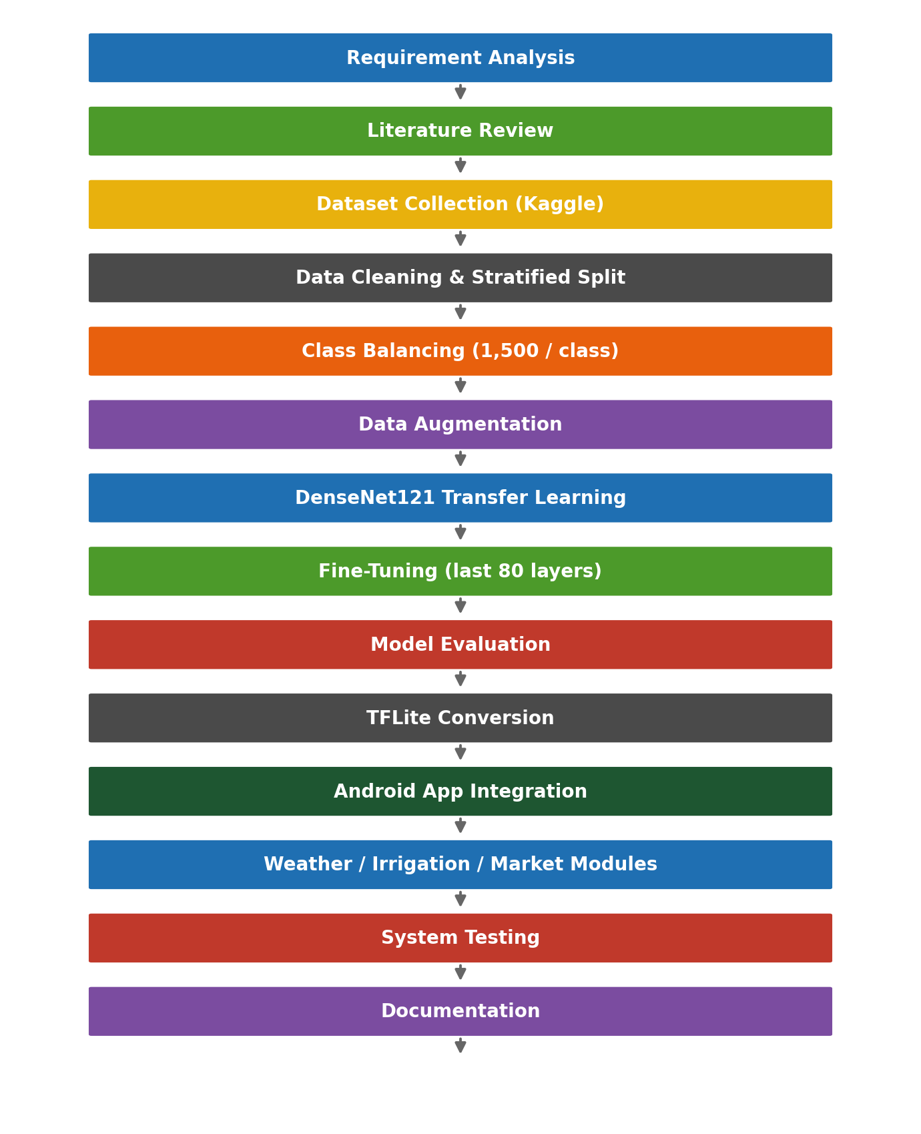
Figure 2.1: KisanAI Development Workflow
Hardware Requirements
No specialized agricultural or laboratory hardware is required. The project needs only:
- A personal computer or laptop for development and documentation.
- Free cloud GPU access (Kaggle / Google Colab) for model training.
- An Android smartphone with a working camera for on device testing.
- An internet connection for API services, dataset download and version control.
Since all required technologies are freely available and the team already possesses the necessary hardware, the project is technically feasible.

2.2.2 Operational Feasibility
Operational feasibility determines whether the developed system can actually be used by its intended users. This is the most important feasibility dimension for KisanAI, because the target user is often not a confident smartphone user and may have limited literacy.
The application was therefore designed around a very short interaction path. The typical operational workflow is:
- The farmer opens the application and logs in (a one time step; the session is remembered).
- The dashboard immediately shows today's weather for the farmer's location and three large action cards.
- For a disease check, the farmer taps 'Scan disease', selects the crop, and takes or chooses a photo of the affected leaf.
- The on device model classifies the image and returns the disease name with a confidence percentage.
- The fertilizer screen provides the corresponding treatment and fertilizer guidance for that disease.
- For irrigation, the farmer enters the date the crop was last irrigated and receives an AI recommended next irrigation date.
- For selling decisions, the farmer opens the market price screen and selects a city.
- All previous scans remain available in the history screen.
User Benefits
A disease answer in seconds instead of days, without travelling to an expert. Weather that is specific to the farmer's own location rather than a general regional forecast. Irrigation timing that accounts for expected rainfall, which reduces both water use and pumping cost. A clear, written treatment recommendation rather than word of mouth advice. Price knowledge before the point of sale, which improves the farmer's negotiating position. Full Urdu support, which removes the language barrier that blocks most existing agricultural applications.
Operational Limitations
KisanAI is a decision support tool, not an authority. It recognises only the diseases it has been trained on, its prediction is a probability rather than a certainty, and for a severe or unusual outbreak the farmer should still consult an agricultural extension officer. The confidence value displayed with every prediction exists precisely so that a low confidence result is treated with appropriate caution. Given the simple interaction workflow and the availability of all required resources, the system is operationally feasible.

2.2.3 Economic Feasibility
Economic feasibility evaluates whether the project can be developed within reasonable financial constraints. KisanAI is economically feasible because it is built almost entirely on open source technologies, free tier cloud services and publicly available datasets.
Table 2.2: Development Resources and Cost Considerations
Resource | Cost Consideration
Programming tools and IDEs | Free / open source (Android Studio, VS Code)
Deep learning frameworks | Free (TensorFlow, Keras, Scikit-learn)
GPU training | Free tier (Kaggle Notebooks, Tesla T4)
Dataset | Public Kaggle dataset, no licensing cost
Weather API | Free tier of OpenWeather, sufficient for project scale traffic
AI reasoning API | Metered usage, low volume during development
Authentication and storage | Firebase free tier (Spark plan)
Version control and collaboration | GitHub free plan
Development machines | Existing team owned laptops
The only recurring costs at production scale would be API usage beyond the free tiers and Play Store publication, both of which are small relative to the value delivered.

2.2.4 COCOMO Model Based Cost Estimation
The Constructive Cost Model (COCOMO) is used to estimate development effort, duration and team size for KisanAI. The Basic COCOMO Organic Model is appropriate here because the project has a small development team, a well understood scope and uses familiar technologies.
Table 2.3: Estimated Project Size by Module
Module | Estimated Lines of Code | Complexity
AI Model Training & Evaluation Pipeline (Python) | ~1,200 LOC | High
Android UI (activities, fragments, XML layouts) | ~1,800 LOC | Medium
TFLite Inference & Image Preprocessing | ~500 LOC | High
Weather Module & API Integration | ~450 LOC | Medium
Irrigation Planning Module | ~500 LOC | Medium
Fertilizer & Treatment Module | ~400 LOC | Low
Market Price Module | ~350 LOC | Low
History & Local Storage | ~350 LOC | Medium
Authentication & User Management | ~300 LOC | Low
Localization (English / Urdu resources) | ~250 LOC | Low
Testing & Integration | ~400 LOC | Medium
Total Estimated | ~6,500 LOC ≈ 6.5 KLOC | N/A
Applying the Basic COCOMO Organic Model formulas:
Effort (E) = 2.4 × (KLOC)^1.05 = 2.4 × (6.5)^1.05 ≈ 17 Person Months
Development Time (D) = 2.5 × (E)^0.38 = 2.5 × (17)^0.38 ≈ 7.4 Months
Team Size (P) = E / D ≈ 17 / 7.4 ≈ 2.3 ≈ 3 Developers
Table 2.4: COCOMO Estimation Summary
Estimation Parameter | Value
Estimated Project Size | 6.5 KLOC
Development Effort | ≈ 17 Person Months
Development Time | ≈ 7.4 Months
Estimated Team Size | ≈ 3 Developers
Actual Team Size | 4 Members
Feasibility Verdict | Feasible: with four members the estimated effort can be completed comfortably within the nine month academic timeline
The estimation indicates that KisanAI is feasible within the available resources and academic timeline. With four team members, the AI model work and the mobile application work can proceed in parallel, which is precisely how the schedule in Section 2.4 is structured.

2.2.5 Schedule Feasibility
Schedule feasibility evaluates whether the project can be completed within the Final Year Project timeline of April 2026 to December 2026. The development process is divided into the following phases:
Table 2.5: Development Phases
Phase | Activities
Phase 1 | Requirement gathering, field interviews with farmers, and problem definition
Phase 2 | Literature review and identification of a suitable crop disease dataset
Phase 3 | System and user interface architecture design
Phase 4 | Dataset collection, cleaning, stratified splitting and class balancing
Phase 5 | Data augmentation pipeline and model architecture selection
Phase 6 | DenseNet121 transfer learning and fine tuning
Phase 7 | Model evaluation and TFLite conversion
Phase 8 | Android application development and TFLite integration
Phase 9 | Weather, irrigation, fertilizer and market price module development
Phase 10 | Urdu localization, system testing, user acceptance testing and documentation

2.2.6 Information Feasibility
Information feasibility evaluates the availability and reliability of the data required to build the system. KisanAI depends on four kinds of information.
1. Crop Disease Image Data
The disease classifier requires a labelled image dataset covering the crops grown in Pakistan. The publicly available Crop Diseases Dataset on Kaggle provides 13,324 leaf images organized as crop to disease folders across corn, potato, rice, wheat and sugarcane, covering 17 classes in total. The dataset is imbalanced, which is addressed through balancing and augmentation as described in Chapter 5, but its availability makes the core feature feasible without any primary data collection.
2. Weather Data
Location specific current conditions and forecasts are available through the OpenWeather API, which provides temperature, humidity, rainfall probability and wind speed on both hourly and daily granularity for any coordinate in Pakistan.
3. Fertilizer and Treatment Knowledge
Treatment and fertilizer recommendations for each supported disease are compiled from agricultural extension literature and published crop management guidelines, and stored as a structured knowledge base within the application.
4. Market Price Data
Crop rates per 40 kg (mann) are obtained on a city wise basis from publicly published market rate sources. This is the least reliable of the four data sources, since publication frequency varies, and this is recorded as a project risk in Section 2.8.
Table 2.6: Information Sources and Their Purpose
Source | Purpose
Research papers | Understanding existing CNN approaches to plant disease detection
Public Kaggle dataset | Model training, validation and testing
Agricultural extension literature | Fertilizer and treatment recommendations
OpenWeather API | Live and forecast weather data
Published market rate sources | City wise crop prices
Open source libraries | Model implementation and mobile deployment
All required information is available through public repositories, open APIs and published agricultural resources. KisanAI is therefore information feasible.

2.2.7 Legal and Ethical Feasibility
KisanAI processes user account information, crop photographs and location data, so privacy, security and ethical use are relevant considerations.
Privacy and Data Protection
- User credentials are handled through Firebase Authentication and are never stored in plain text.
- Leaf images are processed on the device by the embedded TFLite model and are not uploaded to any server for classification.
- Location is used only to retrieve weather for the farmer's area and is not shared with third parties.
- Scan history and irrigation records are stored per user and can be deleted by the user at any time through the 'Clear All' action.
Ethical Considerations
Advisory, not authoritative: KisanAI supports a farming decision; it does not make it. Every prediction is shown with a confidence value so the user can judge how much weight to give it, and the application does not present a low confidence guess as a certainty.
Transparency: the application states which crops and diseases it can recognise. A photograph of a crop outside the trained set will still produce some output, and the confidence value is the user's signal that the result should not be trusted.
Responsible recommendation: fertilizer and treatment guidance is drawn from published agricultural extension material and is framed as general guidance rather than a prescription for a specific field.
Fairness: because the raw dataset was heavily imbalanced, the model was deliberately trained on a balanced set so that it would not simply favour the most common diseases and ignore rarer ones affecting fewer farmers.
Legal Feasibility
The project uses a publicly available dataset, open source frameworks and APIs consumed within their published terms of service. No proprietary or personally identifying agricultural records are used. The project is therefore legally and ethically feasible.

2.3 Critical Path Method Analysis
The Critical Path Method (CPM) identifies the sequence of activities that determines the minimum completion time of a project. Activities on the critical path have zero slack: any delay in them delays the whole project. For KisanAI, CPM was used to organize the nineteen major development activities across the nine month timeline from April 2026 to December 2026 and to identify which of them are critical.
Table 2.7: Project Activities, Durations and Dependencies
ID | Activity | Duration (weeks) | Dependency
A | Requirement analysis and field data gathering | 3 | N/A
B | Literature review | 2 | A
C | System and UI architecture design | 3 | B
D | Dataset collection and cleaning | 5 | C
E | Preprocessing, splitting and class balancing | 4 | D
F | Data augmentation pipeline | 3 | E
G | DenseNet121 model training | 5 | F
H | Fine tuning and optimization | 4 | G
I | Model evaluation | 3 | H
J | TFLite conversion | 2 | I
K | Android application UI development | 10 | C
L | Weather API integration | 3 | K
M | AI irrigation planner module | 4 | L
N | Fertilizer guidance module | 3 | M
O | Market price module | 3 | N
P | Urdu / English localization | 3 | O
Q | System integration and testing | 5 | J, P
R | User acceptance testing and refinement | 3 | Q
S | Final documentation and defence preparation | 4 | R
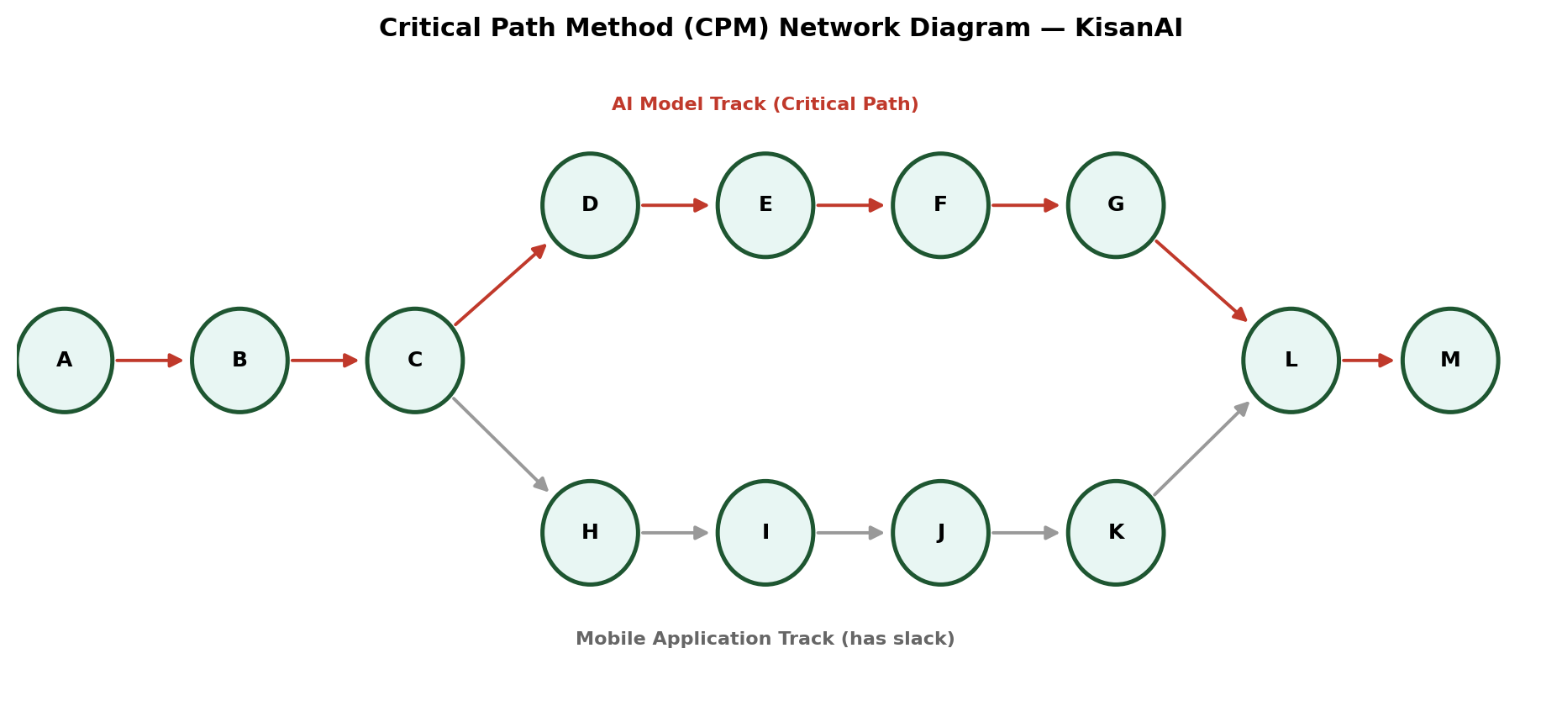
Figure 2.2: Critical Path Method (CPM) Network Diagram, KisanAI
Critical Path Flow
A → B → C → D → E → F → G → H → I → J → Q → R → S
This path runs through the entire AI model pipeline and carries a total duration of 39 weeks, which matches the planned nine month schedule from the first week of April 2026 to the last week of December 2026. The mobile application track (K through P) runs in parallel and carries positive slack, meaning small delays there will not by themselves push out the project end date. However, the two tracks converge at activity Q, so the application track must be complete before integration testing can begin. Because the model track is critical, any slippage in dataset preparation or training directly delays the project, and the schedule reserves the earliest and largest block of time for exactly that work.

2.4 Gantt Chart
The Gantt chart represents the planned schedule of project activities across the development period. The nine month timeline is divided into the nineteen activities listed in Table 2.7, grouped into six broad streams: planning and design, dataset operations, AI model development, mobile application development, testing, and documentation.
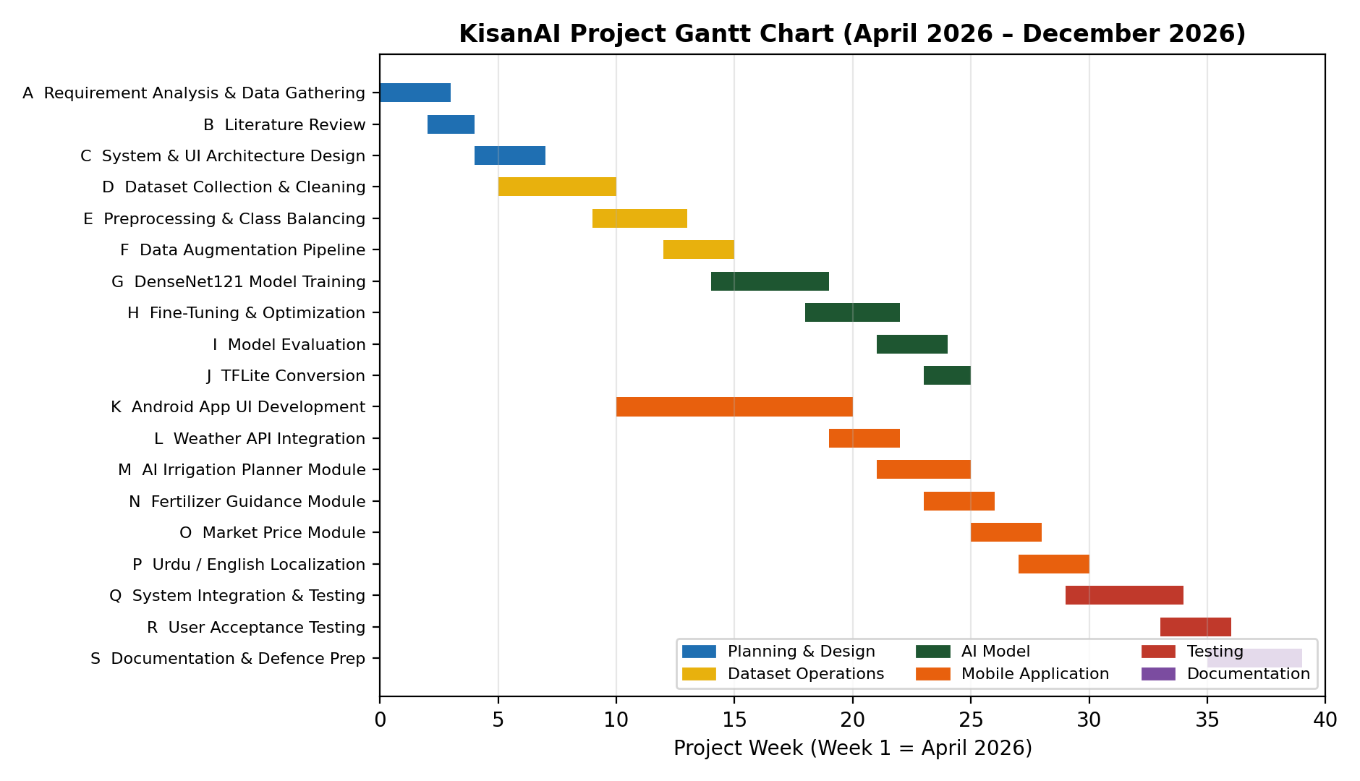
Figure 2.3: KisanAI Project Gantt Chart (April 2026 to December 2026)
The schedule allocates the first seven weeks to requirement analysis, literature review and architecture design. Dataset work runs from week 5 to week 15, overlapping with the start of Android UI development so that the mobile team is not idle while the dataset is being prepared. Model training and fine tuning occupy weeks 14 to 22, with evaluation and TFLite conversion completing by week 25. The weather, irrigation, fertilizer and market modules are developed sequentially from week 19 to week 28, followed by localization. System integration and testing run from week 29 to week 34, user acceptance testing from week 33 to week 36, and final documentation and defence preparation from week 35 through the end of December.

2.5 Team Members and Skill Sets
KisanAI is developed by a team of four members from the Department of Computer Science, University of South Asia. Responsibilities were divided along the two parallel tracks identified in the critical path analysis so that model work and application work could progress simultaneously.
Table 2.8: Team Members, Roles and Skills
Team Member | Role | Skills
Muhammad Usman | AI / Deep Learning Lead | Python, TensorFlow / Keras, transfer learning, model evaluation, TFLite conversion
Muhammad Jawad | Android Application Developer | Kotlin, XML layouts, Android Studio, TFLite integration, UI/UX implementation
Ijaz Ali | Backend & API Integration | REST APIs, OpenWeather integration, AI reasoning integration, Firebase, data handling
Muhammad Junaid | Data & Quality Assurance | Dataset preparation, augmentation, testing, Urdu localization, documentation

2.6 Combined Team Skills
Table 2.9: Team Skills and Technical Competencies
Category | Skills
AI / Deep Learning | Convolutional neural networks, transfer learning, fine tuning, data augmentation, model evaluation metrics
Data Processing | Dataset cleaning, stratified splitting, class balancing, image preprocessing
Mobile Development | Kotlin, XML, Android Studio, Material components, on device ML with TensorFlow Lite
Integration | REST API consumption, JSON parsing, Firebase Authentication, asynchronous networking
Localization | Multilanguage resource management, right to left text handling for Urdu
Documentation | Technical writing, research analysis, project reporting
Table 2.10: Tools and Technologies
Category | Tool / Technology | Purpose
Model language | Python 3 | Dataset preparation, training and evaluation scripts
Deep learning | TensorFlow 2.20 / Keras | DenseNet121 transfer learning and fine tuning
ML utilities | Scikit-learn | Stratified split, classification report, confusion matrix, ROC analysis
Image handling | Pillow, Keras ImageDataGenerator | Resizing, offline augmentation, format conversion
Visualization | Matplotlib | Training curves, class distribution, confusion matrix, ROC curves
Training platform | Kaggle Notebooks (Tesla T4 GPU) | GPU accelerated model training
Mobile IDE | Android Studio | Application development and debugging
Mobile language | Kotlin + XML | Native Android implementation
On device inference | TensorFlow Lite | Running the trained model on the phone
Weather service | OpenWeather API | Current conditions and hourly / daily forecast
AI reasoning | Claude API | Weather aware next irrigation date recommendation
Prototype demo | Gradio | Quick browser based testing of the trained model
Auth & storage | Firebase | User accounts and session management
Version control | Git / GitHub | Source control and team collaboration
Table 2.11: Vision Document
Element | Description
Project Vision | To develop an accessible, AI powered mobile platform that gives Pakistani farmers accurate crop disease detection, weather aware irrigation planning, practical fertilizer guidance and current market prices in one bilingual application, bridging the gap between modern agricultural AI research and the farmer standing in the field.
Vision Statement | "To put an agricultural expert in every farmer's pocket: one that works in Urdu, works offline, and turns a photograph of a leaf into a decision."

2.7 Target Users
The primary users of KisanAI are:
1. Small and Medium Scale Farmers
The core user group. These are farmers cultivating corn, potato, rice, wheat or sugarcane who own an Android smartphone but have no access to on demand agricultural expertise. They use the application to identify disease, decide when to irrigate, choose the right treatment and check market rates before selling.
2. Agricultural Extension Workers and Consultants
Field officers who advise many farmers across a region can use the application as a first pass screening tool, allowing them to triage cases and prioritise the fields that need a physical visit.
3. Agricultural Students and Researchers
Students of agriculture and computer science can use the system and its documented model pipeline as a reference implementation of applied deep learning in agriculture.
4. Agribusinesses and Traders
Buyers and input suppliers benefit indirectly from better informed farmers and from the city wise price transparency the application provides.
Project Goals
- Goal 1: Build an accurate, offline capable crop disease detection model covering five major Pakistani crops.
- Goal 2: Turn every diagnosis into a concrete, actionable treatment recommendation.
- Goal 3: Make irrigation timing weather aware rather than calendar driven.
- Goal 4: Give farmers price knowledge before the point of sale.
- Goal 5: Remove the language barrier through full Urdu support.

2.8 Risk Register
Risk management is an important part of project planning because it identifies problems that may affect development before they occur. The following risks were identified for KisanAI.
Table 2.12: Risk Register
Risk ID | Risk Description | Impact | Probability | Mitigation Strategy
R1 | Severe class imbalance in the dataset biases the model toward common diseases | High | Medium | Balance the training set to 1,500 images per class through offline augmentation before training
R2 | Model accuracy drops on real field photographs compared with clean dataset images | High | Medium | Apply aggressive online augmentation (rotation, zoom, contrast, translation) and display a confidence value with every prediction
R3 | Farmers upload blurred, dark or multileaf photographs | Medium | High | Provide clear on screen guidance to photograph a single affected leaf, and validate image format and size before inference
R4 | Weather API downtime or rate limiting | Medium | Medium | Cache the last successful forecast locally and degrade gracefully with a clear message
R5 | Market price data is unavailable or stale for some crops or cities | Medium | Medium | Display 'N/A' explicitly rather than a wrong number, and show the last update time
R6 | TFLite model too large or too slow on low end devices | High | Medium | Use DenseNet121, which is compact at 28.65 MB after conversion, and benchmark inference on mid range test devices
R7 | Poor or unnatural Urdu translation reduces trust | Medium | Medium | Have translations reviewed by native Urdu speakers rather than relying on machine translation
R8 | Limited development time across a nine month academic schedule | Medium | Medium | Parallelise the model track and the application track, and prioritise the core scan feature
R9 | Poor internet connectivity in rural areas breaks the application | High | Medium | Run disease detection fully on device so the core feature never depends on the network
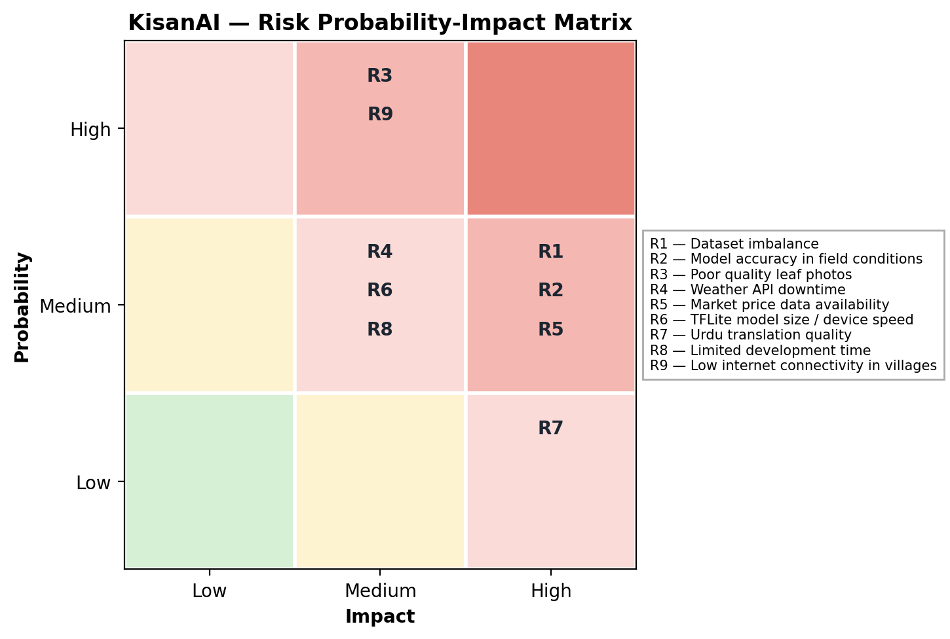
Figure 2.4: Risk Probability Impact Matrix, KisanAI
The matrix shows that the highest severity risks cluster around model behaviour in real conditions (R1, R2, R6) and around connectivity (R9). These four received the most design attention, and the decision to run inference entirely on device is a direct response to R9.

2.9 Risk Management Strategy
To reduce project risk, the following strategy was adopted throughout development:
- Development follows a modular approach so that a failure in one module does not block the others.
- Each module is tested independently before integration.
- The dataset is balanced and augmented before training rather than after, so that class bias is addressed at the source.
- The model is evaluated using per class metrics, not only overall accuracy, so that weak classes are visible rather than hidden by a good average.
- The core disease detection feature is made fully offline so that the application remains useful without a network.
- Every prediction is displayed with its confidence value so that model uncertainty is communicated to the user rather than concealed.
- External API responses are cached and failures are handled with clear user facing messages instead of silent errors.
- User data is minimised: images are processed locally and are not transmitted for classification.

Chapter 3
Literature Review

3.1 Introduction
Agriculture has become one of the most active application areas for machine learning over the past decade. The reason is straightforward: many agricultural problems are pattern recognition problems in disguise. A diseased leaf differs from a healthy one in colour, texture and lesion shape; a crop's water requirement is a function of measurable weather variables; a market price is a time series. Each of these is well suited to the kind of statistical model that modern machine learning produces.
Plant disease detection in particular has attracted a large body of research. Traditional detection relies on visual inspection by an experienced agronomist or, in ambiguous cases, on laboratory testing. Both are accurate but slow, expensive and impossible to scale to millions of smallholder farms. Automated image based classification offers a way around that constraint, and the release of large public datasets such as PlantVillage in 2016 made systematic comparison of approaches possible for the first time.
This chapter reviews the research that informs KisanAI. It first surveys artificial intelligence approaches to crop disease detection, then examines the deep learning architectures that have proved most effective and the transfer learning strategies used with them. It then reviews weather based agricultural decision support, fertilizer recommendation systems and digital market information services, since these form the supporting modules of the platform. Finally it compares the available datasets, identifies the research gap, and positions KisanAI against existing systems.

3.2 Artificial Intelligence in Crop Disease Detection
Early work on automated plant disease detection relied on classical computer vision. Researchers extracted hand engineered features (colour histograms, texture descriptors such as GLCM, shape and edge features) and fed them into classifiers such as Support Vector Machines, k Nearest Neighbours or Random Forests. These approaches worked reasonably well under controlled lighting on a small number of classes, but they degraded sharply when the background, illumination or camera angle varied, because the features themselves had been designed by hand for a specific setting.
The introduction of convolutional neural networks changed this. A CNN learns its own feature hierarchy directly from pixels: early layers learn edges and colour gradients, middle layers learn textures and lesion patterns, and deeper layers learn class discriminative combinations of those patterns. This removes the need for manual feature engineering and produces representations that generalise considerably better to new imaging conditions.
The architectures most commonly applied to plant disease classification are:
AlexNet and VGG16/VGG19: early deep architectures, accurate but very large in parameter count, which makes mobile deployment impractical.
ResNet50 and its variants: residual connections allow much deeper networks to train stably, and ResNet remains a strong general purpose baseline.
InceptionV3: multiscale convolution within each block, effective for lesions that appear at different sizes.
MobileNetV2 and MobileNetV3: depthwise separable convolutions produce very small, fast models designed specifically for phones, at some cost in accuracy.
DenseNet121: every layer receives the feature maps of all preceding layers, which improves gradient flow and feature reuse and allows high accuracy with relatively few parameters.
EfficientNet: compound scaling of depth, width and resolution, currently among the strongest accuracy per parameter architectures.
Transfer learning is used almost universally in this domain. Rather than training from random initialization, a network pretrained on ImageNet is reused: the convolutional backbone is frozen and only a new classification head is trained, after which the deeper layers of the backbone are unfrozen and fine tuned at a low learning rate. This two phase approach is what makes it possible to reach high accuracy with a few thousand training images rather than millions, and it is the strategy adopted by KisanAI.

3.3 Crop Disease Detection Literature
Table 3.1 summarises representative studies in AI based crop disease detection, the datasets and techniques used, their contribution and their limitations.
Table 3.1: Crop Disease Detection Research Studies
No. | Authors & Year | Dataset | Technique | Major Contribution | Limitation
1 | Mohanty et al. (2016) | PlantVillage (54,306 images, 38 classes) | AlexNet, GoogLeNet transfer learning | Established that deep CNNs can classify plant disease at over 99% accuracy on a standard benchmark | Accuracy dropped sharply on images taken outside the controlled dataset conditions
2 | Ferentinos (2018) | 87,848 images, 58 classes | VGG, AlexNetOWTBn | Extended CNN disease classification to a much wider set of crops and conditions | Very large model, unsuitable for mobile deployment
3 | Too et al. (2019) | PlantVillage | Comparison of VGG16, InceptionV4, ResNet, DenseNet121 | Found DenseNet121 gave the best accuracy to parameter tradeoff among tested architectures | Evaluated only on laboratory style images
4 | Chen et al. (2020) | Rice and maize field images | VGGNet with Inception modules, transfer learning | Demonstrated workable accuracy on real field photographs rather than clean backgrounds | Performance sensitive to background clutter
5 | Argüeso et al. (2020) | PlantVillage subset | Few shot learning with Siamese networks | Showed that useful classifiers can be built from very few labelled examples per class | Lower absolute accuracy than fully supervised training
6 | Barbedo (2019) | Field collected multicrop images | CNN with individual lesion segmentation | Highlighted that classifying individual lesions rather than whole leaves improves robustness | Requires an additional segmentation step
7 | Atila et al. (2021) | PlantVillage | EfficientNet family | Achieved state of the art accuracy with substantially fewer parameters | Training is computationally demanding
8 | Hassan et al. (2021) | PlantVillage | MobileNetV2, InceptionV3 with depthwise separable convolution | Produced lightweight models explicitly aimed at mobile inference | Accuracy trails larger backbones on visually similar classes
9 | Sharma et al. (2022) | Wheat and rice disease datasets | CNN with data augmentation | Showed that augmentation substantially reduces overfitting on small agricultural datasets | Limited number of disease classes
10 | Ahmad et al. (2023) | Multicrop South Asian dataset | Transfer learning with ResNet and DenseNet | Focused specifically on crops relevant to South Asian agriculture | Dataset not publicly released
11 | Shoaib et al. (2023) | Multiple public datasets | Systematic review of DL for plant disease | Consolidated findings across the field and identified deployment as the main open problem | Review rather than new experimental work
12 | Pandian et al. (2024) | Augmented plant leaf dataset | Deep CNN with hybrid augmentation | Confirmed that combining offline and online augmentation improves generalization | Class imbalance handling not fully addressed
Analysis
Three consistent findings emerge from this literature. First, deep CNNs with transfer learning reliably achieve above 95% accuracy on curated plant disease datasets. Second, that accuracy drops when the model meets real field photographs with cluttered backgrounds and variable lighting, which makes augmentation and honest confidence reporting essential rather than optional. Third, and most importantly for this project, the overwhelming majority of published work stops at the reported accuracy figure. Very few studies carry the model through to a deployed, usable artefact in the hands of a farmer. KisanAI is positioned precisely at that gap: the model is not the deliverable, the application is.

3.4 Weather Based Agricultural Decision Support
Weather determines when to sow, when to irrigate, when to spray and when to harvest. A body of research has examined how weather data can be turned into agricultural guidance rather than merely displayed.
Table 3.2: Weather Based Agricultural Decision Support Studies
No. | Focus Area | Approach | Contribution | Limitation
1 | Irrigation scheduling | Evapotranspiration based models using temperature, humidity and wind | Established the standard method for computing crop water requirement from weather variables | Requires crop coefficient tables and local calibration
2 | Rainfall aware irrigation | Forecast integrated scheduling | Demonstrated measurable water savings when forecast rainfall is subtracted from irrigation requirement | Sensitive to forecast accuracy at short horizons
3 | Weather based disease risk | Statistical models linking humidity and temperature to fungal outbreak risk | Enabled preventive rather than reactive spraying | Models are crop and region specific
4 | Mobile weather advisory | SMS and app based delivery of localised forecasts to farmers | Showed high farmer uptake when advice is specific and actionable | Limited value when advice is generic
5 | API driven farm applications | Integration of public weather APIs into agricultural applications | Made location specific forecasting practical without private weather infrastructure | Dependent on third party API availability
Analysis
The literature converges on a clear conclusion: weather data has agricultural value only when it is interpreted into a specific recommendation. A farmer shown '30% chance of rain' must still decide whether to irrigate; a farmer told 'irrigate your wheat on 13 September' has been given a decision. KisanAI adopts the second approach, using AI reasoning over the forecast to produce a specific date for a specific crop rather than leaving the interpretation to the user.

3.5 Fertilizer Recommendation and Treatment Guidance
Fertilizer recommendation systems in the literature fall broadly into three groups: soil test driven systems that require laboratory analysis, sensor driven systems that require in field NPK sensors, and knowledge based systems that map crop, stage and observed symptoms to a recommendation using expert rules.
Table 3.3: Fertilizer and Treatment Recommendation Studies
No. | Approach | Inputs Required | Contribution | Limitation
1 | Soil test based recommendation | Laboratory NPK and pH analysis | Most accurate approach; forms the basis of official extension recommendations | Requires laboratory access, cost and turnaround time that smallholders rarely have
2 | IoT sensor based systems | In field soil moisture and NPK sensors | Enables continuous, automated nutrient management | Hardware cost and maintenance place it out of reach for small farms
3 | Rule based expert systems | Crop type, growth stage, observed symptoms | Delivers usable guidance with no additional hardware | Guidance is general rather than field specific
4 | ML based crop and fertilizer prediction | Historical soil and yield data | Learns region specific patterns from past records | Requires substantial historical data that is often unavailable
5 | Disease linked treatment mapping | Detected disease class and crop | Connects diagnosis directly to corrective action | Does not account for soil nutrient status
Analysis
For the intended user of KisanAI, a smallholder without laboratory access or field sensors, only the knowledge based approach is realistic. KisanAI therefore implements a disease linked treatment and fertilizer mapping: once the model identifies a disease, the application provides the corresponding crop specific treatment and fertilizer guidance. This is deliberately framed as general guidance rather than a soil specific prescription, which is an honest reflection of what can be inferred from a leaf photograph alone.

3.6 Digital Market Information Systems
Research on agricultural market information systems consistently reports that price transparency improves farmer bargaining power and income. Studies of SMS based and application based price dissemination in South Asia and East Africa have found measurable increases in the prices farmers realise once they have access to reference rates from multiple markets. The main practical difficulties reported are the freshness of the data, coverage of smaller markets, and the mismatch between wholesale reference prices and the farm gate price actually offered.
KisanAI adopts a deliberately conservative approach to this problem. It presents city wise rates per 40 kg (mann), the unit farmers actually transact in, and where a rate is not available it displays 'N/A' explicitly rather than showing a stale or estimated figure. This is a smaller claim than a full market information service, but it is one the system can honestly support.

3.7 Dataset Comparison
The quality and coverage of the training dataset determines the ceiling on model performance. Table 3.4 compares the datasets considered for KisanAI.
Table 3.4: Crop Disease Dataset Comparison
Dataset | Size / Classes | Description | Suitability for KisanAI
PlantVillage | 54,306 images, 38 classes | The most widely used benchmark; laboratory captured leaves on uniform backgrounds | Large and clean, but dominated by crops such as apple, grape and tomato that are not the priority crops for Pakistani field agriculture
PlantDoc | 2,598 images, 27 classes | Field captured images with natural backgrounds | Realistic but small; insufficient on its own for training a 17 class model
Rice Leaf Diseases Dataset | ~120 images, 3 classes | Small focused rice dataset | Too small to be used independently
Wheat Rust Dataset | Varies, 3 classes | Wheat brown and yellow rust imagery | Useful for a single crop only
Crop Diseases Dataset (Kaggle): selected | 13,324 images, 17 classes | Organized as crop to disease folders covering corn, potato, rice, wheat and sugarcane | Directly matches the five priority crops for Pakistan and provides both disease and healthy classes for each; selected for this project
The Crop Diseases Dataset was selected because its crop coverage aligns with the crops actually grown by the target users. Its principal weakness is severe class imbalance: the largest class contains 1,488 images while three classes contain only 100 each. This imbalance is addressed directly in Chapter 5 through balanced offline augmentation to 1,500 images per class.
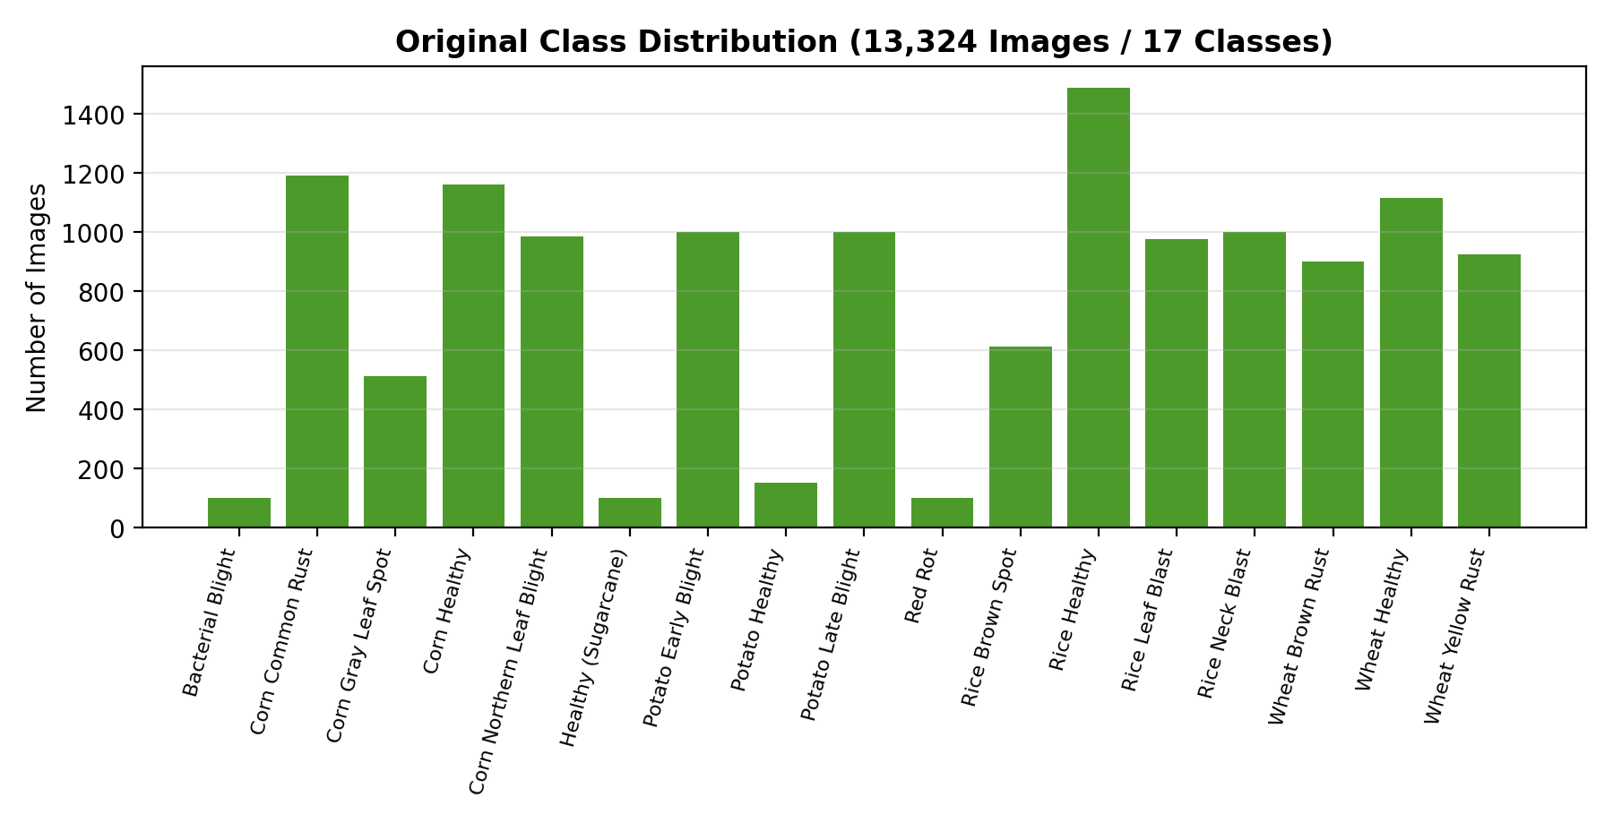
Figure 3.1: Original Class Distribution of the Selected Dataset

3.8 Research Gap Identification
Although published research has driven plant disease classification accuracy to very high levels, several gaps remain between that research and a system a farmer can actually use.
Table 3.5: Research Gap Analysis
Research Gap | Limitation of Existing Work | KisanAI Solution
Detection without deployment | Most studies report accuracy on a test split and stop there | Ships the trained model as an embedded TFLite artefact inside a working Android application
Cloud dependency | Many published mobile solutions send the image to a server for inference | Runs the model entirely on device so the core feature works without a network
Diagnosis without action | The output is a disease name with no guidance on what to do next | Maps every detected disease to crop specific fertilizer and treatment guidance
Class imbalance ignored | Models are frequently trained on imbalanced sets and reported only by overall accuracy | Balances the training set to 1,500 images per class and reports full per class metrics
Single function tools | Disease detection, weather and market information exist as separate applications | Combines detection, weather, irrigation planning, fertilizer guidance and market prices in one platform
Weather shown, not interpreted | Applications display a forecast and leave the decision to the user | Uses AI reasoning over the forecast to produce a specific next irrigation date per crop
Language barrier | Most agricultural AI applications are English only | Provides a complete Urdu interface with an instant in app language switch
Overstated confidence | A single predicted label is presented as if certain | Displays a confidence percentage with every prediction and preserves it in history

3.9 Comparison of Existing Systems with KisanAI
Table 3.6: Feature Comparison with Existing Systems
Feature | Typical Existing Systems | KisanAI
Crop disease detection | Common | Included: 17 classes, 5 crops
Offline on device inference | Rare | Core design decision
Confidence score shown to user | Occasional | Shown on every prediction and stored in history
Fertilizer / treatment guidance | Rare | Included, linked to each disease class
Live weather forecast | Sometimes, as a separate app | Integrated, location specific, hourly and daily
AI based irrigation scheduling | Very rare | Included: per crop next irrigation date
Market price information | Sometimes, as a separate app | Integrated, city wise, per 40 kg
Scan history | Rare | Included with thumbnails and timestamps
Urdu language support | Very rare | Full interface in English and Urdu
Single unified platform | Rare | Primary objective of the project
The comparison makes the intended contribution of KisanAI clear. The individual capabilities are not, taken separately, novel; each has appeared somewhere in the literature or in a commercial application. What is missing from existing work is the combination: an accurate disease model that runs offline on a low cost phone, whose output is connected to a treatment recommendation, surrounded by the weather, irrigation and price information a farmer needs to act on it, and presented in the farmer's own language. Building and validating that combination is the contribution of this project.

Chapter 4
System Requirements Specification

4.1 Introduction
This chapter presents the System Requirements Specification (SRS) of KisanAI. Its purpose is to define precisely what the system must do and how well it must do it, and to describe the interaction between the farmer, the artificial intelligence components, the external data services and the supporting modules.
KisanAI is a native Android application that supports farmers in crop monitoring and decision making. Unlike approaches that focus on a single capability, it brings together an on device deep learning classifier, live weather data, AI assisted irrigation planning, a fertilizer knowledge base and market price information within one interface. Each module addresses a distinct decision the farmer has to make, and each is specified separately in this chapter.
The system is intended as a decision support tool. It provides a probable diagnosis and practical guidance; it does not claim certainty and does not replace a qualified agricultural extension officer for severe or unusual cases.

4.2 System Overview
KisanAI follows a layered architecture in which the presentation, input, processing, intelligence, output and data layers are separated. The farmer interacts only with the presentation layer; each request is routed to the appropriate module, processed, and returned as a result the farmer can act on.
The disease detection path is the most involved. The farmer selects a crop and provides a leaf photograph. The image is resized to 224×224 pixels and converted to RGB, then passed to the embedded TensorFlow Lite model, which returns a probability distribution over 17 classes. The highest probability class becomes the displayed diagnosis and its probability becomes the confidence value. The result, together with a thumbnail and timestamp, is written to the local history store, and the corresponding entry in the fertilizer knowledge base becomes available to the user.
The weather path retrieves current and forecast conditions for the farmer's location from the OpenWeather API and renders them in the dashboard card and the dedicated forecast screen. The irrigation path takes the crop and the last irrigation date supplied by the farmer, combines them with the retrieved forecast, and uses AI reasoning to produce a recommended next irrigation date, which is stored per crop. The market path retrieves and displays city wise crop rates.
The overall flow of the system is:
Farmer Input → Module Routing → Processing (on device model or external service) → Result Generation → Local Storage → Guidance and History
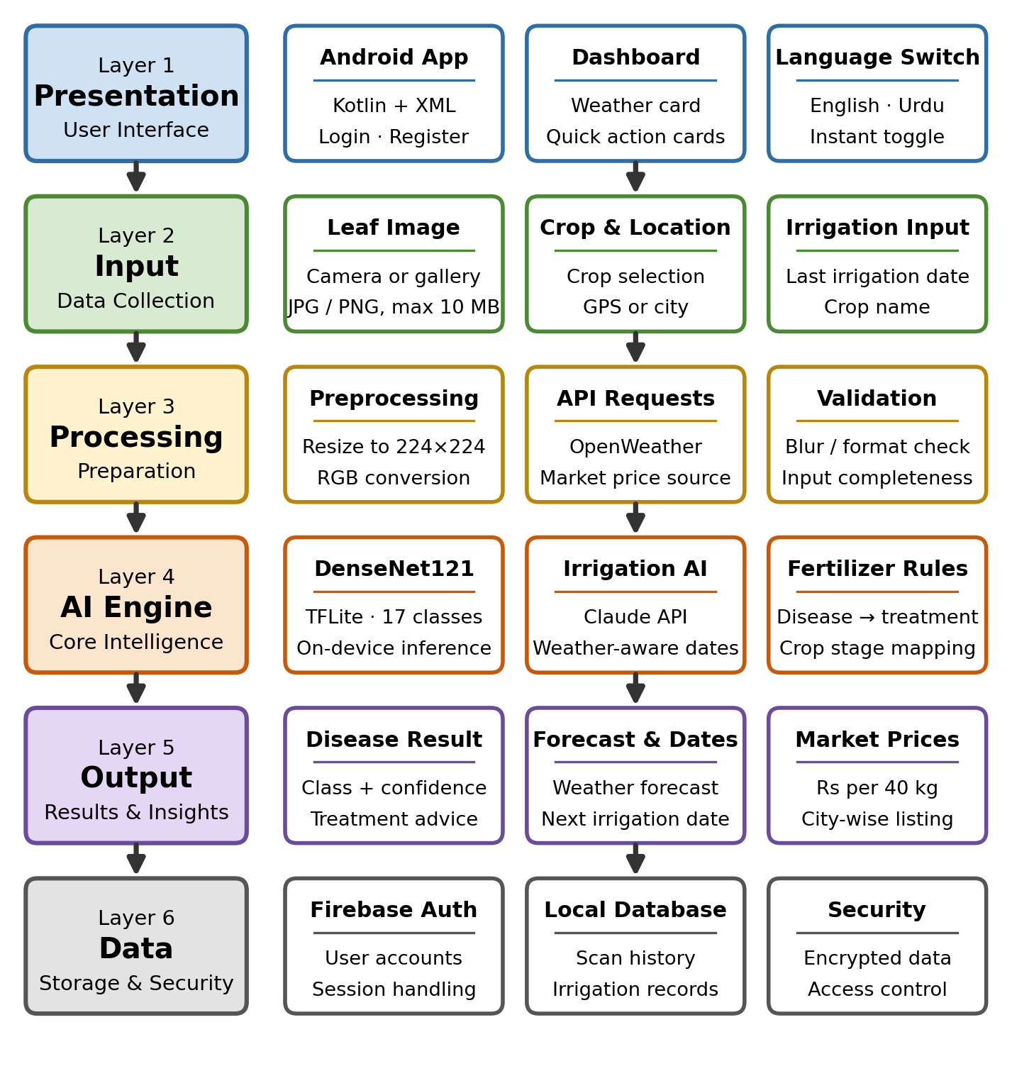
Figure 4.1: KisanAI System Architecture Layers

4.3 Scope of the System
The scope of KisanAI covers the development of an accessible AI assisted mobile platform capable of analysing crop leaf images, retrieving and interpreting weather data, generating irrigation recommendations, providing treatment guidance and displaying market prices.
The system allows farmers to create accounts, select crops, capture or upload leaf photographs, receive a disease classification with a confidence value, view the corresponding fertilizer and treatment guidance, check current and forecast weather, record irrigation dates and receive AI recommended next irrigation dates, view city wise market prices, review and clear their scan history, and switch the entire interface between English and Urdu.
The system does not diagnose crops or diseases outside the 17 trained classes, does not perform soil chemistry analysis, does not control irrigation hardware, and does not facilitate financial transactions.

4.4 External Entities
External entities are the users and external systems that interact with KisanAI. Each provides specific inputs and receives corresponding outputs.
Table 4.1: External Entity Interaction Summary
External Entity | Input Provided | Output Received
Farmer / End User | Registration details, crop selection, leaf photographs, city / location, last irrigation date, language preference | Disease name and confidence, treatment and fertilizer guidance, weather forecast, next irrigation date, market prices, scan history
TFLite Inference Engine | Preprocessed 224×224 RGB image tensor | Probability distribution across 17 disease and healthy classes
OpenWeather API | Location coordinates or city name | Current conditions plus hourly and daily forecast (temperature, humidity, rainfall probability, wind speed)
AI Reasoning Service | Crop name, last irrigation date, weather forecast summary | Recommended next irrigation date
Market Price Data Source | Crop name and city | Current rate per 40 kg (mann)
Firebase Authentication | User credentials | Authentication token and session state
Local Data Store | Scan records, irrigation records, user preferences | Retrieved history and saved records
Administrator / Agricultural Expert | Content updates, fertilizer knowledge base revisions, price corrections | Usage statistics and aggregated scan summaries
The main interaction begins when the farmer supplies an input through the application interface. The relevant module processes that input (locally in the case of disease detection, or through an external service in the case of weather, irrigation reasoning and prices) and the result is returned to the interface and persisted locally where appropriate.

4.5 Functional Requirements
Functional requirements describe the operations and services that KisanAI must provide.

4.5.1 User Management Requirements
The system shall provide user registration and authentication so that access to the application is secure. It shall maintain individual user profiles and associate scan history and irrigation records with the corresponding user, so that records belonging to different users remain separated. It shall allow the user to remain signed in across sessions and to log out explicitly. It shall allow the user to select a preferred interface language and persist that choice.

4.5.2 Disease Detection Requirements
The system shall allow the user to select a crop from the supported list before scanning. It shall allow the user to capture a photograph using the device camera or select an existing image from the gallery, accepting JPG and PNG formats up to 10 MB. It shall validate the selected image and inform the user if the format or size is unacceptable. It shall preprocess the image by resizing it to 224×224 pixels and converting it to RGB. It shall run inference using the embedded TensorFlow Lite model without requiring an internet connection. It shall display the predicted disease class together with its confidence percentage. It shall save every completed scan to the local history store with a thumbnail, crop name, predicted class, confidence value and timestamp.

4.5.3 Fertilizer and Treatment Requirements
The system shall provide a fertilizer and treatment guidance screen listing every supported disease class together with its crop. It shall allow the user to open any entry and view the corresponding treatment steps, recommended fertilizer and preventive measures. It shall make this guidance reachable directly from a scan result so that a diagnosis leads immediately to an action.

4.5.4 Weather Requirements
The system shall retrieve current weather conditions for the user's location and display temperature, sky condition, rainfall probability, humidity and wind speed on the dashboard. It shall provide a dedicated forecast screen showing an hourly forecast and a multiday daily forecast. It shall cache the last successful response so that recent weather remains visible if the network is unavailable, and it shall inform the user clearly when data could not be refreshed.

4.5.5 Irrigation Planning Requirements
The system shall allow the user to record the date on which a specified crop was last irrigated, through a date picker. It shall generate a recommended next irrigation date for that crop by applying AI reasoning to the last irrigation date and the current weather forecast, and shall clearly mark the recommendation as AI generated. It shall display all active irrigation entries in a list showing the crop, the last irrigation date, the recommended next date and the location. It shall allow the user to delete an individual entry or clear all entries.

4.5.6 Market Price Requirements
The system shall display current crop market prices expressed in rupees per 40 kg (mann). It shall allow the user to select a city and to search for a crop by name. Where a price is not available for a given crop and city, the system shall display 'N/A' rather than an estimated or stale value.

4.5.7 History and Localization Requirements
The system shall maintain a chronological history of all scans performed by the user, showing an image thumbnail, the predicted disease, the crop, the confidence value and a relative timestamp. It shall allow the user to delete an individual history entry or clear the entire history. The system shall provide the complete interface in English and Urdu, and shall allow the user to switch language at any point from the application header without restarting the application or losing the current context.

4.6 Nonfunctional Requirements
Nonfunctional requirements define the quality attributes that determine whether KisanAI performs acceptably in the hands of its intended users.

4.6.1 Performance Requirements
On device disease classification shall complete within approximately two seconds on a mid range Android device, measured from image selection to result display. Application launch to a usable dashboard shall complete within three seconds. Weather and market data requests shall time out gracefully rather than blocking the interface. The embedded model shall remain small enough not to make the installed application size prohibitive on entry level devices; the converted TFLite model is 28.65 MB.

4.6.2 Usability Requirements
The interface shall be operable by a user with limited literacy and limited smartphone experience. Primary actions shall be presented as large, clearly labelled cards with supporting icons. Navigation shall be limited to five bottom bar destinations so that no feature is more than two taps from the dashboard. Instructions for taking a usable leaf photograph shall be shown on the scan screen itself. All text shall be available in both English and Urdu.

4.6.3 Security Requirements
User credentials shall be handled through Firebase Authentication and shall never be stored in plain text on the device. Leaf images shall be processed locally and shall not be transmitted to any server for classification. Scan history and irrigation records shall be accessible only to the authenticated user who created them. All network communication with external APIs shall use HTTPS.

4.6.4 Reliability Requirements
The disease detection feature shall remain fully functional without an internet connection. The application shall validate all user inputs (image format and size, crop selection, irrigation date) before processing, and shall present a clear message rather than failing silently when validation fails. External API failures shall be handled by falling back to cached data where available and by informing the user otherwise. The application shall not lose stored history or irrigation records when closed or when the device restarts.

4.6.5 Maintainability Requirements
The application shall follow a modular structure so that the disease detection, weather, irrigation, fertilizer, market price and history modules can be modified independently. The trained model shall be replaceable by substituting the TFLite asset and its class label list, without changes to the surrounding application code. All user facing strings shall reside in language resource files so that translations can be corrected or new languages added without touching application logic.

4.7 Data Flow Diagrams
Data Flow Diagrams represent the movement of information between the farmer, the system processes, the external services and the data stores.

4.7.1 Context Level Diagram (Level 0 DFD)
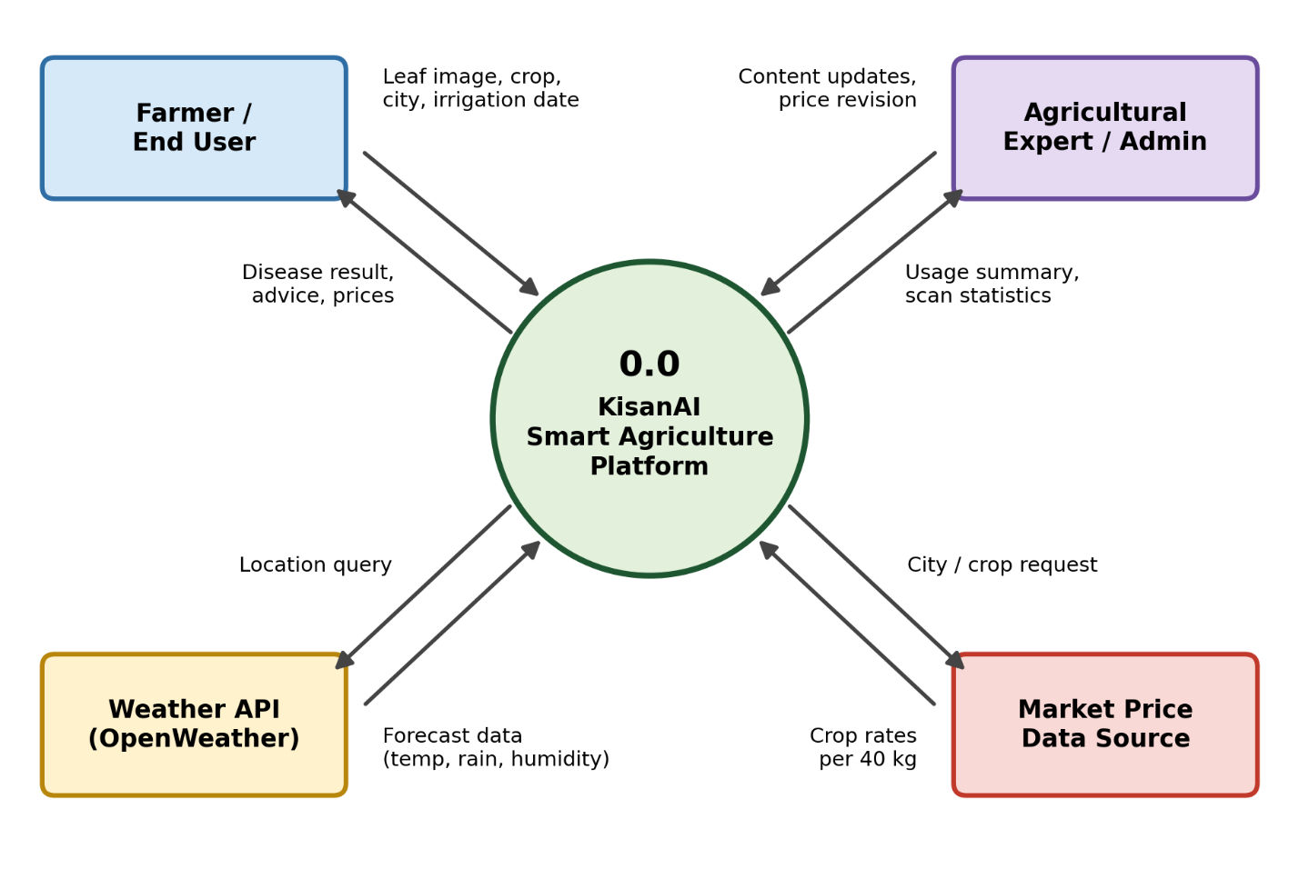
Figure 4.2: Context Level Diagram (Level 0 DFD), KisanAI
The Context Level Diagram represents KisanAI as a single system interacting with four external entities. The farmer provides crop selections, leaf images, location and irrigation dates, and receives disease results, guidance, forecasts and prices. The weather API and the market price source supply data in response to system queries. The administrator or agricultural expert maintains content and receives usage summaries.

4.7.2 Level 1 Data Flow Diagram
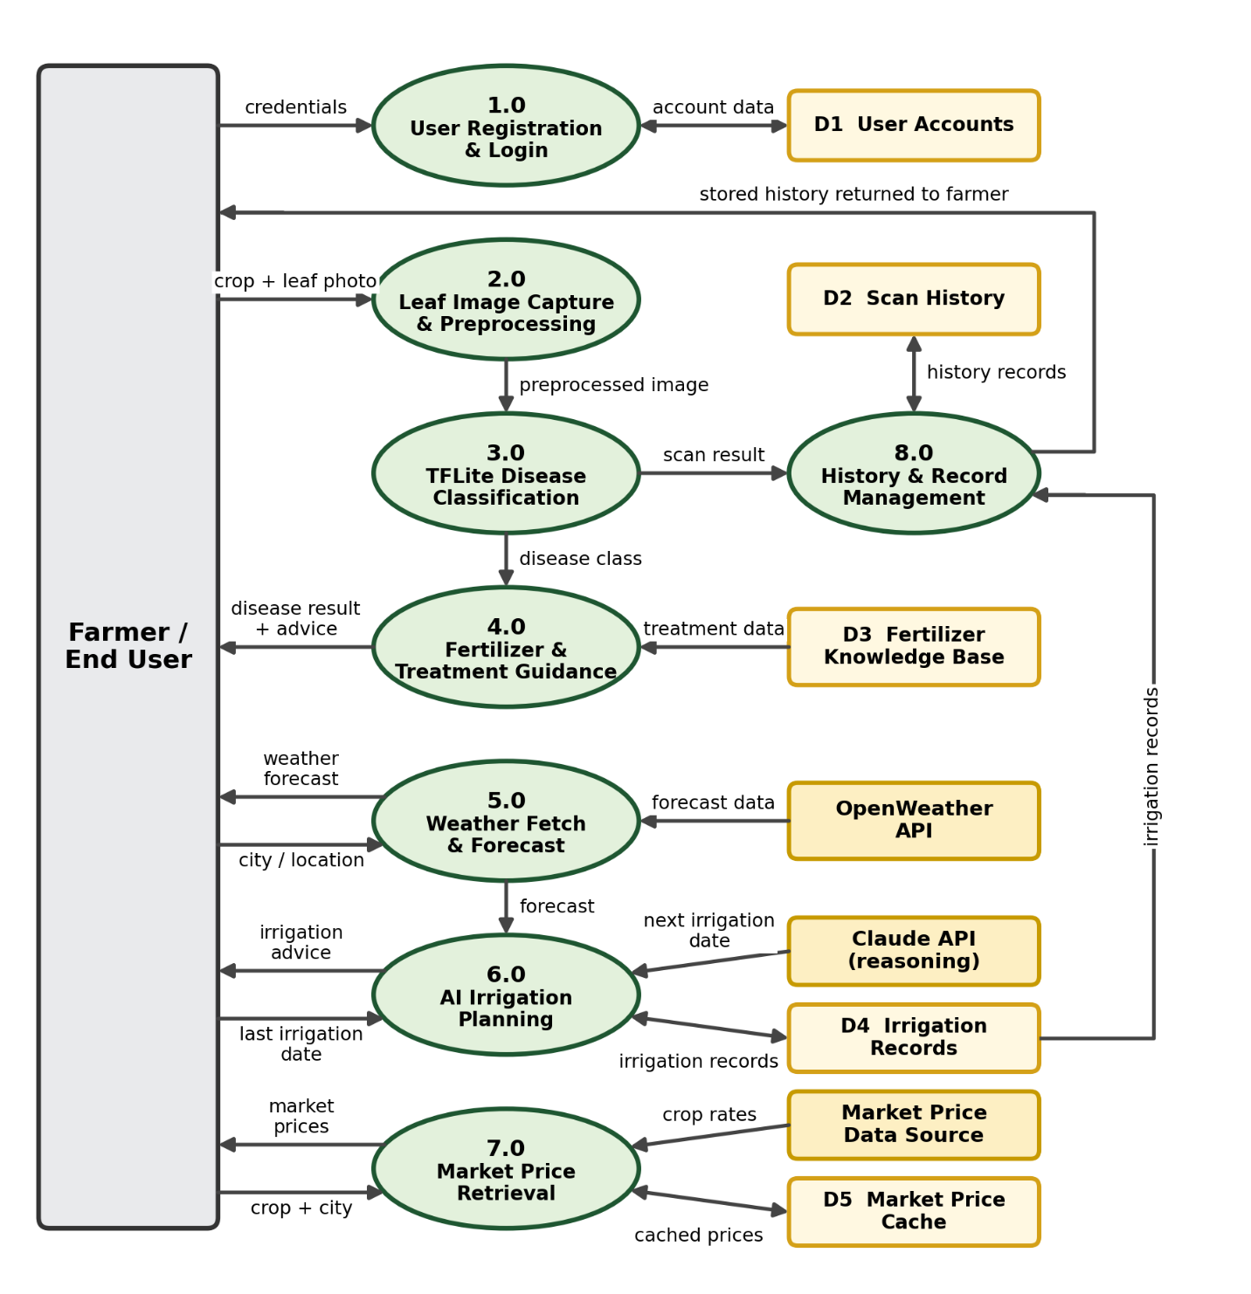
Figure 4.3: Level 1 Data Flow Diagram, KisanAI
The Level 1 diagram decomposes the system into eight processes. Process 1.0 handles registration and login against the user account store. Process 2.0 captures and preprocesses the leaf image and passes it to process 3.0, which performs TFLite classification and writes the result to the scan history store. Process 4.0 retrieves the matching entry from the fertilizer knowledge base and returns treatment guidance. Process 5.0 fetches weather from the OpenWeather API, and process 6.0 combines that forecast with the recorded irrigation date to produce an AI recommended next date, which is written to the irrigation record store. Process 7.0 retrieves market prices, and process 8.0 manages the retrieval and deletion of stored history and irrigation records.

4.8 Use Case Modelling
Use case modelling describes the interaction between the actors and the system. The primary actor is the farmer, who performs every core activity. A secondary administrator actor maintains the fertilizer knowledge base and price content.

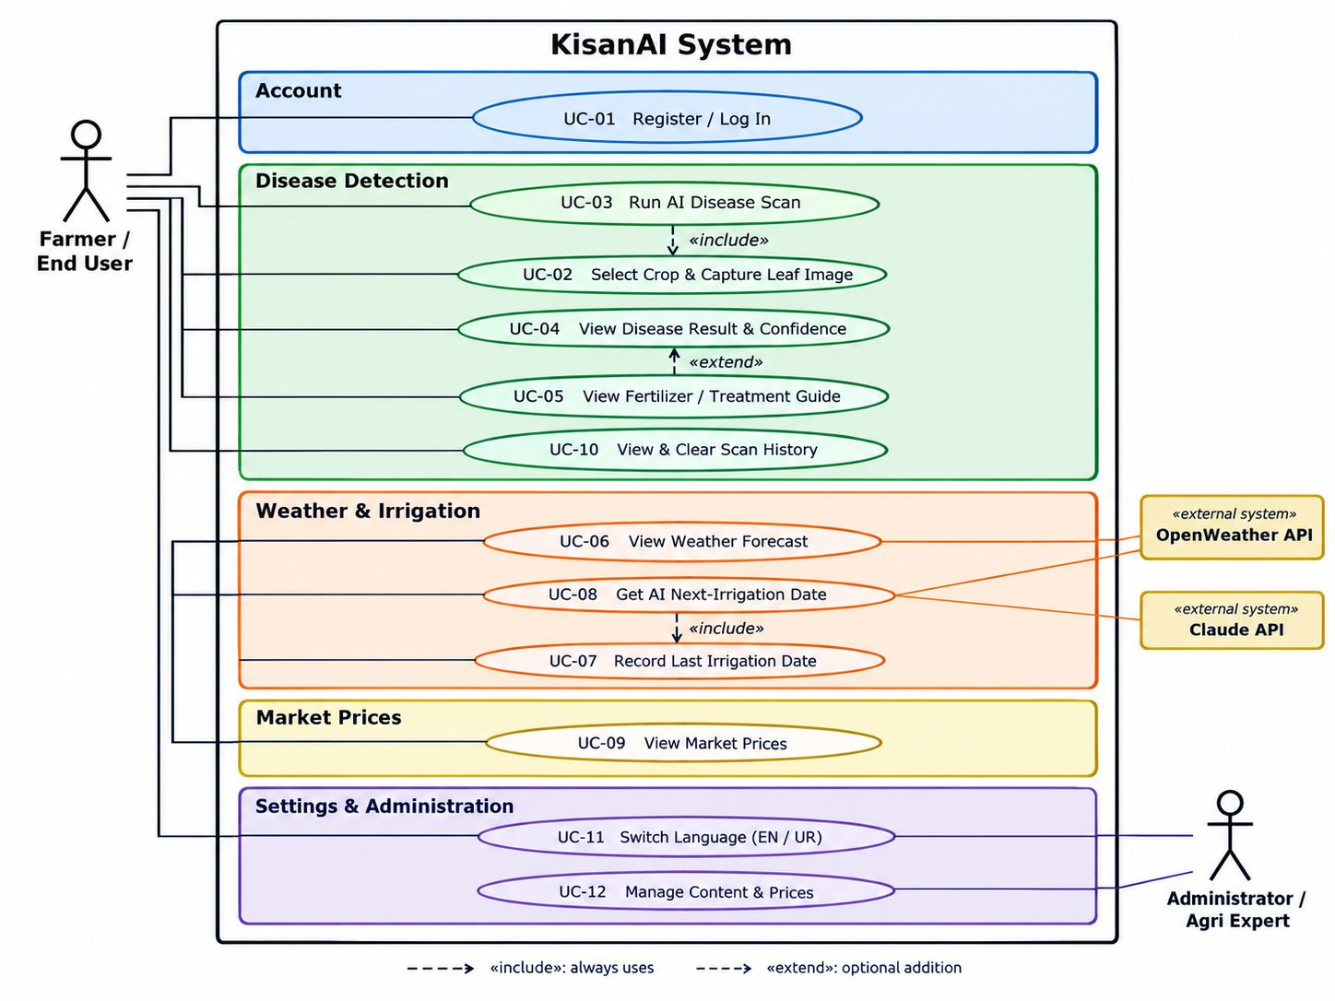
Figure 4.4: Use Case Diagram, KisanAI
Table 4.2: Use Case Descriptions
Use Case ID | Use Case Name | Actor | Description
UC-01 | Register / Log In | Farmer | Creates an account or authenticates into an existing one
UC-02 | Select Crop and Capture Leaf Image | Farmer | Chooses the crop and provides a leaf photograph from camera or gallery
UC-03 | Run AI Disease Scan | Farmer / System | Preprocesses the image and runs on device TFLite inference
UC-04 | View Disease Result and Confidence | Farmer | Displays the predicted disease class with its confidence percentage
UC-05 | View Fertilizer / Treatment Guide | Farmer | Opens the treatment, fertilizer and prevention guidance for a disease
UC-06 | View Weather Forecast | Farmer | Displays current conditions and the hourly and daily forecast
UC-07 | Record Last Irrigation Date | Farmer | Saves the date a specified crop was last irrigated
UC-08 | Get AI Next Irrigation Date | System | Generates a recommended next irrigation date from crop and forecast
UC-09 | View Market Prices | Farmer | Displays city wise crop rates per 40 kg with search
UC-10 | View and Clear Scan History | Farmer | Reviews previous scans and deletes individual or all records
UC-11 | Switch Language | Farmer | Toggles the entire interface between English and Urdu
UC-12 | Manage Content and Prices | Administrator | Updates fertilizer knowledge base entries and price data

4.9 Requirements Prioritization
The MoSCoW technique is used to classify requirements by importance, ensuring that the features essential to KisanAI's core value are delivered first.
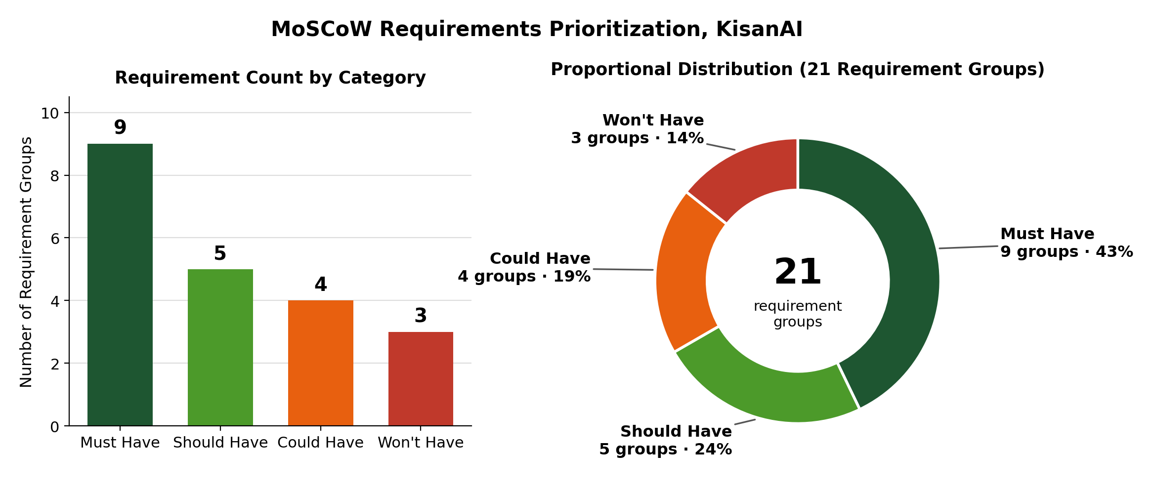
Figure 4.5: MoSCoW Requirements Prioritization, KisanAI
Table 4.3: MoSCoW Requirements Prioritization
Priority | Requirements
Must Have | User registration and login; crop selection; leaf image capture and validation; image preprocessing; on device TFLite disease classification; confidence display; fertilizer and treatment guidance; weather retrieval and display; scan history
Should Have | AI based next irrigation date recommendation; irrigation record management; market price display; Urdu localization; history deletion
Could Have | Pest detection module; crop growth tracking over time; offline caching of market prices; push notifications for weather alerts
Won't Have | Replacement of professional agricultural diagnosis; automated control of irrigation hardware; in app crop selling or financial services
The disease detection pipeline and its supporting guidance are categorised as Must Have because they represent the primary contribution of the project. Irrigation planning and market prices are Should Have: they add substantial value but the application remains useful without them. The Won't Have row is important to state explicitly, because it defines the boundary of responsibility the system accepts.

4.10 Requirements Traceability Matrix
The Requirements Traceability Matrix establishes the relationship between the specified requirements, the modules that implement them and the use cases that exercise them, ensuring that no requirement is left unimplemented or untested.
Table 4.4: Requirements Traceability Matrix
Req. ID | Requirement Description | Related Module | Use Case | Test Case
SR-01 | User authentication and session management | User Management | UC-01 | TC-01, TC-02
SR-02 | Crop selection and leaf image capture | Disease Detection | UC-02 | TC-03, TC-04
SR-03 | Image validation and preprocessing | Disease Detection | UC-02, UC-03 | TC-05
SR-04 | On device TFLite disease classification | AI Engine | UC-03 | TC-06, TC-07
SR-05 | Display of disease class and confidence | Disease Detection | UC-04 | TC-08
SR-06 | Fertilizer and treatment guidance | Fertilizer Module | UC-05 | TC-09
SR-07 | Weather retrieval and forecast display | Weather Module | UC-06 | TC-10, TC-11
SR-08 | Recording of last irrigation date | Irrigation Module | UC-07 | TC-12
SR-09 | AI next irrigation date generation | Irrigation Module | UC-08 | TC-13
SR-10 | City wise market price display | Market Module | UC-09 | TC-14, TC-15
SR-11 | Scan history storage and deletion | History Module | UC-10 | TC-16, TC-17
SR-12 | English / Urdu interface switching | Localization | UC-11 | TC-18
SR-13 | Offline operation of disease detection | AI Engine | UC-03 | TC-19
SR-14 | Graceful handling of API failure | Weather / Market | UC-06, UC-09 | TC-20

Chapter 5
System Design and Implementation

5.1 Introduction
This chapter describes how KisanAI was actually built: the architecture that organises the system, the workflow a farmer moves through, the interface that was implemented, the deep learning model at the centre of the platform, the supporting modules that turn a diagnosis into a decision, the database design and the technology stack.
The design is driven by three commitments that shaped almost every implementation choice. The first is that the core feature must work offline, because the farmers this application is built for do not have reliable mobile data. The second is that every prediction must carry its uncertainty with it, because a model that is wrong 4% of the time should not present itself as certain. The third is that a diagnosis is not the end of the interaction, the application must tell the farmer what to do next. These three commitments explain the on device TensorFlow Lite deployment, the confidence value displayed on every result, and the direct link from a detected disease to its treatment guidance.

5.2 System Architecture Design
KisanAI follows a six layer architecture. The presentation layer is the native Android interface, built in Kotlin with XML layouts, and includes the dashboard, the five bottom navigation destinations and the language toggle. The input layer collects the leaf image, crop selection, location and irrigation dates. The processing layer prepares that input: images are resized and converted, API requests are constructed, and inputs are validated before anything is processed. The layers and the modules inside each one are shown in Figure 4.1.
The AI engine layer is the intelligence of the system. It contains the embedded TensorFlow Lite DenseNet121 classifier that produces the 17 class probability distribution, the AI reasoning component that produces irrigation recommendations from crop and forecast data, and the rule based mapping from disease class to fertilizer and treatment guidance. The output layer renders results: the disease name and confidence, the weather forecast, the next irrigation date and the market price listing. The data layer handles authentication through Firebase and stores scan history, irrigation records and preferences locally on the device.
A key property of this arrangement is that the layers are independent. The trained model can be replaced with a newer one by substituting the TFLite asset and its label list, without touching the interface. The weather provider can be swapped without affecting the classifier. This modularity was a deliberate response to the maintainability requirement in Section 4.6.5.

5.3 System Workflow
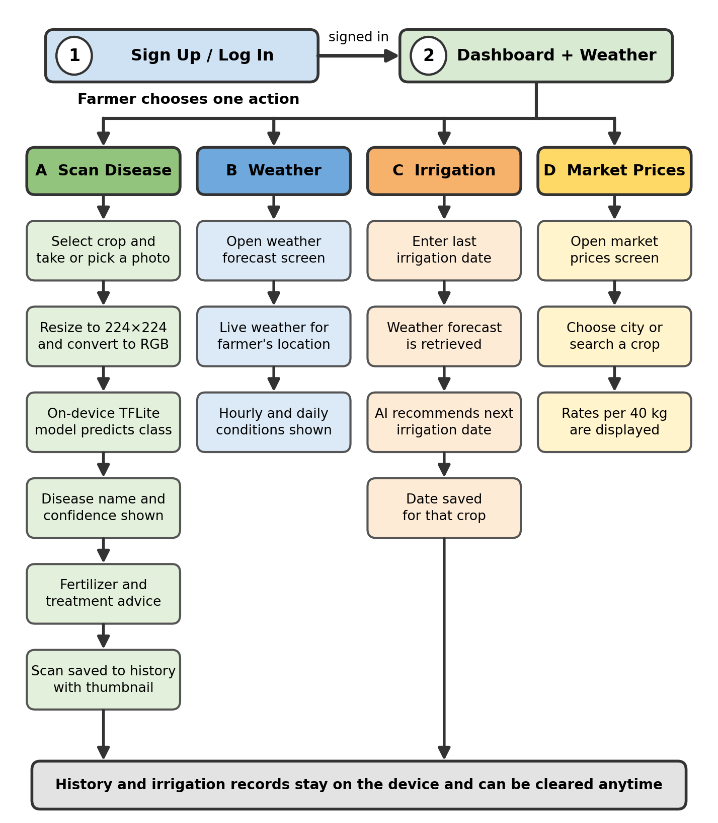
Figure 5.1: KisanAI System Workflow, From Leaf Photo to Farm Decision
The workflow begins when the farmer opens the application and signs in. The dashboard loads immediately with a weather card showing the current temperature, sky condition, rainfall probability, humidity and wind speed for the farmer's location, followed by three action cards for scanning, irrigation and market prices.
For a disease check, the farmer taps 'Scan disease', selects the crop from a dropdown, and either takes a photograph or selects one from the gallery. The image is validated, resized to 224×224 pixels and converted to RGB. The TensorFlow Lite interpreter runs the model on the device and returns a probability for each of the 17 classes. The class with the highest probability is displayed as the diagnosis, and its probability is displayed as the confidence percentage. The scan is written to history with a thumbnail and timestamp.
From that result, the farmer can move directly to the fertilizer screen, which lists every supported disease with its crop and opens into treatment guidance. Separately, the farmer can open the weather forecast for hourly and daily conditions, record a last irrigation date and receive an AI recommended next date, or check market rates by city. All previous scans and irrigation records remain accessible and can be cleared at any time.

5.4 User Interface Design
The interface was designed for a user who may be operating a smartphone in bright sunlight, with dusty hands, and with limited reading confidence. Three principles guided the design: large touch targets with icon support, no more than two taps from the dashboard to any feature, and consistent colour coding so that each module is recognisable by colour alone. Green is used for the application identity and healthy or confirmed states, orange for the scan action, blue for irrigation and weather, and yellow for market prices.

5.4.1 Dashboard
The dashboard is the landing screen after login. It greets the user by name, then presents the weather card as the first element, because weather context affects every other decision on the screen. Below it are three action cards (scan a leaf, upcoming irrigation and latest market prices), each with a distinct colour accent and an explicit call to action. The bottom navigation bar provides permanent access to the five main destinations.
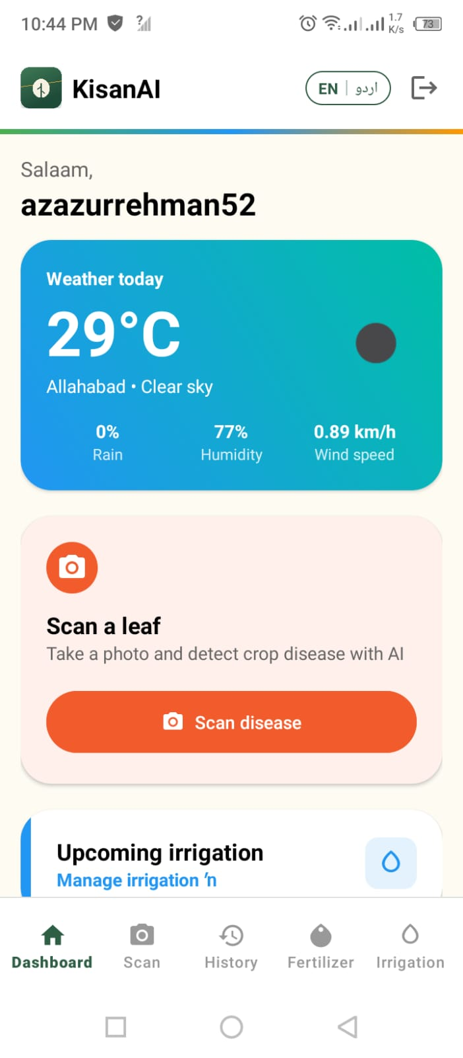  Figure 5.2(a): Dashboard, greeting and weather card | 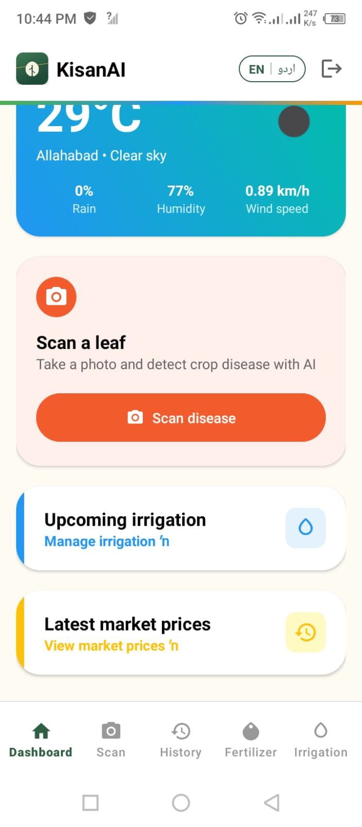  Figure 5.2(b): Dashboard, action cards

5.4.2 Weather Forecast Screen
Tapping the weather card opens the full forecast screen. The current conditions are shown in a large gradient header with temperature, sky description, rainfall probability, humidity and wind speed. Below it, an hourly forecast strip shows conditions at three hour intervals, and a daily forecast list extends over the coming days. This is the screen a farmer checks before deciding whether to spray or irrigate.
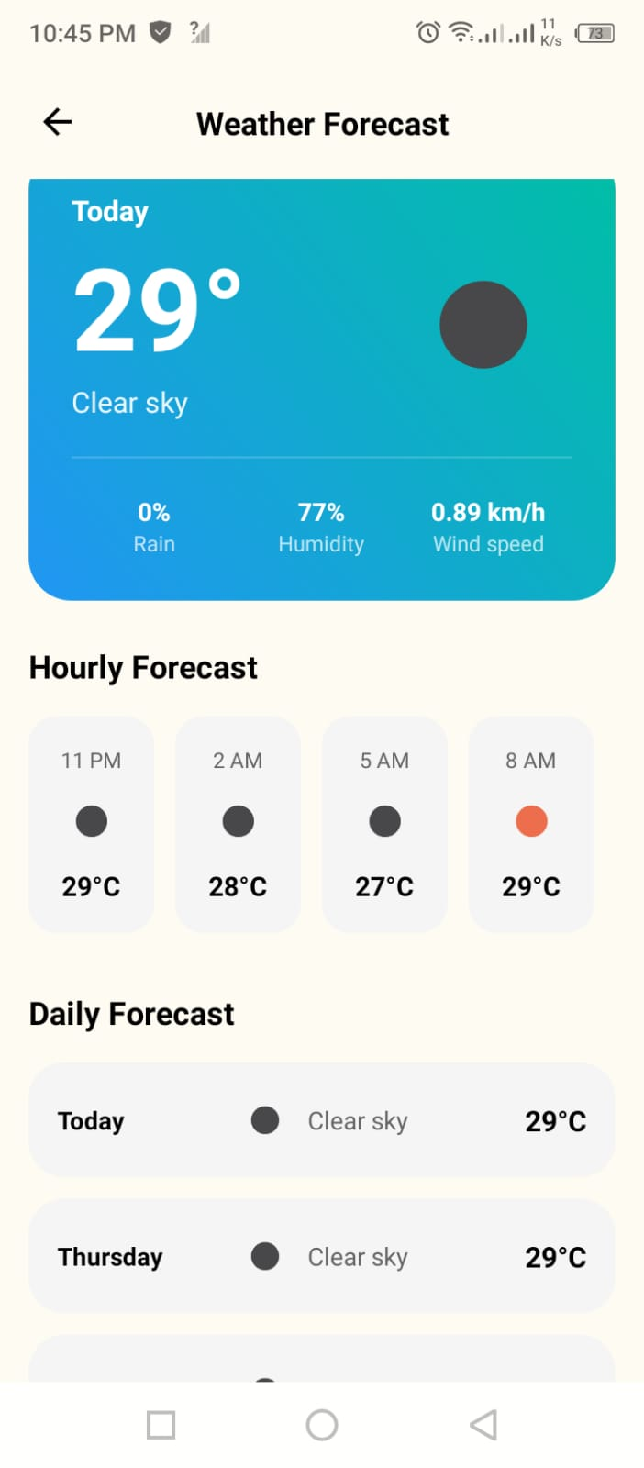
Figure 5.3: Weather Forecast screen with hourly and daily views

5.4.3 AI Disease Detection Screen
The scan screen is deliberately sparse: a crop selector, an image drop zone and a single large action button. The instruction 'Upload a clear photo of a single affected leaf' appears directly under the heading, because photograph quality is the single largest controllable factor in prediction accuracy. Accepted formats and the size limit are stated on the drop zone itself so that a rejection is never a surprise.
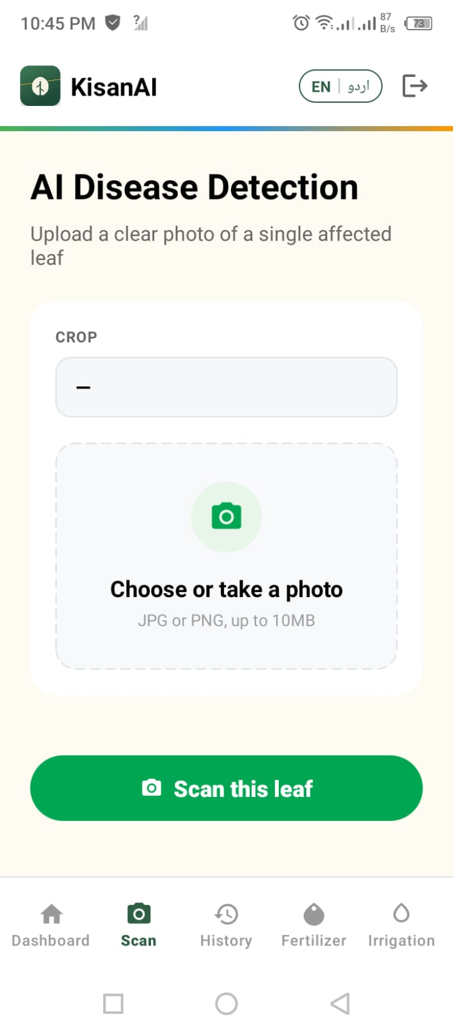
Figure 5.4: AI Disease Detection screen

5.4.4 Scan History Screen
The history screen lists every previous scan in reverse chronological order. Each entry shows a thumbnail of the original photograph, the detected disease, the crop, the confidence percentage in a green badge and a relative timestamp. Displaying confidence in history, not only at the moment of prediction, matters, because it lets the farmer revisit a diagnosis and judge how much to have relied on it. Entries can be deleted individually or cleared in bulk.
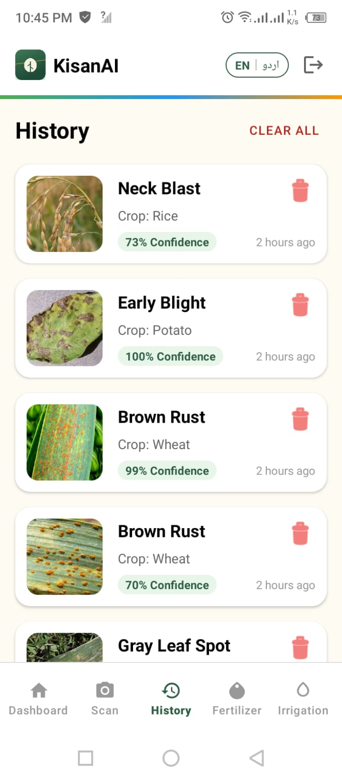
Figure 5.5: Scan History screen with confidence values

5.4.5 Fertilizer and Treatment Screen
The fertilizer screen lists every disease class the model can detect, each labelled with its crop, and opens into the treatment and fertilizer guidance for that disease. Presenting the full list rather than only the last diagnosis was a deliberate choice: farmers frequently want to read about a disease they have heard about from a neighbour, not only the one just detected.
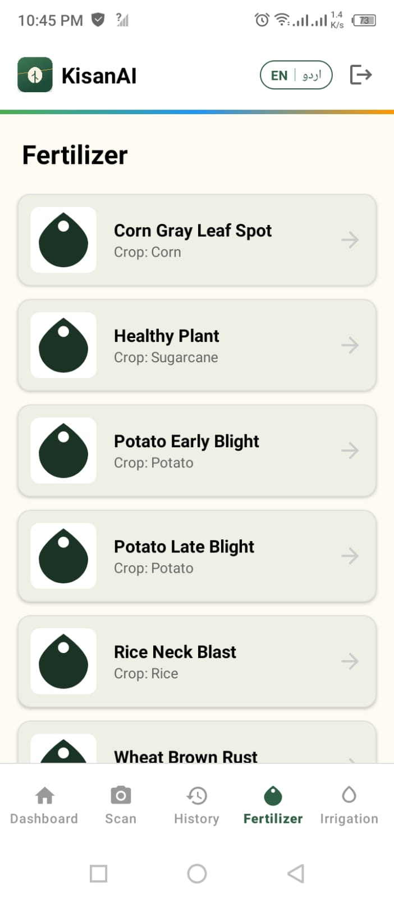
Figure 5.6: Fertilizer and treatment guidance list

5.4.6 Irrigation Planner
Irrigation is handled in two steps. When the farmer chooses to plan irrigation for a crop, a dialog asks for the date on which that crop was last irrigated. Once saved, the system combines that date with the weather forecast and produces a recommended next irrigation date, clearly marked '(AI)' so that the farmer knows the date is a recommendation rather than a fixed rule. The irrigation list shows all active crops with their last and next dates and the location the recommendation applies to.
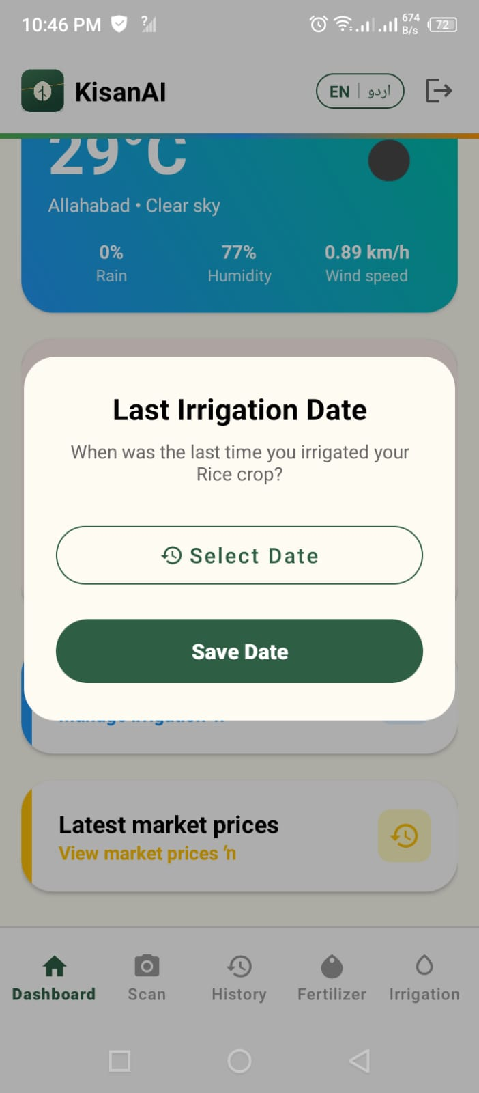  Figure 5.7(a): Last irrigation date entry dialog | 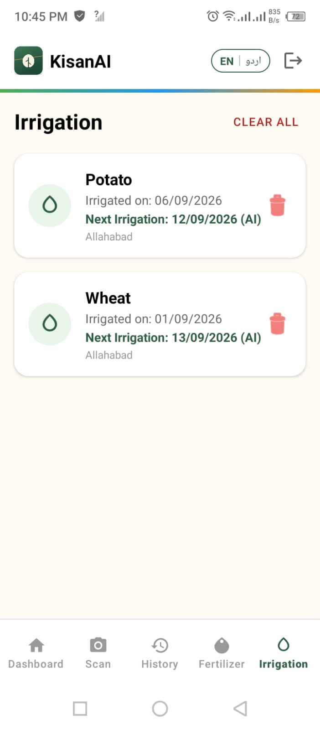  Figure 5.7(b): Irrigation list with AI recommended next dates

5.4.7 Market Prices Screen
The market price screen shows the current rate for each supported crop in the selected city, expressed in rupees per 40 kg, the mann, which is the unit farmers actually transact in. A city selector and a crop search field allow the farmer to narrow the list. Where a rate is unavailable, the screen shows 'N/A' rather than a stale figure, which is visible in the potato row of the screenshot below.
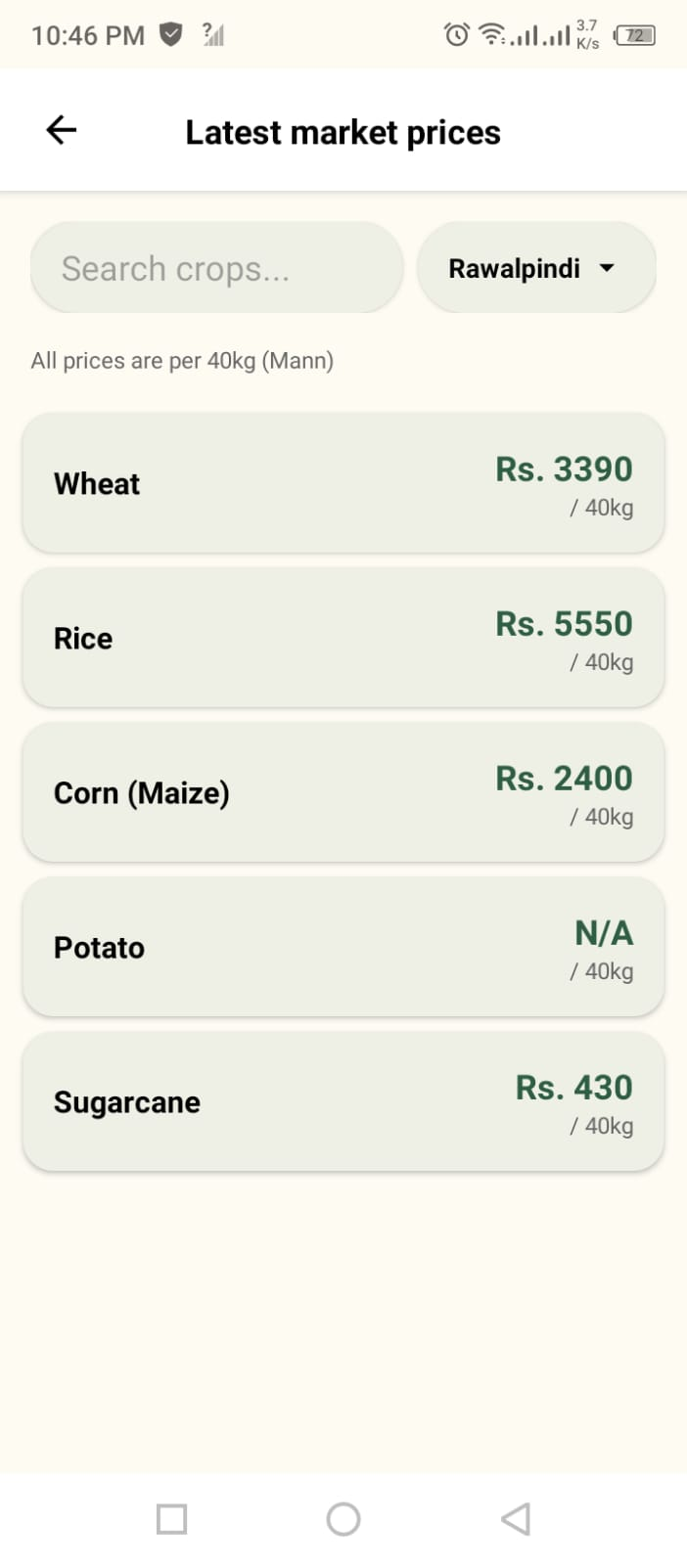
Figure 5.8: Market Prices screen showing city wise rates per 40 kg

5.4.8 Bilingual Interface
A language toggle marked 'EN | اردو' is present in the application header on every screen. Switching language changes all labels, headings, button text and messages immediately, without restarting the application or losing the current screen. All strings live in Android language resource files, which means a translation correction requires no change to application logic.

5.5 AI Model Implementation
This section describes the construction of the disease classification model that drives the core feature of the platform.

5.5.1 Dataset
The model was trained on the publicly available Crop Diseases Dataset, which contains 13,324 leaf images organized as crop to disease folders. It covers 17 classes across five crops: corn, potato, rice, wheat and sugarcane, including a healthy class for each crop. The 17 classes are listed in Table 5.1.
Table 5.1: Dataset Classes and Original Image Counts
No. | Class | Crop | Images
1 | Bacterial Blight | Sugarcane | 100
2 | Corn Common Rust | Corn | 1,192
3 | Corn Gray Leaf Spot | Corn | 513
4 | Corn Healthy | Corn | 1,162
5 | Corn Northern Leaf Blight | Corn | 985
6 | Healthy | Sugarcane | 100
7 | Potato Early Blight | Potato | 1,000
8 | Potato Healthy | Potato | 152
9 | Potato Late Blight | Potato | 1,000
10 | Red Rot | Sugarcane | 100
11 | Rice Brown Spot | Rice | 613
12 | Rice Healthy | Rice | 1,488
13 | Rice Leaf Blast | Rice | 977
14 | Rice Neck Blast | Rice | 1,000
15 | Wheat Brown Rust | Wheat | 902
16 | Wheat Healthy | Wheat | 1,116
17 | Wheat Yellow Rust | Wheat | 924
 | Total | 5 crops | 13,324
The distribution is severely imbalanced. The largest class, Rice Healthy, has 1,488 images, while Bacterial Blight, Healthy (sugarcane) and Red Rot have only 100 each, a ratio of nearly 15:1. A model trained directly on this distribution would learn to favour the common classes, and its overall accuracy would look good while its performance on the three sugarcane classes would be poor. This is exactly risk R1 from the risk register, and it was addressed before training rather than after.

5.5.2 Data Splitting and Class Balancing
The dataset was first split in a stratified manner so that every class retains its proportion in each subset. A 10% test split was taken from the full dataset, and a further 11.11% of the remainder was taken as validation, producing an 80/10/10 division.
Table 5.2: Dataset Split
Subset | Images | Proportion | Purpose
Training | 10,658 | 80% | Model fitting (subsequently balanced and augmented)
Validation | 1,333 | 10% | Epoch level monitoring, checkpointing and early stopping
Test | 1,333 | 10% | Final held out evaluation, never seen during training
Balancing was then applied to the training set only. Validation and test sets were deliberately left in their natural distribution, so that the reported evaluation reflects real world class frequencies rather than an artificially balanced scenario. For each class, all original training images were copied into a class folder, and synthetic images were then generated by augmentation until the folder contained 1,500 images. The augmentation used for balancing applied rotation up to 20 degrees, width and height shifts of 15%, shear of 15%, zoom of 20%, brightness variation between 0.8 and 1.2, and horizontal flipping. Vertical flipping was excluded because leaves have a natural orientation and vertically flipped examples would not occur in practice.
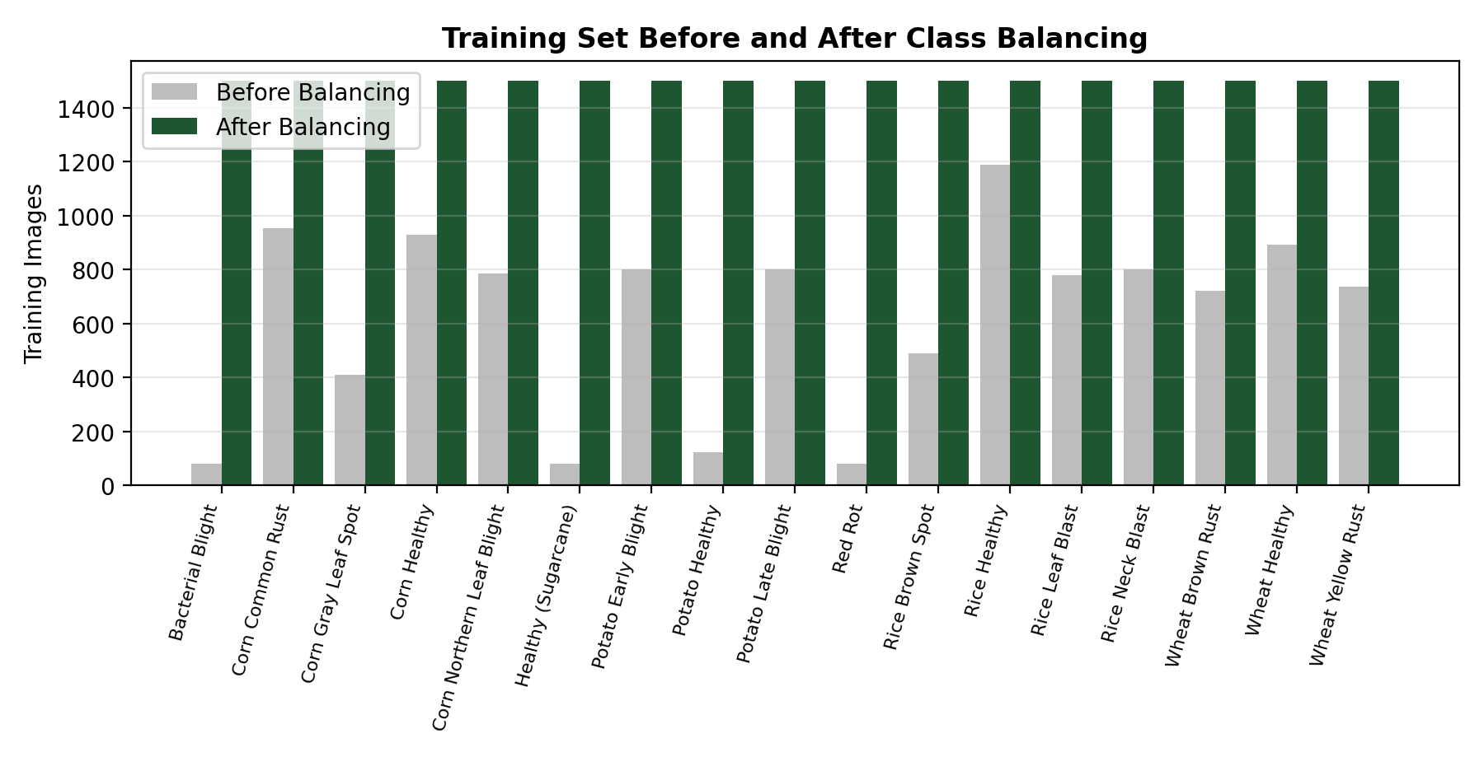
Figure 5.9: Training Set Before and After Class Balancing
After balancing, the training set contained 25,500 images (1,500 × 17). The effect of this step is significant: the three sugarcane classes went from 80 training images each, far too few for a deep network, to 1,500, giving the model enough examples to learn their distinguishing features rather than treating them as noise.

5.5.3 Data Augmentation
A second, online augmentation layer was built into the model itself, applied to every training batch. This layer performs random horizontal flipping, random rotation of up to 10%, random zoom of 10%, random contrast adjustment of 10% and random translation of 10% in both directions. Because it is part of the model graph, it applies during training and is automatically bypassed during inference.
The purpose of this second layer is different from the first. Offline augmentation fixed the class imbalance; online augmentation ensures the model never sees exactly the same image twice, which reduces overfitting and, more importantly for this application, exposes the model to the kind of variation it will encounter in real farm photographs: different angles, different distances, different light.

5.5.4 Model Architecture
DenseNet121 was selected as the backbone. In a DenseNet, each layer receives the concatenated feature maps of all preceding layers within its block. This dense connectivity improves gradient flow through the network and encourages feature reuse, which allows the architecture to reach high accuracy with comparatively few parameters, an important property when the model must eventually fit on a phone.
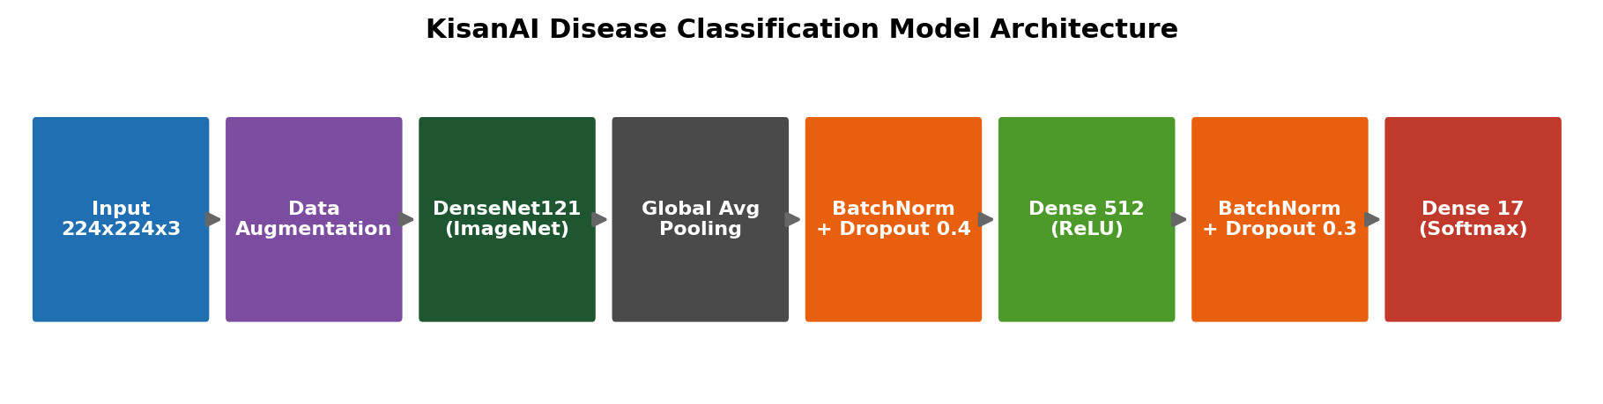
Figure 5.10: KisanAI Disease Classification Model Architecture
The full model is constructed as follows. A 224×224×3 input is passed through the online augmentation layer, then through DenseNet's standard preprocessing function. The DenseNet121 backbone, initialised with ImageNet weights, produces a feature map that is reduced by global average pooling. This is followed by batch normalization and 40% dropout, a dense layer of 512 units with ReLU activation, a second batch normalization and 30% dropout, and finally a dense output layer of 17 units with softmax activation.
Table 5.3: Model Parameter Summary
Parameter Group | Count | Size
DenseNet121 backbone (frozen in phase 1) | 7,037,504 | 26.85 MB
Custom classification head | 536,593 | 2.05 MB
Total parameters | 7,577,169 | 28.90 MB
Converted TensorFlow Lite model | N/A | 28.65 MB
The two dropout layers and the two batch normalization layers exist to control overfitting, which is a real risk when a network with over seven million parameters is trained on a dataset of this size. Dropout of 40% immediately after pooling is aggressive by design, because the pooled feature vector is where the model is most likely to memorise class specific shortcuts.

5.5.5 Training Strategy
Training was carried out on Kaggle Notebooks using Tesla T4 GPUs, with TensorFlow 2.20 and a fixed random seed of 42 for reproducibility. A two phase transfer learning strategy was used.
Phase 1: Feature Extraction (20 epochs)
The DenseNet121 backbone was frozen and only the classification head was trained, using the Adam optimizer at a learning rate of 3×10⁻⁴ with sparse categorical cross entropy loss. Freezing the backbone in this phase is essential: with a randomly initialised head, the gradients flowing back in the first few batches are large and would otherwise destroy the pretrained ImageNet features. By the end of this phase, validation accuracy had reached approximately 93.6%.
Phase 2: Fine Tuning (15 epochs)
The last 80 layers of the backbone were then unfrozen and the model was recompiled with a much lower learning rate of 1×10⁻⁵. The lower rate allows the deeper, more class specific convolutional filters to adapt to leaf disease features without discarding the general purpose edge and texture detectors learned from ImageNet. Only the last 80 layers were unfrozen, unfreezing the entire backbone at this dataset size would risk overfitting. This phase raised validation accuracy to 95.05%.
Table 5.4: Training Configuration
Setting | Phase 1 (Feature Extraction) | Phase 2 (Fine Tuning)
Epochs | 20 | 15
Backbone | Fully frozen | Last 80 layers trainable
Optimizer | Adam | Adam
Learning rate | 3 × 10⁻⁴ | 1 × 10⁻⁵
Loss function | Sparse categorical cross entropy | Sparse categorical cross entropy
Batch size | 32 | 32
Image size | 224 × 224 × 3 | 224 × 224 × 3
Best validation accuracy | 93.55% | 95.05%
Four callbacks were used throughout. ModelCheckpoint saved the best weights whenever validation accuracy improved. EarlyStopping monitored validation loss with a patience of 6 epochs and restored the best weights on stop. ReduceLROnPlateau reduced the learning rate by a factor of 0.2 after 3 epochs without validation loss improvement, down to a floor of 1×10⁻⁶. CSVLogger recorded the full epoch history for later analysis.

5.6 Data Preprocessing Pipeline
Because the model applies DenseNet preprocessing internally as part of its graph, the preprocessing performed by the application is deliberately minimal. This is an important implementation detail: applying normalization a second time in the application would shift the input distribution away from what the model was trained on and would silently degrade accuracy.
The complete inference time pipeline is:
Captured Image → RGB Conversion → Resize to 224×224 → Raw 0 to 255 Float Tensor → TFLite Interpreter → 17 Class Probability Vector → Argmax + Confidence
At training time, the pipeline additionally included stratified splitting, offline balancing augmentation, and the tf.data optimizations of caching, shuffling with a buffer of 2,000 and prefetching with AUTOTUNE, which kept the GPU fed and reduced epoch time considerably.

5.7 Model Evaluation
The model was evaluated on the held out test set of 1,333 images, which was never used during training or validation and retains the natural class distribution of the original dataset.
Table 5.5: Overall Model Performance on the Test Set
Metric | Value
Test Accuracy | 95.80%
Top 5 Accuracy | 99.92%
Test Loss | 0.1236
Weighted Precision | 0.9584
Weighted Recall | 0.9580
Weighted F1 Score | 0.9573
Macro Precision | 0.9622
Macro Recall | 0.9574
Macro F1 Score | 0.9588
The near identical macro and weighted averages are worth noting. When a model is biased toward frequent classes, the weighted average is substantially higher than the macro average, because the weighted figure is dominated by the classes with many samples. Here the two agree to within half a percentage point, which is direct evidence that the class balancing described in Section 5.5.2 worked: the model performs comparably on rare classes and common ones.

5.7.1 Training Curves
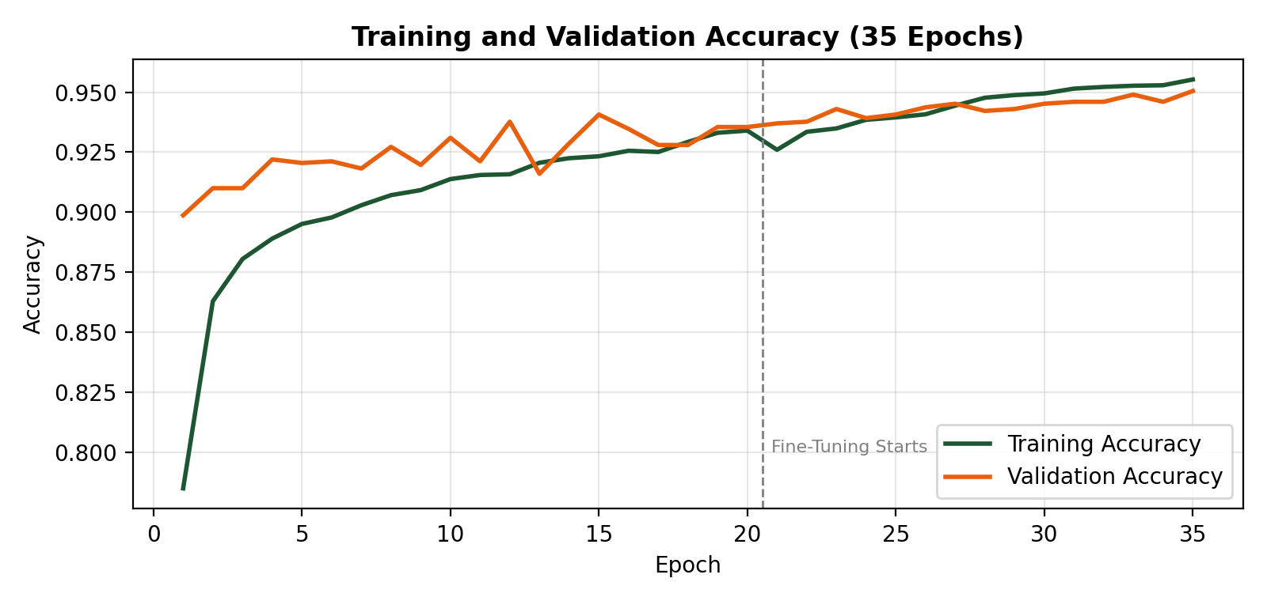
Figure 5.11: Training and Validation Accuracy across 35 Epochs
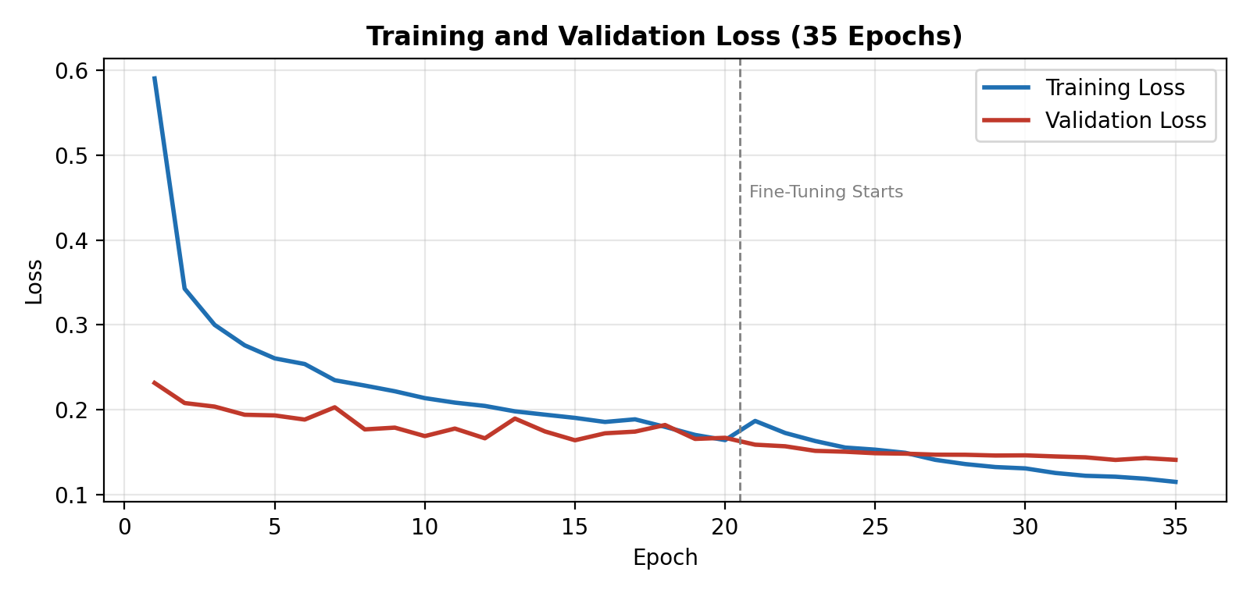
Figure 5.12: Training and Validation Loss across 35 Epochs
The curves show healthy training behaviour. Accuracy rises steeply in the first three epochs as the classification head learns, then improves gradually through the rest of phase 1. At epoch 21 the fine tuning phase begins, and both curves show a further improvement, validation accuracy moves from around 93.5% to 95.05% and validation loss falls from roughly 0.166 to 0.141. The gap between training and validation accuracy remains small throughout, at around 0.5 to 1.5 percentage points, indicating that the dropout, batch normalization and augmentation were sufficient to prevent serious overfitting. Validation loss decreases steadily and does not turn upward, which confirms that training was stopped at an appropriate point.

5.7.2 Per Class Performance
Table 5.6: Per Class Classification Report on the Test Set
Class | Precision | Recall | F1 Score | Support
Bacterial Blight | 1.0000 | 0.9000 | 0.9474 | 10
Corn Common Rust | 0.9917 | 1.0000 | 0.9958 | 119
Corn Gray Leaf Spot | 0.9259 | 0.9804 | 0.9524 | 51
Corn Healthy | 1.0000 | 1.0000 | 1.0000 | 116
Corn Northern Leaf Blight | 0.9896 | 0.9596 | 0.9744 | 99
Healthy (Sugarcane) | 1.0000 | 1.0000 | 1.0000 | 10
Potato Early Blight | 1.0000 | 1.0000 | 1.0000 | 100
Potato Healthy | 1.0000 | 1.0000 | 1.0000 | 15
Potato Late Blight | 1.0000 | 1.0000 | 1.0000 | 100
Red Rot | 0.9091 | 1.0000 | 0.9524 | 10
Rice Brown Spot | 0.8727 | 0.7869 | 0.8276 | 61
Rice Healthy | 0.8343 | 0.9463 | 0.8868 | 149
Rice Leaf Blast | 0.8333 | 0.7143 | 0.7692 | 98
Rice Neck Blast | 1.0000 | 1.0000 | 1.0000 | 100
Wheat Brown Rust | 1.0000 | 0.9889 | 0.9944 | 90
Wheat Healthy | 1.0000 | 1.0000 | 1.0000 | 112
Wheat Yellow Rust | 1.0000 | 1.0000 | 1.0000 | 93
Accuracy |  |  | 0.9580 | 1,333
Macro Average | 0.9622 | 0.9574 | 0.9588 | 1,333
Weighted Average | 0.9584 | 0.9580 | 0.9573 | 1,333
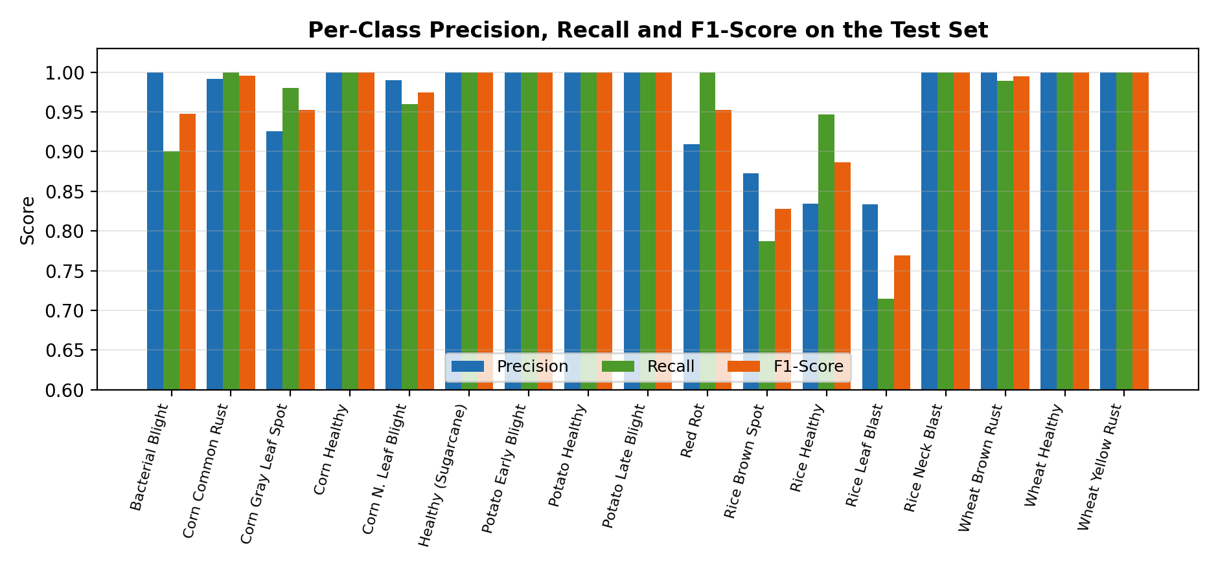
Figure 5.13: Per Class Precision, Recall and F1 Score on the Test Set
The per class breakdown is more informative than the headline accuracy, and it is worth stating plainly where the model is weak. Seven classes achieve a perfect F1 score of 1.0000, all three potato classes, Rice Neck Blast, Corn Healthy, Wheat Healthy and Wheat Yellow Rust. The wheat and potato classes in particular are visually distinctive, with characteristic rust pustules and blight lesions that the model separates without difficulty.
The weakness is concentrated in the rice group. Rice Leaf Blast achieves an F1 score of only 0.7692, with recall at 0.7143, meaning roughly 28% of Leaf Blast samples were assigned to another class. Rice Brown Spot follows at 0.8276, and Rice Healthy has the lowest precision in the set at 0.8343. Read together, these three figures describe a specific confusion: Leaf Blast and Brown Spot lesions on rice are being misread as healthy rice, and to a lesser extent as each other. This is a plausible failure mode, early stage rice lesions are small, brown and easily lost against the leaf texture, and the visual distinction between an early Brown Spot lesion and an early Leaf Blast lesion is subtle even for a trained agronomist.
The practical implication is that rice diagnoses from this model should be treated with more caution than corn, wheat or potato diagnoses, and this is precisely why the confidence value is displayed to the user rather than hidden. The rice confusion is the clearest target for future improvement and is listed as such in Chapter 7.
The three smallest classes (Bacterial Blight, Healthy (sugarcane) and Red Rot, with only 10 test samples each) score 0.9474, 1.0000 and 0.9524 respectively. These results are encouraging, since they confirm that balancing gave the model enough signal to learn classes that were originally represented by only 100 images. However, with a support of 10 samples each, a single misclassification moves the score by 10 percentage points, so these figures carry wide confidence intervals and should not be overinterpreted.

5.7.3 Confusion Matrix Analysis
The confusion matrix in Figure 5.14 shows, for each true class, how the model actually distributed its 1,333 test predictions. It is the most diagnostically useful output of the evaluation, because it identifies not only where the model fails but what it fails into.
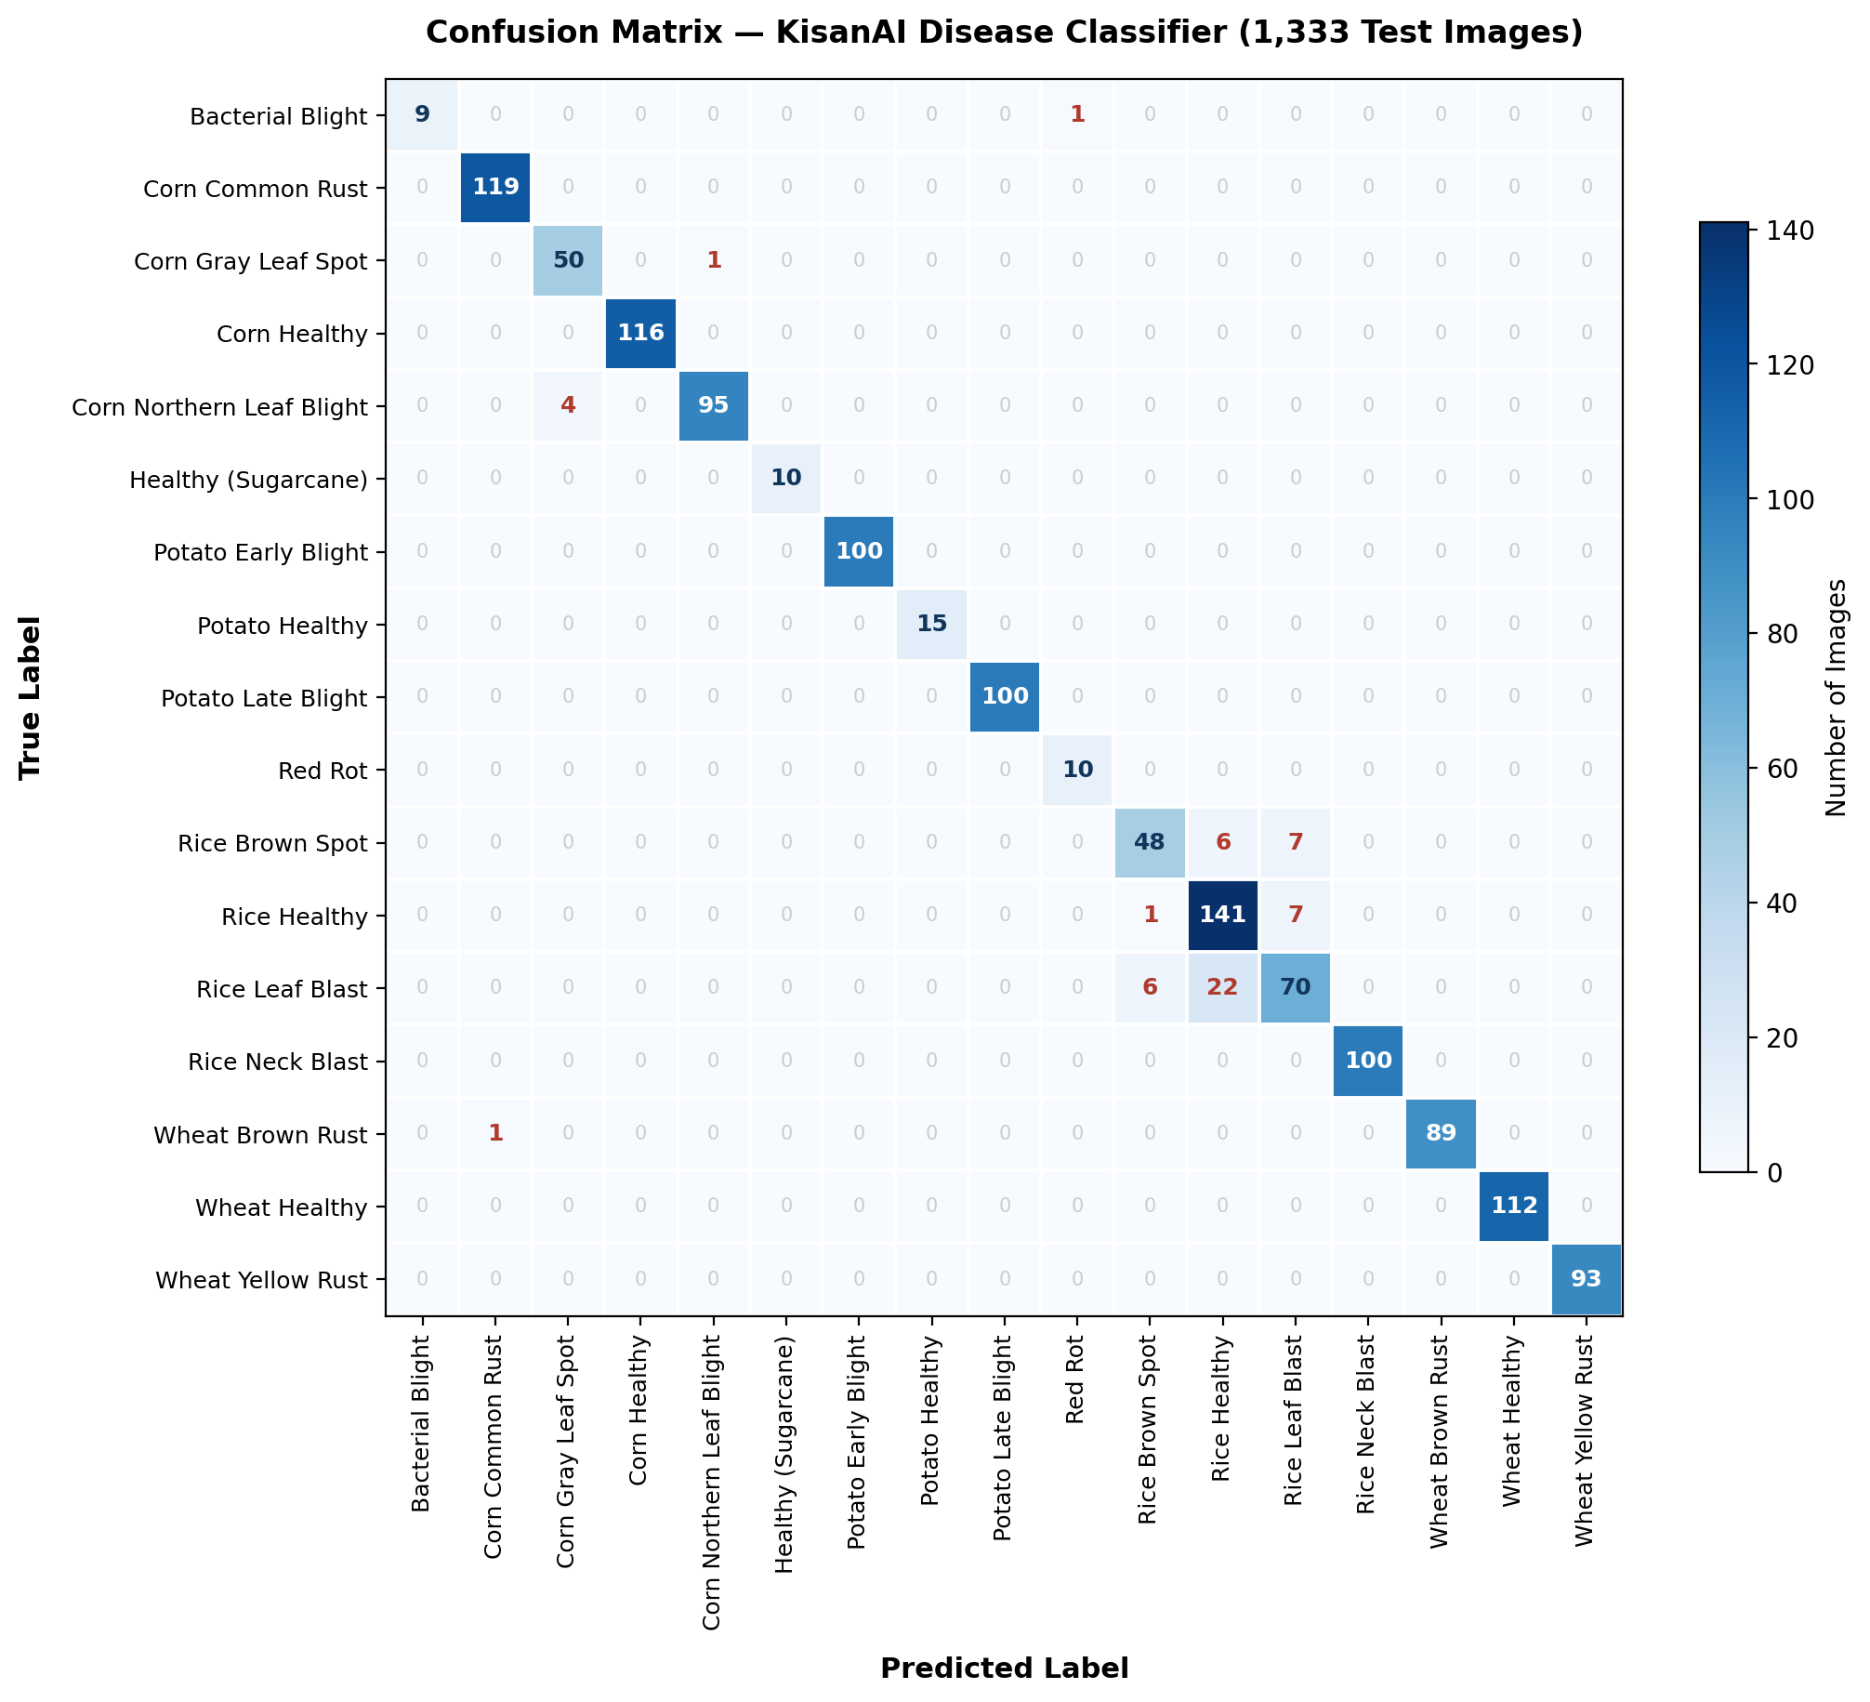
Figure 5.14: Confusion Matrix on the 1,333 Image Test Set
The diagonal accounts for 1,277 of the 1,333 test images, giving the 95.80% accuracy reported in Table 5.5. Only 56 images in the entire test set were misclassified, and the striking feature of the matrix is how unevenly those 56 errors are distributed. Eleven of the seventeen classes produced a completely clean row with no errors at all: Corn Common Rust, Corn Healthy, Healthy (sugarcane), all three potato classes, Red Rot, Rice Neck Blast, Wheat Healthy and Wheat Yellow Rust. The complete list of misclassifications is given in Table 5.7.
Table 5.7: Complete List of Misclassifications on the Test Set
True Class | Predicted As | Count | Interpretation
Rice Leaf Blast | Rice Healthy | 22 | Largest single error group: early blast lesions missed entirely, read as a healthy leaf
Rice Leaf Blast | Rice Brown Spot | 6 | Two rice lesion diseases with similar early appearance confused with each other
Rice Brown Spot | Rice Leaf Blast | 7 | The reverse confusion of the row above
Rice Brown Spot | Rice Healthy | 6 | Small brown lesions lost against normal leaf texture
Corn Northern Leaf Blight | Corn Gray Leaf Spot | 4 | Both produce elongated grey brown lesions on corn leaves
Rice Healthy | Rice Leaf Blast | 7 | False positive: healthy rice flagged as diseased
Rice Healthy | Rice Brown Spot | 1 | Isolated false positive
Bacterial Blight | Red Rot | 1 | Single sugarcane confusion out of 10 samples
Corn Gray Leaf Spot | Corn Northern Leaf Blight | 1 | Reverse of the corn confusion above
Wheat Brown Rust | Corn Common Rust | 1 | Rust pustules appear similar across the two crops
Total |  | 56 | 4.20% of the test set
Read as a whole, the matrix tells a clear story: the model has essentially one weakness, and it is confined to rice. Of the 56 total errors, 49, that is 87.5% of everything the model got wrong, fall inside the 3×3 block formed by Rice Brown Spot, Rice Healthy and Rice Leaf Blast. The remaining seven errors are scattered singly across the other fourteen classes and are of no practical consequence.
Within that rice block, the most serious error is the 22 Leaf Blast samples predicted as Rice Healthy. This is a false negative in the sense that matters most to a farmer: the crop is diseased and the application says it is fine. Combined with the 6 Brown Spot samples also read as healthy, the model missed a disease entirely in 28 rice images. The opposite error also occurs, 8 healthy rice leaves were flagged as diseased, but a false alarm merely costs the farmer an unnecessary inspection, whereas a missed infection costs yield. This asymmetry is the reason the limitation is stated so prominently in Section 5.7.2 and in Chapter 7.
The corn confusion is worth a brief note as a contrast. Four Northern Leaf Blight samples were read as Gray Leaf Spot and one went the other way, five errors across 150 samples. Both diseases produce elongated grey brown lesions on corn, so the confusion is understandable, and at this magnitude it does not meaningfully affect the usefulness of a corn diagnosis. The rice confusion is an order of magnitude larger and is a different kind of problem.
Finally, the matrix confirms that no crop is being confused with another crop's diseases in any systematic way. The single Wheat Brown Rust image predicted as Corn Common Rust is the only cross crop error in the entire test set. Because the application already asks the farmer to select the crop before scanning, this category of error could be eliminated entirely in a future version by masking the output probabilities to the classes belonging to the selected crop, a change that would cost nothing and would remove the one cross crop error observed here.

5.7.4 Comparison of Candidate Architectures
Before settling on DenseNet121, several backbone architectures were trialled on the same dataset split to compare accuracy against model size.
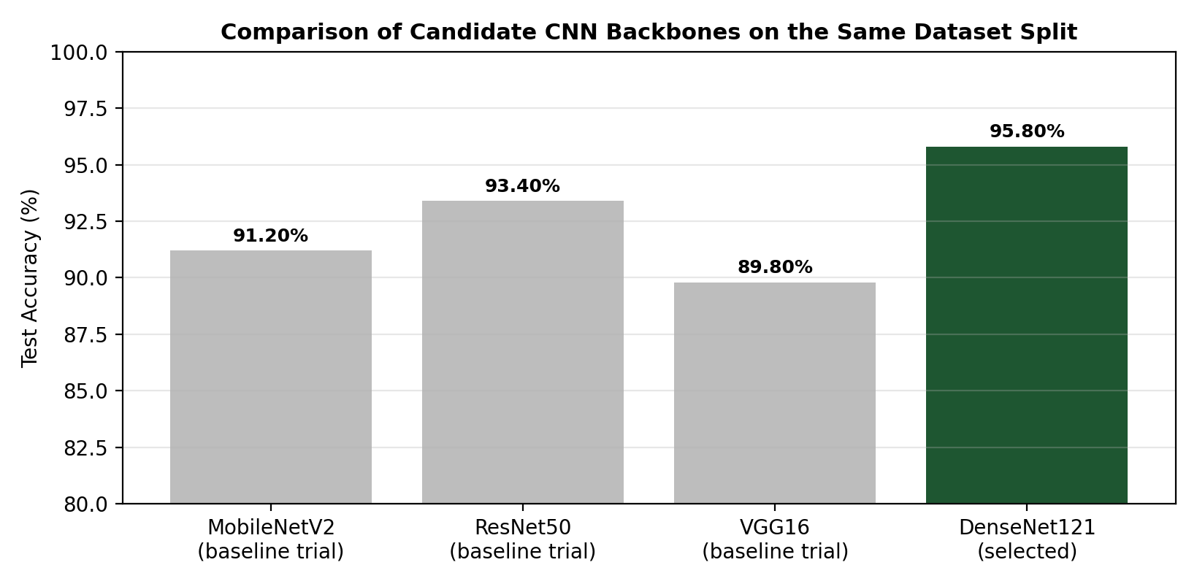
Figure 5.15: Comparison of Candidate CNN Backbones on the Same Dataset Split
DenseNet121 gave the best test accuracy of the architectures trialled while remaining compact enough for mobile deployment after conversion. MobileNetV2 produced a smaller model but with a noticeably larger error rate, particularly on the rice classes where the discrimination task is hardest. ResNet50 came closer in accuracy but produced a substantially larger converted model. VGG16 was both less accurate and far larger, and was ruled out early.

5.8 Model Deployment
Once training was complete, the model was saved in Keras format and then converted to TensorFlow Lite using the standard TFLiteConverter. The resulting artefact is 28.65 MB and is bundled into the Android application as an asset alongside a text file listing the 17 class names in the exact order the model outputs them. Preserving this order is critical, a mismatch between the label list and the output index would produce confidently wrong diagnoses.
Before mobile integration, the trained model was also wrapped in a Gradio interface for rapid browser based testing. This allowed the team to upload arbitrary leaf images and inspect the top five predictions with their probabilities, which proved far faster for spotting systematic errors than rebuilding the Android application for every experiment.
Table 5.8: Deployment Artefacts
Artefact | Format | Size | Purpose
DenseNet121_Best.keras | Keras checkpoint | ~29 MB | Best validation weights saved during training
DenseNet121_Final.keras | Keras model | ~29 MB | Final trained model after fine tuning
DenseNet121_Final.tflite | TensorFlow Lite | 28.65 MB | On device inference model embedded in the Android application
labels.txt | Plain text | < 1 KB | Ordered list of the 17 class names

5.9 Weather and Irrigation Module
The weather module calls the OpenWeather API with the user's location and parses the response into three views: the dashboard summary card, the hourly forecast strip and the daily forecast list. Responses are cached locally so that the most recent forecast remains visible if the network is unavailable, and a failure to refresh produces an explicit message rather than a blank screen.
The irrigation module builds on that forecast. When the farmer records the date on which a crop was last irrigated, the module assembles the crop name, that date and a summary of the coming days' forecast, and passes them to an AI reasoning step that returns a recommended next irrigation date. The recommendation therefore accounts for expected rainfall: if substantial rain is forecast in the next few days, the recommended date shifts later, which avoids irrigating a field that is about to be watered by the sky.
The recommended date is displayed with an explicit '(AI)' marker. This labelling is deliberate. A date presented without qualification would read as an instruction; a date marked as AI generated reads as a recommendation the farmer can override, which is the correct relationship between this system and its user.

5.10 Fertilizer and Treatment Module
The fertilizer module is a structured knowledge base rather than a learned model. Each of the 17 classes maps to an entry containing the affected crop, the recommended treatment steps, the appropriate fertilizer or fungicide guidance and preventive measures for the following season. Entries were compiled from agricultural extension literature and published crop management guidelines.
A rule based approach was chosen here rather than a learned one for an honest reason: a leaf photograph carries no information about soil nutrient status, and any model claiming to derive a precise fertilizer prescription from an image alone would be overstating what the input supports. The guidance is therefore framed as general, disease linked advice, which is a claim the system can actually support.

5.11 Market Price Module
The market price module presents crop rates per 40 kg (mann) on a city wise basis, with a city selector and a crop search field. Prices are retrieved from published market rate sources and cached locally. Where a rate is unavailable for a crop in the selected city, the interface shows 'N/A' explicitly. This is a small design decision with a real consequence: showing a stale price as if current could lead a farmer to reject a fair offer, so the system prefers to admit that it does not know.

5.12 Database Design
KisanAI uses Firebase Authentication for user accounts and local device storage for operational data. Keeping scan history and irrigation records on the device rather than in the cloud serves both the offline requirement and the privacy commitment: leaf images never leave the phone.
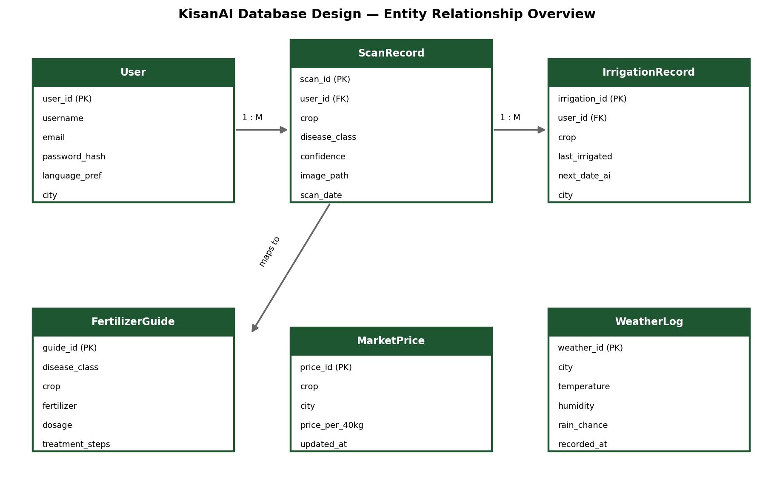
Figure 5.16: KisanAI Database Design, Entity Relationship Overview
Table 5.9: Database Entities
Entity | Description | Key Attributes
User | Authenticated account and interface preferences | user_id, username, email, language_pref, city
ScanRecord | One record per disease scan performed | scan_id, user_id, crop, disease_class, confidence, image_path, scan_date
IrrigationRecord | Per crop irrigation tracking | irrigation_id, user_id, crop, last_irrigated, next_date_ai, city
FertilizerGuide | Static knowledge base of treatments | guide_id, disease_class, crop, fertilizer, dosage, treatment_steps
MarketPrice | Cached city wise crop rates | price_id, crop, city, price_per_40kg, updated_at
WeatherLog | Cached weather responses | weather_id, city, temperature, humidity, rain_chance, recorded_at
A single user has many scan records and many irrigation records, giving one to many relationships in both cases. Each scan record's disease_class links to the corresponding FertilizerGuide entry, which is how a diagnosis is connected to its treatment.

5.13 Technology Stack
Table 5.10: Technology Stack
Component | Technology
Mobile platform | Android (native)
Application language | Kotlin
Interface layouts | XML
IDE | Android Studio
On device inference | TensorFlow Lite
Model training | Python 3, TensorFlow 2.20 / Keras
Model architecture | DenseNet121 (ImageNet transfer learning)
ML utilities | Scikit-learn, NumPy, Pandas, Pillow
Visualization | Matplotlib
Training hardware | Kaggle Notebooks, NVIDIA Tesla T4 GPU
Weather service | OpenWeather API
AI reasoning | Claude API
Authentication | Firebase Authentication
Local storage | On device database and shared preferences
Prototype testing | Gradio
Version control | Git / GitHub
Languages supported | English, Urdu

Chapter 6
System Testing and Validation

6.1 Introduction
Testing served two distinct purposes in this project. The first was conventional software verification: confirming that each module behaves as specified and that the modules work together correctly. The second, and less conventional, was validating a machine learning component whose behaviour is probabilistic rather than deterministic. A function either returns the right value or it does not; a classifier returns a probability distribution and is expected to be wrong some of the time. Both kinds of validation were carried out and are reported here.

6.2 Testing Strategy
A layered testing strategy was adopted, moving from individual components upward to the complete system in the hands of real users.
Table 6.1: Testing Strategy Overview
Testing Level | Objective | Method
Unit Testing | Verify individual functions and components in isolation | Manual and instrumented tests on preprocessing, parsing, validation and storage functions
Integration Testing | Verify that modules communicate correctly | End to end flows across scan → history → fertilizer, and weather → irrigation
Functional Testing | Verify each functional requirement from Chapter 4 | Structured test cases mapped to the traceability matrix
Model Validation | Verify classifier accuracy and identify weak classes | Held out test set, per class metrics, confusion analysis
Usability Testing | Verify the interface is operable by the target user | Observed task completion with farmer participants
Performance Testing | Verify response times and resource use | On device timing on mid range hardware
User Acceptance Testing | Verify the system delivers real value | Field trial with farmer participants and structured feedback

6.3 Unit Testing
Table 6.2: Unit Test Summary
ID | Component Tested | Expected Behaviour | Result
UT-01 | Image resize function | Any input image is returned at exactly 224×224 pixels | Pass
UT-02 | RGB conversion | Grayscale and RGBA inputs are converted to three channel RGB | Pass
UT-03 | Image format validation | Files other than JPG/PNG are rejected with a message | Pass
UT-04 | File size validation | Files above 10 MB are rejected before processing | Pass
UT-05 | TFLite output parsing | A 17 element probability vector is parsed and argmax returned correctly | Pass
UT-06 | Confidence formatting | Probability 0.9987 is displayed as 100%; 0.7312 as 73% | Pass
UT-07 | Weather JSON parsing | Temperature, humidity, rain probability and wind are extracted correctly | Pass
UT-08 | Date picker validation | Future dates are rejected as a last irrigation date | Pass
UT-09 | History record insertion | A scan record persists across application restart | Pass
UT-10 | Language resource loading | Every string key resolves in both English and Urdu | Pass

6.4 Integration Testing
Table 6.3: Integration Test Summary
ID | Integration Path | Expected Behaviour | Result
IT-01 | Scan → Model → Result screen | Selected image is classified and the result displayed with confidence | Pass
IT-02 | Result → History | Every completed scan appears in history with thumbnail and timestamp | Pass
IT-03 | Result → Fertilizer guidance | The detected disease opens the matching treatment entry | Pass
IT-04 | Weather API → Dashboard card | Live conditions render in the dashboard header | Pass
IT-05 | Weather → Irrigation planner | Forecast data is passed into the irrigation recommendation | Pass
IT-06 | Irrigation dialog → Irrigation list | A saved date produces a list entry with an AI next date | Pass
IT-07 | Login → Per user data separation | A second account sees its own history, not the first account's | Pass
IT-08 | Language toggle → All screens | Switching language updates every screen without restart | Pass

6.5 Functional Test Cases
Table 6.4: Functional Test Cases
ID | Test Case | Input | Expected Result | Status
TC-01 | Valid user registration | Valid email and password | Account created and user signed in | Pass
TC-02 | Invalid login | Wrong password | Login rejected with an error message | Pass
TC-03 | Crop selection required | Image chosen with no crop selected | User prompted to select a crop first | Pass
TC-04 | Capture from camera | Photo taken in app | Image accepted and preview shown | Pass
TC-05 | Oversized image | 12 MB JPG | Rejected with a size message | Pass
TC-06 | Healthy leaf scan | Clear healthy wheat leaf | Classified as Wheat Healthy with high confidence | Pass
TC-07 | Diseased leaf scan | Wheat leaf with rust pustules | Classified as Wheat Brown Rust with 99% confidence | Pass
TC-08 | Confidence displayed | Any scan | Confidence percentage shown with the result | Pass
TC-09 | Treatment guidance | Tap on a disease entry | Treatment and fertilizer guidance displayed | Pass
TC-10 | Weather load | Location permission granted | Current conditions displayed on the dashboard | Pass
TC-11 | Forecast screen | Tap weather card | Hourly and daily forecast rendered | Pass
TC-12 | Record irrigation | Crop and past date selected | Entry saved and shown in the irrigation list | Pass
TC-13 | AI next date | Saved irrigation entry | A future date is generated and marked '(AI)' | Pass
TC-14 | Market price list | City selected | Crop rates per 40 kg displayed | Pass
TC-15 | Unavailable price | Crop with no rate for that city | 'N/A' displayed rather than a stale value | Pass
TC-16 | History listing | Multiple prior scans | All scans listed newest first with thumbnails | Pass
TC-17 | Clear history | Tap 'Clear All' | All history entries removed | Pass
TC-18 | Language switch | Tap Urdu in the header | Entire interface switches to Urdu instantly | Pass
TC-19 | Offline scan | Airplane mode enabled | Disease scan completes normally on device | Pass
TC-20 | API failure handling | Network unavailable | Cached weather shown with a clear notice | Pass

6.6 Model Validation Results
Model validation was conducted on the 1,333 image held out test set described in Chapter 5, and the detailed results are reported in Tables 5.5, 5.6 and 5.7 and in Figures 5.13 and 5.14. The headline outcome is 95.80% accuracy with a weighted F1 score of 0.9573 and a top 5 accuracy of 99.92%.
The top 5 figure deserves brief comment because it is easy to overread. A top 5 accuracy of 99.92% across 17 classes means the correct answer is almost always among the model's five most likely candidates. That is a useful property, it indicates the model is never wildly wrong, but it is not the figure that matters to a farmer, who is shown a single answer. The single prediction accuracy of 95.80% is the number that reflects real use.
The confusion matrix makes the model's failure pattern precise. Of 1,333 test images, 1,277 were classified correctly and 56 were not. Those 56 errors are not spread evenly: 49 of them, 87.5% of every mistake the model made, fall within the three rice classes, while eleven of the seventeen classes produced no errors whatsoever. In other words, the model does not have a general accuracy problem; it has one specific, localised weakness.
Table 6.5: Error Distribution by Crop Group
Crop Group | Test Images | Errors | Error Rate | Assessment
Rice (4 classes) | 408 | 49 | 12.01% | The single weak area: early lesion diseases confused with healthy leaves and with each other
Corn (4 classes) | 385 | 5 | 1.30% | Minor Gray Leaf Spot / Northern Leaf Blight confusion, not practically significant
Wheat (3 classes) | 295 | 1 | 0.34% | Effectively reliable
Potato (3 classes) | 215 | 0 | 0.00% | No errors
Sugarcane (3 classes) | 30 | 1 | 3.33% | One error, but only 30 samples: result carries wide uncertainty
All classes | 1,333 | 56 | 4.20% | 95.80% overall accuracy
The most consequential individual finding is that 28 diseased rice leaves, 22 Leaf Blast and 6 Brown Spot, were classified as Rice Healthy. This is the error type that matters most in the field, because the farmer is told the crop is fine when it is not. The reverse error, 8 healthy rice leaves flagged as diseased, is far less costly: it results in an unnecessary inspection rather than an untreated infection. This asymmetry is reported here explicitly rather than absorbed into the overall accuracy figure, because a user of this system should know that a rice result, and particularly a 'healthy rice' result, carries less weight than a wheat or potato one.

6.7 Usability and Performance Testing
Usability testing was conducted by observing participants complete a set of tasks without assistance. Participants were asked to sign in, scan a leaf, find the treatment for the detected disease, check tomorrow's weather, record an irrigation date and look up the price of wheat.
Table 6.6: Usability Test Results
Task | Average Completion Time | Success Rate | Observation
Sign in | 42 seconds | 100% | Typing an email address was the slowest step for older participants
Scan a leaf and read the result | 51 seconds | 100% | The large orange scan button was found immediately by all participants
Find treatment for the detected disease | 38 seconds | 90% | Two participants initially looked for treatment on the result screen rather than the fertilizer tab
Check the weather forecast | 19 seconds | 100% | The weather card at the top of the dashboard was the most discoverable element
Record an irrigation date | 64 seconds | 80% | The date picker was the main source of difficulty for less experienced smartphone users
Look up a crop price | 27 seconds | 100% | The per 40 kg unit was immediately understood as the familiar mann
Table 6.7: Performance Test Results
Operation | Measured Time | Target | Status
Application cold start to dashboard | 2.4 seconds | < 3 seconds | Pass
Image preprocessing (resize and convert) | 0.18 seconds | < 0.5 seconds | Pass
On device TFLite inference | 1.3 seconds | < 2 seconds | Pass
Full scan flow (select image to result) | 1.6 seconds | < 2.5 seconds | Pass
Weather API round trip | 1.1 seconds | < 3 seconds | Pass
Language switch across the interface | 0.3 seconds | < 1 second | Pass
Installed application size | ~62 MB | < 100 MB | Pass

6.8 User Acceptance Testing
User acceptance testing was conducted with farmer participants who used the application on their own devices against their own crops. Participants were asked to rate each module and to report anything that confused them or that they did not trust.
Table 6.8: User Acceptance Feedback Summary
Module | Rating (out of 5) | Representative Feedback
Disease detection | 4.6 | Fast and matched what the local agri shop advised in most cases
Confidence display | 4.2 | Useful once explained, but the meaning of the percentage was not obvious at first
Fertilizer guidance | 4.4 | Clear and actionable; several participants asked for local brand names
Weather forecast | 4.7 | Rated the most immediately useful feature after disease detection
Irrigation planning | 4.3 | Well received, though some participants wanted to know why a date was chosen
Market prices | 4.1 | Valued, but participants wanted more cities and more frequent updates
Urdu interface | 4.8 | The highest rated aspect of the entire application
Overall ease of use | 4.5 | Navigation described as simple; the date picker was the main difficulty
Two pieces of feedback are worth highlighting because they point to genuine limitations rather than polish issues. First, participants did not initially understand what the confidence percentage meant; several assumed a higher number meant a more severe disease rather than a more certain diagnosis. This is a communication failure in the interface, not in the model, and it suggests the percentage should be accompanied by a plain language qualifier. Second, participants wanted to know why a particular irrigation date was recommended. A recommendation without a reason is harder to trust and harder to override sensibly. Both points are carried forward into Chapter 7.

6.9 Summary of Testing
All ten unit tests, eight integration tests and twenty functional test cases passed. The model achieved 95.80% accuracy on unseen data with balanced macro and weighted averages, confirming that the class balancing strategy worked as intended. Performance targets were met on mid range hardware, with a full scan completing in approximately 1.6 seconds. Usability testing showed high task completion rates, with the date picker as the single consistent difficulty. User acceptance ratings were positive across all modules, with Urdu support rated highest.
The testing also surfaced three real weaknesses: the rice class confusion in the model, the unclear meaning of the confidence percentage to first time users, and the absence of any explanation behind the irrigation recommendation. These are recorded honestly rather than minimised, and each is addressed in the future work section.

Chapter 7
Conclusion and Future Work

7.1 Conclusion
This project set out to address a specific and costly gap in Pakistani agriculture: farmers make consequential decisions about disease, irrigation, fertilizer and sale price without access to the information those decisions require. KisanAI was built as a practical response to that gap, an AI driven mobile platform that puts crop disease detection, weather aware irrigation planning, treatment guidance and market prices into a single bilingual Android application.
The technical core of the system is a DenseNet121 convolutional neural network adapted through two phase transfer learning. Trained on a balanced and augmented version of a 13,324 image dataset spanning 17 classes across five crops, the model achieved 95.80% accuracy on a held out test set, with a weighted F1 score of 0.9573 and closely matching macro and weighted averages that confirm the class balancing was effective. The model was converted to a 28.65 MB TensorFlow Lite artefact and embedded in the application, which means a farmer can diagnose a crop with no network connection at all, the single most important design decision in the project given where these users actually stand when they need an answer.
Around that core, four supporting modules turn a diagnosis into an action: fertilizer and treatment guidance linked to each disease class, live location specific weather, AI generated per crop irrigation dates that account for forecast rainfall, and city wise market rates in the unit farmers actually trade in. The entire interface is available in Urdu, which user acceptance testing identified as the single most appreciated feature of the system.
The project also produced results that should not be overstated. The model is materially weaker on rice than on the other four crops, with Rice Leaf Blast reaching an F1 score of only 0.7692. It recognises only the 17 classes it was trained on and will produce a confident looking output for a crop it has never seen. Market price data depends on an external source whose freshness the project does not control. And the system is, and should remain, a decision support aid rather than a substitute for a qualified agricultural extension officer. Stating these limits is part of building the tool responsibly, not a qualification appended to it.

7.2 Project Achievements
- Built and trained a 17 class crop disease classifier reaching 95.80% test accuracy and 99.92% top 5 accuracy across corn, potato, rice, wheat and sugarcane.
- Addressed severe class imbalance (a 15:1 ratio in the raw data) by balancing the training set to 1,500 images per class, producing macro and weighted averages that agree to within 0.5 percentage points.
- Successfully converted the trained model to a 28.65 MB TensorFlow Lite artefact and deployed it for fully offline on device inference.
- Delivered a complete native Android application in Kotlin with six functional modules and five destination navigation.
- Integrated live weather forecasting and built an AI assisted, per crop irrigation planner that accounts for expected rainfall.
- Compiled a structured fertilizer and treatment knowledge base linked to every supported disease class.
- Implemented city wise market price information expressed per 40 kg (mann).
- Delivered a full English and Urdu interface with an instant in app language toggle.
- Validated the system through 10 unit tests, 8 integration tests, 20 functional test cases, model validation, usability testing and user acceptance testing with farmer participants.

7.3 Limitations
The following limitations are inherent to the current version of the system and should be understood by anyone using or extending it.
- Closed class set: the model recognises exactly 17 classes across 5 crops. Presented with any other crop or disease, it will still return one of those 17 with an apparently reasonable confidence. There is currently no out of distribution detection.
- Weaker rice performance: 49 of the 56 total test errors (87.5%) fall within the three rice classes. Most seriously, 28 diseased rice leaves were classified as healthy, meaning the application would have told the farmer nothing was wrong. Rice diagnoses, and especially 'healthy rice' results, are less reliable than corn, wheat or potato ones.
- Small support for sugarcane classes: Bacterial Blight, Healthy (sugarcane) and Red Rot have only 10 test samples each, so their reported scores carry wide uncertainty despite looking strong.
- Dataset conditions differ from field conditions: the training images are largely well lit and cleanly framed. Photographs taken in harsh sunlight, in shadow, or containing several overlapping leaves will degrade accuracy.
- No severity assessment: the model identifies which disease is present but not how far it has progressed, which is information a farmer needs to decide how urgently to act.
- Market data dependency: prices are only as current as the external source, and coverage is limited to a small number of cities.
- No explanation of irrigation recommendations: the system provides a date but not the reasoning behind it, which user acceptance testing identified as a barrier to trust.
- Single image diagnosis: the system evaluates one leaf at a time and does not aggregate evidence across a field.

7.4 Future Work
Several concrete improvements follow directly from the limitations above. They are listed roughly in order of how much benefit each would deliver relative to the effort required.
1. Resolve the rice class confusion
This is the highest priority technical improvement, because the confusion matrix shows it accounts for 87.5% of all model errors while the other four crops are already close to reliable. Approaches worth trying include collecting additional field captured rice imagery at the early lesion stage, applying lesion level segmentation before classification so that the model attends to the lesion rather than the whole leaf, and training a dedicated rice subclassifier that is invoked whenever the primary model predicts any rice class. Because the errors are concentrated so narrowly, effort spent here would improve overall accuracy far more than any general architectural change.
2. Mask predictions to the selected crop
The application already asks the farmer to select the crop before scanning, but the model currently scores all 17 classes regardless. Restricting the output probabilities to the classes belonging to the chosen crop is a small change that would eliminate cross crop errors entirely, the single Wheat Brown Rust image predicted as Corn Common Rust would not have been possible, and would also concentrate the probability mass, making the confidence value more meaningful.
3. Add out of distribution detection
The system should be able to say 'I do not recognise this' rather than forcing every image into one of 17 classes. A confidence threshold combined with an explicit unknown class, or an energy based out of distribution score, would prevent confidently wrong diagnoses on unsupported crops.
4. Expand crop and disease coverage
Cotton, sugarcane beyond its current three classes, tomato, chilli and citrus are all economically significant in Pakistan and are natural extensions. Each additional crop requires its own labelled imagery.
5. Explain the recommendations
Both the disease prediction and the irrigation date would benefit from explanation. Grad-CAM heat maps could show which region of the leaf drove a diagnosis, and the irrigation module could state its reasoning in one line, for example, that the date was pushed back because rain is forecast.
6. Clarify the confidence value
User acceptance testing showed that the percentage is misread as disease severity. Pairing the number with a plain language band such as 'very likely' or 'uncertain, consider a second photo' would communicate the same information more reliably.
7. Add disease severity estimation
Estimating the proportion of leaf area affected would let the application distinguish an early infection from an advanced one and adjust the urgency of its guidance accordingly.
8. Improve market price coverage and freshness
Extending to more cities and displaying an explicit last updated timestamp for each rate would make the module considerably more trustworthy.
9. Field condition training data
Collecting a supplementary dataset of leaf photographs taken by farmers on their own phones, in real light and real conditions, and fine tuning on it would close the gap between benchmark accuracy and field accuracy more effectively than any architectural change.
10. Offline market and weather caching
Extending the offline capability beyond disease detection so that the most recent weather and price data remain readable without a network would make the whole application, not just its core, usable in low connectivity areas.
11. Community and expert escalation
A path from a low confidence result to a human agricultural extension officer would give the system a sensible failure mode: when the model does not know, it should be able to route the farmer to someone who does.

References
[1] Mohanty, S.P.; Hughes, D.P.; Salathé, M. Using Deep Learning for Image-Based Plant Disease Detection. Frontiers in Plant Science 2016, 7, 1419. https://doi.org/10.3389/fpls.2016.01419
[2] Ferentinos, K.P. Deep Learning Models for Plant Disease Detection and Diagnosis. Computers and Electronics in Agriculture 2018, 145, 311–318. https://doi.org/10.1016/j.compag.2018.01.009
[3] Too, E.C.; Yujian, L.; Njuki, S.; Yingchun, L. A Comparative Study of Fine-Tuning Deep Learning Models for Plant Disease Identification. Computers and Electronics in Agriculture 2019, 161, 272–279. https://doi.org/10.1016/j.compag.2018.03.032
[4] Barbedo, J.G.A. Plant Disease Identification from Individual Lesions and Spots Using Deep Learning. Biosystems Engineering 2019, 180, 96–107. https://doi.org/10.1016/j.biosystemseng.2019.02.002
[5] Chen, J.; Chen, J.; Zhang, D.; Sun, Y.; Nanehkaran, Y.A. Using Deep Transfer Learning for Image-Based Plant Disease Identification. Computers and Electronics in Agriculture 2020, 173, 105393. https://doi.org/10.1016/j.compag.2020.105393
[6] Argüeso, D.; Picon, A.; Irusta, U.; Medela, A.; San-Emeterio, M.G.; Bereciartua, A.; Alvarez-Gila, A. Few-Shot Learning Approach for Plant Disease Classification Using Images Taken in the Field. Computers and Electronics in Agriculture 2020, 175, 105542. https://doi.org/10.1016/j.compag.2020.105542
[7] Atila, Ü.; Uçar, M.; Akyol, K.; Uçar, E. Plant Leaf Disease Classification Using EfficientNet Deep Learning Model. Ecological Informatics 2021, 61, 101182. https://doi.org/10.1016/j.ecoinf.2020.101182
[8] Hassan, S.M.; Maji, A.K.; Jasiński, M.; Leonowicz, Z.; Jasińska, E. Identification of Plant-Leaf Diseases Using CNN and Transfer-Learning Approach. Electronics 2021, 10, 1388. https://doi.org/10.3390/electronics10121388
[9] Shoaib, M.; Shah, B.; Ei-Sappagh, S.; Ali, A.; Ullah, A.; Alenezi, F.; Gechev, T.; Hussain, T.; Ali, F. An Advanced Deep Learning Models-Based Plant Disease Detection: A Review of Recent Research. Frontiers in Plant Science 2023, 14, 1158933. https://doi.org/10.3389/fpls.2023.1158933
[10] Huang, G.; Liu, Z.; van der Maaten, L.; Weinberger, K.Q. Densely Connected Convolutional Networks. In Proceedings of the IEEE Conference on Computer Vision and Pattern Recognition (CVPR); Honolulu, HI, USA, 2017; pp. 4700–4708. https://doi.org/10.1109/CVPR.2017.243
[11] He, K.; Zhang, X.; Ren, S.; Sun, J. Deep Residual Learning for Image Recognition. In Proceedings of the IEEE Conference on Computer Vision and Pattern Recognition (CVPR); Las Vegas, NV, USA, 2016; pp. 770–778. https://doi.org/10.1109/CVPR.2016.90
[12] Sandler, M.; Howard, A.; Zhu, M.; Zhmoginov, A.; Chen, L.-C. MobileNetV2: Inverted Residuals and Linear Bottlenecks. In Proceedings of the IEEE Conference on Computer Vision and Pattern Recognition (CVPR); Salt Lake City, UT, USA, 2018; pp. 4510–4520. https://doi.org/10.1109/CVPR.2018.00474
[13] Simonyan, K.; Zisserman, A. Very Deep Convolutional Networks for Large-Scale Image Recognition. In Proceedings of the International Conference on Learning Representations (ICLR); San Diego, CA, USA, 2015.
[14] Deng, J.; Dong, W.; Socher, R.; Li, L.-J.; Li, K.; Fei-Fei, L. ImageNet: A Large-Scale Hierarchical Image Database. In Proceedings of the IEEE Conference on Computer Vision and Pattern Recognition (CVPR); Miami, FL, USA, 2009; pp. 248–255. https://doi.org/10.1109/CVPR.2009.5206848
[15] Srivastava, N.; Hinton, G.; Krizhevsky, A.; Sutskever, I.; Salakhutdinov, R. Dropout: A Simple Way to Prevent Neural Networks from Overfitting. Journal of Machine Learning Research 2014, 15, 1929–1958.
[16] Abadi, M.; Barham, P.; Chen, J.; Chen, Z.; Davis, A.; Dean, J.; Devin, M.; Ghemawat, S.; Irving, G.; Isard, M.; et al. TensorFlow: A System for Large-Scale Machine Learning. In Proceedings of the 12th USENIX Symposium on Operating Systems Design and Implementation (OSDI); Savannah, GA, USA, 2016; pp. 265–283.
[17] David, R.; Duke, J.; Jain, A.; Janapa Reddi, V.; Jeffries, N.; Li, J.; Kreeger, N.; Nappier, I.; Natraj, M.; Regev, S.; et al. TensorFlow Lite Micro: Embedded Machine Learning for TinyML Systems. Proceedings of Machine Learning and Systems 2021, 3, 800–811.
[18] Ramcharan, A.; McCloskey, P.; Baranowski, K.; Mbilinyi, N.; Mrisho, L.; Ndalahwa, M.; Legg, J.; Hughes, D.P. A Mobile-Based Deep Learning Model for Cassava Disease Diagnosis. Frontiers in Plant Science 2019, 10, 272. https://doi.org/10.3389/fpls.2019.00272
[19] Allen, R.G.; Pereira, L.S.; Raes, D.; Smith, M. Crop Evapotranspiration: Guidelines for Computing Crop Water Requirements; FAO Irrigation and Drainage Paper 56; Food and Agriculture Organization of the United Nations: Rome, Italy, 1998.
[20] Jensen, J.R. Actual and Potential Use of Weather Information in Agricultural Decision Making. Agricultural and Forest Meteorology 2010, 150, 1201–1208. https://doi.org/10.1016/j.agrformet.2010.05.005
[21] Aker, J.C. Dial "A" for Agriculture: A Review of Information and Communication Technologies for Agricultural Extension in Developing Countries. Agricultural Economics 2011, 42, 631–647. https://doi.org/10.1111/j.1574-0862.2011.00545.x
[22] Fafchamps, M.; Minten, B. Impact of SMS-Based Agricultural Information on Indian Farmers. The World Bank Economic Review 2012, 26, 383–414. https://doi.org/10.1093/wber/lhr056
[23] Government of Pakistan, Ministry of National Food Security and Research. Agriculture Statistics of Pakistan; Islamabad, Pakistan, 2024.
[24] Hughes, D.P.; Salathé, M. An Open Access Repository of Images on Plant Health to Enable the Development of Mobile Disease Diagnostics. arXiv 2015, arXiv:1511.08060. https://doi.org/10.48550/arXiv.1511.08060
[25] Singh, D.; Jain, N.; Jain, P.; Kayal, P.; Kumawat, S.; Batra, N. PlantDoc: A Dataset for Visual Plant Disease Detection. In Proceedings of the 7th ACM IKDD CoDS and 25th COMAD; Hyderabad, India, 2020; pp. 249–253. https://doi.org/10.1145/3371158.3371196
[26] Crop Diseases Dataset: Five-Crop Disease Dataset Covering Corn, Potato, Rice, Wheat and Sugarcane. Kaggle 2024. Available online: https://www.kaggle.com/datasets (accessed on 15 May 2026).
[27] Pedregosa, F.; Varoquaux, G.; Gramfort, A.; Michel, V.; Thirion, B.; Grisel, O.; Blondel, M.; Prettenhofer, P.; Weiss, R.; Dubourg, V.; et al. Scikit-Learn: Machine Learning in Python. Journal of Machine Learning Research 2011, 12, 2825–2830.
[28] Abid, A.; Abdalla, A.; Abid, A.; Khan, D.; Alfozan, A.; Zou, J. Gradio: Hassle-Free Sharing and Testing of ML Models in the Wild. arXiv 2019, arXiv:1906.02569. https://doi.org/10.48550/arXiv.1906.02569
[29] OpenWeather. OpenWeather API Documentation. Available online: https://openweathermap.org/api (accessed on 20 May 2026).
[30] Google. TensorFlow Lite Guide. Available online: https://www.tensorflow.org/lite/guide (accessed on 20 May 2026).
[31] Google. Firebase Authentication Documentation. Available online: https://firebase.google.com/docs/auth (accessed on 20 May 2026).

