[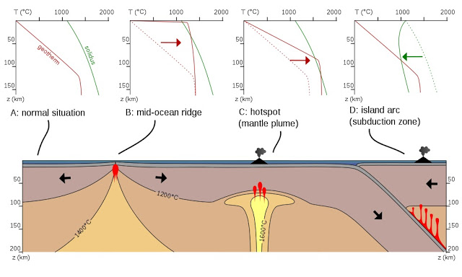](http://1.bp.blogspot.com/--Nzgr5WouEk/VlxfU5PgptI/AAAAAAAAHKU/iUrjtRDFDEs/s1600/Geothermal+gradient-geology+in.jpg)