Adrian Grimm

#8 Case Study

1. SELECT *

FROM Aliases

WHERE Alias LIKE 'B%';



2. SELECT Crime_ID, Criminal_ID, Date_Charged, Status

FROM Crimes

WHERE Date_Charged BETWEEN '01-OCT-08' AND '31-OCT-08';

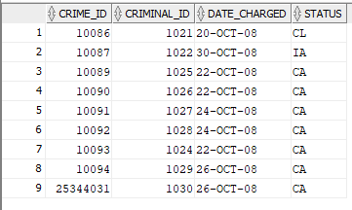

3. SELECT Crime_ID, Criminal_ID, Date_Charged, Classification

FROM Crimes

WHERE Status = 'CA' OR Status = 'IA';

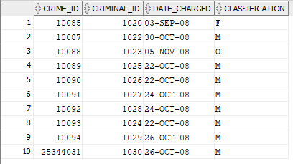

4. SELECT Crime_ID, Criminal_ID, Date_Charged, Classification

FROM Crimes

WHERE Classification = 'F';



5. SELECT Crime_ID, Criminal_ID, Date_Charged, Hearing_Date

FROM Crimes

WHERE Hearing_Date - Date_Charged > 14;

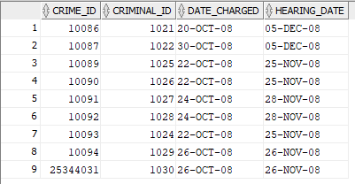

6. SELECT Criminal_ID, Last, ZIP

FROM Criminals

WHERE ZIP = 23510;

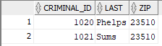

7. SELECT Crime_ID, Criminal_ID, Date_Charged, Hearing_Date

FROM Crimes

WHERE Hearing_Date IS NULL;



8. SELECT Sentence_ID, Criminal_ID, Prob_ID

FROM Sentences

WHERE Prob_ID IS NOT NULL

ORDER BY Prob_ID, Criminal_ID;

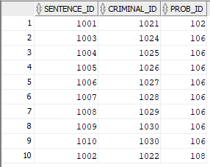

9. SELECT Crime_ID, Criminal_ID, Classification, Status

FROM Crimes

WHERE Classification = 'M' AND Status = 'IA';



10. SELECT Charge_ID, Crime_ID, Fine_Amount, Court_Fee, Amount_Paid, Fine_Amount + Court_Fee -Amount_Paid Amount_Owed

FROM crime_charges

WHERE Fine_Amount + Court_Fee - Amount_Paid > 0;

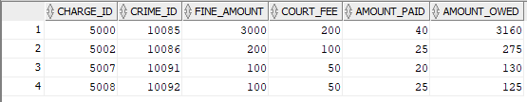

11. SELECT Officer_ID, Last, Precinct, Status

FROM Officers

WHERE Precinct IN ('OCVW','GHNT')

AND Status = 'A'

ORDER BY 3, 1;

