Adrian Grimm

Normalization

10/13/2018

PART 1.

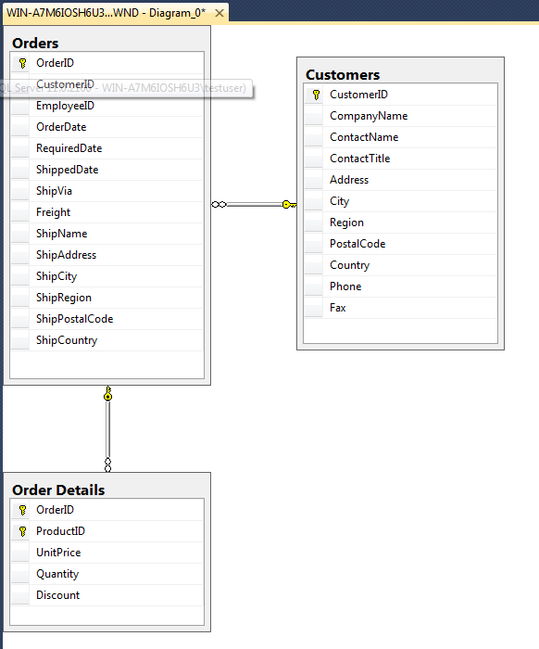

PART 2.

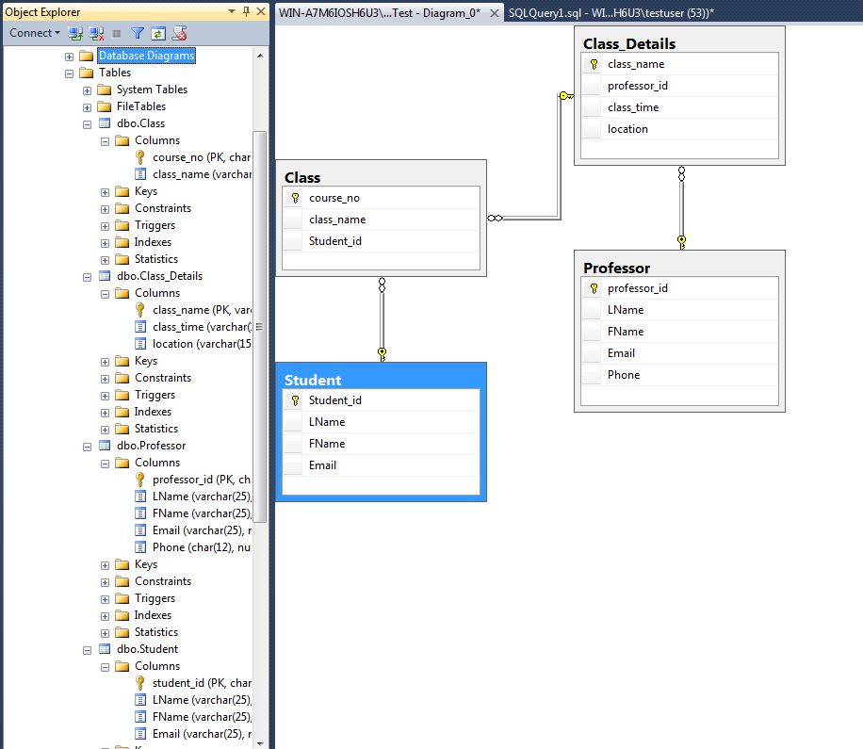

Part 2 includes the tables I created to make the diagrams. The code I used for this follows.

CREATE DATABASE DBTest

ON

(NAME='DBTest',

FILENAME='C:\Program Files\Microsoft SQL Server\MSSQL11.SQLSERVER2012\MSSQL\Data\DBTest.mdf',

SIZE=12,

MAXSIZE=50,

FILEGROWTH=2)

LOG ON

(NAME='DBTestLog',

FILENAME='C:\Program Files\Microsoft SQL Server\MSSQL11.SQLSERVER2012\MSSQL\Data\DBTest.idf',

SIZE=6MB,

MAXSIZE=30MB,

FILEGROWTH=5MB);

USE DBTest;

CREATE TABLE Professor (

professor_id char(7) NOT NULL PRIMARY KEY,

LName varchar(25) NOT NULL,

FName varchar(25) NOT NULL,

Email varchar(25) NOT NULL,

Phone char(12) NULL

);

CREATE TABLE Student (

Student_id char(11) NOT NULL PRIMARY KEY,

LName varchar(25) NOT NULL,

FName varchar(25) NOT NULL,

Email varchar(25) NOT NULL

);

CREATE TABLE Class (

course_no char(6) NOT NULL PRIMARY KEY,

class_name varchar(25) NOT NULL,

Student_id char(11) NOT NULL

);

CREATE TABLE Class_Details (

class_name varchar(25) NOT NULL PRIMARY KEY,

professor_id char(7) NOT NULL,

class_time varchar(15) NOT NULL,

location varchar(15) NOT NULL

);

ALTER TABLE Class

ADD CONSTRAINT FK_StudentAttending

FOREIGN KEY (student_id) REFERENCES Student(student_id);

ALTER TABLE Class_Details

ADD CONSTRAINT FK_ProfessorTeaching

FOREIGN KEY (professor_id) REFERENCES Professor(professor_id);

ALTER TABLE Class

ADD CONSTRAINT FK_Class

FOREIGN KEY (class_name) REFERENCES Class_Details(class_name);