Introduction
In this article, we’ll see the basic concepts of SQL JOINs. In the later part of the article, we’ll focus on the advanced subject of Self-JOIN and some interesting observations on how inner JOIN can be simulated using left JOIN. The author has tried his best to amalgamate various topics in a single concept.
The JOIN keyword is used in a SQL statement to query data from two or more tables based on a relationship between certain columns in these tables.

Inner JOIN
A JOIN that displays only rows that have a match in both the JOINed tables is known as inner JOIN. This is the default type of JOIN in the Query and View Designer.
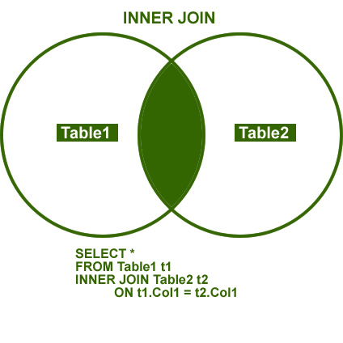

Outer JOIN
A JOIN that includes rows even if they do not have related rows in the joined table is an Outer JOIN. You can create three different outer JOINs to specify the unmatched rows to be included:
Left Outer JOIN: In Left Outer JOIN, all rows in the first-named table, i.e. “left” table, which appears leftmost in the JOIN clause, are included. Unmatched rows in the right table do not appear.
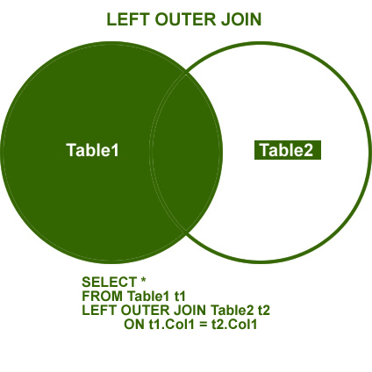
Right Outer JOIN: In Right Outer JOIN, all rows in the second-named table, i.e. “right” table, which appears rightmost in the JOIN clause, are included. Unmatched rows in the left table are not included.
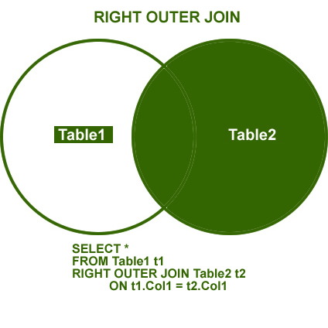
Full Outer JOIN: In Full Outer JOIN, all rows in all the joined tables are included, whether they are matched or not.
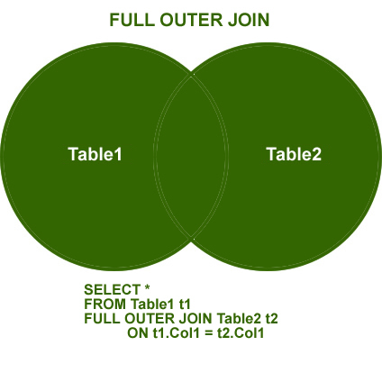

Additional Notes related to JOIN
The following are three classic examples to demonstrate the cases where Outer JOIN is useful. You must have noticed several instances where developers write query as given below.
1.SELECT t1.*
2.FROM Table1 t1
3.WHERE t1.ID NOT IN (SELECT t2.ID FROM Table2 t2)
4.GO
The query demonstrated above can be easily replaced by Outer JOIN. Indeed, replacing it by Outer JOIN is the best practice. The query that generates the same result as above is shown here using Outer JOIN and WHERE clause in JOIN.
1./* LEFT JOIN - WHERE NULL */
2.SELECT t1.*,t2.*
3.FROM Table1 t1
4.LEFT JOIN Table2 t2 ON t1.ID = t2.ID
5.WHERE t2.ID IS NULL
The above example can also be created using Right Outer JOIN.
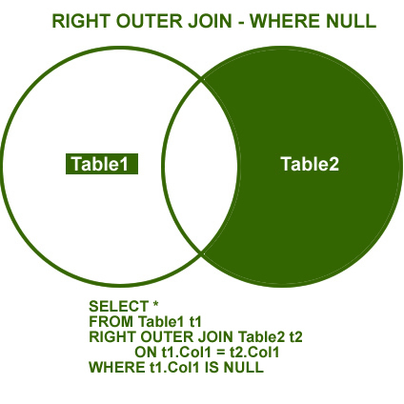
NOT Inner JOIN
Remember, the term Not Inner JOIN does not exist in database terminology. However, when full Outer JOIN is used along with WHERE condition, as explained in the above two examples, it will give you exclusive result to Inner JOIN. This JOIN will show all the results that were absent in Inner JOIN.
