**Changing Server Authentication Configurations**

To change your configuration settings for Server authentication:

* Right click on top node in the Object Explorer window (i.e. your server name).
* Select Properties.
* Click on Security.
* Make sure that the Server authentication is shown as below and Save.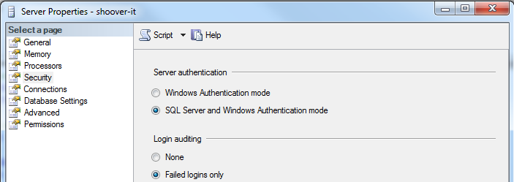

Usually you are required to restart SQL Server in order to see the effect. So after you save the settings above and exit Management Studio, you will need to restart the SQL Server service.

Open the Configuration Manager. Restart your SQL Server Instance as shown below.

