Intel Edison Workshop 2016

**Event Agenda: Day 1-2**

**Date**: 5th and 6th December 2016, IoT Development with Intel Edison

**Venue**: Laboratory 4 Level 3 School of Computer Science Universiti Sains Malaysia Penang 11800

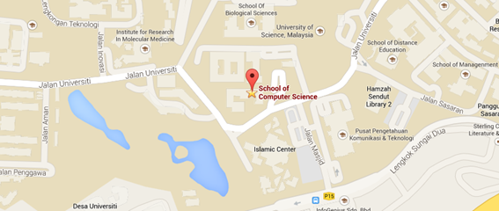

|  |  |  |
| --- | --- | --- |
| Day 1 - Introduction to Intel Edison | | Venue |
| 0830 - 0910 | Registration Welcoming speech by Dean, School of Computer Science USM | Lab 4, Level 3 |
| 0910 - 1030 | ➤Introduction to Intel Edison ➤Hardware specifications ➤Preparing Intel Edison development  ➤Basic with Arduino IDE and Sketch programming ➤Run simple Blink example  ➤Introduction to analog & digital pins ➤Code Challenge - write codes with Arduino IDE for Grove Indoor Environment Kit   * Button (Arduino IDE Examples) * Moisture sensor * UV sensor * Light sensor * PIR sensor | Lab 4, Level 3 |
| 1030 - 1100 | Tea break | BJIM Level 5 |
| 1100 - 1245 | ➤Code Challenge (continued) - manipulate and modify codes  ➤A quick introduction to Node.js  ➤Introduction to Intel XDK IoT Edition  ➤Preparing Intel Edison development with Intel XDK IoT Edition | Lab 4, Level 3 |
| 1245 - 1400 | Lunch break // prayer | BJIM Level 5 |
| 1400 - 1530  1530 - 1700 | ➤Introduction to Libmraa library (and Johnny-five) ➤Code Challenge - rewrite codes with Intel XDK IoT Edition (Node.js) | Lab 4, Level 3 |
| 1530 - 1600 | Tea break | BJIM Level 5 |
| 1600 - 1700 | ➤Useful tools and Linux commands for development | Lab 4, Level 3 |

|  |  |  |
| --- | --- | --- |
| Day 2 - Internet of Things (IoT) Part 1 | | Venue |
| 0900 – 1030 | ➤Code Challenge – Edison-Servo with Johnny-Five  ➤Build HTTP-ExpressJS server on Intel Edison  ➤Introduction to Socket.IO  ➤Code Challenge - apply Socket.IO on Edison-Servo | Lab 4, Level 3 |
| 1030 - 1100 | Tea break | BJIM Level 5 |
| 1100 - 1245 | ➤Build first Mobile-slider HTML5 app with Intel XDK IoT Edition  ➤Code Challenge - connect HTML5 mobile application to Edison-Servo | Lab 4, Level 3 |
| 1245 - 1400 | Lunch break // prayer | BJIM Level 5 |
| 1400 - 1530 | ➤Demo: Edison-Servo with Mobile Slider HTML5 app  ➤Code Challenge - build simple web application  ➤Code Challenge - stream-in data from Intel Galileo/Edison to web application | Lab 4, Level 3 |
| 1530 - 1600 | Tea break | BJIM Level 5 |
| 1600 - 1700 | ➤Final Code Challenge - Deploy Intel Galileo/Edison, web application and HTML5 mobile application  ➤Introduction to MQTT and demo | Lab 4, Level 3 |

**Day 3 – Demo on Power Application with Intel Edison**

**Date:** 7th December 2016, Demo on Power Application with Intel Edison

**Venue:** Laboratory 100, Level 1 School of Physics Science Universiti Sains Malaysia Penang 11800

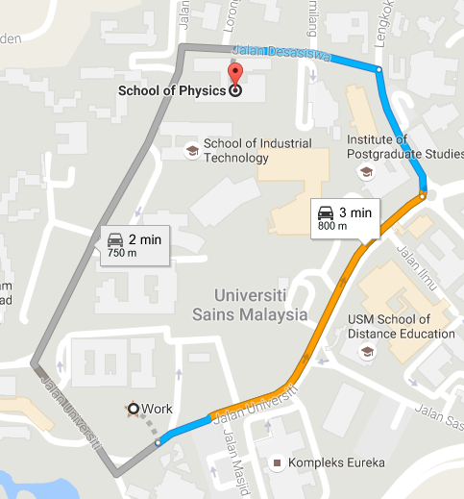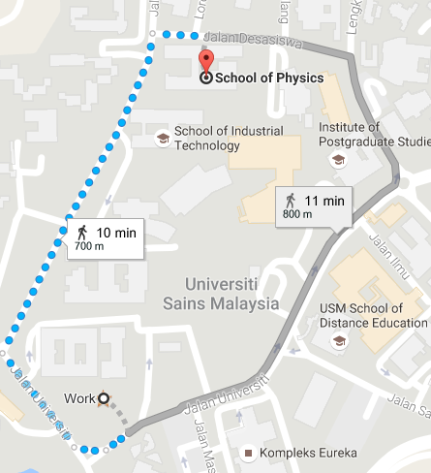  
* Kindly gather at school of computer science, we will provide a transport (car pool) to School of Physics

|  |  |  |
| --- | --- | --- |
| Day 3 – Demo on Power Application with Intel Edison | | Venue |
| 0900 - 1030 | UPM sharing session // Prof Ishak | Lab 100, School of Physics |
| 1030 - 1100 | Tea break |  |
| 1100 - 1245 | UPM sharing session // Prof Ishak (cont.)  Closing ceremony | Lab 100, School of Physics |
| 1300 - 1400 | Lunch break // end |  |