Pre-normative research for safety of hydrogen driven vehicles and transport through tunnels and similar confined spaces

Fuel Cells and Hydrogen Joint Undertaking (FCH JU)
Grant Agreement Number 826193

Field | Possible information
Summary | WP 2 Unignited leaks in tunnels and confined space  2.4.2 Unignited pressure peaking phenomenon  Unignited pressure peaking phenomenon results are based on an experimental series from spring 2019 in Horten, Norway.
Data file name | Concentration data (Excel worksheet): Pressure data (txt document): Mass flow rate data (folder):  HTE242USN00002CONC190621 HTE242USN00002PRESS190621 HTE242USN00001MFR190621  HTE242USN00003CON190621 HTE242USN00003PRESS190621 HTE242USN00002MFR190621  HTE242USN00006CON190621 HTE242USN00004PRESS190621 HTE242USN00003MFR190621  HTE242USN00007CON190621 HTE242USN00005PRESS190621 HTE242USN00004MFR190621  HTE242USN00008CON190621 HTE242USN00006PRESS190621 HTE242USN00005MFR190621  HTE242USN00009CONC190621 HTE242USN00007PRESS190621 HTE242USN00006MFR190621  HTE242USN00009CONC190621 HTE242USN00008PRESS190621 HTE242USN00007MFR190621  HTE242USN00010CONC190621 HTE242USN00009PRESS190621 HTE242USN00008MFR190621  HTE242USN00010CONT190621 HTE242USN00010PRESS190621 HTE242USN00009MFR190621  HTE242USN00011CONT190621 HTE242USN00011PRESS190621 HTE242USN00010MFR190621
Author | André Vagner Gaathaug and Agnieszka W. Lach  17.06.2019 to 21.06.2019  Horten, Norway  André Vagner Gaathaug
Experimental setup | HyTUNNEL-CS D2.2 Intermediate report on analytical, numerical and experimental studies  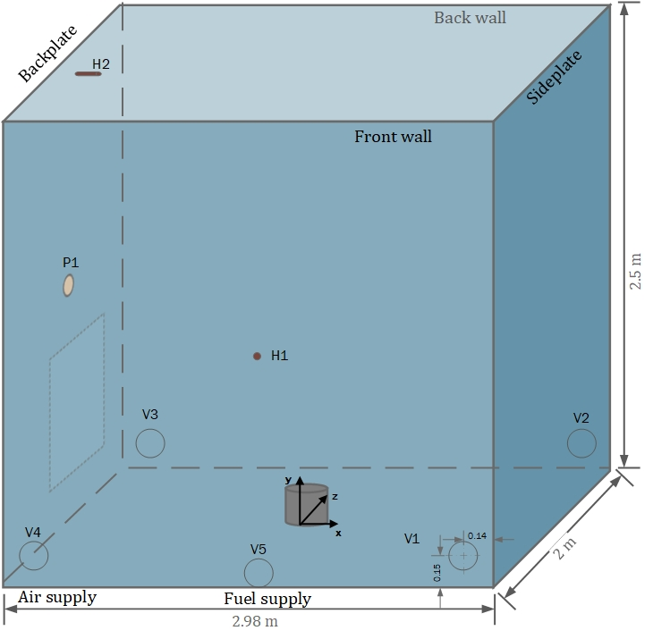  Figur 1: Sketch of the experimental setup  Measurement devices:  Concentration data files: H1 and H2 -> XEN-352 sensors  Pressure data files:  P1 [kPa] -> XTM-190-10A  Mass flow data files:  Mass Flow [V] ->Micro Motion ELITE & Pressure [V] at mass flow meter -> ASI
Objective of the experiment | Experiment goals  - Provide experimental evidence of the Pressure Peaking Phenomenon in large scale.  - Provide validation data for CFD and engineering models.
Experimental procedure | Exp nr Nozzle diameter [m] Enclosure volume [m³] Vent area [m²] Vent size [mm] Mass flow rate [g/s] Static pressure -reservoir [MPa] Experimental overpressure [kPa] Exp time for pressure peak [s] Duration time [s]  2 0.004 14.9 0.0012 9x ∅13 1.9 2.68 0.42 10 90  3 0.004 14.9 0.002 1x ∅51,6 3.5 4.0 0.51 10 120  4 0.004 14.9 0.002 1x ∅51,6 9.05 10.4 2.86 17 120  5 0.004 14.9 0.0014 1x ∅42 9.9 11.0 6.45 37 120  6 0.004 14.9 0.0014 1x ∅42 10.1 11.75 6.74 37 120  7 0.004 14.9 0.0006 * 4x ∅13 3.05 3.6 4.07 80 180  8 0.004 14.9 0.0006* 4x ∅13 3.05 3.97 3.96 77 180  9 0.004 14.9 0.0006* 4x ∅13 4.75 5.85 8.05 89 200  10 0.004 14.9 0.0006* 4x ∅13 4.2 5.26 6.70 89 200  11 0.004 14.9 0.0006* 4x ∅13 blowdown 4.96 7.00 64 1000
Experimental data | Description  - The experimental data is provided in three separate parts.  - Concentration data from 8 experiments are given in a excel datasheet format with the second and third column as the time and concentration data.  - The pressure data is given as text format (ASCII)  Time P1 Trigger  s kPa V  - The mass flow data is given in text format in the corresponding folder, where CH1 is the time vector, CH2 is the mass flow rate given in Volts. It converts to g/s by mfr = (U-1)*6.25 and CH3 is the pressure at the mass flow meter given in units Volts. It converts to unit bar by p=62.5*(U-1).  Experiment data  - The figure shows an example of the measured pressure against time. The data is properly scaled and shows the overpressure in unit kPa and time in seconds.  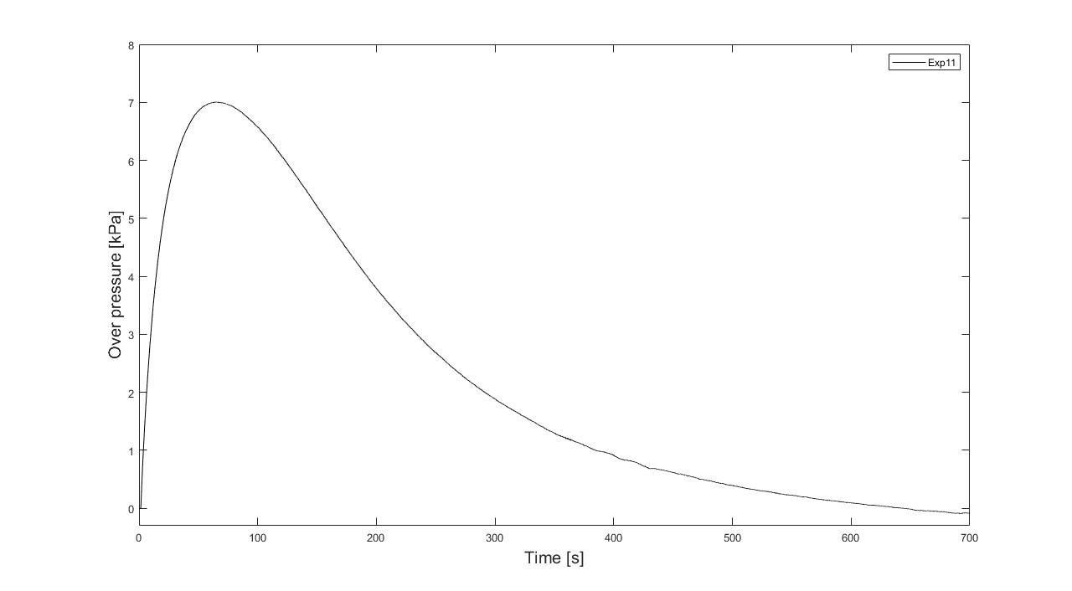  Figure 1: Experiment 11
Comments | No changes made  No validation made
Reference | From the participants or a third party (if it is involved) the reports and papers published including:  Paper: https://doi.org/10.1016/j.ijhydene.2020.08.221  - HyTunnel-CS D2.2 Intermediate report on analytical, numerical and experimental studies
Acknowledgements | The data presented is part of the experimental results of HyTunnel-CS  The project HyTunnel-CS has received funding from the Fuel Cells and Hydrogen 2 Joint Undertaking (JU) under grant agreement No 826193. The JU receives support from the European Union’s Horizon 2020 research and innovation programme and United Kingdom, Germany, Greece, Denmark, Spain, Italy, Netherlands, Belgium, France, Norway, Switzerland

