**C# AUTO INCREMENT VERSION BUILD NUMBER**

**I.** **DELETE ASSEMBLYINFO.CS** **……………………………………...…2**

**II.** **ADD ASSEMBLYINFO.TT****……………….…2**

**III.** **ADD PRE-BUILD PATH** **…….………………….3**

**IV.** **TEST CODE****………………………………………….4**

**V.** **CUSTOMIZE****……………………………………4**

**VI.** **.NET PROJECTS****…………………………………..4**

Tested with;

WPF (.NET FRAMEWORK)

Windows form app (.NET FRAMEWORK)

.NET CORE PROJECTS

IF YOU WANT TO USE IN .NET CORE PROJECTS LOOK AT THE 6. STEP.

# **DELETE ASSEMBLYINFO.CS**

Under the properties you will see AssemblyInfo.cs.

Delete it.

# **ADD ASSEMBLYINFO.TT**

**1-** Right click on the your project > Add > new item > text template ( AssemblyInfo.tt)

**2-** Write that code into AssemblyInfo.tt

Info: It should be generated AssemblyInfo.cs automatically.

<#@ template debug="true" hostspecific="true" language="C#" #>

<#@ output extension=".cs" #>

<#@ import namespace="System.IO" #>

<#@ import namespace="System.Text.RegularExpressions" #>

<#

string output = File.ReadAllText(this.Host.ResolvePath("AssemblyInfo.cs"));

Regex pattern = new Regex("AssemblyVersion\\(\"(?<major>\\d+)\\.(?<minor>\\d+)\\.(?<revision>\\d+)\\.(?<build>\\d+)\"\\)");

MatchCollection matches = pattern.Matches(output);

if( matches.Count == 1 )

{

major = Convert.ToInt32(matches[0].Groups["major"].Value);

minor = Convert.ToInt32(matches[0].Groups["minor"].Value);

build = Convert.ToInt32(matches[0].Groups["build"].Value) + 1;

revision = Convert.ToInt32(matches[0].Groups["revision"].Value);

if( this.Host.ResolveParameterValue("-","-","BuildConfiguration") == "Release" )

revision++;

}

#>

using System.Reflection;

using System.Runtime.CompilerServices;

using System.Runtime.InteropServices;

using System.Resources;

// General Information

[assembly: AssemblyTitle("Insert title here")]

[assembly: AssemblyDescription("Insert description here")]

[assembly: AssemblyConfiguration("")]

[assembly: AssemblyCompany("Insert company here")]

[assembly: AssemblyProduct("Insert product here")]

[assembly: AssemblyCopyright("Insert copyright here")]

[assembly: AssemblyTrademark("Insert trademark here")]

[assembly: AssemblyCulture("")]

// Version informationr(

[assembly: AssemblyVersion("<#= this.major #>.<#= this.minor #>.<#= this.revision #>.<#= this.build #>")]

[assembly: AssemblyFileVersion("1.0.0.0")]

[assembly: NeutralResourcesLanguageAttribute( "en-US" )]

<#+

int major = 1;

int minor = 0;

int revision = 0;

int build = 0;

#>

# **ADD PREBUILD PATH**

Right click on your project> properties> build events> pre-build> add below path according to your file location.

"$(DevEnvDir)TextTransform.exe"

"C:\Users\merti\source\repos\WinFormsApp1\WinFormsApp1\AssemblyInfo.tt"

The red part is to be your file location.

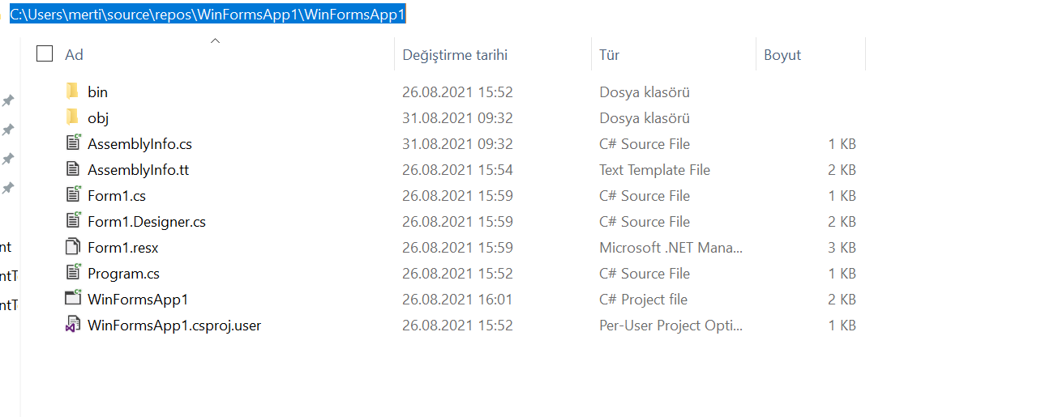

Copy the path and add \AssemblyInfo.tt end of the path.

"C:\Users\merti\source\repos\WinFormsApp1\WinFormsApp1\AssemblyInfo.tt"

# **4-TEST CODE**

In the main program you can test it with that codes.

label1.Text = System.Reflection.Assembly.GetExecutingAssembly().GetName().Version.ToString();

# **5-CUSTOMIZE**

In the AssemblyeInfo.cs, you change the that part

[assembly: AssemblyVersion("1.0.0.0")] as your wish!

# **6- .NET CORE PROJECTS**

In the .net core project you have not AssemblyInfo.cs so you can skip the first step.

The other parts same but, you need to closed generatedAssemblyInfo.

1- Open a text in desktop

2-find your project location

1. Drop that into text file
2. Add that code <GenerateAssemblyInfo>false</GenerateAssemblyInfo>

