**AUTO INCREMENT VERSION BUILD NUMBER**

**I. Create header file ……………………………………...…2**

**II. Import header file into your resource file……………….…2**

**III. Power shell script create and codes…….………………….3**

**IV. Pre-build command………………………………………….4**

**V. Check if its work properly……………………………………4**

1. **Create header file**

First of all, you need to create header file which is name version.h.

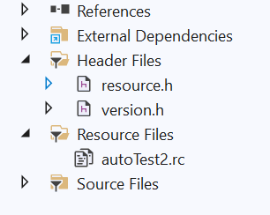

version.h is include ;

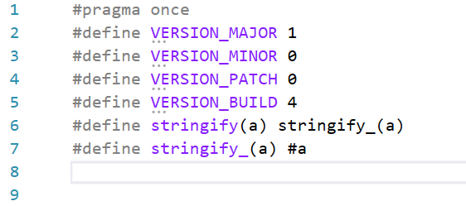

#pragma once

#define VERSION_MAJOR 1

#define VERSION_MINOR 0

#define VERSION_PATCH 0

#define VERSION_BUILD 1

#define stringify(a) stringify_(a)

#define stringify_(a) #a

Note: version.h requires a new line at the end to avoid fatal error RC1004: unexpected end of file found.

You can assign your various version numbers in here. It is up to you!

1. **Import header file into your resource file**

Secondly, we have to change the resource file of project.

If you have not a “nameofyourproject”.rc, you can create easily. Steps are the below;

1. Right click on resource file
2. Click on Add
3. Click on Resource
4. Click on Version

For open the resource file you need to do right click on nameofyourproject.rc > open with >C++ Source code editor.

Then we need to import version.h header file into nameofyourproject.rc.

We have to change the version values,

/////////////////////////////////////////////////////////////////////////////

//

// Version

//

VS_VERSION_INFO VERSIONINFO

FILEVERSION VERSION_MAJOR, VERSION_MINOR, VERSION_PATCH, VERSION_BUILD

PRODUCTVERSION VERSION_MAJOR, VERSION_MINOR, VERSION_PATCH, VERSION_BUILD FILEFLAGSMASK 0x3fL

#ifdef _DEBUG

FILEFLAGS 0x1L

#else

FILEFLAGS 0x0L

#endif

FILEOS 0x40004L

FILETYPE 0x0L

FILESUBTYPE 0x0L

BEGIN

BLOCK "StringFileInfo"

BEGIN

BLOCK "041f04b0"

BEGIN

VALUE "CompanyName", "TODO: <Company name>"

VALUE "FileDescription", "TODO: <File description>"

VALUE "FileVersion", stringify(VERSION_MAJOR) "." stringify(VERSION_MINOR) "." stringify(VERSION_PATCH) "." stringify(VERSION_BUILD)

VALUE "InternalName", "TODO: <Internal name>"

VALUE "LegalCopyright", "Copyright (C) 2021"

VALUE "OriginalFilename", "TODO: <Original filename>"

VALUE "ProductName", "TODO: <Product name>"

VALUE "ProductVersion", stringify(VERSION_MAJOR) "." stringify(VERSION_MINOR) "." stringify(VERSION_PATCH) "." stringify(VERSION_BUILD)

END

END

BLOCK "VarFileInfo"

BEGIN

VALUE "Translation", 0x41f, 1200

END

END

#endif // Turkish (Turkey) resources

/////////////////////////////////////////////////////////////////////////////

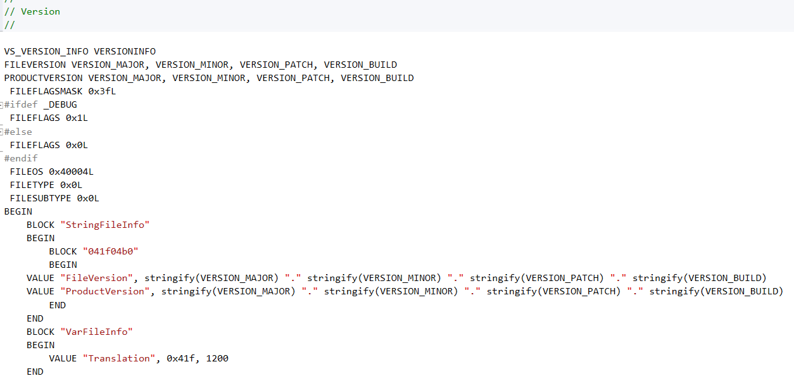

1. **Power shell script create and codes**

Easy way to create power shell script, open a text file and write codes want you need and save as nameofyourscript.ps1.

(Get-Content -path $args[0] -Raw) |

ForEach-Object {

$defstr="#define VERSION_BUILD ";

$regex="$defstr(?<BuildVersion>\d*)";

if($_ -match $regex) {

$_ = $_ -replace $regex,"$($defstr)$(([int]$matches["BuildVersion"])+1)"

}

$_

} |

Out-File $args[0] -encoding ascii -nonewline

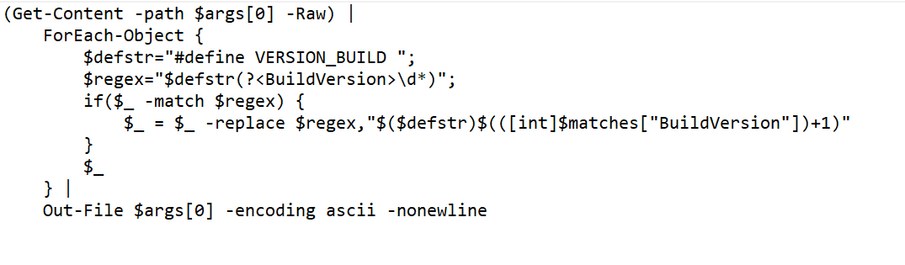

You need to put it in the file where your project is located.

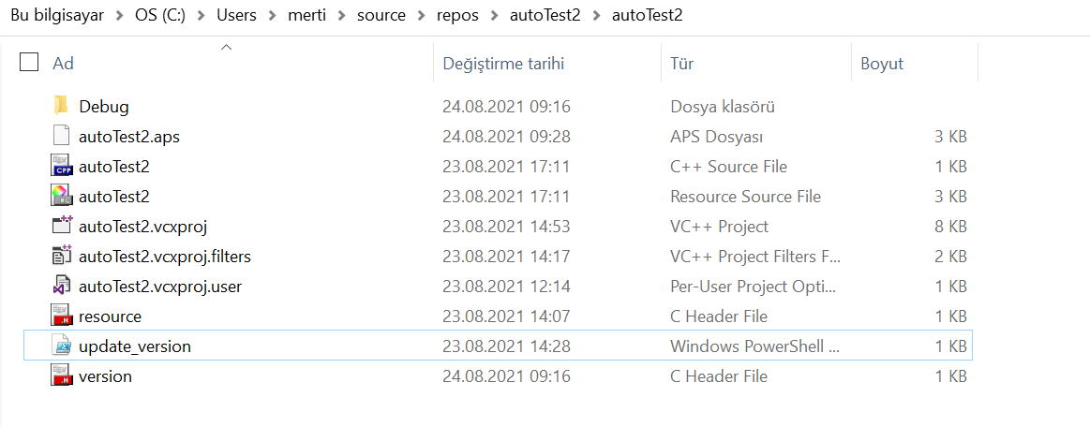

1. **Pre-build command**

You need to add to command for finding nameofyourscript.ps1 file.

Right click on your project > Properties > Build events > Prebuild events > Command line

You need to add command line that code:

**powershell.exe -ExecutionPolicy Bypass -NoProfile -NonInteractive -File NAMEOFYOURSCRIPT.ps1 "./version.h"**

1. **Check if its work properly**

In the main of your program to testing auto increment version number;

You need to import your version header file

And that codes:

std::cout << "Hello World Version " stringify(VERSION_MAJOR) "." stringify(VERSION_MINOR) "." stringify(VERSION_PATCH) "." stringify(VERSION_BUILD) " !\n";

}

