Music Store Analysis_SQL

SQL project to analyse online music store data. It’s a guided Project, Thanks to Rishabh Mishra for guiding and providing enough resources to complete this project.

Tools used

PgAdmin 4

Postgre SQL

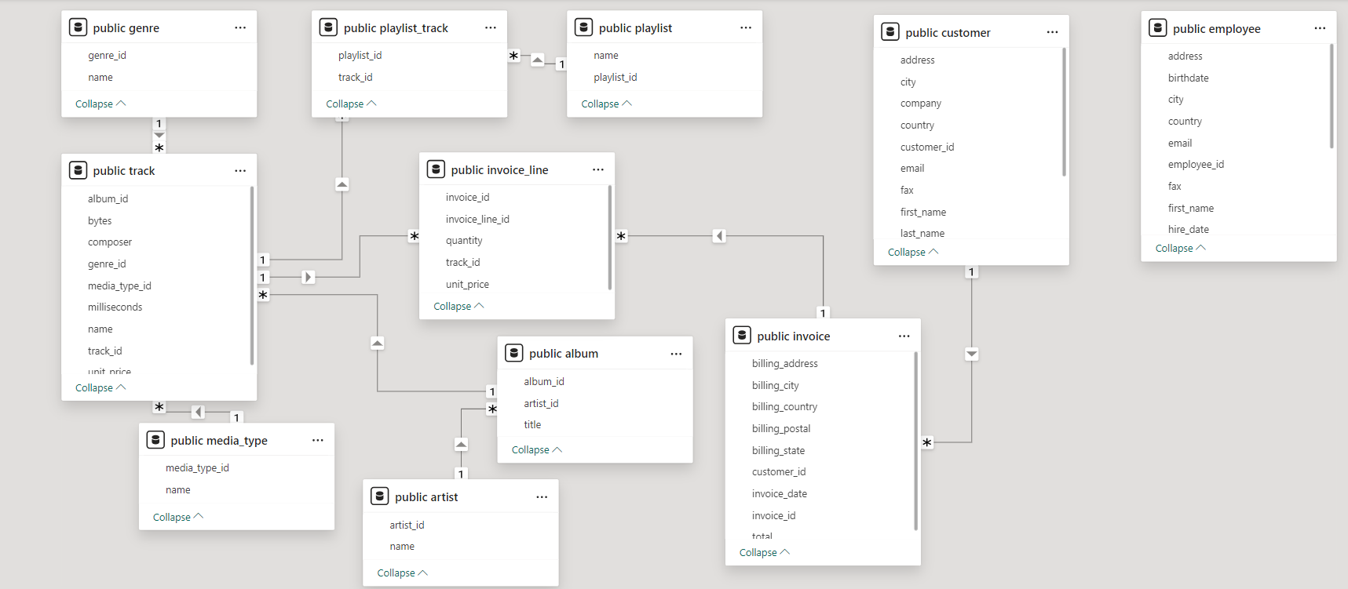Schema Diagram of Music Store Database

*Schema Diagram has been created by using model view tool of PowerBI.