NARA Video Frame Analyzer

Overview
The NARA Video Frame Analysis Tool (a.k.a "SAMMA Analyzer") is designed to automate and standardize the Quality Control (QC) checks that need to be performed on digitized video files.

DESCRIPTION

The NARA Video Frame Analysis application analyzes video frame level metadata generated by the digitization process. The application allows a number pass/fail tests to be configured (RF level, Dropout, etc) and check against the metadata for each frame of video. The application reports on files that have passed and files that have failed each analysis step. For each failure that is identified, a detailed report identifies the time codes and frame ranges containing possible problems.

Conceptually, the NARA Video Frame Analysis application could perform analysis of video metadata generated from a variety of digitization systems provided that frame-level data is generated in a readily parse-able format. In its current form, the application is designed to analyze output from Front Porch Digital's SAMMA Video migration system. As the SAMMA system digitizes video, it produces an XML file containing 37 technical properties (i.e. RF, luminance, dropout, etc) of each frame of video that has been processed. The XML file also contains properties that apply to the entire file (i.e. frame count).

The NARA Video Frame Analysis allows the user to configure a series of tests that will be performed against the generated XML files. Each test falls into one of the following categories.
- Compare a file-level property against a specific value. An entire file either passes or fails based on this condition.
- Compare a frame-level property against a specific value. Define the minimum duration in which the condition must exist in order to report an error.
- Compare the average value of a frame-level property (over a specified duration) against a specific value. Define the minimum duration in which the condition must exist in order to report an error.
BENEFITS

The primary purpose of the NARA Video Frame Analysis application is to reduce the manual effort required to QC digitized video files. While the tool does not eliminate the need to manually review digitized video files, the tool can significantly reduce the effort required by prioritizing the output files that require more careful attention. When performing manual review of an output file, the tool highlights the time code sequences requiring the most diligent review. At NARA, the use of the tool has cut the review time by 50%.

Many steps in the review of video files are subjective. The NARA Video Frame Analysis introduces objective criteria into the review process. Assuming that the test conditions are well-suited to the collection being digitized, the application of these automated tests can provide an objective analysis of the quality of a collection.

The NARA Video Frame Analysis application contains an interface that allows a user to define the "analysis set" to be performed. An analysis set contains the test(s) to be performed as well as the range of values that will pass or fail a specific test. Analysis sets can be refined to closely match the condition of a video collection.

DEPLOYMENT

The application is deployed as a self-extracting JAR file plus a sample analysis set configuration file. The application requires Java SE 1.6 or higher to be present on the user's workstation. The application can be launched by double clicking the jar file.

After launching the application, the user then identifies the following
- Input directory containing video frame XML files to process
- Location of the analysis set configuration file

Using the Application
Start the application by double clicking on the jar file sammaGui.jar.

Configuring the Application
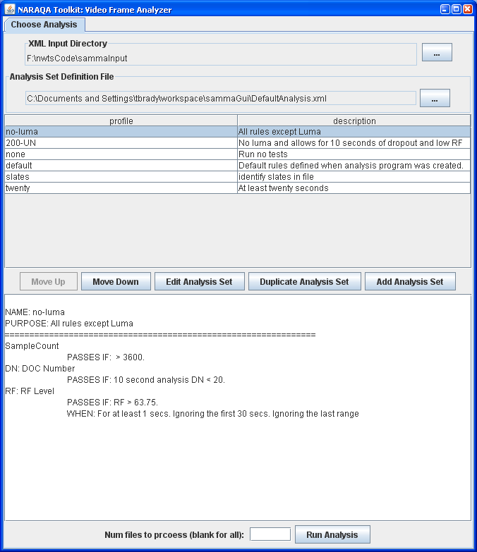
Indicate the location of the input files that you wish to process. (Click the “...” button to navigate to the proper location.
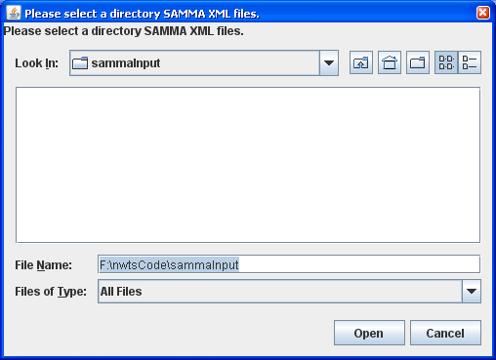
Similarly, the first time that you run the application, you will need to indicate the location of the Analysis Set Definition File. A sample Analysis Set Definition File is provided with the installation.
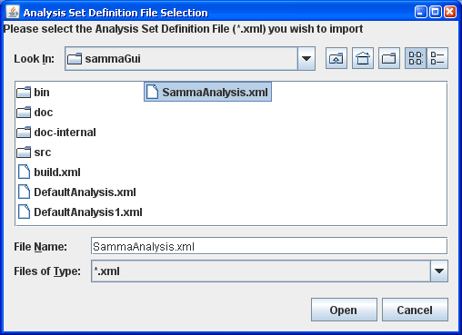
Once a file has been chosen, select the appropriate Analysis Set profile for the collection of files that you wish to process. As you select each profile, a summary of the analysis criteria will display at the bottom of the window.

Performing the Analysis
Click “Run Analysis” to initiate the analysis of your input files. A dashboard will display illustrating the number of errors found for each test within the chosen Analysis Set.
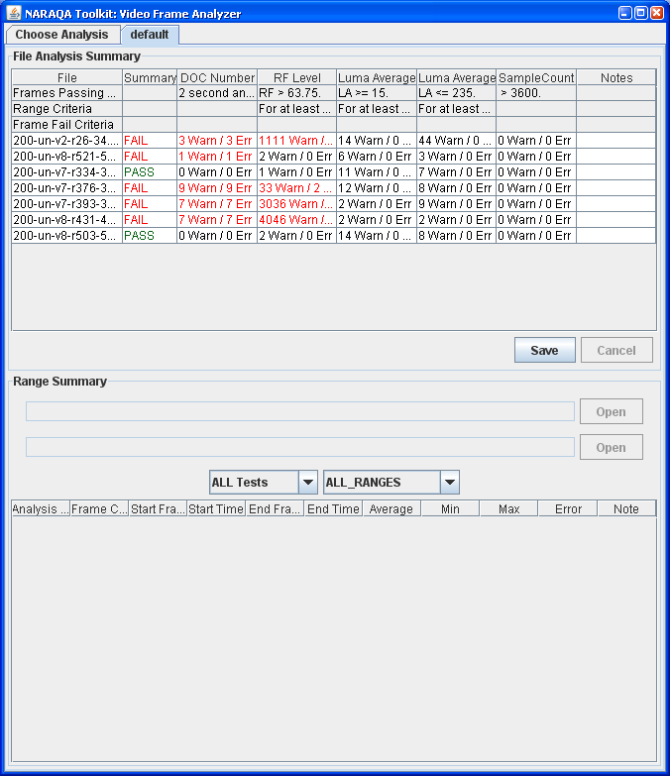
Select a file within the dashboard to view the list of error ranges found within that file. Notes about the file can be captured in the “Notes” column of the dashboard.
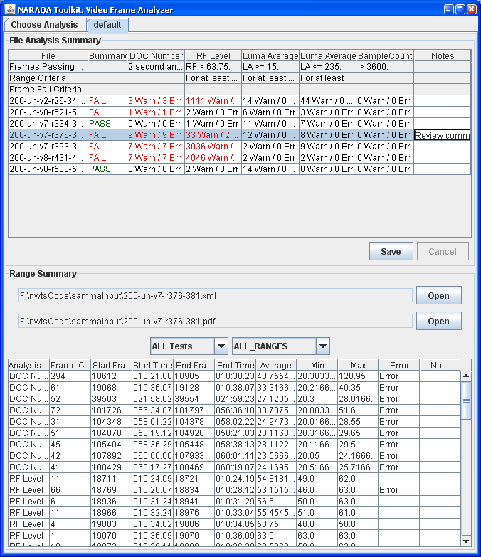

The drop down boxes within the “Range Summary” portion of the screen allow the user to filter the ranges that are displayed by Test and by resulting status. The rows of the table can be sorted by clicking on the column header.

Exporting Test Results
Click “Save” to export your test results to a file.
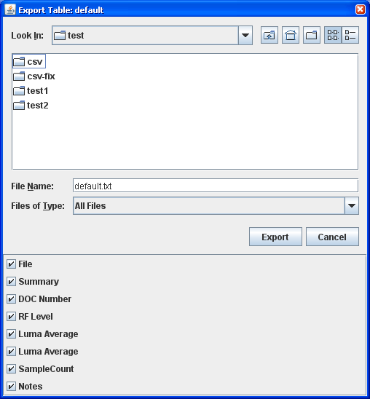

Refining the Analysis to Match Your Collection
To get the best results from the application, it is likely that you will need to refine the analysis criteria to match the properties of your collection.
From the “Choose Analysis” tab of the main window, it is possible to create and modify Analysis Sets. Any changes that are made will be saved to the Analysis Set Definition File.
If a suitable Analysis Set does not exist, you will be able to refine the Analysis Sets using the buttons in the middle of the window. Click “Edit Analysis Set” to modify the details view of the Analysis Set properties.

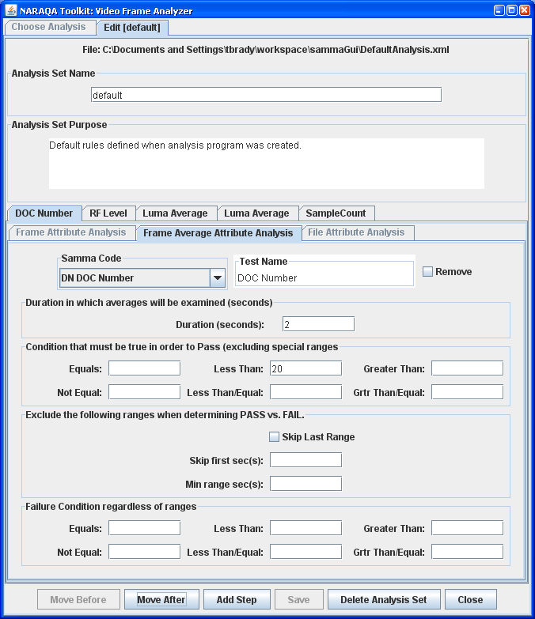
The following about information is contained within the file.
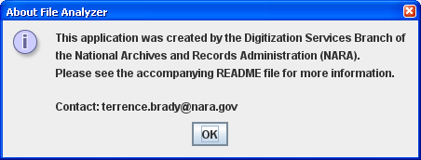

Understanding the Analysis Set Definition File
The Analysis Set Definition editing screens are provided for convenience. Changes are saved to the Analysis Set Definition File. An XML Schema (samma.xsd) is provided with the installation. This schema provides additional details about the fields within the XML file.

