# **CSC 431** <Stocksimulation> System Architecture Specification (SAS)

**4**

|  |  |
| --- | --- |
| Kerui Zeng | Team leader |
| Xing Rong | Team member |
| Xingyang Wu | Team member |
| Bocheng Huang | Team member |

# Version History

|  |  |  |  |
| --- | --- | --- | --- |
| Version | Date | Author(s) | Change Comments |
| 1.0 | 3/26/2020 | Kerui Zeng | Finish form |
|  |  |  |  |
|  |  |  |  |
|  |  |  |  |

# Table of Contents

1. System Analysis 6

1.1 System Overview 6

1.2 System Diagram 6

1.3 Actor Identification 6

1.4 Design Rationale 6

1.4.1 Architectural Style 6

1.4.2 Design Pattern(s) 6

1.4.3 Framework 6

2. Functional Design 7

2.1 Diagram Title 7

3. Structural Design 8

4. Behavioral Design 9

# Table of Tables

<Generate table here>

# Table of Figures

<Generate table here>

### System Analysis

#### System Overview

The stock simulation trading system function has designed three modules: stockholder login, market center and stockholder operation. So the system provides user registration and login module, quote inquiry page and buying & selling module. After the investors register successfully, they can log in to the system. In the market module center, users of stock speculation can inquire about the details of a listed company. The Users can check the latest price, gain, buy price, sell price, transaction volume, turnover, lowest price, highest price, yesterday’s closing, today’s opening through the market query page. First, our stock real time data is provided by a financial information website. Then design the database of the simulated stock trading system based on MySQL. The database contains the order cancellation table, position table, transaction table, optional stock table, user table and user information table. In which, the transaction table is a statistical table of user buying and selling stock transactions. The user information table records the personal information of shareholders’ users. Our website server is from Hong Kong and our domain name comes from Tencent cloud. The graph’s information is provided with Echarts plugin. The web URL is www.ithub.vip .

#### System Diagram

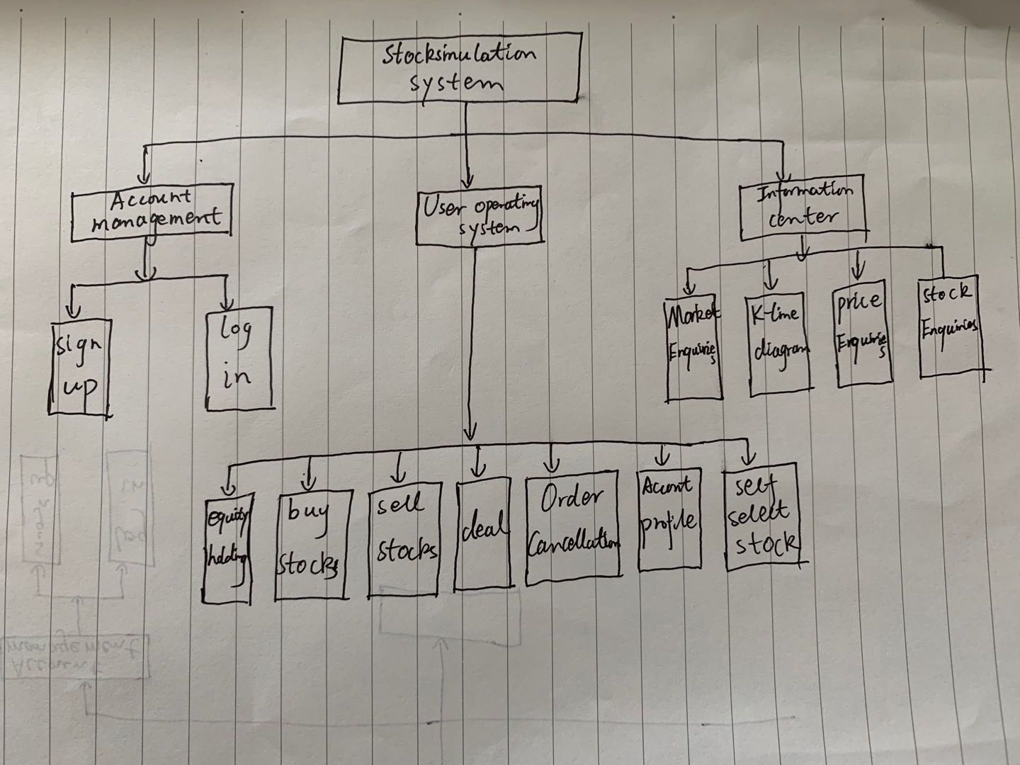

#### Actor Identification

There is one type of human actor in this system that is stock investor. Stock investors can access all the system’s function and their accounts were verified after they finished signing up. Stock investors can sell or buy in stocks, cancel a trade, view their profiles and read news about financial. In our information center, stock investors can view different graphs.

#### Design Rationale

##### Architectural Style

We have three tires : client-server, business, and database-centric. The client-server the controller receives user input, validates the input, and passes that on to be processed by the business tier before responding to the client’s request. The business tier, requests data from the database-centric tier, converts that data and, finally, archives the converted data and sends it back to the client-server tier. Database-centric tier, is to interface with the database. In this program, we used PHP+Apache+MYsql.

##### Design Pattern(s)

Factory: Define an interface for creating objects, but let subclasses decide which class to initialize. Factory methods delegate the initialization of a class to a subclass.

Singleton: Ensure that a class has only one instance and provide global access to that instance.

Proxy: Provide a proxy for other objects to control access to this object.

Appearance : Provides a consistent interface for a set of interfaces in a subsystem. The appearance mode defines a high-level interface that makes this subsystem easier to use.

##### Framework

We used ThinkPHP 5 as the framework. It is an open source framework for building web interfaces, providing data-driven components. It connects with PHP and database.

### Functional Design

<Identify all significant workflows as sequence diagrams using the following format>

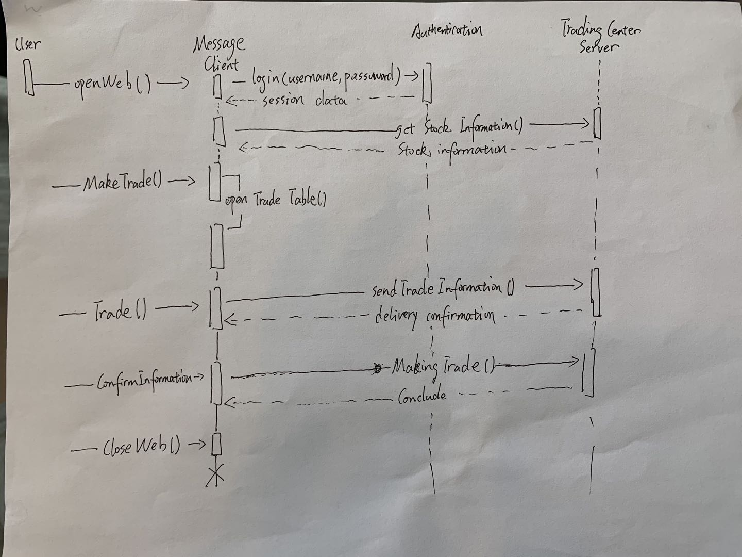

#### Diagram Title

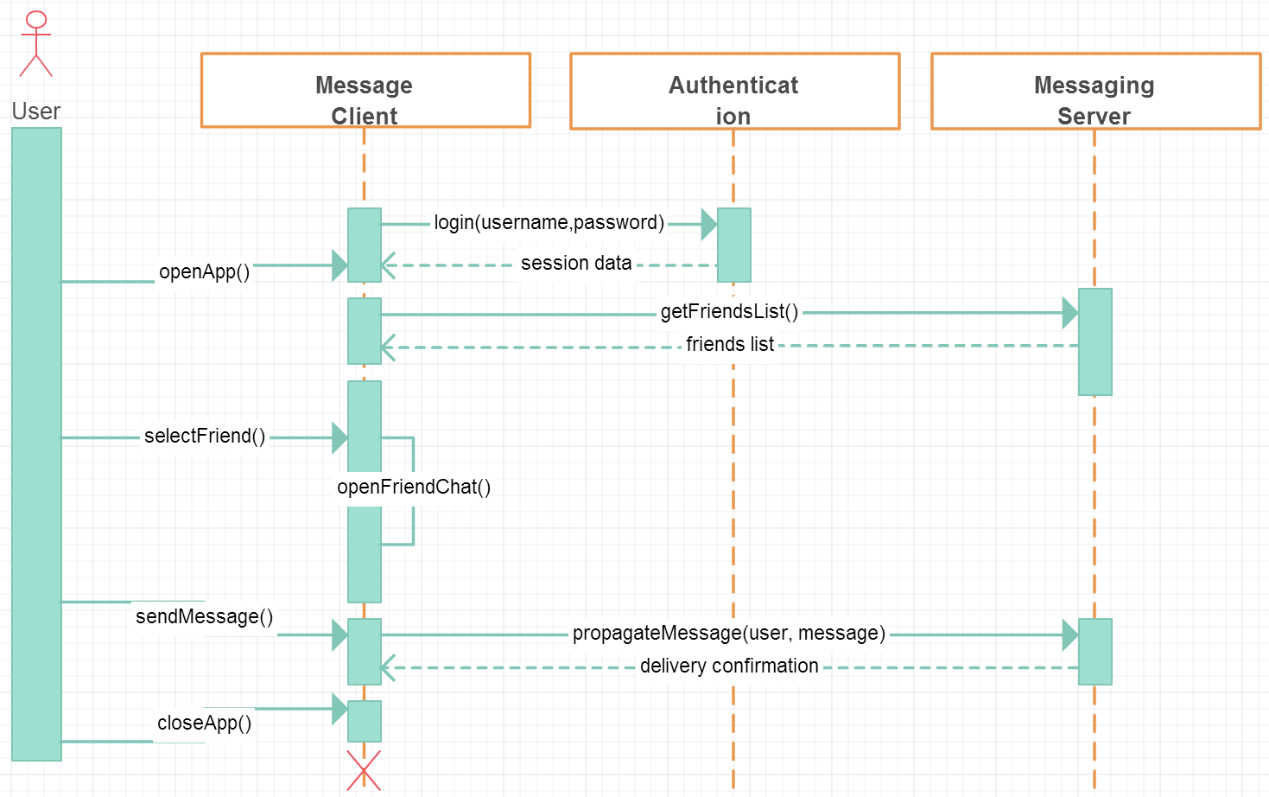

### Structural Design

<Identify all components and model them using class diagrams>

