/



## CSC 431

**Stock Market Simulation**

**Software Requirements Speciﬁcation (SRS)**

**Team Number:**

|  |  |
| --- | --- |
| Kerui Zeng | Team Leader |
| Xing Rong | <Role> |
| Xinyang Wu | <Role> |
| Bocheng Huang | <Role> |

/

# Version History

|  |  |  |  |
| --- | --- | --- | --- |
| **Version** | **Date** | **Author(s)** | **Change Comments** |
| **1.0** | 02/10/20 | Backburners Group | Title and Description for parts 1.1 and 1.2 |
| **2.0** | 02/20/20 | Stock simulation Group | Finish all the requirement. |
|  |  |  |  |
|  |  |  |  |

/

/

**Table of Contents**

1. System Requirements 6
   1. Functional Requirements 6
      1. Requirement Title 6
   2. Non-Functional Requirements 6
      1. Requirement Title 6
2. System Constraints 7
   1. Tool Constraints 7
      1. Requirement Title 7
   2. Language Constraints 7
      1. Requirement Title 7
   3. Platform Constraints 7
      1. Requirement Title 7
   4. Hardware Constraints 7
      1. Requirement Title 7
   5. Network Constraints 7
      1. Requirement Title 8
   6. Deployment Constraints 8
      1. Requirement Title 8
   7. Transition & Support Constraints 8
      1. Requirement Title 8
   8. Budget & Schedule Constraints 8
      1. Requirement Title 8
   9. Miscellaneous Constraints 8
      1. Requirement Title 8
3. Requirements Modeling 10

3.1.1 Requirement Title 10

1. Evolutionary Requirements 11
   1. Functional Requirements 11
      1. Requirement Title 11
   2. Non-Functional Requirements 11
      1. Requirement Title 11

/

/

**Table of Tables**

<Generate table here>

/

/

**Table of Figures**

<Generate table here>

/

1. **System Requirements**
   1. **Functional Requirements**

< List all functional requirements in the following example format >

**1.1.1 Requirement Title**

|  |  |
| --- | --- |
| ID | FR0 |
| Title | Importing Stock Information |
| Description | They have to have relevant stocks that the user can purchase/sell |
| Priority | 0 |
|  |  |
| Precondition(s) | Entering information center |
| Basic Flow | 1. Clients log into the application. 2. Clients enter information center. 3. Clients inquire details of certain stocks. 4. System display the specified information. |
| Postconditions(s) | Display different kinds of information |
| Use Case Diagram | Information center diagram |

|  |  |
| --- | --- |
| ID | FR1 |
| Title | Transaction table |
| Description | Table with the users buying and selling transactions |
| Priority | 0 |
| Precondition(s) | User login |
| Basic Flow | 1. When clients buy/sell stocks. 2. The system changes user’s stock amount. |
| Postconditions(s) | System writes in or freezes equity holdings sheet |
| Use Case Diagram | Trading center diagram |

|  |  |
| --- | --- |
| ID | FR2 |
| Title | Money balance |
| Description | Site should display monetary balance |
| Priority | 0 |
| Precondition(s) | Clients enter login system |
| Basic Flow | 1. Clients enter login system 2. The system displays money balance |
| Postconditions(s) | System displays user’s balance sheet |
| Use Case Diagram | Login system |

|  |  |
| --- | --- |
| ID | FR3 |
| Title | Login System |
| Description | System that allows users to create accounts and login thus accessing their data pertaining to their account. User can also request to change their password using their email or username. |
| Priority | 0 |

/

|  |  |
| --- | --- |
| Precondition(s) | *No precondition |
| Basic Flow | 1. Clients opens the application 2. System shows the UI of login system 3. Clients inputs the account’s username and password 4. The system opens main frame |
| Postconditions(s) | Logged in successfully |
| Use Case Diagram | Login system |

|  |  |
| --- | --- |
| ID | FR4 |
| Title | S tocks Order Cancellation Table |
| Description | U sers are allowed to cancel stocks buying or selling in the t ransaction table when the market is closed. |
| Priority | 0 |
| Precondition(s) | Entering Trading Center |
| Basic Flow | 1. Clients cancelled the buying or selling when the market is closed. 2. System updates equity holdings sheet. |
| Postconditions(s) | System updates equity holdings sheet |
| Use Case Diagram | Trading Center |

|  |  |
| --- | --- |
| ID | FR5 |
| Title | User Profile |
| Description | Stores the user’s login information (username and password) and allows them to change it if need be. Also allows the user to add an email, phone number, etc. |
| Priority | 0 |
| Precondition(s) | Clients enter accounts management |
| Basic Flow | 1. Clients enter accounts management. 2. Clients input username and password. 3. The system displays details of user information. |
| Postconditions(s) | Display users’ name, password, balance amount…. |
| Use Case Diagram | Login system |

/

* 1. **Non-Functional Requirements**

< List all non-functional requirements in the following example format >

**1.1.1 Requirement Title**

|  |  |
| --- | --- |
| ID | NFR0 |
| Title | Stock Market Modeling |
| Description | The stocks on the simulator must accurately model the trends and fluctuations observed in real the life stock market. |
| Priority | 2 |
| Applicable FR(s) | Importing Stock Information |

|  |  |
| --- | --- |
| ID | NFR1 |
| Title | Transaction Table |
| Description | buying or selling stock should be reflected in the users money balance |
| Priority | 3 |
| Applicable FR(s) | Transaction table |

|  |  |
| --- | --- |
| ID | NFR2 |
| Title | Money balance |
| Description | The site should keep track of how much money the user has accumulated/lost |
| Priority | 4 |
| Applicable FR(s) | Money balance |

|  |  |
| --- | --- |
| ID | NFR3 |
| Title | Data/Database |
| Description | Data from finance web service API needs to be provided by Yahoo! and with this a database of the simulated stock trading system needs to be designed. This database will contain all of the other tables. |
| Priority | 1 |
| Applicable FR(s) | Importing Stock Information |

|  |  |
| --- | --- |
| ID | NFR4 |
| Title | Equity Return |
| Description | The system will add or subtract the amount spent on the stock and return how much they have earned or loss in both percentages and monetary amounts. |

/

|  |  |
| --- | --- |
| Priority | 4 |
| Applicable FR(s) | Money balance |

|  |  |
| --- | --- |
| ID | NFR5 |
| Title | Chart Styles |
| Description | Types of charts to display stock information whether candle sticks or line charts |
| Priority | 5 |
| Applicable FR(s) | Importing Stock Information |

|  |  |
| --- | --- |
| ID | NFR6 |
| Title | S tocks Order Cancellation Table |
| Description | T he order that is bought or sold will disappear from the Order T ransaction table and won’t be retrieved |
| Priority | 5 |
| Applicable FR(s) | S tocks Order Cancellation Table |

/

**System Constraints**

* 1. **Tool Constraints**

< List all tool constraints in the following example format >

**1.2.1 Requirement Title**

|  |  |
| --- | --- |
| ID | <a unique ID for the constraint, e.g., C1)> |
| Title | <Insert title> |
| Description | <A one or two sentence description> |
| Priority | <Priority from 0 (highest) – 5 (lowest)> |

* 1. **Language Constraints**

< List all language constraints in the following example format >

**1.3.1 Requirement Title**

|  |  |
| --- | --- |
| ID | LC0 |
| Title | C ++, MySQL |
| Description | T he back-end part of the website will be supported by MySQL a nd C++ will |
| Priority | 0 |

|  |  |
| --- | --- |
| ID | LC1 |
| Title | J avascript, CSS (Bootstrap), HTML |
| Description | T he website will be written as a combination of Javascript, H TML, and CSS (bootstrap and other libraries) |
| Priority | 2 |

* 1. **Platform Constraints**

< List all platform constraints in the following example format >

**1.4.1 Requirement Title**

|  |  |
| --- | --- |
| ID | <a unique ID for the constraint, e.g., C1)> |
| Title | <Insert title> |
| Description | <A one or two sentence description> |
| Priority | <Priority from 0 (highest) – 5 (lowest)> |

* 1. **Hardware Constraints**

< List all hardware constraints in the following example format >

/

**1.5.1 Requirement Title**

|  |  |
| --- | --- |
| ID | <a unique ID for the constraint, e.g., C1)> |
| Title | <Insert title> |
| Description | <A one or two sentence description> |
| Priority | <Priority from 0 (highest) – 5 (lowest)> |

* 1. **Network Constraints**

< List all network constraints in the following example format >

**1.6.1 Requirement Title**

|  |  |
| --- | --- |
| ID | <a unique ID for the constraint, e.g., C1)> |
| Title | <Insert title> |
| Description | <A one or two sentence description> |
| Priority | <Priority from 0 (highest) – 5 (lowest)> |

* 1. **Deployment Constraints**

< List all deployment constraints in the following example format >

**1.7.1 Requirement Title**

|  |  |
| --- | --- |
| ID | <a unique ID for the constraint, e.g., C1)> |
| Title | <Insert title> |
| Description | <A one or two sentence description> |
| Priority | <Priority from 0 (highest) – 5 (lowest)> |

* 1. **Transition & Support Constraints**

< List all transition & support constraints in the following example format >

**1.8.1 Requirement Title**

|  |  |
| --- | --- |
| ID | <a unique ID for the constraint, e.g., C1)> |
| Title | <Insert title> |
| Description | <A one or two sentence description> |
| Priority | <Priority from 0 (highest) – 5 (lowest)> |

* 1. **Budget & Schedule Constraints**

< List all budget & schedule constraints in the following example format >

/

**1.9.1 Requirement Title**

|  |  |
| --- | --- |
| ID | <a unique ID for the constraint, e.g., C1)> |
| Title | <Insert title> |
| Description | <A one or two sentence description> |
| Priority | <Priority from 0 (highest) – 5 (lowest)> |

* 1. **Miscellaneous Constraints**

< List all miscellaneous constraints in the following example format >

* + 1. **Requirement Title**

|  |  |
| --- | --- |
| ID | <a unique ID for the constraint, e.g., C1)> |
| Title | <Insert title> |
| Description | <A one or two sentence description> |
| Priority | <Priority from 0 (highest) – 5 (lowest)> |

/

**Requirements Modeling**

< List all Use-case diagrams for the functional requirements in the following format>

* + 1. **Requirement Title**

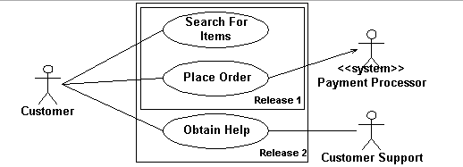

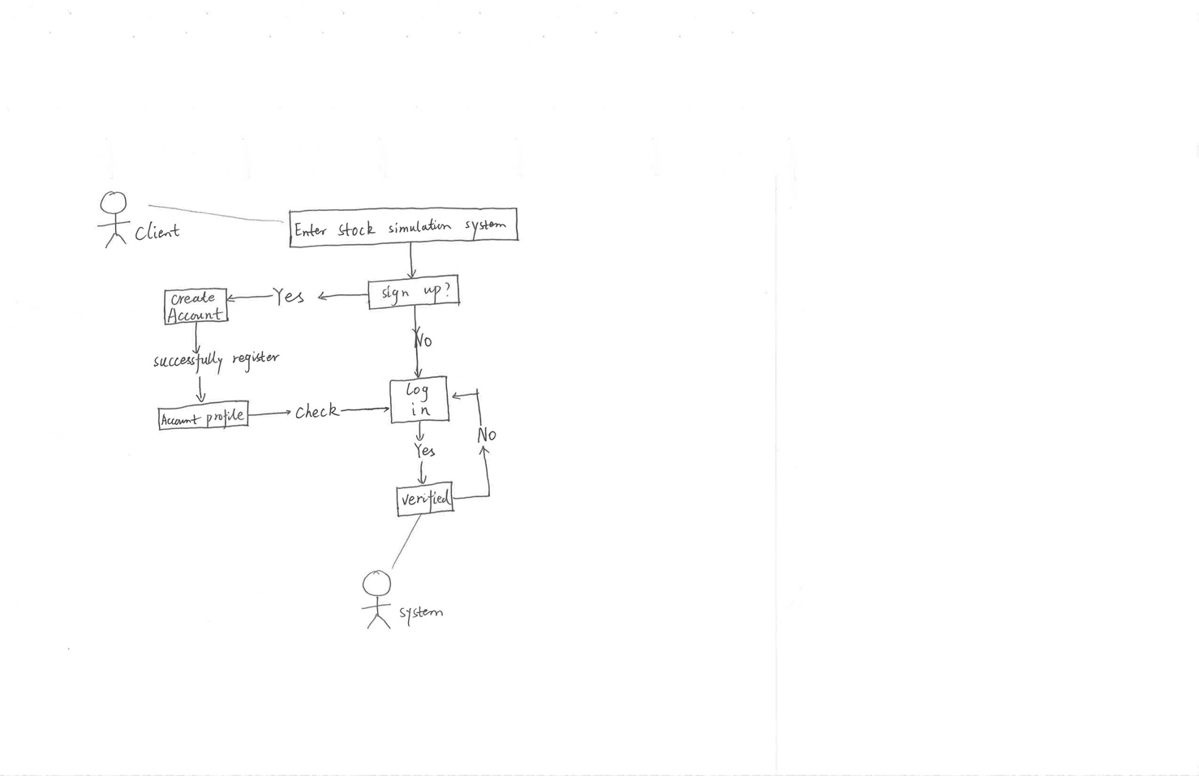

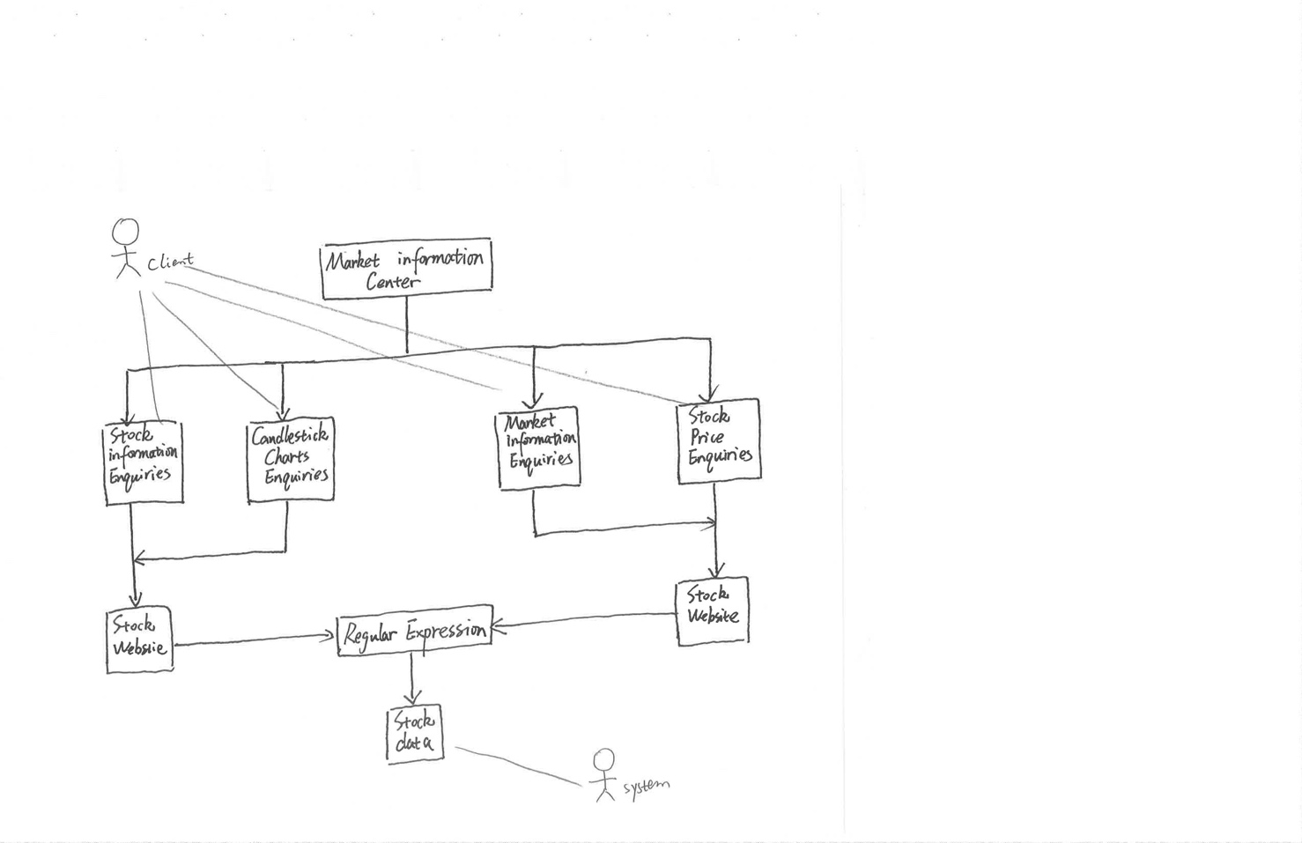

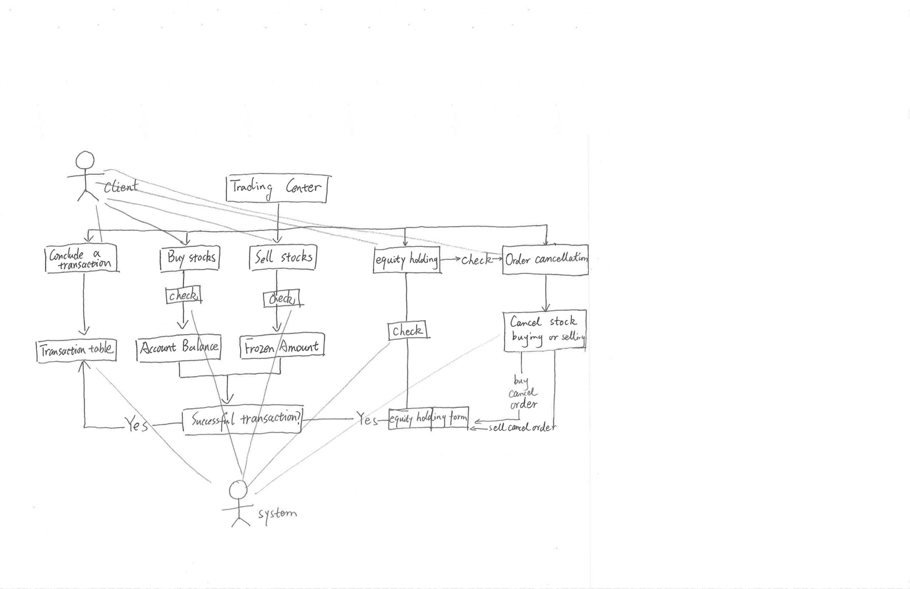



/

/

**Evolutionary Requirements**

* 1. **Functional Requirements**

< List all functional requirements in the following example format >

**2.1.1 Requirement Title**

|  |  |
| --- | --- |
| Title | <Insert title> |
| Description | <A one or two sentence description> |
| Priority | <Priority from 0 (highest) – 5 (lowest)> |
| Precondition(s) | <What needs to happen before> |
| Postconditions(s) | <What happens as a result> |
| Use Case Diagram | <Link or number, if present> |

* 1. **Non-Functional Requirements**

< List all non-functional requirements in the following example format >

**2.2.1 Requirement Title**

|  |  |
| --- | --- |
| Title | <Insert title> |
| Description | <A one or two sentence description> |
| Priority | <Priority from 0 (highest) – 5 (lowest)> |
| Applicable FR(s) | <Which functional requirement(s) is this applicable to?> |