OVERVIEW
The documentation below is taken from the 1994 version of the AGA-8 publication. This material was removed from the 2015 revision, but is given here as supplementary material for those still using the 1994 code.

APPENDIX A

DETAIL characterization method COMPUTATION PROCEDURES
This appendix provides summary documentation for the FORTRAN language computer program code for the DETAIL characterization method. This documentation includes a summary flow diagram of the computer program and descriptions of the main program and each subroutine. Additional documentation is provided by comment statements within the computer program listing.
Figure A.1 gives the procedure used for computation of the compressibility factor Z using the DETAIL characterization method.
- Input is made of the mole fractions of the components in the gas. The gas mixture molar mass is calculated.
- Input is made for the temperature and pressure for which the computation of the compressibility factor is desired.
- Computation is made of the coefficients B and 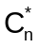 in the equation of state. These coefficients are functions of absolute temperature and the mole fractions of the components in the gas mixture.
- The molar density d is computed using the equation of state relation for the pressure P. The computation procedure used is referred to as Brent’s method. In the iterative procedure for solving for the molar density d, the convergence criterion is either agreement of the calculated pressure with the specified pressure within an absolute relative deviation of 1x10⁻⁶ or agreement of successive iterative values of d within an absolute relative deviation of 1x10⁻⁶.
- The compressibility factor Z is computed.
- Figure A.2 is a summary flow diagram for use of the computer program. This computer program was developed for efficient computations of natural gas compressibility factors using the DETAIL characterization method, in which the mole percentages of gas mixture components are known.
One program driver block (Application Program) and four computation blocks are shown in Figure A.2. The principal subroutine used by a given computation block is shown to the left of that computation block. The computation blocks and the principal subroutines used are
- calculation of component dependent quantities (PARAMDL)
- calculation of composition dependent quantities (CHARDL)
- calculation of temperature dependent quantities (TEMP)
- calculation of density dependent quantities (DDETAIL)
For efficient computations, the application program should call the principal subroutines in a sequence corresponding to the four computation blocks. This computation sequence is efficient because it minimizes unnecessary repeated calculations. An example of an unnecessary repeated calculation is the calculation of a temperature dependent quantity each time the density is calculated at a series of pressures, even though the temperature may be the same for some of these density calculations. Thus, if the computation sequence in Figure A.2 is incorporated in any other driver program, the efficiency of this sequence will be maintained.
The computer program structure shown in Figure A.2 corresponds to the four levels of information which are required in the DETAIL characterization method equation of state. First, the components of which the gas mixture is composed must be identified. The number of components, NCC, and the component identification numbers, CID(1), CID(2), …, CID(NCC), are required by subroutine PARAMDL. PARAMDL obtains fixed parameters from BLOCK DATA and calculates other parameters required subsequently. This completes the first computation block. Note that for most efficient computation, subroutine PARAMDL is never called again until the components in the gas mixture change.
For computations in the second computation block, the composition of the gas mixture must be identified. The mole percentages of each component, Xl(1), Xl(2), ..., XI(NCC), are required by subroutine CHARDL. CHARDL calculates composition dependent quantities which are required subsequently. Note that for most efficient computation, CHARDL subroutine is never called again until there is a change in the composition of the gas mixture.
For computations in the third computation block, the temperature must be identified. Subroutine TEMP requires the absolute temperature T. TEMP calls subroutine B, which calculates the second virial coefficient B for the gas mixture at the temperature T. TEMP then calculates the other coefficients in the equation of state for the gas mixture for the absolute temperature T. Note that for most efficient computation, subroutine TEMP and subroutine B are never called again until there is a change in the temperature of the gas mixture.
For computations of density and density dependent quantities in the fourth computation block, the pressure must be identified. Function DDETAIL requires the absolute pressure P. DDETAIL uses Brent’s method to solve for the density of the gas mixture of composition Xl(1), Xl(2), ..., XI(NCC) at absolute temperature T and specified absolute pressure P. Function DDETAIL calls subroutine BRAKET, which determines two values of density, RHOL and RHOH, which, when used in the equation of state, yield calculated absolute pressures PRHOL and PRHOH which bracket the specified pressure P. The densities RHOL and RHOH, which bracket the solution for density at the specified pressure P, are then used in function DDETAIL to solve for the density corresponding to the specified pressure P. Both function DDETAIL and subroutine BRAKET call function PDETAIL, which calculates the pressure for a specified density, RHO. Function PDETAIL calls function ZDETAIL, which calculates the compressibility factor for a specified temperature and density.
Descriptions of Functions and Subroutines
FORTRAN functions and subroutines used to calculate density related properties from the DETAIL CHARACTERIZATION MODEL are listed below. These routines are available in the module DETAILXZ.FOR.
FUNCTION DDETAIL (P, T)
FUNCTION PDETAIL (D, T)
FUNCTION ZDETAIL (D, T)
SUBROUTINE B (T, BMIX)
SUBROUTINE BRAKET (CODE, T, P, RHO, RHOL, RHOH, PRHOL, PRHOH)
SUBROUTINE CHARDL (NCC, XI, ZB, DB)
SUBROUTINE PARAMDL (NCC, CID)
SUBROUTINE TEMP (T)
BLOCK DATA
BLOCK DATA is a block data section which contains the fixed constants used in the equation of state computations of the compressibility factor using the DETAIL characterization method. These fixed constants include the gas constant, RGAS, the equation of state constants, A(1) through A(58), compound characterization parameters, that is, the molecular masses CMWB(J) for each compound, energy, size and orientation parameters EIB(J), RKIB(J), and WIB(J) for each compound, and the binary interaction parameters BEIJB(I,J), BKIJB(I,J), BWIJB(I,J), and BUIJB(I,J).
Subroutine PARAMDL
Subroutine PARAMDL assigns component and binary parameters for a mixture containing NCC components with component identification numbers CID(1), CID(2), …, CID(NCC). Pure component and binary parameters in BLOCK DATA which are required by PARAMDL are accessed through the common block COMMON/PARAM/.
Subroutine CHARDL
Subroutine CHARDL calculates a number of composition dependent quantities using the mole percent values for the components in the mixture, Xl(1), Xl(2), ..., XI(NCC). The mole percent values are used to calculate normalized mole fractions by dividing each component mole percent by the sum of the component mole percents. The gas mixture average molar mass is calculated as the molar average of the component molar masses. Composition dependent coefficients of temperature functions in the second virial coefficient are calculated for subsequent use in subroutine B. Also calculated are values of the mixture size parameter (K³ in the text and RK3PO in the program), the mixture quadrupole parameter (Q² in the text and Q2PO in the program), the mixture energy parameter (U in the text and U in the program), and the mixture orientation parameter (W in the text and W in the program).
Subroutine B
Subroutine B calculates the second virial coefficient for the gas mixture at the absolute temperature T. The required composition dependent coefficients are accessed through COMMON/VIR/. The computed second virial coefficient BMIX is made accessible through the subroutine argument.
Subroutine TEMP
Subroutine TEMP calculates a number of quantities which are functions of temperature but not density. These quantities are B1 through B12 and FN(13) through FN(58), which are related to the coefficients of the density functions in the equation of state. Required mixture parameters are accessed through COMMON/AGAVARIABLES/. Required equation of state parameters are accessed from BLOCK DATA through COMMON/EOSAl/. The required absolute temperature T is accessed through the subroutine TEMP argument. Subroutine TEMP calls subroutine B for the calculation of the second virial coefficient at the absolute temperature T. The quantities calculated in subroutine TEMP are made accessible through COMMON/AGAVARIABLES/ and COMMON/AGAEOS/.
Function Subprogram DDETAIL
Function subprogram DDETAIL uses Brent’s method to calculate the molar density for the specific temperature and pressure in argument of DDETAIL (P, T).
DDETAIL calls subroutine BRAKET, which brackets the solution for the density. BRAKET determines two values of density, RHOL and RHOH, which, when used in the equation of state, yield calculated absolute pressures PRHOL and PRHOH which bracket the specified pressure P. The densities RHOL and RHOH, which bracket the solution for density at the specified pressure P, are then used by DDETAIL as initial values for use in Brent’s method.
The first iteration of Brent’s method uses inverse linear interpolation between RHOL and RHOH to estimate a third trial root. Subsequent iterations of Brent’s method make the most efficient choice between inverse quadratic interpolation, inverse linear interpolation and bisection to estimate a new trial root. New trial roots in a given iteration are not allowed to step outside of the current bounds which bracket the solution for density (if an interpolation fails to stay within the bracketing bounds, the method defaults to the bisection method for that iteration).
DDETAIL calls function subprogram PDETAIL for the calculation of the absolute pressure at trial density roots. The iterative calculation is considered converged in DDETAIL when the absolute value of the difference between the calculated pressure and the specified pressure is less than the product of the specified absolute pressure and the pressure convergence tolerance EPSP and when the absolute value of the difference between two densities which bracket the solution is less than the product of the more accurate density and the density convergence tolerance EPSR. The two convergence tolerances EPSP and EPSR are specified in DDETAIL. The maximum allowed number of iterations, ITMAX, also is specified in the data statement. The quantity EPSMIN, which must be smaller than EPSR and greater than the machine floating point precision for the computer being used, must also be specified in DDETAIL so that iterative steps in density which are smaller than the computer precision will not be attempted. The quantity CODE is initialized to 0.0; CODE is set to 1.0 in subroutine BRAKET when there is a maximum in pressure versus density at a pressure below the specified absolute pressure P.
Subroutine BRAKET
Subroutine BRAKET determines two densities, RHOL and RHOH, which bracket the solution for density. The corresponding absolute pressures, PRHOL and PRHOH, bracket the specified pressure P. Thus, when the density RHOL is used in the equation of state, the absolute pressure PRHOL is calculated, such that PRHOL<P. Similarly, when the density RHOH is used in the equation of state, the absolute pressure PRHOH is calculated, such that PRHOH>P.
The first trial values for density in BRAKET are RHO1=0.0 and RHO2. RHO2 is approximately the ideal gas equation density. This density is then used in the equation of state to calculate the pressure P2; BRAKET calls function PDETAIL for this calculation. If P2>P then the solution for density is bracketed between RHOL = 0.0 (for which PRHOL = 0.0) and RHOH = RHO2 (for which PRHOH = P2); BRAKET then returns these results to DDETAIL through the subroutine BRAKET argument.
When the trial for density in BRAKET, RHO2 yields a value of P2 which is less than P, an algorithm is initiated to bracket the solution for density. In this algorithm, the trial density is increased iteratively until the calculated absolute pressure exceeds the specified absolute pressure P. The density is then bracketed between the values of density from the final two iterations. In the first step, the density is increased by DEL. In subsequent steps, the density is increased by twice the previous value of DEL. The solution for density is bracketed in this manner and the resultant values of RHOL, RHOH, PRHOL and PRHOH are returned to DDETAIL through the subroutine BRAKET argument. If an iterative value of the calculated absolute pressure is less than a previous value, this indicates that there is a maximum in pressure versus density at a pressure less than P. Then CODE is changed from 0.0 to 1.0 and the density from the previous iteration is returned to DDETAIL as RHO in argument list of subroutine BRAKET. Function subprogram DDETAIL then uses the value RHO for the solution for density and returns this value to the calling location; Brent’s method is not used in DDETAIL in this situation because it requires two densities which bracket the solution for density.
Function Subprogram PDETAIL
Function subprogram PDETAIL calculates the absolute pressure using the equation of state equation for pressure. The function subprogram ZDETAIL is called for the calculation of the compressibility factor.
Function Subprogram ZDETAIL
Function subprogram ZDETAIL calculates the compressibility factor using the DETAIL characterization method equation of state.
Example Calculations
Presented below is a computer listing for an example application and the output from this example. This example simulates a flow computer application in which there are 20 discrete step temperature-pressure conditions and the gas composition changes during these 20 discrete steps. The last column of the output gives the number of computation blocks in that were called for each calculation of Z.

C--------------------------------------------------------------------------
PROGRAM EXAMPLE
C PURPOSE:
C This example program shows how to use the DETAIL method as a
C stand-alone program.
C COMPILED WITH:
C DETAILXZ. FOR - Source code which contains routines for calculating
C properties with the DETAIL characterization method.
C UNITS.FOR – Source code which contains unit conversion routines.
C--------------------------------------------------------------------------
INTEGER I, CIDH(21), NCCH, IH, CID(21), NCC, ICOMP, ILEVEL, ITABLE
REAL*8 D, Z, ZB, DB, FPV, TK, PMP, DDETAIL, ZDETAIL, UNITS
REAL*8 TDATA(20), PDATA(20), XK(21,2), XI(21), XIH(21), XIC(21)
C--------------------------------------------------------------------------
C Set up pressure & temperature arrays:
C | TDATA() – Array of temperatures in degrees F.
C | PDATA() – Array of pressures in psia.
C Set up composition tables:
C | XK(I,J) Array of mole fraction compositions.
C | 1 - | Methane |  |  | 8 | - Hydrogen | 15 | - n-Hexane
C | 2 - | Nitrogen |  |  | 9 | - Carbon Monoxide | 16 | - n-Heptane
C | 3 - | Carbon Dioxide |  |  | 10 | - Oxygen | 17 | - n-Octane
C | 4 - | Ethane |  |  | 11 | - i-Butane | 18 | - n-Nonane
C | 5 - | Propane |  |  | 12 | - n-Butane | 19 | - n-Decane
C | 6 - | Water |  |  | 13 | - i-Pentane | 20 | - Helium
C | 7 - | Hydrogen | Sulfide |  | 14 | - n-Pentane | 21 | - Argon
C--------------------------------------------------------------------------
DATA (TDATA{I),I=1,20)/65.D0,65.D0,65.05D0,65.05D0,65.05D0,
& 65.05D0,65.05D0,65.05D0,65.05D0,65.1D0,65.15D0,65.15D0,65.15D0,
& 65.15D0,65.15D0,65.15D0,65.15D0,65.15D0,65.2D0,65.25DO/
DATA (PDATA(I),I=1,20)/750.D0,750.5D0,751.D0,751.D0,751.0D0,
& 751.0D0,751.D0,751.5D0,751.5D0,752.D0,752.5D0,752.5D0,752.5D0,
& 752.5D0,752.5D0,753.D0,753.5D0,753.5D0,754.D0,754.D0/
C--------------------------------------------------------------------------
C The following two compositions are for Gulf Coast Gas and Amarillo Gas.
C--------------------------------------------------------------------------
DATA (XK(I,1),I=1,21)/.965222D0,.002595D0,.005956D0,.018186D0,
& .004596D0,0,0,0,0,0,0.000977D0,0.001007D0,.000473D0,.000324D0,
& .000664D0,0,0,0,0,0,0/
DATA (XK(I,2),I=1,21)/.906724D0,.031284D0,.004676D0,.045279D0,
& .00828D0,0,0,0,0,0,0.001037D0,0.001563D0,.000321D0,.000443D0,
& .000393D0,0,0,0,0,0,0/
ICOMP = 1
ITABLE = 20
OPEN (UNIT=1,FILE =’TA_3_1’)
WRITE (1,11)
11 FORMAT (//,33X, ’TABLE A.3-1’,/,
& 24X, ’Detail Characterization Method’,/,
& 25X, ’Output from EXAMPLE Program’,/,
& 22X, ’For Program Verification Purposes’,//)
WRITE (1,12)
- FORMAT (5X,’VALUE’,4X,’T (F) ’,4X, ’P (psia)’,4X,’D (lbm/ft^3)’,
& 5X,’Z’,10X,’FPV’,3X,’LEVEL’,/,4X,72(’-’),/)
C-------------------------------------------------------------------------
C Start DO loop to set up Table with ITABLE Values.
C Change to second Composition at 10th Table Value.
C-------------------------------------------------------------------------
DO IH=1,ITABLE
IF (IH.EQ.10) ICOMP = 2
NCC = 0
ILEVEL = 0
DO I=1, 21
IF (XK(I,ICOMP).NE.0) THEN
NCC = NCC + 1
CID(NCC) = I
XI(NCC) = XK(I,ICOMP)
XIC(NCC) = XK(I,ICOMP)
ENDIF
ENDDO
IF (IH.EQ.l) GOTO 400
C-------------------------------------------------------------------------
C Check last values (NCCH, CIDH, XIH, etc.) with new values to see if
C they are different. For the first pass, call all subroutines. If the
C composition has changed, call CHARDL. If the temperature is different,
C recalculate the virial coefficients. If the pressure is different,
C recalculate the density. If nothing has changed, print the previous
C results. The LEVEL column is interpreted as follows:
C 0 -- No change
C 1 -- Pressure change
C 2 -- Temperature change
C 3 -- Gas characterization change
C 4 -- Set up GROSSXZ constants
C-------------------------------------------------------------------------
IF (NCCH.NE.NCC) GOTO 400
DO I=1,NCC
IF (CIDH (I).NE.CID(I)) GOTO 400
ENDDO
DO I=1,NCC
IF(XIH(I).NE.XI(I)) GOTO 300
ENDDO
IF (TDATA(IH).NE.TDATA(IH-l)) GOTO 200
IF (PDATA(IH).NE.PDATA(IH-1)) GOTO 100
GOTO 10
C-------------------------------------------------------------------------
C Start the calculation process by calling the appropriate subroutine.
C-------------------------------------------------------------------------
400 CALL PARAMDL(NCC, CID)
ILEVEL = ILEVEL + 1
300 CALL CHARDL(NCC, XI, ZB, DB)
ILEVEL = ILEVEL + 1
200 TK = UNITS(TDATA(IH), ’T’, ’F’ ’, ’K ’)
CALL TEMP(TK)
ILEVEL = ILEVEL + 1
100 PMP = UNITS(PDATA(IH), ’P’, ’psia ’, ’Mpa ’)
ILEVEL = ILEVEL + 1
D = DDETAIL(PMP, TK)
Z = ZDETAIL(D, TK)
FPV = DSQRT(ZB/Z)
D = UNITS(D, ’D’ , ’mol/dm^3 ’, ’lbm/ft^3 ’)
C--------------------------------------------------------------------------
C Print results.
C--------------------------------------------------------------------------
10 WRITE (1,1000) IH, TDATA(IH), PDATA(IH), D, Z, FPV, ILEVEL
1000 FORMAT (4X,I5,2F12.6,F13.5,F12.6,F13.5,2X,I2)
C--------------------------------------------------------------------------
C Hold values for checking in next iteration.
C--------------------------------------------------------------------------
DO I=1,NCC
CIDH(I) = CID(I)
XIH(I) = XIC(I)
ENDDO
NCCH = NCC
ENDDO
999 END

Detail Characterization Method
Output from EXAMPLE Program
For Program Verification Purposes
VALUE | T(F) | P (psia) | D (lbm/ft^3) | Z | FPV level
1 | 65.000000 | 750.000000 | 2.49294 | 0.897619 | 1.05436 | 4
2 | 65.000000 | 750.500000 | 2.49478 | 0.897555 | 1.05440 | 1
3 | 65.050000 | 751.000000 | 2.49628 | 0.897529 | 1.05441 | 2
4 | 65.050000 | 751.000000 | 2.49628 | 0.897529 | 1.05441 | 0
5 | 65.050000 | 751.000000 | 2.49628 | 0.897529 | 1.05441 | 0
6 | 65.050000 | 751.000000 | 2.49628 | 0.897529 | 1.05441 | 0
7 | 65.050000 | 751.000000 | 2.49628 | 0.897529 | 1.05441 | 0
8 | 65.050000 | 751.500000 | 2.49812 | 0.897465 | 1.05445 | 1
9 | 65.050000 | 751.500000 | 2.49812 | 0.897465 | 1.05445 | 0
10 | 65.100000 | 752.000000 | 2.63098 | 0.893031 | 1.05702 | 3
11 | 65.150000 | 752.500000 | 2.63256 | 0.893004 | 1.05703 | 2
12 | 65.150000 | 752.500000 | 2.63256 | 0.893004 | 1.05703 | 0
13 | 65.150000 | 752.500000 | 2.63256 | 0.893004 | 1.05703 | 0
14 | 65.150000 | 752.500000 | 2.63256 | 0.893004 | 1.05703 | 0
15 | 65.150000 | 752.500000 | 2.63256 | 0.893004 | 1.05703 | 0
16 | 65.150000 | 753.000000 | 2.63451 | 0.892937 | 1.05707 | 1
17 | 65.150000 | 753.500000 | 2.63646 | 0.892870 | 1.05711 | 1
18 | 65.150000 | 753.500000 | 2.63646 | 0.892870 | 1.05711 | 0
19 | 65.200000 | 754.000000 | 2.63803 | 0.892843 | 1.05713 | 2
20 | 65.250000 | 754.000000 | 2.63766 | 0.892884 | 1.05710 | 2

APPENDIX B
GROSS characterization method COMPUTATION PROCEDURES
This appendix provides summary documentation for the FORTRAN language computer program code for the GROSS characterization method. This documentation includes a summary flow diagram of the computer program and descriptions of the main program and each subroutine. Additional documentation is provided by comment statements within the computer program listing. Two different input methods are available for use in the GROSS characterization method. These input parameters are summarized in the table below.
Methods for Determining Equivalent Hydrocarbon Properties
Method Number | Input Parameters
Method 1 | Volumetric gross heating value, relative density, and mole fraction CO₂
Method 2 | Relative density, mole fraction N₂, and mole fraction CO₂
METHOD 1
Input Parameters: Volumetric Gross Heating Value, Relative Density, Mole Fraction CO₂
Figure B.1 outlines the procedures for calculating the molar gross heating value of the equivalent hydrocarbon, H_{CH}, and the nitrogen mole fraction, x_{N2}, based on inputs of volumetric gross heating value, relative density, and mole fraction of carbon dioxide.
METHOD 2
Input Parameters: Relative Density and Mole Fractions of N₂ and CO₂
Figure B.2 outlines the procedure for calculating the heating value of the equivalent hydrocarbon, H_{CH}, based on inputs of relative density at reference conditions T_{gr}, P_{gr} and mole fractions of N₂ and CO₂.
SGERG Method Equation of State for Pressure
The SGERG model is explicit in density and temperature. An iteration procedure is necessary to determine the compressibility factor based on the inputs of pressure and temperature. This procedure is illustrated in Figure B.3. When B_{mix} and C_{mix} have been determined for a given natural gas mixture at a given absolute temperature T, the molar density d at a given absolute pressure P can be determined. The calculation procedure is iterative; the molar density d is varied until the calculated pressure agrees with the specified pressure within a convergence criterion of 1x10⁻⁶ MPa.
The following five step procedure can be used for computation of the compressibility factor Z.
- Input is made of the characterization information for the gas, corresponding to one of the methods given in the table above. The computation of the molar gross heating value of the equivalent hydrocarbon and other parameters is performed.
- Input is made for the temperature and pressure for which the computation of the compressibility factor is desired.
- Computation is made of the second and third virial coefficients B_{mix} and C_{mix} in the equation of state. These coefficients are functions of absolute temperature, hydrocarbon molar gross heating value, and the mole fractions of nonhydrocarbon components in the gas mixture.
- The molar density d is computed using the equation of state relation for the pressure P.
- The compressibility factor Z is computed.

Figure B.4 is a summary flow diagram which illustrates the use of the computer program. This computer program was developed for efficient computations of natural gas compressibility factors using the GROSS characterization method.
One program driver block (Application Program) and four computation blocks are shown in Figure B.4. The principal subroutine used by a given computation block is shown to the left of each computation block. The computation blocks and the principal subroutines are
- initialize constants (PARAMGS)
- calculation of characterization dependent quantities (CHARGS)
- calculation of temperature dependent quantities (VIRGS)
- calculation of density dependent quantities (PGROSS, DGROSS, ZGROSS)
For efficient computations, the application program should call the principal subroutines in the sequence shown in Figure B.4. This computation sequence is efficient because it minimizes unnecessary calculations. A similar computation sequence is used in the DETAIL characterization method.
In the first computation block, the constants of the equation of state and the molecular weights are specified. Subroutine PARAMGS is called only once at the beginning of the user application.
In the second computation block, the characterization (Method 1 or 2) of the gas mixture is identified. Subroutine CHARGS is never called again until there is a change in the characterization of the gas mixture.
In the third computation block, the temperature must be specified. VIRGS is called by DGROSS. VIRGS calculates the second and third virial coefficients for the gas mixture at the absolute temperature T. Subroutine VIRGS is never called again until there is a change in the temperature of the gas mixture.
In the last computation block, density dependent quantities are determined. Function DGROSS requires the absolute pressure P as an input. DGROSS uses Chamber’s method to solve for the density of the gas mixture at absolute temperature T and absolute pressure P. The bounds for this method are the upper and lower limits of the SGERG model. DGROSS calls the function PGROSS, which calculates the pressure for a specified temperature and density. Function PGROSS calls function ZGROSS to calculate the compressibility factor for a specified temperature and density.
Descriptions of Functions and Subroutines
FORTRAN functions and subroutines used to calculate density related properties from the SGERG model are listed below. These routines are available in the module GROSSXZ.FOR.
FUNCTION DGROSS(P, T)
FUNCTION PGROSS(D, T)
FUNCTION ZGROSS(D, T)
SUBROUTINE CHARGS(METHOD, HV, GR, X, TH, TD, PD, TGR, PGR, ZB, DB, ERRNUM)
SUBROUTINE PARAMGS
SUBROUTINE VIRGS(T, X, BMIX, CMIX, BCH, OPT, ERRNUM)
Subroutine CHARGS
CHARGS determines the heating value of the equivalent hydrocarbon using one of the two methods discussed earlier. The required inputs to this subroutine are the method number, the volumetric heating value (kJ/dm³), the relative density, and the 5 element array X containing the mole fractions of N2, CO2, H2, and CO in positions 2 through 5, respectively. CHARGS returns the base compressibility and density at 60 °F and 14.73 psia.
Function DGROSS
DGROSS calculates the molar density of a natural gas mixture given pressure and temperature. Pressure must be in MPa and the temperature must be in kelvins. Density is returned in mol/dm³.
Subroutine PARAMGS
PARAMGS sets up the constants used by the SGERG equation of state. These constants include the molecular weights of nitrogen and carbon dioxide, the gas constant, and the constants used in the equation of state.
Function PGROSS
PGROSS calculates the pressure for natural gas mixtures as a function of density and temperature. Density must be in mol/dm³ and the temperature must be in kelvins. Pressure is returned in MPa.
Subroutine VIRGS
VIRGS calculates the second and third virial coefficients of the mixture at the given temperature. The coefficient constants are stored in arrays and are combined using the combining rules.
Function ZGROSS
ZGROSS calculates the compressibility factor for natural gas mixtures as a function of density and temperature. Density must be in mol/dm³ and the temperature must be in kelvins.
Example Calculations
Presented below are computer listings for Methods 1 and 2 and their outputs for the same example applications given for the DETAIL characterization method.
C
PROGRAM EXAMPLE1
C PURPOSE:
C This example program shows how to use the GROSS method 1 as a stand-alone
C program.
C COMPILED WITH:
C GROSSXZ.FOR - Source code which contains routines for calculating
C properties with the GROSS characterization method.
C UNITS.FOR – Source code which contains unit conversion routines.
C
INTEGER I, IH, ICOMP, ILEVEL, ITABLE, ERRNUM, METHOD, J
REAL*8 D, Z, ZB, DB, FPV, TK, PMP, DGROSS, ZGROSS, UNITS
REAL*8 TDATA(20), PDATA(20), XK(9, 2), X(5), XDC(9)
REAL*8 XDH(9), XD(9), TBHS, TBDR, PB, HS, SPECG
C
C Set up pressure & temperature arrays:
C TDATA() - Array of temperatures in degrees F.
C PDATA() - Array of pressures in psia.
C Set up gas value tables:
C XK(I,J) - Array of gas input values with the I column defined as:
C 1 - Gross heating value in Btu/ft^3.
C 2 - Reference temperature for molar heating values, degrees F.
C 3 - Reference pressure for molar heating values, psia.
C 4 - Relative density of gas (specific gravity).
C 5 - Reference temperature for relative density, degrees F.
C 6 - Reference pressure for relative density, psia
C 7 - Carbon dioxide mole fraction.
C 8 - Hydrogen mole fraction.
C 9 - Carbon monoxide mole fraction.
C
DATA (TDATA(I),I=1,20)/65.D0,65.D0,65.05D0, 65.05D0, 65.05D0,
& 65.05D0,65.05D0,65.05D0,65.05D0,65.1D0,65.15D0, 65.15D0,65.15D0,
& 65.15D0,65.15D0,65.15D0,65.15D0,65.15D0,65.2D0,65.25D0/
DATA (PDATA(I),I=1,20)/750.D0,750.5D0,751.D0,751.D0,751.0D0
& 751.0D0,751.D0,751.5D0,751.5D0,752.D0,752.5D0,752.5D0,752.5D0,
& 752.5D0,752.5D0,753.D0,753.5D0,753.5D0,754.D0,754.D0/
C
C The following values are for Gulf Coast Gas and Amarillo Gas.
C
DATA (XK(I,1),I=1,9)/1036.05D0,60.D0,14.73D0,.581078D0,60.D0,
& 14.73D0,.005956D0,0,0/
DATA (XK(I,2),I=1,9)/1034.85D0,60.D0,14.73D0,.608657D0,60.D0,
& 14.73D0,.004676D0,0,0/
ICOMP = 1
METHOD = 1
ITABLE =20
OPEN (UNIT=1,FILE = ’TB-4-1’)
WRITE (1,11)
11 FORMAT (//,33X, ’TABLE B.4-1’,/,
& 23X, ’Gross Characterization Method 1’,/,
& 24X, ’Output from EXAMPLE1 Program’,/,
& 22X, ’For Program Verification Purposes’,//)
WRITE (1,12)
12 FORMAT (5X,’VALUE’,4X,’T(F) ’,4X,’P(psia)’,4X,’D(lbm/ft^3)’,
& 5X,’Z’,10X,’FPV’,3X,’LEVEL’,/,4X,72(’-’),/)
C
C Start DO loop to set up Table with ITABLE Values.
C Change to second Composition at 10th Table Value.
C
DO IH=1,ITABLE
IF (IH.EQ.10) ICOMP = 2
ILEVEL = 0
DO J=l,9
XD(J) = XK(J, ICOMP)
XDC(J) = XK(J, ICOMP)
ENDDO
IF (IH.EQ.1) GOTO 400
C
C Check last values (XDH, TDATA AND PDATA) with new values to see if
C they are different. For the first pass, call all subroutines. If the
C composition has changed, call CHARGS. If the temperature is different,
C recalculate the virial coefficients. If the pressure is different,
C recalculate the density. If nothing has changed, print the previous
C results. The LEVEL column is interpreted as follows:
C 0 -- No change
C 1 -- Pressure change
C 2 -- Temperature change
C 3 -- Gas characterization change
C 4 -- Set up GROSSXZ constants
C
DO 1=1,9
IF (XDH(I).NE.XD(I)) GOTO 300
ENDDO
IF (TDATA(IH).NE.TDATA(IH-1)) GOTO 200
IF (PDATA(IH).NE.PDATA(IH-1)) GOTO 100
GOTO 10
C
C Start the calculation process by calling the appropriate subroutine.
C
400 CALL PARAMGS()
ILEVEL = ILEVEL + 1
300 TBDR = UNITS(XD(5),’T’,’F ’,’K ’)
TBHS = UNITS(XD(2),’T’,’F ’,’K ’)
PB = UNITS(XD(6),’P’,’psia ’,’Mpa ’)
SPECG = XD(4)
HS = UNITS(XD(1),’H’,’Btu/ft^3 ’,’kJ/dm^3 ’)
X(l) = 0
X(2) = 0
DO I=3,5
X(I) = XD(I + 4)
ENDDO
CALL CHARGS(METHOD, HS, SPECG, X, TBHS, TBDR, PB, TBDR, PB,
& ZB, DB, ERRNUM)
ILEVEL = ILEVEL + 1
200 TK = UNITS(TDATA(IH),’T’,’F ’,’K ’)
ILEVEL = ILEVEL + 1
100 PMP = UNITS(PDATA(IH),’P’,’psia ’,’Mpa ’)
ILEVEL = ILEVEL + 1
D = DGROSS(PMP, TK)
Z = ZGROSS(D, TK)
FPV = DSQRT(ZB/Z)
D = UNITS(D,’D’,’mol/dm^3’,’lbm/ft^3 ’)
C
C Print results.
C
10 WRITE (1,1000) IH, TDATA(IH), PDATA(IH), D, Z, FPV, ILEVEL
1000 FORMAT (4X,I5,2F12.6,F13.5,F12.6,F13.5,2X,I2)
C
C Hold values for checking in next iteration.
C
DO I=1,9
XDH(I) = XDC(I)
ENDDO
ENDDO
999 END

Output from EXAMPLEl Program
For Program Verification Purposes
VALUE | T(F) | P (psia) | D (lbm/ft^3) | Z | FPV level
1 | 65.000000 | 750.000000 | 2.49325 | 0.897558 | 1.05439 | 4
2 | 65.000000 | 750.500000 | 2.49509 | 0.897494 | 1.05443 | 1
3 | 65.050000 | 751.000000 | 2.49658 | 0.897468 | 1.05444 | 2
4 | 65.050000 | 751.000000 | 2.49658 | 0.897468 | 1.05444 | 0
5 | 65.050000 | 751.000000 | 2.49658 | 0.897468 | 1.05444 | 0
6 | 65.050000 | 751.000000 | 2.49658 | 0.897468 | 1.05444 | 0
7 | 65.050000 | 751.000000 | 2.49658 | 0.897468 | 1.05444 | 0
8 | 65.050000 | 751.500000 | 2.49842 | 0.897404 | 1.05448 | 1
9 | 65.050000 | 751.500000 | 2.49842 | 0.897404 | 1.05448 | 0
10 | 65.100000 | 752.000000 | 2.63061 | 0.893197 | 1.05692 | 3
11 | 65.150000 | 752.500000 | 2.63219 | 0.893171 | 1.05693 | 2
12 | 65.150000 | 752.500000 | 2.63219 | 0.893171 | 1.05693 | 0
13 | 65.150000 | 752.500000 | 2.63219 | 0.893171 | 1.05693 | 0
14 | 65.150000 | 752.500000 | 2.63219 | 0.893171 | 1.05693 | 0
15 | 65.150000 | 752.500000 | 2.63219 | 0.893171 | 1.05693 | 0
16 | 65.150000 | 753.000000 | 2.63413 | 0.893104 | 1.05697 | 1
17 | 65.150000 | 753.500000 | 2.63608 | 0.893037 | 1.05701 | 1
18 | 65.150000 | 753.500000 | 2.63608 | 0.893037 | 1.05701 | 0
19 | 65.200000 | 754.000000 | 2.63765 | 0.893011 | 1.05703 | 2
20 | 65.250000 | 754.000000 | 2.63728 | 0.893051 | 1.05701 | 2

C
PROGRAM EXAMPLE2
C PURPOSE:
C This example program shows how to use the GROSS method 2 as a stand-alone
C program.
C COMPILED WITH:
C GROSSXZ.FOR - Source code which contains routines for calculating
C properties with the GROSS characterization method.
C UNITS.FOR – Source code which contains unit conversion routines.
C
INTEGER I, IH, ICOMP, ILEVEL, ITABLE, ERRNUM, METHOD, J
REAL*8 D, Z, ZB, DB, FPV, TK, PMP, DGROSS, ZGROSS, UNITS
REAL*8 TDATA(20), PDATA(20), XK(7, 2), X(5), XDC(7)
REAL*8 XDH(7), XD(7), TBDR, PB, HS, SPECG
C
C Set up pressure & temperature arrays:
C TDATA() - Array of temperatures in degrees F.
C PDATA() - Array of pressures in psia.
C Set up gas value tables:
C XK(I,J) - Array of gas input values with the I column defined as:
C 1 - Relative density of gas(specific gravity).
C 2 - Reference temperature for relative density, degrees F.
C 3 - Reference pressure for relative density, psia
C 4 - Nitrogen mole fraction.
C 5 - Carbon dioxide mole fraction.
C 6 - Hydrogen mole fraction.
C 7 - Carbon monoxide mole fraction.
C
DATA (TDATA(I),I=1,20)/65.D0,65.D0,65.05D0,65.05D0,65.05D0,
& 65.05D0,65.05D0,65.05D0,65.05D0,65.1D0,65.15D0,65.15D0,65.15D0,
& 65.15D0,65.15D0,65.15D0,65.15D0,65.15D0,65.2D0, 65.25D0/
DATA (PDATA(I),I=1,20)/750.D0,750.5D0,751.D0,751.D0,751.0D0,
& 751.0D0,751.D0,751.5D0,751.5D0,752.D0,752.5D0, 752.5D0,752.5D0,
& 752.5D0,752.5D0,753.D0,753.5D0,753.5D0,754.D0,754.D0/
C
C The following values are for Gulf Coast Gas and Amarillo Gas.
C
DATA (XK(I,1),I=1,7)/.581078D0,60.D0,14.73D0,
& 0.002595D0,.005956D0,0,0/
DATA (XK(I,2),I=1,7)/.608657D0,60.D0,14.73D0,
& 0.031284D0,.004676D0,0,0/
ICOMP = 1
METHOD = 2
ITABLE = 20
OPEN (UNIT=1,FILE =’TB-4-2’)
WRITE (1,11)
11 FORMAT (//,33X, ’TABLE B.4-2’,/,
& 23X, ’Gross Characterization Method 2’,/,
& 24X, ’Output from EXAMPLE2 Program’,/,
& 22X, ’For Program Verification Purposes’,//)
WRITE (1,12)
12 FORMAT (5X,’VALUE’,4X,’T(F) ’,4X,’P(psia)’,4X,’D(lbm/ft^3)’,
& 5X,’Z’,10X,’FPV’,3X,’LEVEL’,/,4X, 72(’-’),/)
C
C Start DO loop to set up Table with ITABLE Values.
C Change to second Composition at 10th Table Value.
C
DO IH=1,ITABLE
IF (IH.EQ.10) ICOMP = 2
ILEVEL = 0
DO J=l,7
XD(J) = XK(J, ICOMP)
XDC(J) = XK(J, ICOMP)
ENDDO
IF (IH.EQ.1) GOTO 400
C
C Check last values (XDH, TDATA AND PDATA) with new values to see if
C they are different. For the first pass, call all subroutines. If the
C composition has changed, call CHARGS. If the temperature is different,
C recalculate the virial coefficients. If the pressure is different,
C recalculate the density. If nothing has changed, print the previous
C results. The LEVEL column is interpreted as follows:
C 0 -- No change
C 1 -- Pressure change
C 2 -- Temperature change
C 3 -- Gas characterization change
C 4 -- Set up GROSSXZ constants
C
DO I=1,7
IF (XDH(I).NE.XD(I)) GOTO 300
ENDDO
IF (TDATA(IH).NE.TDATA(IH-1)) GOTO 200
IF (PDATA(IH).NE.PDATA(IH-1)) GOTO 100
GOTO 10
C
C Start the calculation process by calling the appropriate subroutine.
C
400 CALL PARAMGS()
ILEVEL = ILEVEL + 1
300 TBDR = UNITS(XD(2),’T’,’F ’,’K ’)
PB = UNITS(XD(3),’P’,’psia ’,’Mpa ’)
SPECG = XD(1)
HS = 0
X(1) = 0
DO I=2,5
X(I) = XD(I + 2)
ENDDO
CALL CHARGS(METHOD, HS, SPECG, X, TBDR, TBDR, PB, TBDR, PB,
& ZB, DB, ERRNUM)
ILEVEL = ILEVEL + 1
200 TK = UNITS(TDATA(IH),’T’,’F ’,’K ’)
ILEVEL = ILEVEL + 1
100 PMP = UNITS(PDATA(IH),’P’,’psia ’,’Mpa ’)
ILEVEL = ILEVEL + 1
D = DGROSS(PMP, TK)
Z = ZGROSS(D, TK)
FPV = DSQRT(ZB/Z)
D = UNITS(D,’D’,’mol/dm^3 ’,’lbm/ft^3 ’)
C
C Print results.
C
10 WRITE (1,1000) IH, TDATA(IH), PDATA(IH), D, Z, FPV, ILEVEL
1000 FORMAT (4X,I5,2F12.6,F13.5,F12.6,F13.5,2X,I2)
C
C Hold values for checking in next iteration.
C
DO I=1,7
XDH(I) = XDC(I)
ENDDO
ENDDO
999 END

Gross Characterization Method 2
Output from EXAMPLE2 Program
For Program Verification Purposes
VALUE | T(F) | P (psia) | D (lbm/ft^3) | Z | FPV level
1 | 65.000000 | 750.000000 | 2.49309 | 0.897616 | 1.05436 | 4
2 | 65.000000 | 750.500000 | 2.49493 | 0.897551 | 1.05440 | 1
3 | 65.050000 | 751.000000 | 2.49643 | 0.897526 | 1.05441 | 2
4 | 65.050000 | 751.000000 | 2.49643 | 0.897526 | 1.05441 | 0
5 | 65.050000 | 751.000000 | 2.49643 | 0.897526 | 1.05441 | 0
6 | 65.050000 | 751.000000 | 2.49643 | 0.897526 | 1.05441 | 0
7 | 65.050000 | 751.000000 | 2.49643 | 0.897526 | 1.05441 | 0
8 | 65.050000 | 751.500000 | 2.49827 | 0.897462 | 1.05445 | 1
9 | 65.050000 | 751.500000 | 2.49827 | 0.897462 | 1.05445 | 0
10 | 65.100000 | 752.000000 | 2.63038 | 0.893277 | 1.05687 | 3
11 | 65.150000 | 752.500000 | 2.63196 | 0.893250 | 1.05689 | 2
12 | 65.150000 | 752.500000 | 2.63196 | 0.893250 | 1.05689 | 0
13 | 65.150000 | 752.500000 | 2.63196 | 0.893250 | 1.05689 | 0
14 | 65.150000 | 752.500000 | 2.63196 | 0.893250 | 1.05689 | 0
15 | 65.150000 | 752.500000 | 2.63196 | 0.893250 | 1.05689 | 0
16 | 65.150000 | 753.000000 | 2.63390 | 0.893183 | 1.05693 | 1
17 | 65.150000 | 753.500000 | 2.63585 | 0.893117 | 1.05697 | 1
18 | 65.150000 | 753.500000 | 2.63585 | 0.893117 | 1.05697 | 0
19 | 65.200000 | 754.000000 | 2.63742 | 0.893090 | 1.05698 | 2
20 | 65.250000 | 754.000000 | 2.63705 | 0.893131 | 1.05696 | 2
APPENDIX C

UNIT CONVERSION PROGRAM DOCUMENTATION
In the DETAIL characterization method and GROSS characterization method, equations of state are based on molar density units of mol/dm³ and temperature units of kelvins. Pressure is calculated in megapascals. In the GROSS characterization method, the gross heating value is in kJ/dm³. Inputs with other units must be converted to these units before using either the DETAILXZ or GROSSXZ program modules. Computer code is provided to facilitate these conversions. Common conversion factors are given below.
The function subprogram named UNITS can be used to change units. This function is called using the syntax:
NEWVAL = UNITS(VALUE, TYPE, ALPH1, ALPH2)
Here VALUE is the number to be converted, ALPH1 and ALPH2 are CHARACTER variables representing the units to convert from and to, respectively, TYPE is a CHARACTER variable representing the type of variable to be converted, and NEWVAL is the converted value. TYPE can be temperature "T", pressure "P", density "D", or gross heating value "H". The subroutine can convert from density to volume and vice versa by selecting the appropriate density or volume units. Possible ALPH1 and ALPH2 strings are listed in the "Unit Conversion Options" table below. Unit strings should be entered exactly as they are shown in this table.
Pressure Conversions
To convert from | To | Use
psia | MPa | VALUE * 0.006894757
bar | MPa | VALUE * 0.1
mmHg | MPa | VALUE* 0.000133322
atm | MPa | VALUE* 0.101325
MPa gage | MPa | VALUE + 0.101325
psig | MPa | (VALUE + 14.696) * 0.006894757
bar gage | MPa | (VALUE + 1.01325) * 0.1
atm gage | MPa | (VALUE + 1.0) * 0.101325
mmHg gage | MPa | (VALUE + 760) * 0.000133322
MPa | psia | VALUE / 0.006894757
MPa | bar | VALUE * 10
MPa | mmHg | VALUE / 0.000133322
MPa | atm | VALUE / 0.101325
MPa | MPa gage | VALUE - 0.101325
MPa | psig | VALUE / 0.006894757 - 14.696
MPa | bar gage | VALUE * 10 - 1.01325
MPa | atm gage | VALUE / 0.101325 - 1
MPa | mmHg gage | VALUE / 0.000133322 - 760

Temperature Conversions
To convert from | To | Use
°C | K | VALUE + 273.15
R | K | VALUE * 5/9
°F | K | 5/9 * (VALUE + 459.67)
K | °C | VALUE - 273.15
K | °R | VALUE * 9/5
K | °F | VALUE * 9/5 - 459.67

Density Conversions
To convert from | To | Use
kg/m³ | mol/dm³ | VALUE / MW
Ibm/ft³ | mol/dm³ | VALUE* 16.01846 / MW
m³/kg | mol/dm³ | 1. / (VALUE * MW)
ft³/lbm | mol/dm³ | 16.01846 / (VALUE * MW)
mol/dm³ | kg/m³ | VALUE * MW
mol/dm³ | lbm/ft³ | VALUE * MW / 16.01846
mol/dm³ | m³/kg | 1. / (VALUE * MW)
mol/dm³ | ft³/lbm | 16.01846 / (VALUE*MW)

Gross Heating Value Conversions
To convert from | To | Use
Btu/ft³ | kJ/dm³ | VALUE * 1.055056/28.316846592
Btu/in³ | kJ/dm³ | VALUE * 1.055056 / 0.016387064
kcal/m³ | kJ/dm³ | VALUE* 4.184 * 10⁻³
MJ/m³ | kJ/dm³ | VALUE
kJ/m³ | kJ/dm³ | VALUE * 10⁻³
kJ/dm³ | Btu/ft³ | VALUE * 28.316846592 / 1.055056
kJ/dm³ | Btu/in³ | VALUE * 0.016387064 / 1.055056
kJ/dm³ | kcal/m³ | VALUE / (4.184 * 10⁻³)
kJ/dm³ | MJ/m³ | VALUE
kJ/dm³ | kJ/m³ | VALUE * 10³

Unit Conversion Options
Property | TYPE | Label **
Temperature | ’T’ | ’K | ’*
 | ’T’ | ’C | ’
 | ’T’ | ’R | ’
 | ’T’ | ’F | ’
Pressure | ’P’ | ’MPa | ’*
 | ’P’ | ’psia | ’
 | ’P’ | ’bar | ’
 | ’P’ | ’mmHg | ’
 | ’P’ | ’atm | ’
 | ’P’ | ’Mpa gage | ’
 | ’P’ | ’psig | ’
 | ’P’ | ’bar gage | ’
 | ’P’ | ’mmHg gage | ’
 | ’P’ | ’atm gage | ’
Density | ’D’ | ’mol/dm^3 | ’*
 | ’D’ | ’kg/m^3 | ’
 | ’D’ | ’lbm/ft^3 | ’
Volume | ’D’ | ’dm^3/mol | ’
 | ’D’ | ’m^3/kg | ’
 | ’D’ | ’ft^3/lbm | ’
Gross Caloric | ’H’ | ’Btu/ft^3 | ’
Value | ’H’ | ’Btu/in^3 | ’
 | ’H’ | ’kcal/m^3 | ’
 | ’H’ | ’kJ/dm^3 | ’*
 | ’H’ | ’MJ/m^3 | ’
 | ’H’ | ’kJ/m^3 | ’
* Units used in AGA8PROG

APPENDIX D

UTILITY PROGRAM (AGA8PROG)
The DETAIL characterization method and GROSS characterization method calculation subprograms have been tied together by an interactive application program entitled AGA8PROG. The program allows the user to conveniently calculate Z, F_{pv}, d, and ρ in a variety of formats. It was developed by the Center for Applied Thermodynamic Studies at the University of Idaho for GRI. AGA8PROG provides an interactive, menu-driven program. The program allows the user to direct the generated property data to the screen, to a file or to the printer as desired. S.I. and engineering units are supported. The default is S.I. User-selected units can also be specified.
Most options are accompanied by brief explanation statements in the menu to the right of the option. In some situations AGA8PROG will prompt the user to enter values for various input properties. Requested values can be entered from the keyboard by following the rules of free-format input (separate the values by blanks or commas). Options can also be selected through a configuration file. This file can be created through the SAVE CONFIGURATION command in the main menu and edited through an ASCII editor. The saved file will be called "CONF.SAV", unless the user chooses to specify a different filename. This file can then be loaded in subsequent uses of AGA8PROG.
Figure E.1 provides a flow diagram of AGA8PROG. The tables below show the menu structure for AGA8PROG. The last option in each menu is the "Quit" option. Choosing this option causes AGA8PROG to return to the main menu. Option 0, "Exit", from the main menu causes AGA8PROG to return to the operating system. Choosing the "Status" option will display a screen containing information about current program settings. These include the range of validity, output device, mixture parameters, and units.
Option 2, "Select calculation method", must be chosen before viewing the status screen or calculating thermodynamic properties. The user must then select whether to use the DETAIL characterization method or the GROSS characterization method to calculate natural gas properties. The DETAIL characterization method, option 1, will display a screen from which the user then selects which fluids compose the natural gas mixture, and their mole percents. Option 0 will exit this screen. If the mole percents do not sum to 100%, the user must select whether to normalize the mole fractions or to return to the fluid composition screen.
The GROSS characterization method, option 2, has two submethods. Depending on which of the two submethods is selected, the user will be asked to input the gross heating value, the specific gravity, and the mole fractions of carbon dioxide and nitrogen. Hydrogen and carbon monoxide input mole fractions are also supported for syngas mixture applications.
Main Menu
(1) | Select UNITS
(2) | Select CALCULATION METHOD
(3) | View calculation setup
(4) | Generate a TABLE of properties (Z, Fpv or d)
(5) | Calculate Z, Fpv, and d at T and P
(6) | Calculate Z, Fpv, and d at constant T
(7) | Calculate Z, Fpv, and d at constant P
(8) | Select OUTPUT device
(9) | SAVE setup information to a file
(10) | LOAD setup information from a file
(0) | EXIT to operating system
Method Menu
(1) | DETAIL characterization method
(2) | GROSS characterization method
(3) | Return to Main Menu

Menu for DETAIL characterization method
(0) | Return to Main Menu
(1) | Methane
(2) | Ethane
(3) | Propane
(4) | Isobutane
(5) | n-Butane
(6) | Isopentane
(7) | n-Pentane
(8) | n-Hexane
(9) | n-Heptane
(10) | n-Octane
(11) | n-Nonane
(12) | n-Decane
(13) | Carbon dioxide
(14) | Nitrogen
(15) | Hydrogen sulfide
(16) | Helium
(17) | Water
(18) | Oxygen
(19) | Argon
(20) | Hydrogen
(21) | Carbon monoxide
Menu for GROSS characterization method
(1) | Use heating value, relative density, and the mole fraction of carbon dioxide
(2) | Use relative density and the mole fractions of nitrogen and carbon dioxide
(3) | Change reference conditions: T(combustion), T(flow), P(flow)

Units Menu
(1) | S. I. (molar) | (MPa, mol/dm³, K, kJ/dm³)
(2) | S. I. (mass) | (MPa, kg/m³, °C, MJ/dm³)
(3) | Engineering (molar) | (psia, Ibmol/ft³, °F, Btu/ft³)
(4) | Engineering (mass) | (psia, Ibm/ft³ ,°F, Btu/ft³)
(5) | Custom | (Choose your own units)
(0) | Quit | (Return to the Main Menu)
Output Menu
(1) | Display | (Display only)
(2) | File | (Display and a file)
(3) | Printer | (Display and the printer)
(0) | Quit | (Return to the main menu)
Custom Menu
(1) | Temperature Units | (K, °C, °R, °F)
(2) | Pressure Units | (MPa, psia, bar, mmHg, atm, gage)
(3) | Density Units | (mol/dm³, kg/m³, Ibm/ft³, Ibmol/ft³)
(4) | Heating Value | (kJ/dm³, MJ/m³, kcal/m³, Btu/ft³)
(0) | Quit | (Return to the Units Menu)
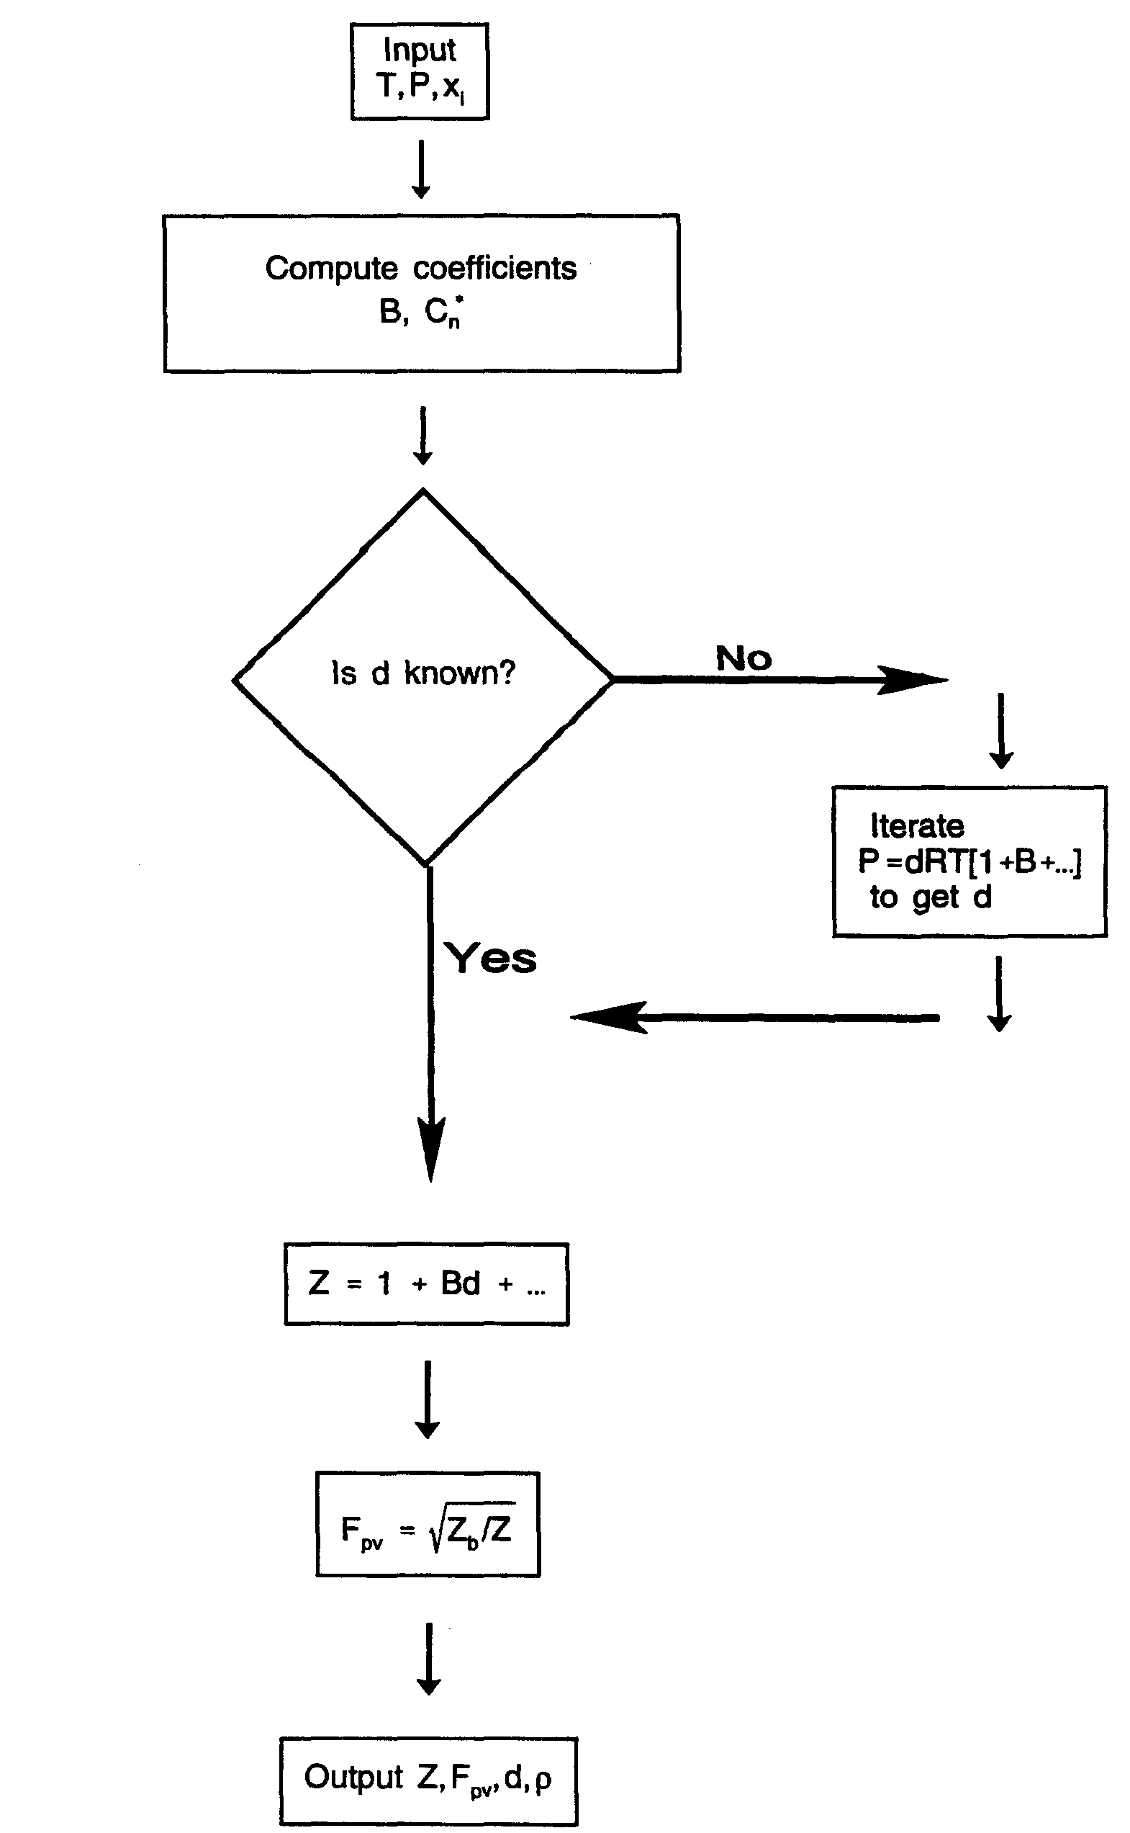
Figure A.1. Procedure for Calculation of Z, Fpv, d, and ρ
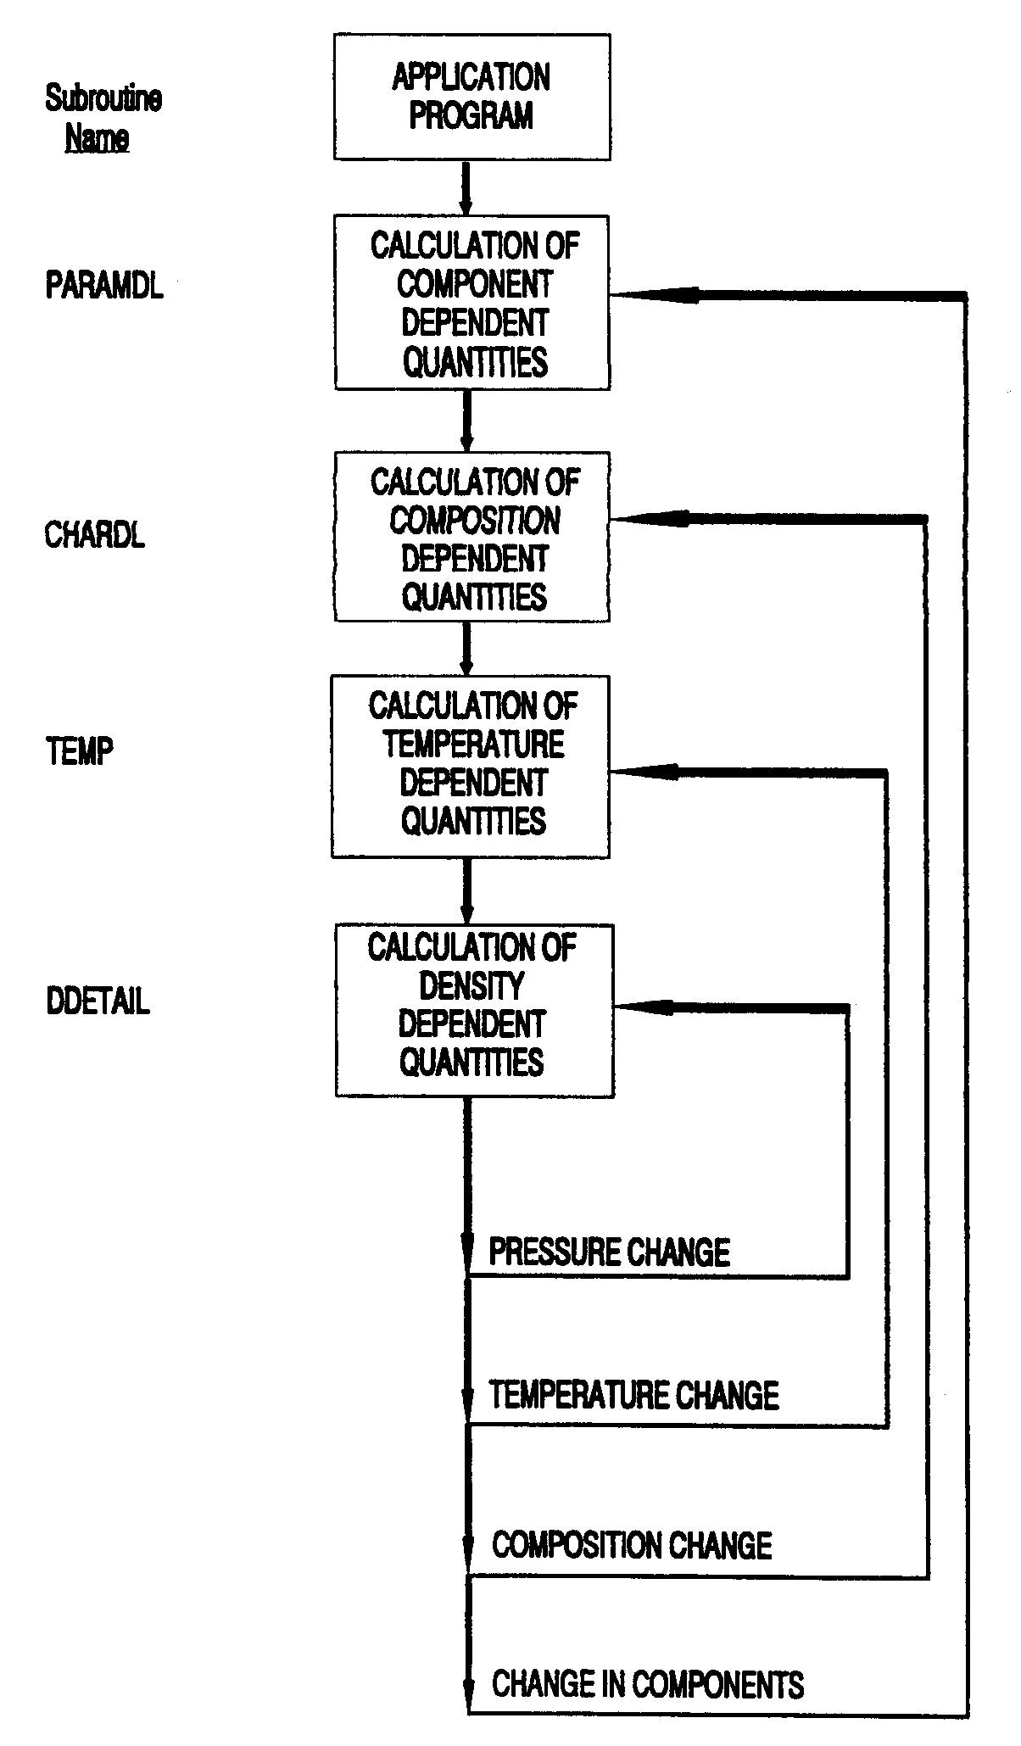
Figure A.2. Computation Sequence for DETAIL Characterization Method Computer Program
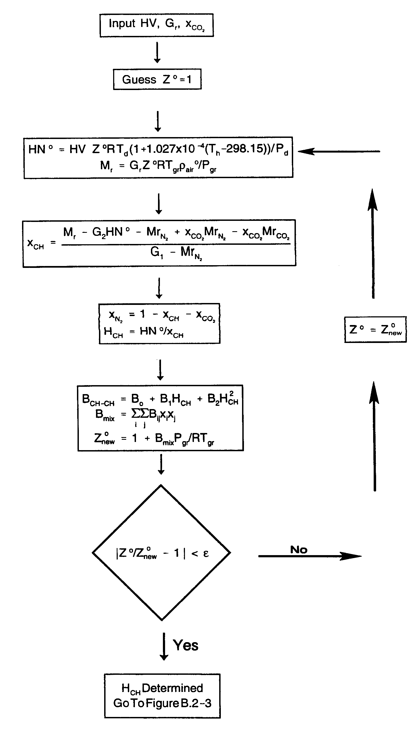
Figure B.1. Method 1 for the GROSS Characterization Method
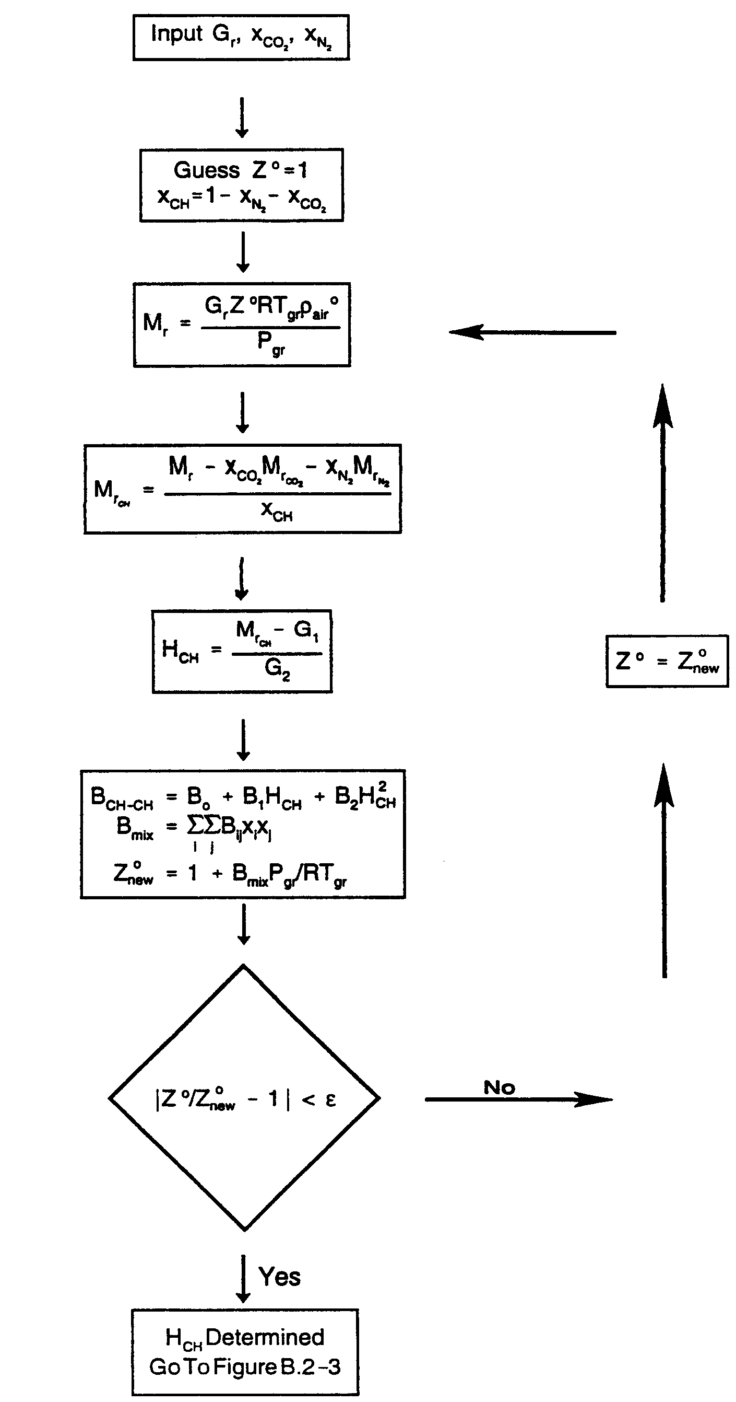
Figure B.2. Method 2 for the GROSS Characterization Method
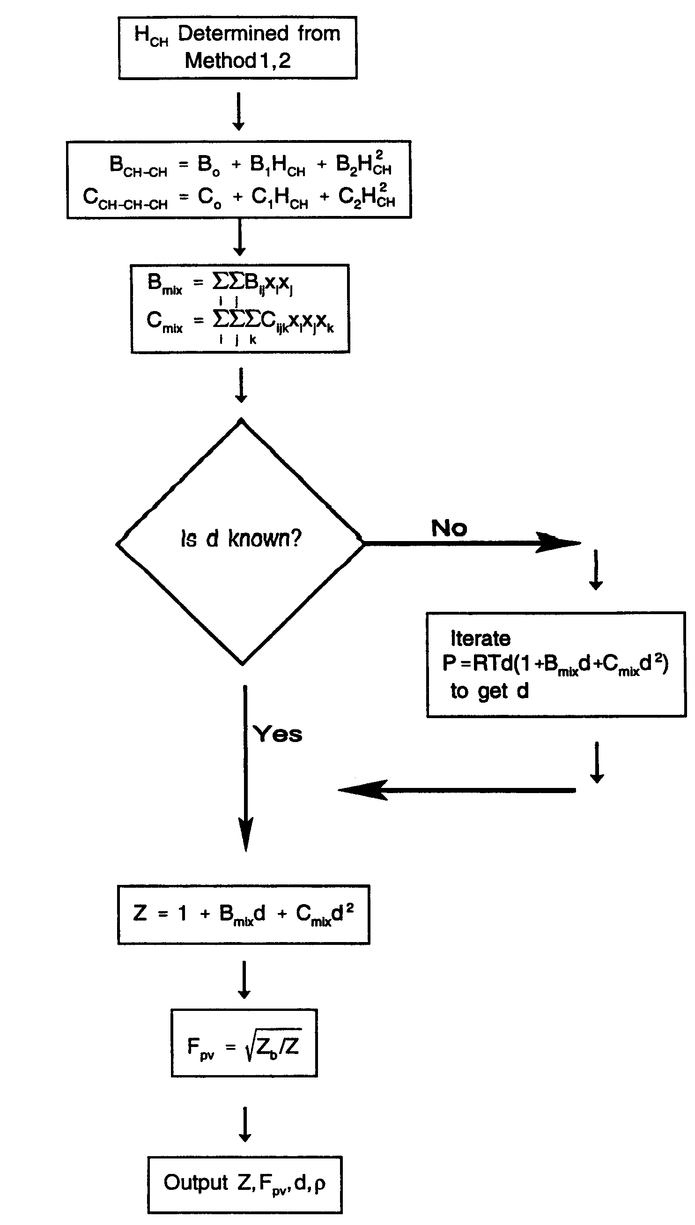
Figure B.3. Procedure for Calculation of Z, Fpv, d, and ρ
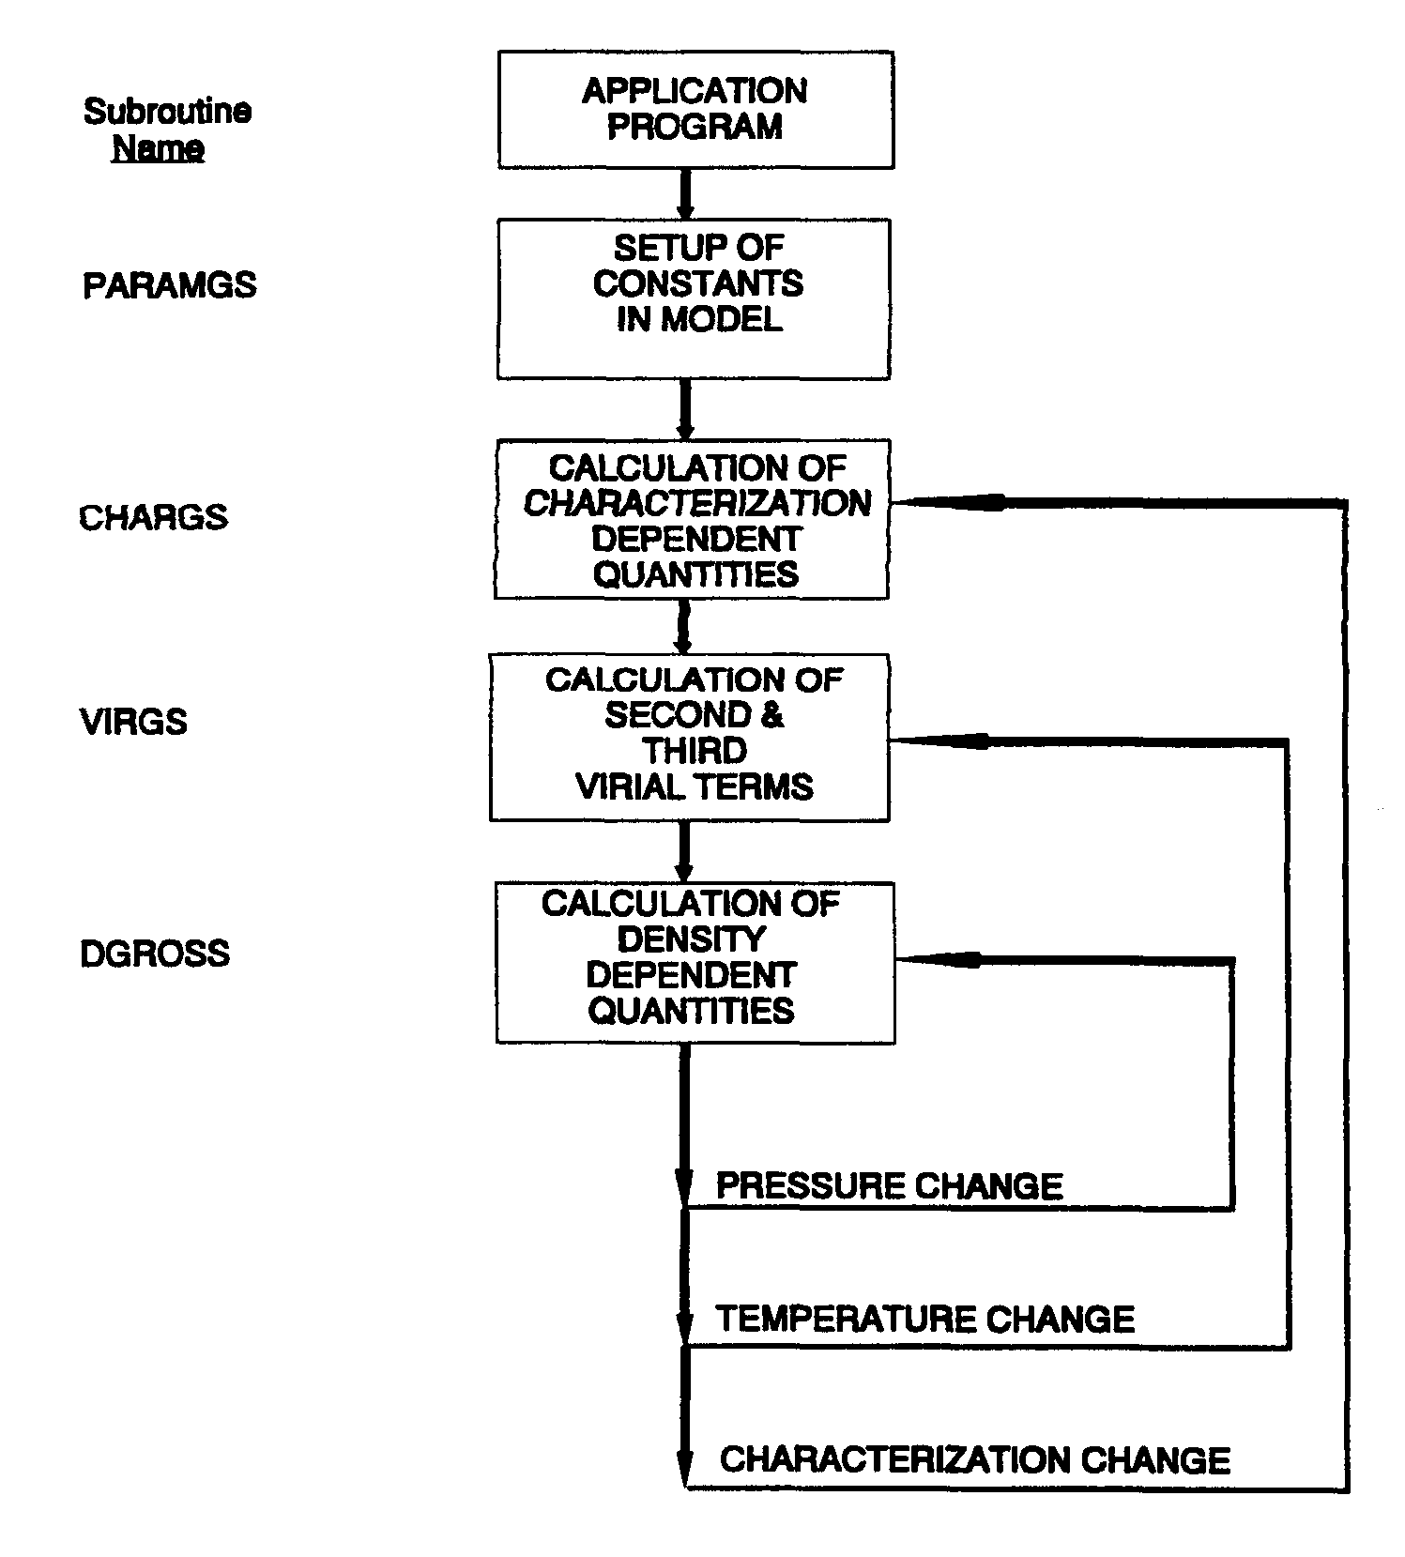
Figure B.4. Computation Sequence for GROSS Characterization Method Computer Program
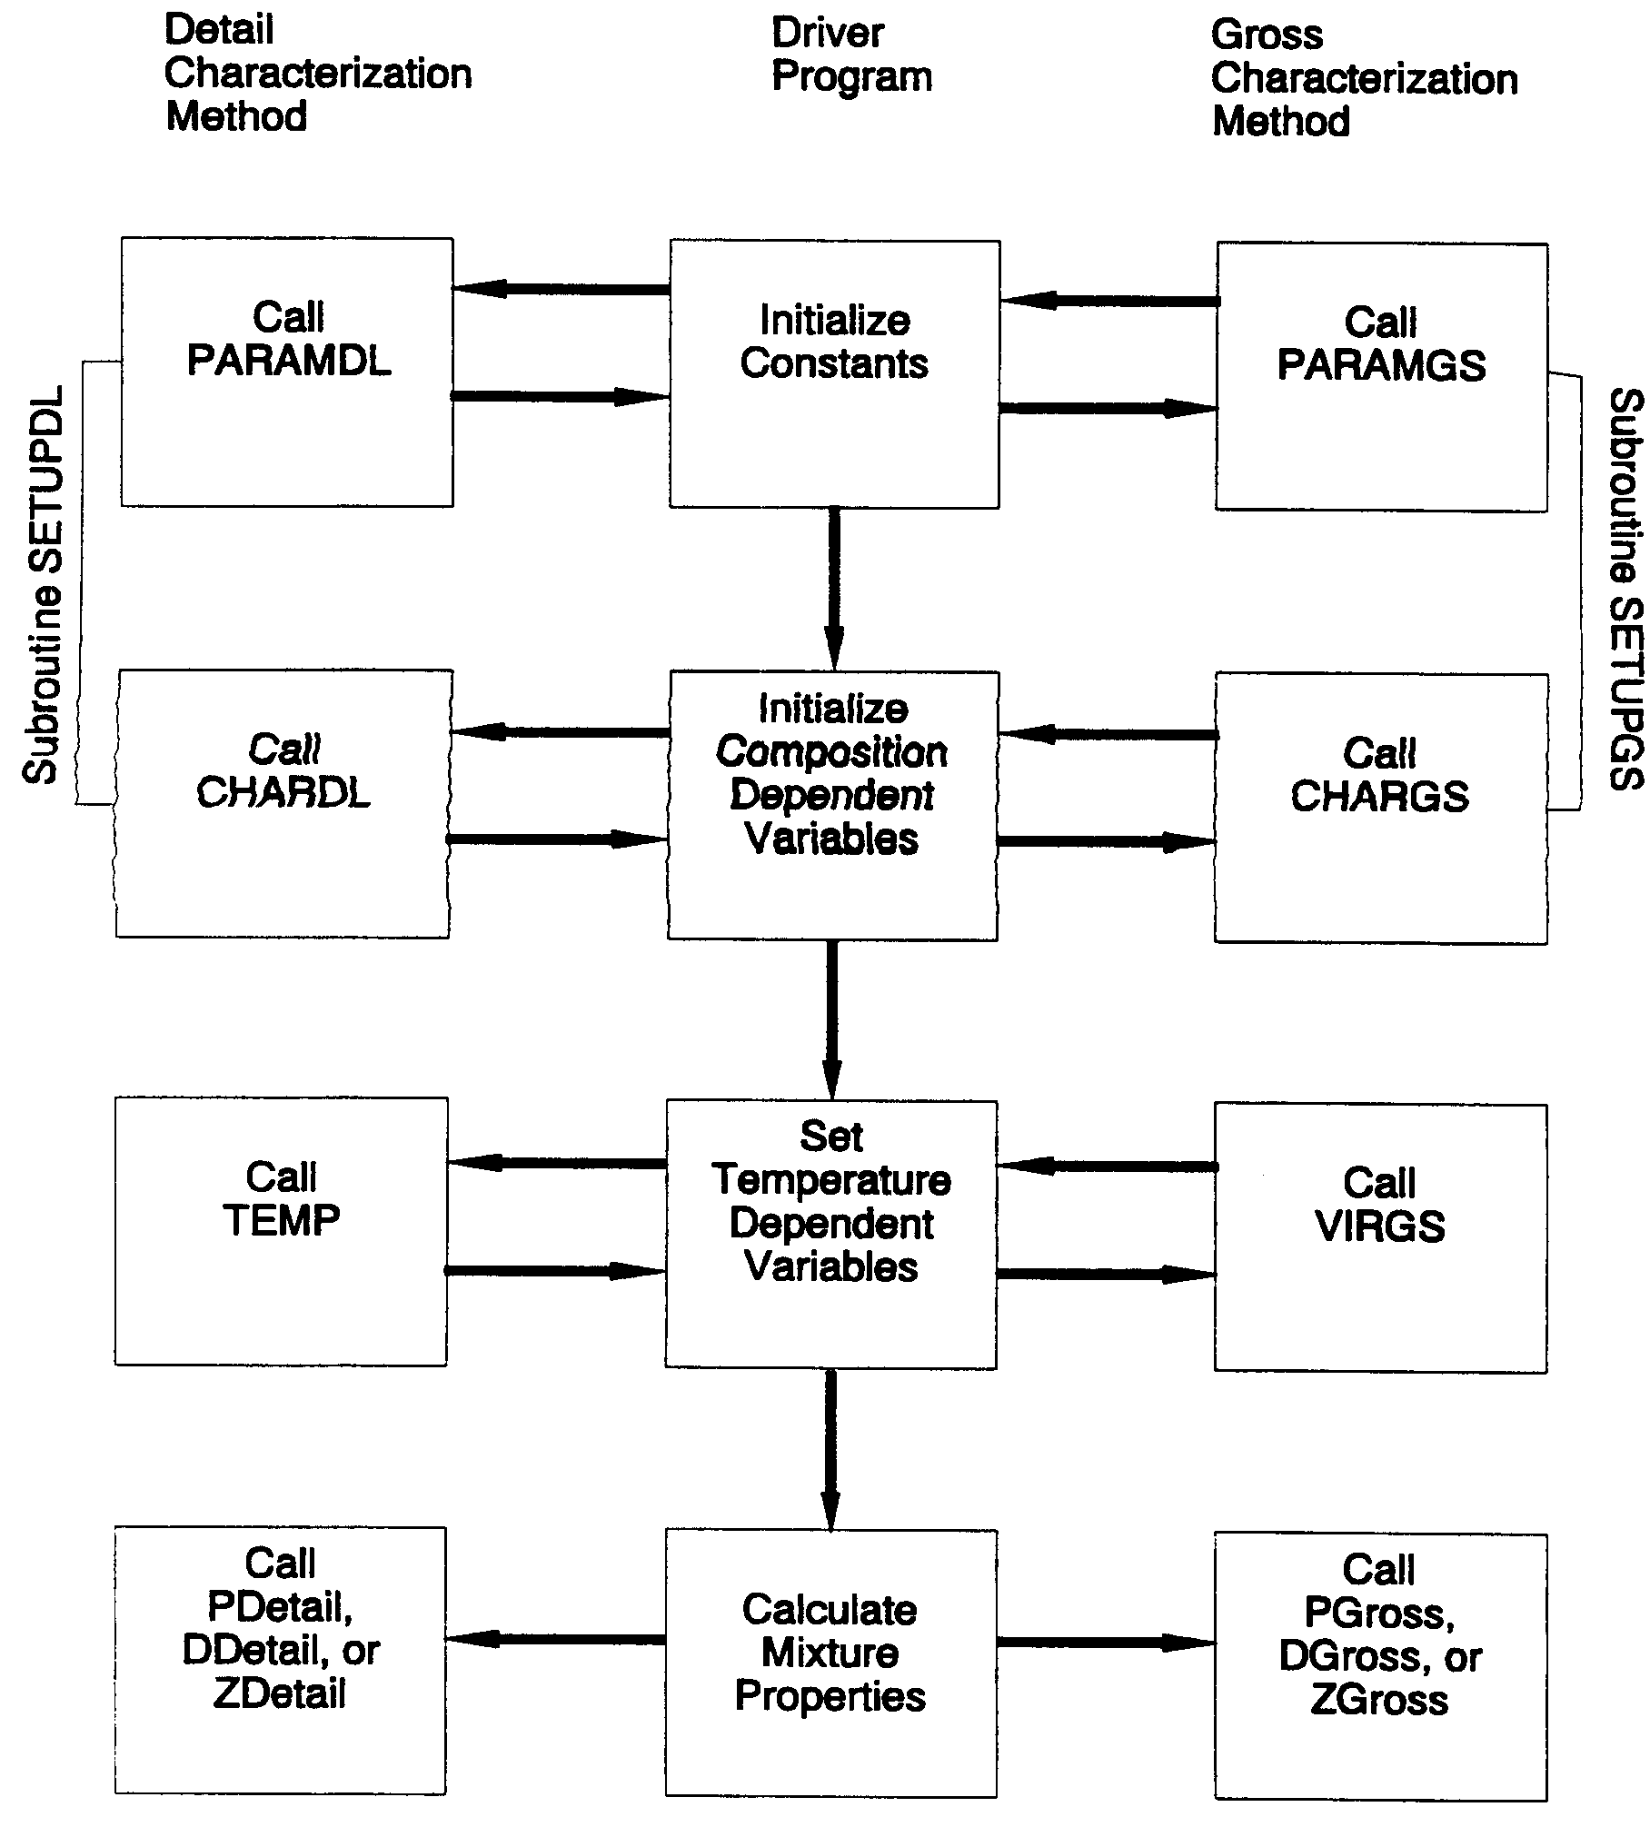
Figure E.1 Flow Diagram of AGA8PROG

