NIST V1.0 - CastVoteRecords

Author:

Revision:

|  |  |
| --- | --- |
|  |  |
|  | November 08, 2018 |

**Approval**

|  |
| --- |
| The original of this document is approved and signed by:  Name:  Surname:  Title:  Date:  Signature: |

**Revision History**

|  |  |  |  |
| --- | --- | --- | --- |
| **Revision** | **Date** | **Description** | **Author** |
|  |  |  |  |

| Table of Contents |
| --- |
| Microsoft Word users please click here and press F9 to create Table of Contents.  OpenOffice.org users please remove this text and select Insert Table of Content from menu. |

| Table of Figures |
| --- |
| Microsoft Word users please click here and press F9 to create Table of Contents.  OpenOffice.org users please remove this text and select Insert Table of Content from menu. |

# Introduction

## Purpose

## Scope

## Overview

# Package CVR

|  |  |
| --- | --- |
| **Name** | CVR |
| **Qualified Name** | CVR |

## Class Annotation

Annotation is used to record annotations made by one or more adjudicators.

CVRSnapshot includes Annotation.

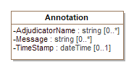

1. Annotation

| **Attribute** | **Multiplicity** | **Type** | **Attribute Description** |
| --- | --- | --- | --- |
| AdjudicatorName | 0..* | string | The name(s) of the adjudicator(s). |
| Message | 0..* | string | A message created by the adjudicator(s). |
| TimeStamp | 0..1 | dateTime | The date and time of the annotation. |

## Class BallotMeasureContest

BallotMeasureContest is a subclass of Contest and is used for ballot measure contests. It inherits attributes from Contest.

-1349962198.png

1. BallotMeasureContest

## Class BallotMeasureSelection

BallotMeasureSelection is a subclass of ContestSelection and is used for ballot measures. The voter's selected response to the ballot selection (e.g., "yes" or "no") may be in English or other languages as utilized on the voter's ballot.

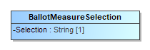

1. BallotMeasureSelection

| **Attribute** | **Multiplicity** | **Type** | **Attribute Description** |
| --- | --- | --- | --- |
| Selection | 1 | String | The voter's selection, i.e., 'yes' or 'no', in English or in other languages as utilized on the voter's ballot. |

## Class Candidate

Candidate identifies a candidate in a contest on the voter's ballot. Election includes instances of Candidate for each candidate in a contest; typically only those candidates who received votes would be included.

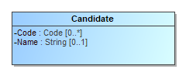

1. Candidate

| **Attribute** | **Multiplicity** | **Type** | **Attribute Description** |
| --- | --- | --- | --- |
| Code | 0..* | Code | A code or identifier associated with the candidate. |
| Name | 0..1 | String | Candidate's name as listed on the ballot. |
| {Party} | 0..1 | Party | The party associated with the candidate. |

## Class CandidateContest

CandidateContest is a subclass of Contest and is used to identify the type of contest as involving one or more candidates. It inherits attributes from Contest.

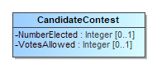

1. CandidateContest

| **Attribute** | **Multiplicity** | **Type** | **Attribute Description** |
| --- | --- | --- | --- |
| NumberElected | 0..1 | Integer | The number of candidates to be elected in the contest. |
| {PrimaryParty} | 0..1 | Party | The party associated with the contest, if a partisan primary. |
| VotesAllowed | 0..1 | Integer | The number of votes allowed in the contest, e.g., 3 for a 'choose 3 of 5 candidates' contest. |

## Class CandidateSelection

CandidateSelection is a subclass of ContestSelection and is used for candidates, including for write-in candidates.

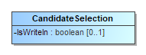

1. CandidateSelection

| **Attribute** | **Multiplicity** | **Type** | **Attribute Description** |
| --- | --- | --- | --- |
| {Candidate} | 0..* | Candidate | The candidate associated with the contest selection. For contests involving a ticket of multiple candidates, an ordered list of candidates as they appeared on the ballot would be created. |
| IsWriteIn | 0..1 | boolean | A flag to indicate if the candidate selection is associated with a write-in. |

## Class CastVoteRecordReport

The root class/element; attributes pertain to the status and format of the report and when generated.

CastVoteRecordReport includes multiple instances of CVR, one per CVR or sheet of a multi-page cast vote record. CastVoteRecordReport also includes multiple instances of Contest, typically only for those contests that were voted so as to reduce file size. The Contest instances are later referenced by other classes to link them to contest options that were voted and the indication(s)/mark(s) made.

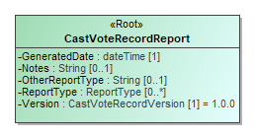

1. CastVoteRecordReport

| **Attribute** | **Multiplicity** | **Type** | **Attribute Description** |
| --- | --- | --- | --- |
| {CVR} | 0..* | CVR | Used to include instances of CVR classes, one per cast vote record in the report. |
| {Election} | 1..* | Election | Used to include the election(s) associated with the CVRs. |
| GeneratedDate | 1 | dateTime | Identifies the time that the election report was generated. |
| {GpUnit} | 1..* | GpUnit | Used to include the political geography, i.e., location, for where the cast vote record report was generated and for linking cast vote records to their corresponding precinct or split (or otherwise smallest unit). |
| Notes | 0..1 | String | Notes that can be added as appropriate, presumably by an adjudicator. |
| OtherReportType | 0..1 | String | If ReportType is 'other', this contains the report type. |
| {Party} | 0..* | Party | The party associated with the ballot sheet for a partisan primary. |
| {ReportGeneratingDevice} | 1..* | ReportingDevice | Identifies the device used to generate the CVR report. |
| {ReportingDevice} | 1..* | ReportingDevice | The device creating the report. The reporting device need not necessarily be the creating device, i.e., for an aggregated report, the reporting device could be an EMS used to aggregate and tabulate cast vote records. |
| ReportType | 0..* | ReportType | The type of report, using the ReportType enumeration. |
| Version | 1 | CastVoteRecordVersion | The version of the CVR specification being used (1.0). |

## Class Code

Code is used in Election, GpUnit, Contest, Candidate, and Party to identify an associated code as well as the type of code.

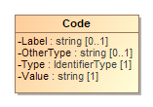

1. Code

| **Attribute** | **Multiplicity** | **Type** | **Attribute Description** |
| --- | --- | --- | --- |
| Label | 0..1 | string | A label associated with the code, used as needed. |
| OtherType | 0..1 | string | If Type is 'other', the type of code. |
| Type | 1 | IdentifierType | Used to indicate the type of code, from the IdentifierType enumeration. |
| Value | 1 | string | The value of the code, i.e., the identifier. |

## Class Contest

BallotMeasureContestContest represents a contest on the ballot. CastVoteRecordReport initially includes an instance of Contest for each contest on the ballot. Other classes can subsequently reference the instances as necessary to link together items on the cast vote record, such as a contest, its voted ballot selection(s), and the mark(s) associated with the selection(s).

Contest has three subclasses, each used for a specific type of contest: These subclasses inherit Contest's attributes.

* PartyContest - used for straight party contests,
* BallotMeasureContest - used for contests, and
* CandidateContest - used for candidate contests.

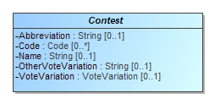

1. Contest

| **Attribute** | **Multiplicity** | **Type** | **Attribute Description** |
| --- | --- | --- | --- |
| Abbreviation | 0..1 | String | An abbreviation associated with the contest. |
| Code | 0..* | Code | A code or identifier used for this contest. |
| {ContestSelection} | 1..* | ContestSelection | Identifies the contest selections in the contest. |
| Name | 0..1 | String | Title or name of the contest, e.g., "Governor" or "Question on Legalization of Gambling". |
| OtherVoteVariation | 0..1 | String | If VoteVariation is 'other', the vote variation for this contest. |
| VoteVariation | 0..1 | VoteVariation | The vote variation for this contest, from the VoteVariation enumeration. |

## Class ContestSelection

ContestSelection represents a contest selection in a contest. Contest can include an instance of ContestSelection for each contest selection in the contest or, as desired, all contest selections.

ContestSelection has three subclasses, each used for a specific type of contest selection:

* BallotMeasureSelection - used for ballot measures,
* CandidateSelection - used for candidate selections, and
* PartySelection - used for straight party selections.

Instances of CVRContestSelection subsequently link to the contest selections as needed so as to tie together the contest, the contest selection, and the mark(s) made for the contest selection.

ContestSelection contains one attribute, Code, that can be used to identify the contest selection and thereby eliminate the need to identify it using the subclasses.

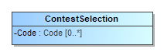

1. ContestSelection

| **Attribute** | **Multiplicity** | **Type** | **Attribute Description** |
| --- | --- | --- | --- |
| Code | 0..* | Code | Code used to identify the contest selection. |

## Class CVR

CVR constitutes a cast vote record, generated by a ballot scanning device, containing indications of contests and contest options chosen by the voter, as well as other information for auditing and annotation purposes. Each sheet of a multi-page paper ballot is represented by an individual CVR, e.g., if all sheets of a 5-sheet ballot are scanned, 5 CVRs will be generated. CastVoteRecordReport includes multiple instances of CVR as applicable.

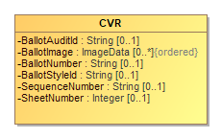

1. CVR

| **Attribute** | **Multiplicity** | **Type** | **Attribute Description** |
| --- | --- | --- | --- |
| BallotAuditId | 0..1 | String | A unique identifier for this CVR, used to link the CVR with the corresponding audit record, e.g., a paper ballot. This identifier may be impressed on the corresponding audit record as it is scanned, or otherwise associated with the corresponding ballot. |
| BallotImage | 0..* | ImageData | An image of the ballot sheet created by the scanning device. |
| BallotNumber | 0..1 | String | A unique identifier for the ballot (or sheet of a multi-sheet ballot) that this CVR represents, used if ballots are pre-marked with unique identifiers. If provided, this number would be the same on all CVRs that represent individual sheets from the same multi-sheet ballot. This identifier is not the same as one that may be impressed on the corresponding ballot as it is scanned or otherwise associated with the corresponding ballot; see the Identifier attribute. |
| BallotStyleId | 0..1 | String | An identifier of the ballot style associated with the corresponding ballot. |
| {BallotStyleUnit} | 0..1 | GpUnit | Identifies the smallest unit of geography associated with the corresponding ballot, typically a precinct or split-precinct. |
| {CreatingDevice} | 0..1 | ReportingDevice | Identifies the device that created the CVR. |
| {CurrentSnapshot} | 1 | CVRSnapshot | Identifies the snapshot that is currently tabulatable. |
| {CVRSnapshot} | 1..* | CVRSnapshot | Identifies the repeatable portion of the CVR that links to contest selections and related information. |
| {Election} | 1 | Election | Used to identify an election with which the CVR is associated. |
| {Party} | 0..* | Party | Identifies the party associated with a CVR, typically for partisan primaries. |
| SequenceNumber | 0..1 | String | The sequence number for this CVR. This represents the ordinal number that this CVR was processed by the tabulating device. |
| SheetNumber | 0..1 | Integer | A unique number for the ballot (or sheet of a multi-sheet ballot) that this CVR represents, used if ballots are pre-marked with unique numbers. If provided, this number would be the same on all CVRs that represent individual sheets from the same multi-sheet ballot. This number is not the same as one that may be impressed on the corresponding ballot as it is scanned or otherwise associated with the corresponding ballot; see the BallotAuditId attribute. |

### Business Rules

#### unnamed1

There must be exactly one original CVR.:

self.CVRSnapshot->select(s | s.Type = CVRType::original)->size() = 1

## Class CVRContest

CVRContest class is included by CVRSnapshot for each contest on the ballot that was voted, that is, whose contest options contain indications that may constitute a vote. CVRContest includes CVRContestSelection for each contest option in the contest containing an indication or write-in.

CVRSnapshot can also include CVRContest for every contest on the ballot regardless of whether any of the contest options contain an indication, for cases where the CVR must include all contests that appeared on the ballot.

CVRContest attributes are for including summary information about the contest.

Overvotes plus Undervotes plus TotalVotes must equal the number of votes allowable in the contest, e.g., in a "chose 3 of 5" contest in which the voter chooses only 2, then Overvotes = 0, Undervotes = 1, and TotalVotes = 2, which adds up to the number of votes allowable = 3.

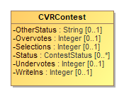

1. CVRContest

| **Attribute** | **Multiplicity** | **Type** | **Attribute Description** |
| --- | --- | --- | --- |
| {Contest} | 1 | Contest | Used to link to an instance of Contest specific to the contest at hand, for the purpose of specifying information about the contest such as its contest identifier. |
| {CVRContestSelection} | 0..* | CVRContestSelection | Used to include information about a contest selection in the contest, including the associated indication(s). |
| OtherStatus | 0..1 | String | Used when Status is 'other' to include a user-defined status. |
| Overvotes | 0..1 | Integer | The number of votes lost due to overvoting. |
| Selections | 0..1 | Integer | Used to indicate the number of possible contest selections in the contest. |
| Status | 0..* | ContestStatus | The status of the contest, e.g., overvoted, undervoted, from the ContestStatus enumeration. If no values apply, use 'other' and include a user-defined status in OtherStatus. |
| Undervotes | 0..1 | Integer | The number of votes lost due to undervoting. |
| WriteIns | 0..1 | Integer | The total number of write-ins in the contest. |

## Class CVRContestSelection

CVRContestSelection is used to link those contest options that contain a indication to information about the indication, such as whether the mark constitutes a countable vote, or whether the mark is determined to be marginal, etc. CVRContest includes an instance of CVRContestSelection when an indication for the selection is present, and CVRContestSelection then includes SelectionPosition for each indication present. To tie the indication to the specific contest selection, CVRContestSelection links to an instance of ContestSelection that has previously been included by Contest.

Since multiple indications per contest option are possible for some voting methods, CVRContestSelection can include multiple instances of SelectionPosition, one per indication. CVRContestSelection can also be used for the purpose of including, in the CVR, all contest options in the contest regardless of whether indications are present. In this case, CVRContestSelection would not include SelectionPosition if no indication is present but would link to the appropriate instance of ContestSelection.

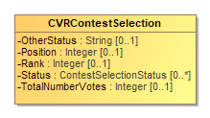

1. CVRContestSelection

| **Attribute** | **Multiplicity** | **Type** | **Attribute Description** |
| --- | --- | --- | --- |
| {ContestSelection} | 0..1 | ContestSelection | Used to link to an instance of a contest selection that was previously included by Contest. |
| OtherStatus | 0..1 | String | Used when Status is 'other' to include a user-defined status. |
| Position | 0..1 | Integer | Used to include the ordinal position of the contest option as it appeared on the ballot. |
| Rank | 0..1 | Integer | For the RCV voting variation, the rank chosen by the voter, for when a contest selection can represent a ranking. |
| {SelectionPosition} | 1..* | SelectionPosition | Used to include further information about the indication/mark associated with the contest selection. Depending on the voting method, multiple indications/marks per selection may be possible. |
| Status | 0..* | ContestSelectionStatus | Contains the status of the contest selection, e.g., 'needs-adjudication' for a contest requiring adjudication, using values from the ContestSelectionStatus enumeration. If no values apply, use 'other' and include a user-defined status in OtherStatus. |
| TotalNumberVotes | 0..1 | Integer | Contains the total number of votes across all indications/marks. |

## Class CVRSnapshot

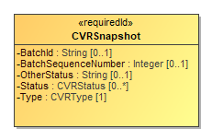

1. CVRSnapshot

| **Attribute** | **Multiplicity** | **Type** | **Attribute Description** |
| --- | --- | --- | --- |
| {Annotation} | 0..* | Annotation | Used to include an annotation associated with the CVR snapshot. |
| BatchId | 0..1 | String | The identifier for the batch that includes this CVR. |
| BatchSequenceNumber | 0..1 | Integer | The sequence number of the corresponding paper ballot within a batch. |
| {CVRContest} | 0..* | CVRContest | Identifies the contests in the CVR. |
| OtherStatus | 0..1 | String | When Status is 'other', contains the ballot status. |
| Status | 0..* | CVRStatus | The status of the CVR. |
| Type | 1 | CVRType | The type of the snapshot, e.g., original. |

## Class CVRWriteIn

CVRWriteIn is used when the contest selection is a write-in. It has attributes for the image or text of the write-in.

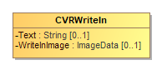

1. CVRWriteIn

| **Attribute** | **Multiplicity** | **Type** | **Attribute Description** |
| --- | --- | --- | --- |
| Text | 0..1 | String | Used for the text of the write-in, typically present when the CVR has been created by electronic ballot marking equipment. |
| WriteInImage | 0..1 | ImageData | Used for an image of the write-in, typically made by a scanner when scanning a paper ballot. |

## Class Election

Election defines instances of the Contest and Candidate classes so that they can be later referenced in CVR classes. Election includes an instance of Contest for each contest in the election and includes an instance of Candidate for each candidate. This is done to utilize file sizes more efficiently; otherwise each CVR would need to define these instances separately and much duplication would occur.

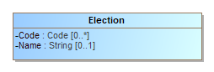

1. Election

| **Attribute** | **Multiplicity** | **Type** | **Attribute Description** |
| --- | --- | --- | --- |
| {Candidate} | 0..* | Candidate | Used to establish a collection of candidate definitions that will be referenced by the CVRs. The contests in each CVR will reference the candidate definitions. |
| Code | 0..* | Code | Used for a code associated with the election, e.g., a precinct identifier if the election scope is a precinct. |
| {Contest} | 1..* | Contest | Used for establishing a collection of contest definitions that will be referenced by the CVRs. |
| {ElectionScope} | 1 | GpUnit | Used to identify the election scope, i.e., the political geography corresponding to the election. |
| Name | 0..1 | String | A text string identifying the election. |

## Class File

Used to hold the contents of a file or identify a file created by the scanning device. The file generally would contain an image of the scanned ballot or an image of a write-in entered by a voter onto the scanned ballot. SubClass Image is used if the file contains an image.

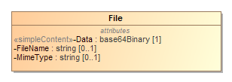

1. File

| **Attribute** | **Multiplicity** | **Type** | **Attribute Description** |
| --- | --- | --- | --- |
| Data | 1 | base64Binary | Contains the base64 binary contents of the file. |
| FileName | 0..1 | string | Contains the name of the file or an identifier of the file. |
| MimeType | 0..1 | string | The mime type of the file, e.g., image/jpeg. |

## Class GpUnit

Used for identifying a geographical unit for various purposes, including:

* the reporting unit of the report generation device, e.g., a precinct location of a scanner that generates the collection of CVRs,
* the geographical scope of the election, or the unit of geography associated with an individual CVR.

CastVoteRecordReport includes instances of GpUnit as needed. Election references GpUnit as ElectionScope, for the geographical scope of the election. CVR references GpUnit to link a CVR to the smallest political subdivision that the CVR "belongs" to.

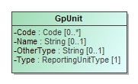

1. GpUnit

| **Attribute** | **Multiplicity** | **Type** | **Attribute Description** |
| --- | --- | --- | --- |
| Code | 0..* | Code | A code associated with the geographical unit. |
| Name | 0..1 | String | Name of the geographical unit. |
| OtherType | 0..1 | String | Used when Type is 'other' to include a user-defined type. |
| {ReportingDevice} | 0..* | ReportingDevice | The collection of cast vote records associated with the reporting unit and the reporting device. |
| Type | 1 | ReportingUnitType | Contains the type of geographical unit, e.g., precinct, split-precinct, vote center, using values from the ReportingUnitType enumeration. If no values apply, use 'other' and include a user-defined type in OtherType. |

## Class Hash

Hash is used to specify a hash associated with a file such as an image file of a scanned ballot.

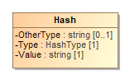

1. Hash

| **Attribute** | **Multiplicity** | **Type** | **Attribute Description** |
| --- | --- | --- | --- |
| OtherType | 0..1 | string | If Type is 'other', the type of the hash. |
| Type | 1 | HashType | The type of the hash, from the HashType enumeration. |
| Value | 1 | string | The hash value, encoded as a string. |

## Class Image

Used by File for a file containing an image, e.g., an image of a write-in on a paper ballot.

-1320838961.png

1. Image

## Class ImageData

ImageData is used to specify an image file such as for a write-in or the entire ballot. It works with several other classes, as follows:

* File with SubClass Image – to contain either a filename for an external file or the file contents, and
* Hash – to contain cryptographic hash function data for the file.

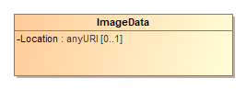

1. ImageData

| **Attribute** | **Multiplicity** | **Type** | **Attribute Description** |
| --- | --- | --- | --- |
| {Hash} | 0..1 | Hash | A hash value for the image data, used for verification comparisons against subsequent copies of the image. |
| {Image} | 0..1 | Image | The image of an individual ballot sheet created by the scanner, could possibly include both sides of a two-sided ballot sheet depending on the scanner's configuration. |
| Location | 0..1 | anyURI | A pointer to the location of the image file. |

## Class Mark

An indication that represents a mark made by a voter on a paper ballot.

It includes MarkMetricValue for assigning a quality metric to the mark.

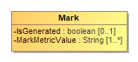

1. Mark

| **Attribute** | **Multiplicity** | **Type** | **Attribute Description** |
| --- | --- | --- | --- |
| IsGenerated | 0..1 | boolean | Whether the mark was made by a ballot marking device. |
| MarkMetricValue | 1..* | String | The value of the mark metric, represented as a string. |

## Class Party

Party is used for describing information about a political party associated with the voter's ballot. CVR includes instances of Party as needed, e.g., for a CVR corresponding to a ballot in a partisan primary, and CandidateContest references Party as needed to link a candidate to their political party.

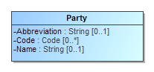

1. Party

| **Attribute** | **Multiplicity** | **Type** | **Attribute Description** |
| --- | --- | --- | --- |
| Abbreviation | 0..1 | String | Short name for the party, e.g., "DEM". |
| Code | 0..* | Code | A code associated with the party. |
| Name | 0..1 | String | Official full name of the party, e.g., "Republican". |

## Class PartyContest

PartyContest is a subclass of Contest and is used to identify the type of contest as involving a straight party selection. It inherits attributes from Contest.

857847513.png

1. PartyContest

## Class PartySelection

PartySelection is a subclass of ContestSelection and is used typically for a ballot selection in a straight-party contest.

-1447129566.png

1. PartySelection

| **Attribute** | **Multiplicity** | **Type** | **Attribute Description** |
| --- | --- | --- | --- |
| {Party} | 1..* | Party | The party associated with the contest selection. |

## Class ReportingDevice

ReportingDevice is used to specify a voting device as the “political geography” at hand. CastVoteRecordReport refers to it as ReportGeneratingDevice and uses it to specify the device that generated the CVR report. CVR refers to it as CreatingDevice to specify the device that generated the CVRs.

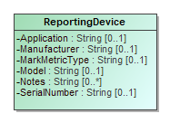

1. ReportingDevice

| **Attribute** | **Multiplicity** | **Type** | **Attribute Description** |
| --- | --- | --- | --- |
| Application | 0..1 | String | The application associated with the reporting device. |
| Manufacturer | 0..1 | String | Manufacturer of the reporting device. |
| MarkMetricType | 0..1 | String | The type of metric being used to determine quality. The type must be specific enough that the attached value can be accurately verified later, e.g., 'Acme Mark Density' may be a sufficiently specific type. |
| Model | 0..1 | String | Manufacturer's model of the reporting device. |
| Notes | 0..* | String | Additional explanatory notes as applicable. |
| SerialNumber | 0..1 | String | Serial number or other identification that can uniquely identify the reporting device. |

## Class RetentionContest

RetentionContest is a subclass of BallotMeasureContest and is used to identify the type of contest as involving a retention, such as for a judicial retention. While it is similar to BallotMeasureContest, it contains a link to Candidate that BallotMeasureContest does not. RetentionContest inherits attributes from Contest.

-1325574944.png

1. RetentionContest

| **Attribute** | **Multiplicity** | **Type** | **Attribute Description** |
| --- | --- | --- | --- |
| {Candidate} |  | Candidate | Identifies the candidate in the retention contest. |

## Class SelectionPosition

CVRContestSelection includes SelectionPosition to specify a voter's indication/mark in a contest option, and thus, a potential vote. The number of potential SelectionPositions that should be included by CVRContestSelection is, for paper ballots, the same as the number of ovals next to a particular option. There will be usually 1 instance of SelectionPosition for plurality voting, but there could be multiple instances for RCV, approval, cumulative, or other vote variations in which a voter can select multiple options per candidate.

SelectionPosition contains additional information about the mark to specify whether the indication/mark is allocable, as well as information needed for certain voting methods.

SelectionPosition includes CVRWriteIn, whose attributes are used to include information about the write-in including the text of the write-in or an image of the write-in.

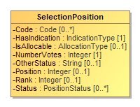

1. SelectionPosition

| **Attribute** | **Multiplicity** | **Type** | **Attribute Description** |
| --- | --- | --- | --- |
| Code | 0..* | Code | Code used to identify the contest selection position. |
| {CVRWriteIn} | 0..1 | CVRWriteIn |  |
| HasIndication | 1 | IndicationType | Whether the contest option position contains an indication (e.g. a Mark). |
| IsAllocable | 0..1 | AllocationType | Whether this indication should be allocated to the contest option's accumulator. |
| {Mark} | 0..1 | Mark |  |
| NumberVotes | 1 | Integer | The number of votes represented by the position, usually 1 but may be more depending on the voting method. |
| OtherStatus | 0..1 | String | Used when Status is 'other' to include a user-defined status. |
| Position | 0..1 | Integer | The ordinal position of the selection position within the contest option. |
| Rank | 0..1 | Integer | For the RCV voting variation, the rank chosen by the voter, for when a position can represent a ranking. |
| Status | 0..* | PositionStatus | Status of the position, e.g., "generated-rules" for generated by the machine, from the PositionStatus enumeration. If no values apply, use 'other' and include a user-defined status in OtherStatus. |

## Enumeration AllocationType

Used in SelectionPosition::IsAllocable to indicate whether the SelectionPosition::NumberVotes should be allocated to the underlying contest option counter.

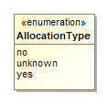

1. AllocationType

| **Value** | **Value Description** |
| --- | --- |
| no | To not allocate votes to the contest option's accumulator. |
| unknown | When the decision to allocate votes is unknown, such as when the adjudication is needed. |
| yes | To allocate votes to the contest option's accumulator. |

## Enumeration CastVoteRecordVersion

To identify the version of the CVR specification being used, i.e., version 1.0.0. This will need to be updated for different version of the specification.

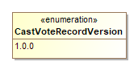

1. CastVoteRecordVersion

| **Value** | **Value Description** |
| --- | --- |
| 1.0.0 | Fixed value for the version of this specification. |

## Enumeration ContestSelectionStatus

Used in CVRContestSelection::Status to identify the status of a contest selection in the CVR.

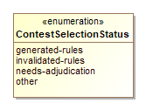

1. ContestSelectionStatus

| **Value** | **Value Description** |
| --- | --- |
| generated-rules | To indicate that the contest selection was generated per contest rules. |
| invalidated-rules | To indicate that the contest selection was invalidated by the generating device because of contest rules. |
| needs-adjudication | To indicate that the contest selection was flagged by the generating device for adjudication. |
| other | Used in conjunction with CVRContestSelection::OtherStatus when no other value in this enumeration applies. |

## Enumeration ContestStatus

Used in CVRContest::Status to identify the status of a contest in which contest selection(s) were made.

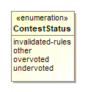

1. ContestStatus

| **Value** | **Value Description** |
| --- | --- |
| invalidated-rules | To indicate that the contest has been invalidated by the generating device because of contest rules. |
| other | Used in conjunction with CVRContest::OtherStatus when no other value in this enumeration applies. |
| overvoted | To indicate that the contest was overvoted. |
| undervoted | To indicate that the contest was undervoted. |

## Enumeration CVRStatus

Used in CVRSnapshot::Status to identify the status of the CVR.

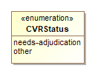

1. CVRStatus

| **Value** | **Value Description** |
| --- | --- |
| needs-adjudication | To indicate that the CVR needs to be adjudicated. |
| other | Used in conjunction with CVRSnapshot::OtherStatus when no other value in this enumeration applies. |

## Enumeration CVRType

Used in CVRSnapshot::Type to identify what the CVR represents.

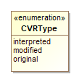

1. CVRType

| **Value** | **Value Description** |
| --- | --- |
| interpreted | Has been adjudicated. |
| modified | After contest rules applied. |
| original | As scanned, no contest rules applied. |

## Enumeration HashType

Used in Hash::Type to indicate the type of hash being used for an image file.

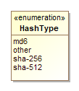

1. HashType

| **Value** | **Value Description** |
| --- | --- |
| md6 | To indicate that the MD6 message digest algorithm is being used. |
| other | Used in conjunction with Hash::OtherType when no other value in this enumeration applies. |
| sha-256 | To indicate that the SHA 256-bit signature is being used. |
| sha-512 | To indicate that the SHA 512-bit (32-byte) signature is being used. |

## Enumeration IdentifierType

Used in Code::Type to indicate the type of code/identifier being used.

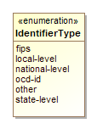

1. IdentifierType

| **Value** | **Value Description** |
| --- | --- |
| fips | To indicate that the identifier is a FIPS code. |
| local-level | To indicate that the identifier is from a local-level scheme, i.e., unique to a county or city. |
| national-level | To indicate that the identifier is from a national-level scheme other than FIPS or OCD-ID. |
| ocd-id | To indicate that the identifier is from the OCD-ID scheme. |
| other | Used in conjunction with Code::OtherType when no other value in this enumeration applies. |
| state-level | To indicate that the identifier is from a state-level scheme, i.e., unique to a particular state. |

## Enumeration IndicationType

Used in SelectionPosition::HasIndication to specify whether an indication (e.g. a Mark) exists.

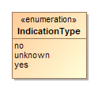

1. IndicationType

| **Value** | **Value Description** |
| --- | --- |
| no | For no indication at the selection. |
| unknown | When the existence of an indication is unknown, such as before analysis of the contest option position is performed. |
| yes | For an indication at the selection. |

## Enumeration PositionStatus

Used in SelectionPosition::Status to identify the status of a vote mark.

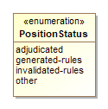

1. PositionStatus

| **Value** | **Value Description** |
| --- | --- |
| adjudicated | To indicate that the vote mark was adjudicated. |
| generated-rules | To indicate that the vote mark was generated by the generating device per contest rules. |
| invalidated-rules | Used to indicate that the vote mark was invalidated by the generating device because of contest rules. |
| other | Used in conjunction with SelectionPosition::OtherStatus when no other value in this enumeration applies. |

## Enumeration ReportingUnitType

Used in GpUnit::Type to indicate a type of political geography.

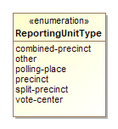

1. ReportingUnitType

| **Value** | **Value Description** |
| --- | --- |
| combined-precinct | To indicate a combined precinct. |
| other | Used in conjunction with GpUnit::OtherType when no other value in this enumeration applies. |
| polling-place | To indicate a polling place. |
| precinct | To indicate a precinct. |
| split-precinct | To indicate a split-precinct. |
| vote-center | To indicate a vote-center. |

## Enumeration ReportType

Used in CastVoteRecordReport::ReportType to indicate the type of the CVR report.

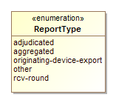

1. ReportType

| **Value** | **Value Description** |
| --- | --- |
| adjudicated | To indicate that the report contains adjudications. |
| aggregated | To indicate that the report is an aggregation of device reports. |
| originating-device-export | To indicate that the report is an export from a device such as a scanner. |
| other | Used in conjunction with CastVoteRecordReport::OtherReportType when no other value in this enumeration applies. |
| rcv-round | To indicate that the report is the result of a ranked choice voting round. |

## Enumeration VoteVariation

Used in Contest::VoteVariation to indicate the vote variation (vote method) used to tabulate the contest.

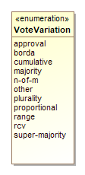

1. VoteVariation

| **Value** | **Value Description** |
| --- | --- |
| approval | To indicate approval voting. |
| borda | To indicate the borda count method. |
| cumulative | To indicate cumulative voting. |
| majority | To indicate majority voting. |
| n-of-m | To indicate the N of M voting method. |
| other | Used in conjunction with Contest::OtherVoteVariation when no other value in this enumeration applies. |
| plurality | To indicate plurality voting. |
| proportional | To indicate proportional voting. |
| range | To indicate range voting. |
| rcv | To indicate Ranked Choice Voting (RCV). |
| super-majority | To indicate the super majority voting method. |

# Package CVRConstraints

|  |  |
| --- | --- |
| **Name** | CVRConstraints |
| **Qualified Name** | CVRConstraints |

# Appendix A: Diagram

## CastVoteRecords

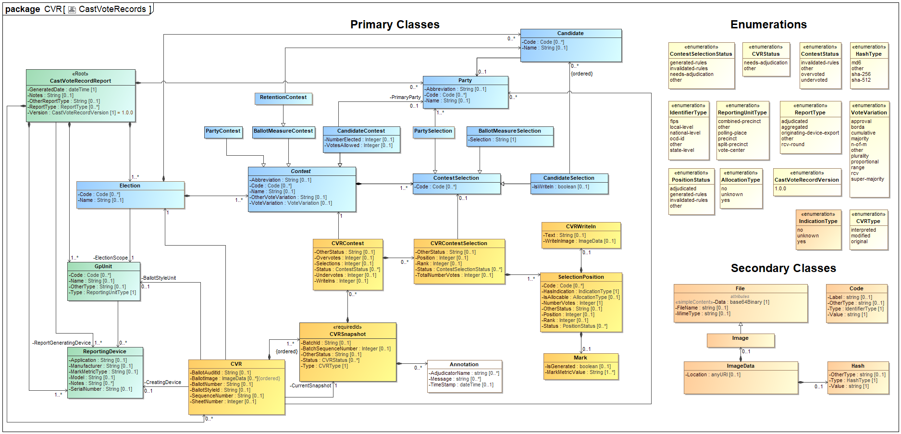

1. CastVoteRecords