PySTLTweak

# INSTALLATION

(Assumes installation of Windows github GUI tools – use Git Bash on windows below).

1. Clone PySTLTweak

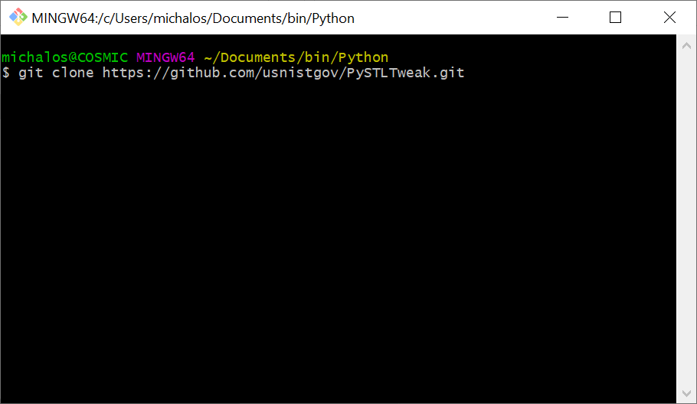

1. Install jetbrains pycharm (or Python IDE of your choice) Instructions below are for PyCharm community.
2. Bring up PyCharm, click File->settings scroll down to Project

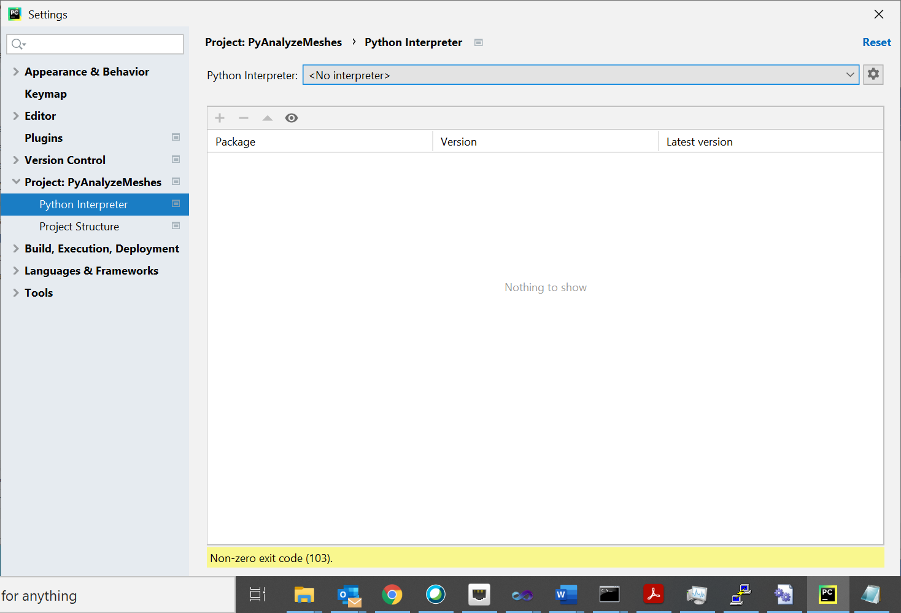

1. Click gear box to add python interpreter:
   * Choose Virtualenv Environment (loads Python interpreter locally NOT windows)
   * Select latest and click ok
   * Wait a while for it to install interpreter and base modules
   * Now add modules – click the [+] button and you should see this popup dialogue:

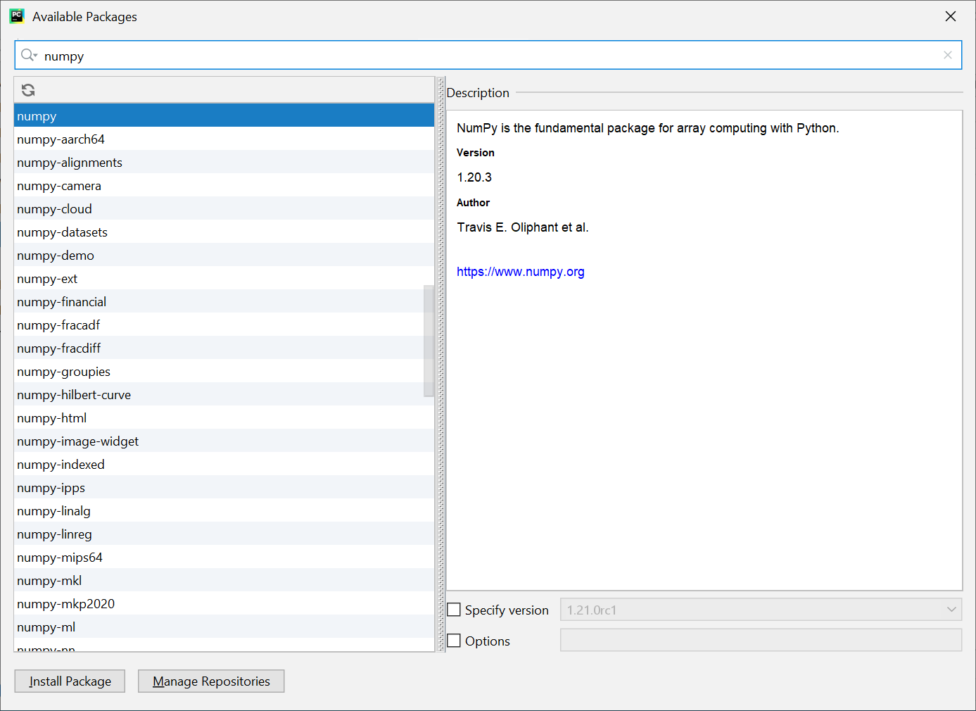

* + - Put numpy in the search bar and press magnifying glass and click Install Package
    - Put numpy-stl in the search bar and press magnifying glass and click Install Package This is the major STL mesh analysis library. We just wrap it.
    - Click X to exit [+] and Ok to exit Setttings

## DEBUGGING

To debug the program: Click run->debug then select PyAnalyseMesh

NOTE YOU WILL NEED TO MODIFY YOUR DEBUG command line arguments

* Menu Run->Edit configurations will get you pop up.

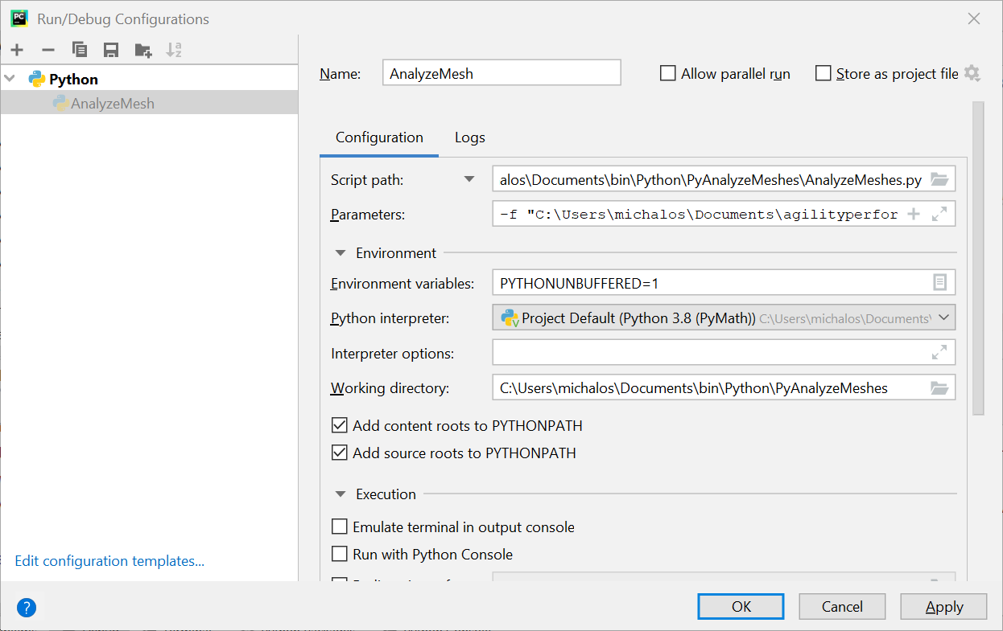

Under parameters

-s 2.0 -i "C:\Users\michalos\Documents\agilityperformancemetrics\TaskBoard\STL\taskboard-pegarray1-1_Centered_ZeroZmin.stl"

Put in an STL file from the folder under your github repository. Note -s 2.0 tells is to scale. -I is the input file.

## Using Bash script

Install github on Windows and use its bash here when you right click on a folder.

In the folder PyAnalyzeMeshes/bin is a bash script to run Python to analyze and make minor changes to STL meshes. It will automatically generate a mesh analysis report containing volume, COG, Inertial Frame, and min/max xyz. For gears I tried to center and translate the mesh so that the minimum z is 0, and when this is done it automatically generates a new file name with "_Centered"or "_ZeroZmin" or "_ZeroZmax" or "_Rotate" axes appended to original file name.

AnalyzeMeshes.py use stl-mesh python library to tweak STL files:

usage: AnalyzeMeshes.py [-h] [-v] [-c] [-maxz] [-minz] [-p PATTERN]

[-i INPUTFILE] [-o OUTPUTFILE] [-f FOLDER] [-rx ROTX]

[-ry ROTY] [-rz ROTZ] [-tx TRANSX] [-ty TRANSY]

[-tz TRANSZ] [-sx SCALEX] [-sy SCALEY] [-sz SCALEZ]

optional arguments:

-h, --help show this help message and exit

-v, --verbose increase output verbosity

-c, --center center mesh around (0,0,0) origin

-maxz, --maxz maximum z at (0,0,0) origin

-minz, --minz minimum z at (0,0,0) origin

-p PATTERN regex pattern for matching file

-i INPUTFILE input file name

-o OUTPUTFILE output file name

-f FOLDER base file folder

-rx ROTX rotation around X angle in degrees

-ry ROTY rotation around Y angle in degrees

-rz ROTZ rotation around Z angle in degrees

-tx TRANSX translation along X axis in meters

-ty TRANSY translation along Y axis in meters

-tz TRANSZ translation along Z axis in meters

-sx SCALEX scale X relative to 1

-sy SCALEY scale Y relative to 1

-sz SCALEZ scale Z relative to 1

Sample bash script:

#!/bin/bash

python38="/c/Users/michalos/Documents/bin/Python/PyAnalyzeMeshes/venv/Scripts/python.exe"

$python38 AnalyzeMeshes.py -rx -90 -i "C:\Users\michalos\Documents\bin\Python\PyAnalyzeMeshes\STL\taskboard_arraybase-1.STL"

$python38 AnalyzeMeshes.py -a -c -i "C:\Users\michalos\Documents\bin\Python\PyAnalyzeMeshes\STL\taskboard_arraybase-1_Rotatex.stl"

$python38 AnalyzeMeshes.py -a -minz -i "C:\Users\michalos\Documents\bin\Python\PyAnalyzeMeshes\STL\taskboard_arraybase-1_Rotatex_Centered.stl"

$python38 AnalyzeMeshes.py -rx -90 -i "C:\Users\michalos\Documents\bin\Python\PyAnalyzeMeshes\STL\taskboard-arrayback-1.STL"

$python38 AnalyzeMeshes.py -a -c -i "C:\Users\michalos\Documents\bin\Python\PyAnalyzeMeshes\STL\taskboard-arrayback-1_Rotatex.stl"

$python38 AnalyzeMeshes.py -a -minz -i "C:\Users\michalos\Documents\bin\Python\PyAnalyzeMeshes\STL\taskboard-arrayback-1_Rotatex_Centered.stl"

$python38 AnalyzeMeshes.py -rx -90 -i "C:\Users\michalos\Documents\bin\Python\PyAnalyzeMeshes\STL\taskboard-pegarray1-1.STL"

$python38 AnalyzeMeshes.py -a -c -i "C:\Users\michalos\Documents\bin\Python\PyAnalyzeMeshes\STL\taskboard-pegarray1-1_Rotatex.stl"

$python38 AnalyzeMeshes.py -a -minz -i "C:\Users\michalos\Documents\bin\Python\PyAnalyzeMeshes\STL\taskboard-pegarray1-1_Rotatex_Centered.stl"

$python38 AnalyzeMeshes.py -rx -90 -i "C:\Users\michalos\Documents\bin\Python\PyAnalyzeMeshes\STL\taskboard-pegarray2-1.STL"

$python38 AnalyzeMeshes.py -a -c -i "C:\Users\michalos\Documents\bin\Python\PyAnalyzeMeshes\STL\taskboard-pegarray2-1_Rotatex.stl"

$python38 AnalyzeMeshes.py -a -minz -i "C:\Users\michalos\Documents\bin\Python\PyAnalyzeMeshes\STL\taskboard-pegarray2-1_Rotatex_Centered.stl"

$python38 AnalyzeMeshes.py -rx 90 -i "C:\Users\michalos\Documents\bin\Python\PyAnalyzeMeshes\STL\taskboard_square_peg-1.STL"

$python38 AnalyzeMeshes.py -a -c -i "C:\Users\michalos\Documents\bin\Python\PyAnalyzeMeshes\STL\taskboard_square_peg-1_Rotatex.stl"

$python38 AnalyzeMeshes.py -a -minz -i "C:\Users\michalos\Documents\bin\Python\PyAnalyzeMeshes\STL\taskboard_square_peg-1_Rotatex_Centered.stl"

$python38 AnalyzeMeshes.py -c -i "C:\Users\michalos\Documents\bin\Python\PyAnalyzeMeshes\STL\taskboard_round_peg-1.STL"

$python38 AnalyzeMeshes.py -a -minz -i "C:\Users\michalos\Documents\bin\Python\PyAnalyzeMeshes\STL\taskboard_round_peg-1_Centered.stl"