**Overview**

Cumulative Voting is a voting method that applies to a single multi-seat contest that allows a voter to distribute the allowed number of votes to one or more candidates in whole vote increments. It is touted to provide minority voting groups the ability to concentrate their vote on one or more candidates to attempt to ensure representation rather than limiting their vote to one vote per candidate. Ballot layout and selection method depend on the voting system. Typically each candidate has as many selection positions as votes allowed. This may be implemented by associating multiple voting positions with a single candidate listing or by repeating the candidate listing in a way that identifies it as the same candidate. Tabulation essentially treats the contest as a “Regular” contest with the set of voting positions acting as if they were all different candidates for under and over vote determination. However, once the set of selections are validated, more than one vote can be assigned to a given candidate. Cumulative voting has been used in systems that don’t support it by listing each candidate the required number of times on the ballot, tabulating each listing as if it was a different candidate and manually combining the results to get actual candidate totals.

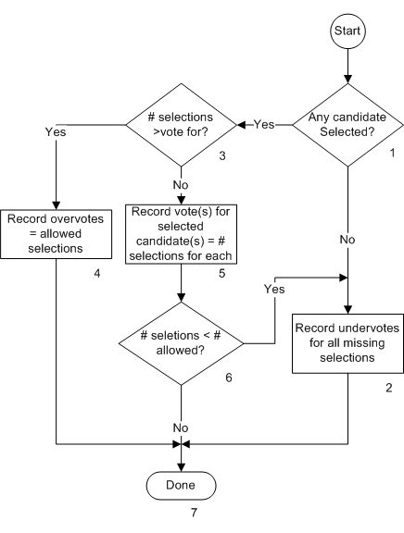The flow chart below indicates the processing flow for the contest and each block in the flow is described.

**Description**

1. Any Candidate Selected?

Is there a vote selection for any candidate in the contest? If there is any candidate selection, the Yes path is taken. Otherwise the No path is taken.

1. Record Undervotes for all missing selections

This process will be executed if there are no selections identified at all in the contest or if there are fewer selections made than allowed. An undervote will be recorded for each missing selection.

1. # selections > vote for?

The number of total selections made (including multiple selections for the same candidate) is compared to the number of allowed selections. The Yes path is taken if the number exceeds the number allowed. The No path is taken if the number is less than or equal to the number allowed.

1. Record overvotes = allowed selections

This process will be executed if the number of selections made exceeds the number of selections allowed. A number of overvotes for the contest will be counted equal to the number of selections allowed in the contest. The count essentially indicates the number of votes lost due to the overvote.

1. Record vote(s) for each selected candidate(s) = # selections for each

Since the number of selections made in total is less than or equal to the number allowed, each selected candidates will receive a number of votes that is equal to the number of selections made for that candidate.

1. # selections < # allowed

The number total sections made is compared to the number of selections allowed. If it is equal to the number allowed, the No path is taken. If it is less than the number allowed, the Yes path is taken.

1. Done

All processing for the contest on the current ballot has been completed.