**Introduction**

Massachusetts Group Voting is voting method that only appears on a Massachusetts Presidential Primary ballot and is used to elect members of a Town, Village or Ward Committee. These committees have a large number of seats with all candidates selected from a single contest (i.e. 35). Candidates may run as part of a specific group or run unaffiliated with a group. Due to the large number of candidates that can be selected, the contest format using this method has a group select as the first candidate listed in the group with all group members listed subsequent to the group select. Following the group, there may be a group select for a next group (if there is one) followed by its members. Following all of the groups there would be a list of unaffiliated candidates and finally a list of write-in positions usually equal to the number of seats. The group select is used as a convenience for the voter to avoid the need to individually select all candidates in the group. A group selection acts as if all candidates in the group are individually selected. Note that Group Select ballot positions are uniquely identified and each candidate in the group is linked to its group selection position.

Tabulation in this contest determines all candidates that are selected whether by group select or individually. If a group is selected, candidate selections in the same group have no effect. However, if a candidate is selected outside the group, whether in a different group, an unaffiliated candidate or a write-in, if the group is full (the number of candidates in the group is equal to the number of seats), an overvote is created. The only time candidates may be selected outside the group is if the group has less candidates than the number of seats and then the number of selections is limited to the number of missing candidates. If they exist, multiple groups may be selected without causing an overvote as long as the total number of candidates selected combined to not exceed the number of selections allowed.

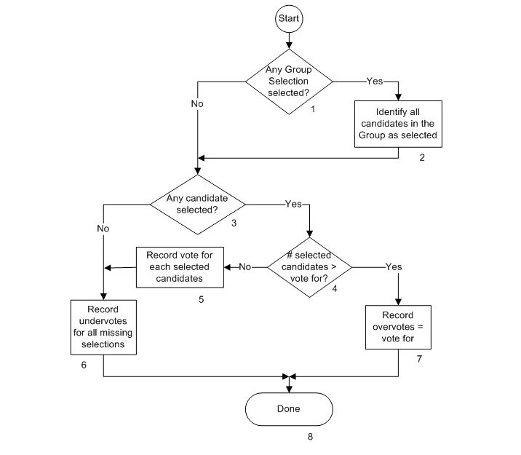**Description**

1. Any Group Selection selected?

A Group Selection position is a special position listed prior to all the candidates in a defined group that automatically selects all candidates in the group (similar to a straight party selection). The Yes path is taken if there is at least one Group Selection position chosen. The No path is taken if there is no Group Selection chosen.

1. Identify all candidates in the Group as selected

Selecting the Group Select is treated the same as if an individual selection is made for every candidate that is linked to the group. A selection is marked for each candidate in the group just as if every candidate in the group was individually chosen

1. Any candidate selected?

Has any candidates been selected whether individually or as a result of a group selection? The No path is taken if there is neither individually selected candidates nor a group selected. It indicates that the contest is unvoted. The Yes path is taken if there are one or more individual candidate selected or if a group is selected.

1. The number of selected candidates > vote for?

Whether a candidate is individually selected, selected indirectly by a group selection or is selected by both still only represents one selection. If the total number of candidates selected is greater than the votes allowed, it is an overvote and the Yes path is taken. If not, the No path is taken.

1. Record vote for each selected candidate

Since this box is reached if there was no overvote, each selected candidate, whether individually selected or selected indirectly as part of a group will receive a vote,

1. Record undervotes for all missing selections

If there are no candidates selected or the number of selected candidates is less than the number of allowed selections (vote for number), a number of undervotes will be recorded for each unused vote selection.

1. Record overvotes = vote for

This box is reached if the contest has more selections than allowed. A number of overvotes are recorded equal to the allowed number of selections.

1. Done

Processing of the Massachusetts Group Vote contest is complete.