**Overview**

This document describes the low level processing associated with a partisan contest on an Open Primary ballot. States that have Open Primaries (ones where a single ballot contains contests from all eligible parties) allow the voter to select the party whose ballot they intend to vote in the privacy of the voting booth. However, the voter may not select candidates in contests associated with more than one party. If they do, the partisan portion of the ballot is spoiled and the ballot is considered cross-voted. See Open Primary Voting Method for a description of Open Primary with and without the use of the Party Preference Contest, a contest that is included on the ballot to protect the voter from spoiling their ballot.

Note that issues with handling Open Primary partisan contests are generally restricted to paper ballot processing where the ballot is submitted completed and the tabulator must therefore determine validity of the set of selections when performing the tabulation. DRE or BMD units do not have this issue as selections are validated prior to acceptance and, for an Open Primary ballot, once a partisan selection is made (or a party is selected in a Party Preference contest), only that party’s contests are available to be voted.

The flow chart below along with the block by block descriptions explains the processing of these contests.

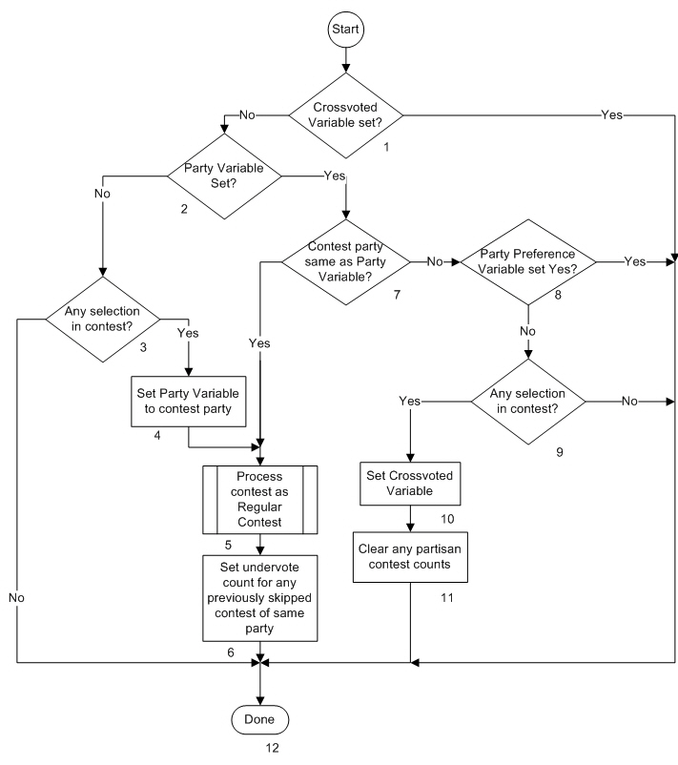**Description**

1. Cross-voted variable set?

Processing an Open Primary ballot partisan contest requires knowledge of whether the ballot has already been spoiled based on processing of previous contests on the ballot. The Crossvoted variable is the term being used to remember this condition. If the Crossvoted variable has been already set, any further processing of partisan contests is ignored. The Yes path is taken if the variable is set. The No path is taken if it is not set.

1. Party Variable set?

Processing an Open Primary ballot partisan contest requires knowledge of whether the ballot already has a party selection. This can be recorded when the first candidate selection in a partisan contest is encountered or, if on a ballot with a Party Preference contest, a party has been selected. The Party Variable is the term being used to identify whether the ballot currently has a party affiliation. If the Party Variable is set, the Yes path is taken. If it is not set, the No path is taken

1. Any selection in contest?

If there is no selection in the contest, the No path is taken (the contest is skipped and not processed) since the ballot is not yet associated with any party. If there is a selection, whether valid or not, the Yes path is taken.

1. Set Party Variable to contest party

The Party Variable is set to the party that is associated with the current contest. Any contest selection, whether or not valid, sets the ballot to be associated with that party.

1. Process contest as Regular Contest

Once the determination is made that the contest will be processed, it is processed using the Regular Contest processing flow. Any candidate votes, undervotes or overvotes are recorded as determined by the processing.

1. Set undervote count for any previously skipped contest of same party

In an Open Primary without a Party Preference contest, a ballot does not become associated with a party until a contest is processed with a choice for a party. When this occurs it is possible that contests of that party without any selections have previously been processed without being tabulated (skipped). Those contests should now be considered tabulated and the number of undervotes set to the number of votes allowed.

1. Contest party same as Party Variable?

Is the party associated with the current contest the same as the Party Variable (selected party associated with the ballot). If it is, the Yes path is taken and the contest is processed using the Regular Contest process flow. If it is not, the No path is taken.

1. Party Preference Variable set Yes?

Since the Party Variable does not match the party of the contest being processed, it makes a difference whether the Party Variable was set from a Party Preference contest. If the Party Preference Variable is set to Yes, the contest is skipped due to the fact that is not part of the selected party ballot and the Yes path is taken. If it is not set to Yes, the No path is taken.

1. Any selection in contest?

If there is no selection in the contest, the contest is skipped and not tabulated as it is not part of the selected party ballot and the No path is taken. If there is any selection, this becomes a crossvoted ballot and the Yes path is taken.

1. Set Crossvoted Variable

Since there are selections made in contests associated with more than one party and there is no protection from a party selection made in a party Preference contest (which may not even be on the ballot), the Crossvoted Variable is set to prevent any further processing of partisan contests.

1. Clear any partisan contest counts

All tabulated results from any previously processed partisan contests are cleared (including over and under votes) as this is now a crossvoted/spoiled ballot and nothing partisan is to be tabulated.

1. Done

All processing of this contest has been completed.