**Introduction**

The Presidential Preference contest appears on the closed Presidential Preference Primary ballots of two states, Alabama (both Democratic and Republican ballots) and Rhode Island (Democratic ballot only). It not only allows the voter to select their Presidential choice but also controls the Delegate to the party’s National Nominating Convention that the voter may vote for based on their presidential choice. This document describes the low level processing associated with the contest. See Presidential Delegate Voting Method for a description of this special Presidential Preference Primary.

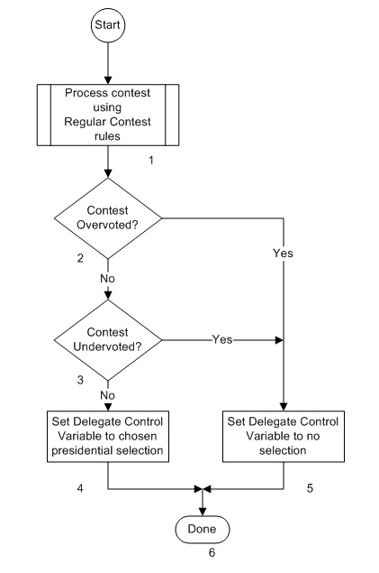The flow chart below indicates the processing flow for the contest and each block in the flow is described.

**Description**

1. Process the Contest using Regular Contest rules.

Although the result of processing this contest has special uses, the processing itself treats it like any other Regular contest. Selections are always limited to one choice so there are 3 possible processing results, a presidential choice selected, an undervote (no selection) or an overvote (too many selections).

1. Contest Overvoted?

Was the result of processing the contest an overvote? The Yes path is taken if it was. The No path is taken if it wasn’t.

1. Contest Undervoted?

Was the result of processing the contest an undervote? The Yes path is taken if it was. The No path is taken if it wasn’t.

1. Set Delegate Control Variable to chosen Presidential selection

This block is only reached if there was a valid Presidential choice made by the voter. The Delegate Control Variable is set to the chosen Presidential selection. For flow chart purposes, the Delegate Control Variable is the term being used to remember the valid selection made in the Presidential Preference contest. This selection is needed when processing selections from Presidential Delegate contests on the ballot.

1. Set Delegate Control Variable to No and Party Variable to no selection

This block is reached if the contest was either not voted or overvoted. In either case there is no valid Presidential selection and the Delegate Control Variable is set to no selection.

1. Done

Processing of the Presidential Preference contest is complete.