**Overview**

There is a contest pair, one controlling and the other controlled that are traditionally called Recall. This document describes the low level processing associated with contest that is controlling whether the Controlled contest is eligible to be tabulated. See the Recall Contest Control Voting Method document for a full description. The Controlling contest must be voted according to 1 of 2 rules in order for the Controlled contest to be tabulated. Otherwise it is ignored for processing. Depending on the rules, it is either any vote in the controlling contest or a Yes vote. In traditional use, the Controlling contest is in a referendum format.

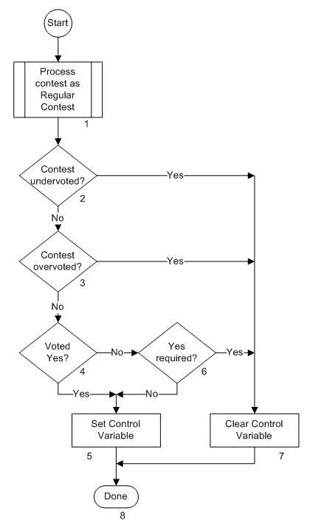The flow chart below indicates the processing flow for the Recall Controlling contest and each block in the flow is described.

**Description**

1. Process contest as Regular Contest

The controlling contest is normally a Regular contest and is processed using the Regular Contest flow. In traditional use, it is a referendum on recalling a candidate.

1. Contest Undervoted?

If the contest is undervoted, the Yes path is taken as the vote does not satisfy the requirement to allow tabulation of the contest that is being controlled. If it is not undervoted, the No path is taken.

1. Contest Overvoted?

If the contest is undervoted, the Yes path is taken as the vote does not satisfy the requirement to allow tabulation of the contest that is being controlled. If it is not overvoted, the No path is taken.

1. Voted Yes?

This flow assumes that the contest is a referendum. The Yes path is taken if there was a Yes vote or the equivalent thereof (i.e. For). The No path is taken if the selection was a No or the equivalent thereof (i.e. Against)

1. Set Control Variable

Since tabulation of this contest is controlling by the vote processing in another contest (the Controlled Contest), for description purposes, the Control variable is the term being used to capture the result of tabulating this contest. The Control Variable is set to allow tabulation of the Controlled contest.

1. Yes required?

Entering this test, we know that there was a valid vote but it was not Yes (or the equivalent). This test establishes whether jurisdiction rules require a Yes vote in the Controlling contest to allow tabulation of the Controlled contest. The Yes path is taken if it is required thus not allowing tabulation of the Controlled contest. The No path is taken if it isn’t required thus allowing tabulation of the Controlled contest.

1. Clear Control Variable

The Control Variable is cleared thus preventing the Controlled contest from being tabulated and is effectively skipped.

1. Done

Processing of the contest is complete.