**Introduction**

This document describes the low level processing associated with the contest on the ballot that allows the user to select a straight party ticket. This contest, which allows the voter to make select a straight party selection, is treated like a regular contest as far as identifying and validating selections. The voter may select a valid candidate, may not select any candidate or may select more candidates than allowed. The Straight Party contest normally has a number of contests on the ballot that are tied to (or linked to) it so that candidates in those contests can be indirectly selected with a single straight party selection. Generally the Straight Party contest must precede the contests that are tied or affected by it on the ballot. Rules for the Straight Party voting method are covered in a separate document.

Note that Straight Party processing rules are generally restricted to paper ballot processing where the voter does not generally make direct candidate selections in each contest but may select a straight party selection and only make exception selections within a contest. The tabulator must therefore determine voter intent from the superposition of these selections base on state specific rules. DRE or BMD units generally show both direct selections as well as indirect selection when viewing a contest. They also consider all current selections when accepting or rejecting a selection attempt according to the allowed number of selections in a contest so interpretation of voter intent is not required.

For governmental elections, there are essentially two general rule sets. The differences only come into play in contests where more than one choice is allowed. These rules are designated as Inclusive and Exclusive. Inclusive rules allow any additional candidates selected by the straight party to be included with directly selected candidates if the total number of candidates does not exceed the number of selections allowed. Exclusive rules exclude any straight party selections if there is a directly selected candidate in a contest.

The flow chart below indicates the processing flow and each block in the flow is described.

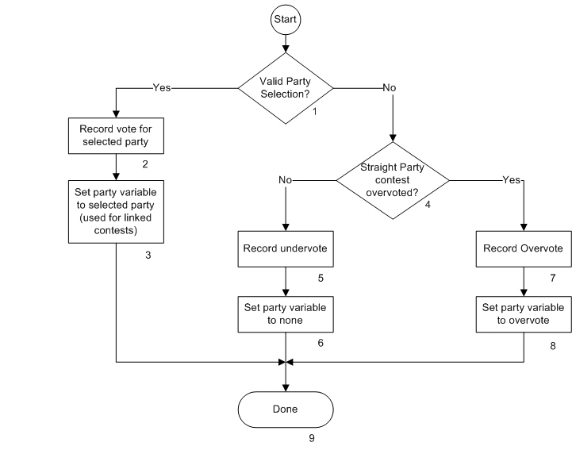

**Description**

1. Valid Party Selected?

It is determined whether there are any straight party selections and whether they are valid (not more than 1 selection). The Yes path is taken if there is and the No path is take if there isn’t. Note that, although there are no current rules using this, prior to eliminating straight party voting, Illinois used to allow multiple straight party selections and look at the consequence for overvote on a contest by contest basis. Illinois also used to allow multiple Straight Party contests on a ballot in local elections, one for the County and one for the Township.

1. Record vote for selected party

A vote for the selected party is recorded so that it can be used for reporting of the number of ballots that selected each party. Some systems also record “true straight party ballots” and remove the count of this selection if any candidate is directly selected in any contest that is not of the same party.

1. Set party variable for selected party

The party variable is set to the party selected by the voter. For flow chart purposes, the party variable term is being used to remember the result of this straight party contest processing so that it can be used when processing selections in any contest tied to this straight party contest.

1. Straight Party contest overvoted?

The Yes path is taken if there are more selections than allowed (typically more than 1 selection). The No path is taken if there is no selection (if there is a valid selection, it is determined in block 1 and this block will not be reached).

1. Record undervote

An undervote is recorded for the contest for reporting and auditing purposes.

1. Set party variable to none

The party variable, used in processing contests tied to the straight party, is set to none.

1. Set party variable to overvote

The party variable, used in processing contests tied to the straight party, is set to overvote.

1. Done

Processing of the Straight party contest is complete.