**Introduction**

This document describes the processing of a “regular” contest on a ballot such as one that is part of “plurality” voting, “majority” voting, “first past the post” voting or voting that is related to a referendum that may be on a ballot. The differences between these voting methods relate to how the outcome of the results after ballots are processed according to describe processing method are handled after they are aggregated from the results of this processing. The differences relate to how the winners are determined or whether a referendum passes. Even the handling of a tie for a potential winner or winners is outside the process of how a selection or selections in a contest that is subject to the voting method is handled. That is subject to the jurisdiction rules that apply to the election being run.

Note that a “regular” contest is considered to be any contest that does not have special processing/tabulation rules associated with it. This includes nonpartisan contests, partisan contests on a Closed Primary ballot, partisan contests on a General election ballot that does not contain straight party voting and even partisan contests on a General election ballot with straight party voting but where a straight party selection was not made.

The voting methods using the “regular” contest processing are defined below:

Plurality Voting – A voting method that can apply to a single seat or a multi-seat contest. Independent of the number of candidates running, the winner (single seat) or winners (multi-seat) is the candidate or candidates that receive the highest number of votes independent of the percentage of votes cast.

First Past the Post (FPTP) – A voting method that applies to a single seat contest where the winner is the individual that receives the highest number of votes independent of the percentage of votes cast. It is a special case of Plurality Voting as it only applies to a single seat contest.

Majority Voting – A voting method that applies to a single seat contest where the winner must receive more than 50% of the votes cast (more than all other candidates combined) in the contest. If no candidate receives more than 50% of the votes, the 2 candidates receiving the most vote participate in a runoff election.

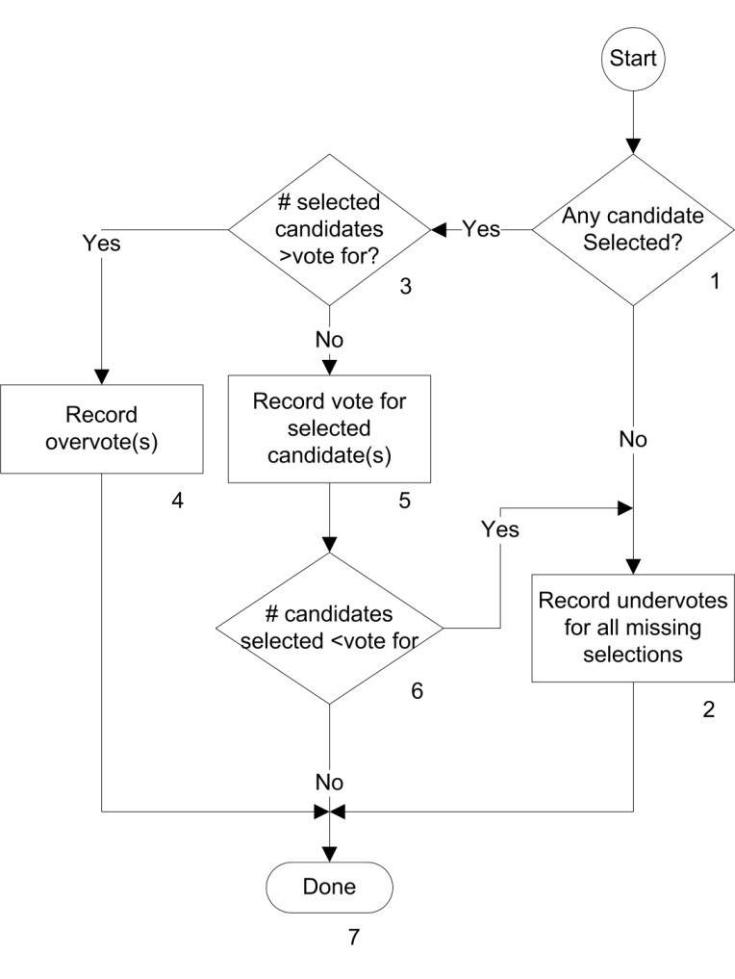

**Description**

1. Any Candidate Selected?

Does the contest have any vote selections identified? If there is any selection identified, then the Yes path is taken. Otherwise the No path is taken.

1. Record Undervotes for all missing selections

This process will be executed if there are no selections identified in the contest or if it is a multi-seat contest and there are fewer selections made than allowed. An undervote will be recorded for each missing selection.

1. # Candidates selected > vote for?

The number of candidates selected is compared to the number of allowed selections. The Yes path is taken if the number exceeds the number allowed. The No path is taken if the number is less than or equal to the number allowed. If the contest is a single seat contest or referendum, the number allowed is 1. If a multi-seat contest, the number allowed is equal to the number of seats.

1. Record Overvote(s)

This process will be executed if the number of candidates selected in a contest exceeds the number of selections allowed. A number of overvotes for the contest will be counted equal to the number of selections allowed in the contest. The count essentially indicates the number of votes lost due to the overvote. There is an exception to this rule that applies to the states of Hawaii and Illinois. In these states, the number of overvotes counted for a ballot is always one independent of the number of selections allowed. It essentially reflects a count of the number of ballots containing an overvote for the contest. This difference only manifests itself in a multi-seat contest where votes lost on a ballot and ballots containing the overvote are not equal.

1. Record vote for selected candidate(s)

This process will be executed if there are valid selections in the contest being processed. (At least one selection is detected and the number of selections do not exceed the allowed number of selections.) Each selected candidate will receive a vote.

1. # selected candidates < vote for

The number of selected candidates is compared to the number of selections allowed. If it is equal to the number allowed, the No path is taken. If it is less than the number allowed (can only happen in a multi-seat context), the Yes path is taken.

1. Done

All processing for the contest on the current ballot has been completed.