**Introduction**

The purpose of this document is to provide the structure that describes the flow of how a ballot may be processed, contest by contest, even though the ballot contains multiple voting methods each with one or more contests and may contain a method where processing of a given contest is dependent on processing results from other contests. This document provides the overview and is used in conjunction with referenced documents that provide the detailed processing flow and descriptions for each of the contest types identified in the flow shown below. It is expected that contests are processed in ballot order sequence to produce the correct outcome when contests using a voting method are dependent on other contests using the voting method. A pass through the flow chart is made for each contest on the ballot.

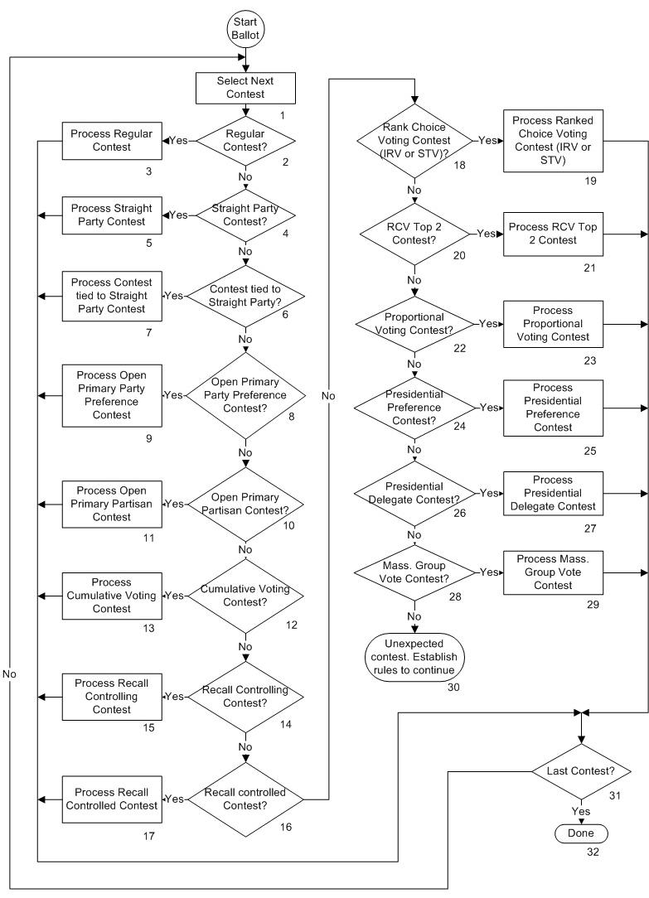

**Description**

1. Select Next Contest

The next contest on the ballot is selected (or the first contest if processing is just beginning).

1. Regular Contest?

A “Regular Contest” is one whose tabulation does not interact with the tabulation of any other contest and has no special contest type identification. It would include any nonpartisan contest on a partisan or nonpartisan ballot as well as any contest on a General election ballot where straight party voting is not applicable as well as any contest on a Closed Primary ballot (one that is issued based on party registration or party choice). The No path is taken if the contest is not “Regular”. The Yes path is taken if it is.

1. Process Regular Contest

Use the Regular Contest Tabulation document for the low level flow chart and description of processing a Regular contest.

1. Straight Party Contest?

A Straight Party contest is used on a General election ballot in states where straight party voting is permitted. It is the contest that provides party selection. The No path is taken if the contest is not a Straight Party contest. The Yes path is taken if it is.

1. Process Straight Party Contest

The Straight Party voting method provides a voter the ability, with a single ballot selection, to select all candidates on the ballot associated with a given party in all contests on the ballot. The Straight Party contest contains the list of party selections. See the Straight Party Voting Methods document for an overview of this method and the variations. See the Process Straight Party Contest for the low level flow chart and description of processing a Straight Party contest.

1. Contest Tied to Straight Party?

For a Straight Party selection to control selection of candidates of that party in other contests, those contests must be programmatically tied to the Straight Party contest. The No path is taken if the contest is not one that is tied to a Straight Party contest. The Yes path is taken if it is.

1. Process Contest Tied to Straight Party Contest

A contest that is tied to the Straight Party contest allows a party selection in the Straight Party contest to select all candidates associated with the selected party to be automatically selected. See the Straight Party Voting Methods document for an overview of this method and the variations. See the Process Contest Tied to Straight Party for the low level flow chart and description of processing this contest.

1. Open Primary Party Preference Contest?

An Open Primary ballot is one that contains partisan contests from all parties but the voter can only choose to only vote in contests from one party. If they vote in contests from more than one party, their entire partisan ballot is spoiled. The Open Primary Party Preference contest is used in some states to allow the voter to select the party ballot they intend to vote in. If a selection is made in the contest, it prevents the voter from spoiling their partisan ballot. The No path is taken if the contest is not a Party Preference contest. The Yes path is taken if it is.

1. Process Open Primary Party Preference Contest

The Open Primary Party Preference contest is a nonpartisan contest that allows the voter to choose the party who’s set of contests that they plan on voting in. It only applies to an Open Primary ballot (one that contains the set of contest for all parties represented in the election). See the Open Primary Voting Method document for an overview of this method of voting. See the Process Open Primary Party Preference Contest document for the low level flow chart and description of processing this contest.

1. Open Primary Partisan Contest?

An Open Primary ballot is one that contains partisan contests from all parties but the voter can only choose to only vote in contests from one party. If they vote in contests from more than one party, their entire partisan ballot is spoiled. The No path is taken if this is not a Partisan contest on an Open Primary ballot. The Yes path is taken if it is.

1. Process Open Primary Partisan Contest

An Open Primary contest is a partisan contest that appears on an Open Primary ballot (one that contains the set of contest for all parties represented in the election). See the Open Primary Voting Method document for an overview of this method of voting. See the Process Open Primary Partisan Contest document for the low level flow chart and description of processing this contest.

1. Cumulative Voting Contest?

A Cumulative Voting contest is one where a voter can allot more than one vote to a candidate selection. The number of choices allowed can be distributed to one or more desired candidates but in whole vote increments. The total number of distributed votes cannot exceed the number allowed. The No path is taken if the contest is not a Cumulative Voting contest. The Yes path is taken if it is.

1. Process Cumulative Voting Contest

A Cumulative Voting Contest is one where the voter can allot the allowable votes to one or more candidates in whole vote increments. See the Process Cumulative Voting Contest document for the low level flow chart and description of processing this contest.

1. Recall Controlling Contest?

A recall controlling contest is one where it is part of a linked contest pair and a vote selection in it determines whether the contest that is linked to/controlled by it is tabulated or skipped. The No path is taken if the contest is not a Recall Controlling contest. The Yes path is taken if it is.

1. Process Recall Controlling Contest

This is the controlling contest in a linked pair of contests where a selection in this contest determines whether the linked contest is tabulated. See the Recall Contest Control Voting Method for an overview of this voting method. See the Process Recall Controlling Contest document for the low level flow chart and description of processing this contest.

1. Recall Controlled Contest?

Is the contest under control of a specific Recall Controlling contest? The No path is taken if the contest is not a Recall Controlled contest. The Yes path is taken if it is.

1. Process Recall Controlled Contest

This is a contest whose tabulation is controlled by selections (or lack thereof) in the linked controlling contest. See the Recall Contest Control Voting Method for an overview of this voting method. See the Process Recall Controlled Contest document for the low level flow chart and description of processing this contest.

1. Ranked Choice Voting Contest (IRV or STV)?

Ranked Choice Voting (RCV) is a method of allowing the voter to identify their order of preference of candidates running for the designated office. The contest can be a single seat or multi-seat contest and uses a process known as Instant Runoff Voting (IRV) for single seat or Single Transferrable Vote (STV) for multi-seat. The No path is taken if the contest is not a “traditional” Rank Choice Voting contest (not an RCV contest nor the Top 2 variation of an RCV contest). The Yes path is taken if it is.

1. Process Ranked Choice Voting Contest (IRV or STV)

Ranked Choice Voting (RCV) is a method of allowing the voter to identify their order of preference of candidates running for the designated office. RCV requires a winning candidate to have sufficient votes to exceed a threshold (typically 50% + 1 in a single seat contest). There are several variations for processing Ranked Choice Voting (RCV) depending on jurisdiction rules. Some of these variations depend on whether the contest is a single seat or a multi-seat contest. Some jurisdictions use tabulated 1st choice to determine whether RCV processing is required. RCV processing requires the use of a Cast Vote Record of the voted choices on each ballot cast. The CVRs from all ballots are required for algorithmic processing that uses multiple passes/round to essentially eliminate candidates with the least votes and promote the next choice of a non-eliminated candidate to count in place of the eliminated candidate. This round by round process continues until a winner is established. See the Process Ranked Choice Voting Contest (IRV or RCV) document for a more detailed overview and for the low level flow chart and description of processing this contest with its different variations. This document does not cover the Top 2 variation for handling single seat contests.

1. RCV Top 2 Contest?

Ranked Choice Voting (RCV) is a method of allowing the voter to identify their order of preference of candidates running for the designated office. There is a variation of RCV in a single seat contest where only the top 2 vote getters are eligible to win. The Yes path is taken if this contest uses the Top 2 variation of RCV processing. The No path is taken if it is not.

1. Process RCV Top 2 Contest

Ranked Choice Voting (RCV) is a method of allowing the voter to identify their order of preference of candidates running for the designated office. RCV requires a winning candidate to have sufficient votes to exceed a threshold (typically 50% + 1 in a single seat contest). However, the method of processing of these selections can vary including methods known as IRV or STV as well as Top 2. Block 19 covers IRV and STV processing. See the Process RCV Top 2 Contest document for an overall description of the Top 2 method and the low level flow chart that shows how the contest choices are processed and a description of the blocks in the flow chart.

1. Proportional Voting Contest?

A Proportional Voting contest allots a number of votes to each selected candidate equal to the votes allowed divided by the number of selected candidates as long as the number of selected candidates doesn’t exceed the allowed number of selections. The No path is taken if the contest is not a Proportional Voting contest. The Yes path is taken if it is.

1. Process Proportional Voting Contest

A Proportional Voting contest is one where the votes allowed is proportionally allotted to selected candidates. See the Process Proportional Voting Contest document for the low level flow chart and description of processing this contest.

1. Presidential Preference Contest?

The Presidential Preference contest appears on a Presidential Preference Primary partisan ballot for a specific party where party rules restrict the vote for delegates to their national nominating convention to those candidates representing the presidential choice made by the voter. The No path is taken if this is not a Presidential Preference contest. The Yes path is taken if it is.

1. Process Presidential Preference Contest

The Presidential Preference contest is partisan contest used on a Presidential Preference Primary ballot in states where a political party requires the presidential candidate selection to restrict delegate selection to the nominating convention to those candidates representing their presidential selection. See the Presidential Delegate Voting Method document for an overview of this voting method. See the Process Presidential Preference Contest document for the low level flow chart and description of processing this contest.

1. Presidential Delegate Contest?

The Presidential Delegate contest is a partisan contest on a Presidential Preference Primary ballot where delegates to the party’s National Nominating Convention are chosen from various categories but where the voter’s choice is limited to the candidates that represent their presidential choice. The No path is taken if this is not a Presidential Delegate contest. The Yes path is taken if it is.

1. Process Presidential Delegate Contest

The Presidential Delegate contest appears on specific party ballot in a Presidential Preference Primary where candidate selection is limited to candidates representing the presidential candidate selected in the Presidential Preference contest on the same ballot. See the Presidential Delegate Voting Method document for an overview of this voting method. See the Process Presidential Delegate Contest document for the low level flow chart and description of processing this contest.

1. Mass. Group Vote Contest

A Massachusetts Group Vote contest is a contest for Town, Village or Ward Committee and only appears on a Massachusetts Presidential Primary ballot. A large number of candidates are are concurrently chosen and candidates may run in groups with a special group selection position embedded in the contest. The No path is taken if this is not a Massachusetts Group Vote contest. The Yes path is taken if it is.

1. Process Mass. Group Vote Contest

The Massachusetts Group Vote contest only appears on a Massachusetts Presidential Primary ballot and is used to elect a large number of candidates (as many as 35) for Town, Village or Ward committee. Due to the large number of candidates and seats to be filled, candidates can run as affiliated groups (i.e. incumbents) with a group select for each indentified group to simplify voting for the large number. See the Process Massachusetts Group Vote document for the low level flow chart and description of processing this contest.

1. Unexpected contest. Establish rules to continue

This is a place holder to cover the existence of a contest type associated with a voting method that is not currently included. If encountered, it would essentially cause contest processing of the ballot to cease. Rules would have to be determined for a new contest type and added to the flow diagram and explanation.

1. Last Contest?

If the last contest on the ballot has just been processed, the Yes path is taken and processing has been completed. If not, the No path is taken and the next contest on the ballot is selected for the next processing iteration.

1. Done

Processing of all contests on the ballot has been completed.