**Introduction**

This document describes the low level processing associated with a contest that is tied to/affected by a contest that allow a voter to make a straight party selection. When voting a General Election paper ballot with the ability to select a Straight Party, the only selections that usually appear on the ballot other than nonpartisan contest selections, are the straight party selection and any exception selections in partisan contests. The tabulator, using state specific rules, must determine the candidates that the voter intends to select by looking at any straight party selection in combination with any direct selection of candidates within contests. The Straight Party Voting Method is described in overview in a separate document. Also reference Process Straight Party Contest for further information.

For governmental elections, there are essentially two general rule sets. The differences only affect contests where more than one choice is allowed. These rules are designated as Inclusive and Exclusive. Inclusive rules allow any additional candidates selected by the straight party to be included with directly selected candidates if the total number of candidates does not exceed the number of selections allowed. Exclusive rules exclude any straight party selections if there is a directly selected candidate in a contest.

The flow chart below along with the block by block descriptions explains the processing of these contests.

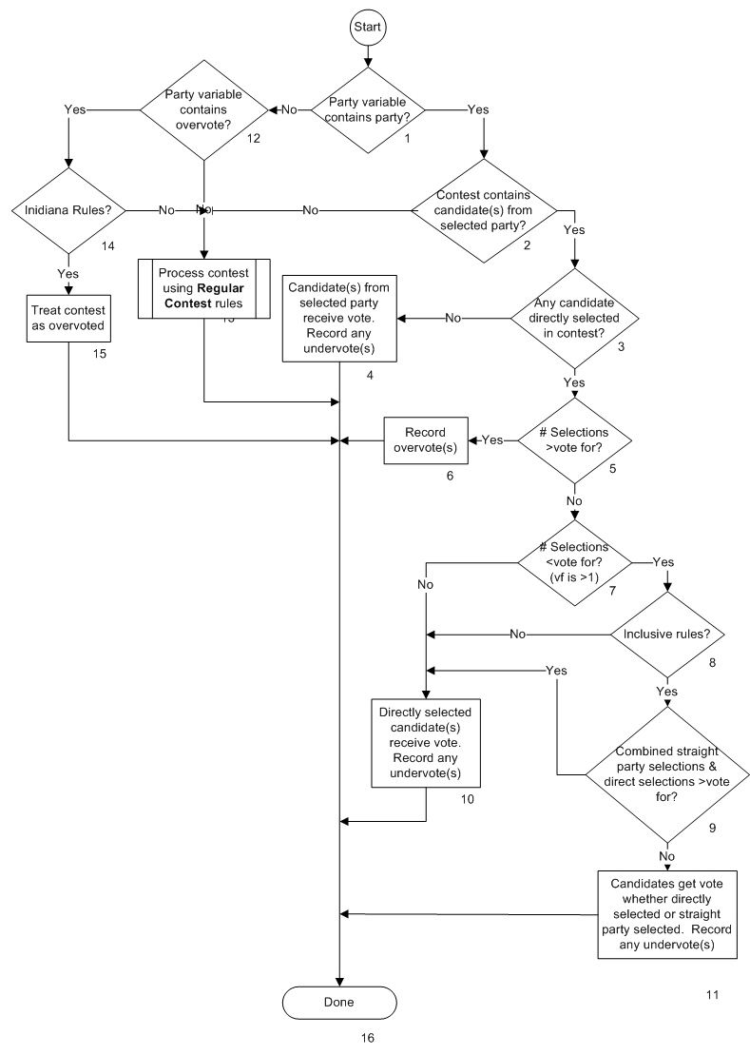

**Description**

1. Party variable contains party?

Processing of this contest requires knowledge of the result of processing the straight party selection contest. For description purposes, the party variable is the term being used to capture this result. If the party variable contains a specific party the Yes path is taken. If it doesn’t, the No path is taken.

1. Contest contains candidates(s) of selected party?

The No path is taken if the contest does not contain any candidates from the party selected in the Straight Party contest as it is unaffected by the straight party selection. The Yes path is taken if the contest does contain one or more candidates from the selected party.

1. Any candidate selected in contest?

The No path is taken if there are no direct candidate selections in the contest. The Yes path is taken if there are one or more directly selected candidates.

1. Candidate(s) from the selected party receive vote

Since there are no candidates directly selected in the contest, any candidate associated with the straight party selection will receive a vote. In a multiple vote for contest, if the slate for the party is not full (number of candidates is less than the number of seats), undervotes are recorded for all missing votes.

1. # Selections <vote for?

If the number of selections is greater than the vote for, the contest is overvoted independent of any straight party selection and the Yes path is taken. If not, then the No path is taken to determine candidate vote selections.

1. Record Overvote(s)

A number of overvotes equal to the vote for in the contest is recorded. Note that in Hawaii and Illinois (neither of which currently use straight party) only 1 overvote would be recorded as they track number of overvoted ballots rather than votes lost due to overvote.

1. # Selections < vote for? (vf is >1)

If there are selections in the contest and the number is less than the allowed number of selections, the contest must be a multi-seat contest. The No path is taken if the number of selections made is equal to the allowed number. The Yes path is taken if the number is less than the allowed number.

1. Inclusive Rules?

At this point in the flow, we know that the contest is a multi-seat contest, that there is one or more direct selections for candidates with the number being less than the number allowed and that there is also a straight party selection. The candidates that will receive votes depend on the rules used for determining voter intent. If Inclusive rules are used the Yes path is taken. If Exclusive rules are used, the No path is taken.

1. Combined straight party selections & direct selections >vote for?

The candidates that will receive votes using the Inclusive rules will depend on whether the **additional** candidates selected by the straight party selection when combined with the candidates directly selected will exceed the number of selections allowed. If they do, the Yes path is taken. If the combined selections are less than or equal to the number allowed, the No path is taken.

1. Directly selected candidate(s) receive vote. Record any undervote(s).

Since adding straight party selections of candidates to the directly selected candidates results in more selections than allowed, only direct selections will receive votes. Straight party selections are ignored/discarded. Undervotes are recorded for any unallocated votes.

1. Candidates get vote whether directly selected or straight party selected. Record any undervote(s).

All candidates that are selected will receive votes whether directly selected or selected by the straight party selection or selected by both. This is according to inclusive rules. Undervotes are recorded for any unallocated votes.

1. Party variable contains overvote?

If the party variable indicates that the Straight Party contest was overvoted, the Yes path is taken. The No path is taken if the Straight Party contest was not voted (not overvoted).

1. Use Process Regular Contest

Even though the contest is tied to the straight party contest, if there is no straight party selection, if the straight party contest is overvoted but Indiana rules do not apply, or if a straight party selection was made but there are no candidates in the contest from the selected party, the contest is processed as a regular contest. The Process Regular Contest flow diagram is used at this point.

1. Indiana rules?

The Yes path is taken if Indiana rules apply. The No path is taken if they don’t apply.

1. Treat contest as overvoted

As in #6 a number of overvotes equal to the vote for in the contest is recorded. According to Indiana rules, if the Straight Party contest is overvoted, all contests that are partisan are also overvoted even if there are no partisan candidates in the contest (non-affiliated or write-in).

1. Done

Contest Processing is complete.